Project_2
2025-11-17

1. Data cleaning and preparation
I first wrote a cleaning function to process the raw air quality data for each year. This function renames the pollutant concentration columns to short, meaningful variable names, converts the date variable to a proper Date format, and aggregates multiple records from the same calendar day into a single daily mean for CO, PM2.5, and O3. It also treats negative concentration values as measurement error by truncating them to zero and removes any remaining duplicate rows. I then applied this function to the 2018, 2019, and 2020 datasets, added year and month variables, and combined them into a single dataset that includes one record per date.
## # A tibble: 6 × 6
## date co pm25 o3 year month
## <date> <dbl> <dbl> <dbl> <dbl> <dbl>
## 1 2018-01-01 0.2 7.5 0.037 2018 1
## 2 2018-01-02 0.7 8.95 0.034 2018 1
## 3 2018-01-03 0.9 15.2 0.032 2018 1
## 4 2018-01-04 0.2 9.7 0.035 2018 1
## 5 2018-01-05 0.2 7.75 0.036 2018 1
## 6 2018-01-06 0.2 7.6 0.036 2018 1

2. Description for Plot 1 (CO & O3 with 95% CIs)
Figure 1 displays the monthly mean CO and O3 concentrations across 2018–2020 combined, with 95% confidence intervals for each month. CO concentrations are generally higher in the winter months and lower in the summer, whereas O3 shows the opposite seasonal pattern, with peak concentrations in late spring and summer and the lowest values in winter. Although the error bars reflect uncertainty around the monthly means, the overall seasonal trends for each pollutant are clear and highlight their contrasting temporal patterns.
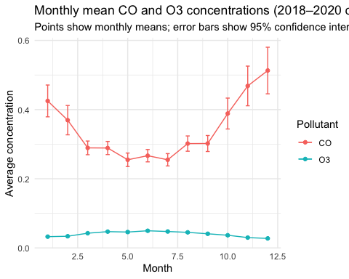

3. Description for Plot 2 (PM2.5 by year)
Figure 2 shows the monthly mean PM2.5 concentrations by year for 2018, 2019, and 2020. All three years exhibit a similar seasonal pattern, with somewhat higher PM2.5 levels in winter and early spring and lower levels in the summer months. The lines also suggest modest differences in overall PM2.5 levels across years, indicating year-to-year variation in air quality while maintaining the same general seasonal structure.
## # A tibble: 6 × 3
## year month mean_pm25
## <dbl> <dbl> <dbl>
## 1 2018 1 9.24
## 2 2018 2 7.39
## 3 2018 3 7.67
## 4 2018 4 7.80
## 5 2018 5 7.64
## 6 2018 6 9.16
