1. Please follow the below instructions. - In A11_1.R

**1.1 [10 points]** Manually draw the undirected graph with 8 nodes and edges between the following pairs of nodes:

(1, 2) (2,4) (1, 3) (3,4) (4,5) (5,6) (6,7) (6,8) (5,7) (7,8)

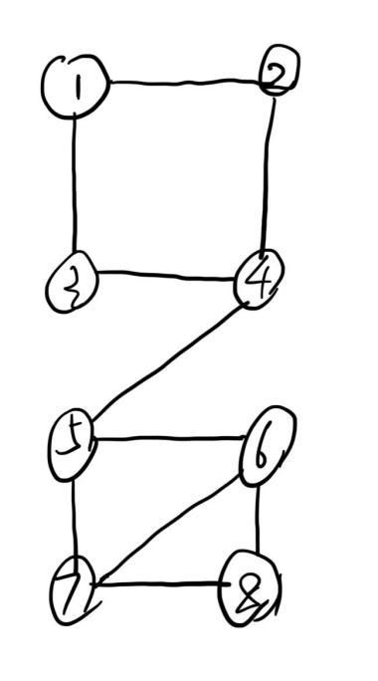

* 1. **[10 points]** Write out the adjacent matrix of this graph.

1 2 3 4 5 6 7 8

1 0 1 1 0 0 0 0 0

2 1 0 0 1 0 0 0 0

3 1 0 0 1 0 0 0 0

4 0 1 1 0 1 0 0 0

5 0 0 0 1 0 1 1 0

6 0 0 0 0 1 0 1 1

7 0 0 0 0 1 1 0 1

8 0 0 0 0 0 1 1 0

* 1. **[10 points]** Write an R script to create a graph object (see igraph package) in R for the above graph.

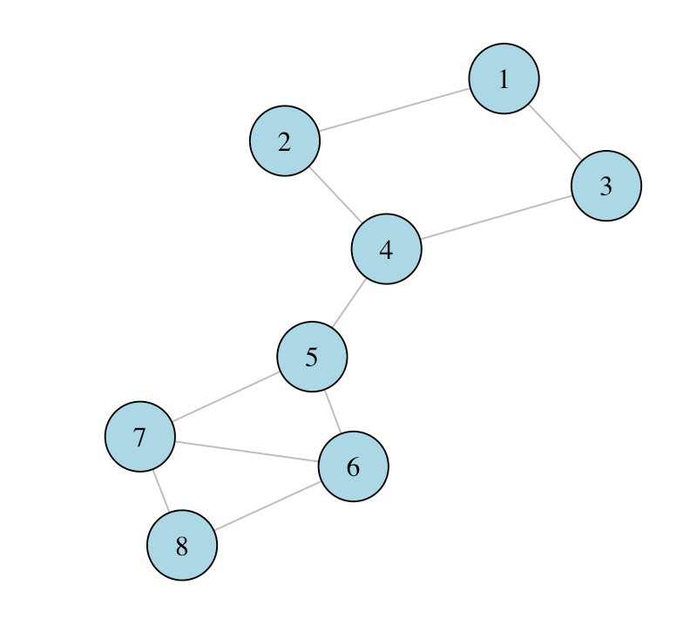

* 1. **[10 points]** Derive 2 modules using cluster_edge_betweenness() in the igraph package.

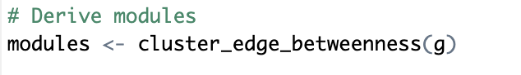

**1.5[10 points]** Draw the topology of this graph using plot.igraph(). Color one module in red and another one in green.

* I indeed use “green”, but it tends to be more “blue”.

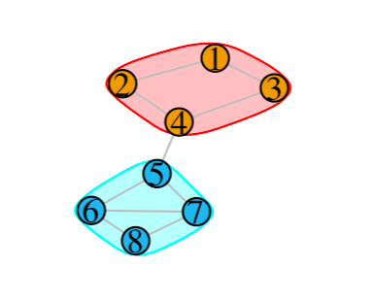

1. **[50 points]** Please follow the example code in the Lab to apply glasso and space on CPTAC-2016 protein data. Specifically, in the lab folder, please follow the instruction in file “Lab_Apr08_space.html” to build the network using “glasso” and “space.joing” function. Generate a bar plot (similar as shown in the example) to showing the degree distribution of the top 10 hubs.

- In A11_2.R

Glasso:

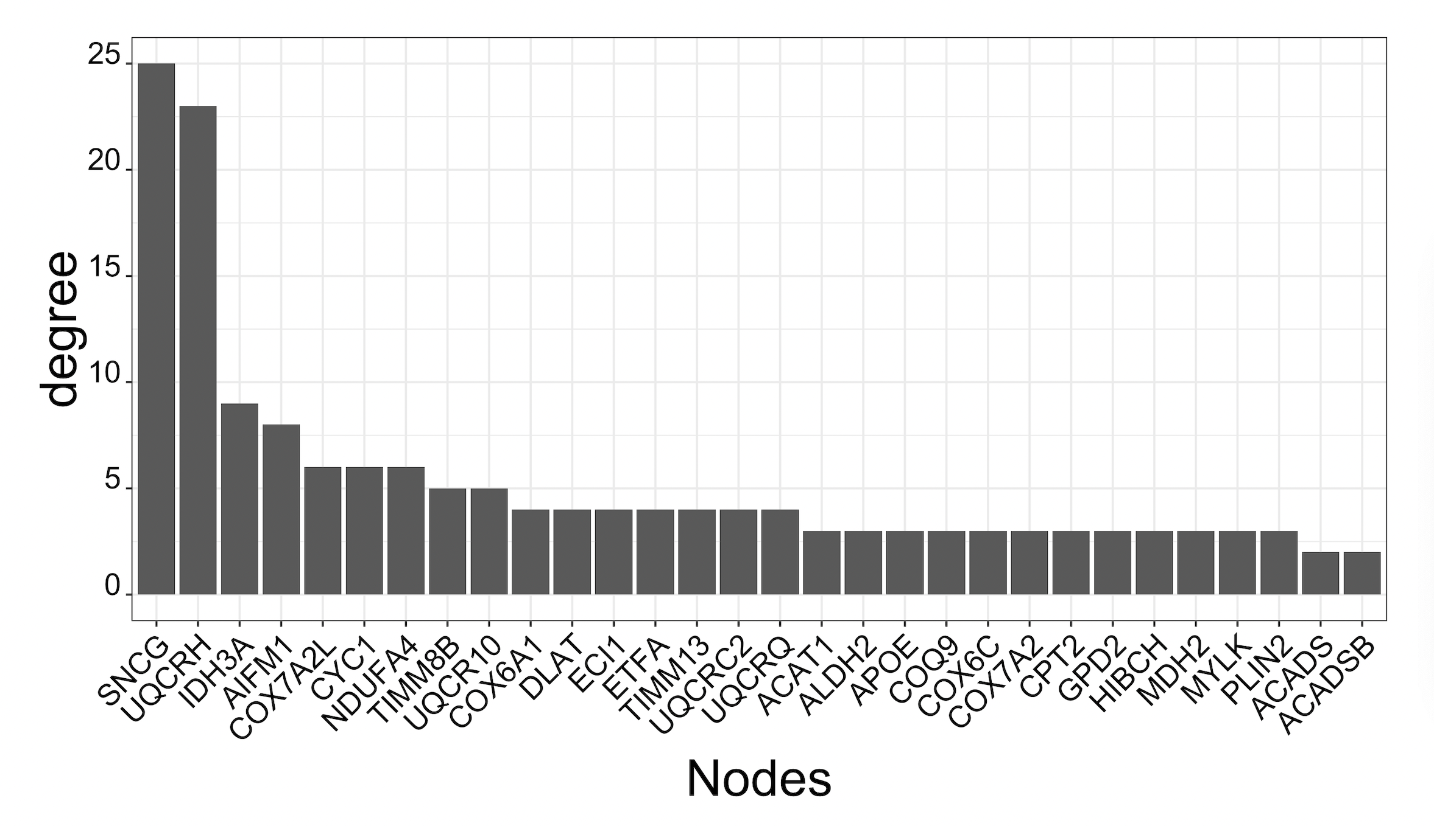

Space.joint:

