1. **[20 points]** Consider a “medical diagnostic” graph as illustrated in below. Find at least 4 conditional independence relationships according to the graph. 

Vaccine-muscle pain

Season-congestion

Season-muscle pain

Vaccine-congestion

1. This problem uses the data in the attached file "network_assignment_data_set.txt", which lists the values that 6 variables take in 200 different samples/observations. Answer the following problems using your preferred Bayesian network learning package, such as the bnlearn package in R.
   1. **[30 points]** Build a DAG-structured Bayesian network of the 6 variables using the hill climbing algorithm. Plot the inferred network. (Hint: use the “hc” function in the *bnlearn* package, or the equivalent in the package you’re using).

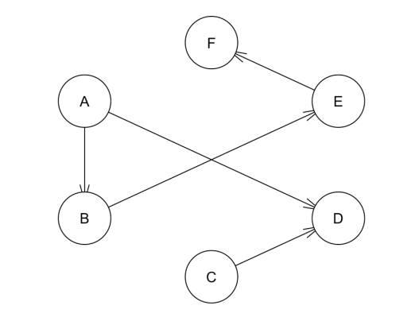

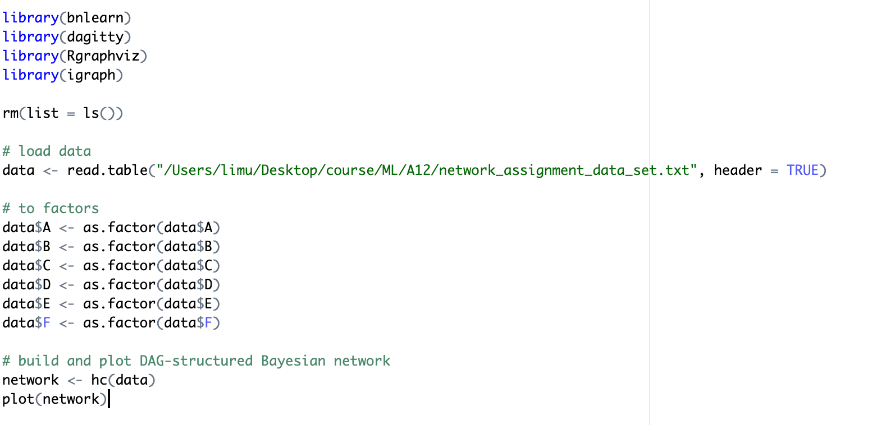

* 1. **[10 points]** Plot (or draw) the moral graph of the inferred DAG.

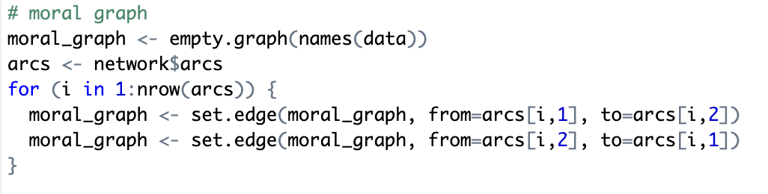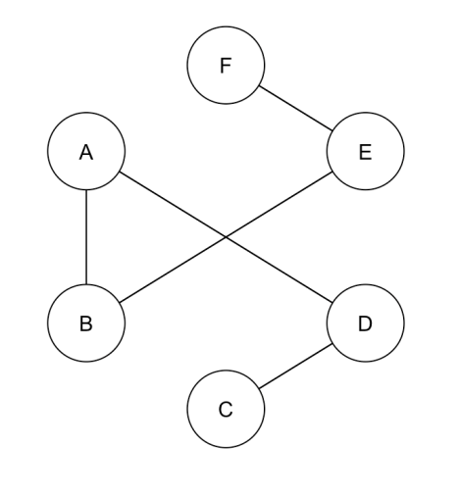

* 1. **[20 points]** Write out the conditional probability table of the edge E->F in the above DAG, i.e., the value of P(F=a|E=a) and all other such combinations. (Hint: use the “bn” function in the *bnlearn* package, or the equivalent in the package you’re using).

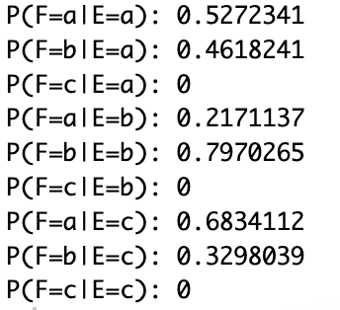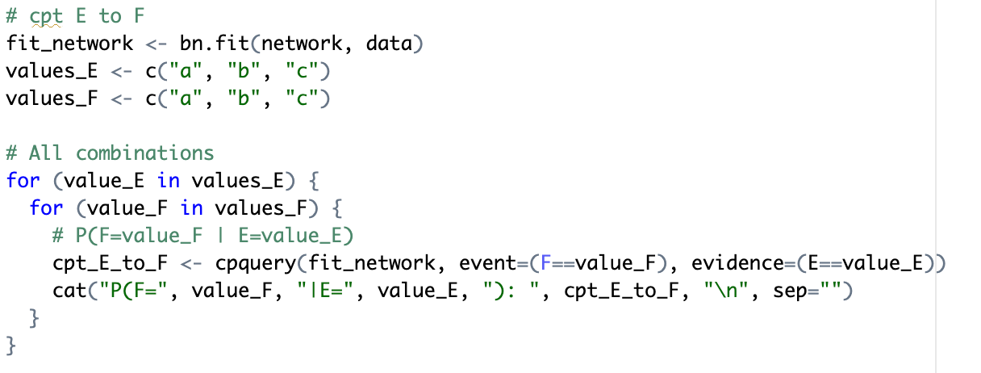

**[20 points]** In addition to answers to the above problems, also include the code segments used to generate them in the report.