**PyCity School Analysis**

**Summary**

In Figure 1, there are a total of 15 schools with 39,170 students, and the total budget for all schools is $24,649,428. The average math score for all students is 78.985, with a passing rate of 74.981%. The average reading score is 81.878, with a passing rate of 85.805%. Additionally, 65.172% of students passed both math and reading.

Figure 1.



Figure 2 provides a description of different school types, the total number of students in each school, the total budget and budget per student for each school, as well as the average math and reading scores with passing rates, including the passing rate for students who passed both math and reading.

Figure 2.

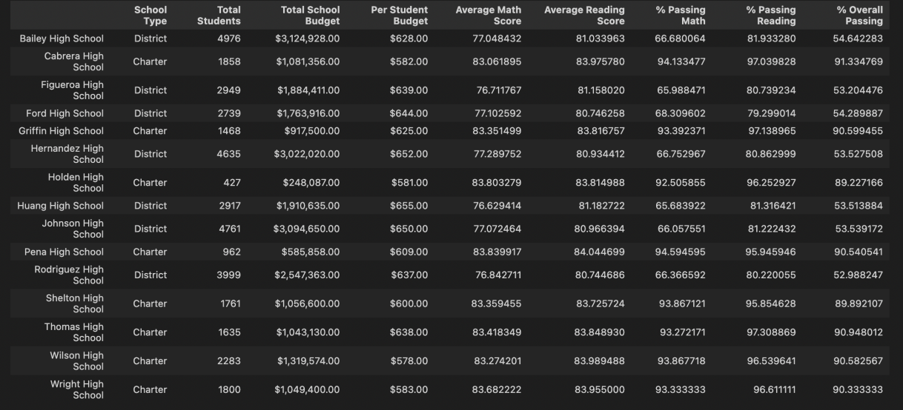

Based on the sorting of the overall passing rate, we identified the highest and lowest performing schools. Cabrera High School has the highest overall passing rate of 91.335%, while Rodriguez High School has the lowest overall passing rate of 52.988%. For more specific information about these two schools, refer to Figure 3.

Figure 3.





Figure 4 displays the math and reading scores for different grades in different schools.

Figure 4.

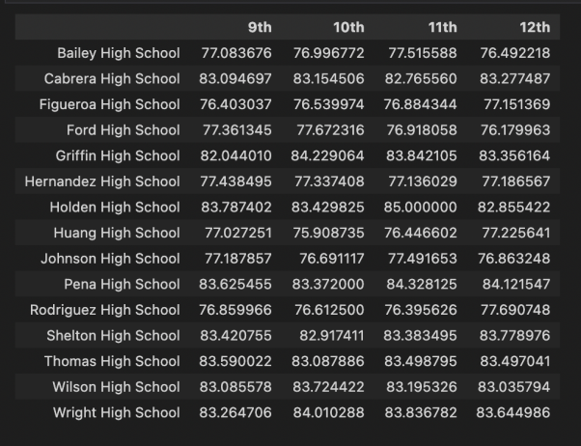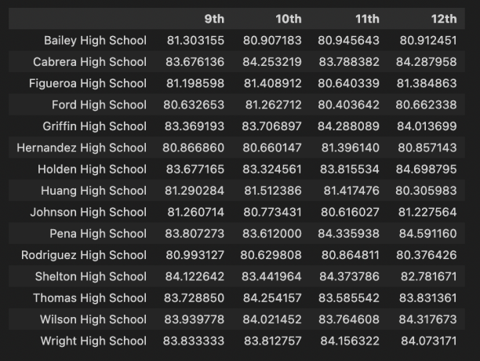

Figure 5 illustrates the average math and reading scores and passing rates based on different school spending levels.

Figure 5.

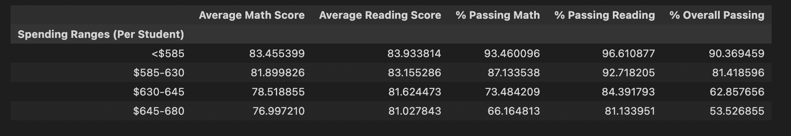

Figure 6 shows the average math and reading scores and passing rates based on different school sizes.

Figure 6.

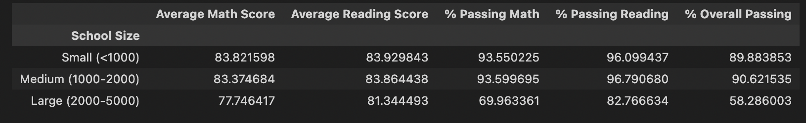

Figure 7 presents the average math and reading scores and passing rates based on different school types.

Figure 7.

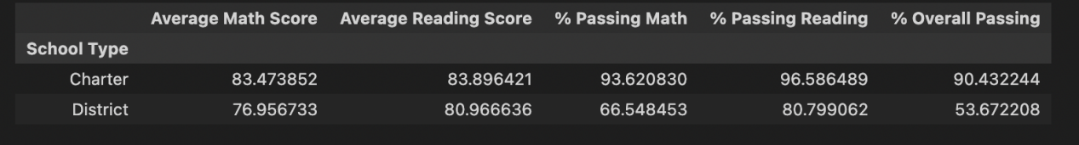

**Two Conclusions:**

1. Charter schools have significantly higher average math and reading scores, as well as higher passing rates, compared to district schools.

2. As the school size and budget increase, the average math and reading scores, as well as the passing rates, decrease.