Natural Language Processing

Unit | Syllabus coverage
Unit I | Finding the structure of words and of documents
Unit II | Syntax I: parsing, treebanks, representation, parsing algorithms
Unit III | Syntax II: ambiguity resolution, multilingual issues; Semantic parsing I: word sense
Unit IV | Semantic parsing II: predicate argument structure, meaning representation
Unit V | Language modeling: n-grams, evaluation, estimation, Bayesian methods

Contents
UNIT I: Finding the Structure of Words and Documents
Q1. Explain words and their components: morphemes, graphemes, phonemes, tokens and tokenization.
Q2. What are lexemes, morphs and allomorphs? How do they differ from morphemes?
Q3. What is typology? Explain morphological typology with examples.
Q4. Discuss the issues and challenges in morphological parsing: irregularity, ambiguity and productivity.
Q5. Explain the main morphological models: dictionary lookup, finite-state, unification-based, functional and morphology induction.
Q6. What is sentence boundary detection and why is it difficult?
Q7. Explain topic (discourse) segmentation, its applications and its difficulties.
Q8. Describe the statistical classification approaches to segmentation: generative, discriminative and hybrid, with complexity and performance.
Q9. Explain the features used for segmentation of text and speech.
UNIT II: Syntax I (Parsing Natural Language)
Q1. What is parsing? Why do we parse natural language and where is it used?
Q2. Explain context free grammar (CFG) and the problem of ambiguity with the Catalan number.
Q3. What is a treebank? How does it help parsing?
Q4. Explain dependency graphs and projectivity.
Q5. Explain phrase structure trees and null elements, and compare them with dependency trees.
Q6. Explain derivations and the shift-reduce parsing algorithm with an example.
Q7. Explain the CKY parser, parse forests, thresholding and the minimum spanning tree approach.
UNIT III: Syntax II and Semantic Parsing I
Q1. Explain probabilistic context free grammars (PCFG) with a worked example.
Q2. Explain generative models for parsing and their limitation.
Q3. Explain discriminative models for parsing: the global linear model and CRF.
Q4. Explain the multilingual issues in parsing: tokenization, case and encoding.
Q5. Explain word segmentation and morphology as multilingual issues in parsing.
Q6. What is semantic parsing? Distinguish deep and shallow semantic parsing and explain the five components.
Q7. Explain word sense and word sense disambiguation (WSD), granularity, and its usefulness.
Q8. How do you build a WSD model for an application? Explain with the agriculture advisory and literary ambiguity examples.
UNIT IV: Semantic Parsing II
Q1. What is predicate argument structure? Explain the semantic role labeling algorithm.
Q2. Compare the five syntactic representations used for SRL: PSG, CCG, TAG, dependency trees and chunks.
Q3. Explain the features for SRL, the path feature and how its sparsity is reduced.
Q4. Explain the classification paradigms used in SRL and the classifiers SVM and decision trees.
Q5. What is meaning representation? Explain deep semantic parsing.
UNIT V: Language Modeling
Q1. What is a language model? Explain n-gram models with an example.
Q2. Explain language model evaluation: coverage, OOV rate and perplexity.
Q3. Explain maximum likelihood estimation, the zero probability problem and smoothing (backoff).
Q4. Explain Bayesian parameter estimation and language model adaptation.
Q5. Briefly explain advanced language models: class based, variable length, Bayesian topic based and multilingual or cross lingual models.

UNIT I: Finding the Structure of Words and Documents
Unit I answers two simple questions. First, how do we break a word into its meaningful parts so a computer can understand it? Second, how do we break a long stream of text or speech into sentences and topics? The first is called morphological analysis, the second is document structure analysis. Everything later in NLP (parsing, semantics, language models) depends on getting these first steps right.
Topic | One line idea | Key terms
Words and components | A word is built from smaller meaningful pieces | morpheme, token, lexeme, allomorph
Typology | Languages are grouped by how they build words | isolating, agglutinative, fusional
Issues and challenges | Why word analysis is hard | irregularity, ambiguity, productivity
Morphological models | Five ways to build an analyzer | dictionary, FST, unification, functional, induction
Sentence and topic boundaries | Find where sentences and topics start and end | HMM, HELM, CRF, TextTiling
Features | Clues the classifier uses | lexical, syntactic, discourse, prosodic

Q1. Explain words and their components: morphemes, graphemes, phonemes, tokens and tokenization.
In plain language, a word is the smallest piece of language that can stand alone as a complete utterance. But a word is usually not the smallest meaningful piece. Take the word unhappiness. It is made of three parts: un (meaning not), happy (the root, the core meaning) and ness (meaning a state or condition). Each of these parts is a morpheme, defined as the smallest unit of language that carries meaning. So unhappiness literally means the state of not being happy. Morphological parsing is the process of discovering these morphemes and the grammatical information they carry, such as tense or number.
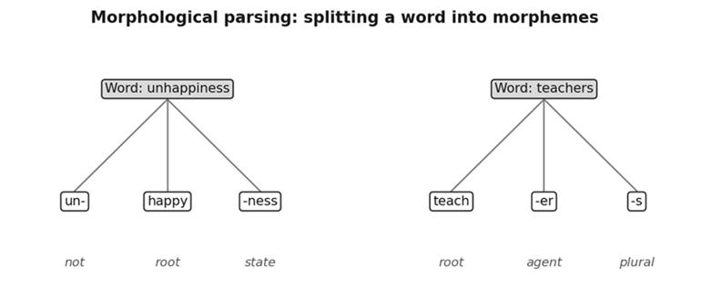
Figure 1.1: Two words split into morphemes with the role of each piece.
Morphemes can be written or spoken. When written, they are spelled with graphemes, which are the symbols of writing such as letters or characters. When spoken, they are realized as phonemes, the distinctive units of sound. Language itself has five levels that linguists study: phonology (sounds), morphology (word structure), syntax (sentence structure), semantics (meaning) and pragmatics (meaning in context). Morphology sits between sound and sentence, which is why it is the first step in an NLP pipeline.
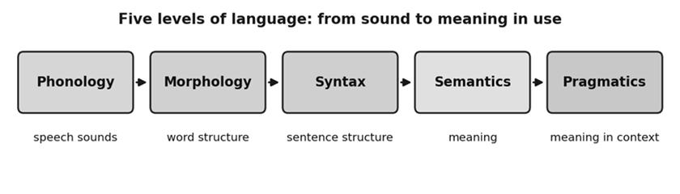
Figure 1.2: The five levels of language that NLP systems model.
A token is a word or meaningful unit identified in running text, and tokenization is the process of splitting text into tokens. It sounds trivial, but it is not. The word newspaper is written as one word yet can be analyzed as news plus paper. The contraction won't is written as one word yet hides two syntactic units, will and not. In Arabic and Hebrew some tokens, called clitics, are glued to the neighbouring word and may even change form. In Chinese, Japanese and Thai there are no spaces between words, so even finding the word boundary is a task. In Korean, strings called eojeol are larger than words but smaller than clauses.
Input | Tokenization result | Remark
newspaper | news + paper | Compound word
won't | will + not | Contraction
Will you read the newspaper? | Will, you, read, the, newspaper | Word tokens
I won't read it. | I, will, not, read, it | Normalized tokens

To remember: a morpheme is the meaning unit, a grapheme or phoneme is how it is written or sounded, and a token is the practical unit a program works with. Good tokenization is the foundation, because every later NLP step assumes the tokens are correct.

Q2. What are lexemes, morphs and allomorphs? How do they differ from morphemes?
Think of a dictionary. A dictionary does not list see, sees, saw, seen and seeing as five separate headwords. It lists one entry, SEE, and says the other forms belong to it. That dictionary entry is a lexeme. A lexeme is the basic, abstract form of a word that groups together all of its grammatical variants. The collection of all lexemes of a language is its lexicon. So the lexeme RUN covers run, runs, ran and running, and the lexeme MOUSE covers mouse and mice.
Lexeme | Word forms belonging to it
mouse | mouse, mice
see | see, sees, saw, seen, seeing
run | run, runs, ran, running
receive | receive, receiver, reception

Now the finer distinction. A morpheme is an abstract unit of meaning, for example the plural. A morph is the actual physical form that appears in a word. The plural morpheme is realized by the morph s in cats. The difference is exactly like the difference between an idea and its written copy. Sometimes one morpheme appears in different shapes depending on the sounds around it. These different shapes are allomorphs. The English past tense is a good example: walk becomes walked, play becomes played and want becomes wanted. The ending is spelled ed in all three, but it is pronounced t, d and id respectively. They are different allomorphs of the same past tense morpheme and the meaning does not change.
Concept | What it is | Example
Lexeme | Abstract dictionary entry covering all inflected forms | SEE covers saw, seen
Morpheme | Smallest meaningful unit | plural
Morph | Actual form seen in a word | -s in cats
Allomorph | Variant form of one morpheme | -t, -d, -id for past tense

Why does this matter for NLP? A system that treats saw and seen as unrelated words must learn everything twice. If we normalize allomorphs to a single canonical morpheme and map word forms to their lexeme, the system sees through surface variation. The workflow is simple: take a word, separate it into morphs, map the morphs to morphemes, and then analyze. In the example sentences Did you see him, I didn't see him and I didn't see anyone, tokenization splits didn't into did and not, and lexeme analysis maps see in every sentence to SEE. Korean gives a harder illustration, where some contractions are phonologically unpredictable and depend on the word, so the analyzer must store them explicitly.

Q3. What is typology? Explain morphological typology with examples.
Typology is a way of classifying languages by their structure rather than by their history. This is different from a language family, which groups languages by common ancestry. English and Mandarin Chinese are not genetically related, yet both mostly follow the subject, verb, object word order, so they are typologically similar. Word order itself is one typological feature: English is SVO (She eats apples), Hindi and Japanese are SOV (She apples eats), and Classical Arabic and Welsh are VSO (Eats she apples).
Morphological typology classifies languages by the typical way they build words. In an isolating or analytic language most words consist of a single morpheme, so grammar is expressed by separate words and word order. Chinese, Vietnamese and Thai are typical members, and English has analytic tendencies. Synthetic languages pack several morphemes into one word, and they split into two groups. In agglutinative languages every morpheme carries exactly one grammatical function and morphemes are glued one after another like beads on a string. Korean, Japanese, Finnish and Tamil are examples. In fusional languages one morpheme can express several grammatical features at once, so the feature to morpheme ratio is above one. Arabic, Czech, Latin, Sanskrit and German are fusional.
Type | Characteristic | Example languages
Isolating (analytic) | Mostly one morpheme per word | Chinese, Vietnamese, Thai
Synthetic | Several morphemes combined in one word | Umbrella for the next two
Agglutinative | Each morpheme has one grammatical function | Korean, Japanese, Finnish, Tamil
Fusional | One morpheme expresses many features | Arabic, Latin, Sanskrit, German

There is a second dimension, which is how morphemes are joined. Concatenative languages link morphs one after another, as in teach plus er. Nonlinear languages allow components to merge without a simple left to right order, for example by changing the vowel template of a word or by using tonal morphemes. Arabic root and pattern morphology is the classic case. For NLP this matters directly: an analyzer built for English prefixes and suffixes will fail on Arabic templates, and a tokenizer that relies on spaces will fail on Chinese. Knowing the type of a language tells an engineer which tools to expect to work and which to rebuild.

Q4. Discuss the issues and challenges in morphological parsing: irregularity, ambiguity and productivity.
Morphological parsing tries to reduce the messy variety of word forms into clean units whose meaning and grammar are explicit. Human language, however, is inherently irregular and ambiguous, and it keeps growing. These three properties are the central challenges.
Irregularity means some words ignore the regular rules. The plural rule add s works for cat and book, but fails for mouse (mice), child (children), man (men) and the past tense go (went). A rule based analyzer would produce mouses or goed, which is wrong. Irregular forms must therefore be stored explicitly in a lexicon, which adds effort and memory.
Regular pattern | Expected | Actual | Problem for parser
cat to cats | cats | cats | Easy
mouse to mouses | mouses | mice | Rule fails
child to childs | childs | children | Special form must be stored
go to goed | goed | went | Completely different form

Ambiguity means a form can have several interpretations. Bank may be a financial institution or a river bank, bat may be an animal or a cricket bat, and watch may be a noun or a verb. A morphological analyzer working on one word alone cannot choose, so it needs context. Productivity means speakers constantly create new words from existing morphemes: read becomes reread, happy becomes unhappiness, nation becomes internationalization, and Google becomes googling. Any dictionary will be missing some of these, so analyzers meet unknown words all the time.
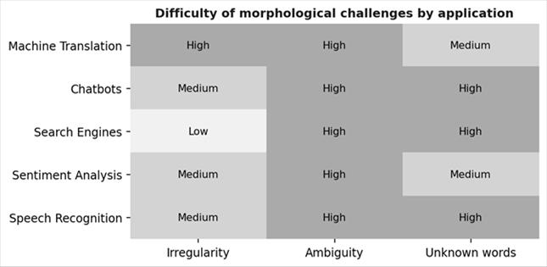
Figure 1.3: Difficulty of the three challenges for common NLP applications (ratings from the lecture slide).
The heat map shows that ambiguity is rated high for every application, because inputs such as search queries or chat messages are short and give little context. Irregularity hurts machine translation most, while unknown words hurt chatbots, search engines and speech recognition most, because of brand names, slang and typos. The practical lesson is that an analyzer needs three things together: a lexicon for irregular forms, rules for productive patterns, and context or statistics to resolve ambiguity.
Exam tip: when asked about challenges, always give one example per challenge and then say how it is handled. Irregularity is handled with a stored exception list, productivity with rules that generalize to new words, and ambiguity with context or probabilities. A good closing line is that no single technique solves all three, which is why real analyzers mix a lexicon, rules and statistics. Also remember that unknown words are not a rare edge case. In real text, new names, spellings and borrowed words appear constantly, so a system that fails on them will fail often.

Q5. Explain the main morphological models: dictionary lookup, finite-state, unification-based, functional and morphology induction.
A morphological model is a computational method to analyze a word into its parts and also to generate word forms. There are five main approaches, ordered here from simplest to most data driven.
Dictionary lookup stores every word form with its analysis, for example cats as cat plus plural and went as go plus past. It is simple, fast and fully accurate for stored words, but it cannot handle unseen words and needs a very large dictionary. Finite-state morphology uses finite-state transducers, which are small machines that map between the surface form (what is written, such as women or replaying) and the lexical form (woman plus plural, re plus play plus ing). Spelling alternations are encoded in the transducer. It is efficient, works in both directions, and is the most popular framework, but it struggles with complex patterns such as reduplication.
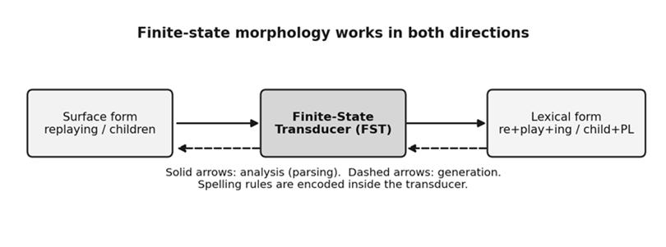
Figure 1.4: A finite-state transducer converts between surface and lexical forms.
Unification-based morphology represents words as feature structures, which are bundles of attribute value pairs. The word runs becomes lexeme run, part of speech verb, person third, number singular, tense present. Two partial structures can be unified into one consistent structure, which makes it good for grammar checking and machine translation. Functional morphology treats morphology as mathematical functions: parsing maps a form to meaning, inflection maps a lexeme to a word form, derivation maps a lexeme to a new lexeme and lookup maps meaning back to a lexeme. It gives modular, reusable and easily maintained systems. Morphology induction learns word structure automatically from raw text without a hand made dictionary. Seeing play, plays, played and playing, it infers the stem and suffixes. It is excellent for low resource languages, but suffers from ambiguity, irregular words and the need for large datasets.
Model | Core idea | Strength | Limitation
Dictionary lookup | Store all forms | Fast, accurate | Unseen words fail
Finite-state | Transducers with spelling rules | Efficient, bidirectional | Reduplication hard
Unification-based | Feature structures | Rich grammar | Complex to build
Functional | Mathematical functions | Modular, reusable | Needs linguistic design
Induction | Learn from raw text | No manual effort | Needs big data, ambiguity

A quick way to remember the five models is the phrase store, transduce, unify, compute, learn. Dictionary lookup stores, finite-state transduces, unification-based merges feature structures, functional computes with functions, and induction learns from raw text. In an exam, a comparison table like the one above earns marks quickly, and one line on when to prefer each model completes the answer. For a well studied language with good resources, finite-state or functional models are usually chosen. For a new language with no dictionary, induction is the practical start.

Q6. What is sentence boundary detection and why is it difficult?
Words combine into sentences, sentences into paragraphs, and sentences are linked by discourse connectives such as therefore. Finding the structure of a document means finding these units automatically. Sentence boundary detection, also called sentence segmentation, is the task of automatically splitting a sequence of word tokens into sentence units. Almost every downstream task, such as parsing, translation and summarization, assumes the text has already been split into sentences.
In English a sentence starts with a capital letter and ends with a period, question mark or exclamation mark. Unfortunately these clues are unreliable. A period is also used in abbreviations like Dr. and in numbers like 3.14. Capital letters mark proper nouns, not only sentence starts. Quoted speech may contain several sentences inside one sentence, and boundaries can occur inside the quotes. Informal text such as SMS and chat often has no punctuation at all, though humans can still infer the breaks, and as text becomes more ungrammatical the agreement between human annotators falls.
Multilingual and technical text add more difficulty. Code-switching happens when a speaker mixes languages in one text, and punctuation conventions may follow either language; Spanish, for instance, starts questions with an inverted question mark. Technical text reuses periods, slashes and symbols in URLs, programming code and mathematical notation, so these constructs must be detected and handled explicitly. For speech, there is no punctuation at all, so the system must rely on acoustic cues.
Challenge | Example | Why it breaks simple rules
Abbreviation | Dr. Rao arrived. | Period does not end the sentence
Number or URL | Pi is 3.14 and see a.b.com | Period inside token
Quotation | He said, "Go. Now." | Boundary inside quotes
Informal text | ok see u tmrw call me | No punctuation
Code-switching | ¿Qué pasa? I am fine. | Mixed conventions

Two broad solutions exist. Hand written rules are quick to start and precise, but they are brittle and need rebuilding for every language and genre. A trained classifier looks at each candidate boundary with its surrounding features and decides. Classifiers adapt better to new data, which is why statistical approaches dominate and are the subject of the later answers in this unit.
Consider a worked example of why a rule based splitter fails. In the text Dr. Rao met Mr. Das at 3.30 p.m. on Monday. They discussed the budget., a naive rule that splits at every period produces six fragments, though there are only two sentences. A trained classifier learns that a period after Dr, Mr and p.m. is usually not a boundary, and that a period followed by a capitalized word after a full word like Monday usually is. This is the difference between rules and learning: the classifier discovers exceptions from data instead of relying on a human to list them all.

Q7. Explain topic (discourse) segmentation, its applications and its difficulties.
Topic segmentation, also called discourse segmentation or text segmentation, divides a stream of text or speech into blocks that each talk about one topic. Given a sequence of words, the goal is to find the points where the topic changes. The classic example is a broadcast news programme: each news story is a coherent block, separated from the next by a topic boundary. The unit of sentence segmentation is the word, whereas the natural unit for topic segmentation is the sentence.
The applications are practical. In information retrieval a user asking a question should receive only the relevant segment, not a three hour recording. In automatic summarization it is much better to summarize coherent units than an undifferentiated stream. In the late 1990s the US agency DARPA started the Topic Detection and Tracking (TDT) programme. One core TDT task was to segment a continuous news stream into stories. It created a common test bed, and researchers also built simulated environments, for example by concatenating Reuters news stories.
The difficulty starts with the definition of a topic. Topics are not flat; they form a hierarchy, so granularity is inherently ambiguous. If one sentence is about soccer and the next about baseball, one annotator will mark a topic change while another will not, since both belong to sports. This is why human agreement on topic boundaries is not very high. Modality adds a second difficulty. Written text has headings, paragraphs and punctuation, while spoken broadcast has none of these but has pauses, pitch and speaker changes, and its transcripts contain recognition errors.
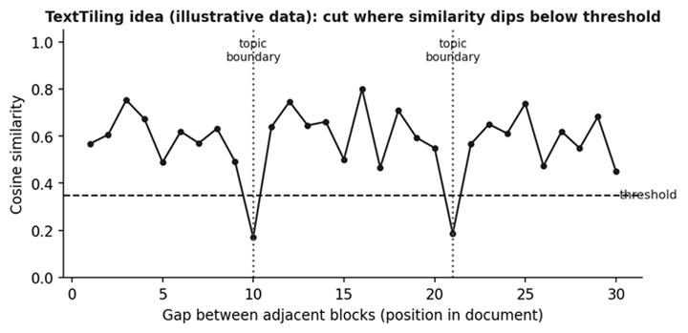
Figure 1.5: TextTiling compares neighbouring blocks and cuts the document where similarity drops (synthetic illustration).
A well known method is TextTiling, which uses lexical cohesion. Adjacent blocks of text are compared by how many words they share, using a cosine similarity over term weights. Inside one topic the same keywords keep recurring, so similarity is high. At a topic change the vocabulary changes and similarity dips. The document is cut wherever the similarity falls below a threshold. TextTiling can be seen as a local classifier with a single feature, which is similarity.

Q8. Describe the statistical classification approaches to segmentation: generative, discriminative and hybrid, with complexity and performance.
Both sentence and topic segmentation can be turned into a classification problem. First we find candidate boundaries, each with a feature vector x (the observation, for example the words around it, an inside quotation flag, membership in an abbreviation list, or pause and pitch for speech) and a label y to predict. In the binary case, y is boundary or non-boundary. Given training pairs, we learn a function that labels unseen candidates. For topic segmentation, y can have several values because each y can represent a topic. Classifiers are either local, labeling one candidate at a time, or sequence classifiers, which label all candidates together because neighbouring decisions depend on each other.
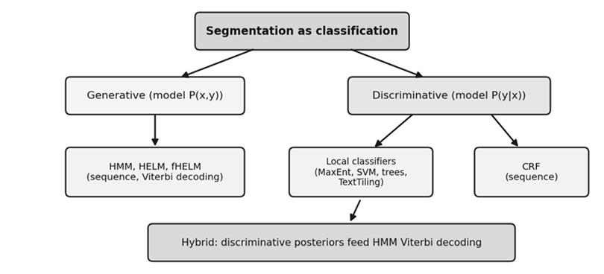
Figure 1.6: Families of statistical approaches to segmentation.
Generative sequence models, mainly the Hidden Markov Model (HMM), model how the features and labels are jointly generated. With m labels it is an m state Markov model with transition probability P(yi given yi-1) and observation likelihood P(xi given yi). The most probable boundary sequence is found by dynamic programming, the Viterbi algorithm. Extensions include the Hidden Event Language Model (HELM), where boundary tokens become extra meta tokens emitted by their own states, and the factored HELM (fHELM), which adds morphological and part of speech information.
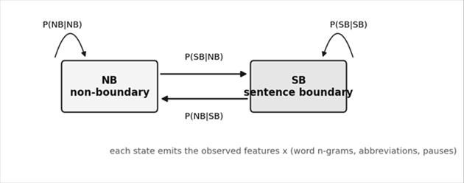
Figure 1.7: A two state HMM for sentence boundary detection (SB and NB).
Discriminative models learn P(y given x) directly. Local versions classify each boundary separately using algorithms such as decision trees, maximum entropy, support vector machines, neural networks and naive Bayes. Sequence versions such as Conditional Random Fields (CRFs) are log-linear models over the entire label sequence, trained by maximizing regularized likelihood and decoded with Viterbi. Hybrid approaches take the posterior probabilities of a strong discriminative classifier and convert them into HMM observation likelihoods by dividing out the priors, then run Viterbi, balancing transition and observation scores with tuned weights.
Aspect | Generative (HMM, HELM) | Discriminative (MaxEnt, CRF)
Models | P(x,y) | P(y|x)
Training cost | Cheap, can use orders of magnitude more data | Multiple passes to tune feature weights
Features | Limited by independence assumptions | Wide variety, overlapping features allowed
Best when | Huge training data, limited compute | Smaller annotated data, rich features
Performance | Good baseline | Often better accuracy

To summarize the comparison in one line: generative models are cheap to train and can use huge data, while discriminative models are stronger when features are rich and overlap. For the viva, remember the decoding step. Whether the model is an HMM, a HELM or a CRF, the best label sequence is found with the Viterbi algorithm, which uses dynamic programming to avoid checking every possible sequence. This makes the cost linear in the number of candidate boundaries and quadratic in the number of states, which is why even long documents can be segmented quickly.

Q9. Explain the features used for segmentation of text and speech.
A classifier is only as good as the clues it receives. Features for segmentation fall into four families: lexical, syntactic, discourse and prosodic. Choosing which to use depends on whether the input is clean text or speech.
Lexical features come from the words themselves. For sentence boundaries these are word n-grams around the candidate, abbreviation list membership and capitalization. For topic segmentation there are three kinds. Cue phrases are words such as now, next or in conclusion that often start a new topic. Similarity features measure how alike the text before and after the boundary is, typically with cosine similarity between the previous and next sentences. Lexical chains are sequences of semantically related words, such as leaf, rose and flower. A candidate boundary where many chains break, meaning words before the boundary are linked to words after it by few chains, is likely a topic change.
Syntactic features use grammatical information. For morphologically rich languages such as Czech and Turkish, morphological analyses of words are good extra clues, and n-grams of part of speech tags around the boundary mirror word n-grams. Discourse features describe relations between sentences, which are at a higher level than syntax. A change of speaker often signals a sentence boundary, and a commercial break signals a topic boundary in broadcast news. Prosodic features exist only for speech, where there is no punctuation or capitalization. The key ones are pause duration, pitch (the fundamental frequency resets at the start of a new unit), lengthening of the last syllable before a boundary, energy and speaking rate.

Feature type | Examples | Used for
Lexical | Word n-grams, cue phrases, cosine similarity, lexical chains | Text and speech transcripts
Syntactic | POS tag n-grams, morphological analysis | Morphologically rich languages
Discourse | Speaker change, commercials | Conversation, broadcast
Prosodic | Pause, pitch reset, final lengthening, energy | Speech only

Consider an ASR transcript such as so i checked the report yesterday it needs more work on the interface. There is no punctuation or capitalization, so orthographic features are unusable and word n-grams are degraded by recognition errors. The most essential features are prosodic: a pause or a pitch reset after yesterday would signal a sentence break. This example shows the rule of thumb: match the feature type to the modality.

UNIT II: Syntax I (Parsing Natural Language)
Syntax is about how words are arranged into phrases and sentences. Parsing is the job of uncovering that hidden arrangement. This unit explains why parsing is needed, how grammars and treebanks describe syntax, the two ways of representing a parse (dependency and phrase structure), and the algorithms that search for the best parse efficiently.
Topic | One line idea | Key terms
Parsing | Recover the hidden structure of a sentence | POS tags, parse tree
CFG | Rules that generate sentences | terminals, nonterminals, Catalan ambiguity
Treebank | Corpus of sentences with full analyses | style book, interannotator agreement
Representation | Dependency graph or phrase structure tree | head, projectivity, null element
Algorithms | Search for the best tree in polynomial time | shift-reduce, CKY, MST, thresholding

Q1. What is parsing? Why do we parse natural language and where is it used?
When you read a sentence you instantly feel its structure: which words group together and which word modifies which. A computer sees only a string of tokens, so parsing is the process of uncovering this hidden structure. In NLP the analysis can be very shallow, such as tagging each word with its part of speech (POS), where the tag says whether a word is a noun or verb, singular or plural, past tense or not. It can also be very deep, such as recovering the dependency between each predicate and its explicit and implicit arguments. The output of parsing is usually a tree or a graph.
Why bother? The example of intonation makes it clear. Compare He wanted to go for a drive in movie with He wanted to go for a drive in the country. In the second sentence a natural pause appears between drive and in, reflecting a break in the underlying structure. A text to speech system can only place that pause correctly if it has parsed the sentence. A second use is paraphrasing. The phrases European countries, the countries of Europe and simply Europe can be swapped in the sentence open borders imply increasing racial fragmentation in Europe without changing the meaning. A paraphrasing system built on a parser does two jobs: it identifies which constituent can be replaced and it finds phrases that can legally substitute for it. Such paraphrases have proven useful in statistical machine translation.
Application | How parsing helps
Text to speech | Places pauses and stress using phrase boundaries
Machine translation | Reorders and paraphrases constituents between languages
Question answering and information extraction | Finds who did what to whom
Grammar checking | Detects ungrammatical structure
Semantic parsing | Syntax supplies the material for features and meaning

The key point is that parsing recovers information that is not explicit in the input. This means the parser needs knowledge in addition to the sentence itself, namely a specification of what kind of syntactic analysis it should output. That knowledge can be written as a grammar, or it can be learned from a treebank, and these two sources are the subject of the next answers.

Q2. Explain context free grammar (CFG) and the problem of ambiguity with the Catalan number.
A context free grammar is a set of rewriting rules. Words are the terminal symbols and are introduced by rules of the form X → w, where X is the part of speech of the word w. These part of speech nonterminals are called preterminals, for example V → bought. Higher rules combine them: S → NP VP says a sentence is a noun phrase followed by a verb phrase, NP → D N says a noun phrase can be a determiner and a noun, VP → V NP says a verb phrase can be a verb followed by a noun phrase, and PP → P NP says a prepositional phrase is a preposition with a noun phrase. Parsing with a CFG means deriving the input from the start symbol S, and the derivation is the parse tree.
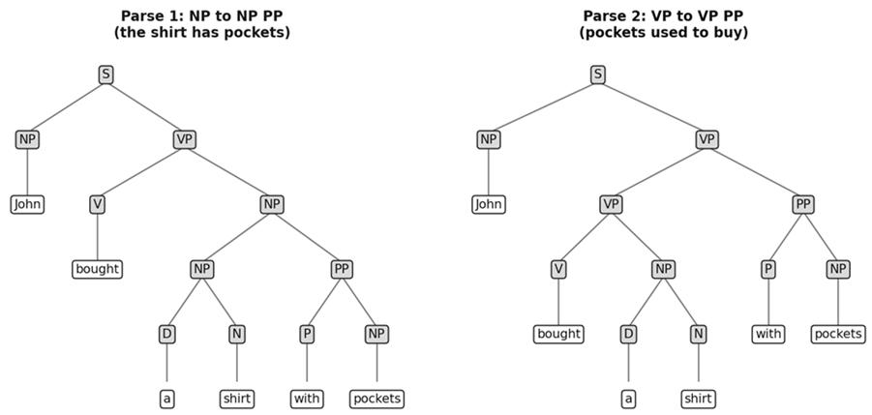
Figure 2.1: Two parses of John bought a shirt with pockets. Both are grammatical, only one is sensible.
The sentence John bought a shirt with pockets shows ambiguity. If with pockets attaches to the noun shirt (NP → NP PP), it means the shirt has pockets, which is the plausible reading. If it attaches to the verb phrase (VP → VP PP), it means pockets were used as the currency to buy the shirt, which is grammatical but silly. Likewise The dog chased the cat with a stick can mean the dog used the stick to chase, or the cat has the stick. A CFG alone cannot decide which parse is right.
The deeper problem is that recursive rules make ambiguity explode. For natural, natural language, natural language processing and natural language processing book, the number of parses is 1, 1, 2 and 5. In general the number of parses obtained by applying a recursive rule repeatedly is a Catalan number, which grows exponentially in the number of words. Listing all parses is therefore computationally hopeless, though a chart parser can still decide in O(n cubed) time, using O(n squared) storage, whether a parse exists.
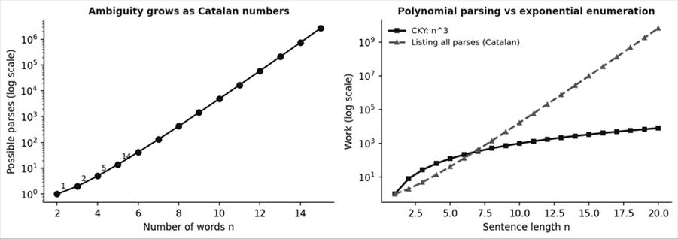
Figure 2.2: Left, parses grow exponentially with sentence length. Right, CKY stays polynomial while enumeration explodes.

Words | Phrase | Parses
1 | natural | 1
2 | natural language | 1
3 | natural language processing | 2
4 | natural language processing book | 5

Writing a CFG by hand has further problems. Natural language is much more complex than a programming language, a plain list of rules does not capture interaction between components, listing every construction is nearly impossible, and it is hard to list the lexical properties of every word, which is called the knowledge acquisition problem. These limitations motivated treebanks.

Q3. What is a treebank? How does it help parsing?
A treebank is a collection of sentences, a corpus, in which every sentence has been given a complete syntactic analysis by human experts. The remarkable thing is what it does not contain: there is no explicit grammar, no rule list and usually no inventory of syntactic constructions. The assumptions about syntax are present, but only implicitly in the annotations. Instead of rules, a detailed annotation guideline, called a style book, is written before annotation starts so that annotators produce one consistent, most plausible analysis for each sentence.
Consistency is measured rather than assumed. About 10 percent of the material is annotated by more than one annotator and the interannotator agreement is computed on that overlap. A parser is then trained on the treebank, usually by supervised machine learning, so that it generalizes the annotated patterns to new sentences. This approach solves two knowledge acquisition problems. First, nobody has to write down all the rules, since the data shows which constructions occur. Second, the parser learns which analysis is most likely when several are possible, because the annotators already chose the plausible one for every training sentence, which removes the unresolved ambiguity of a plain CFG.
Property | Hand written CFG | Treebank
Knowledge source | Linguist writes rules | Annotators label real sentences
Coverage | Hard to make complete | Reflects real usage
Ambiguity | Returns many parses | One plausible parse per sentence
Quality control | Rule testing | Style book and interannotator agreement
Explicit grammar | Yes | No, only implicit

Treebanks are built using one of two representations, dependency graphs or phrase structure trees, covered in the next answers. Which one is chosen depends largely on the language. Dependency treebanks are favoured for freer word order languages such as Czech and Turkish, while phrase structure treebanks are typically used for languages with less flexible order, such as English and French.
Think of a treebank as a very large answer key. Instead of telling the parser the rules of syntax, we show it a hundred thousand correct solved examples and let it work out the patterns. This is the same idea as learning from solved homework. The Penn Treebank for English is the best known example, and parsers trained on it learn which attachments are common, so that with pockets will usually attach to shirt, not to bought. Remember also that the quality of the parser is capped by the quality and consistency of the annotation, which is why the style book and the agreement score matter so much.

Q4. Explain dependency graphs and projectivity.
A dependency graph is the simplest way to show syntax. The only nodes are the words of the sentence. Each word is linked to the word it depends on, using a directed arrow from the head to the dependent. In John saw Mary, saw is the head and John and Mary are its dependents, so the arrows go saw to John and saw to Mary. Exactly one word depends on the artificial ROOT. The head dependent relation can be read semantically as head and modifier, or syntactically as head and specifier.
The defining feature is minimalism. A dependency analysis deliberately avoids hidden structure, empty elements standing in for missing arguments and any hierarchy that is not strictly necessary. This is why it suits free word order languages, where a predicate's arguments appear in many positions and no fixed phrase boundaries can be assumed.
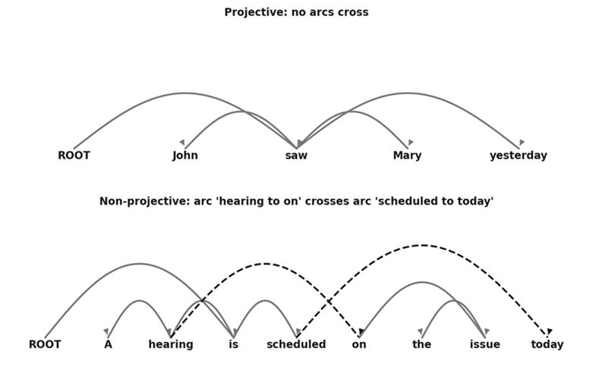
Figure 2.3: A projective tree (top) and a non-projective tree (bottom) where arcs cross.
Projectivity is a constraint that comes from the linear order of words. Put the words in order with ROOT first. A dependency tree is projective if every arc can be drawn above the words without crossing any other arc. Equivalently, for every word, its descendants form a contiguous stretch of the sentence. A non-projective tree has at least one word whose descendants are scattered, which creates crossing arcs. In the figure, A hearing is scheduled on the issue today is non-projective because the phrase on the issue modifies hearing but is separated from it by scheduled.
Property | Projective tree | Non-projective tree
Crossing arcs | None | At least one
Convertible to a CFG | Yes, and vice versa | No CFG can capture it
Frequency in English | Almost all trees | Very few
Frequency in Czech and Turkish | Most | A much higher share

A projective dependency tree can be converted to a context free grammar and the reverse also holds, but there is no CFG that can capture a non-projective dependency. If we want a dependency parser to produce only projective trees, we can implicitly build an equivalent CFG which ignores all non-projective dependencies. This is the bridge between dependency parsing and the CFG based algorithms in the later answers.

Q5. Explain phrase structure trees and null elements, and compare them with dependency trees.
A phrase structure tree derives from the traditional sentence diagram. The sentence is partitioned into constituents, and smaller constituents are merged into larger ones, up to S at the root. The leaves are words, the internal nodes are labels such as NP, VP and PP. A phrase structure tree implicitly carries predicate argument structure, which is recovered from function labels. In Mr. Baker seems especially sensitive, the subject is marked -SBJ and the predicate -PRD, and a logical subject would be marked -LGS. These labels let us read who did what straight off the tree.
Phrase structure can record things that are not visible in the string, using null elements. A null element is a constituent with no words, similar to epsilon in formal language theory. In What is Tim eating, the subject is Tim, but the object is not present at the usual place because it moved to the front as what. A marker such as *T* is placed in the object position to show where the missing object belongs, which localizes the predicate argument relation that the surface string has displaced. Another example shows why this is powerful: in someone persuaded him to leave and someone promised him to leave, the missing subject of leave is the object of persuaded in the first case but the subject of promised in the second. A dependency analysis cannot see this difference because both trees have the same words, heads and labels. The distinction lives entirely in the null element.
Aspect | Dependency graph | Phrase structure tree
Nodes | Words only | Words plus phrase labels
Hidden structure and null elements | None | Allowed
Annotation effort | Light | Heavier, more theory laden
Long distance dependencies | Crossing arcs if needed | Shown with null elements
Best suited to | Free word order (Czech, Turkish) | Fixed word order (English, French)

A practical note: most statistical parsers trained on phrase structure treebanks largely ignore the rich annotation such as function tags and null elements, and learn only the bracketing. Empty categories can be recovered by post processing, and special evaluation schemes compare parsers on predicate argument recovery. The treebank may therefore contain far more information than your parser actually uses.

Q6. Explain derivations and the shift-reduce parsing algorithm with an example.
A derivation is a sequence of rule applications that leads from the start symbol to the input string. Each line of a derivation is called a sentential form. In a rightmost derivation, we always expand the rightmost nonterminal. If the rightmost derivation is written in reverse, it becomes exactly the sequence of steps a bottom up parser must perform, which is the idea behind shift-reduce parsing. One parse tree corresponds to one rightmost derivation, but a tree can also have many different derivations that differ only in the order of expansion.
A shift-reduce parser uses a stack and an input buffer. It starts with an empty stack and the whole sentence in the buffer. It succeeds when the stack holds only the start symbol and the buffer is empty. Otherwise it chooses between two actions. Shift moves the next input word from the buffer onto the stack. Reduce replaces the top k symbols of the stack, if they match the right side of a rule A → α1 ... αk, by the left side A. If neither is possible, the parser fails. If a choice is ambiguous, an oracle decides. The four operations are shift, reduce, accept and error.
Trace for the sentence the dog chased a cat with the CFG: S → NP VP, NP → D N or NP PP, VP → V NP or VP PP, PP → P NP, D → the or a, N → dog or cat or stick, V → chased, P → with.
Step | Stack (bottom to top) | Buffer | Action
1 | (empty) | the dog chased a cat | Shift
2 | the | dog chased a cat | Reduce D → the
3 | D | dog chased a cat | Shift
4 | D dog | chased a cat | Reduce N → dog
5 | D N | chased a cat | Reduce NP → D N
6 | NP | chased a cat | Shift
7 | NP chased | a cat | Reduce V → chased
8 | NP V | a cat | Shift
9 | NP V a | cat | Reduce D → a
10 | NP V D | cat | Shift
11 | NP V D cat | (empty) | Reduce N → cat
12 | NP V D N | (empty) | Reduce NP → D N
13 | NP V NP | (empty) | Reduce VP → V NP
14 | NP VP | (empty) | Reduce S → NP VP
15 | S | (empty) | Accept

With the longer input the dog chased a cat with a stick, the parser reaches a conflict when the stack is NP V NP and with is in the buffer. It can reduce VP → V NP (then later VP → VP PP, so the dog uses the stick), or shift with (then the NP absorbs the PP, so the cat has the stick). Both lead to valid parses, which shows ambiguity directly. Shift-reduce parsing can run in linear time when the oracle always chooses correctly, but for a general CFG it may need backtracking, which in the worst case costs exponential time.

Q7. Explain the CKY parser, parse forests, thresholding and the minimum spanning tree approach.
To avoid backtracking, the CKY algorithm first binarizes the grammar so that each rule has at most two symbols on its right side. It then labels the gaps between words with positions, called spans: 0 a 1 and 2 b 3 or 4 c 5. For each span of each length, it tries every split point and checks whether some rule can combine the two sub spans into a bigger one. Nonterminals carry their span, such as N[0,5]. The set of span annotated rules is a compact encoding of all legal parse trees at once, called a parse forest. When nodes with the same label and span are merged, the forest becomes a hypergraph. N[0,5] appearing on the left of two rules shows two ambiguous readings that share their sub parts.
The loops visit all spans and all split points, so CKY takes O(n cubed) time for a sentence of n words, with O(n squared) storage for the chart. Listing every tree in the forest can still be exponential, but picking the single best tree using learned scores also needs only O(n cubed). If scores are log probabilities, the best scoring tree is the Viterbi parse.
Technique | What it does | Risk
Beam thresholding | Compare entry X[i,j] with the best entry Y[i,j] for the same span; discard X if far worse | May cause a search error, but rarely
Global thresholding | Delete a chunk that has no neighbour to combine with; it can never join a full parse | No search error

Thresholding trades accuracy for speed. Beam thresholding looks inside one span, while global thresholding looks across the whole chart. For dependency parsing a different approach is used, based on minimum spanning trees. Instead of a chart, we build a fully connected directed graph in which every possible head to dependent arrow has a score. The task becomes choosing a subset of arrows that forms a valid tree with the maximum total score. This formulation ignores word order, so it can recover non-projective dependencies.
The algorithm for John saw Mary works in steps. First pick the highest scoring incoming edge for each word. If the result is a tree, it is the answer. If it contains a cycle, contract the cycle into a single node, recompute the edge weights to and from that node while remembering which member gave the maximum, and recurse. Repeat until there is no cycle, then expand the contracted nodes back. This is the Chu-Liu-Edmonds style method for finding the optimum branching in a directed graph.
Parser | Output | Time | Handles non-projective
Shift-reduce | Constituency or dependency | Linear with oracle, worst case exponential | Depends on the system
CKY | Parse forest and best tree | O(n cubed) | No (projective)
MST | Dependency tree | Polynomial | Yes

UNIT III: Syntax II and Semantic Parsing I
Unit II showed how to search for a parse. Unit III asks how to score parses so the best scoring tree is the correct one, and how parsers cope with languages other than English. It then moves from syntax to meaning: semantic parsing, word senses and how to design a word sense disambiguation system.
Topic | One line idea | Key terms
PCFG | Attach probabilities to grammar rules | rule probability, parent annotation, lexicalization
Generative and discriminative parsing | Two ways to score a tree | history, global linear model, CRF
Multilingual issues | Tokens, case, encoding, segmentation, morphology | lattice, pattern tokens
Semantic parsing | Map text to a computable meaning | shallow vs deep, five components
Word sense | Choose the right meaning of a word in context | granularity, hard and soft clusters, WordNet

Q1. Explain probabilistic context free grammars (PCFG) with a worked example.
A plain CFG tells us what parses are possible, but not which is most likely. A probabilistic CFG (PCFG) attaches a probability to every rule. The probability of a parse tree is the product of the probabilities of all the rules used in it, or equivalently the sum of log probabilities if we work with scores. When a sentence has several parses, we choose the one with the highest probability. For the probabilities to form a valid distribution, each rule is conditioned on its left side: for a rule N → α we use P(N → α given N), and all rules that expand the same nonterminal must sum to 1. For instance NP → John (0.1), pockets (0.1), D N (0.3) and NP PP (0.5) add up to 1.0.
Rule probabilities are estimated from a treebank by counting. If a rule is used c times out of all times its left side is expanded, its probability is c divided by that total. If trees t1, t2 and t3 occur 10, 20 and 50 times, the rule counts are weighted accordingly and then normalized per left side.
Worked example with the grammar S → NP VP (1.0), NP → John (0.1), NP → pockets (0.1), NP → D N (0.3), NP → NP PP (0.5), VP → V NP (0.6), VP → VP PP (0.4), PP → P NP (1.0), and D, N, V, P rules at 1.0. For John bought a shirt with pockets, the two parses share most rules. Only NP → NP PP and VP → VP PP differ, so they decide the winner.
Parse | Rules multiplied | Probability
P1: with pockets attaches to the NP shirt | 1.0 x 0.1 x 0.6 x 1.0 x 0.5 x 0.3 x 1.0 x 1.0 x 1.0 x 1.0 x 0.1 | 0.0009
P2: with pockets attaches to the VP | 1.0 x 0.1 x 0.4 x 0.6 x 1.0 x 0.3 x 1.0 x 1.0 x 1.0 x 1.0 x 0.1 | 0.00072

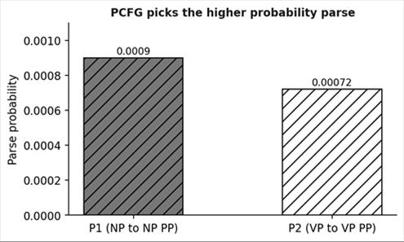
Figure 3.1: The PCFG prefers parse P1, the sensible reading.
P1 is more likely, matching human intuition. A PCFG is still limited because it is context free: the probability of a rule does not depend on where it appears in the tree, so the model can mix rules into combinations never seen together. The fix is to enrich the labels. Parent annotation attaches the parent label to each node, so VP under S becomes VP^S, a different symbol from VP under VP. Automatic split-merge with EM lets an unsupervised algorithm discover useful subcategories by splitting labels and merging back those that do not help. Lexicalization attaches the head word to each nonterminal, so an attachment can depend on actual words, for example shirt with pockets versus bought with cash.

Q2. Explain generative models for parsing and their limitation.
A generative parser describes how a tree is generated step by step. Building a parse tree is viewed as making a sequence of decisions D = d1, d2, ..., dn, where each decision might be which rule to apply or which word to attach. The probability of the whole tree is the product of the probabilities of each decision given all earlier decisions, P(di given d1 ... d(i-1)). The earlier decisions are called the history, and they represent the partially built tree.
There is a practical problem. Every sentence produces a different, ever growing history, so there are infinitely many possible histories and we can never estimate P(di given history) directly from data. The solution is to introduce a function Φ that maps each history to a small fixed set of features, such as the parent label, the head word or the previous sibling. Two histories that map to the same features are treated as equivalent, so they fall into the same equivalence class. Now the probability can be estimated by counting within each class. This is why the model is called generative: it models the process that generates the tree, and in essence it is a more detailed PCFG.
Concept | Meaning
Decision d(i) | One choice in building the tree
History | All earlier decisions, the partial tree
Feature map Φ | Compresses an unbounded history into finite features
Equivalence class | Histories with the same features share one probability

The limitation is that the structure of the CFG dictates what the model can condition on. It is hard to use arbitrary features of the entire tree, such as whether a long distance pattern exists. Generative models also require careful design of independence assumptions. Discriminative models were created precisely for this freedom, which we study next. The trade off is that generative models are simple to train from counts and can use very large training sets.
A simple analogy helps. Imagine describing a recipe by listing every step in order. To predict the next step you could use the whole list so far, but no two recipes share the same list, so you could never count anything. Instead you summarize the list by a few facts, such as the dish type and the last ingredient added, and you predict from those. That summary is the function Φ, and the group of lists with the same summary is the equivalence class. The skill in generative parsing lies in choosing summaries that keep the useful information and throw away the rest.

Q3. Explain discriminative models for parsing: the global linear model and CRF.
Instead of modelling how a tree is generated, a discriminative model scores candidate trees directly and picks the best. The global linear model is a clean framework that also covers tagging and chunking. It has four ingredients. The input x is a sentence. GEN(x) is a function that produces all candidate outputs y for x, such as all valid parse trees. Φ(x, y) is a feature vector, a long list of numbers describing properties of the pair, and any feature is allowed, for example whether the tree contains NP → NP PP, whether the head word is shirt, or whether an arrow crosses another. Finally w is a weight vector learned from data, one weight per feature. The score of a candidate is the dot product Φ(x, y) · w, and the parser outputs the candidate with the highest score.
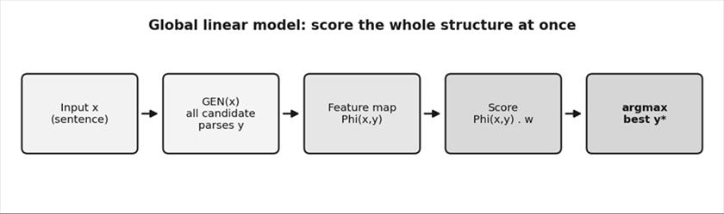
Figure 3.2: The global linear model generates candidates, scores them with feature weights and returns the best.
The word global means the score is over the entire structure at once, not decision by decision. A Conditional Random Field (CRF) is closely related. It turns the linear score into a proper conditional probability by adding a normalization term, while the global linear model drops the normalization and uses the raw score. Both are trained so that correct parses get higher scores than competitors, often with perceptron or maximum likelihood training.
Aspect | Generative parser | Discriminative parser
Models | Joint probability of tree and sentence | Score or P(y|x) of tree given sentence
Features | Restricted by the grammar structure | Any feature of the whole tree
Training | Counting, simple | Iterative weight learning
Example | PCFG, history based models | Global linear model, CRF

Compare the two styles using the same sentence. A generative parser asks how probable it is that this tree and this sentence arose together, and has to spread probability over all possible sentences. A discriminative parser only asks which of the trees for this sentence looks best, and never needs to model the sentence itself, which frees it to use any feature. That freedom is the whole reason for its better accuracy in practice. A further advantage is that features can describe the tree globally, for example how balanced the tree is or whether a verb has two subjects, which a step by step generative model would find very hard to capture.

Q4. Explain the multilingual issues in parsing: tokenization, case and encoding.
So far we assumed that the notion of a word token is well defined. Across languages this assumption often fails, and a parser that works for English may break on another language. Even in English a token is not simply what lies between spaces. A parser treats today's as today and 's, and There's as There and 's. The possessive 's does not even always attach to the preceding word. In First of America's operating results the 's belongs to the whole constituent First of America, not just America. In There's nothing very hot the 's is actually the verb is. So tokenization must follow the treebank's conventions.
Issue 1 is case. It is tempting to lowercase all training and input text for standardization, since a word at the start of a sentence is capitalized only because it is first. But case carries information. An unseen word like Boeing might look like a progressive verb because of the ing ending, while the capital letter makes a proper noun more likely. A good solution is to replace rare words with case preserving pattern tokens. A rare word like Patagonia becomes Xxx, meaning a capital followed by lowercase letters, so that any new unknown word of that shape is handled alike. The same idea collapses dates, times, IP addresses and URLs into pattern tokens so the parser is not derailed by unique strings.
Issue 2 is encoding. Text is bytes in some encoding, and if the treebank and the input differ the data must be converted. Chinese, for example, appears in GB, BIG5 and UTF-8 depending on where the text originates. This is algorithmically trivial compared with writing a parser, but ignoring it silently corrupts the input.
Issue | Example | Remedy
Tokenization | today's, There's, First of America's | Follow treebank conventions
Case | Boeing looks like a verb | Keep case, use pattern tokens such as Xxx
Rare strings | Dates, URLs, IP addresses | Collapse to pattern tokens
Encoding | GB, BIG5, UTF-8 | Convert to one encoding

Putting the three issues together, a multilingual parser should apply a short preprocessing recipe before parsing. Convert all text to one encoding, tokenize according to the treebank's conventions, keep case information, and replace rare or unpredictable strings with pattern tokens. For languages without spaces, add a segmentation step or use a word lattice, and for morphologically rich languages add richer tags. Skipping any of these steps usually costs more accuracy than switching to a more advanced parsing algorithm, which is why engineers check the preprocessing first.

Q5. Explain word segmentation and morphology as multilingual issues in parsing.
Many writing systems, Chinese in particular, put characters side by side with no spaces. Before tagging or parsing, one must decide where each word ends, and the choice changes the meaning. The string meaning competition among university students in Beijing can be read as Beijing, university students, competition. But Beijing University can also be a single word, and the same characters would then be read as Beijing University gives birth to competition. Since part of speech tags attach to words and the parse tree is built over words, nothing downstream works until segmentation is done.
Two approaches are described. The first parses the character sequence directly, letting the tree itself define words: a nonterminal covering a group of characters effectively declares that these characters form a word. The study found that immediate local context was the most useful for predicting word boundaries, while global sentence context helped surprisingly little, even though occasionally long distance information from the tree is needed. The second approach avoids the danger of a pipeline, where one segmentation is chosen first and the parser cannot reconsider it. Instead, the parser is given a word lattice, a finite-state automaton encoding many ranked segmentations at once, and the parser uses the automaton's states as its indices, generalizing the positions 0, 1, 2 used in CKY. Segmentation and parsing are decided together and the best parse selects the segmentation.
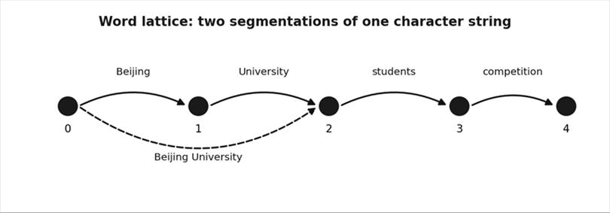
Figure 3.3: A word lattice packs two segmentations into one structure for the parser.
Morphology is the second challenge. In many languages a word is a stem plus attached morphemes, so syntax may depend on the pieces inside a word. Agglutinative languages such as Turkish and Finnish take this to the extreme, packing a clause worth of meaning into one long word by stacking morphemes. Inflectional languages such as Czech and Russian mark case, gender, degree and polarity with morphemes that are orthogonal, meaning they combine independently. A practical solution is to turn morphology into complex part of speech tagging: instead of physically splitting each word, give each word a rich structured tag that encodes all its morphological dimensions at once. A morphology aware parser can then use agreement, for example matching case and number between an adjective and a noun, to resolve ambiguity.

Q6. What is semantic parsing? Distinguish deep and shallow semantic parsing and explain the five components.
Semantics is the study of meaning and parsing is examining something in fine detail, so semantic parsing is the process of identifying chunks of meaning in text. The goal is to map natural text into a representation a computer can work with, for tasks like retrieving information, answering questions, populating a database or taking an action. An ideal representation would be detailed enough for reasoning systems to make deductions and general enough to work across many domains with little change. Such representations are extremely hard to build, so two compromises exist. Deep, domain specific parsing builds one rich meaning representation for a limited domain such as air travel or geographic queries. It is powerful but does not port to new domains. Shallow, general purpose parsing splits understanding into smaller domain independent pieces, such as word sense disambiguation and predicate argument structure, and the data and methods are reusable.
Aspect | Deep (domain specific) | Shallow (general purpose)
Representation | Rich, formal meaning | Intermediate, partial
Portability | Low, rebuild per domain | High, reusable
Examples | Air travel queries, football simulation | Word sense disambiguation, semantic role labeling
Cost | Very high | Moderate

Katz and Fodor argued that semantics is needed to explain ambiguous sentences such as The bill is large (money or a bird's beak), to resolve ambiguity in context when it continues but need not be paid, to detect meaningless yet grammatical sentences such as Colorless green ideas sleep furiously, and to identify paraphrases.
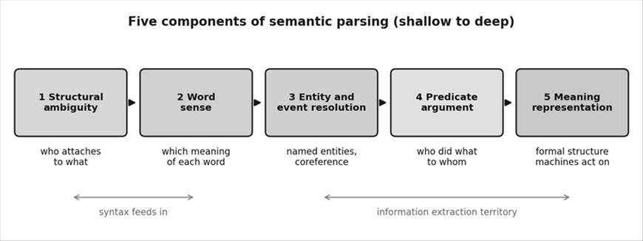
Figure 3.4: The five components of semantic interpretation.
The five components are: structural ambiguity resolution (syntax comes first because syntax and semantics interact strongly); word sense (He nailed the arm of the chair with a hammer tells you which sense of nail is meant); entity and event resolution, which includes named entity resolution and coreference resolution so that Bell Atlantic Corp., the company and it are linked to the same entity; predicate argument structure, which answers who did what to whom, when, where, why and how, for example the nested say and acquire events; and finally the meaning representation, a formal structure that algorithms can manipulate to answer questions, fill a database or act.

Q7. Explain word sense and word sense disambiguation (WSD), granularity, and its usefulness.
A word sense is one of the distinct meanings of a word. The nature of word senses is still not settled, since it is unclear whether a finite set of senses exists for each word, or whether a word in a context evokes one discrete sense or a distribution over several. Take run. A shiver ran down her spine borrows the movement sense, but nothing moves on legs. It is a metaphor that creates a new sense on the fly. In the newspaper ran the story, several senses are active at different intensities rather than one clean choice.
Sense disambiguation is the task of identifying the appropriate sense of a word in context. Early systems were rule or knowledge based, using dictionary definitions. As language keeps growing, later systems used unsupervised word sense induction, learning senses from how words appear in corpora and clustering similar usages. Clusters may be hard (one cluster per word in context, 1 or 0) or soft (a probability for each cluster, 0.0 to 1.0).
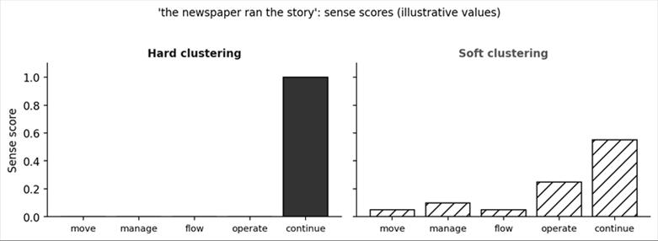
Figure 3.5: Hard versus soft sense assignment (illustrative values).
Granularity is how finely senses are sliced. Coarse granularity gives few broad senses, higher annotator agreement and easier learning but may miss nuance. Fine granularity captures nuance but is costly and reduces agreement. For the word paper, a coarse inventory has two senses (material and document), while a fine one separates the physical material, newspaper, academic article, exam, wallpaper and official papers.
Granularity | Advantages | Disadvantages
Coarse | High agreement, easy to learn, cheap | May be too blunt for the application
Fine | Captures nuance | Costly, low agreement, harder to learn

Is WSD useful in practice? Fine grained WSD has drawbacks: it is hard to create huge manually sense tagged corpora, it consumes computing resources, and no standard criteria exist to merge sense resources. In information retrieval, overlap among several query words already gives implicit disambiguation. In speech recognition context classes have proved more useful than word classes. In domain specific systems a word usually maps to one concept, so the problem becomes easier. WSD therefore pays off most when the application is carefully scoped.

Q8. How do you build a WSD model for an application? Explain with the agriculture advisory and literary ambiguity examples.
Designing a WSD model means making a sequence of decisions: the model type (supervised, unsupervised or semi-supervised), the dataset (sense inventory, granularity and data source), the features, and the output with hyperparameters. Parameters are values learned from data during training, while hyperparameters, such as model size and number of epochs, are set before training. A feature is a measurable property of the data, like an ingredient in a recipe. A supervised model needs labelled data, an unsupervised model groups unlabeled data by similarity, and semi-supervised learning is a mix, for example bootstrapping from a small labelled seed onto a large unlabeled pool. The sense inventory is the fixed menu of senses the model may choose from; for English the standard is WordNet.
Application 1 is an agriculture advisory app answering short farmers' messages. Words like crop (plant, trimming, a bird's pouch) and yield (harvest quantity or give way) are ambiguous, and a wrong sense routes the query to the wrong knowledge base. English has WordNet, but farming slang and fertilizer terms are missing, so the best design is semi-supervised: seed with WordNet backed senses and bootstrap on unlabeled farming text. The domain is narrow, so coarse granularity is enough, only the senses that change the routing. Data is a small labelled seed plus large unlabeled farming text. Features are context words in a window (harvest, soil, sow), part of speech and domain indicator words. The output is per sense association values, with a small to average model and small to average epochs.
Application 2 is a literary ambiguity tool. Poets deliberately use words with several live meanings, such as spring (water source, season, rebirth) in The Waste Land. WordNet cannot supply these metaphorical senses, so an unsupervised soft clustering model is chosen. The domain is not narrow, so fine granularity is used. Data is a large unlabeled literary corpus. Features are co-occurring adjective and noun imagery phrases and position in the poem (title, opening or closing line). The output is a probability distribution of senses per word, with a large model (many clusters) and few epochs.
Decision | Agriculture advisory | Literary analysis
Model type | Semi-supervised | Unsupervised, soft clustering
Granularity | Coarse | Fine
Data | Small labelled seed plus unlabeled farm text | Large unlabeled poems and stories
Features | Window words, POS, domain words | Imagery phrases, position in poem
Output | Sense association per word | Probability over senses
Model size and epochs | Small to average, small to average | Large, small

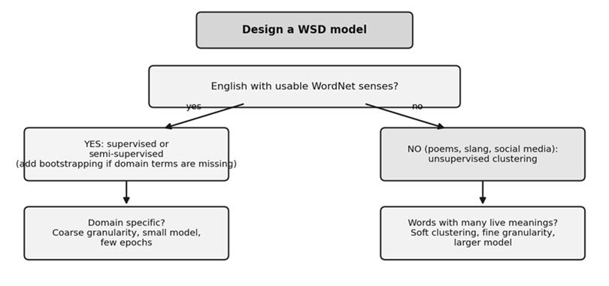
Figure 3.6: Rules of thumb for choosing a WSD design.

UNIT IV: Semantic Parsing II
Topic | One line idea | Key terms
Semantic role labeling | Find who did what to whom for each predicate | FrameNet, PropBank, argument, null node
Syntactic representations | Five ways to represent the parse used for SRL | PSG, CCG, TAG, dependency, chunks
Features | What the classifier looks at | path, verb cluster, named entity
Classification paradigms | How decisions are combined | independent, postprocessing, joint decoding
Meaning representation | Unambiguous form a machine can act on | deep semantic parsing

Q1. What is predicate argument structure? Explain the semantic role labeling algorithm.
Every sentence is about events or states, and the predicate (usually the verb) is the word that names the event. A predicate has slots, called arguments, that must be filled: who did it, to whom, when, where, why and how. In Bell Atlantic Corp. said it will acquire one of Control Data Corp.'s computer-maintenance businesses there are two predicates, said and acquire, and each has its own who and what. Semantic role labeling (SRL) is the task of identifying the word sequences that are the semantic arguments of a given predicate and labelling their roles. Unlike word sense disambiguation, little research has used unannotated corpora for this, because SRL is close to real applications and has been absorbed into information extraction. Two resources drive the work: FrameNet, hand tagged arguments of predicates, and PropBank, a resource for verbs and their alternations.
Early systems relied on heuristics over syntax trees, with the trees themselves rule based, until treebanks allowed supervised syntactic parsers. SRL was then formulated as supervised classification, assuming the predicate and each of its arguments can be mapped to a node in the syntax tree. The algorithm runs in a fixed order, shown in the figure. A full syntactic parse of the sentence is generated first. The predicates are identified. A set of features is extracted for each node in the tree relative to the predicate under consideration. Each feature vector is classified, and the highest scoring class is selected. Each node is either an argument (a non-null node) or not an argument (a null node).
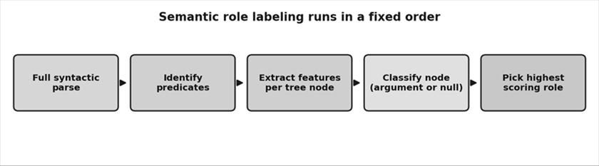
Figure 4.1: Steps of the SRL algorithm.
The ordering has an important consequence. The syntactic parse is not just preprocessing, it supplies the material from which every feature is built. If the form of the syntactic analysis changes, the entire feature inventory changes. That is why researchers have tried several syntactic representations, which the next answer describes. Three standard tasks are performed under SRL: argument identification (is this node an argument), argument classification (which role is it), and the combination of both. Consider Today, I ate a car: the parser will find car as the object of ate, but a trained model knows that car is an implausible argument for ate, which is one reason sequence information is later used for postprocessing.

Q2. Compare the five syntactic representations used for SRL: PSG, CCG, TAG, dependency trees and chunks.
SRL needs a syntactic parse, but which kind? The representations fail in different ways, and the preferred one depends on the input conditions and the evaluation criterion. Phrase structure grammar (PSG) analyzes the sentence by recursive partition into constituents, each covering a contiguous span of words and labeled NP, VP or S. It exists because PropBank tags nodes on exactly these trees. A typical feature is the path NP↑S↓VP↓VBD, but paths can be long and sparse.
Combinatory Categorial Grammar (CCG) assigns categories to words and combines them with binary rules. It was used because dependency like relations give shorter paths from the predicate to its dependent words, a more robust complement to phrase structure paths, though the structures may not align with annotated spans. Tree Adjoining Grammar (TAG) builds an analysis by combining elementary trees, each tied to a lexical item. It was chosen for its ability to handle long distance dependencies, where an argument is far from the predicate that governs it, at the cost of a surface versus deep structure complexity. Results were reported with surface syntactic features and with extra features from a TAG extracted from the Penn Treebank.
A dependency tree has no phrasal nodes: each word links directly to the single word it depends on, and words are the only nodes. The motivation is about evaluation more than grammar, because exact bracketing is hard to get right. Finally, base phrase chunks abandon hierarchy entirely. The sentence is divided into flat, non-overlapping base phrases, each with a syntactic tag. Chunking is faster and more robust to phrase reordering, as in speech data, but gives up some accuracy.

Representation | Structure | Why used | Cost
PSG | Nested constituent tree | PropBank is annotated on it | Long sparse paths
CCG | Binary, categories on words | Shorter paths | Span alignment problems
TAG | Elementary tree per word | Long distance dependencies | Surface versus deep complexity
Dependency | Words and arcs only | Exact bracketing not needed | Constituents do not match annotation
Chunks | Flat boxes with tags | Speed, robust for speech | Lower accuracy

To choose among the five, ask two questions. Do I need exact span boundaries, as PropBank annotation does? Then use PSG. Is speed and robustness more important, as with noisy speech transcripts? Then use chunks. If long distance dependencies are common, TAG is appealing, and if short, robust paths are wanted, CCG or dependencies are useful. Research found that no single representation wins everywhere, and that combining features from several, for example PSG paths together with chunk information, gives the best results. The takeaway is that SRL quality depends heavily on the quality of the underlying syntax.

Q3. Explain the features for SRL, the path feature and how its sparsity is reduced.
After a parse is obtained and predicates are chosen, features are extracted for each node. For PSG trees the main features are the path, the predicate and verb clusters, named entities, position, distance and neighbours, cue words, punctuation and feature context. The predicate itself is one of the most useful clues for the argument class, but any amount of hand tagged data is limited given the many constructions a verb occurs in. The fix is verb clustering: group similar predicates into classes and use the cluster as a feature alongside or instead of the verb. Named entity features, for example Boolean tags for person, organization, location, date, time, money and percent, show what kind of thing the constituent is. Position and neighbour features include the first and last word and their part of speech, the ordinal position of the constituent and its tree distance to the predicate.
Temporal cue words such as today, yesterday, tomorrow, now, later, soon and recently are added as binary features since the named entity tagger misses them. Punctuation before and after a constituent helps with adjunct arguments, for example in Hyderabad as a location or every Monday as a time. Feature context uses the parent and sibling constituents; in John bought a car in Delhi, John is the parent context and a car and in Delhi are siblings.
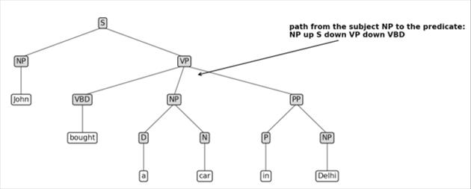
Figure 4.2: The path from the subject NP to the predicate verb is NP↑S↓VP↓VBD.
The path is the syntactic route through the tree from the constituent to the predicate. For argument identification it is the single most salient feature, and without it the model converges very slowly. It is also the most sparse feature: long paths are nearly unique, so a given path is seen once in training and never again, whereas a model learns only when training samples share attribute values. Sparsity means meaningful values are scattered thinly across a large pool, and the cure is to cluster or generalize values, at the risk of losing structural information. Several generalizations are used.
Generalization | What it does
Path n-grams | Split the path into overlapping three-node pieces (trigrams), pad short paths with nulls
Single character phrase tags | Keep only the first letter of each label, so NP and N become N, S and SBAR become S
Path compression | Collapse repeated identical labels into one
Directionless path | Drop the up and down markers and keep only labels
Partial path | Keep only the climb up to the lowest common ancestor and discard the descent

Q4. Explain the classification paradigms used in SRL and the classifiers SVM and decision trees.
Once features are extracted for every node, we must decide for each node whether it is an argument of the predicate and which one. Four paradigms exist, with growing sophistication. In pure classification each node is classified independently, without knowing that other nodes exist. The weakness is the overlap problem: two overlapping constituents can both be labelled as arguments. In a parse tree overlapping nodes always have an ancestor and descendant relation, so overlaps are subsumptions. The second paradigm keeps independent classification and adds a simple postprocessor that removes implausible analyses such as overlapping arguments. The third uses richer postprocessing with argument sequence information: a predicate usually takes a certain set of argument types in a certain order, and a labelling that no real sentence would produce is probably wrong, however plausible each single label looked. The fourth, joint decoding, abandons the two stage structure and decodes all arguments together, for example with a global log-linear model or integer linear programming that finds the highest scoring labels satisfying all predicates simultaneously.
Paradigm | Idea | Weakness solved
Pure classification | Classify each node alone | None, ignores context
Independent plus simple postprocessing | Remove overlapping arguments afterwards | Overlap
Richer postprocessing | Use likely argument sequences | Implausible combinations
Joint decoding | Decide all arguments together (log-linear, ILP) | Interdependence of arguments

Two popular classifiers are Support Vector Machines and decision trees. An SVM is a supervised algorithm that finds the best hyperplane, a decision boundary that separates the classes. The margin is the distance between the hyperplane and the closest points of each class, and the SVM maximizes it while keeping errors small, which usually generalizes well even with many sparse features. A decision tree is a hierarchical structure of a root node, branches, internal nodes and leaves. It splits the dataset on feature values to create pure subsets, and each leaf gives a class label or value. Trees are easy to interpret, while SVMs are strong in high dimensional text style features.
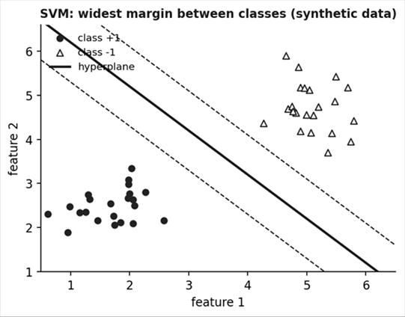
Figure 4.3: An SVM places the boundary with the widest margin between classes.
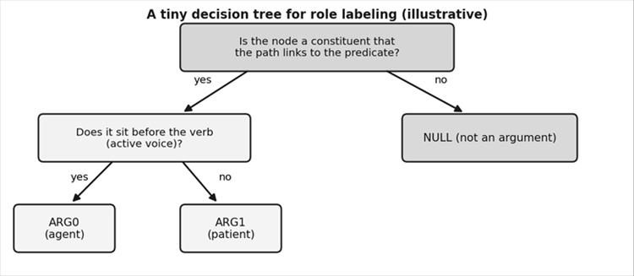
Figure 4.4: A small illustrative decision tree for role labeling.
Here is an overlap example. In the sentence John bought a car in Delhi, a classifier might label both the VP bought a car in Delhi and the NP a car as arguments, even though the second sits inside the first. A postprocessor keeps only the better scoring one. For sequences, a typical verb like give expects an agent, a theme and a recipient, so a labelling with two agents is rejected. Joint decoding gets this right by construction, because it searches for the best complete set of labels instead of fixing mistakes afterwards.

Q5. What is meaning representation? Explain deep semantic parsing.
Meaning representation is a deeper level of semantic interpretation whose objective is to take natural language input and transform it into an unambiguous representation that a machine can act on. It is also called a deep representation. It is the final stage in the five component view: after structure, word sense, entities and predicate arguments are resolved, a formal structure is built that algorithms can manipulate to answer a question, populate a database or take an action. For example the question Which flights go from Hyderabad to Delhi on Monday would be converted into a database query with explicit fields for origin, destination and day, with no ambiguity left.
Researchers have spent decades working out how to interpret and encode context and world knowledge so that machines can understand what humans seem to understand effortlessly. Progress is still limited. The techniques that exist work only within specific domains and problems, and do not scale to arbitrary domains. This is why the field distinguishes deep semantic parsing, which builds complete meaning representations for restricted domains, from shallow semantic parsing, which consists of word sense disambiguation and semantic role labeling, general techniques that produce partial meaning but are reusable.
Level | Tasks | Output | Scope
Shallow semantic parsing | Word sense disambiguation, SRL | Senses and role labels | Any domain
Deep semantic parsing | Full meaning representation | Formal query or logical form | Specific domain

Meaning representation systems differ in expressive power. The more expressive the representation, the more reasoning is possible, but the harder it is to build resources and to port to a new domain. The pragmatic strategy used in industry is to combine shallow, reusable components with a small, domain specific deep layer on top.
For revision, remember this ladder of meaning. Tokens and morphemes give the words. Syntax gives the structure. Word sense gives the intended meanings. Predicate argument structure gives who did what to whom. Meaning representation turns all of that into one formal object that a program can execute, such as a database query or a logical formula. The higher you climb the ladder, the more useful and the less portable the system becomes. Most deployed systems, such as flight booking assistants, sit at the top of the ladder in one narrow domain.

UNIT V: Language Modeling
A language model assigns a probability to a sequence of words. It is the engine inside speech recognition, machine translation, spelling correction and modern text generation. This unit covers n-gram models, how to evaluate them, how to estimate their parameters and smooth them, and the Bayesian ideas behind adaptation.
Topic | One line idea | Key terms
N-gram models | Predict a word from the previous n minus 1 words | unigram, bigram, trigram
Evaluation | Test on held-out data | coverage, OOV rate, perplexity
Estimation | Maximum likelihood relative frequencies | smoothing, backoff
Bayesian estimation | Use a prior to combine sources | hyperparameters, adaptation
Advanced models | Class based, variable length, topic based, multilingual | clusters, mixtures

Q1. What is a language model? Explain n-gram models with an example.
A statistical language model specifies the prior probability of a particular word sequence in a language. Given a vocabulary Σ (the unique words in training data) and a sequence W = w1 w2 ... wT, the model computes P(W). Its parameters are estimated beforehand from training data. A language model is combined with other models that propose word sequences. In speech recognition, acoustic model scores are combined with language model scores to decode the spoken words. In machine translation, the language model scores translation hypotheses from the translation model. Models can be defined over words, characters or acoustic units, and choosing the unit is hard in languages other than English.
By the chain rule, P(W) is the product of P(wi given all earlier words). The history grows, so we use the n-gram approximation: all words except the n minus 1 words immediately before the current word are assumed irrelevant. All histories sharing the same last n minus 1 words are treated as one history equivalence class. A unigram uses no history, a bigram uses one previous word and a trigram uses two.
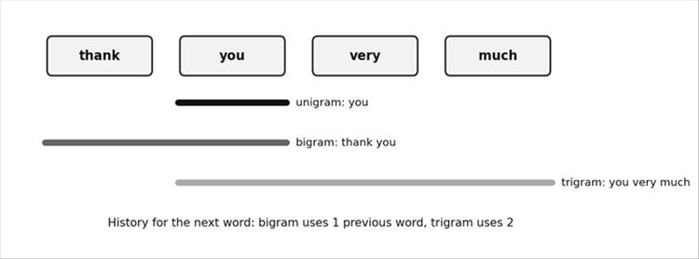
Figure 5.1: Unigram, bigram and trigram windows over the phrase thank you very much.
Worked bigram example. Take a toy corpus of three sentences: <s> I love NLP </s>, <s> I love data </s> and <s> I study NLP </s>. The bigram probability is P(wn given wp) = count(wp wn) divided by count(wp). The word I appears 3 times and the pair I love appears 2 times, so P(love given I) = 2/3 and P(study given I) = 1/3. The word love appears 2 times and love NLP appears once, so P(NLP given love) = 1/2. Then P(I love NLP) = P(I given <s>) x P(love given I) x P(NLP given love) x P(</s> given NLP) = 1 x 2/3 x 1/2 x 1 = 1/3.
Bigram | Count of pair | Count of first word | Probability
<s> I | 3 | 3 | 1
I love | 2 | 3 | 2/3
I study | 1 | 3 | 1/3
love NLP | 1 | 2 | 1/2
love data | 1 | 2 | 1/2
NLP </s> | 2 | 2 | 1

Why is the n-gram assumption reasonable? Most of the useful information for predicting a word lies in the few words just before it. After the words thank you very, the next word is much more likely to be much more than elephant, and knowing three more words further back rarely changes this. The cost is that long distance relations are lost. This is the central trade off: a larger n captures more context but needs far more training data, since the number of possible n-grams grows as the vocabulary size is raised to the power n.

Q2. Explain language model evaluation: coverage, OOV rate and perplexity.
How do we know if a language model estimates probabilities well? Two criteria are used, both measured on a held-out test set that is not part of the training data, because measuring on the training data would reward memorization, not prediction. The first criterion is the coverage rate, the percentage of n-grams in the test set that are represented in the model. A special case is the out-of-vocabulary (OOV) rate, defined as 100 minus the unigram coverage rate, which is the percentage of unique word types in the test set that the model does not know at all. A high OOV rate warns that the vocabulary is too small for the domain.
The second criterion is perplexity, an information theoretic measure built on entropy, the uncertainty in a distribution. For a test sequence of N words, perplexity is PP = P(W) raised to the power of minus 1/N, which equals 2 raised to the cross entropy H. Intuitively, perplexity is the weighted average number of choices the model considers at each word. A model that gives every test word probability 0.1 has perplexity 10, as if it were choosing among 10 equally likely words. Lower perplexity means the model is less surprised and is better.
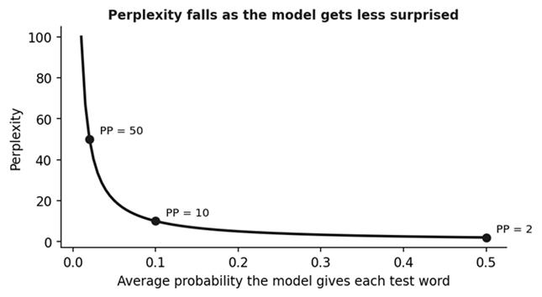
Figure 5.2: Perplexity is the inverse of the average word probability.
Measure | What it tells | Better when
Coverage rate | Share of test n-grams seen by the model | Higher
OOV rate | Share of unknown word types | Lower
Perplexity | Average branching, how surprised the model is | Lower

One caution applies when comparing models. Models that cut text into different units, such as a word based model and a morpheme based model, produce different numbers of units for the same text, so their raw perplexities are not comparable. The perplexities must first be normalized to the same number of units. Only then does the comparison mean something.
Here is a short numeric example. Suppose a model gives the four test words probabilities 0.1, 0.2, 0.05 and 0.1. The product is 0.0001 and, raising it to the power of minus one quarter, the perplexity is 10 to the power of one, which is exactly 10. That tells us the model behaves as though it picks among about 10 equally likely words at each step. If a second model gave a perplexity of 5 on the same test set, it would be the better model. Always remember that perplexity is only meaningful when two models are tested on the same text.

Q3. Explain maximum likelihood estimation, the zero probability problem and smoothing (backoff).
The standard way to train an n-gram model is maximum likelihood estimation (MLE) combined with smoothing. MLE simply computes relative frequencies. For a trigram, P(wi given wi-2, wi-1) = c(wi-2, wi-1, wi) divided by c(wi-2, wi-1): count how often the trigram occurred, then divide by how often its two word history occurred. This is the same calculation as the bigram example earlier, just with a longer history.
Raw MLE fails in two ways. First, it assigns zero probability to any sequence not seen in training. One unseen n-gram makes the whole product zero, so a perfectly good sentence is judged impossible. Second, sequences that were observed may be overestimated, because an n-gram seen twice in a large corpus is almost certainly rarer than its relative frequency says. Both failures arise because the training corpus is finite and the distribution it implies is too sharp.
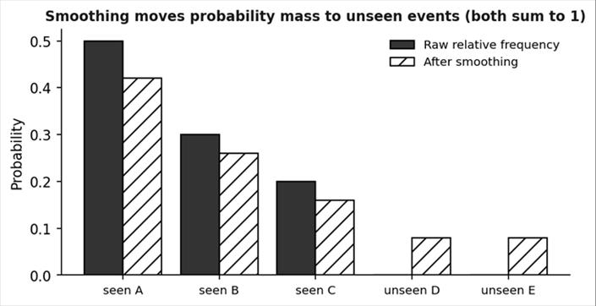
Figure 5.3: Smoothing flattens peaks and gives unseen events a small nonzero probability.
Smoothing redistributes probability mass: peaks are flattened and zero estimates are raised to small nonzero values. Mass is taken from observed n-grams and given to unseen ones, and the total still sums to one. The most common method is backoff. N-grams are split by a threshold τ on their training counts. If the count is above τ, the n-gram keeps its maximum likelihood estimate, discounted by a factor that frees probability mass for the lower order model. If the count is below τ, the estimate is replaced by one derived from the lower order (n minus 1) gram probability multiplied by a backoff weight. A trigram that was never seen is therefore estimated from the bigram, and the bigram from the unigram if needed.
Situation | Raw MLE | With backoff smoothing
Unseen trigram | Probability 0 | Estimate from bigram times backoff weight
Frequent trigram | Relative frequency | Slightly discounted relative frequency
Rare trigram seen once or twice | Overestimated | Replaced by lower order estimate
Total probability | 1 | Still 1

Here is a mini example of the zero probability problem. Using the toy corpus from the earlier answer, the bigram love study never occurs, so MLE gives P(study given love) = 0. A new sentence I love to study would receive probability 0, no matter how good the rest is. With smoothing, a little mass is moved from the seen bigrams, so that love study gets a small positive value. Other smoothing methods, such as add one smoothing, interpolation and Good-Turing, follow the same logic of taking from the rich and giving to the poor, and they differ only in how much is moved.

Q4. Explain Bayesian parameter estimation and language model adaptation.
Maximum likelihood treats the training data as the only source of knowledge. Bayesian estimation instead treats model parameters as random variables with a prior distribution that expresses beliefs before seeing the data. Bayes rule combines the prior with the observed counts into a posterior, and the posterior is used for prediction. The prior has its own parameters, called hyperparameters. For n-gram probabilities, which follow a multinomial distribution, a common choice of prior is the Dirichlet distribution, whose hyperparameters act like imaginary counts added to the observed counts. This gives a principled explanation for add one smoothing and shows that smoothing is really Bayesian prior knowledge.
Hyperparameters offer a convenient way of integrating different information sources into the estimation process. This has been most successful in language model adaptation. Suppose you have a huge amount of general text, such as news, but only a small amount of text from your target domain, such as medical dictation. The prior is computed from the large out-of-domain data, and the counts observed in the small in-domain data update it. With little in-domain data, the model stays close to the general prior. As more in-domain data arrives, the posterior moves towards the domain. This avoids both overfitting to a tiny domain sample and ignoring domain specific vocabulary.
Aspect | Maximum likelihood | Bayesian estimation
Parameters | Fixed unknown values | Random variables with a prior
Uses prior knowledge | No | Yes, through hyperparameters
Small data behaviour | Overfits, zero counts | Stays near the prior
Typical use | Basic training | Adaptation, smoothing, mixing sources

Recent progress in Bayesian statistics has produced alternative models, including topic based and nonparametric models, that give good results. The central message is that a language model should not rely on one dataset alone; combining a broad prior with specific evidence gives more reliable probabilities.
A small example makes adaptation concrete. Imagine a general model where the word stent is very rare, with probability near zero. A hospital collects a few hundred sentences in which stent occurs many times. With plain maximum likelihood on that small sample the model would overreact and also forget common words. With a Bayesian prior built from the general data, stent rises sharply but common words keep sensible probabilities. This balance between old knowledge and new evidence is the reason adaptation techniques are widely used when moving a recogniser from one domain to another.

Q5. Briefly explain advanced language models: class based, variable length, Bayesian topic based and multilingual or cross lingual models.
This part of the syllabus extends the basic n-gram model; the lecture slides stop at estimation, so the notes below follow the standard textbook outline. Class based language models group words into classes, such as days of the week or city names, and predict the next class and then the word inside the class. This reduces the number of parameters, handles rare words better and generalizes, because Monday and Tuesday share statistics. The classes are learned automatically by clustering words that occur in similar contexts.
Variable length language models do not use a fixed n. Instead, they choose the history length according to the context: a long history is used where it is frequent and informative, and a short history is used where data is scarce. Examples include models based on suffix trees and the idea of backoff to the longest reliable context. This saves memory compared with storing all trigrams or higher, and captures long phrases such as fixed expressions. Bayesian topic based models, such as those using latent topics, assume each document is a mixture of topics, and each topic has its own word distribution. The model adapts the word probabilities to the topic of the current document, capturing long distance context that n-grams ignore.
Multilingual and cross lingual language modeling deals with several languages. A multilingual model is trained on data in many languages and can be used for any of them. A cross lingual model transfers knowledge from a resource rich language to a low resource one, for example by sharing vocabulary units such as subwords or by mapping words through translation. Challenges include different scripts, morphology (agglutinative languages have huge vocabularies), word segmentation and code-switching. Choosing units smaller than words, like morphemes or characters, helps with these problems.
Model | Main idea | Benefit
Class based | Predict word classes, then the word | Fewer parameters, better for rare words
Variable length | History length depends on context | Efficient, captures long phrases
Bayesian topic based | Documents are mixtures of topics | Captures long range topical context
Multilingual and cross lingual | Share knowledge across languages | Supports low resource languages

When answering this question in an exam, begin with a one line statement of the problem each model solves. Class based models solve data sparsity, variable length models solve the fixed history limit, topic based models solve the lack of long range context, and multilingual models solve the shortage of data for many languages. Then give one example each, and finish with the table. Neural language models, which are covered in the textbook after n-grams, generalize all of these ideas by learning word representations, but the classical models here remain important baselines and are still used in many production systems.

