DATA MINING · C4105 · IV B.TECH CSE (DATA SCIENCE)
Data Mining
Mid-2 Important Questions — Units 3, 4 & 5 · Complete 5-mark answer key
Unit 3 — Decision Trees, SVM, k-NN, Rule-based, Neural Networks, Evaluation, Ensembles
Unit 4 — Clustering (k-means, AGNES/DIANA, DBSCAN) and Outlier Detection
Unit 5 — Temporal, Spatial and Web Mining

Every answer ≈ 300 words with diagrams, graphs, tables and worked examples. An extra section covers formulas and additional likely concepts.

UNIT 3 — Classification
Decision Trees · SVM · k-NN · Rule-based · Neural Networks · Evaluation · Ensembles

Q1. Compare decision tree, SVM, and k-NN classifiers.
5 Marks · ~300 words
All three are supervised classifiers that learn from labelled data, but they differ sharply in how they represent knowledge. A decision tree learns a hierarchy of IF-THEN tests on attributes (an eager, rule-like model). An SVM finds the maximum-margin hyperplane separating classes, using kernels for non-linear data. k-NN is a *lazy*, instance-based learner: it stores all training data and classifies a new point by majority vote of its k closest neighbours.
Aspect | Decision Tree | SVM | k-NN
Learning type | Eager (builds model) | Eager (builds model) | Lazy (no model, stores data)
Decision boundary | Axis-parallel rectangles | Optimal hyperplane / kernel surface | Irregular, local (Voronoi-like)
Key parameter | Max depth, pruning | C, kernel, γ | k, distance metric
Interpretability | Very high (readable rules) | Low (black-box with kernels) | Moderate (“similar cases”)
Training cost | Fast | Slow for very large data (O(n²)–O(n³)) | None
Prediction cost | Very fast | Fast (only support vectors) | Slow (distance to all points)
Data types | Numeric + categorical | Numeric (needs scaling) | Numeric (needs scaling)
Handles noise | Overfits unless pruned | Robust (soft margin) | Sensitive for small k
High dimensions | Moderate | Excellent | Poor (curse of dimensionality)
Best used when | Explainability required | Small/medium, high-dim data | Small data, simple baseline

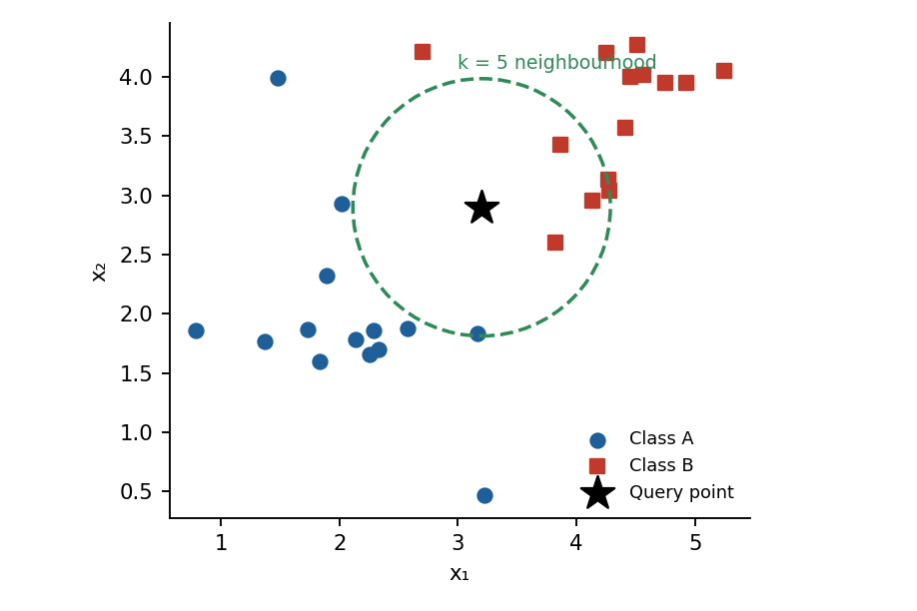
Fig: k-NN decides by the majority class among the k nearest points
Conclusion: choose decision trees when explanation matters, SVM when accuracy on high-dimensional data matters, and k-NN as a simple, no-training baseline for small datasets.

Q2. Explain ensemble methods Bagging and Boosting in classification.
5 Marks · ~300 words
An ensemble combines the predictions of several base classifiers (often called weak learners) so that the group is more accurate and stable than any single member. The two most popular strategies are Bagging and Boosting.

Bagging (Bootstrap Aggregating)
1. Draw n bootstrap samples from the training set D by sampling *with replacement* (each has ≈63.2% unique records).
2. Train one classifier on each sample independently (in parallel).
3. For a new tuple, every model votes; the majority class is the final prediction (average for regression).
Bagging mainly reduces variance and overfitting, and works best with unstable learners such as full decision trees. Random Forest = bagging + random feature selection at each split.

Boosting
1. Give every training tuple an equal weight (1/N).
2. Train a weak learner; increase the weights of misclassified tuples so the next learner concentrates on hard cases.
3. Repeat for T rounds; the final output is a weighted vote — more accurate models get larger weight αₜ.
Boosting mainly reduces bias and builds models sequentially. Examples: AdaBoost, Gradient Boosting, XGBoost.
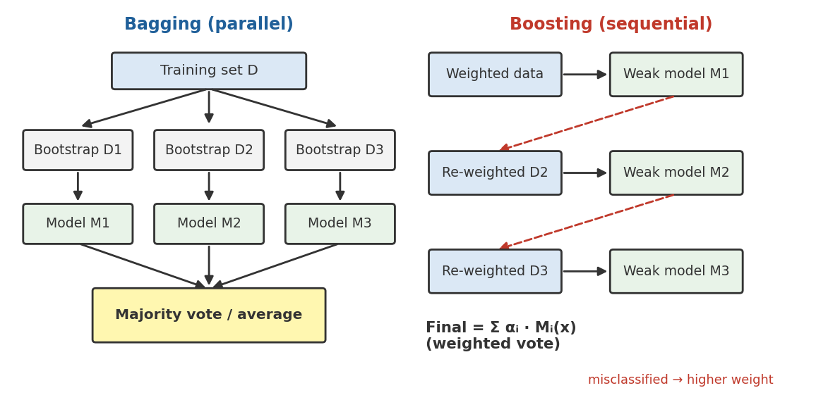
Fig: Bagging trains models in parallel on bootstrap samples; boosting trains them sequentially on re-weighted data
Feature | Bagging | Boosting
Training | Parallel, independent | Sequential, dependent
Sampling | Bootstrap (random, with replacement) | Weighted — focuses on errors
Voting | Equal-weight majority vote | Weighted vote
Reduces | Variance | Bias (and variance)
Noise/outliers | Robust | Sensitive
Example | Random Forest | AdaBoost, XGBoost

Q3. Describe the process of decision tree induction with an example.
5 Marks · ~300 words
A decision tree is a flowchart-like tree in which each internal node tests an attribute, each branch is an outcome of the test, and each leaf holds a class label. Induction is learning such a tree from labelled training tuples using a greedy, top-down, recursive divide-and-conquer approach (ID3 / C4.5 / CART).

Algorithm (Hunt’s / ID3)
1. Start with all training tuples at the root.
2. If all tuples belong to the same class → make a leaf with that class.
3. If no attributes remain → make a leaf labelled with the majority class.
4. Otherwise choose the best splitting attribute using an attribute-selection measure (Information Gain, Gain Ratio or Gini index).
5. Create a branch for each value of the attribute and partition the tuples.
6. Recurse on every partition; finally apply pruning to avoid overfitting.

Attribute selection measures
Entropy(S) = − Σ pᵢ log₂ pᵢ Gain(S, A) = Entropy(S) − Σ (|Sᵥ|/|S|) · Entropy(Sᵥ)
Gain Ratio = Gain(A) / SplitInfo(A) Gini(S) = 1 − Σ pᵢ²
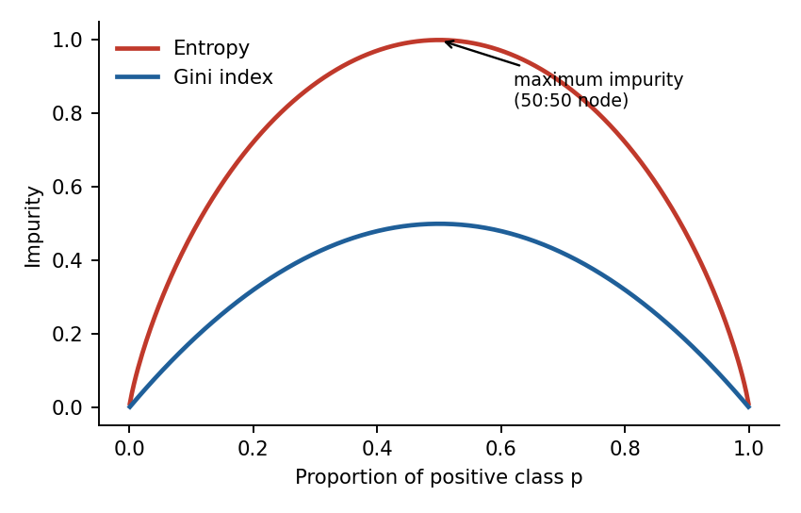
Fig: Impurity is zero for a pure node and maximum for a 50:50 node

Example — Play Tennis (14 days: 9 Yes, 5 No)
Entropy(S) = −(9/14)log₂(9/14) − (5/14)log₂(5/14) = 0.940. Information gain: Outlook 0.247, Humidity 0.152, Windy 0.048, Temperature 0.029 → Outlook becomes the root. Overcast is pure (all Yes). Under Sunny, Humidity gives gain 0.971 (high → No, normal → Yes); under Rainy, Windy gives gain 0.971 (true → No, false → Yes).
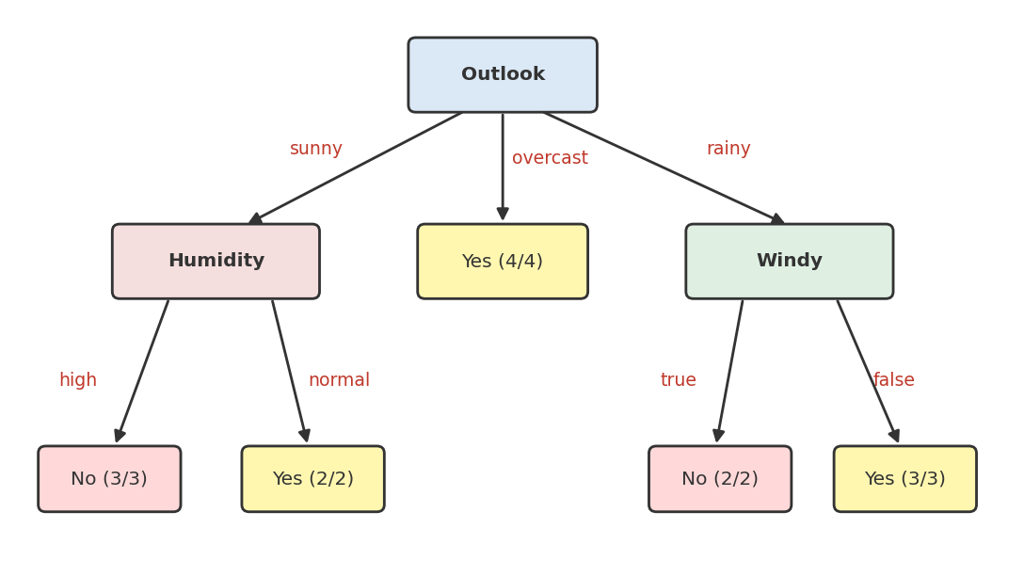
Fig: Final decision tree for the Play Tennis data
Rules extracted: IF Outlook = overcast THEN Play = Yes; IF Outlook = sunny AND Humidity = normal THEN Yes; IF Outlook = rainy AND Windy = false THEN Yes; otherwise No. Pruning (pre-pruning by stopping early, post-pruning by cutting weak subtrees) keeps the tree small and generalisable.

Q4. Problems on decision tree induction.
5 Marks · ~300 words
Two worked problems are given: Problem 1 is the standard 14-day Play Tennis table; Problem 2 is the 10-row “child goes out to play” table from your notes (recomputed — see the note below).

Problem 1 — Play Tennis (14 records)
Day | Outlook | Temp | Humidity | Windy | Play
1 | sunny | hot | high | F | no
2 | sunny | hot | high | T | no
3 | overcast | hot | high | F | yes
4 | rainy | mild | high | F | yes
5 | rainy | cool | normal | F | yes
6 | rainy | cool | normal | T | no
7 | overcast | cool | normal | T | yes
8 | sunny | mild | high | F | no
9 | sunny | cool | normal | F | yes
10 | rainy | mild | normal | F | yes
11 | sunny | mild | normal | T | yes
12 | overcast | mild | high | T | yes
13 | overcast | hot | normal | F | yes
14 | rainy | mild | high | T | no

Step 1 — Entropy of S: 9 yes, 5 no → H(S) = 0.940.
Step 2 — Gain(Outlook): sunny (2 yes, 3 no) H = 0.971; overcast (4,0) H = 0; rainy (3,2) H = 0.971. Weighted = (5/14)(0.971) + 0 + (5/14)(0.971) = 0.693. Gain = 0.940 − 0.693 = 0.247.
Attribute | Weighted entropy | Information Gain
Outlook | 0.693 | 0.247 ← max
Humidity | 0.788 | 0.152
Windy | 0.892 | 0.048
Temperature | 0.911 | 0.029

Step 3: Root = Outlook. Sunny subset {1,2,8,9,11}: Humidity gain = 0.971 → high = No, normal = Yes. Rainy subset {4,5,6,10,14}: Windy gain = 0.971 → true = No, false = Yes. Overcast → Yes. The tree is the one drawn in Q3.

Problem 2 — 10-record data (Weather, Temperature, Humidity, Wind → Play)
Day | Weather | Temp | Humidity | Wind | Play
1 | Sunny | Hot | High | Weak | No
2 | Cloudy | Hot | High | Weak | Yes
3 | Sunny | Mild | Normal | Strong | Yes
4 | Cloudy | Mild | High | Strong | Yes
5 | Rainy | Mild | High | Strong | No
6 | Rainy | Cool | Normal | Strong | No
7 | Rainy | Mild | High | Weak | Yes
8 | Sunny | Hot | High | Strong | No
9 | Cloudy | Hot | Normal | Weak | Yes
10 | Rainy | Mild | High | Strong | No

H(Y) = 1 (5 yes, 5 no). Weather: Sunny (1 yes, 2 no), Cloudy (3,0), Rainy (1,3) → weighted entropy 0.6 → IG = 0.400. Wind: IG = 0.1245. Temperature: IG = 0.1145. Humidity: IG = 0.0349. Weather is the root.
Cloudy → Yes (pure). Rainy {5,6,7,10}: Wind gives IG = 0.811 → Strong = No, Weak = Yes. Sunny {1,3,8}: Temperature and Humidity tie (IG = 0.918) — choose Humidity: High = No, Normal = Yes.
Note on your notes: the PDF shows IG(Temp) = 0.2116 and IG(Humidity) = 0.1349; recomputing from the table gives 0.1145 and 0.0349. The root (Weather) and the final tree are unchanged. In the exam, always show the entropy formula and the weighted-average line — method marks are given for them.

Q5. Discuss the metrics used to evaluate classifier performance.
5 Marks · ~300 words
Evaluation metrics measure how well a classifier predicts unseen data. They are all derived from the confusion matrix (TP, TN, FP, FN) for a binary problem.
Metric | Formula | Meaning
Accuracy | (TP + TN) / (TP + TN + FP + FN) | Overall fraction of correct predictions
Error rate | (FP + FN) / Total = 1 − Accuracy | Fraction misclassified
Precision | TP / (TP + FP) | Of predicted positives, how many are truly positive
Recall / Sensitivity / TPR | TP / (TP + FN) | Of actual positives, how many were found
Specificity / TNR | TN / (TN + FP) | Of actual negatives, how many were found
F1-score | 2·P·R / (P + R) | Harmonic mean of precision and recall
F-β score | (1+β²)·P·R / (β²·P + R) | β > 1 favours recall, β < 1 favours precision

Accuracy is misleading on imbalanced data — a model that always predicts “no fraud” can score 99% accuracy yet catch no fraud. In such cases use precision, recall and F1. Use recall when missing a positive is costly (cancer screening) and precision when false alarms are costly (spam filters).
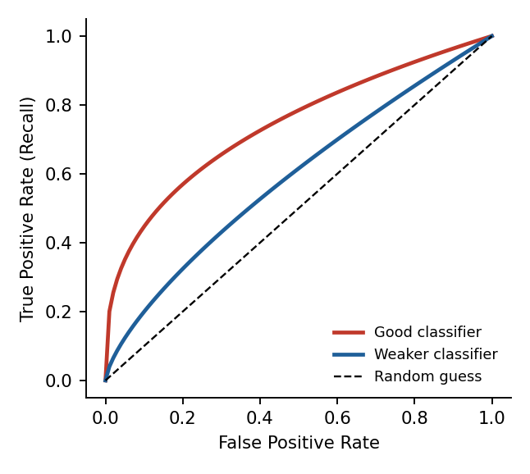
Fig: ROC curve: TPR vs FPR at different thresholds; larger area under curve (AUC) = better classifier
ROC curve and AUC: the ROC plots TPR against FPR for all thresholds; AUC = 1 is perfect, 0.5 is random guessing. Other measures: speed, scalability, robustness, interpretability, and estimation methods such as the holdout method, k-fold cross-validation and bootstrap.

Q6. Explain the importance of training and testing datasets in model building.
5 Marks · ~300 words
A classifier is built in two steps: learning (training data → model) and classification (test data → accuracy estimate). Splitting the labelled data is essential because a model evaluated on the same data it learned from will look unrealistically good — it may simply have memorised the data.
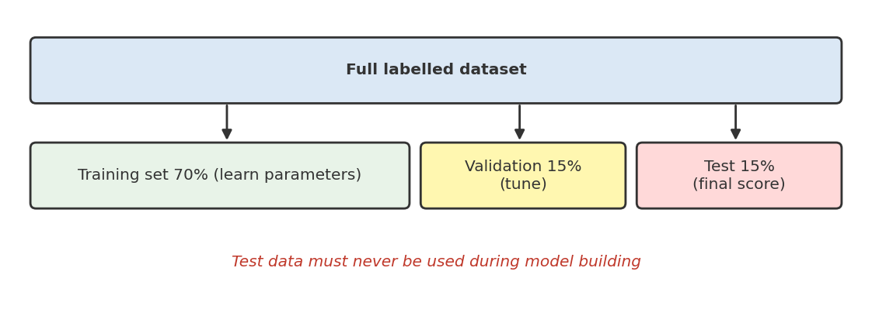
Fig: A typical train / validation / test partition
Dataset | Purpose | Used when
Training set (≈60–80%) | Learn model parameters (tree splits, weights) | Model construction
Validation set (≈10–20%) | Tune hyper-parameters (k, depth, C); select model | Model selection
Test set (≈10–20%) | Give an unbiased estimate of accuracy on unseen data | Only once, at the very end

Why it matters
- Detects overfitting: high training accuracy but low test accuracy signals memorisation.
- Honest performance estimate: the test set simulates future, unseen data.
- Model comparison and tuning without leaking test information.
- Generalisation — the real goal of data mining is predicting new data, not old data.

Splitting methods
- Holdout: random split (e.g., 70:30).
- k-fold cross-validation: data divided into k parts; each part serves once as test (commonly k = 10) and results are averaged — best for small data.
- Leave-one-out and stratified sampling (keeps class proportions); bootstrap (sampling with replacement).
Golden rule: never let test data influence training or tuning (data leakage).

Q7. Explain the confusion matrix and how it helps in evaluating classifiers.
5 Marks · ~300 words
A confusion matrix is an N×N table that compares the classifier’s predicted classes with the actual classes. For binary classification it has four cells.
 | Predicted Positive | Predicted Negative
Actual Positive | TP – True Positive (correct) | FN – False Negative (miss, Type II error)
Actual Negative | FP – False Positive (false alarm, Type I error) | TN – True Negative (correct)

Diagonal cells (TP, TN) are correct predictions; off-diagonal cells (FP, FN) are errors.

Worked example
A cancer classifier is tested on 165 patients: TP = 100, FN = 5, FP = 10, TN = 50.
Metric | Calculation | Value
Accuracy | (100 + 50) / 165 | 0.909 (90.9%)
Precision | 100 / (100 + 10) | 0.909
Recall (Sensitivity) | 100 / (100 + 5) | 0.952
Specificity | 50 / (50 + 10) | 0.833
F1-score | 2(0.909)(0.952) / (0.909 + 0.952) | 0.930

How it helps
- Shows what kind of errors are made — not just how many (FN is dangerous in medicine, FP in spam filtering).
- Gives all metrics (accuracy, precision, recall, F1) from one table.
- Reveals class-imbalance problems hidden by accuracy.
- For multi-class problems it shows which classes are confused with each other.

Q8. Explain rule-based classification and its advantages.
5 Marks · ~300 words
Rule-based classification uses a set of IF-THEN rules to classify records. A rule has the form IF (antecedent) THEN (consequent); the antecedent is a conjunction (AND) of attribute tests and the consequent is the predicted class.
R1: IF age = youth AND student = yes THEN buys_computer = yes

Rule assessment
Coverage(R) = n_covers / |D| Accuracy(R) = n_correct / n_covers
Coverage is the fraction of tuples satisfying the antecedent; accuracy (confidence) is the fraction of those covered tuples that the rule classifies correctly. Rules should be mutually exclusive (no two fire for the same record) and exhaustive (every record is covered). When several rules fire, conflict resolution is used: size ordering (most attribute tests wins), rule ordering (decision list), or class-based ordering; if none fires, a default rule applies.

Rule extraction
- Indirect method: extract one rule per root-to-leaf path of a decision tree (e.g., outlook = overcast → yes).
- Direct method — sequential covering (AQ, CN2, RIPPER, FOIL): learn one good rule for a class, remove the tuples it covers, repeat for the remaining tuples.
Advantages | Limitations
Easy to understand and interpret (explainable AI) | Large rule sets become hard to manage
Expressive — as powerful as decision trees | Conflicts when rules overlap
Easy to add new rules / modify knowledge | Poor on noisy data unless pruned
Fast classification | Greedy rule learning may miss optimal rules
Handles class imbalance well | Continuous attributes need discretisation

Q9. What is a Support Vector Machine (SVM)? Explain its working principle.
5 Marks · ~300 words
An SVM is a supervised learning algorithm for classification (and regression) that finds the optimal separating hyperplane — the decision boundary that maximises the margin between the classes. It works very well in high-dimensional spaces and with limited samples.

Key concepts
- Hyperplane: decision boundary, w·x + b = 0.
- Margin: distance between the hyperplane and the nearest points of each class = 2/‖w‖.
- Support vectors: the critical training points lying on the margin; only they define the hyperplane (memory efficient).
- Optimal hyperplane: maximum margin → better generalisation.
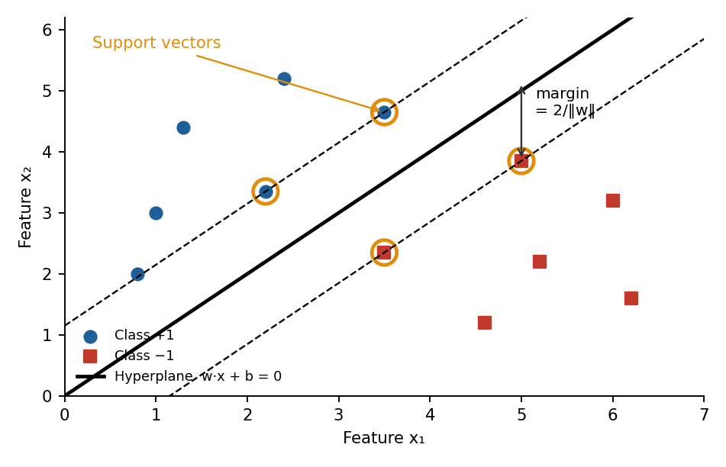
Fig: Maximum-margin hyperplane with support vectors

Working principle
1. Many hyperplanes can separate linearly separable data; SVM picks the one with the largest margin.
2. This is solved as a constrained optimisation: minimise ½‖w‖² subject to yᵢ(w·xᵢ + b) ≥ 1.
3. Soft margin: for overlapping data, slack variables ξ allow some errors; parameter C trades margin width against misclassification.
4. Non-linear data: the kernel trick implicitly maps data to a higher-dimensional space where it becomes separable — linear, polynomial, RBF (K = exp(−γ‖x−x′‖²)) and sigmoid kernels.
5. A new tuple is classified by the sign of w·x + b.
Advantages | Disadvantages
Effective in high dimensions | Slow on very large datasets
Works with small samples | Kernel and C/γ choice is critical
Only support vectors stored | Less interpretable than trees
Flexible through kernels | Struggles with heavily overlapping classes

Q10. Discuss overfitting and underfitting in classification.
5 Marks · ~300 words
A good classifier must generalise — perform well on unseen data, not merely on the training data. Failure occurs in two directions.
 | Underfitting | Overfitting
Meaning | Model too simple to capture the pattern | Model too complex; memorises noise
Training error | High | Very low
Test error | High | High
Cause | Few features, shallow tree, strong regularisation, too little training | Too many features, very deep tree, too many hidden units, noisy or small data
Statistical view | High bias | High variance
Example | Straight line through curved data | Tree with one leaf per training record

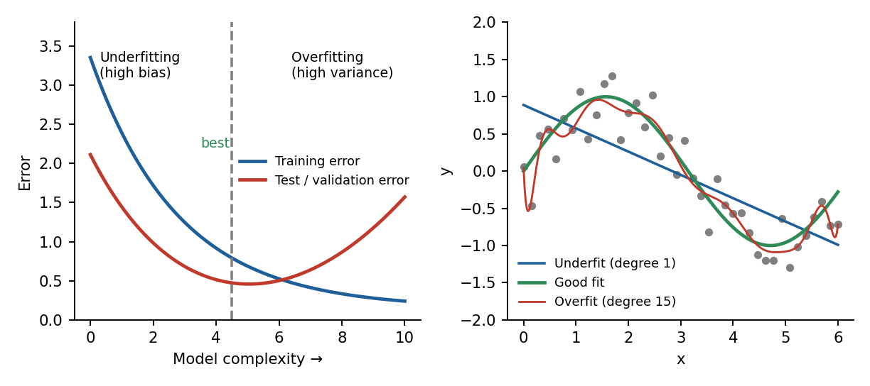
Fig: Left: error vs. model complexity. Right: underfit, good fit and overfit curves

Detection
Compare training and validation errors: a large gap means overfitting; both high means underfitting. Learning curves and k-fold cross-validation help diagnose this.

Remedies
- Overfitting: more training data, pruning (decision trees), regularisation (L1/L2), early stopping, dropout, feature selection, ensembles (bagging), simpler model.
- Underfitting: more expressive model, more or better features, longer training, reduce regularisation.
The goal is the bias–variance trade-off: choose the complexity at the minimum of the validation-error curve.

Q11. Explain Multilayer Feed-Forward Neural Network and its advantages & limitations.
5 Marks · ~300 words
A multilayer feed-forward neural network (MLFFNN) is an artificial neural network made of an input layer, one or more hidden layers and an output layer. Each node is connected to all nodes of the next layer (fully connected) and data flows only forward — there are no feedback loops.
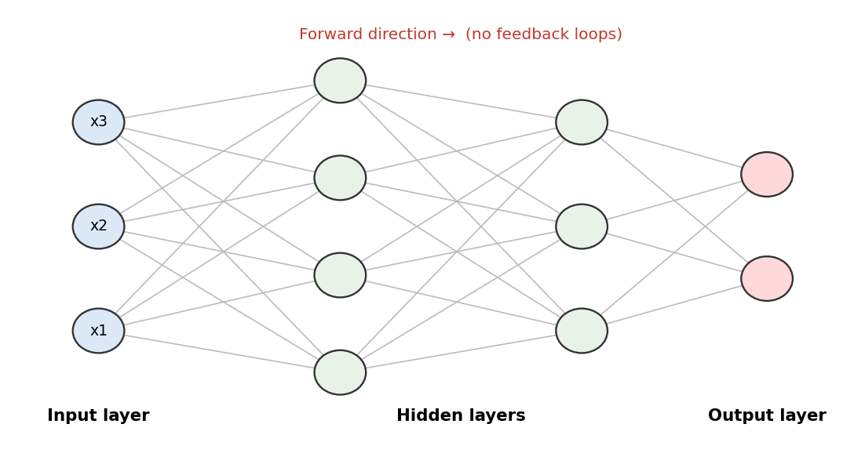
Fig: Architecture of a multilayer feed-forward network

Working
- Input layer: one neuron per feature; passes raw values forward without computation.
- Hidden layers: each neuron computes a weighted sum z = Σ wᵢxᵢ + b and applies a non-linear activation function (sigmoid, tanh, ReLU) — this lets the network learn non-linear patterns.
- Output layer: regression → one linear neuron; binary classification → one sigmoid neuron; multi-class → one neuron per class with softmax.
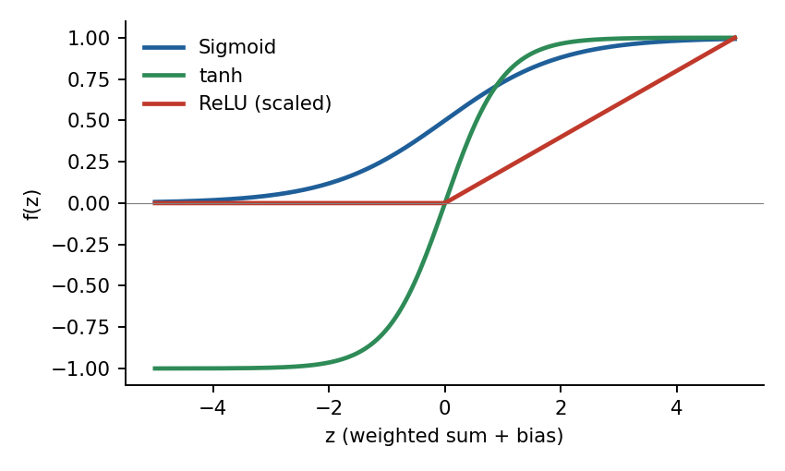
Fig: Common activation functions

Training by backpropagation
1. Forward pass: compute predictions.
2. Loss function: measure error (MSE or cross-entropy).
3. Backward pass: propagate error backwards, computing gradients by the chain rule.
4. Weight update: w ← w − η·∂E/∂w using gradient descent, SGD or Adam; repeat for many epochs.
Advantages | Limitations
Models complex non-linear relationships | Needs large labelled datasets
High accuracy in image, text and speech | Computationally expensive (GPU/TPU)
Scales to deep architectures | Slow to train; many hyper-parameters
General-purpose learner; tolerant to noisy data | Black box; risk of overfitting without regularisation

UNIT 4 — Cluster Analysis & Outlier Detection
k-Means · k-Medoids · AGNES/DIANA · DBSCAN · Similarity measures · Outliers

Q1. Explain the DBSCAN algorithm and its approach to finding clusters.
5 Marks · ~300 words
DBSCAN (Density-Based Spatial Clustering of Applications with Noise) groups points that are densely packed together and labels points in low-density regions as noise. Unlike k-means it needs no value of k and finds clusters of arbitrary shape.

Parameters and definitions
- ε (eps): radius of the neighbourhood around a point.
- MinPts: minimum number of points required within ε for a region to be dense.
- Core point: has ≥ MinPts points (including itself) within ε.
- Border point: fewer than MinPts in its ε-neighbourhood but lies within ε of a core point.
- Noise (outlier): neither core nor border.
- Directly density-reachable / density-reachable / density-connected: a chain of core points links points into one cluster.
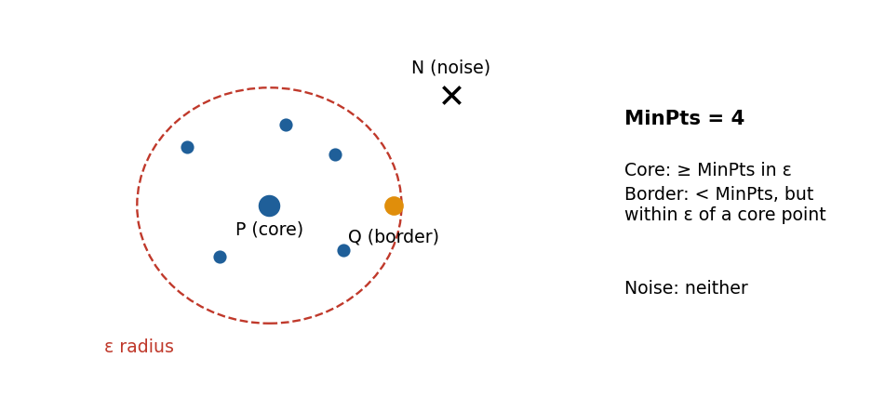
Fig: Core, border and noise points (MinPts = 4)

Algorithm
1. Pick an unvisited point p and find its ε-neighbourhood.
2. If |N(p)| < MinPts, tentatively mark p as noise; otherwise create a new cluster with p.
3. Add all neighbours to the cluster; for every neighbour that is itself a core point, add *its* neighbours too (expansion).
4. Continue until no more points can be added; then pick the next unvisited point.
5. Stop when all points are visited. Time complexity O(n²), or O(n log n) with a spatial index (R-tree).
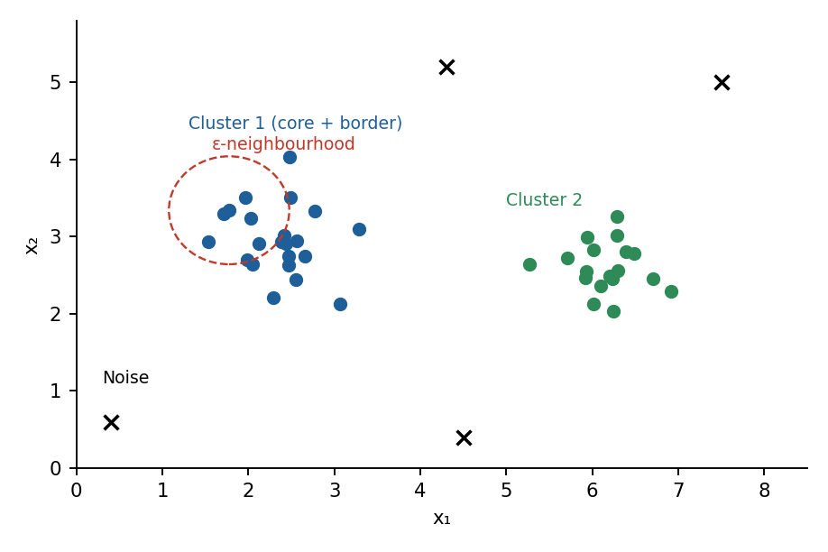
Fig: DBSCAN finds two dense clusters and marks isolated points as noise
Choosing parameters: MinPts ≈ 2 × dimensions (≥ 4); ε is found from the “knee” of the sorted k-distance graph.

Q2. Compare clustering and classification.
5 Marks · ~300 words
Both organise data into groups, but classification is supervised (classes are predefined and labelled) whereas clustering is unsupervised (groups are discovered from the data itself).
Basis | Classification | Clustering
Learning type | Supervised | Unsupervised
Class labels | Known in training data | Not available
Goal | Predict the class of new tuples | Discover natural groupings
Process | Training → model → testing | Partition data by similarity
Number of groups | Fixed in advance by labels | May be unknown (k chosen or found)
Evaluation | Accuracy, precision, recall, F1 | Silhouette, SSE, intra/inter-cluster distance
Techniques | Decision tree, SVM, k-NN, NN, Naïve Bayes | k-means, k-medoids, AGNES, DBSCAN
Example | Spam / not-spam email | Customer segmentation

Clustering is often used as a pre-processing step for classification (e.g., to label data or detect outliers), and classification on labelled data can validate cluster quality.

Q3. Discuss the basic methods of clustering and their characteristics.
5 Marks · ~300 words
Clustering methods are grouped by the way they form clusters.
Method | Idea | Examples | Characteristics
Partitioning | Divide n objects into k partitions, optimising a criterion (e.g., SSE) | k-means, k-medoids | Needs k; spherical clusters; efficient; sensitive to outliers (k-means)
Hierarchical | Build a tree (dendrogram) of clusters | AGNES, DIANA, BIRCH, CHAMELEON | No k needed up front; cannot undo merges/splits; O(n²)
Density-based | Dense regions separated by sparse regions | DBSCAN, OPTICS, DENCLUE | Arbitrary shapes; handles noise; sensitive to ε/MinPts
Grid-based | Quantise space into grid cells and cluster cells | STING, CLIQUE | Very fast, independent of n; accuracy depends on cell size
Model-based | Assume a statistical model per cluster | EM / Gaussian mixtures, SOM | Soft (probabilistic) membership; model assumptions needed

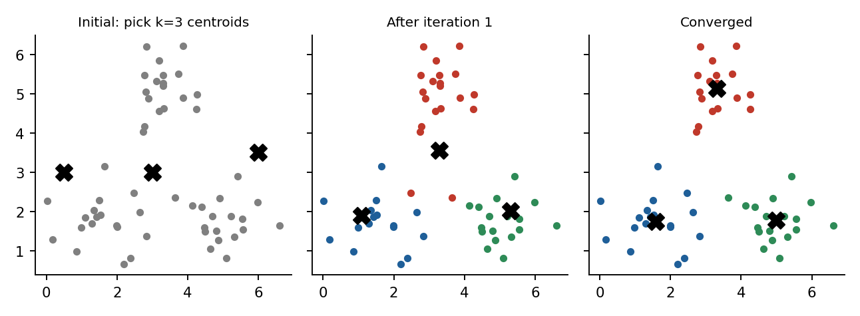
Fig: Partitioning method (k-means): centroids move until the clusters stabilise
The right method depends on data size, cluster shape, presence of noise and whether k is known. Hierarchical methods suit small data needing a taxonomy; density-based methods suit spatial data with noise; partitioning methods are the default for large numeric data.

Q4. Compare partitioning and hierarchical clustering methods.
5 Marks · ~300 words
Basis | Partitioning (k-means / k-medoids) | Hierarchical (AGNES / DIANA)
Output | Single flat partition into k clusters | Nested tree (dendrogram) of clusters
Number of clusters | Must be given in advance | Not required; choose by cutting the dendrogram
Approach | Iterative relocation of centroids/medoids | Agglomerative (bottom-up) or divisive (top-down)
Time complexity | O(n·k·t) – scalable | O(n²) or worse – poor scalability
Reversibility | Points can move between clusters | Merge/split is final (greedy, no backtracking)
Cluster shape | Convex / spherical | Depends on linkage (single-link finds chains)
Determinism | Depends on initial centroids | Deterministic for given linkage
Outliers | k-means sensitive, k-medoids robust | Single-link sensitive (chaining)
Best for | Large datasets | Small datasets; taxonomies / biology

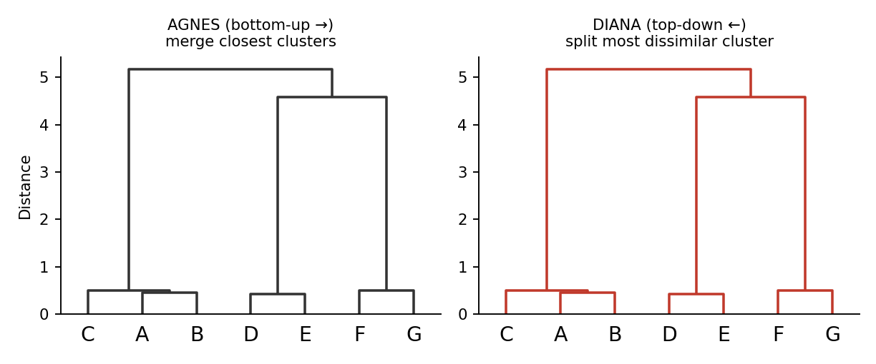
Fig: Hierarchical clustering produces a dendrogram; cutting at a height gives k clusters
In practice, hybrid methods such as BIRCH first summarise large data with a CF-tree and then apply hierarchical clustering, combining the strengths of both.

Q5. Discuss applications of clustering in real-world data mining tasks.
5 Marks · ~300 words
Clustering is used wherever structure must be found without labels, either as a stand-alone tool or as a pre-processing step.
Domain | Application
Marketing / CRM | Customer segmentation – group buyers by behaviour for targeted campaigns; market-basket grouping
Biology & medicine | Grouping genes with similar expression; patient subtypes; species taxonomy
Information retrieval / Web | Document and news clustering, search-result grouping, recommender systems
Image processing | Image segmentation, colour quantisation, object recognition
Finance & insurance | Fraud detection, risk grouping, identifying unusual claims
Urban planning / GIS | Grouping houses by value, location and type; earthquake epicentre zones; crime hot-spots
Social networks | Community detection
Telecom & networks | Intrusion / anomaly detection; user usage profiling
Data preprocessing | Data reduction/summarisation, outlier detection, discretisation

Typical workflow: select features → scale data → choose algorithm and k/ε → cluster → interpret and validate → act on the result (e.g., design a plan per customer segment).

Q6. Define clustering. Explain the requirements for cluster analysis.
5 Marks · ~300 words
Clustering is the process of partitioning a set of data objects into groups (clusters) so that objects in the same cluster are highly similar to each other and dissimilar to objects in other clusters. Formally, for D = {x₁…xₙ}, clusters C₁…C_k satisfy ∪Cᵢ = D and Cᵢ ∩ Cⱼ = ∅ (for hard clustering). It is unsupervised learning, also called data segmentation.

Requirements for cluster analysis
Requirement | Explanation
Scalability | Must work on millions of objects, not just small samples
Different attribute types | Numeric, categorical, binary, ordinal and mixed data
Arbitrary-shaped clusters | Not only spherical clusters found by distance measures
Minimal domain knowledge | Parameters like k should be easy to set
Robustness to noise and outliers | Results should not be distorted by erroneous data
Incremental clustering / order insensitivity | Handle new data and not depend on input order
High dimensionality | Work with many attributes (sparse data)
Constraint-based clustering | Allow user constraints (e.g., ATM locations)
Interpretability and usability | Clusters should be meaningful and usable

A good clustering has high intra-cluster similarity and low inter-cluster similarity; the quality depends on the similarity measure and its ability to discover hidden patterns.

Q7. Explain the working of the k-means clustering algorithm with an example.
5 Marks · ~300 words
k-means is a partitioning algorithm that groups n objects into k clusters, each represented by its centroid (mean). It minimises the sum of squared errors.
SSE = Σᵢ Σ_{x∈Cᵢ} ‖x − mᵢ‖²
1. Initialise: choose k objects as initial centroids.
2. Assign: put every object in the cluster of the nearest centroid (Euclidean distance).
3. Update: recompute each centroid as the mean of its cluster.
4. Repeat steps 2–3 until the centroids stop changing (convergence).

Example — cluster {2, 4, 10, 12, 3, 20, 30, 11, 25} into k = 2, initial means 2 and 10
Iteration | Mean m₁ , m₂ | Cluster 1 | Cluster 2 | New means
1 | 2 , 10 | {2, 3, 4} | {10, 11, 12, 20, 25, 30} | 3 , 18
2 | 3 , 18 | {2, 3, 4, 10} | {11, 12, 20, 25, 30} | 4.75 , 19.6
3 | 4.75 , 19.6 | {2, 3, 4, 10, 11, 12} | {20, 25, 30} | 7 , 25
4 | 7 , 25 | {2, 3, 4, 10, 11, 12} | {20, 25, 30} | 7 , 25 (no change)

The means no longer change, so the final clusters are {2, 3, 4, 10, 11, 12} and {20, 25, 30}.
Fig: k-means on 2-D data: initial centroids, after iteration 1, and at convergence
Pros: simple, fast O(nkt). Cons: k must be known, sensitive to initial centroids and outliers, finds only spherical clusters, works on numeric data. k-medoids (PAM) uses actual objects as centres and is more robust to outliers.

Q8. Explain AGNES and DIANA hierarchical clustering algorithms.
5 Marks · ~300 words
Hierarchical clustering builds a tree of nested clusters (dendrogram), so no k is needed in advance.

AGNES (Agglomerative Nesting) — bottom-up
1. Treat every object as its own cluster.
2. Compute the proximity (distance) matrix.
3. Merge the two closest clusters.
4. Update the distance matrix using a linkage rule.
5. Repeat until a single cluster remains; cut the dendrogram at the desired level.

DIANA (Divisive Analysis) — top-down
1. Start with all objects in one cluster.
2. Find the cluster with the largest diameter; pick the object with the greatest average dissimilarity as the seed of a “splinter group”.
3. Move objects closer to the splinter group than to the rest.
4. Repeat splitting until every object is a singleton (or a stopping criterion is met).
Linkage | Inter-cluster distance | Behaviour
Single | min distance between any two points | Chaining effect, long clusters
Complete | max distance between any two points | Compact clusters
Average | mean of all pairwise distances | Balanced
Centroid / Ward | distance of centroids / variance increase | Round clusters

Example (1-D points A=1, B=2, C=5, D=7, E=12, single link): merge A,B at distance 1 → merge C,D at 2 → merge {A,B} with {C,D} at 3 (|2−5|) → merge E at 5 (|7−12|). The dendrogram height shows these merge distances.
Fig: AGNES reads the dendrogram bottom-up; DIANA reads it top-down
Limitations: O(n²) memory/time, and merges/splits cannot be undone; BIRCH and CHAMELEON improve scalability and quality.

Q9. Explain various methods for detecting outliers.
5 Marks · ~300 words
An outlier is a data object that deviates so much from the rest that it appears generated by a different mechanism. Outlier detection is used in fraud detection, intrusion detection, fault diagnosis and medical monitoring.
Method | Principle | Example / Technique
Statistical (parametric) | Assume a distribution (e.g., Gaussian); objects with low probability are outliers | Z-score: |x−μ|/σ > 3; Grubbs’ test; box-plot (IQR) rule
Statistical (non-parametric) | No assumed distribution; use histograms or kernel density | Histogram bins with very low counts
Proximity-based | Outlier is far from its neighbours | Distance-based DB(p, D); k-NN distance
Density-based | Outlier lies in a region of much lower density than its neighbours | LOF (Local Outlier Factor), DBSCAN noise points
Clustering-based | Outliers belong to no cluster, small clusters, or are far from centroids | k-means distance to centroid, DBSCAN
Classification-based | Train a one-class classifier on normal data | One-class SVM
High-dimensional / subspace | Find outliers in subspaces | Subspace and projection methods

Supervision view
- Supervised: labelled normal and outlier examples (a classification problem with class imbalance).
- Semi-supervised: only normal examples are labelled.
- Unsupervised: no labels — assumes normal objects are far more frequent.

Outlier categories
Global (point) outliers deviate from the whole dataset; contextual (conditional) outliers deviate only in a context (e.g., 30 °C in winter); collective outliers are a group of objects that is abnormal together (e.g., a burst of network packets).
IQR rule: outlier if x < Q1 − 1.5·IQR or x > Q3 + 1.5·IQR.

Q10. Explain the role of similarity measures in clustering.
5 Marks · ~300 words
Clustering is defined by similarity: objects in a cluster must be similar and those in different clusters dissimilar. A similarity (or distance) measure quantifies this, so the choice of measure directly determines the shape and quality of the clusters.
Measure | Formula | Used for
Euclidean | d = √Σ(xᵢ − yᵢ)² | Numeric, spherical clusters (k-means)
Manhattan | d = Σ|xᵢ − yᵢ| | Grid-like data, robust to outliers
Minkowski | d = (Σ|xᵢ − yᵢ|ᵖ)^(1/p) | General form (p=1 Manhattan, p=2 Euclidean)
Cosine similarity | cos θ = (x·y)/(‖x‖‖y‖) | Text and document vectors
Jaccard coefficient | |A∩B| / |A∪B| | Binary / set data, market baskets
Simple matching | (matches)/(attributes) | Nominal / categorical attributes
Hamming | Number of differing positions | Binary strings
Gower | Weighted mix of the above | Mixed-type attributes

Example: for x = (1, 2) and y = (4, 6): Euclidean = √(9+16) = 5; Manhattan = 3+4 = 7.

Role in clustering
- Defines which objects belong together and drives assignment (k-means), merging (AGNES) and neighbourhoods (DBSCAN).
- Different measures give different clusters from the same data.
- Normalisation is needed so that large-scale attributes do not dominate.
- Choice depends on data type: numeric, binary, categorical, text or mixed.
- Metric properties (non-negativity, symmetry, triangle inequality) allow efficient indexing.

Q11. Discuss the advantages and limitations of density-based clustering.
5 Marks · ~300 words
Density-based clustering (DBSCAN, OPTICS, DENCLUE) treats clusters as dense regions separated by low-density regions.
Advantages | Limitations
Discovers clusters of arbitrary shape (rings, crescents) | Fails when clusters have very different densities (single ε)
No need to specify k | Sensitive to parameters ε and MinPts
Identifies noise/outliers explicitly | Struggles in high dimensions (distances lose meaning)
Robust to outliers | Border points can be assigned to either cluster (order-dependent)
Efficient O(n log n) with spatial index | Without an index, O(n²) is slow for huge data
Single scan over the data; good for spatial data | Needs a meaningful distance measure and scaling

Fig: Density-based clusters of arbitrary shape and noise points
Remedies: OPTICS produces an ordering that handles varying densities; the k-distance graph helps pick ε; dimensionality reduction (PCA) helps in high dimensions. In contrast, k-means fails on non-convex clusters, which is where density-based methods shine.

Q12. Discuss the challenges in outlier detection.
5 Marks · ~300 words
Challenge | Explanation
Defining normal vs. outlier | The border between normal and abnormal is fuzzy; a point near the boundary is hard to label
Application-specific | The notion of an outlier depends on the domain and distance measure
Noise vs. outliers | Noise can be mistaken for an outlier and genuine outliers hidden by noise
Lack of labelled data | Few or no labelled examples; severe class imbalance
High dimensionality | Distances become similar, so outliers are masked (curse of dimensionality)
Handling different types | Contextual and collective outliers need context and group information
Understandability / justification | Users need to know *why* an object was flagged
Scalability and real-time | Large streams need efficient, incremental methods
Choosing parameters / thresholds | Too strict → false alarms, too lenient → missed outliers
Adversarial behaviour | Fraudsters adapt to look normal

Because of these issues, outlier detection is usually run with domain knowledge, a mix of methods (statistical + proximity + clustering) and human review of flagged cases. The goal is to balance false positives (normal flagged as outlier) against false negatives (outliers missed).

UNIT 5 — Temporal, Spatial & Web Mining
Time series · Sequences · Temporal rules · Spatial data · Web content / structure / usage mining

Q1. Define Temporal Data Mining.
5 Marks · ~300 words
Temporal data mining is the process of discovering interesting patterns, relationships and trends from data in which time is an explicit attribute — data that changes or is recorded over time. It extends ordinary mining by asking not only *what* happens but *when*, *in what order* and *how often*.

Types of temporal data
Type | Description | Example
Time series | Numeric values recorded at regular intervals | Daily stock price, hourly temperature
Temporal sequences | Ordered events (not necessarily equally spaced) | Customer purchase history, web click-stream
Event / transaction data with timestamps | Records tagged with time stamps | Bank transactions, patient visits
Spatio-temporal data | Time combined with location | Moving vehicles, hurricane tracks

Main tasks
- Trend analysis / characterisation — long-term movement.
- Similarity search — find sequences similar to a query.
- Periodicity (cyclic) detection — repeating patterns.
- Sequential pattern mining and temporal association rules.
- Classification, clustering and prediction/forecasting of temporal data.
- Anomaly detection — unusual temporal behaviour.

Temporal concepts
Mining uses valid time (when a fact is true in the real world), transaction time (when it was stored in the database) and time granularity (second, day, month). Temporal relations between events follow Allen’s interval relations (before, after, meets, overlaps, during, equals).
Difference from ordinary mining: the order and timing of records are meaningful, so records cannot be treated as independent, unordered tuples.

Q2. Explain modeling of temporal events.
5 Marks · ~300 words
Modeling temporal events means representing real-world occurrences, their timing and their relationships in a form that mining algorithms can process.

Basic model elements
- Event: an occurrence with a type and a time of occurrence, e.g., (Login, t₁).
- Time point (instant) vs. time interval: an event may occur at a single instant or last for an interval [start, end].
- Event sequence: an ordered list ⟨(e₁,t₁), (e₂,t₂), …, (eₙ,tₙ)⟩ with t₁ ≤ t₂ ≤ … ≤ tₙ.
- Time granularity: the unit (hour, day, week) used to group events.
- Time window: a fixed length W within which events are considered related.

Temporal relationships (Allen’s algebra)
Relation | Meaning
A before B | A ends before B starts
A meets B | A ends exactly when B starts
A overlaps B | A starts first and overlaps B
A during B | A lies fully inside B
A starts / finishes B | Both start (or end) together
A equals B | Identical intervals

Modeling approaches
Approach | Idea
Time-series model | Treat data as a numeric series (trend + seasonality + noise)
Sequence / episode model | Ordered event types with time constraints (e.g., A then B within 5 minutes)
Markov / Hidden Markov models | Next state depends on the current state: P(sₜ₊₁ | sₜ)
Temporal databases | Store valid time and transaction time with each tuple
Temporal logic / Petri nets / finite-state automata | Formal specification of event patterns

Example: a hospital log ⟨(Admit, 9:00), (Test, 9:30), (Diagnosis, 11:00), (Discharge, 18:00)⟩ is a four-event sequence; the rule “Test within 1 hour of Admit” is a temporal constraint used in mining.

Q3. Explain pattern detection and sequence mining in temporal data.
5 Marks (covers: pattern detection · sequence mining · both combined) · ~300 words

Pattern detection
Pattern detection finds recurring, meaningful structures in temporal data. It includes:
- Trend detection: upward or downward movement (e.g., rising sales).
- Periodic / cyclic patterns: repeat at fixed intervals (weekly traffic peaks, yearly festival sales).
- Similarity (subsequence) matching: find patterns similar to a query shape using distance measures such as Euclidean distance or Dynamic Time Warping (DTW), usually after representing the series by DFT/DWT or SAX symbols.
- Motif and anomaly (discord) discovery: frequently repeating shapes versus rare, unusual ones.
- Change-point detection: find where behaviour shifts.

Sequence mining
Sequential pattern mining finds frequently occurring ordered subsequences in a sequence database. Support of a pattern = fraction of sequences containing it in order (not necessarily contiguously).
Seq ID | Sequence
S1 | ⟨ a (b c) d ⟩
S2 | ⟨ a b d ⟩
S3 | ⟨ b c d ⟩
S4 | ⟨ a c d ⟩

With min_support = 3 of 4: ⟨a, d⟩ (S1, S2, S4) and ⟨b, d⟩ (S1, S2, S3) and ⟨c, d⟩ (S1, S3, S4) are frequent.
Algorithm | Idea
GSP | Apriori-style: generate candidate k-sequences from frequent (k−1)-sequences and scan
SPADE | Vertical id-list format; lattice decomposition
PrefixSpan | Pattern growth: project the database by frequent prefixes; no candidate generation, fastest

Applications: next-purchase prediction, click-stream analysis, DNA motif finding, fault prediction from log events. Relation: pattern detection works on numeric series shapes, whereas sequence mining works on symbolic ordered events; together they reveal both *what shape* and *what order* repeats.

Q4. Describe Web Structure Mining and its importance.
5 Marks · ~300 words
Web structure mining discovers useful knowledge from the hyperlink structure of the Web. The Web is modelled as a directed graph in which pages are nodes and hyperlinks are edges, and mining analyses this graph to find important pages and communities.
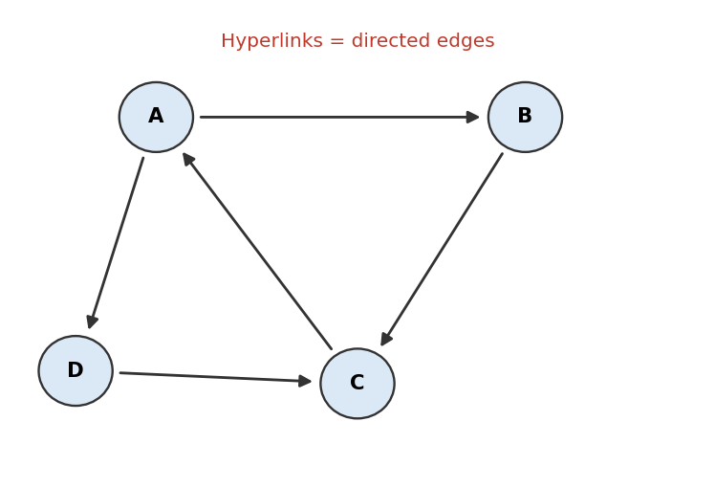
Fig: Web graph: pages are nodes, hyperlinks are directed edges

Key algorithms
- PageRank (Google): a page is important if important pages link to it. PR(P) = (1−d) + d · Σ PR(Q)/L(Q), where the sum is over pages Q linking to P, L(Q) is Q’s number of out-links and d ≈ 0.85 is the damping factor. It models a random surfer.
- HITS (Hubs and Authorities): an authority is a page with many good in-links; a hub is a page that links to many good authorities. Scores are updated iteratively and mutually reinforce each other.
- Community discovery / link analysis and web-graph clustering.

Importance
- Ranking of search results (PageRank made Google effective).
- Discovering authoritative pages and web communities (related topics).
- Spam and link-farm detection.
- Crawling strategy: focus on important pages first.
- Site structure improvement and navigation design; analysing the structure of social networks.
Internal structure (links inside a document, tags/DOM) and external structure (links between pages) are both mined; structure mining uses link information, content mining uses page text.

Q5. Explain Web Usage Mining and its applications.
5 Marks · ~300 words
Web usage mining (web log mining) discovers user access patterns from web server logs, browser/proxy logs, cookies and user sessions. It answers: who visits, which pages, in what order and for how long.

Process
1. Data collection: server access logs (IP, time, URL, status, referrer), proxy and client-side data.
2. Pre-processing: data cleaning (remove image/robot requests), user identification, session identification, path completion.
3. Pattern discovery: association rules, sequential patterns, clustering of users/pages, classification.
4. Pattern analysis: filter, visualise and interpret patterns.
Technique | Result
Association rules | Pages often visited together (/laptops → /bags)
Sequential patterns | Common navigation paths: Home → Product → Cart → Pay
Clustering | User segments with similar browsing behaviour
Classification | Predict user type or likelihood to buy

Applications
- Personalisation and recommendation (e-commerce, streaming sites).
- Website design improvement — fix poorly navigated pages.
- Marketing — customer profiling, targeted ads, conversion analysis.
- Caching / prefetching to cut latency; load balancing.
- Fraud and intrusion detection; usability studies.
Challenges: privacy of user data, anonymous or proxy users, and identifying sessions accurately.

Q6. Discuss the role of spatial classification and spatial clustering algorithms.
5 Marks · ~300 words
Spatial data mining must account for location and for the fact that nearby objects are related (Tobler’s first law of geography: *near things are more related than distant things*). So classification and clustering are adapted to include spatial neighbourhoods.

Spatial classification
Spatial classification assigns spatial objects to classes using both non-spatial attributes (population, soil type) and spatial attributes (neighbours, distance to a river, adjacency). Typical examples: classifying land cover from satellite images (forest, water, urban), predicting house prices, and identifying areas prone to flooding.
- Decision trees and neural networks with spatial predicates (adjacent_to, within_distance, inside).
- Spatial autoregression / contextual classifiers that include neighbours’ class values (e.g., Markov random field).
- Spatial ID3: the learning data is extended with aggregated neighbour information.

Spatial clustering
Spatial clustering groups objects by geographical closeness and similarity.
Algorithm | Type | Role
CLARANS | Partitioning (medoid, randomised search) | Efficient clustering of large spatial data
DBSCAN / OPTICS | Density-based | Clusters of arbitrary shape with noise (hot-spots)
STING / CLIQUE | Grid-based | Fast clustering on hierarchical grid cells
BIRCH | Hierarchical (CF-tree) | Large spatial datasets

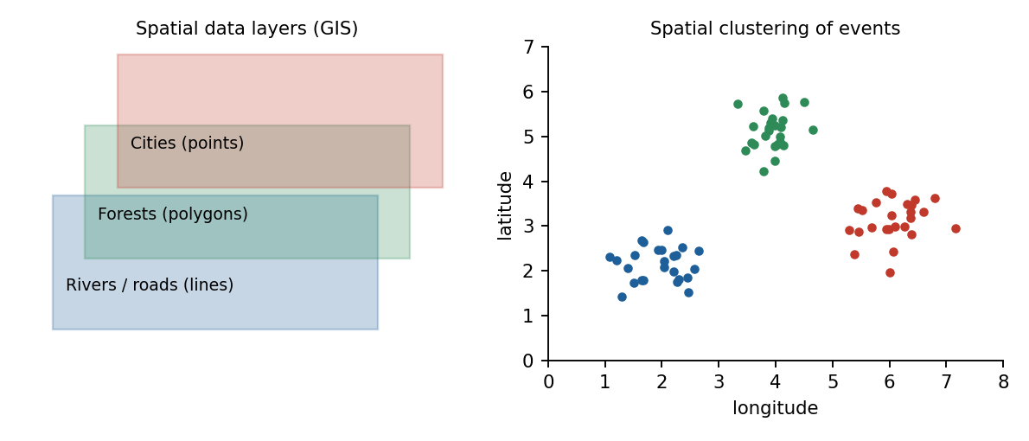
Fig: Spatial layers (left) and spatial clusters of events (right)
Role: classification predicts the class of a location, while clustering discovers unknown regions (crime hot-spots, disease clusters, customer catchment areas) — together they support planning and decision making.

Q7. What are temporal association rules? Give examples.
5 Marks · ~300 words
A temporal association rule is an association rule whose validity depends on time: it holds only during certain periods, at certain times, or with a time delay between events. Ordinary rules such as {bread} → {butter} assume the pattern is constant over time, but many real patterns are seasonal or evolve.
X ⇒ Y [support s, confidence c] valid in time interval T

Kinds of temporal association rules
Type | Meaning | Example
Cyclic rules | Hold periodically at regular intervals | {Sunscreen} → {Sunglasses} every summer; {Newspaper} → {Coffee} every morning
Calendar-based rules | Hold in a particular calendar period (day, week, season) | {Sweets} → {Dry fruits} during Diwali
Lifespan / interval rules | Valid only during an interval after a product launch | {New phone} → {Case} in the first 3 months after launch
Inter-transaction / delayed rules | Antecedent and consequent in different transactions separated by time | Buy a PC → buy a printer within 2 weeks
Trend / emerging rules | Support or confidence changes over time | {Vegan food} → {Organic} growing since 2020

Mining method
1. Divide the database into time units (e.g., days or months).
2. Find frequent itemsets in each unit using Apriori or FP-growth.
3. Compute rule support and confidence per time unit.
4. Keep rules whose measures hold in the required time unit, cycle or interval (with time-based min support).
Worked example: if {Umbrella} → {Raincoat} has confidence 85% in June–September but only 10% over the whole year, the temporal rule (monsoon season) is far more useful than the global rule, which would be pruned.

Q8. Discuss applications of spatial data mining.
5 Marks · ~300 words
Area | Applications
Geography / GIS | Land-use and land-cover classification, map generalisation, terrain analysis
Environmental science | Climate and pollution pattern analysis, deforestation monitoring, flood and wildfire risk
Public health / epidemiology | Disease-outbreak clustering, finding disease hot-spots, locating clinics
Transportation | Route optimisation, traffic hot-spots, accident-prone road segments
Urban planning & real estate | Land-price prediction, site selection (stores, hospitals, schools)
Crime analysis | Crime hot-spot mapping and police patrol allocation
Agriculture | Precision farming from soil and satellite maps, crop yield prediction
Business / marketing | Geo-marketing, customer catchment-area analysis
Defence & disaster management | Remote sensing, target identification, evacuation planning
Astronomy & resource exploration | Sky-image mining, mineral and oil-resource location

Example: clustering GPS locations of dengue cases with DBSCAN identifies outbreak zones; overlaying them with rainfall and drainage layers (spatial association) explains *why* the zone is affected and where to deploy resources.
Spatial–temporal view: many applications combine both dimensions — tracking cyclone paths, predicting traffic flow, monitoring animal migration or seasonal pollution.

Q9. Discuss applications of temporal data mining (and of spatial & temporal data mining together).
5 Marks · ~300 words
Area | Applications
Finance / stock market | Stock-price trend prediction, volatility analysis, algorithmic trading, fraud detection
Retail / e-commerce | Seasonal market-basket analysis, demand forecasting, next-purchase recommendation
Healthcare | Patient monitoring (ECG/EEG signals), disease progression, treatment-pattern analysis
Weather & environment | Weather and rainfall forecasting, climate-change trend analysis
Telecom / network | Network traffic prediction, intrusion and failure detection from event logs
Industry / IoT | Predictive maintenance from sensor streams, energy-load forecasting
Web & social media | Click-stream and trending-topic analysis
Bioinformatics | DNA/protein sequence motifs, gene-expression time series
Education & HR | Student-performance trajectories, employee attrition trends

Combined spatial–temporal applications
- Traffic management: predicting congestion at each road segment by hour.
- Epidemic spread: modelling how a disease moves across regions over weeks.
- Cyclone / weather tracking and disaster early warning.
- Mobility analytics: taxi demand, fleet tracking, ride-sharing.
- Wildlife migration and crop monitoring over seasons.
Temporal mining answers *when and in what order*; spatial mining answers *where*; combining them gives spatio-temporal intelligence for forecasting and real-time decisions.

Q10. What is a time series? Discuss how a time series is analysed in temporal mining.
5 Marks · ~300 words
A time series is a sequence of observations x₁, x₂, …, x_t recorded at successive, usually equally spaced, points in time — for example daily closing price, monthly rainfall or hourly electricity demand.

Components of a time series
Component | Meaning | Example
Trend (T) | Long-term increase or decrease | Rising population
Seasonality (S) | Regular fixed-period fluctuation | Ice-cream sales every summer
Cyclic (C) | Longer, irregular-period waves | Business cycles
Irregular / noise (I) | Random, unpredictable variation | Sudden strikes

Additive model: Yₜ = Tₜ + Sₜ + Cₜ + Iₜ Multiplicative: Yₜ = Tₜ × Sₜ × Cₜ × Iₜ
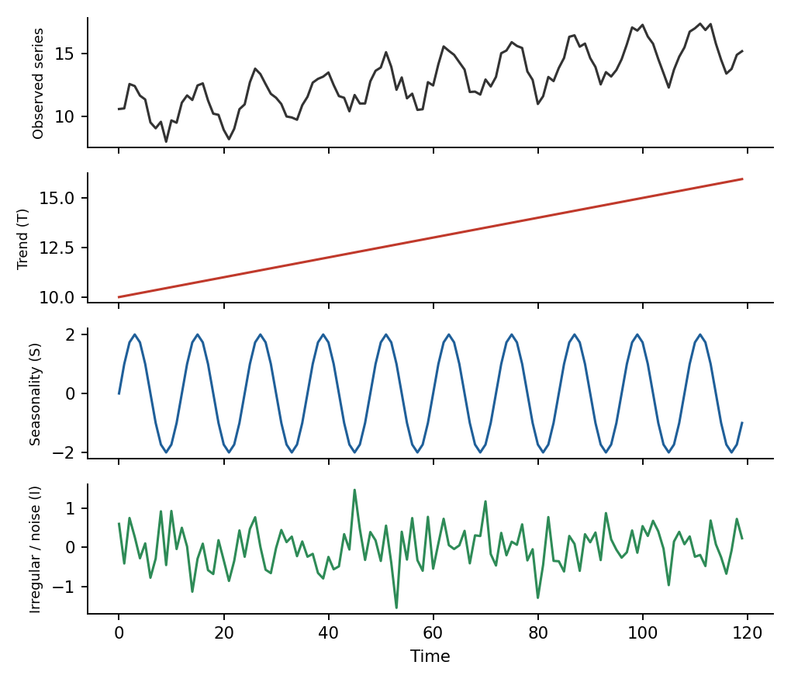
Fig: Decomposition of a time series into trend, seasonality and noise

How a time series is analysed
1. Pre-processing: handle missing values, remove noise (smoothing), normalise, resample.
2. Decomposition / trend analysis: separate T, S, C, I; use moving averages (e.g., 3-point: (xₜ₋₁ + xₜ + xₜ₊₁)/3) or regression.
3. Representation / dimensionality reduction: DFT, wavelets (DWT), PAA, SAX to make series compact.
4. Similarity search: compare series using Euclidean distance or DTW.
5. Pattern discovery: periodicity, motifs, anomalies, change points.
6. Classification and clustering of series; forecasting with ARIMA, exponential smoothing or neural networks (LSTM).
Example: a 3-point moving average of sales 10, 12, 14, 13, 17 gives 12, 13, 14.7 (smoothing reveals the upward trend). Forecasts are validated on held-out recent data.

Q11. Explain the process and techniques of Web Content Mining.
5 Marks · ~300 words
Web content mining extracts useful information from the content of web pages — text, images, audio, video, tables and metadata. The Web is huge, heterogeneous, semi-structured (HTML/XML) and unlabelled, which makes content mining harder than ordinary text mining.
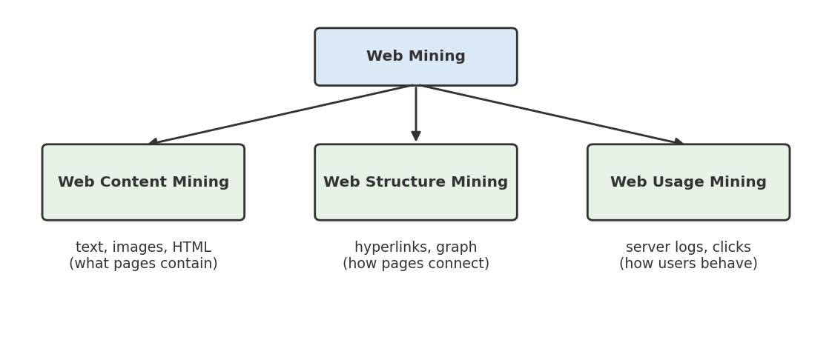
Fig: Three categories of Web mining

Process
1. Crawling / data collection: web crawlers download pages.
2. Pre-processing: remove HTML tags and scripts, tokenise, remove stop-words, stem words, build term vectors (TF-IDF).
3. Information extraction: use wrappers or DOM-tree/XPath to extract the data fields.
4. Mining: classification, clustering, summarisation, association, opinion mining.
5. Evaluation and presentation of results.
TF-IDF(t, d) = tf(t, d) × log( N / df(t) )

Two approaches
Approach | Technique
Information Retrieval (IR) view — unstructured/semi-structured text | Vector-space model, keyword search, text classification and clustering, topic modelling
Database view — structured data | Wrapper induction, extracting data records and tables, building structured data from web pages
Multimedia content mining | Image/audio/video indexing and classification
Web opinion / sentiment mining | Mining reviews and social-media posts

Applications: search engines, price comparison, news categorisation, spam filtering, product-review analysis and building knowledge bases. Challenges: noisy pages, dynamic (deep-web) content, duplicates, multiple languages.

Q12. What is Spatial Data Mining?
5 Marks · ~300 words
Spatial data mining is the discovery of interesting, implicit and previously unknown patterns from spatial data — data related to objects in space, such as maps, satellite images, GPS traces and geographic databases (GIS). It differs from ordinary mining because location, distance and neighbourhood relationships are central.

Spatial data types
- Points (cities, shops), lines (roads, rivers), polygons (lakes, districts) — the vector model.
- Raster (grid/pixel) data such as satellite images.
- Spatial networks (road networks).

Spatial relationships
Topological (adjacent, inside, overlaps, disjoint), distance (near, far, within 5 km) and directional (north of, east of).

Spatial mining tasks
Task | Example
Spatial characterisation / discrimination | Summarise features of high-rainfall regions
Spatial association rules | is_a(x, school) ∧ close_to(x, park) → close_to(x, residential) [80%]
Spatial classification | Classify land use from imagery
Spatial clustering | Crime hot-spot detection
Spatial outlier detection | House with unusual price compared to neighbours
Trend / co-location mining | Which features occur near each other

Specific issues: spatial autocorrelation (nearby objects are similar), large data volume, complex data types, and the need for spatial indexes (R-tree, quad-tree) and spatial data structures for efficient computation.

Q13. Explain the characteristics of spatial data.
5 Marks · ~300 words
Characteristic | Explanation
Location is intrinsic | Every object has a position (coordinates) and often a shape/extent
Spatial autocorrelation | Nearby objects tend to be similar (Tobler’s first law) — violates the independence assumption of normal mining
Spatial heterogeneity | Relationships vary across space; no single global model fits
Complex data types | Points, lines, polygons, rasters, and networks with geometry
Implicit spatial relationships | Topological, distance and direction relations are not stored but must be computed (expensive)
Neighbourhood dependence | The class of an object depends on its neighbours
Large volume and multi-scale | Satellite and GPS data are massive; patterns depend on the scale of analysis
Multiple layers | Themes (soil, rainfall, roads) are stored as separate overlapping layers
Continuous vs. discrete | Fields (temperature) are continuous; objects (buildings) are discrete
Uncertainty and noise | Measurement errors, boundary fuzziness

Because of these characteristics, spatial mining uses spatial indexing, neighbourhood graphs/matrices, spatial joins, and spatial-aware algorithms instead of treating records as independent rows.

EXTRA — Other Important Concepts for Mid-2
Likely exam extras beyond your question list

Q1. k-NN worked numeric example (frequently asked)
Problem · ~300 words
Training data (acid durability, strength → class): (7, 7, Bad), (7, 4, Bad), (3, 4, Good), (1, 4, Good). Classify the query (3, 7) with k = 3.
Point | Class | Distance to (3, 7) | Rank
(7, 7) | Bad | √(16+0) = 4.00 | 3
(7, 4) | Bad | √(16+9) = 5.00 | 4
(3, 4) | Good | √(0+9) = 3.00 | 1
(1, 4) | Good | √(4+9) = 3.61 | 2

The 3 nearest neighbours are Good, Good, Bad → majority vote → Good. Tips: scale attributes first; use odd k; weighted voting (weight = 1/d²) can improve results.

Q2. ID3 vs C4.5 vs CART
Comparison · ~300 words
Feature | ID3 | C4.5 | CART
Split measure | Information gain | Gain ratio | Gini index
Attribute types | Categorical only | Categorical + continuous | Both
Missing values | No | Yes | Yes (surrogate splits)
Pruning | None | Post-pruning (pessimistic) | Cost-complexity pruning
Tree shape | Multiway | Multiway | Binary only
Also does | — | Rule extraction | Regression trees

Why gain ratio? Information gain is biased toward attributes with many values (e.g., an ID column); dividing by SplitInfo corrects this.

Q3. Kernel functions and SVM parameters
Concept · ~300 words
Kernel | Formula | Use
Linear | K(x, y) = x·y | Linearly separable, text data
Polynomial | K = (x·y + c)^d | Curved boundaries, image data
RBF (Gaussian) | K = exp(−γ‖x − y‖²) | Default for complex non-linear data
Sigmoid | K = tanh(κ x·y + c) | Neural-network-like

- Large C → narrow margin, fewer training errors (risk of overfitting); small C → wide margin, more errors allowed.
- Large γ → each point has local influence (overfit); small γ → smoother boundary.

Q4. k-Medoids (PAM), BIRCH and cluster-quality measures
Concept · ~300 words
- k-medoids / PAM: centres are actual objects; swap a medoid with a non-medoid if total cost (sum of distances) decreases. Robust to outliers but O(k(n−k)²) — slower than k-means. CLARA/CLARANS scale it up.
- BIRCH: builds a CF-tree of Clustering Features CF = (N, LS, SS) in a single scan; memory-efficient and handles noise.
- Silhouette coefficient: s = (b − a) / max(a, b), where a = mean intra-cluster distance and b = mean distance to the nearest other cluster; ranges from −1 to +1 (higher is better).
- SSE / elbow method: plot SSE against k and pick the “elbow” to choose k.

Q5. Quick-revision formula sheet
Cheat sheet · ~300 words
Topic | Formula
Entropy | H(S) = − Σ pᵢ log₂ pᵢ
Information gain | Gain(A) = H(S) − Σ (|Sᵥ|/|S|) H(Sᵥ)
Gain ratio | Gain(A) / (− Σ (|Sᵥ|/|S|) log₂(|Sᵥ|/|S|))
Gini index | 1 − Σ pᵢ²
Accuracy | (TP + TN) / (TP + TN + FP + FN)
Precision / Recall | TP/(TP+FP) ; TP/(TP+FN)
F1-score | 2PR / (P + R)
SVM margin | 2 / ‖w‖ ; decision: sign(w·x + b)
RBF kernel | exp(−γ‖x − y‖²)
Neuron output | a = f(Σ wᵢxᵢ + b) ; update w ← w − η ∂E/∂w
Sigmoid / ReLU | 1/(1 + e⁻ᶻ) ; max(0, z)
Euclidean / Manhattan | √Σ(xᵢ−yᵢ)² ; Σ|xᵢ−yᵢ|
k-means SSE | Σ Σ ‖x − mᵢ‖²
Jaccard / Cosine | |A∩B|/|A∪B| ; x·y / (‖x‖‖y‖)
PageRank | PR(P) = (1−d) + d Σ PR(Q)/L(Q)
TF-IDF | tf × log(N/df)
Time series | Y = T + S + C + I (additive)
IQR outlier rule | x < Q1 − 1.5 IQR or x > Q3 + 1.5 IQR

Q6. Last-minute tips for a 5-mark answer
Strategy · ~300 words
- Write: definition (2–3 lines) → diagram → table/points → example → conclusion.
- For problems show every step — entropy formula, weighted average, gain — method marks matter.
- For comparison questions draw a table with at least 6 rows.
- Draw neat, labelled diagrams: SVM margin, decision tree, MLFFNN, dendrogram, DBSCAN point types.
- Memorise one example per topic (Play Tennis tree, k-means {2,4,10,12,3,20,30,11,25}, confusion-matrix numbers).

