Natural Language Processing
Mid 2 Important Questions
Section | Questions | Answer length
Part A: 2 Marks | 15 questions | About 100 words each, with a table or diagram where it helps
Part B: 5 Marks | 15 questions | About 300 words each, with tables, diagrams and graphs

Contents
PART A: 2 Marks Questions
Q1. State the meaning of morphological parsing and illustrate it with a suitable example.
Q2. Differentiate between morphemes and morphs with a suitable example.
Q3. Discuss the importance of parsing with an example.
Q4. Construct a Context-Free Grammar (CFG) for the sentence "The dog chased the cat with a stick" and use the grammar to represent its syntactic structure.
Q5. What are discriminative models for parsing?
Q6. Define semantic interpretation in Natural Language Processing.
Q7. What is Word Sense Disambiguation (WSD)? Give a suitable example.
Q8. Define predicate-argument structure with a suitable example.
Q9. What is a meaning representation system?
Q10. Define a language model and state its purpose.
Q11. What is an N-Gram language model?
Q12. Define perplexity in language model evaluation.
Q13. What is Bayesian parameter estimation in language modeling?
Q14. Define a class-based language model.
Q15. Differentiate between multilingual and cross-lingual language modeling.
PART B: 5 Marks Questions
Q1. State the purpose of Sentence Boundary Detection (Sentence Segmentation) in Natural Language Processing.
Q2. Discuss the issues and challenges with morphological parsing.
Q3. Given the sentence "Beyond the basic level, the operations of the three products vary widely", analyze its syntactic structure using a parse tree, identifying the major phrases and their relationships.
Q4. Discuss the various parsing algorithms.
Q5. What is the importance of Probabilistic Context-Free Grammars? Discuss the advantages and disadvantages.
Q6. A dictionary represents related word forms under a single basic entry. Describe the concept of a lexeme and illustrate it with suitable examples.
Q7. Explain the concept of semantic interpretation. Discuss the major system paradigms used for semantic interpretation with suitable examples.
Q8. What is Word Sense Disambiguation (WSD)? Explain the major approaches to word sense disambiguation with suitable examples.
Q9. Explain predicate-argument structure in semantic parsing. Analyze the sentence "Ravi gave a book to Sita" by identifying the predicate and its arguments.
Q10. Discuss the various meaning representation systems used in Natural Language Processing. Explain their significance with suitable examples.
Q11. Explain N-Gram language models. Discuss unigram, bigram, and trigram models with suitable examples.
Q12. Discuss the methods used for language model evaluation. Explain perplexity and its significance.
Q13. Explain Bayesian parameter estimation in language modeling. Discuss the role of prior probabilities and observed data in parameter estimation.
Q14. What is language model adaptation? Explain the need for adapting language models to specific domains with suitable examples.
Q15. Explain class-based, variable-length, and Bayesian topic-based language models. Discuss their advantages over conventional N-Gram models.

PART A: 2 Marks Questions
Each answer is about 100 words. It starts with the plain idea, then the technical terms, an example and a table or diagram where it helps.

Q1. State the meaning of morphological parsing and illustrate it with a suitable example.
Morphological parsing is the process of analyzing a word to find its morphemes, the smallest meaningful parts, and the grammatical information they carry, such as tense, number or part of speech. In simple words, it cuts a word into pieces and says what each piece does. Example: unhappiness is parsed as un (prefix, meaning not), happy (the root) and ness (suffix that makes a noun meaning a state). So the word means the state of not being happy. In the same way, teachers is teach (root) plus er (agent) plus s (plural). Morphological parsing helps machine translation, search and text analysis because the system can handle every form of a word.
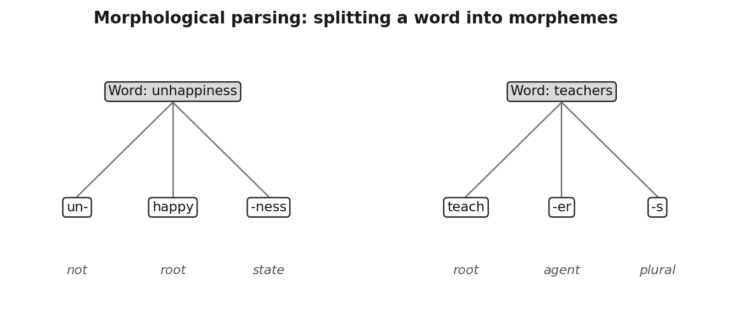
Figure 1: Words split into morphemes with the role of each piece.

Q2. Differentiate between morphemes and morphs with a suitable example.
A morpheme is the smallest meaningful unit of a language. It is an abstract idea, such as the plural or the past tense. A morph is the actual spoken or written form in which that morpheme appears inside a word. When one morpheme has several forms, these variants are called allomorphs. Example: the past tense morpheme appears as the morph ed in walked, played and wanted, but it is pronounced t, d and id. The plural morpheme appears as s in cats and es in boxes. So the morpheme is the idea, and the morph is the way the idea is written or sounded.
Point | Morpheme | Morph
Nature | Abstract unit of meaning | Actual form in a word
Example | Plural, past tense | s in cats, ed in walked
Variants | Has allomorphs | Each variant is one allomorph

Q3. Discuss the importance of parsing with an example.
Parsing uncovers the hidden structure of a sentence: which words group into phrases and which word modifies which. A computer sees only a string of tokens, so parsing recovers information that is not written explicitly, and later tasks depend on it. Example: in text to speech, a natural pause falls after drive in He wanted to go for a drive in the country, but not in He wanted to go for a drive in movie. A system can place this pause correctly only if it has parsed the sentence. Parsing also helps paraphrasing, machine translation, question answering and grammar checking.
Application | How parsing helps
Text to speech | Places pauses at phrase boundaries
Machine translation | Reorders and paraphrases phrases
Question answering | Finds who did what to whom
Grammar checking | Detects ungrammatical structure

Q4. Construct a Context-Free Grammar (CFG) for the sentence "The dog chased the cat with a stick" and use the grammar to represent its syntactic structure.
A context free grammar is a set of rewriting rules. Words are terminals, their parts of speech are preterminals, and phrases are built above them. The grammar below generates the sentence. The start symbol S expands to a noun phrase and a verb phrase, the verb phrase holds the verb and its object, and the prepositional phrase with a stick is added by a recursive rule. Because the same rule set allows the prepositional phrase to attach to the verb phrase or to the noun phrase, the sentence has two parses. In parse 1 the dog uses the stick to chase. In parse 2 the cat has the stick.
Rule type | Rules
Phrase rules | S → NP VP, NP → D N | NP PP, VP → V NP | VP PP, PP → P NP
Preterminals | D → the | a, N → dog | cat | stick, V → chased, P → with

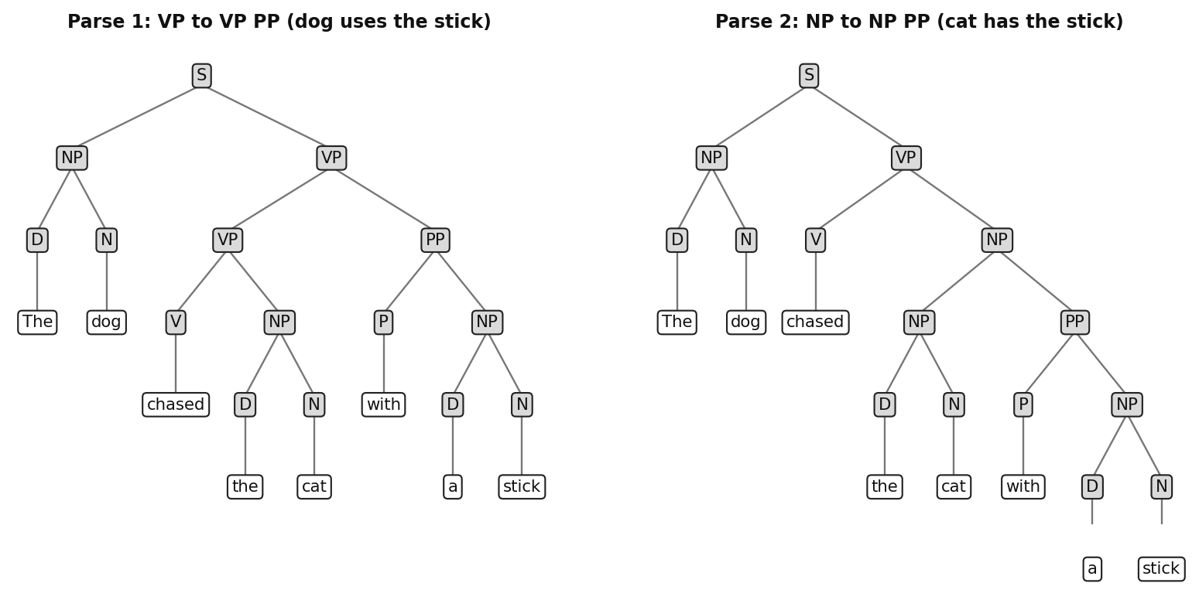
Figure 2: Two parse trees for The dog chased the cat with a stick.

Q5. What are discriminative models for parsing?
Discriminative parsing models do not model how a tree is generated. They score every candidate tree for a sentence directly and return the best one. In the global linear model, GEN(x) lists the candidate parses of sentence x, a feature function Φ(x, y) turns each candidate into a vector of numbers, and a learned weight vector w gives the score Φ(x, y) · w. The parser outputs the highest scoring tree. Any feature of the whole tree can be used, for example whether it contains NP → NP PP or what the head word is. A Conditional Random Field is closely related and adds normalization so the score becomes a probability.
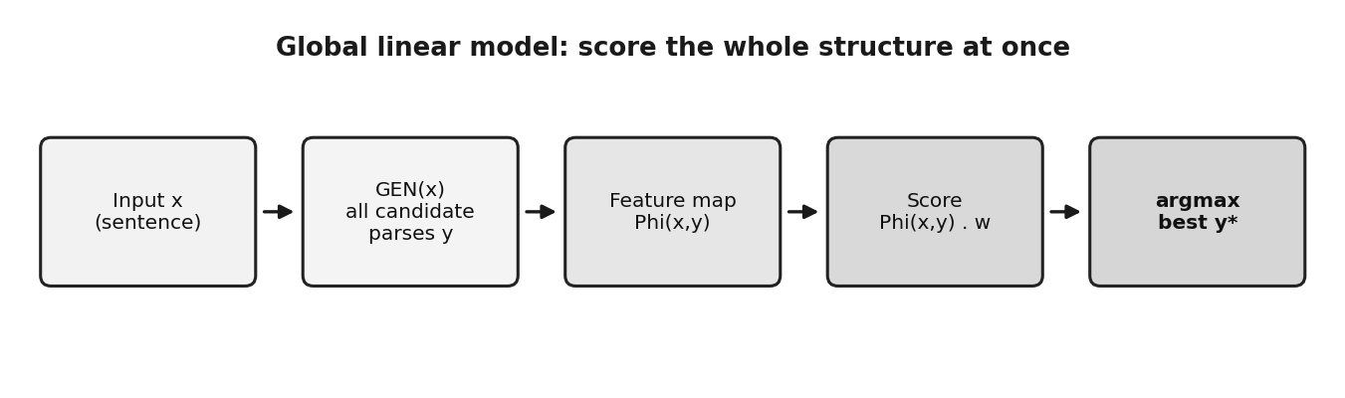
Figure 3: The global linear model scores whole parse trees and picks the best.

Q6. Define semantic interpretation in Natural Language Processing.
Semantic interpretation is the process of working out the meaning of a sentence and expressing it in a form that a computer can use. Syntax tells how words are arranged, while semantics tells what they mean. Interpretation has five parts: resolving structural ambiguity, finding word senses, resolving entities and events (including coreference), finding the predicate argument structure, and building a formal meaning representation. Its goal is to map ordinary text into a representation that lets a system retrieve information, answer a question, fill a database or take an action. Example: in Bell Atlantic Corp. said it will acquire a business, the word it must be linked to Bell Atlantic Corp.
Component | What it does
Structural ambiguity | Uses syntax to decide what attaches to what
Word sense | Chooses the right meaning of each word
Entity and event resolution | Links names and pronouns to the same entity
Predicate argument structure | Finds who did what to whom
Meaning representation | Builds a formal structure a machine can act on

Q7. What is Word Sense Disambiguation (WSD)? Give a suitable example.
Word sense disambiguation is the task of identifying which sense, or meaning, of a word is used in a given context. Many words have several senses, and a program must pick the right one. Example: in He deposited money in the bank, bank means a financial institution, but in They sat on the river bank it means the edge of a river. The surrounding words, such as deposited and river, are the clues. In He nailed the arm of the chair with a hammer, the sense of nail is to fasten, not a fingernail. The senses normally come from an inventory such as WordNet.
Sentence | Clue words | Sense of bank
He deposited money in the bank | deposited, money | Financial institution
They sat on the river bank | river, sat | Edge of a river

Q8. Define predicate-argument structure with a suitable example.
Predicate argument structure describes who did what to whom in a sentence. The predicate, usually the verb, names the event, and it opens slots called arguments that must be filled: who did it, to whom, when, where, why and how. Finding these arguments is the job of semantic role labeling. Example: in John bought a car in Delhi, the predicate is bought. John is the buyer (ARG0), a car is the thing bought (ARG1), and in Delhi is a location modifier. The structure stays the same even if the sentence is rearranged, for example the passive A car was bought by John, so it captures meaning better than word order does.
Part | Phrase | Role
Predicate | bought | The event
ARG0 | John | Buyer (agent)
ARG1 | a car | Thing bought
Modifier | in Delhi | Location

Q9. What is a meaning representation system?
A meaning representation system is a formal framework that converts natural language input into an unambiguous structure a machine can act on. It is the deepest level of semantic interpretation and is also called a deep representation. After structure, word senses, entities and arguments are resolved, the system builds a formal structure, such as a logical formula or a database query, that algorithms can manipulate to answer a question, populate a database or take an action. Example: the question Which flights go from Hyderabad to Delhi on Monday is turned into a query with explicit fields for origin, destination and day. Today such systems work only inside specific domains.
Natural language | Meaning representation
Which flights go from Hyderabad to Delhi on Monday | Query: origin = Hyderabad, destination = Delhi, day = Monday

Q10. Define a language model and state its purpose.
A language model is a statistical model that assigns a probability to a sequence of words, that is, it estimates how likely a sentence is in a language. For a sequence W = w1 w2 ... wT it computes P(W) using parameters learned from training text. Its purpose is to prefer fluent, likely word sequences over unlikely ones. In speech recognition the acoustic score is combined with the language model score to choose the right words, and in machine translation it scores candidate translations. It is also used in spelling correction, text prediction and text generation. Example: P(I love NLP) is higher than P(love NLP I).
Use | Role of the language model
Speech recognition | Chooses likely words among acoustic matches
Machine translation | Scores fluent output sentences
Spelling correction, text prediction | Ranks likely next words or corrections

Q11. What is an N-Gram language model?
An n-gram language model predicts a word from the previous n minus 1 words. Using the chain rule, the probability of a sentence is the product of P(word given all earlier words), but the history keeps growing. The n-gram approximation fixes this by treating all words except the last n minus 1 as irrelevant. A unigram uses no history, a bigram uses one previous word and a trigram uses two. The probabilities are estimated by counting in a training corpus, for example P(wn given wp) = count(wp wn) divided by count(wp). Larger n captures more context but needs much more training data.
Model | History used | Example
Unigram | None | P(you)
Bigram | 1 previous word | P(you given thank)
Trigram | 2 previous words | P(much given thank you very)

Q12. Define perplexity in language model evaluation.
Perplexity is an information theoretic measure of how well a language model predicts a test set. For a test sequence of N words, PP = P(W) raised to the power of minus 1/N, which equals 2 raised to the cross entropy. In simple words, it is the average number of equally likely choices the model faces at each word. If a model gives every test word the probability 0.1, its perplexity is 10, as if it chose among 10 equally likely words. Lower perplexity means the model is less surprised and is better. It must be measured on held-out data, and models that use different units cannot be compared directly.
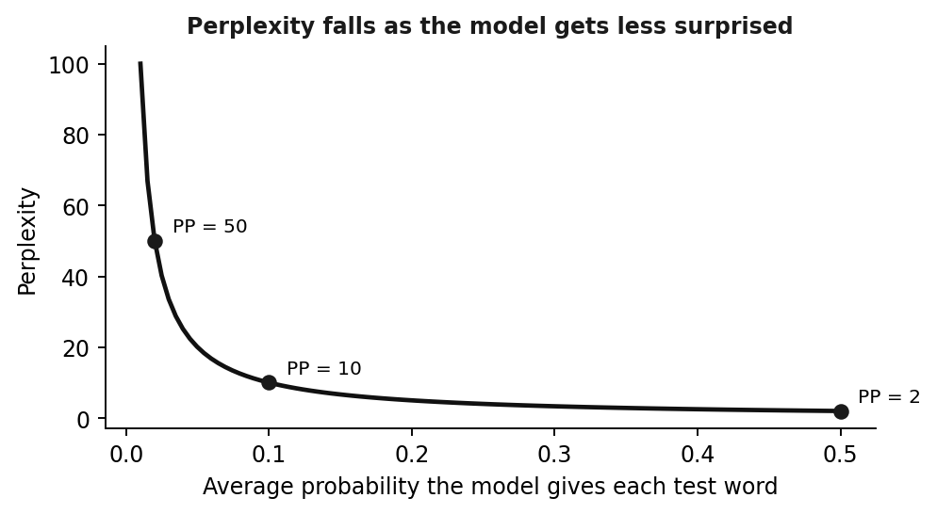
Figure 4: Perplexity is the inverse of the average probability given to each test word.

Q13. What is Bayesian parameter estimation in language modeling?
Maximum likelihood treats the training data as the only source of knowledge. Bayesian parameter estimation treats model parameters, such as n-gram probabilities, as random variables with a prior distribution that expresses beliefs before seeing the data. Bayes rule combines the prior with the observed counts into a posterior, which is used for prediction. The prior has its own parameters, called hyperparameters, and they offer a convenient way of combining different information sources. Its best known use is language model adaptation: the prior comes from a large out of domain corpus and the observed counts come from a small in domain corpus.
Element | Meaning
Prior | Belief about the parameter before seeing data
Likelihood | How well the observed counts fit each parameter value
Posterior | Prior combined with data, used for prediction

Q14. Define a class-based language model.
A class based language model groups words into classes, such as days, cities or numbers, and predicts the next class first and then the word inside that class. For a bigram, P(wi given wi-1) is approximated by P(wi given ci) multiplied by P(ci given ci-1), where ci is the class of word wi. This reduces the number of parameters and helps with data sparsity. Example: if on Monday is common but on Thursday is rare, both words share the class DAY, so Thursday borrows evidence from Monday. Classes are defined by hand or learned by clustering words with similar contexts, and the model is usually interpolated with a word n-gram model.
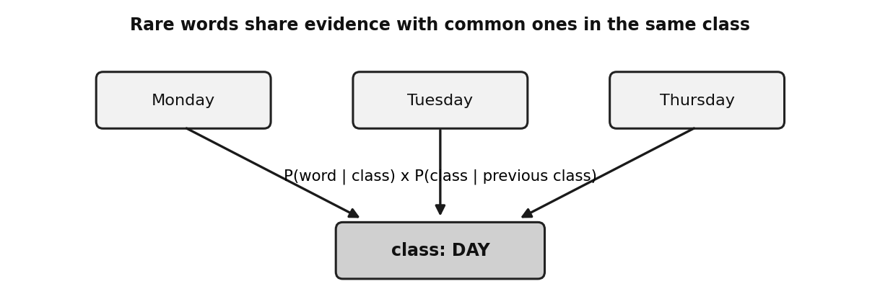
Figure 5: Words of one class share statistics in a class based model.

Q15. Differentiate between multilingual and cross-lingual language modeling.
Multilingual language modeling trains one model on data from many languages together, so the same model can be used for any of them. Cross lingual language modeling transfers knowledge from a resource rich language, such as English, to a low resource language that has little text, for example by sharing subword units, mapping words through translation, or adapting a model with a small amount of target language data. Both face problems such as different scripts, missing word boundaries, rich morphology and code switching. The difference is the direction: multilingual means many languages in one model, while cross lingual means knowledge flowing from one language to another.
Point | Multilingual | Cross-lingual
Idea | One model for many languages | Transfer from one language to another
Data | Text in all the languages | Rich source plus small target data
Example | One model for English, Hindi, Telugu | English model adapted to a low resource language

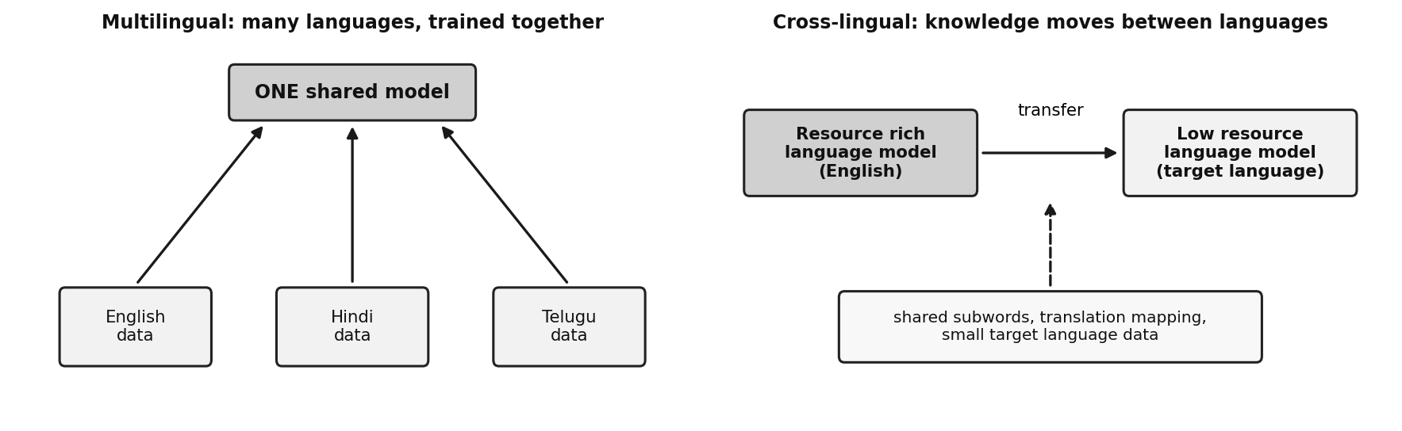
Figure 6: Multilingual (many languages, one model) versus cross-lingual (transfer).

PART B: 5 Marks Questions
Each answer is about 300 words. Points that go beyond the lecture slides are marked as supplementary in the text.

Q1. State the purpose of Sentence Boundary Detection (Sentence Segmentation) in Natural Language Processing.
Sentence boundary detection, also called sentence segmentation, is the task of splitting a stream of word tokens into separate sentences. In plain words, it decides where one sentence ends and the next begins. Its purpose is to give every later NLP step a clean unit to work on. Parsing, machine translation, summarization, question answering and text to speech all assume that the text has already been divided into sentences, so an error here spreads to every step after it. It also makes the output of speech recognition readable, because spoken language has no punctuation or capital letters.
The task looks easy because in English a sentence ends with a period, question mark or exclamation mark, but these clues are unreliable. A period also marks an abbreviation (Dr.) or a number (3.14), a capital letter may start a proper noun and not a sentence, and quoted speech can hold boundaries inside the quotes. Informal text such as chat has almost no punctuation, mixed language text follows two punctuation conventions, and technical text contains URLs, code and symbols that reuse periods.
Because hand written rules are brittle, modern systems treat each candidate boundary as a classification problem with two labels, boundary and non-boundary. Generative models such as the Hidden Markov Model, discriminative models such as maximum entropy and CRFs, and hybrid models are used, with lexical, syntactic, discourse and prosodic features. The purpose is to turn raw text or speech into correct sentence units.
A short example makes the answer clear. In Dr. Rao met Mr. Das at 3.30 p.m. yesterday, a naive splitter cuts after every period and produces several false sentences, while a trained classifier that has learned the role of abbreviations and numbers produces one correct sentence. In summary, the purpose is to give later NLP tasks clean sentence units, the difficulty is that punctuation is ambiguous, and the solution is classification using features.
Challenge | Example | Why a simple rule fails
Abbreviation | Dr. Rao arrived. | Period does not end the sentence
Number or URL | 3.14, a.b.com | Period inside a token
Quotation | He said, "Go. Now." | Boundary inside quotes
Informal text | ok see u tmrw call me | No punctuation at all

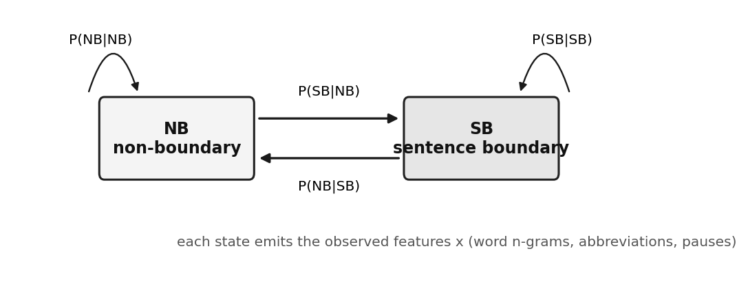
Figure 7: A two state HMM for boundary detection: SB (sentence boundary) and NB (non-boundary).

Q2. Discuss the issues and challenges with morphological parsing.
Morphological parsing tries to turn the messy variety of word forms into clean units whose meaning and grammar are explicit. Natural language is irregular, ambiguous and constantly growing, and these three properties are the central challenges.
Irregularity means that some words ignore the regular rules. The plural rule add s works for cat, but mouse gives mice, child gives children and the past tense of go is went. A rule based analyzer would wrongly produce mouses or goed, so irregular forms must be stored in a lexicon. Ambiguity means one form has several analyses. Bank can be a financial institution or a river edge, and watch can be a noun or a verb. A parser looking at one word cannot choose, so it needs context. Productivity means speakers constantly build new words from known morphemes, for example reread, internationalization and googling. No dictionary can list them all, so analyzers meet unknown words all the time.
The language type adds difficulty. Isolating languages such as Chinese have almost one morpheme per word, agglutinative languages such as Turkish and Tamil stack many morphemes in one long word, and fusional languages such as Arabic and Latin pack several grammatical features into one morpheme. Tokenization itself is a problem when words are not separated by spaces.
In practice an analyzer combines three tools: a lexicon for irregular forms, rules or finite-state transducers for regular and productive patterns, and statistics or context to resolve ambiguity and unseen words.
An example shows all three together. The word unhappier is analyzed as un + happy + er, and this needs a spelling rule because y changes to i. The irregular form better cannot be derived from good by any rule, and a new word such as unfriend must be handled even though it may be missing from the lexicon. This is why one technique is never enough.
Challenge | Example | Typical remedy
Irregularity | mouse to mice, go to went | Store exceptions in a lexicon
Ambiguity | bank, watch, bat | Use context or probabilities
Productivity | reread, googling | Rules that generalize to new words

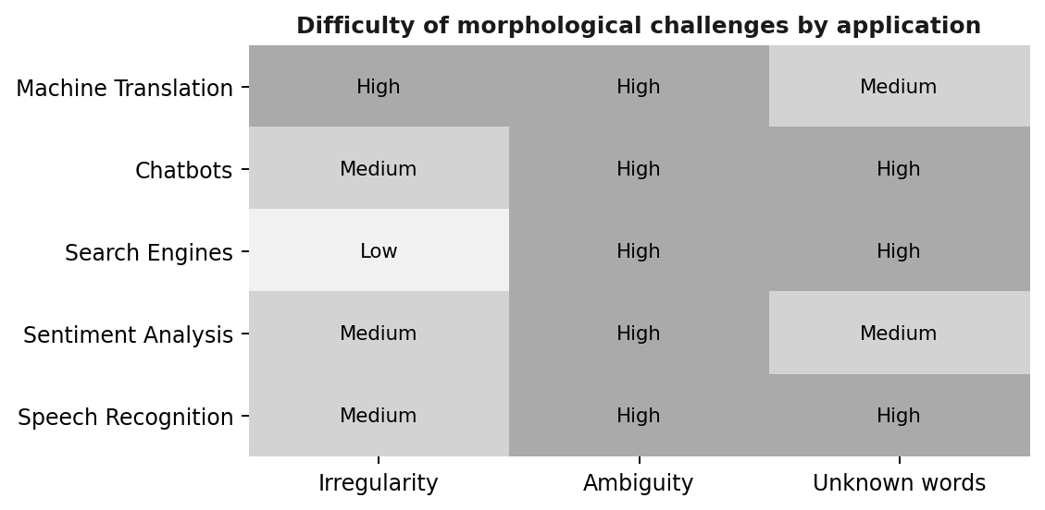
Figure 8: Difficulty of the three challenges for common NLP applications (ratings from the lecture slide).

Q3. Given the sentence "Beyond the basic level, the operations of the three products vary widely", analyze its syntactic structure using a parse tree, identifying the major phrases and their relationships.
Parsing groups words into phrases and shows how the phrases relate. The sentence has three major parts: a fronted prepositional phrase, a subject noun phrase and a verb phrase. The first part, Beyond the basic level, is a prepositional phrase (PP). It starts with the preposition Beyond, and its noun phrase the basic level contains a determiner (the), an adjective (basic) and the head noun level. This PP is an adjunct: it tells under what condition or range the statement holds, and it is moved to the front of the sentence.
The second part, the operations of the three products, is the subject noun phrase. Its head noun is operations, with the determiner the, and it carries its own prepositional phrase of the three products. That inner PP has the preposition of and a noun phrase made of the determiner the, the numeral three and the head noun products. The noun phrase operations therefore has the structure NP → D N PP, and the plural head operations agrees with the plural verb vary.
The third part, vary widely, is the verb phrase (VP). Its head is the intransitive verb vary and it takes the adverb widely as a modifier, so VP → V ADV. The whole sentence follows S → PP NP VP, where the NP is the subject and the VP is the predicate. Note that a PP at the start could in principle attach to the VP, but here it modifies the whole clause. The relations are therefore: Beyond the basic level modifies the clause, of the three products modifies operations, and widely modifies vary.
In bracket form the analysis is: [S [PP Beyond [NP the basic level]] [NP the operations [PP of [NP the three products]]] [VP vary [ADV widely]]]. The structure is hierarchical: smaller phrases are nested inside larger ones, which is exactly what a context free grammar derivation records, and it is the information a later semantic step needs.
Phrase | Type | Head word | Relationship
Beyond the basic level | PP | Beyond | Fronted adjunct of the clause
the operations of the three products | NP | operations | Subject of vary
of the three products | PP | of | Modifies the noun operations
vary widely | VP | vary | Predicate of the sentence
widely | ADV | widely | Modifies the verb vary

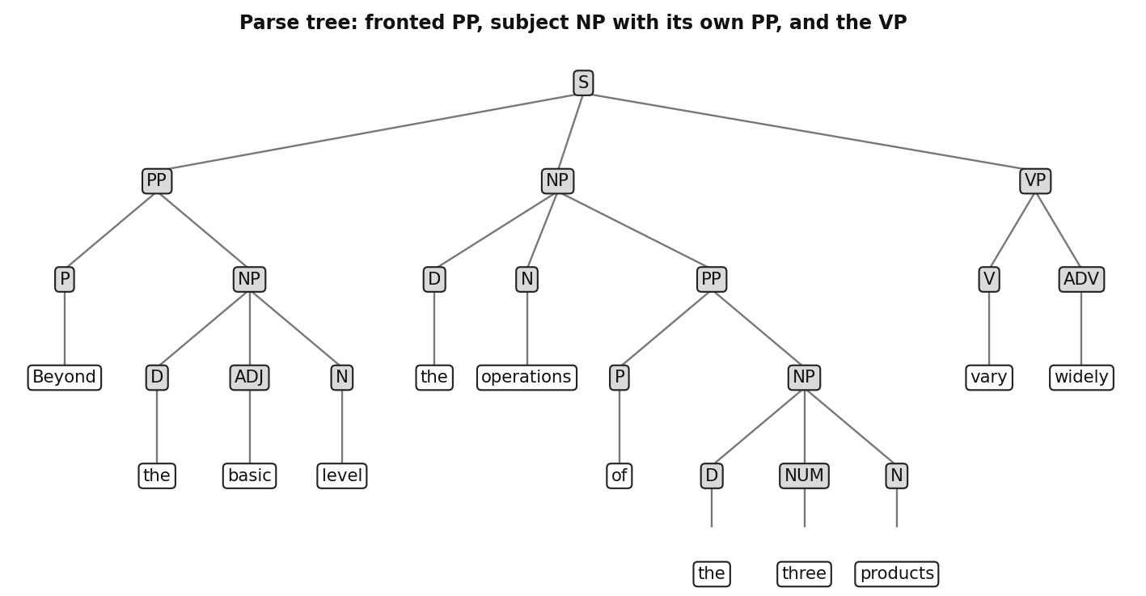
Figure 9: Parse tree for Beyond the basic level, the operations of the three products vary widely.

Q4. Discuss the various parsing algorithms.
A parsing algorithm searches for the correct structure of a sentence under a grammar. Because ambiguity grows as a Catalan number with sentence length, listing all parses is exponential, so efficient algorithms are essential. Three main families are discussed.
Shift-reduce parsing is a bottom up method. It uses a stack and an input buffer. Shift moves the next word onto the stack, and reduce replaces the top symbols of the stack by the left side of a matching rule, for example D N becomes NP. The parser accepts when the stack holds only the start symbol and the buffer is empty. It is linear in time when an oracle always picks the right action, but with ambiguity it may need backtracking, which can be exponential. A derivation read in reverse is a rightmost derivation, which is exactly the sequence of reduce steps.
The CKY algorithm is a chart parser. It first binarizes the grammar so each rule has at most two symbols on the right. It then labels spans between words (0 to n) and, for each span and each split point, checks whether two smaller spans combine by a rule. The stored result is a parse forest, a compact encoding of all trees. CKY takes O(n cubed) time and O(n squared) space. With rule scores, the best tree is found by the Viterbi method, and thresholding (beam or global) prunes unlikely entries to gain speed.
For dependency parsing, the minimum spanning tree approach builds a fully connected graph of word to word arcs with scores and selects the highest scoring tree. It ignores word order, so it can find non-projective trees. If the best incoming arcs form a cycle, the cycle is contracted and the process repeats.
Which algorithm to use depends on the grammar and the output wanted: CKY with scores for phrase structure trees, MST for dependency trees, and shift-reduce when speed matters most.
Algorithm | Output | Time | Non-projective
Shift-reduce | Constituent or dependency tree | Linear with oracle, exponential worst case | Depends on system
CKY | Parse forest, best tree | O(n cubed) | No
MST | Dependency tree | Polynomial | Yes

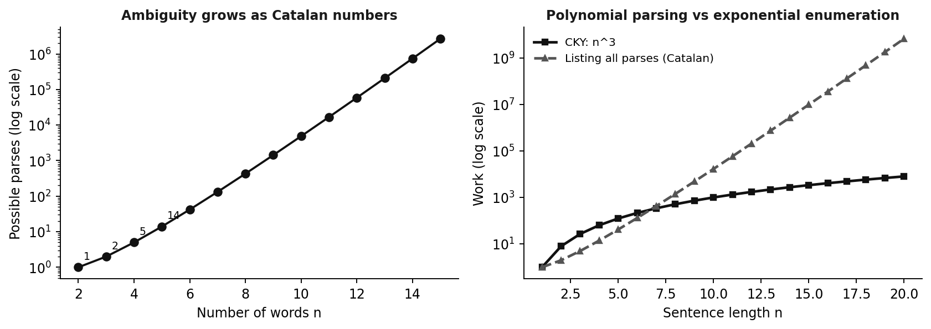
Figure 10: Left: parses grow exponentially. Right: CKY stays polynomial while enumeration explodes.

Q5. What is the importance of Probabilistic Context-Free Grammars? Discuss the advantages and disadvantages.
A plain context free grammar says which parses are possible but not which one is most likely. A probabilistic CFG (PCFG) attaches a probability to every rule, and all rules with the same left side sum to 1. The probability of a tree is the product of the probabilities of the rules it uses, and the parser outputs the tree with the highest probability. This is its importance: it resolves ambiguity in a principled way. Rule probabilities are estimated from a treebank by counting, as c(rule) divided by the number of times the left side is expanded.
Example: for John bought a shirt with pockets, the parse where with pockets attaches to the noun shirt has probability 0.0009, while the parse where it attaches to the verb phrase has probability 0.00072. The PCFG chooses the first, which matches the sensible reading.
Advantages: it ranks all parses by a number, so ambiguity is resolved automatically. Probabilities are learned from a treebank, so no manual ranking is needed. It is a simple extension of a CFG and can reuse CKY with Viterbi scoring, and it can also act as a language model for sentences.
Disadvantages: the rules are context free, so the probability of a rule does not depend on where it appears in the tree, and the model can combine rules in ways never seen together. It ignores the actual words, so a choice such as bought with cash versus shirt with pockets cannot depend on vocabulary. Products of probabilities favour short trees, and the results depend heavily on the quality and size of the treebank. Improvements include parent annotation (VP^S), lexicalization with head words, and automatic split and merge of labels.
In short, a PCFG upgrades a CFG from a tool that only recognizes sentences into one that also ranks their analyses and chooses the most likely one.
Parse | Rules multiplied | Probability
P1: with pockets modifies shirt (NP) | 1.0 x 0.1 x 0.6 x 1.0 x 0.5 x 0.3 x 1.0 x 1.0 x 1.0 x 1.0 x 0.1 | 0.0009
P2: with pockets modifies the VP | 1.0 x 0.1 x 0.4 x 0.6 x 1.0 x 0.3 x 1.0 x 1.0 x 1.0 x 1.0 x 0.1 | 0.00072

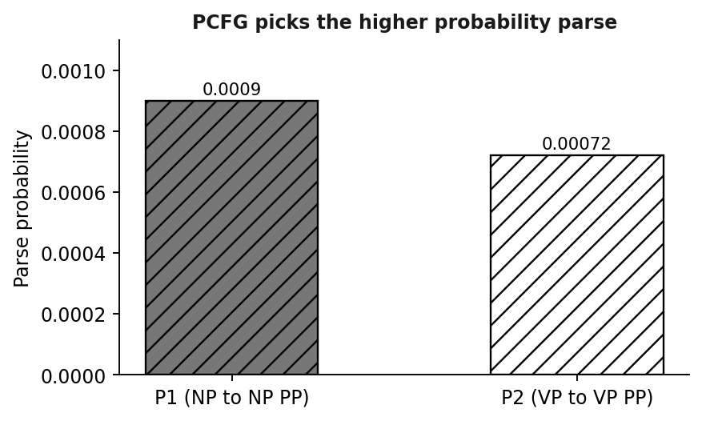
Figure 11: The PCFG prefers parse P1, the sensible reading.

Q6. A dictionary represents related word forms under a single basic entry. Describe the concept of a lexeme and illustrate it with suitable examples.
Think of a dictionary. It does not list see, sees, saw, seen and seeing as five separate headwords. It has one entry, SEE, and says the other forms belong to it. That entry is a lexeme: the basic, abstract form of a word that groups together all of its inflected variants. The collection of all lexemes of a language is its lexicon. So the lexeme RUN covers run, runs, ran and running, and the lexeme MOUSE covers mouse and mice.
A lexeme is different from a morpheme. A morpheme is the smallest unit of meaning, such as the plural or the past tense. A morph is the actual form of a morpheme seen in a word, such as s in cats, and allomorphs are different shapes of the same morpheme, such as t, d and id for the English past tense. A lexeme sits one level above: it is a whole word entry together with all its grammatical forms. The same lexeme may be built from several morphemes, for example the forms of RECEIVE include receive, receiver and reception in the example list of the course.
Lexemes matter for NLP because a system that treats saw and seen as unrelated words must learn everything twice. If word forms are mapped to their lexeme, the system sees through surface variation. For example, in Did you see him, I didn't see him and I didn't see anyone, tokenization splits didn't into did and not, and lexeme analysis maps see in all three sentences to SEE. Search engines, translation systems and text analysis all use this idea to match different forms of the same word.
Example: a search for see should also match saw and seen. With lexemes, the engine maps every form to SEE and matches all of them, so the user gets complete results. The same idea helps translation and text analysis.
Lexeme | Word forms
SEE | see, sees, saw, seen, seeing
RUN | run, runs, ran, running
MOUSE | mouse, mice
RECEIVE | receive, receiver, reception

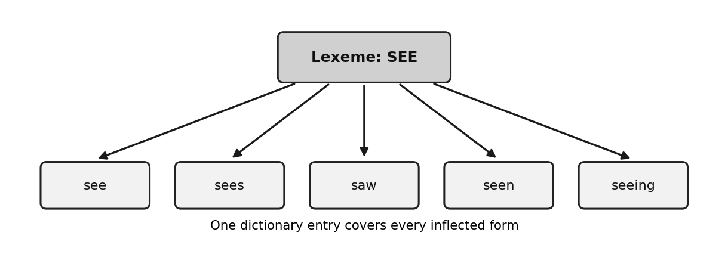
Figure 12: One lexeme covers all inflected forms of a word.

Q7. Explain the concept of semantic interpretation. Discuss the major system paradigms used for semantic interpretation with suitable examples.
Semantic interpretation means finding the meaning of text and expressing it in a form a computer can compute with, for example to retrieve information, answer a question, fill a database or take an action. Ideally the representation is detailed enough for reasoning, yet general enough for many domains, but such representations are very hard to build. So two compromises are used: deep, domain specific parsing builds one rich representation for a limited domain such as air travel, and shallow, general purpose parsing splits the task into reusable pieces such as word sense disambiguation and semantic role labeling. Interpretation has five components: resolving structural ambiguity, word sense, entity and event resolution, predicate argument structure and a final meaning representation.
System paradigms describe how such systems get their knowledge. In rule based or knowledge based systems, experts write rules and use dictionaries; they are precise but cannot keep up with new words. Supervised systems learn from labelled data, such as sense tagged text or PropBank, and are accurate when labels exist. Unsupervised systems use only raw text and cluster similar usages, so they suit changing language such as social media. Semi-supervised systems start from a small labelled seed and bootstrap onto a large unlabelled pool, which suits domain specific tasks.
Example: to interpret He nailed the arm of the chair with a hammer, a system must choose the right sense of nail (fasten), find the predicate nailed with its arguments, and build a formal structure from them.
Example of deep versus shallow: a flight booking system builds one rich representation for air travel, but if it is moved to hotel booking, most of it must be rebuilt. A word sense disambiguation module, in contrast, works in any domain, which is why shallow pieces are reusable. The paradigm names here follow the word sense slides and the textbook.
Paradigm | Knowledge source | Example use
Rule or knowledge based | Hand written rules, dictionary | Closed domain query systems
Supervised | Labelled corpus (WordNet senses, PropBank) | WSD for English
Semi-supervised | Small seed plus unlabelled text | Farming advice app
Unsupervised | Raw text, clustering | Poetry and social media

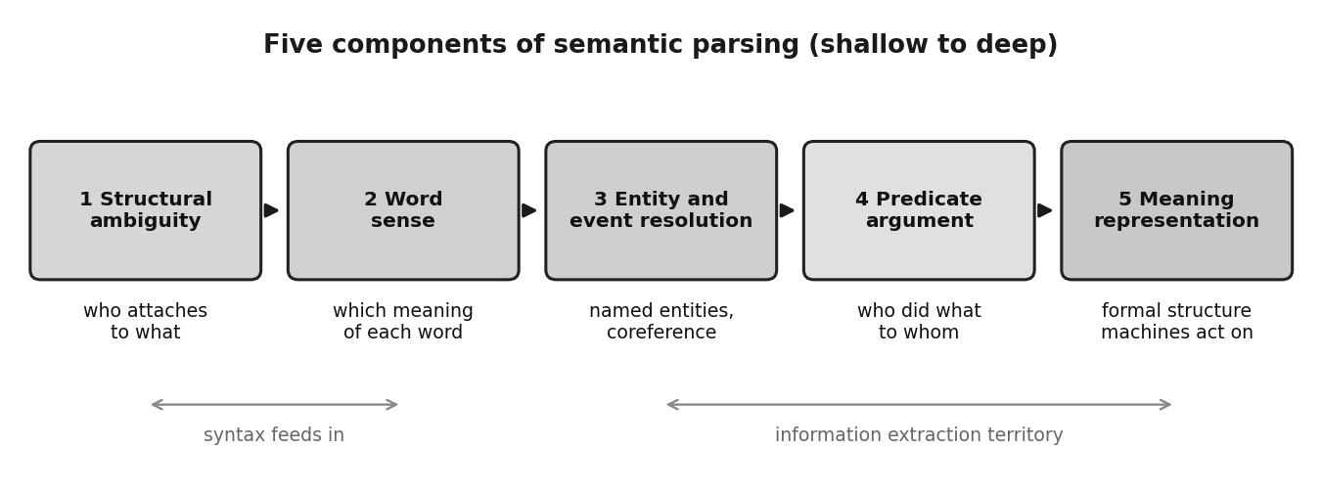
Figure 13: The five components of semantic interpretation.

Q8. What is Word Sense Disambiguation (WSD)? Explain the major approaches to word sense disambiguation with suitable examples.
A word sense is one of the distinct meanings of a word, and word sense disambiguation (WSD) is the task of choosing the correct sense in a given context. In plain words, it answers: which meaning does the speaker intend? In He deposited money in the bank, bank is a financial institution, while in the river bank it is an edge. Senses can also be metaphorical, as in A shiver ran down her spine, where ran does not mean movement on legs.
Knowledge based or rule based approaches use dictionary definitions, rules and sense inventories such as WordNet. They need no training data but are costly to extend as language keeps growing. Supervised approaches learn from text where each word is tagged with its sense, using context words, part of speech and position as features. They give high accuracy but need expensive labelled corpora. Semi-supervised approaches start from a small labelled seed and bootstrap on unlabelled text, which helps with domain terms missing from WordNet, for example crop and yield in a farming advice app.
Unsupervised approaches, called word sense induction, cluster similar usages in raw text. Clusters can be hard (1 or 0 for each sense) or soft (a probability for each sense). For The newspaper ran the story, soft clustering gives several senses of run different strengths. This suits poetry, slang and social media where WordNet is outdated.
Design also depends on granularity. Coarse senses are easier and give higher annotator agreement, while fine senses capture nuance but cost more. For a narrow domain, use coarse senses and a small model.
Choosing between approaches: for English text with WordNet senses, use supervised or semi-supervised learning. For poetry or slang, where the inventory is missing, use unsupervised soft clustering. For a narrow domain use coarse senses, and for words with many live meanings use fine senses and a larger model.
Approach | Needs | Example
Knowledge based | Dictionary, WordNet | Match context to definition
Supervised | Sense tagged corpus | Classifier on window words
Semi-supervised | Small seed plus raw text | Farming terms
Unsupervised | Raw text only | Soft clusters for poetry

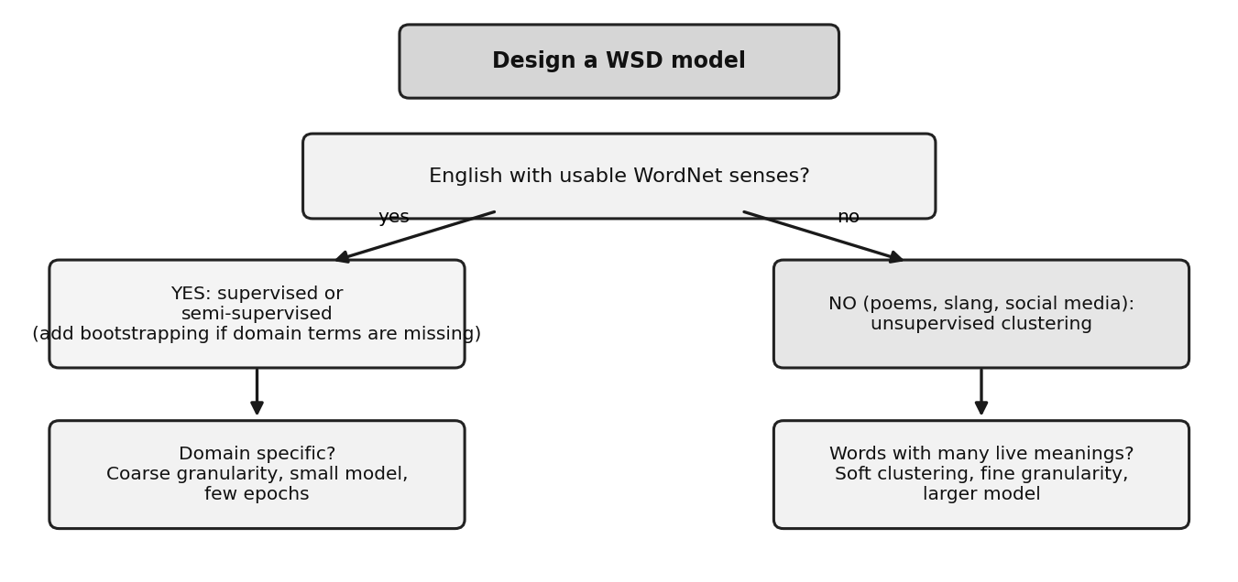
Figure 14: Rules of thumb for choosing a WSD design.
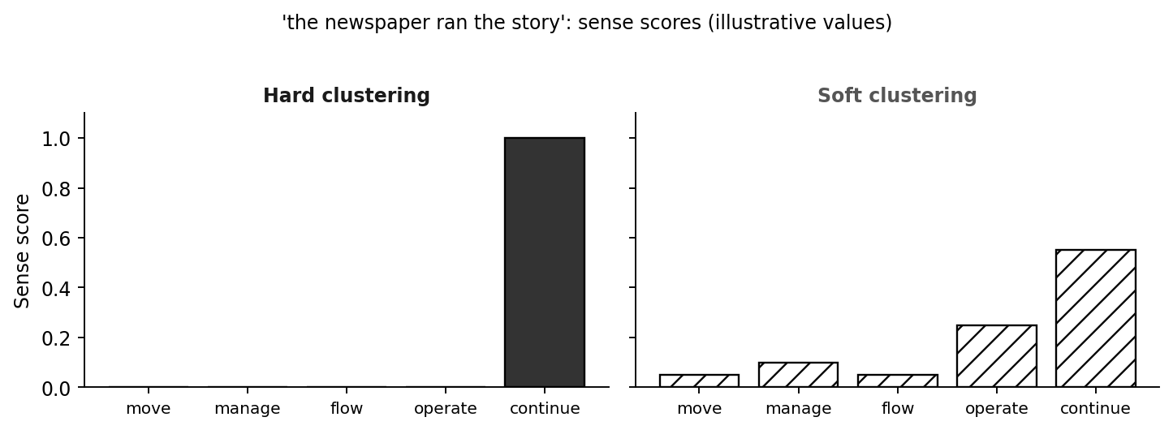
Figure 15: Hard versus soft sense assignment for run (illustrative values).

Q9. Explain predicate-argument structure in semantic parsing. Analyze the sentence "Ravi gave a book to Sita" by identifying the predicate and its arguments.
Predicate argument structure describes the event in a sentence: who did what to whom, and when, where, why and how. The predicate, usually the verb, names the event and opens slots called arguments. Finding the predicates and filling their slots is called semantic role labeling (SRL), and it is a main part of shallow semantic parsing. Resources such as PropBank, which lists verbs and their argument roles, and FrameNet provide the labels.
In SRL, a full syntactic parse is built first, the predicates are identified, and a set of features is extracted for each node of the tree relative to the predicate. Each node is classified as an argument or not (a null node) and the highest scoring role is chosen. One important feature is the path from the node to the predicate in the tree.
Analysis of Ravi gave a book to Sita: the parse tree is S → NP VP, where NP is Ravi and VP → V NP PP. The predicate is gave, a verb of transfer. Its first argument, ARG0, is Ravi, the giver (agent). The second argument, ARG1, is a book, the thing given (theme). The third argument, ARG2, is to Sita, the receiver (recipient). The path from the subject NP to the predicate is NP up S down VP down V. The roles stay the same in the rearranged sentence Ravi gave Sita a book and in the passive A book was given to Sita by Ravi, which shows that the structure captures meaning and not word order.
SRL is useful because it supports question answering and information extraction. For the question Who gave Sita a book? the system finds the predicate gave and returns the filler of ARG0, Ravi. For What did Ravi give? it returns the filler of ARG1, a book. The same answers work for the passive form of the sentence.
Element | Text | Role
Predicate | gave | Event of giving
ARG0 | Ravi | Giver (agent)
ARG1 | a book | Thing given (theme)
ARG2 | to Sita | Receiver (recipient)

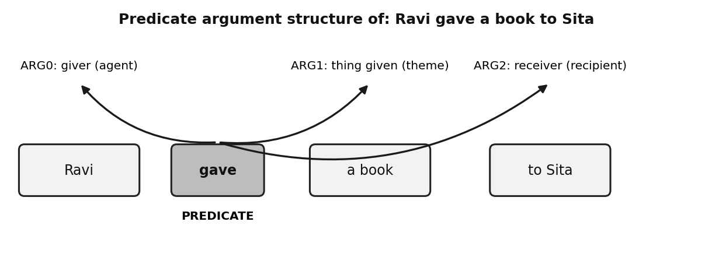
Figure 16: Predicate and arguments of Ravi gave a book to Sita.

Q10. Discuss the various meaning representation systems used in Natural Language Processing. Explain their significance with suitable examples.
A meaning representation system turns natural language into an unambiguous, formal structure that a machine can act on. It is the deepest stage of semantic interpretation and is also called deep semantic parsing. The lecture notes define it and note that current techniques work only within specific domains. The common types below are the standard ones from the textbooks and go beyond the slides, so treat them as supplementary.
First order logic expresses meaning with predicates, variables and quantifiers, for example exists b: Book(b) AND Give(Ravi, b, Sita). It supports logical reasoning and checking truth. A semantic network is a graph in which nodes are concepts and labelled arcs are relations, such as Give with agent Ravi, theme book and goal Sita. It is easy to visualize and good for relations between concepts. A frame is a structured record with slots and values, such as a GIVE frame with giver, thing and receiver; it suits events and filling database like slots. A database or logical query language represents a question as a query, for example origin = Hyderabad, destination = Delhi, day = Monday, and is used in domain specific systems like air travel.
Significance: meaning representations remove ambiguity, let programs answer questions, populate databases and take actions, and allow inference that is impossible on raw text. The more expressive the representation, the more reasoning is possible, but the harder it is to build resources and move to a new domain. In practice, a reusable shallow layer (word senses and semantic roles) is combined with a small domain specific deep layer.
Example of use: the sentence Ravi gave a book to Sita can be stored as a frame or a logic formula, and then a program can answer Who received the book? by looking up the receiver slot. This shows why a formal representation is needed beyond plain text.
System | Idea | Example | Best for
First order logic | Predicates and quantifiers | Give(Ravi, book, Sita) | Reasoning, truth checking
Semantic network | Concept graph with relations | Give-agent-Ravi | Relations between concepts
Frame | Slots and values | GIVE: giver, thing, receiver | Events, templates
Query language | Question as a structured query | origin, destination, day | Domain specific systems

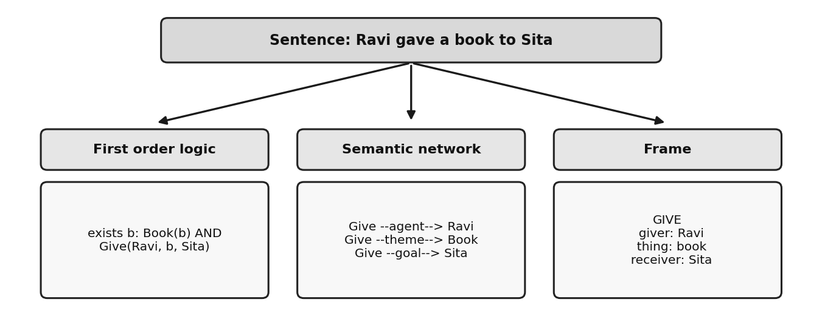
Figure 17: One sentence in three meaning representations.

Q11. Explain N-Gram language models. Discuss unigram, bigram, and trigram models with suitable examples.
A language model gives a probability to a word sequence. By the chain rule, P(W) is the product of P(wi given all earlier words), but the history grows without limit and most long histories never occur in training data. The n-gram model therefore assumes that only the previous n minus 1 words matter. All histories that share the same last n minus 1 words form one equivalence class. A unigram model uses no history, a bigram uses one previous word and a trigram uses two.
Probabilities are estimated by counting: P(wn given wp) = count(wp wn) divided by count(wp), and for a trigram, count of the three words divided by count of the two word history. Example corpus: <s> I love NLP </s>, <s> I love data </s> and <s> I study NLP </s>. The word I occurs 3 times, I love occurs 2 times and I study once. So the bigram probability P(love given I) = 2/3 and P(study given I) = 1/3. For the trigram, I love occurs 2 times and I love NLP once, so P(NLP given I love) = 1/2. For the unigram, the corpus has 15 tokens and I occurs 3 times, so P(I) = 3/15 = 0.2. Then P(I love NLP) under the bigram model = P(I given <s>) x P(love given I) x P(NLP given love) x P(</s> given NLP) = 1 x 2/3 x 1/2 x 1 = 1/3.
Larger n gives more context and better predictions but needs far more data, because the number of possible n-grams grows as vocabulary size raised to n. Unseen n-grams get zero probability, so smoothing and backoff are used.
Choosing n is a trade off. Bigrams are common and well estimated, trigrams capture fixed phrases such as thank you very much, but higher orders become sparse. Real systems combine several orders with smoothing.
Model | Condition | Example from toy corpus | Value
Unigram | None | P(I) = 3/15 | 0.2
Bigram | 1 previous word | P(love given I) = 2/3 | 0.667
Trigram | 2 previous words | P(NLP given I love) = 1/2 | 0.5

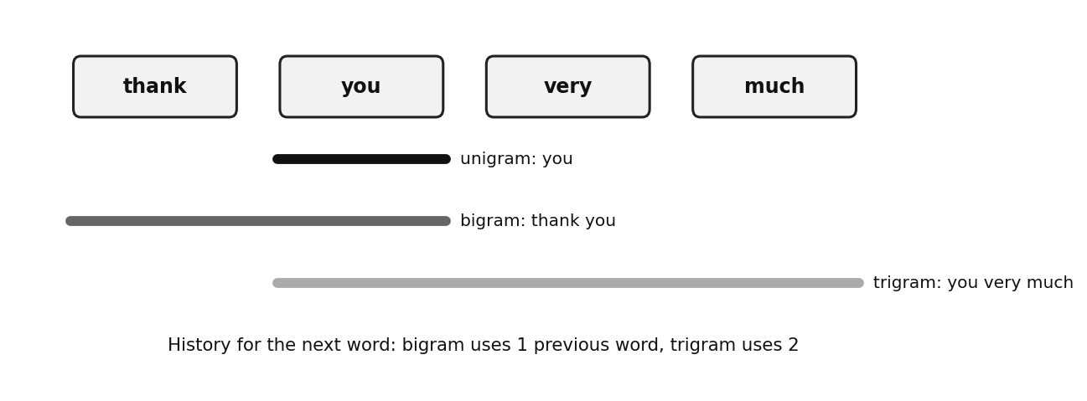
Figure 18: Unigram, bigram and trigram windows over the phrase thank you very much.

Q12. Discuss the methods used for language model evaluation. Explain perplexity and its significance.
To know whether a language model is good, we test it on held-out text that was not used for training, because scoring on training data would reward memorization. Two criteria are used. The coverage rate is the percentage of n-grams in the test set that are represented in the model. A special case is the out-of-vocabulary (OOV) rate, which equals 100 minus the unigram coverage rate and is the share of test word types that the model has never seen. A high OOV rate shows that the vocabulary is too small for the domain.
The second criterion is perplexity, built on entropy, the uncertainty in a probability distribution. For a test sequence of N words, PP = P(W) raised to the power of minus 1/N, which equals 2 raised to the cross entropy H. It is the average number of equally likely choices the model faces at each word. Example: if a model gives the four test words the probabilities 0.1, 0.2, 0.05 and 0.1, the product is 0.0001 and PP = (0.0001) raised to minus 1/4 = 10. The model behaves as though choosing among 10 equally likely words per step. Another model with perplexity 5 on the same text would be better. On the toy corpus, the bigram model gives the test sentence I love NLP a perplexity of 1.32, while the unigram model gives 6.12.
Significance: perplexity gives one number to compare models and to tune smoothing. Lower is better. It is meaningful only when models are tested on the same text and use the same units, so a word model and a morpheme model must be normalized to the same number of units before comparison.
To remember: coverage and the OOV rate check the vocabulary of the model, while perplexity checks the quality of its probabilities. Use all three, on held-out data.
Measure | Meaning | Better when
Coverage rate | Share of test n-grams found in the model | Higher
OOV rate | Share of unseen word types | Lower
Perplexity | Average number of choices per word | Lower

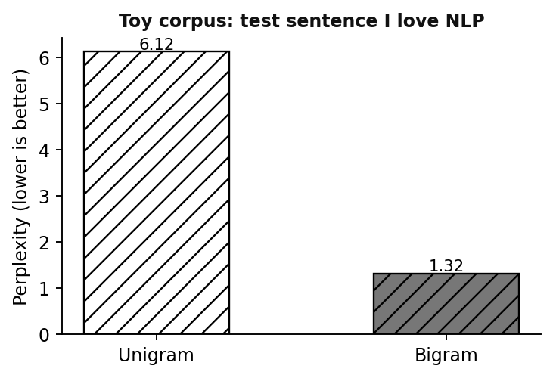
Figure 19: Perplexity of unigram and bigram models for the test sentence I love NLP (toy corpus).

Q13. Explain Bayesian parameter estimation in language modeling. Discuss the role of prior probabilities and observed data in parameter estimation.
Maximum likelihood estimation uses only the training counts. Bayesian parameter estimation instead treats each model parameter, such as an n-gram probability, as a random variable. Before seeing data, we have a belief about it, called the prior distribution. After observing data, Bayes rule combines the prior with the likelihood of the observed counts to give the posterior: posterior is proportional to likelihood times prior. The posterior is then used to predict new text. The prior has its own parameters, called hyperparameters.
The prior carries knowledge from outside the data. It can come from a large general corpus, from a related language, or from a general belief that no word is impossible. It keeps estimates sensible when data is small and prevents zero probabilities. The observed data carries evidence about the actual situation. With little data the posterior stays close to the prior, and with a lot of data the posterior moves towards the observed frequencies. The balance between them is controlled by the hyperparameters.
For n-gram probabilities, which follow a multinomial distribution, a common prior is the Dirichlet, whose hyperparameters act like imaginary counts added to the real counts. This detail goes beyond the slides but explains smoothing. Example: a vocabulary of 3 words, prior counts of 2 for each, and observed counts 4, 1 and 0. Maximum likelihood gives 0.80, 0.20 and 0. The Bayesian estimate gives (4+2)/11, (1+2)/11 and (0+2)/11, that is 0.55, 0.27 and 0.18. The unseen word receives a nonzero probability. The most successful use in the slides is language model adaptation.
In a language model the prior might come from a large news corpus and the observed data from a few hundred medical sentences. The hyperparameters decide how strongly the model trusts the news prior compared with the new data. This is why Bayesian estimation is the natural base for adaptation and for smoothing.
Word | Observed count | Maximum likelihood | Bayesian (prior count 2)
w1 | 4 | 0.80 | 0.55
w2 | 1 | 0.20 | 0.27
w3 | 0 | 0.00 | 0.18

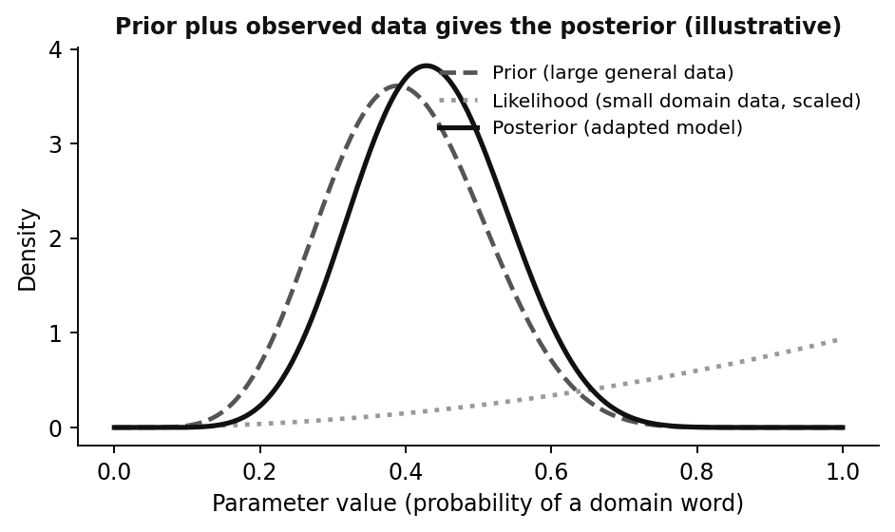
Figure 20: Prior plus observed data gives the posterior (illustrative curves).

Q14. What is language model adaptation? Explain the need for adapting language models to specific domains with suitable examples.
Language model adaptation means adjusting a general language model so that it works well on a specific domain, topic or style. A model trained on news text knows everyday vocabulary but may give very low probability to the words of a hospital, a court or a cricket commentary. Adaptation fixes this by using a small amount of text from the target domain.
The need comes from the mismatch between training data and test data. Vocabulary differs: stent, biopsy and dosage are common in medical dictation but rare in news, so the model gives them almost no probability and the out-of-vocabulary rate is high. Style differs: legal text has long sentences and fixed phrases, while chat text is short and informal. Collecting a large amount of data for every domain is expensive, and training on a tiny domain sample alone would overfit and forget common words.
The slides describe the Bayesian solution. The prior is computed from a large out-of-domain data set, and the observed counts come from a small in-domain data set. With little domain data, the adapted model stays close to the general prior. As more domain data arrives, the posterior moves towards the domain. A common practical alternative, which goes beyond the slides, is to interpolate a general model and a domain model with a weight.
Examples: a speech recognizer moved from news to medical dictation so that stent is recognized correctly instead of a similar sounding word; a keyboard prediction model adapted to a user's own messages; and a machine translation system adapted to legal documents. Adaptation gives lower perplexity on the target domain and higher recognition accuracy without collecting huge domain data.
In summary, adaptation is needed because no single corpus represents every domain, and it is possible because a prior built from general text can be updated cheaply with a small amount of domain evidence.
Situation | General model | Adapted model
Medical dictation: the word stent | Probability near zero | Much higher probability
Common words like the, is | Good estimates | Still good (kept by the prior)
Little domain data | Not used | Posterior stays close to prior

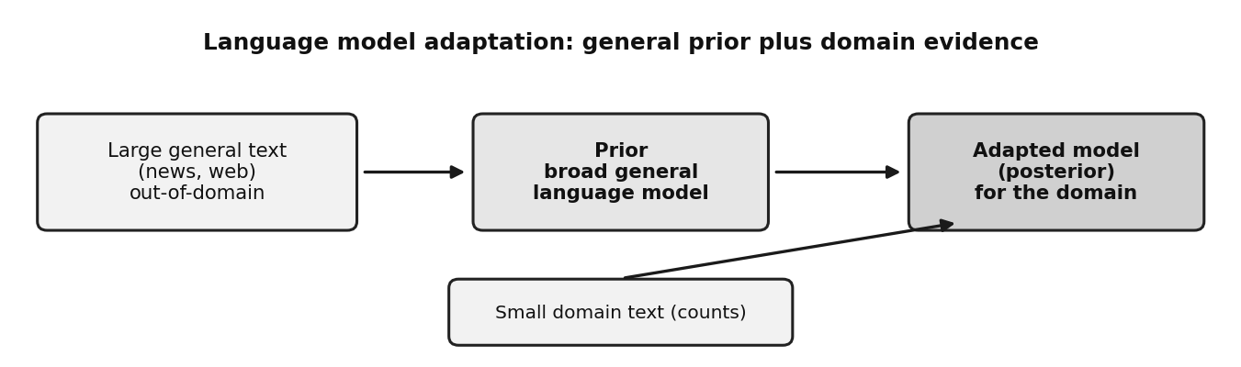
Figure 21: Adaptation combines a general prior with domain evidence.

Q15. Explain class-based, variable-length, and Bayesian topic-based language models. Discuss their advantages over conventional N-Gram models.
A conventional n-gram model uses a fixed history and treats every word as a separate symbol. It suffers from data sparsity, a rigid history length and no knowledge of the document topic. Three advanced models address these problems.
Class based models group words into classes such as days, cities and numbers. They predict P(wi given wi-1) as P(wi given ci) x P(ci given ci-1). Because Monday and Thursday share a class, a rare word borrows evidence from common ones. The model has far fewer parameters, generalizes better to unseen word pairs, and is usually interpolated with a word n-gram model. Variable length models choose the history length per context. United States of needs a long history, while he said that needs a short one. Long contexts are kept only if they change the prediction, which saves memory, captures long phrases, and falls back to a shorter history where data is scarce.
Bayesian topic based models assume that each document is a mixture of topics, such as sports and politics, with a prior on the mixture. Each word chooses a topic and is drawn from that topic's word distribution. The probability of the next word is a sum over topics, combined with the n-gram probability. As more of the document is seen, the model expects the right vocabulary, so it captures long range topical context that n-grams cannot. These ideas go beyond the slides in detail and follow the standard textbook outline.
Summary of advantages over a plain n-gram: class based models reduce sparsity and model size, variable length models use history where it helps and ignore it where it does not, and topic based models add document level context. In practice they are interpolated with the standard n-gram model, because each captures something the others miss, and the combination usually gives lower perplexity.
Model | Problem of n-gram it solves | Key idea
Class based | Data sparsity, huge parameter count | Predict class, then word
Variable length | Fixed history, memory waste | History length chosen per context
Bayesian topic based | No long range context | Document is a mixture of topics

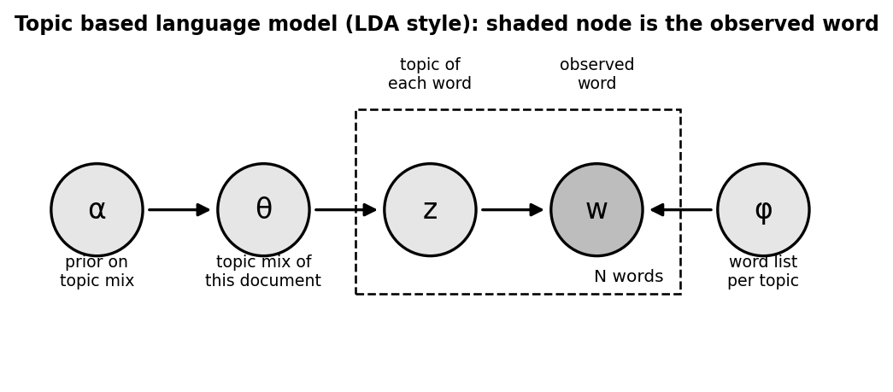
Figure 22: Bayesian topic model: a prior gives the topic mixture, each word picks a topic and is drawn from it.

