PREDICTIVE ANALYSIS
Exam pattern shared by the lecturer
Unit | Topics | Expected questions
Unit 3 | Logistic regression, KNN, Bayesian method | Two 5 mark and two 2 mark
Unit 4 | Model ensembles, bagging, boosting, random forest, stochastic gradient boosting, heterogeneous ensembles | Gradient boosting numerical (5 marks), one 5 mark theory on bagging or a boosting method, two 2 mark
Unit 5 | Survey analysis, question answering and challenges in text mining, persuasion by the numbers | Two 5 mark scenario based, two 2 mark direct

Things to confirm before the exam
1. Unit 3, lecture Question 1 (β₀ = 1, β₁ = 8, x = 60): the slide says p ≈ 0.44, but the numbers give p ≈ 1.000. See Question 3.2.
2. Unit 3 slides contain no KNN numerical and no Bayesian content. Questions 3.3 to 3.6 are supplementary. The lecturer said they would share more.
3. Unit 4 AdaBoost: the slides round the weights (0.12 and 0.553). Exact values are 0.125 and 0.5. See Question 4.7.
4. Unit 4 slide claims about ChatGPT, DALL-E and Midjourney using ensembles, and the Unit 5 tweet study, could not be verified. Avoid stating them as facts.

Contents
Unit 3: Logistic Regression, KNN and the Bayesian Method
Question 3.1: What is logistic regression? Explain the sigmoid function, odds, log-odds and the threshold.
Question 3.2: Numerical problems on logistic regression (lecture examples).
Question 3.3: Explain KNN classification and how to choose the value of k.
Question 3.4: KNN worked with full distance calculations.
Question 3.5: Explain Bayes' theorem and the Bayesian (Naive Bayes) classifier.
Question 3.6: Naive Bayes numerical example with Laplace smoothing.
Quick revision for Unit 3: likely 2 mark questions
Unit 4: Model Ensembles
Question 4.1: What is an ensemble model? Explain the motivation and the wisdom of crowds principle.
Question 4.2: Explain bagging (bootstrap aggregating).
Question 4.3: Explain the Random Forest algorithm.
Question 4.4: Explain boosting and how it differs from bagging.
Question 4.5: Explain gradient boosting for regression and classification.
Question 4.6: Numerical example of gradient boosting using two or more decision trees.
Question 4.7: Explain the AdaBoost algorithm with a numerical example.
Question 4.8: Explain XGBoost and the reasons it is fast and accurate.
Question 4.9: Numerical example of XGBoost (gradient, Hessian, gain and leaf weights).
Question 4.10: Compare LightGBM and XGBoost.
Question 4.11: Explain stochastic gradient boosting.
Question 4.12: Differentiate homogeneous and heterogeneous ensembles. Explain stacking.
Quick revision for Unit 4: likely 2 mark questions
Unit 5: Case Studies in Text Mining
Question 5.1: Explain survey analysis using machine learning. Describe its five techniques.
Question 5.2: Scenario: how can a telecom company improve customer experience by analysing survey feedback with ML?
Question 5.3: What is question answering in predictive analytics? Explain its challenges in text mining.
Question 5.4: Explain 'Persuasion by the numbers': how can text mining measure persuasion?
Quick revision for Unit 5: likely 2 mark questions

Unit 3: Logistic Regression, KNN and the Bayesian Method
This unit is about classification: predicting a category such as Yes or No, Pass or Fail, Spam or Not spam. Logistic regression turns a straight line into a probability. KNN lets the nearest examples vote. The Bayesian method uses probability rules to update a belief when new evidence arrives. Expected in the exam: two 5 mark questions and two 2 mark questions.
Topic | One line idea | Key terms
Logistic regression | Predicts the probability of a Yes/No class using an S-shaped curve | sigmoid, odds, log-odds, threshold
KNN classification | A new point takes the majority class of its k nearest neighbours | distance, k, feature scaling
Bayesian method | Starts with a prior belief and updates it using evidence to get a posterior | prior, likelihood, posterior, Naive Bayes

Source status. Logistic regression (theory and two worked examples) is in the lecturer's slides. For KNN the slides only give the rule for choosing k and a video link, and the Bayesian method is not in the uploaded slide file. Those parts are supplementary, written from standard textbook knowledge, and are marked as such. If the lecturer shares more slides, check these answers against them.

Question 3.1: What is logistic regression? Explain the sigmoid function, odds, log-odds and the threshold. (5 marks)
Simple idea. Linear regression draws a straight line and can give any number, such as 120 or -35. When the answer must be a category like Yes or No, a number outside 0 to 1 makes no sense. Logistic regression fixes this by bending the line into an S shape, so the output is always a probability between 0 and 1.
Definition. Logistic regression is a supervised classification algorithm used when the dependent variable (the thing we predict) is categorical, most often binary. The lecture examples are: is a mail spam or not spam, should a student be admitted or not based on entrance marks, and will a student pass or fail based on marks. The model first predicts the probability of the event, and then a threshold turns that probability into a class.

Step 1: from a straight line to odds
A straight line is y = β₀ + β₁x, where β₀ is the intercept (value of y when x is zero) and β₁ is the slope (change in y for one unit of x). Probability P cannot be modelled directly by this line because it must stay between 0 and 1. So we first convert it to odds, which compare the chance that the event happens with the chance that it does not.
Odds O = P / (1 - P)
For example, if P = 0.8, then O = 0.8 / 0.2 = 4. This is read as 4 to 1 in favour. Odds can take any value from 0 to infinity. Probability lies between 0 and 1.

Step 2: log-odds and the sigmoid
Taking the natural logarithm of the odds gives the log-odds, also called the logit. The log-odds can be any real number, so it can safely be set equal to the straight line. This is the logit transformation in the lecture.
ln( P(x) / (1 - P(x)) ) = β₀ + β₁x = z
Now solve for P. Raise e to both sides: P/(1 - P) = e^{z}. Multiply out: P = e^{z}(1 - P), so P(1 + e^{z}) = e^{z}. Therefore P = e^{z}/(1 + e^{z}), and dividing top and bottom by e^{z} gives the sigmoid (logistic) function:
P(x) = 1 / (1 + e^{-(β_{0} + β₁x)})
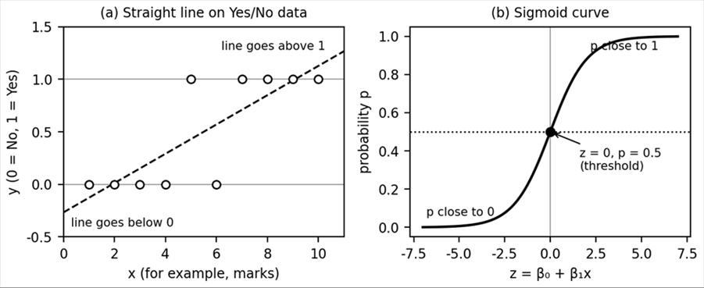
Figure 1. (a) A straight line fitted to Yes/No data leaves the 0 to 1 range. (b) The sigmoid curve stays between 0 and 1. Both panels are illustrative, not real data.

Step 3: the threshold
A probability is still not a class. The threshold is a cut-off value, usually 0.5. If P is at least 0.5 we predict Yes, otherwise No. Because the sigmoid gives 0.5 exactly when z = 0, the decision boundary is the point where β₀ + β₁x = 0. The lecture table shows this: probabilities 0.85 and 0.70 give Promotion Yes, while 0.40 and 0.15 give Promotion No. The threshold can be moved. A hospital that wants to miss no sick patient may use 0.3 instead.
z (log-odds) | e^{-z} | P = 1/(1+e^{-z}) | Class at threshold 0.5
-4 | 54.598 | 0.018 | No
-2 | 7.389 | 0.119 | No
0 | 1.000 | 0.500 | Boundary
2 | 0.135 | 0.881 | Yes
4 | 0.018 | 0.982 | Yes

Point | Linear regression | Logistic regression
Output | Any real number (numerical response) | Probability from 0 to 1, then a class
Used for | Predicting amounts, such as salary increase | Classification, such as promotion Yes or No
Shape | Straight line | S-curve (sigmoid)
Model | y = β₀ + β₁x | ln(P/(1-P)) = β₀ + β₁x
Supplementary: how are β₀ and β₁ found? They are learned from training data by maximum likelihood, which means choosing the values that make the observed labels most probable. This is done by minimising the log-loss J = -(1/n) Σ [ y ln p + (1 - y) ln(1 - p) ] with gradient descent, using the update β_{j} ← β_{j} - α (1/n) Σ (p_{i} - y_{i}) x_{ij}, where α is the learning rate. In the lecture examples the values of β₀ and β₁ are simply given.
Takeaway. Logistic regression predicts the probability of an event with a sigmoid curve and then applies a threshold to get a Yes/No class. Use it for binary classification when you also want a probability, not only a label.

Question 3.2: Numerical problems on logistic regression (lecture examples). (5 marks)
Simple idea. Every logistic regression numerical has the same two moves. First compute the straight line value z = β₀ + β₁x. Then push z through the sigmoid to get the probability, and compare it with the threshold. If the question runs backwards (give the probability, find x), first turn the probability back into z using z = ln(p/(1-p)).

Part A: entrance marks (lecture Question 1)
Given: β₀ = 1, β₁ = 8, marks x = 60. Compute the probability and the class.
1. Write the model: p(x) = 1 / (1 + e^{-(β_{0} + β₁x)}).
2. Substitute: z = β₀ + β₁x = 1 + (8 × 60) = 1 + 480 = 481.
3. Probability: p = 1 / (1 + e⁻⁴⁸¹). The number e⁻⁴⁸¹ is about 1.3 × 10⁻²⁰⁹, which is almost zero, so p is essentially 1.000.
4. Classify with threshold 0.5: since p is far above 0.5, the candidate with 60 marks is selected.
Check with your lecturer. The slide prints p ≈ 0.44 and concludes 'not selected'. That does not follow from the numbers given. A value of 0.44 would need z ≈ -0.24, but z = 481 here. The slide value is most likely a typing or copying error in the slide (the true parameters may differ). In the exam, show the method clearly, state your computed value, and ask the lecturer which result they expect.

Part B: pass or fail dataset (lecture Question 2)
Student | Hours studied (x) | Result (y)
1 | 29 | 0 (fail)
2 | 15 | 0 (fail)
3 | 33 | 1 (pass)
4 | 28 | 1 (pass)
5 | 39 | 1 (pass)
The lecture assumes the optimiser gave the model log(odds) = z = -64 + 2 × hours, because the fitted values were not supplied. Use the sigmoid g(z) = 1/(1 + e^{-z}).
(1) Probability of passing for 33 hours. z = -64 + 2 × 33 = -64 + 66 = 2. Then p = 1/(1 + e⁻²) = 1/(1 + 0.1353) = 1/1.1353 = 0.8808, so there is an 88% chance of passing. In odds form, the odds of passing are e² = 7.389 to 1.
(2) Minimum hours for a pass probability above 95%. Set 1/(1 + e^{-z}) = 0.95. Then 1 + e^{-z} = 1/0.95 = 1.0526, so e^{-z} = 0.0526 (exactly 0.05/0.95 = 1/19). Taking natural logs, -z = ln(0.0526) = -2.944, so z = 2.944. The lecture notes that the variable x in the sigmoid and z are the same quantity here. Now solve the line: 2.944 = -64 + 2h, so 2h = 66.944 and h = 33.47 hours. A student must study at least about 33.47 hours.
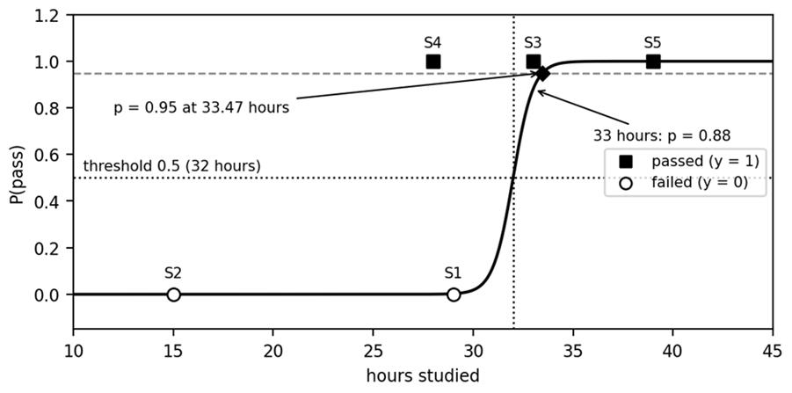
Figure 2. The assumed model from the slide, log(odds) = -64 + 2 × hours, with the five students. The probability crosses 0.5 at 32 hours and reaches 0.95 at 33.47 hours.

Checking the model on all five students
Student | Hours | z = -64 + 2h | p (pass) | Predicted | Actual | Log-loss term
1 | 29 | -6 | 0.0025 | 0 | 0 | 0.0025
2 | 15 | -34 | 0.0000 | 0 | 0 | 0.0000
3 | 33 | 2 | 0.8808 | 1 | 1 | 0.1269
4 | 28 | -8 | 0.0003 | 0 | 1 | 8.0003
5 | 39 | 14 | 1.0000 | 1 | 1 | 0.0000

Four of five students are classified correctly (80% accuracy). Student 4 studied 28 hours and passed, but the model predicts fail with p = 0.0003, which gives a large log-loss term of 8.0003. The total log-loss is 8.13 and the average is 1.626. This is why the assumed model is only illustrative: a real optimiser would adjust β₀ and β₁ to reduce this loss. The decision boundary is where z = 0, that is 32 hours, and each extra hour multiplies the odds by e² = 7.389.
Takeaway. Compute z, apply the sigmoid, compare with 0.5. For reverse questions use z = ln(p/(1-p)) and solve the line for x.

Question 3.3: Explain KNN classification and how to choose the value of k. (5 marks)
Supplementary. The slides give only the rules for choosing k (and a video for the numerical). The algorithm, distances and the pros and cons below are standard textbook content.
Simple idea. KNN (k-nearest neighbours) works like asking your neighbours for advice. To decide what a new point is, look at the k points in the training data that are closest to it and let them vote. If most of them are Pass, the new point is classified as Pass.
Technical description. KNN is a supervised, distance based classifier. It is called a lazy learner or instance based learner because it does no training. It simply stores the data and does all the work when a new query arrives. It makes no assumption about the shape of the data, so it is also called non-parametric.

Algorithm
1. Choose k, the number of neighbours.
2. Compute the distance from the new point to every training point.
3. Sort the distances and pick the k smallest.
4. Classification: take the majority class among those k. Regression: take the average of their target values.
Euclidean distance d(p, q) = √( (p₁ - q₁)² + (p₂ - q₂)² + ... + (p_{n} - q_{n})² )
Manhattan distance d(p, q) = |p₁ - q₁| + |p₂ - q₂| + ... + |p_{n} - q_{n}|

How to choose k (from the lecture)
The lecture states: small k gives low bias and high variance, large k gives high bias and low variance. With k = 1 the boundary follows every noisy point, so the model overfits. With a very large k the vote is dominated by the majority class and the model underfits. Two methods are given.
• Method 1, square root method: k = √(number of data points in the training set). Choose k as an odd number to avoid ties in a two-class vote. For example, with 100 training points, √100 = 10, so use 9 or 11.
• Method 2, trial and error: try several values of k, evaluate each on validation data, and pick the k with the best performance.

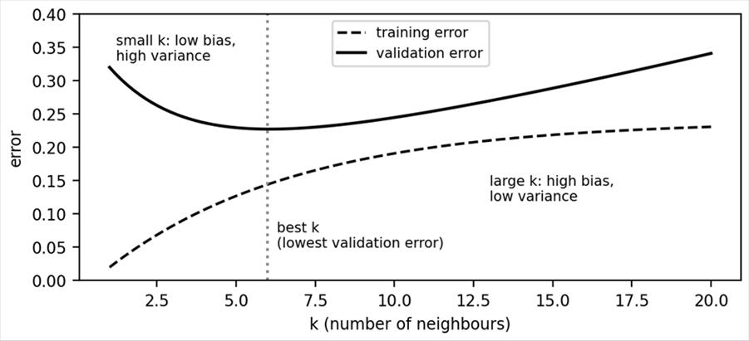
Figure 3. Effect of k on error. The curves are illustrative and only show the typical shape, not measured values.
Feature scaling. Distance treats every feature equally, so a feature with large numbers (attendance in percent) can swamp a feature with small numbers (hours). Rescale features first, for example with min-max scaling x' = (x - min)/(max - min). Question 3.4 shows this effect with numbers.
Advantages | Disadvantages
Very simple, no training step | Slow prediction on large data, since every distance is computed
Works for classification and regression | Sensitive to feature scale and irrelevant features
Naturally handles complex boundaries | Performance falls in very high dimensions

Takeaway. KNN classifies a new point by the vote of its k closest training points. Choose k odd, near √n, and confirm it on validation data. Always scale the features.

Question 3.4: KNN worked example with full distance calculations. (5 marks)
Supplementary. The slides refer to a video for the KNN numerical, so this dataset is made up to teach the method. The calculations have been rechecked.
Simple idea. Measure how far the new student is from every old student, list the closest ones, and let them vote. Below, seven past students are labelled Pass or Fail using study hours and attendance. A new student Q studies 5 hours with 70% attendance. Will Q pass?
Student | Hours | Attendance % | Result
A | 2 | 50 | Fail
B | 3 | 60 | Fail
C | 5 | 65 | Fail
D | 6 | 80 | Pass
E | 8 | 85 | Pass
F | 9 | 90 | Pass
G | 7 | 70 | Pass

Step 1: Euclidean distance from Q = (5, 70)
Student | Calculation | Distance | Rank
A | √((2-5)² + (50-70)²) = √(9 + 400) = √409 | 20.22 | 6
B | √((3-5)² + (60-70)²) = √(4 + 100) = √104 | 10.20 | 4
C | √((5-5)² + (65-70)²) = √(0 + 25) = √25 | 5.00 | 2
D | √((6-5)² + (80-70)²) = √(1 + 100) = √101 | 10.05 | 3
E | √((8-5)² + (85-70)²) = √(9 + 225) = √234 | 15.30 | 5
F | √((9-5)² + (90-70)²) = √(16 + 400) = √416 | 20.40 | 7
G | √((7-5)² + (70-70)²) = √(4 + 0) = √4 | 2.00 | 1

Step 2: vote for different k
k | Nearest neighbours (in order) | Votes | Class of Q
1 | G | Pass 1, Fail 0 | Pass
3 | G, C, D | Pass 2, Fail 1 | Pass
5 | G, C, D, B, E | Pass 3, Fail 2 | Pass
7 | all seven | Pass 4, Fail 3 | Pass

Using the square root rule, √7 = 2.65, so the nearest odd value is k = 3. The three nearest are G (Pass), C (Fail) and D (Pass). Pass wins by 2 to 1, so Q is classified as Pass. Every k in the table gives the same answer, which gives more confidence in the result.
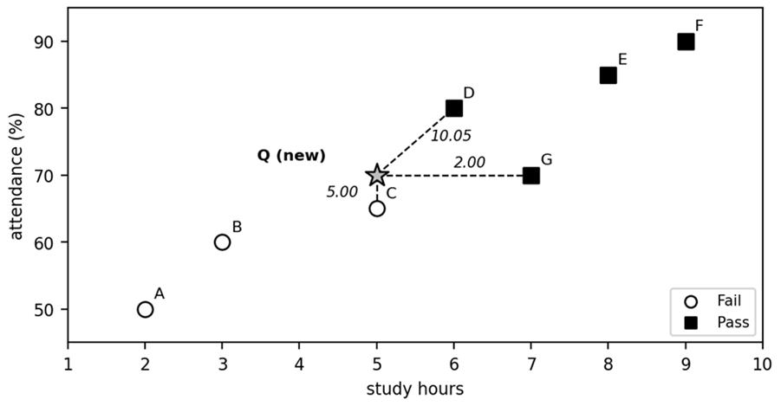
Figure 4. The seven training students and the new point Q. Dashed lines connect Q to its three nearest neighbours, with the distances. The two axes use different units, so distances on paper look distorted.
Reading the result. The vote works because the three closest students are the ones most similar to Q in both hours and attendance. If two classes tie, which is why k should be odd for two classes, the vote cannot be settled, and a common fix is to give closer neighbours more weight, for example weight = 1/distance². Here G, at distance 2.00, would then count far more than D at 10.05. Also note that KNN needs no training: all seven rows are simply kept in memory, and the whole computation above happens only when Q arrives. This is why prediction is slow for large datasets, since every distance must be computed again for every new query.

Step 3: the effect of feature scaling
Attendance ranges over 40 units (50 to 90) while hours range over only 7 units (2 to 9), so attendance dominates the raw distances. Apply min-max scaling: scaled hours = (h - 2)/7 and scaled attendance = (a - 50)/40. Then Q becomes (0.4286, 0.5).
Student | Scaled hours | Scaled attendance | Distance to Q | Result
C | 0.4286 | 0.375 | 0.1250 | Fail
G | 0.7143 | 0.500 | 0.2857 | Pass
D | 0.5714 | 0.750 | 0.2879 | Pass
B | 0.1429 | 0.250 | 0.3796 | Fail
E | 0.8571 | 0.875 | 0.5695 | Pass
A | 0.0000 | 0.000 | 0.6585 | Fail
F | 1.0000 | 1.000 | 0.7593 | Pass

After scaling, the nearest neighbour becomes C (Fail), so k = 1 now predicts Fail, while k = 3 (C, G, D) still gives Pass 2 to 1. The scaled result is more trustworthy because both features now count fairly. Takeaway: compute all distances, rank them, vote among the k nearest, and scale the features before measuring distance.

Question 3.5: Explain Bayes' theorem and the Bayesian (Naive Bayes) classifier. (5 marks)
Supplementary. The Bayesian method is not in the uploaded Unit 3 slides. This answer follows standard textbook treatment, using Naive Bayes as the Bayesian classification method.
Simple idea. Bayes' theorem is a rule for updating a belief when new evidence arrives. You start with an initial belief (it rarely rains here), then see evidence (the road is wet), and update to a new belief (rain is now more likely). The more reliable the evidence, the bigger the update.
Technical terms. The belief before evidence is the prior P(H). How likely the evidence is if the hypothesis is true is the likelihood P(E|H). The updated belief is the posterior P(H|E). The total probability of seeing the evidence is the evidence P(E), which scales the result so that probabilities add up to 1.
P(H | E) = P(E | H) × P(H) / P(E)
where P(E) = P(E | H) P(H) + P(E | not H) P(not H)

Worked example: a screening test
A disease affects 1% of people. A test detects it 90% of the time when the person is sick (sensitivity) and wrongly says positive for 5% of healthy people (false positive rate). If a person tests positive, what is the chance they are sick? P(sick) = 0.01, P(positive | sick) = 0.90, P(positive | healthy) = 0.05. Then P(positive) = 0.90 × 0.01 + 0.05 × 0.99 = 0.009 + 0.0495 = 0.0585. So P(sick | positive) = 0.009 / 0.0585 = 0.1538, about 15.4%. Most positives are false alarms because healthy people are so much more common. This is the base rate effect.
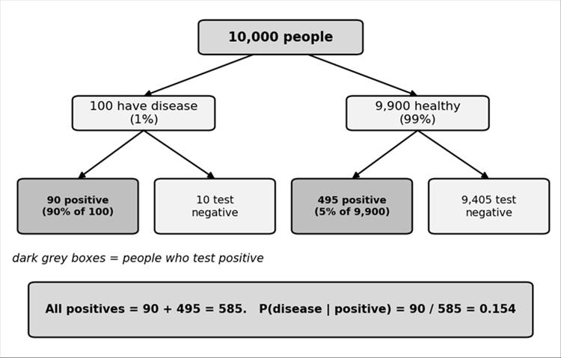
Figure 5. Natural frequency view of the screening example with 10,000 people. Of 585 positive tests, only 90 are truly sick.

From Bayes' theorem to a classifier
To classify a sample x, compute the posterior for each class C and choose the largest. This is the maximum a posteriori (MAP) rule. The denominator P(x) is the same for every class, so only the numerator matters:
predicted class = argmax over C of P(C) × P(x | C)
Estimating P(x | C) for many features together needs huge amounts of data. The Naive Bayes classifier simplifies this with a naive assumption: features are independent of each other once the class is known. Then P(x | C) = P(x₁|C) × P(x₂|C) × ... × P(x_{n}|C). The assumption is rarely perfectly true, but the classifier often works well, especially for text such as spam filtering.
Zero frequency problem and Laplace smoothing. If a feature value never appears with a class in training, its probability is 0 and wipes out the whole product. Laplace smoothing adds 1 to each count: P(x_{j} = v | C) = (count + 1) / (N_{C} + number of distinct values of that feature).
Advantages | Limitations
Fast to train and predict, even with many features | Independence assumption is often unrealistic
Works well with small data and text | Zero counts need smoothing
Gives probabilities, easy to explain | Probability estimates can be poorly calibrated

Takeaway. Bayes' theorem turns prior belief plus evidence into a posterior. Naive Bayes applies it to classification by multiplying the prior with the per-feature likelihoods and choosing the class with the highest score.

Question 3.6: Naive Bayes numerical example with Laplace smoothing. (5 marks)
Supplementary. The dataset is the six-row Job Profile table from the Unit 4 AdaBoost slides, reused here so you can practise Naive Bayes on data you already have. The Naive Bayes calculation itself is not from the slides.
Simple idea. For each class, start with how common the class is, then multiply by how typical each feature value is for that class. The class with the larger product wins. Predict whether a student with the profile below gets a job.
No. | CGPA | Interactiveness | Practical knowledge | Communication | Job profile
1 | ≥ 9 | Yes | Good | Good | Yes
2 | < 9 | No | Good | Moderate | Yes
3 | ≥ 9 | No | Average | Moderate | No
4 | < 9 | No | Average | Good | No
5 | ≥ 9 | Yes | Good | Moderate | Yes
6 | ≥ 9 | Yes | Good | Moderate | Yes

New student x: CGPA ≥ 9, Interactiveness = Yes, Practical knowledge = Good, Communication = Moderate.

Step 1: priors
There are 6 rows, 4 with Job = Yes and 2 with Job = No. So P(Yes) = 4/6 = 0.6667 and P(No) = 2/6 = 0.3333.

Step 2: likelihoods from counts
Feature value | P(. | Yes), 4 rows | P(. | No), 2 rows
CGPA ≥ 9 | 3/4 | 1/2
Interactiveness = Yes | 3/4 | 0/2
Practical knowledge = Good | 4/4 | 0/2
Communication = Moderate | 3/4 | 1/2

Step 3: scores without smoothing
Yes: 0.6667 × (3/4 × 3/4 × 4/4 × 3/4) = 0.6667 × 0.4219 = 0.2813. No: 0.3333 × (1/2 × 0 × 0 × 1/2) = 0. The class No gets exactly zero only because two combinations never occurred in the small No group. This is the zero frequency problem, so we smooth.

Step 4: Laplace smoothing
Each feature has 2 possible values here, so add 1 to every count and 2 to every denominator. For class Yes (4 rows) the denominator becomes 6, and for class No (2 rows) it becomes 4.
Feature value | Smoothed P(. | Yes) | Smoothed P(. | No)
CGPA ≥ 9 | (3+1)/(4+2) = 4/6 | (1+1)/(2+2) = 2/4
Interactiveness = Yes | (3+1)/(4+2) = 4/6 | (0+1)/(2+2) = 1/4
Practical knowledge = Good | (4+1)/(4+2) = 5/6 | (0+1)/(2+2) = 1/4
Communication = Moderate | (3+1)/(4+2) = 4/6 | (1+1)/(2+2) = 2/4

Yes: 4/6 × 4/6 × 5/6 × 4/6 = 0.2469. Score = 0.6667 × 0.2469 = 0.1646. No: 2/4 × 1/4 × 1/4 × 2/4 = 0.015625. Score = 0.3333 × 0.015625 = 0.0052.

Step 5: decide and normalise
The scores are not probabilities yet. Divide each by their sum 0.1646 + 0.0052 = 0.1698. P(Yes | x) = 0.1646 / 0.1698 = 0.969 and P(No | x) = 0.0052 / 0.1698 = 0.031. Since 0.969 > 0.031, the predicted class is Job profile = Yes.
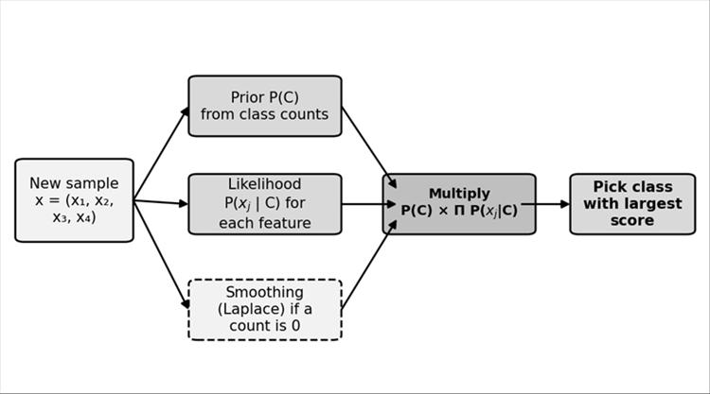
Figure 6. Flow of a Naive Bayes prediction: priors and likelihoods are multiplied, and the class with the largest score is chosen.
Reading the result. The posterior of 0.969 means that, given this profile, the model is about 97% sure the student gets the job. This is high partly because Naive Bayes multiplies four pieces of evidence that all point toward Yes, and it treats them as independent even though a high CGPA and good practical knowledge are probably related. With only six training rows the estimates are rough, and smoothing makes them less extreme than the raw counts (the raw count gave Yes a probability of exactly 1). For the exam, remember the order of work: priors, counts, smoothing if needed, multiply, then normalise only if the question asks for probabilities. If it only asks for the class, comparing the two unnormalised scores is enough.
Takeaway. Write priors, write per-feature likelihoods, apply Laplace smoothing if any count is zero, multiply, and choose the larger score.

Quick revision for Unit 3: likely 2 mark questions
Likely question | Short answer
Why not use linear regression for classification? | It can output values below 0 or above 1 and is built for numerical responses, not categories.
Define the sigmoid function. | g(z) = 1/(1 + e^{-z}). It maps any real number to a value between 0 and 1.
What are odds? | Odds = P/(1 - P), the chance an event happens divided by the chance it does not. Range 0 to infinity.
What is the logit? | The natural log of the odds, ln(P/(1-P)). Logistic regression sets it equal to β₀ + β₁x.
What is the threshold in logistic regression? | A cut-off, usually 0.5. A probability at or above it gives class Yes, below it gives No.
What is KNN? | A lazy, distance based classifier that gives a new point the majority class of its k nearest training points.
Write the Euclidean distance formula. | d = √( Σ (p_{i} - q_{i})² ).
How is k chosen? | Square root of the number of training points, made odd, or trial and error on validation data.
Effect of small and large k? | Small k: low bias, high variance. Large k: high bias, low variance.
State Bayes' theorem. | P(H|E) = P(E|H) P(H) / P(E).
What is the naive assumption? | Features are independent of each other given the class.
Why use Laplace smoothing? | It adds 1 to counts so a zero count does not make the whole probability product zero.

Unit 4: Model Ensembles
An ensemble combines the predictions of many models so that the group is more accurate and more stable than any single model. This unit covers why ensembles work (wisdom of crowds), bagging and random forests, boosting (gradient boosting, AdaBoost, XGBoost, LightGBM), stochastic gradient boosting and heterogeneous ensembles. Expected in the exam: one 5 mark gradient boosting numerical, one 5 mark theory question on bagging or a boosting method, and two 2 mark questions.
Topic | One line idea | Key terms
Motivation, wisdom of crowds | Many reasonably accurate models with different errors beat one model | bias, variance, majority vote
Bagging and random forest | Train models in parallel on bootstrap samples and average or vote | bootstrap, out-of-bag, feature sampling
Boosting | Train models one after another, each fixing earlier mistakes | weak learner, residual, learning rate
Gradient boosting, AdaBoost | Fit residuals (gradient boosting) or reweight samples (AdaBoost) | stump, alpha, eta, n_estimators
XGBoost, LightGBM | Fast, regularised boosting; level-wise versus leaf-wise growth | gradient, Hessian, gain, lambda
Stochastic gradient boosting | Each tree sees only a random subset of rows | subsample
Homogeneous and heterogeneous ensembles | Same type versus different types of base models, stacking | meta-learner, stacking

Source status. All topics are in the lecturer's Unit 4 PDF. Where the PDF is short (bagging mathematics, LightGBM details, stacking numbers) the extra content is marked supplementary.

Question 4.1: What is an ensemble model? Explain the motivation and the wisdom of crowds principle. (5 marks)
Simple idea. Ask one friend to guess the number of beans in a jar and the guess may be far off. Ask 100 friends and average their guesses, and the result is usually close. Each guess has errors, but the errors point in different directions and cancel. An ensemble applies the same idea to machine learning.
Definition. An ensemble model combines the predictions of several learned models (the base models or weak learners, such as KNN, decision trees, linear regression or SVM) to produce one final prediction. A group of reasonably accurate models can outperform any single model when their errors are not perfectly correlated, that is, when they do not all make the same mistakes. The wisdom of the crowd principle says the same thing: combining the opinions of many individuals often gives a better decision than relying on one.
Two terms to know. Bias is error from wrong assumptions in the model (the model is too simple). Variance is error from sensitivity to the training data, such as outliers (the model changes a lot when data changes). Ensembles reduce bias, variance, or both, and help prevent overfitting, which means memorising training noise.

Why use ensembles? (the five motivations)
Motivation | Meaning | Example from the lecture
Better predictions | Several models give more correct answers than one | Three models vote on spam: Spam, Spam, Not spam. Majority vote gives Spam.
Less variance and overfitting | Averaging smooths out noise that one model memorised | One decision tree fits training emails perfectly but fails on new ones; a random forest of many trees fixes this.
Errors compensate | If one model is wrong, the others can outvote it | Three diagnosis models: one is wrong, two are right, so the majority is correct.
Robustness and generalisation | Less affected by noise and small input changes, and good on unseen data | Digit recognition from several models works better on unfamiliar handwriting.
Different patterns combined | Different algorithms learn different things from the same data | Decision tree finds rules, logistic regression finds probability links, a neural network finds non-linear patterns.

The mathematics behind the crowd
Suppose three independent classifiers are each correct with probability 0.7. The majority vote is correct if at least two of them are correct. The probability is 3 × (0.7)² × 0.3 + (0.7)³ = 0.441 + 0.343 = 0.784. So three 70% models give a 78.4% ensemble. With more independent models the accuracy keeps rising, as the figure shows.
P(majority correct) = Σ over k > B/2 of C(B, k) p^{k} (1 - p)^{B-k}
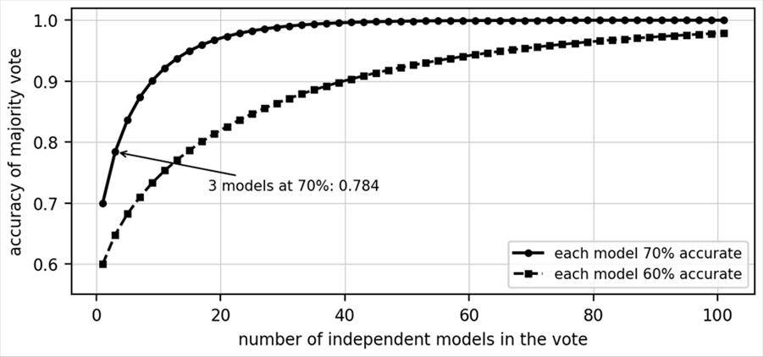
Figure 7. Accuracy of a majority vote of B independent classifiers, computed from the binomial formula for p = 0.7 and p = 0.6.
Important caution. This calculation assumes the models make independent errors. Real models trained on the same data are correlated, so the real gain is smaller. That is why bagging, random forests and stacking deliberately make the models different. Also, the slide says tools like ChatGPT, DALL-E and Midjourney use ensemble methods behind the scenes. This is not something that can be confirmed from public documentation, so do not write it as a fact; say instead that ensemble ideas are widely used in industry.
Advantages of ensembles | Disadvantages of ensembles
Higher accuracy than a single model | Higher computation and memory cost
Reduces overfitting by averaging | Harder to interpret, especially with many models
Works well for complex problems | Needs careful tuning of parameters
Takeaway. Use an ensemble when one model is not accurate or stable enough and you can afford extra computation. The key requirement is that the base models are accurate and make different errors.

Question 4.2: Explain bagging (bootstrap aggregating). (5 marks)
Simple idea. Imagine five students each study a different random selection of pages from the textbook, then answer an exam question together by vote. Each student knows slightly different things, so their combined answer is steadier than any one student's. Bagging does this with models.
Definition. Bagging (Bootstrap Aggregating) trains many models on different random subsets of the training data, each sampled with replacement (a row can be picked more than once), and then combines their outputs. Each random subset is a bootstrap sample of the same size as the original data. The models are independent of each other, so they can be trained in parallel. The final prediction is the majority vote for classification or the average for regression.

Steps
1. From the dataset D of n rows, draw m bootstrap samples D₁, D₂, ..., D_{m} by row sampling with replacement.
2. Train one model M_{i} on each sample D_{i}. The base model is usually a model with low bias and high variance, such as a fully grown decision tree.
3. For a new input, collect the prediction of every model.
4. Classification: majority vote. Regression: mean of all outputs.

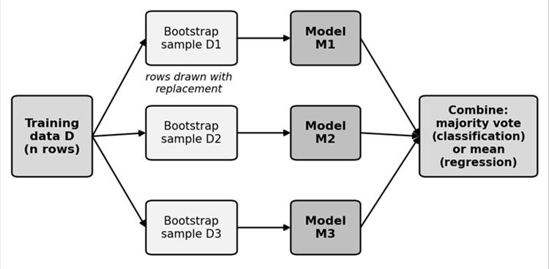
Figure 8. Bagging: bootstrap samples are drawn from the training data, one model is trained on each, and the outputs are combined by voting or averaging.

Why bagging works
The lecture explains it through bias and variance. A fully grown decision tree has low bias (it fits the training data well) but high variance (it overfits and changes a lot with new data). Voting over many such trees turns the high variance into low variance, so bagging converts low bias, high variance into low bias, low variance (randomisation plus aggregation). The number of models is a hyperparameter to tune. The lecture adds that changing even 200 of 1000 samples hardly changes the output, because the majority vote absorbs the change.
Mathematics (supplementary). If B models each have variance σ² and are independent, the average has variance σ²/B. If they have pairwise correlation ρ, the variance of the average is ρσ² + (1 - ρ)σ²/B. For ρ = 0.3 and B = 100 this is 0.3σ² + 0.007σ² = 0.307σ². Averaging helps most when the models are less correlated, which is the reason random forests add feature sampling.
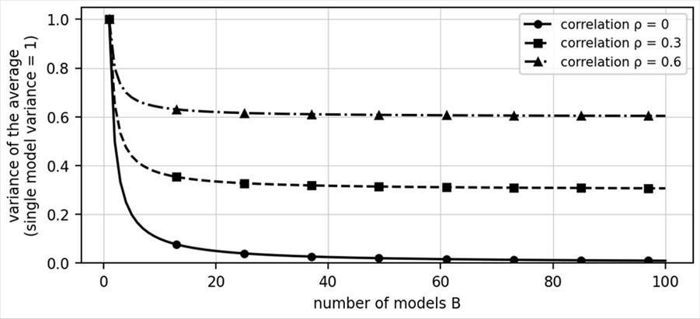
Figure 9. Variance of the average of B models, computed from ρσ² + (1 - ρ)σ²/B with σ² = 1. Higher correlation leaves a higher floor.

Worked examples
Bootstrap sample. Take 6 rows numbered 1 to 6. One possible draw with replacement is {2, 2, 4, 5, 5, 6}. Only rows 2, 4, 5 and 6 appear, so rows 1 and 3 are left out. Those left-out rows are called out-of-bag (OOB) rows and can be used to test that model. For a large dataset, the chance a given row is never picked is (1 - 1/n)^{n}, which tends to 1/e = 0.368. So each bootstrap sample holds about 63.2% of the distinct rows, and about 36.8% are OOB.
Classification vote. Five trees predict Spam, Spam, Not spam, Spam, Not spam. Spam gets 3 votes and Not spam gets 2, so the bagged prediction is Spam. Regression. Three models predict 62, 58 and 60 marks. The bagged prediction is (62 + 58 + 60)/3 = 60.

Feature | Bagging
Training order | Parallel, models independent
Sampling | Rows with replacement
Combining | Equal vote or plain average
Main effect | Reduces variance, little change in bias
Typical example | Random forest

Takeaway. Bagging reduces the variance of unstable, low bias models by averaging many of them trained on bootstrap samples. Use it with deep decision trees on noisy data.

Question 4.3: Explain the Random Forest algorithm. (5 marks)
Simple idea. A random forest is a committee of decision trees where each tree sees a random part of the data and, at every decision point, only a random few of the questions it could ask. Because every tree is forced to think differently, the committee vote is more reliable than any one tree.
Definition. A random forest is a bagging method in which the base model is a decision tree and, besides row sampling, feature sampling is also used. It works as a classifier (majority vote) or a regressor (mean of outputs). In the lecture's bagging diagram, the model M₁ is replaced by a decision tree and both rows and features are sampled.

Algorithm
1. Draw a bootstrap sample of rows (sampling with replacement).
2. Grow a decision tree on that sample. At each node, choose the best split from only a random subset of m features out of the p available, instead of all p.
3. Grow the tree to full depth without pruning.
4. Repeat for the chosen number of trees.
5. Predict by majority vote (classification) or mean (regression).

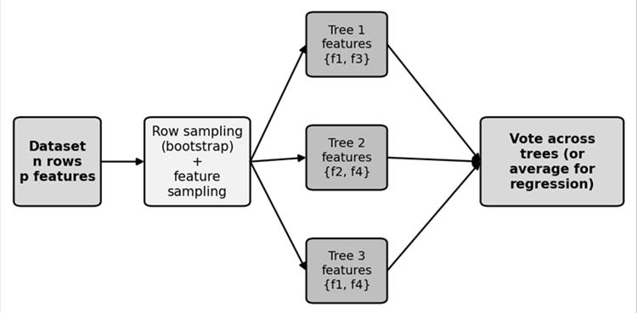
Figure 10. Random forest: each tree uses a bootstrap sample and its own random subset of features, and the trees vote.
Why it works. A single fully grown tree has low bias but high variance: it overfits the training set and makes large errors on new data. Averaging many trees brings the variance down, so the forest is low bias and low variance. Feature sampling matters because, without it, every tree would pick the same strong features at the top and the trees would be highly correlated. From the variance formula ρσ² + (1 - ρ)σ²/B, lowering the correlation ρ lowers the variance of the forest.
Common settings (supplementary). A usual choice is m = √p features per split for classification and m = p/3 for regression. For p = 16 features, m = 4. The number of trees, the maximum depth and m are hyperparameters tuned on validation data. The OOB rows of each tree give a free estimate of test error, and the average drop in impurity from each feature gives a measure of feature importance.

Worked example
Five trees classify a student as Pass or Fail: Pass, Fail, Pass, Pass, Fail. The vote is 3 to 2, so the forest predicts Pass. For a regression forest, five trees predict marks 40, 44, 42, 38 and 41. The forest prediction is the mean: (40 + 44 + 42 + 38 + 41)/5 = 205/5 = 41.
Point | Bagging with trees | Random forest
Row sampling | Yes | Yes
Feature sampling at each split | No, all features considered | Yes, random subset of m features
Correlation between trees | Higher | Lower
Result | Good variance reduction | Usually better variance reduction
Takeaway. A random forest is bagged decision trees plus random feature selection at each split. It is a strong default for tabular data, needs little tuning, and is hard to overfit by adding more trees.

Question 4.4: Explain boosting and how it differs from bagging. (5 marks)
Simple idea. A student takes a practice test, finds the questions answered wrongly, and studies those topics before the next test. Repeating this makes the student steadily better. Boosting trains models in the same way: each new model focuses on the mistakes left by the previous ones.
Definition. Boosting trains models sequentially. Each new model corrects the errors of the earlier ones, which is like fine tuning. The predictions are combined as a weighted sum of all models. Boosting combines many weak learners (simple models only slightly better than guessing, such as shallow decision trees) into one strong learner. Well known algorithms are AdaBoost, Gradient Boosting, XGBoost and LightGBM.

How boosting works (from the lecture)
1. Start with models that have high bias and low variance, such as shallow trees. The first model h₀(x) predicts y with training error e₀ = y - h₀(x), which is large.
2. The next model uses the same data plus the previous error e₀ and learns to predict it. Each later model is trained on the error left by the models before it.
3. The number of models is the parameter n_estimators (for example 10, 100 or 1000).
4. The final output is the sum of all contributions, F(x) = Σ α_{m} h_{m}(x), where α is a weight. Models with lower error get a higher weight.

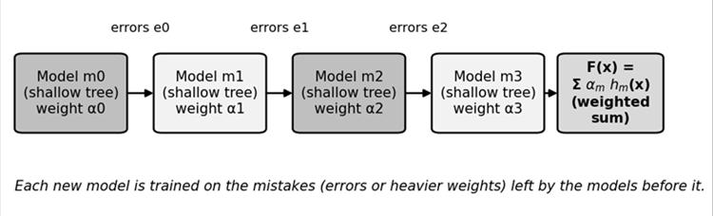
Figure 11. Boosting: shallow models are built one after another, each trained on the errors of the previous ones, and the final output is a weighted sum.
Bias and variance view. Bagging converts low bias, high variance models into low bias, low variance (randomisation plus aggregation). Boosting converts high bias, low variance models into low bias, low variance (additive combining). A shallow tree alone has high error; adding many small corrections reduces the bias step by step.
Small numerical idea. A student actually scored 40 marks. The first model predicts the average, 65. The error is 40 - 65 = -25. The next model learns this correction (for example -15 for this kind of student). With learning rate 0.1 the new prediction is 65 + 0.1 × (-15) = 63.5, closer to 40. Question 4.6 completes this idea fully.
Point | Bagging | Boosting
Training order | Parallel, independent models | Sequential, each depends on the last
Data for each model | Random bootstrap sample | Same data, focus on previous errors or weights
Combining | Equal vote or average | Weighted sum
Starts with | Low bias, high variance models | High bias, low variance models
Mainly reduces | Variance | Bias (and variance)
Risk | Little help if models are highly correlated | Sensitive to noisy data; can overfit
Examples | Random forest | AdaBoost, Gradient Boosting, XGBoost

Takeaway. Bagging averages independent strong-but-unstable models to cut variance. Boosting adds weak models one by one, each repairing the last one's mistakes, to cut bias. Choose boosting when accuracy matters most and the data is reasonably clean.

Question 4.5: Explain gradient boosting for regression and classification. (5 marks)
Simple idea. Think of throwing darts. After your first throw you see how far you missed, and the second throw aims to correct exactly that gap. The gap is the residual, the actual value minus the predicted value. Gradient boosting builds each new small model to predict the leftover gap of the models before it.
Definition. Gradient boosting is a machine learning technique for both regression and classification. It builds models sequentially, each correcting the errors of the previous ones, and combines weak learners (small decision trees) into a strong learner. Learning happens by optimising a loss function (L1 or L2 loss, MSE, RMSE and so on), that is, by minimising the loss. The lecture describes two parts: a first average-type model (with a learning rate) and trees that learn from the errors. In the lecture example each tree is small (one split).
new model = base model + learning rate × residual model
F_{m}(x) = F_{m-1}(x) + η h_{m}(x)

Algorithm
Step | Action | Explanation
1 | Start with an initial prediction F₀ | Mean of y for regression, log-odds for classification
2 | Compute residuals r = y - F | Errors between actual and predicted values
3 | Fit a new tree h on the residuals | The tree learns where the current model is wrong
4 | Update F = F + η h | Add the tree's output scaled by the learning rate η
5 | Repeat | Until the stopping rule (n_estimators or small error) is met

Why 'gradient'? (supplementary) For squared error with the loss L = ½ (y - F)², the negative gradient with respect to the prediction F is -∂L/∂F = y - F, which is exactly the residual. So fitting a tree to the residuals is the same as taking a gradient descent step, but in the space of functions instead of numbers. For other losses, such as log-loss in classification, the tree is fitted to the negative gradient (the 'pseudo-residuals'), which for log-loss equals y - p, where p is the current predicted probability.

The learning rate η
The learning rate (also called shrinkage) controls how much of each tree's correction is applied. A small η learns slowly but usually generalises better and needs more trees. The lecture shows for student A with residual -15 and starting prediction 65: with η = 1 the new prediction is 65 - 15 = 50 (a big jump), while with η = 0.1 it is 65 - 1.5 = 63.5 (a gentle step).
η | Behaviour | Notes (from the lecture)
1.0 | Very fast learning, high risk of overfitting | Rarely used
0.3 | Moderate speed | Default in XGBoost
0.1 | Balanced, commonly used | Works well with 100 to 300 trees
0.01 | Very slow learning, needs more trees | High accuracy but long training time

• Classification uses the same loop, but the first prediction is the log-odds of the positive class and each tree corrects the gap between actual labels and predicted probabilities.
• Main hyperparameters: number of trees (n_estimators), learning rate η, and tree depth.
• Strength: high accuracy on tabular data. Weakness: sequential training is slower and noisy data can cause overfitting.

Takeaway. Gradient boosting repeatedly fits a small tree to the current residuals and adds a fraction η of it to the prediction. Small η plus many trees is the safe recipe.

Question 4.6: Numerical example of gradient boosting using two or more decision trees. (5 marks)
Simple idea. Predict the marks of four students from their study hours. Start by guessing the average for everyone. Look at how wrong each guess is. Train a small tree to predict those errors, add a small fraction of it to the guess, and repeat. Every round the guesses move closer to the real marks.

Part A: student marks, learning rate η = 0.1 (lecture example)
Student | Study hours (x) | Marks (y)
A | 2 | 40
B | 4 | 60
C | 6 | 70
D | 8 | 90

Step 0: initial model. For squared error, F₀(x) is the mean of y: (40 + 60 + 70 + 90)/4 = 260/4 = 65 for every student. Residuals r₀ = y - F₀ are -25, -5, +5, +25. Mean squared error (MSE) = (625 + 25 + 25 + 625)/4 = 325.
Step 1: first tree h₁ on the residuals. The tree splits on hours ≤ 4. The left leaf (A, B) predicts the average residual (-25 + -5)/2 = -15. The right leaf (C, D) predicts (5 + 25)/2 = +15. The lecture notes the values were chosen so that the tree is balanced. Update: F₁(x) = F₀(x) + η h₁(x). For A and B: 65 + 0.1 × (-15) = 63.5. For C and D: 65 + 0.1 × 15 = 66.5. New residuals r₁ = y - F₁: 40 - 63.5 = -23.5, 60 - 63.5 = -3.5, 70 - 66.5 = 3.5, 90 - 66.5 = 23.5. MSE = (552.25 + 12.25 + 12.25 + 552.25)/4 = 282.25.
Step 2: second tree h₂ on r₁. Left leaf: (-23.5 + -3.5)/2 = -13.5. Right leaf: (3.5 + 23.5)/2 = +13.5. F₂ = F₁ + 0.1 h₂: A and B: 63.5 - 1.35 = 62.15. C and D: 66.5 + 1.35 = 67.85. Residuals r₂: -22.15, -2.15, 2.15, 22.15. MSE = (490.6225 + 4.6225 + 4.6225 + 490.6225)/4 = 247.6225.
Step 3: third tree h₃ on r₂. Left leaf: (-22.15 + -2.15)/2 = -12.15. Right leaf: +12.15. F₃: A and B: 62.15 - 1.215 = 60.935. C and D: 67.85 + 1.215 = 69.065. Residuals r₃: -20.935, -0.935, 0.935, 20.935. MSE = 219.574.
Round | Tree output (left, right) | Predictions for A, B, C, D | MSE
F₀ | none | 65, 65, 65, 65 | 325.000
F₁ | -15, +15 | 63.5, 63.5, 66.5, 66.5 | 282.250
F₂ | -13.5, +13.5 | 62.15, 62.15, 67.85, 67.85 | 247.623
F₃ | -12.15, +12.15 | 60.935, 60.935, 69.065, 69.065 | 219.574

F(x) = F₀(x) + η h₁(x) + η h₂(x) + η h₃(x) + ... + η h_{M}(x)
Predicting a new student. A student who studies 5 hours falls in the right leaf (hours > 4) of every tree: F₃ = 65 + 0.1 × (15 + 13.5 + 12.15) = 65 + 4.065 = 69.065. A student with 3 hours falls in the left leaf: 65 - 4.065 = 60.935.
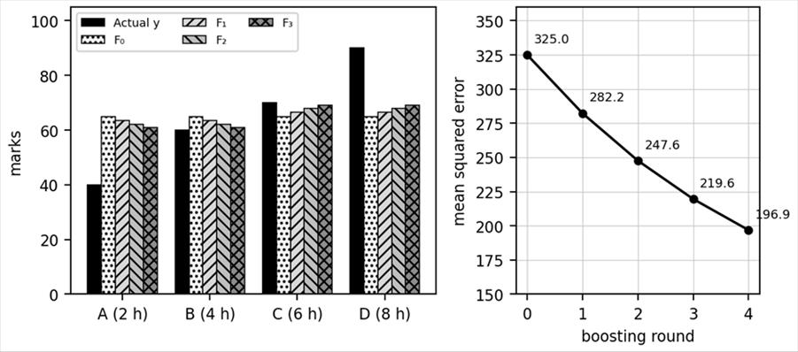
Figure 12. (a) Actual marks and predictions after each round. (b) Mean squared error after each round, computed from the tables above.
Effect of η. With η = 1 the first update would be 65 - 15 = 50 for A and 65 + 15 = 80 for D, a full correction in one step. With η = 0.1 the step is only 63.5 and 66.5, so many small steps are needed. Note that this one-split tree can never do better than the group means 50 and 80 (MSE = 100), because residuals within a group cannot be separated. In practice later trees use other splits and greater depth.

Part B: house prices, η = 1 (the second lecture example)
House | Area (sq ft) | Actual price (Rs lakhs)
A | 1000 | 100
B | 1500 | 120
C | 2000 | 140
D | 2500 | 160

1. Base model: F₀ = (100 + 120 + 140 + 160)/4 = 130 for every house. Residuals y - F₀: -30, -10, +10, +30 (a negative residual means the model overpredicts). MSE = (900 + 100 + 100 + 900)/4 = 500.
2. First model RM1 on area. Split at area ≤ 1500: left average (-30 + -10)/2 = -20, right average (10 + 30)/2 = +20.
3. Update (η = 1): F₁ = 130 + RM1 = 110, 110, 150, 150. New residuals: 100 - 110 = -10, 120 - 110 = +10, 140 - 150 = -10, 160 - 150 = +10. MSE = 100. Errors remain for all four houses.
4. Second model RM2 is trained on these residuals. The lecture notes that averaging with the same split would give 0 in each group, so RM2 must be flexible enough to learn the four residuals exactly: -10, +10, -10, +10.
5. Update: F₂ = F₁ + RM2 = 110 - 10 = 100, 110 + 10 = 120, 150 - 10 = 140, 150 + 10 = 160. These equal the actual prices, so MSE = 0.

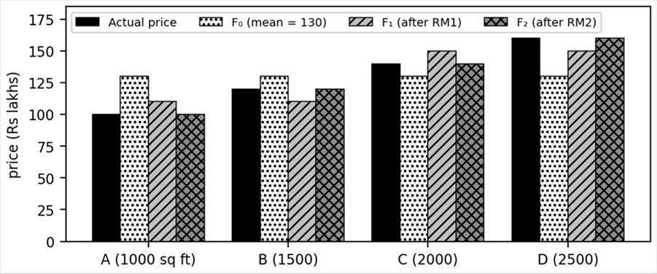
Figure 13. Actual prices and the predictions after the base model, RM1 and RM2 (η = 1). The error falls from 500 to 100 to 0.

How to write this in the exam
• State the formula F_{m} = F_{m-1} + η h_{m}, with residual = y - F_{m-1}.
• Show F₀ as the mean, then a residual table.
• Show each tree's leaf values as the average residual in each leaf.
• Show the update table with η and the new residuals.
• Stop after two or three rounds and write the final model F(x) = F₀ + η Σ h_{m}(x).

Takeaway. Initial prediction, residuals, small tree on residuals, update with η, repeat. The MSE falls every round, which proves the model is learning.

Question 4.7: Explain the AdaBoost algorithm with a numerical example. (5 marks)
Simple idea. In AdaBoost, after every round the training examples the model got wrong are made heavier, so the next model pays more attention to them. Each model also earns a 'say' in the final vote according to how accurate it was. Very accurate models speak loudly and poor models speak softly.
Definition. AdaBoost (Adaptive Boosting) learns by weight updates: it increases the weights of misclassified samples and decreases the weights of correctly classified ones. Its weak learners are decision stumps, trees of depth 1 (a single question). Each stump is chosen by the lowest entropy or Gini impurity (highest information gain).

Algorithm (lecture steps)
1. Give each of the n samples the weight w_{i} = 1/n.
2. For each attribute build a stump, pick the best one (lowest Gini or entropy), and find its total error ε = sum of the weights of the misclassified samples.
3. Compute the stump's performance (its say): α = ½ ln((1 - ε)/ε).
4. Update the weights: wrong samples w × e^{α}; correct samples w × e^{-α}.
5. Normalise so that the weights add to 1: divide each by the sum of all new weights.
6. Repeat until the required number of estimators is reached. Final prediction: P = Σ α_{j} h_{j}(x), with h_{j}(x) = +1 for Yes and -1 for No. If P > 0 predict Yes, else No.

Worked example (lecture dataset, 6 students)
No. | CGPA | Interactiveness | Practical knowledge | Communication | Job profile
1 | ≥ 9 | Yes | Good | Good | Yes
2 | < 9 | No | Good | Moderate | Yes
3 | ≥ 9 | No | Average | Moderate | No
4 | < 9 | No | Average | Good | No
5 | ≥ 9 | Yes | Good | Moderate | Yes
6 | ≥ 9 | Yes | Good | Moderate | Yes

Round 1. Initial weight is 1/6 for each sample. Take the stump on CGPA: ≥ 9 predicts Yes, < 9 predicts No. Sample 2 (CGPA < 9, actual Yes) and sample 3 (CGPA ≥ 9, actual No) are wrong. Total error ε = 2 × 1/6 = 1/3. Performance α = ½ ln((1 - 1/3)/(1/3)) = ½ ln 2 = 0.3466 (the slide gives 0.347). Then e^{α} = 1.4142 and e^{-α} = 0.7071.
New weights: wrong samples (2 and 3): 1/6 × 1.4142 = 0.2357. Correct samples (1, 4, 5, 6): 1/6 × 0.7071 = 0.1179. Sum = 2 × 0.2357 + 4 × 0.1179 = 0.9428. Normalised: wrong samples 0.2357/0.9428 = 0.25; correct samples 0.1179/0.9428 = 0.125. Check: 2 × 0.25 + 4 × 0.125 = 1.
Round 2. The Interactiveness stump (Yes predicts Yes, No predicts No) gets only sample 2 wrong. Its weight is 0.25, so ε = 0.25 (the slide: error = 1 × 0.25). α = ½ ln(0.75/0.25) = ½ ln 3 = 0.5493 (slide: 0.549). e^{α} = 1.7321 and e^{-α} = 0.5774. Unnormalised: sample 2: 0.25 × 1.7321 = 0.4330; sample 3: 0.25 × 0.5774 = 0.1443; samples 1, 4, 5, 6: 0.125 × 0.5774 = 0.0722 each. Sum = 0.4330 + 0.1443 + 4 × 0.0722 = 0.8660. Normalised: sample 2 = 0.5, sample 3 = 0.1667, others = 0.0833.
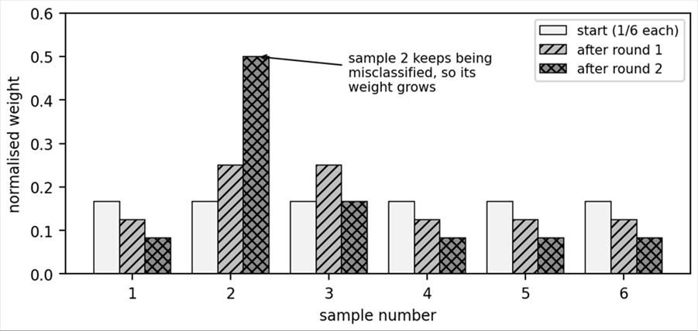
Figure 14. Normalised sample weights at the start and after rounds 1 and 2, computed exactly. The repeatedly misclassified sample 2 grows to weight 0.5.
Sample | Start | After round 1 | After round 2
1 | 0.1667 | 0.125 | 0.0833
2 | 0.1667 | 0.250 | 0.5000
3 | 0.1667 | 0.250 | 0.1667
4 | 0.1667 | 0.125 | 0.0833
5 | 0.1667 | 0.125 | 0.0833
6 | 0.1667 | 0.125 | 0.0833

Final prediction with the two stumps. F(x) = 0.3466 h₁(x) + 0.5493 h₂(x). Sample 1: +0.3466 + 0.5493 = +0.896, Yes. Sample 3: +0.3466 - 0.5493 = -0.203, No. Sample 4: -0.3466 - 0.5493 = -0.896, No. Samples 5 and 6: +0.896, Yes. Sample 2: -0.896, No, which is wrong. So the two stumps give 5 of 6 correct, and a third round would focus on sample 2, which now carries weight 0.5.
Rounding note. The slides use rounded weights (0.12 and 0.25 in round 1) and so show 0.088, 0.553 and 0.184 after round 2. The exact values above are 0.083, 0.5 and 0.167. Either is acceptable, but follow your lecturer's rounded numbers if the question copies the slide. Also, the lecture's Practical Knowledge stump classifies all six samples correctly (error 0). Then α = ½ ln((1 - 0)/0) is infinite, so the slide simply leaves the weights unchanged; libraries add a tiny constant to avoid dividing by zero. If a stump has ε above 0.5, α is negative and its vote is flipped.
Point | AdaBoost | Gradient boosting
Learns by | Reweighting samples | Fitting residuals (gradients)
Weak learner | Stump, depth 1 | Small tree, several leaves
Model weight | α from the error | Fixed learning rate η
Final answer | Sign of weighted vote | Sum of scaled tree outputs

Takeaway. AdaBoost raises the weight of mistakes, gives each stump a say α = ½ ln((1 - ε)/ε), and combines the stumps by a weighted vote.

Question 4.8: Explain XGBoost and the reasons it is fast and accurate. (5 marks)
Simple idea. XGBoost is gradient boosting built like a racing car. It builds trees one after another like ordinary gradient boosting, but it looks at the curve of the error as well as its slope, penalises over-complicated trees, and uses clever computer engineering to run quickly.
Definition. XGBoost (eXtreme Gradient Boosting) is an optimised and efficient implementation of gradient boosting designed for high accuracy on structured (tabular) data. It builds decision trees (weak learners) one after another, and each new tree improves on the predictions of the trees already built. No single tree needs to be perfect, because the group corrects itself over time. It is widely used in finance, healthcare and e-commerce.

Why XGBoost is fast and efficient
Feature | Meaning | Lecture example
Parallelised split finding | Candidate splits on different features are evaluated in parallel | Splits on study hours and attendance are tested at the same time
Cache-aware access | Data is stored in compressed column blocks that suit the CPU cache | 10,000 students' marks, attendance and hours are scanned efficiently
Sparsity-aware splits | Missing values learn a default branch direction automatically | A missing study-hours value is sent left or right with no imputation
Weighted quantile sketch | For huge data, split points come from weighted percentiles instead of every value | For one million marks, test representative splits such as 40, 60 and 80
Built-in regularisation | L1 and L2 penalties are part of the objective | A 20-leaf tree that fits noise is penalised into a simpler tree
Shrinkage (learning rate) | Controls how much each new tree contributes | Smaller η learns slowly but generalises better
How XGBoost works: five parts of every round
1. Base learners: start with simple decision trees. Tree 1 fits the residual error, tree 2 fits what remains, tree 3 fits what remains after that.
2. Second-order boosting: use both the gradient g (first derivative of the loss) and the Hessian h (second derivative). This is a Newton-style step. It uses the curvature of the loss to decide how large the update should be, not only the direction.
3. Best split (gain): score every candidate split and keep the best.
4. Regularisation: penalise complex trees to avoid overfitting.
5. Final prediction: add up every tree's small, learning-rate-scaled contribution.
For squared error L = (ŷ - y)²: g_{i} = 2(ŷ - y), h_{i} = 2
Leaf weight w = -G / (H + λ)
Gain = ½ [ G_{L}²/(H_{L} + λ) + G_{R}²/(H_{R} + λ) - G²/(H + λ) ]
Update F_{t}(x) = F_{t-1}(x) + η w
Here G and H are the sums of the gradients and Hessians of the samples in a node, and L and R mean the left and right child. Regularisation: λ (L2) penalises large leaf weights so predictions shrink toward zero; α (L1) pushes some leaf weights to exactly zero; η scales each tree's contribution. The full objective adds a penalty Ω(w) = ½ λ Σ w² (L2) or α Σ |w| (L1) to the loss. Supplementary: the standard XGBoost objective also has a term γT that charges for each leaf and is subtracted from the Gain; a split is kept only if its gain exceeds γ. The slide formula leaves γ out.
Point | Plain gradient boosting | XGBoost
Derivatives used | First only | First and second (gradient and Hessian)
Regularisation | None built in | L1 and L2 in the objective
Missing values | Must be imputed | Learned default direction
Speed | Slower | Parallel, cache-aware
Takeaway. XGBoost is gradient boosting plus second-order optimisation, built-in regularisation and efficient engineering. Question 4.9 shows its calculation on numbers.

Question 4.9: Numerical example of XGBoost (gradient, Hessian, gain and leaf weights). (5 marks)
Simple idea. XGBoost uses the same student data. For each student it measures the gradient (how wrong and in which direction) and the Hessian (how sharply the error curves). It then chooses the split with the highest gain and sets each leaf to w = -G/(H + λ).
Setup (lecture). Hours x = 2, 4, 6, 8 with marks y = 40, 60, 70, 90. Use λ = 1 and η = 0.1. Initial prediction F₀ = mean(y) = 65. Loss L = (ŷ - y)², so g = 2(ŷ - y) and h = 2.

Round 1: gradients and Hessians
Student | y | ŷ = F₀ | g = 2(ŷ - y) | h
A (2 h) | 40 | 65 | 2(65 - 40) = 50 | 2
B (4 h) | 60 | 65 | 2(65 - 60) = 10 | 2
C (6 h) | 70 | 65 | 2(65 - 70) = -10 | 2
D (8 h) | 90 | 65 | 2(65 - 90) = -50 | 2

Student A and B are underpredicted, so g is positive, and C and D are overpredicted. Parent node: G = 50 + 10 - 10 - 50 = 0 and H = 8, so G²/(H + λ) = 0/9 = 0.

Scoring the splits (λ = 1)
Split | G_{L}, H_{L} | G_{R}, H_{R} | Gain = ½ [ G_{L}²/(H_{L}+1) + G_{R}²/(H_{R}+1) - 0 ]
hours ≤ 2 (A | B, C, D) | 50, 2 | -50, 6 | ½ [2500/3 + 2500/7] = ½ [833.33 + 357.14] = 595.24
hours ≤ 4 (A, B | C, D) | 60, 4 | -60, 4 | ½ [3600/5 + 3600/5] = ½ [720 + 720] = 720
hours ≤ 6 (A, B, C | D) | 50, 6 | -50, 2 | ½ [2500/7 + 2500/3] = 595.24

The split hours ≤ 4 has the highest gain (720), so it becomes the first split. Leaf weights: left leaf w = -G/(H + λ) = -60/(4 + 1) = -12; right leaf w = -(-60)/(4 + 1) = +12. Update: η w = 0.1 × (-12) = -1.2 for A and B, and +1.2 for C and D. F₁ = 63.8, 63.8, 66.2, 66.2.
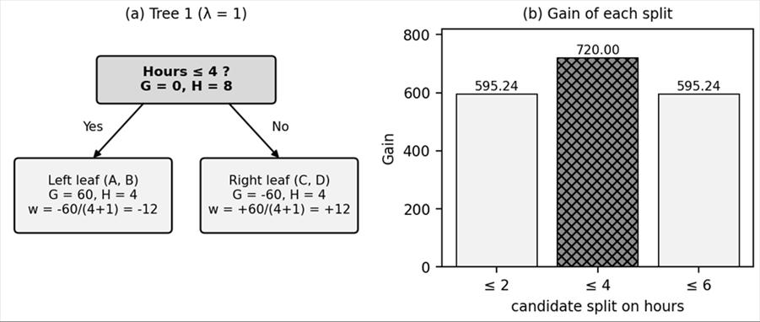
Figure 15. (a) The first tree with its sums and leaf weights. (b) Gain of the three candidate splits; hours ≤ 4 is best.

Round 2 and later rounds
With the new predictions, g = 2(ŷ - y): A: 2(63.8 - 40) = 47.6; B: 2(63.8 - 60) = 7.6; C: 2(66.2 - 70) = -7.6; D: 2(66.2 - 90) = -47.6. For the same split, G_{L} = 47.6 + 7.6 = 55.2 and H_{L} = 4. Leaf weight w_{L} = -55.2/5 = -11.04, so the update is 0.1 × (-11.04) = -1.104. F₂ = 63.8 - 1.104 = 62.696 for A and B, and 66.2 + 1.104 = 67.304 for C and D. Rounds 3 and 4 give updates of ±1.016 and ±0.934, matching the lecture's convergence table (about 1.01 and 0.9).
Tree | Update size (±) | Predictions A, B | C, D | MSE
0 (start) | none | 65 | 65 | 325.00
1 | 1.200 | 63.800 | 66.200 | 290.44
2 | 1.104 | 62.696 | 67.304 | 261.19
3 | 1.016 | 61.680 | 68.320 | 236.43
4 | 0.934 | 60.746 | 69.254 | 215.47

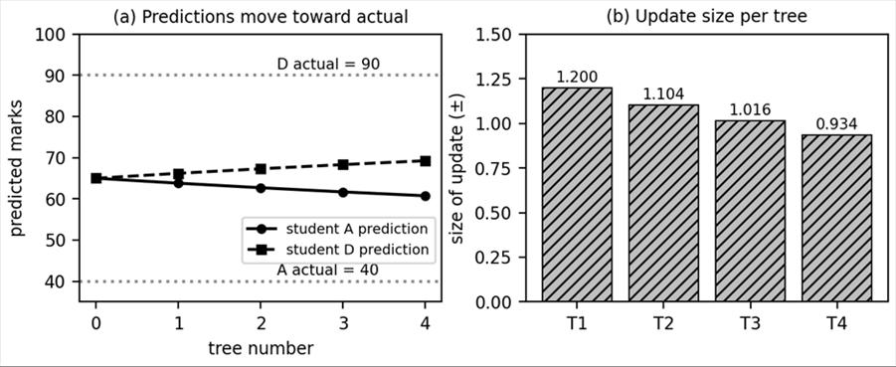
Figure 16. (a) Predictions for students A and D move toward their actual marks. (b) The size of each tree's update shrinks as the residuals shrink.
Comparing with plain gradient boosting. After the first tree, plain gradient boosting with η = 0.1 gave predictions 63.5 and 66.5 and an MSE of 282.25, while XGBoost with λ = 1 gave 63.8 and 66.2 and an MSE of 290.44. The XGBoost step is smaller because the leaf weight is -60/5 = -12 instead of the plain average residual -15. This is regularisation at work: XGBoost deliberately moves a little less in each round to protect against overfitting. The price is a slightly higher training error early on, but the model usually generalises better on new data, which is the purpose of the penalty.

Effect of λ on the leaf weight
λ | Left leaf weight -60/(4 + λ) | Meaning
0 | -15.00 | No control; same as the mean residual in plain gradient boosting
1 | -12.00 | Mild shrinkage, as in this example
10 | -4.29 | Strong shrinkage, a cautious update

Takeaway. For each round compute g and h, score splits with the Gain formula, set leaf weights with -G/(H + λ), and update with η w. A larger λ makes smaller, safer updates; with λ = 0 XGBoost reduces to the residual averages of plain gradient boosting.

Question 4.10: Compare LightGBM and XGBoost. (5 marks)
Simple idea. Picture growing a tree in a garden. XGBoost grows it evenly, finishing one level of branches before starting the next. LightGBM looks at all the branch tips and grows the one that will help the most, even if that makes one side much deeper than the other.
Definition. LightGBM is a fast, distributed, high-performance gradient boosting framework based on decision trees. Its key difference is that it grows trees leaf-wise, whereas XGBoost grows level-wise (level by level). Leaf-wise growth selects the leaf that gives the greatest reduction in loss and splits that leaf, even if it is deeper than the other leaves. At each step LightGBM asks: which leaf should split next to reduce the loss the most? XGBoost's level-wise approach asks: which eligible nodes should split at this level?
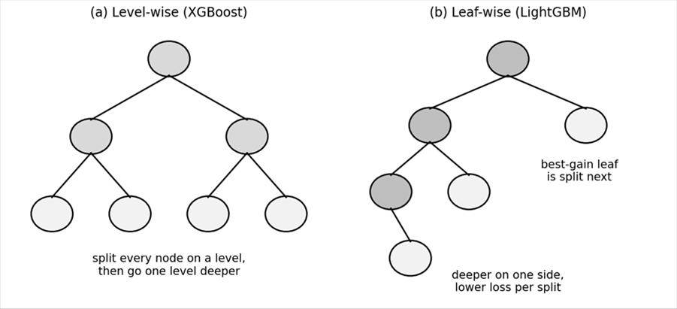
Figure 17. (a) Level-wise growth splits every node on a level before going deeper. (b) Leaf-wise growth splits the leaf with the best gain, so the tree can become lopsided and deep.
Point | XGBoost | LightGBM
Tree growth | Level-wise (depth by depth) | Leaf-wise (best leaf first)
Choosing a split | All eligible nodes on the current level | The single leaf with the greatest loss reduction
Training speed | Fast | Often faster, especially on large data
Accuracy | Strong | Can be higher on large data, since each split removes more loss
Overfitting | Controlled by depth and regularisation | Leaf-wise trees can overfit, so limit the depth and the number of leaves
Tuning | Many hyperparameters | Many hyperparameters to optimise
Lecture uses | General tabular data | Image segmentation, breast cancer detection

Numerical illustration (made up). Suppose after the first split two leaves are available. Leaf P could reduce the loss by 40 and leaf Q by 25. LightGBM splits P (40) first, even if P is deeper than Q. XGBoost would split both P and Q because both are on the same level. With the same number of leaves, LightGBM keeps the total loss lower, but one branch may become very deep, which is why a depth limit is needed.
Supplementary. LightGBM is also made fast by histogram-based split finding (grouping feature values into bins) and by sampling and bundling techniques, and its main control for complexity is the maximum number of leaves. The slide says LightGBM is more accurate and faster than XGBoost; treat this as 'often faster, and accuracy depends on the data', since neither algorithm always wins.
Which one to choose. For small or medium datasets the two perform similarly, and XGBoost is a safe, well-tested default. For very large datasets, where training time is the bottleneck, LightGBM is often preferred. In both libraries the key settings are the learning rate, the number of trees and the tree complexity. For XGBoost the complexity is mainly controlled by the maximum depth, and for LightGBM by the number of leaves and a minimum number of samples per leaf, because a leaf-wise tree can otherwise chase noise down a narrow branch.
Takeaway. XGBoost is level-wise and balanced; LightGBM is leaf-wise and aggressive. Choose LightGBM for large datasets when speed matters, and set depth limits to control overfitting.

Question 4.11: Explain stochastic gradient boosting. (5 marks)
Simple idea. Suppose each round of studying uses only a random half of your notes, and the half changes every round. Each round is quicker, and because you never memorise one fixed set, you are less likely to over-fit. Stochastic gradient boosting does exactly this with training rows.
Definition. Stochastic gradient boosting is a gradient boosting technique in which each new decision tree is trained on a randomly selected subset of the training data instead of the whole dataset. As in ordinary gradient boosting, each new tree tries to correct the errors made by the existing ensemble. The extra random sampling can reduce computation and help reduce overfitting. Ordinary gradient boosting learns sequentially by correcting previous errors; the stochastic version adds randomness by training each tree on only a randomly selected portion of the data.
Key parameter: subsample. This is the fraction of the training rows used for each tree. The subset is generally drawn anew for each boosting iteration. A smaller value adds more randomness, but too small a value can reduce learning quality because each tree sees too little data. A value of 1.0 gives ordinary gradient boosting.
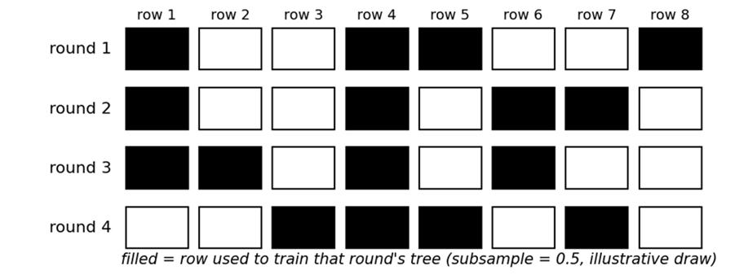
Figure 18. Rows used in each of four boosting rounds when subsample = 0.5. Each round draws a new random half of the 8 rows (illustrative draw).

Worked numerical illustration
A dataset has n = 1000 rows and the model uses 100 trees with subsample = 0.5. Each tree is trained on 0.5 × 1000 = 500 rows, a fresh random set each time. The total number of row visits is 100 × 500 = 50,000, compared with 100 × 1000 = 100,000 for ordinary gradient boosting, so the work per tree is halved. In the figure, round 1 trains on rows 1, 4, 5 and 8, round 2 on rows 1, 4, 6 and 7, and so on, so every tree sees a different part of the data.
Point | Gradient boosting | Stochastic gradient boosting
Rows used per tree | All rows | A random fraction (subsample)
Randomness | None | Row sampling each round
Speed per tree | Slower | Faster
Overfitting | More likely | Reduced
Risk | Overfitting | Too small a subsample hurts learning

Supplementary. Stochastic gradient boosting is attributed to Jerome Friedman. In common libraries the sampling is done without replacement, and the residuals (pseudo-residuals) of the sampled rows are what the tree is fitted to. XGBoost and LightGBM expose this idea as the subsample (and column sampling) settings, which are tuned along with the learning rate and number of trees.
Takeaway. Stochastic gradient boosting is gradient boosting with a new random subset of rows for every tree. Tune the subsample fraction: smaller is faster and more regularised, but too small hurts accuracy.

Question 4.12: Differentiate homogeneous and heterogeneous ensembles. Explain stacking. (5 marks)
Simple idea. A homogeneous team is made of people with the same skill, such as ten doctors of the same specialty. A heterogeneous team mixes different skills, such as a doctor, a nurse and a lab technician. Combining different skills can cover more ground, but someone must decide how to combine their opinions.
Homogeneous ensemble learning. All base models are of the same type. Bagging and boosting are examples, because they use the same type of base learner (for example decision trees) with weighted inputs or contributions. Heterogeneous ensemble learning combines different types of base models, such as SVM, ANN and decision trees. Stacking is the standard example.
Point | Homogeneous | Heterogeneous
Base models | Same type, for example all decision trees | Different types, for example tree, logistic regression, SVM
Source of diversity | Different data samples, weights or features | Different algorithms and their different assumptions
Examples | Bagging, random forest, boosting | Stacking, voting
Combining | Vote, average or weighted sum | Another model (meta-learner) or a vote

How stacking works
1. Level 0: train several different base models (for example decision tree, logistic regression and SVM) on the training data.
2. Collect each base model's prediction for every training example. These predictions become new input features.
3. Level 1: train another model, the meta-learner, to combine the base predictions into the final prediction. The lecture example is a neural network combining the predictions of decision trees and logistic regression.
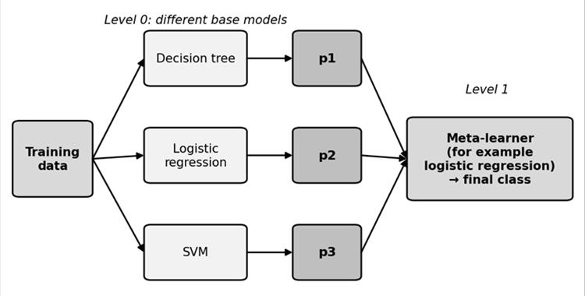
Figure 19. Stacking: different base models make predictions p1, p2, p3, and a meta-learner combines them into the final class.
Supplementary. To avoid leakage, the base predictions given to the meta-learner are usually out-of-fold predictions from cross-validation, so the meta-learner never sees predictions made on data the base model trained on.

Numerical illustration (made up)
For one new sample, the three base models give the probability of the positive class as p₁ = 0.8, p₂ = 0.6 and p₃ = 0.9. A plain soft vote averages them: (0.8 + 0.6 + 0.9)/3 = 0.767, which is above 0.5, so the class is positive. Now suppose a stacking meta-learner (logistic regression) has learned weights 1.2, 0.8 and 1.0 and bias -1.5. Then z = -1.5 + 1.2 × 0.8 + 0.8 × 0.6 + 1.0 × 0.9 = -1.5 + 0.96 + 0.48 + 0.90 = 0.84, and the final probability is 1/(1 + e^{-0.84}) = 0.698, so the class is also positive. The weights are invented to show the arithmetic; in practice the meta-learner learns them from data, giving more say to the more reliable base models.
Takeaway. Homogeneous ensembles repeat one type of model; heterogeneous ensembles mix types, and stacking trains a meta-learner to combine them. Stacking can beat each base model but costs more and is harder to interpret.

Quick revision for Unit 4: likely 2 mark questions
Likely question | Short answer
What is an ensemble model? | A model that combines the predictions of several base models to make one final prediction that is more accurate and stable.
State the wisdom of crowds principle. | Combining the decisions of many individuals often beats the decision of one individual.
What is bagging? | Training models in parallel on bootstrap samples (rows with replacement) and combining them by vote or average.
What is a bootstrap sample? | A random sample of the same size as the data, drawn with replacement.
How does random forest differ from bagging? | It also samples features at each split, so the trees are less correlated.
What is boosting? | Training weak models one after another, each correcting the errors of the previous ones, combined by a weighted sum.
Bagging versus boosting in one line. | Bagging cuts variance with parallel models; boosting cuts bias with sequential models.
What is a weak learner? | A simple model only slightly better than guessing, such as a shallow tree or a stump.
What is the residual? | Actual value minus predicted value, y - F(x).
Gradient boosting update formula? | F_{m}(x) = F_{m-1}(x) + η h_{m}(x).
What is the learning rate? | A factor between 0 and 1 that scales each tree's contribution; smaller means slower, safer learning.
What does AdaBoost change after each round? | It raises the weights of misclassified samples and lowers the weights of correct ones.
Write the AdaBoost performance formula. | α = ½ ln((1 - ε)/ε).
Why is XGBoost fast? | Parallel split finding, cache-aware layout, sparsity-aware splits, quantile sketch, regularisation.
What does XGBoost use besides the gradient? | The Hessian (second derivative), giving a Newton-style update.
Leaf-wise versus level-wise? | LightGBM splits the best leaf; XGBoost splits all eligible nodes on a level.
What is the subsample parameter? | The fraction of rows used to train each tree in stochastic gradient boosting.
What is stacking? | A heterogeneous ensemble where a meta-learner combines the predictions of different base models.

Unit 5: Case Studies in Text Mining
Topic | One line idea | Key terms
Survey analysis | ML turns open-ended survey text into measurable themes, sentiments and trends | coding, topic modelling, sentiment, trend
Question answering (QA) | Users ask in natural language and get answers from data or documents | ambiguity, retrieval, bias, RAG
Persuasion by the numbers | Text mining measures how language tries to influence people | ethos, pathos, logos, persuasion score

Question 5.1: Explain survey analysis using machine learning. Describe its five techniques. (5 marks)
Simple idea. Suppose a college asks 1,000 students, 'What do you think about the quality of teaching?' Reading 1,000 free-text answers by hand takes days. Machine learning reads them all in minutes, sorts them into groups, and tells you how students feel. That is survey analysis with ML.
Definition. Survey analysis in machine learning uses algorithms to automatically extract patterns, themes and sentiment from large sets of survey responses, especially open-ended text. A survey usually mixes quantitative responses (numbers, such as a rating from 1 to 5) and qualitative responses (descriptive text, such as 'explain what you liked'). Traditional statistics handles the numbers well. Text mining and NLP (natural language processing, which lets computers work with human language) extract information from the text.
Type | Meaning | Example
Quantitative | Numerical data | Rate teaching from 1 to 5
Qualitative | Descriptive or textual data | Explain what you liked about teaching

Objective. Transform unstructured text feedback into structured, quantifiable data to understand what respondents want, need and feel. Example: 500 students rate teaching and the average is 3.8 out of 5; 300 of them also write comments, and text analysis shows they like faculty support but worry about limited laboratory time. The two together give a fuller picture than either alone.
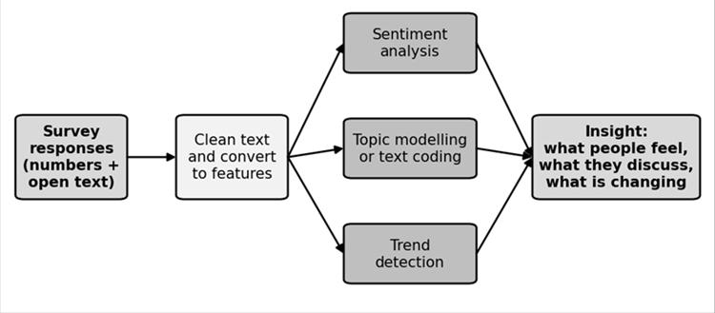
Figure 20. Survey analysis pipeline: responses are cleaned and converted to features, three kinds of analysis run, and the results become insight.

The five techniques
Technique | Meaning | Example from the slides
1. Sentiment analysis | Identify whether an opinion is positive, negative or neutral | 'The teacher explains concepts clearly' is Positive; 'The laboratory sessions are too short' is Negative; 'The course contains five units' is Neutral
2. Topic modelling | Automatically discover the topics in a large collection of text, for example with Latent Dirichlet Allocation (LDA), without pre-assigned categories | Words teacher, explanation, faculty form the topic Teaching quality; computers, equipment form Laboratory facilities
3. Automated text coding | Assign comments to predefined categories using a classifier trained on labelled comments | 'There are not enough computers' becomes Infrastructure
4. Pattern and trend identification | Find recurring problems and changes over time, but a relationship is not proof of cause | Internet complaints rise over three semesters while teaching complaints fall
5. Enhanced survey design | Use past results to improve future questions | If students keep mentioning internet, add questions on connectivity
Coding versus topic modelling. Here 'coding' means labelling text with categories, not writing programs. Text coding assigns comments to known categories using a model trained on labelled examples. Topic modelling discovers topics from the data without labels. This difference is a favourite short question.
Worked numbers: summarising 200 responses
Topic identified | Responses | Percentage
Teaching quality | 80 | 80/200 = 40%
Laboratory facilities | 60 | 60/200 = 30%
Course difficulty | 40 | 40/200 = 20%
Other issues | 20 | 20/200 = 10%
Total | 200 | 100%

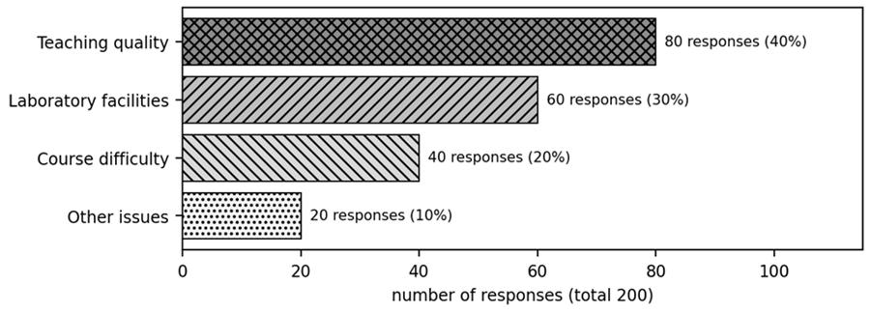
Figure 21. Topics found in 200 responses (counts and percentages from the lecture table). Decision makers can see at once which issues matter most.
Instead of reading all 200 comments, a manager sees that 40% concern teaching quality and 30% concern laboratories, and can prioritise improvements.
Supplementary: a simple sentiment score. A basic dictionary method counts positive and negative words. Score = (positive words - negative words)/total words. For 'The faculty explain concepts clearly', with 'clearly' counted positive: score = (1 - 0)/5 = +0.2, Positive. For 'The laboratory facilities are poor', with 'poor' negative: (0 - 1)/5 = -0.2, Negative. Modern models such as BERT or logistic regression classifiers learn this from labelled data instead of using a fixed word list.
Takeaway. Survey analysis uses ML to code, group, score and track text responses, turning opinions into numbers a decision maker can act on. Use it whenever the volume of text is too large to read by hand.

Question 5.2: Scenario: how can a telecom company improve customer experience by analysing survey feedback with ML? (5 marks)
How to answer a scenario question. Use the pattern: situation, technique, application, impact. Name the technique, say what it does to the data in the scenario, and state the result for the organisation. The slides use exactly this pattern for a telecom company, so learn it as a template.
Scenario. A telecom company receives thousands of customer feedback responses every month. They include structured questions (rate the service from 1 to 5) and open-ended questions such as 'What could we do better?' Reading all of it manually is impossible, so the company applies text mining, NLP and machine learning.
Technique | Technique used | Application in the scenario | Impact
Sentiment analysis | BERT or logistic regression classifiers label feedback positive, negative or neutral | Classify all feedback by tone | Negative sentiment spikes after outages in certain regions, so the company prioritises upgrades there
Topic modelling | Latent Dirichlet Allocation finds recurring themes | LDA shows billing confusion and slow internet are common | Launches a billing FAQ and improves network speed in affected areas
Automated text coding | Models tag responses with categories such as technical issue, customer service, pricing | System categorises thousands of comments instantly | Tracks which departments receive most complaints and allocates resources
Pattern and trend identification | Decision trees or clustering detect correlations | Customers who mention long wait times also give low satisfaction scores | Reduces call centre wait times and satisfaction rises
Enhanced survey design | ML analyses past surveys to see which questions give useful answers | Vague questions are replaced with targeted ones | Higher response quality and completion rates

Benefits
Benefit | Real-time impact at the telecom company
Efficiency | Analysed 50,000+ responses in hours instead of weeks
Scalability | Handled feedback from millions of users across regions
Accuracy | Reduced manual coding errors and bias
Deeper insights | Discovered hidden issues such as billing confusion
Faster decisions | Launched service improvements within days of feedback

Worked numbers: spotting a trend (university complaints over three semesters)
Issue | Semester 1 | Semester 2 | Semester 3 | Change S1 to S2 | Change S2 to S3
Internet | 20 | 35 | 60 | +75.0% | +71.4%
Teaching | 40 | 32 | 25 | -20.0% | -21.9%
Laboratory | 15 | 22 | 30 | +46.7% | +36.4%
Total | 75 | 89 | 115

The percentage change is (new - old)/old × 100. For internet: (35 - 20)/20 = 75%, and (60 - 35)/35 = 71.4%. Internet complaints also grow from 20/75 = 26.7% of all complaints in semester 1 to 60/115 = 52.2% in semester 3, so internet is becoming the main issue while teaching complaints fall. The lecture warns that such a relationship does not prove that one factor causes another, so the university should investigate before acting.
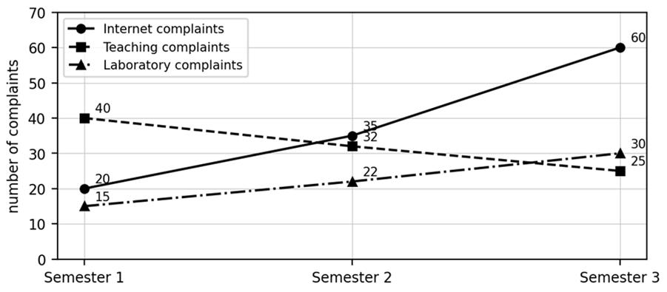
Figure 22. Complaints per semester from the lecture table: internet complaints rise sharply while teaching complaints fall.

Model answer outline for a scenario question
1. Situation: state the organisation, the data (ratings and open text) and the problem (too many responses to read).
2. Techniques: name the five techniques, one line each, linked to the scenario data.
3. Results: give measurable outcomes, such as the percentage of responses per topic or the change in complaints between semesters.
4. Impact: link each result to a decision, such as upgrading the network in a region or adding a billing FAQ.
5. Limits: mention that a trend is not proof of cause and that models can be biased, so humans should verify findings.

Notice how the telecom slides always follow the same chain: a technique finds a pattern, the pattern points to a cause, and the company acts. If the exam gives a different organisation, such as a hospital collecting patient feedback or a college collecting student feedback, keep the same chain and only change the example words. This shows the examiner that you understand the method and not only the telecom case.
Takeaway. In a scenario answer, map each technique to the data, show the measurable result, and finish with the business impact: faster, scalable, more accurate and better informed decisions.

Question 5.3: What is question answering in predictive analytics? Explain its challenges in text mining. (5 marks)
Simple idea. A question answering (QA) system lets you ask a computer a question in ordinary words and get an answer taken from data, model results or documents, instead of searching and reading yourself. In predictive analytics, a telecom manager could ask: 'How many customers are likely to leave next month?', 'Which customers have the highest churn risk?', 'What factors are linked to churn?' or 'What would happen to predicted churn if we offered a discount?'
The system retrieves the relevant data or model results and presents the answer. Making this work on text is hard because human language is complex and most text is unstructured. The lecture groups the difficulties into five challenges.
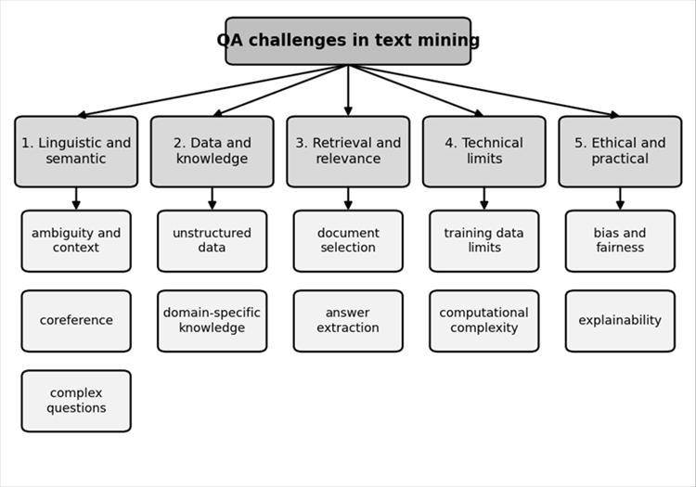
Figure 23. The five challenge groups for question answering in text mining and their sub-challenges.
Challenge group | Sub-challenge | Meaning and example
1. Linguistic and semantic | Ambiguity and context | The same word has different meanings: 'The bank is near the river' versus 'I deposited money in the bank'
1. Linguistic and semantic | Coreference resolution | Knowing that 'He' refers to the person named earlier in 'Barack Obama was the president... He served two terms'
1. Linguistic and semantic | Complex questions | Negation ('Which students did not pass?'), hypotheticals ('What if temperature rises 10°C?'), multi-part ('Who developed it and what does it solve?')
2. Data and knowledge representation | Unstructured data | Emails, reviews, PDFs have no fixed table, so facts must be extracted from sentences like 'revenue increased by 15%'
2. Data and knowledge representation | Domain-specific knowledge | Medicine, law or cybersecurity need specialised terms and training data
3. Information retrieval and relevance | Document selection | Finding the HR leave policy among 10,000 documents
3. Information retrieval and relevance | Answer extraction | From '20 days of annual leave and 10 days of sick leave', answer 20 for annual leave, not 10
4. Technical and model limits | Training data limits | Models trained on datasets like SQuAD may not generalise to real questions
4. Technical and model limits | Computational complexity | Running a large model over millions of documents for every question is slow and costly
5. Ethical and practical | Bias and fairness | A recruitment QA system trained on biased hiring records may favour some profiles
5. Ethical and practical | Explainability | Users need to know why: 'Why was this claim rejected?' should cite the policy clause

Why QA is harder than search. A search engine returns a list of documents and leaves the reading to you. A QA system must go further: it must understand the question, find the right document, locate the exact answer inside it, and present it in a form the user can trust. Each of these stages can fail in a different way, which is why the challenges fall into the five groups above. Take the churn manager. If the model results are stored in a table, the question 'How many customers are likely to leave next month?' needs the system to turn words into a database query. If the answer must come from a policy document, the system needs retrieval and answer extraction. If the manager asks 'What would happen if we offered a discount?', the system must handle a hypothetical question, which is one of the complex question types. Finally, if the manager asks why a particular customer was flagged, the system must explain its reasoning, which links to explainability.

How the challenges are addressed
Approach | Meaning | Example
Deep learning | Learns complex language patterns from data | A transformer model understands the context of a question
Transfer learning | Adapts a model trained on large data to a specific task | Fine-tuning BERT for medical QA
Hybrid approaches | Combine neural networks with rule-based or symbolic reasoning | NLP understands the question and a rule engine checks the answer against policy
Retrieval-Augmented Generation (RAG) | First retrieve relevant documents, then generate an answer from them | Improves factual grounding but does not remove wrong answers

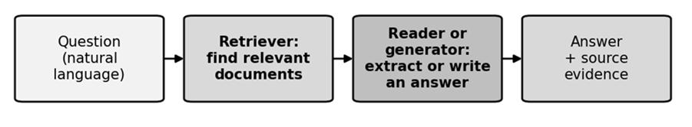
Figure 24. A practical QA pipeline: retrieve relevant documents first, then extract or generate the answer, and show the evidence.
Supplementary: scoring an answer. QA systems are often scored by token overlap F1. Suppose the correct answer is '20 days of annual leave' (5 words) and the system returns '20 days' (2 words). Overlap = 2. Precision = 2/2 = 1.0, recall = 2/5 = 0.4, F1 = 2 × 1.0 × 0.4/(1.0 + 0.4) = 0.571. The answer is correct but incomplete, so it gets partial credit.
Takeaway. QA must overcome language ambiguity, messy data, weak retrieval, model limits and ethical risk. Deep learning, transfer learning, hybrid methods and RAG reduce these problems but do not remove them.

Question 5.4: Explain 'Persuasion by the numbers': how can text mining measure persuasion? (5 marks)
Simple idea. A persuasive message tries to change what you think, feel or do. Instead of just asking a person 'was that convincing?', we can count and measure the features of the text: its words, tone, structure and evidence. Text mining and machine learning turn these features into numbers, such as a persuasion score. Examples include a political speech, an advertisement or a customer review.

Core component 1: rhetorical strategies
Rhetoric means using language effectively to convince an audience. There are three classical strategies.
Strategy | Appeals to | Example | What text mining detects
Ethos | Credibility, authority, trust | 'Recommended by experienced cardiologists' | References to experts, credentials, trusted institutions
Pathos | Emotion such as hope, fear, sympathy | 'Help children build a brighter future' | Emotional words and sentiment
Logos | Logic, facts, statistics | 'Reduced processing time by 40% in testing' | Numerical claims and evidence words (claims still need verification)

Core component 2: sentiment and emotion detection
Sentiment analysis classifies text as positive, negative or neutral. Emotion mining finds more specific emotions such as joy, anger, sadness, fear or surprise. 'This product is fantastic!' is Positive (joy); 'I am furious about this service' is Negative (anger); 'I am worried about losing my savings' is Negative (fear); 'The meeting starts at 10 AM' is Neutral. Emotional language does not guarantee persuasion, but it helps researchers compare messages that create fear or hope with those that only give facts.

Core component 3: stylistic features
Feature | Meaning | Example
Repetition | Repeating words to reinforce an idea | 'Save more. Spend less. Live better.'
Hyperbole | Deliberate exaggeration | 'The best phone in the entire world!'
Framing | Presenting the same fact in a way that steers interpretation | '90% survival rate' versus '10% mortality rate'

Text mining quantifies these with NLP methods: n-gram analysis finds frequent word sequences such as 'limited time offer'; syntactic parsing examines grammatical structure; keyword extraction finds the important terms.

The persuasion score pipeline
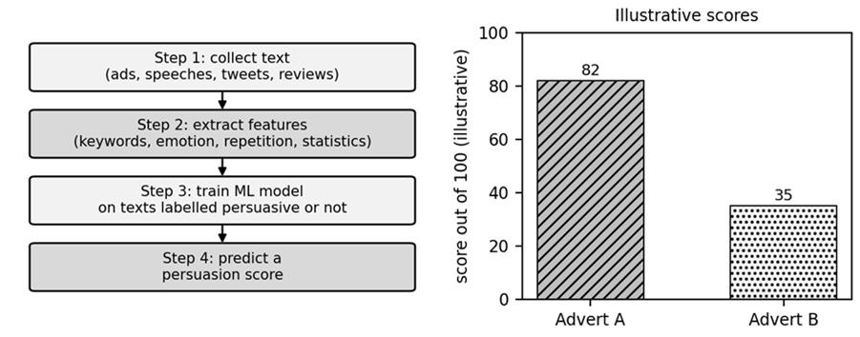
Figure 25. Persuasion analysis pipeline (left) and the lecture's illustrative scores for two adverts (right). The scores are illustrative, not measured.
The steps are: collect text (adverts, speeches, tweets, reviews); extract features (keywords, emotional tone, repetition, statistics, credibility markers); train an ML model on texts labelled persuasive or not persuasive; predict a persuasion score. The slide gives Advertisement A, 'Trusted by leading experts. Join thousands of happy customers today!', a score of 82/100 for credibility, social proof and positive emotion, and Advertisement B, 'This product contains 500 ml of liquid', a score of 35/100 because it is mostly factual.
Supplementary: how such a score could be computed. A logistic model turns weighted features into a score: score = 100 × 1/(1 + e^{-z}). Illustrative weights chosen only to reproduce the slide's scores: bias -1.0, credibility +1.0, social proof +0.9, positive emotion +0.6, plain factual claim +0.4. Advertisement A has credibility, social proof and positive emotion: z = -1.0 + 1.0 + 0.9 + 0.6 = 1.5, so score = 100/(1 + e^{-1.5}) = 81.8, about 82. Advertisement B has only a factual claim: z = -1.0 + 0.4 = -0.6, so score = 100/(1 + e^{0.6}) = 35.4, about 35. These weights are invented; they are not the lecturer's model.
A higher score does not prove people will actually be convinced, because real persuasion depends on the audience, context, trust and delivery.

Applications, limitations and the future
Domain | Use case
Marketing | Analyse ad copy to improve conversion rates
Politics | Study speeches or debates to measure influence
Social media | Identify viral posts and why they resonate
Customer service | Detect persuasive complaints or endorsements in reviews
Education | Teach persuasive writing using model feedback

The lecture cites a study of a US presidential candidate's tweets in the 2016 election that reported emotionally charged tweets, hyperbole and repetition, and higher pathos than logos. The slide does not name the study, so verify it before quoting it as a fact. Limitations: context sensitivity, cultural differences, bias inherited from training data, and lack of explainability. Future: real-time feedback on persuasive writing, personalised messaging based on audience psychology, and ethical frameworks to prevent manipulative language.
Takeaway. Persuasion by the numbers measures ethos, pathos, logos, emotion and style from text and combines them into a score with ML. Use the score as a guide to a message's persuasive cues, not as proof of its effect.

Quick revision for Unit 5: likely 2 mark questions
Likely question | Short answer
Define survey analysis in machine learning. | Using algorithms to extract patterns, themes and sentiment automatically from survey responses, especially open text.
Quantitative versus qualitative responses? | Quantitative is numerical (a 1 to 5 rating); qualitative is descriptive text.
What is sentiment analysis? | Classifying text as positive, negative or neutral.
Text coding versus topic modelling? | Coding assigns comments to predefined categories; topic modelling discovers topics from the data.
Name an algorithm for topic modelling. | Latent Dirichlet Allocation (LDA).
Why not conclude cause from a trend? | A relationship between two factors does not prove that one causes the other.
What is question answering? | A system that answers natural language questions from data, model results or documents.
What is coreference resolution? | Identifying that different words, such as 'He', refer to the same entity.
What is SQuAD? | The Stanford Question Answering Dataset, used to train and evaluate QA models.
What is RAG? | Retrieval-Augmented Generation: retrieve relevant documents first, then generate an answer from them.
Define ethos, pathos and logos. | Persuasion by credibility, by emotion, and by logic and evidence.
What is framing? | Presenting the same information so as to steer interpretation, such as 90% survival versus 10% mortality.
What is an n-gram? | A sequence of n consecutive words, such as 'limited time offer'.
Why must a persuasion score be treated with care? | It measures persuasive cues in text, not whether real people will be convinced.

