PREDICTIVE ANALYTICS
Likely 2 mark questions: Units 3, 4 and 5 (Mid Term 2)
Item | Details
Course | Predictive Analytics (C4101), IV B.Tech CSE (Data Science), Semester I, 2026-27
Source | Unit 3 slides, Unit 4 PDF, Unit 5 slides shared by the lecturer
Answer length | About 100 words each, with a table, graph or diagram where it helps
Exam pattern | Two 2 mark questions from each of Units 3, 4 and 5
Tag | [High chance] is my guess of the most probable questions. It is not confirmed by the lecturer.
Full answers | The 5 mark answers and all numericals are in the separate full notes file

Contents
Unit 3: Logistic Regression and KNN
Question 3.1: Define logistic regression. [High chance]
Question 3.2: What are odds? Give the formula and an example.
Question 3.3: What is the logit (log-odds) transformation?
Question 3.4: Write the sigmoid function and state its range. [High chance]
Question 3.5: What is the threshold value in logistic regression?
Question 3.6: Differentiate linear regression and logistic regression.
Question 3.7: Find the probability of passing for a student who studied 33 hours, given log(odds) = -64 + 2 × hours. [High chance]
Question 3.8: How many hours must a student study to have a pass probability above 95%?
Question 3.9: What do the parameters β0 and β1 represent in logistic regression?
Question 3.10: What is the effect of a small k and a large k in KNN? [High chance]
Question 3.11: How do you choose the value of k in KNN? [High chance]
Question 3.12: Give three applications of logistic regression from the lecture.
Question 3.13: What is KNN?
Question 3.14: State Bayes' theorem.
Question 3.15: What is the naive assumption in Naive Bayes?
Unit 4: Model Ensembles
Question 4.1: What is ensemble learning? [High chance]
Question 4.2: State the wisdom of the crowd principle.
Question 4.3: Why do we use ensembles? List the motivations.
Question 4.4: Define bagging. [High chance]
Question 4.5: What is bootstrap sampling (row sampling with replacement)?
Question 4.6: How does a random forest differ from bagging? [High chance]
Question 4.7: Why does bagging reduce variance?
Question 4.8: Define boosting. [High chance]
Question 4.9: Differentiate bagging and boosting. [High chance]
Question 4.10: What is a weak learner? What is a decision stump?
Question 4.11: What is gradient boosting? Write its update formula. [High chance]
Question 4.12: What is the role of the learning rate in gradient boosting?
Question 4.13: What is a residual? Give an example.
Question 4.14: How does AdaBoost update the sample weights?
Question 4.15: Why is XGBoost fast and efficient?
Question 4.16: What are the gradient and the Hessian in XGBoost?
Question 4.17: Differentiate L1 and L2 regularisation in XGBoost.
Question 4.18: Compare LightGBM and XGBoost.
Question 4.19: What is stochastic gradient boosting?
Question 4.20: Differentiate homogeneous and heterogeneous ensembles. [High chance]
Question 4.21: What is stacking?
Question 4.22: State the advantages and disadvantages of ensemble learning.
Unit 5: Case Studies in Text Mining
Question 5.1: What is survey analysis in machine learning? [High chance]
Question 5.2: Differentiate quantitative and qualitative survey responses.
Question 5.3: What is sentiment analysis? Give examples. [High chance]
Question 5.4: What is topic modelling?
Question 5.5: Differentiate automated text coding and topic modelling. [High chance]
Question 5.6: What is pattern and trend identification in survey analysis?
Question 5.7: What is enhanced survey design?
Question 5.8: List the benefits of ML-based survey analysis at the telecom company.
Question 5.9: What is question answering (QA) in predictive analytics? [High chance]
Question 5.10: What are ambiguity and coreference resolution in QA?
Question 5.11: List the main challenges of question answering in text mining. [High chance]
Question 5.12: How can the challenges of QA be addressed?
Question 5.13: What is Retrieval-Augmented Generation (RAG)?
Question 5.14: What is 'Persuasion by the numbers'? [High chance]
Question 5.15: Explain ethos, pathos and logos with examples. [High chance]
Question 5.16: How is a persuasion score produced?
Question 5.17: Explain repetition, hyperbole and framing as stylistic features.
Question 5.18: State the limitations of measuring persuasion with text mining.

Unit 3: Logistic Regression and KNN
Likely 2 mark questions from the Unit 3 slides (logistic regression, odds, sigmoid, the two worked examples, and how to choose k in KNN). Each answer is about 100 words. Questions tagged [High chance] are my guess for the most probable ones.
Supplementary. Questions 3.13 to 3.15 (KNN definition and the Bayesian method) are not in the Unit 3 slides you shared. They are written from standard textbook content because ma'am said the unit includes KNN and Bayesian methods.

Question 3.1: Define logistic regression. [High chance] (2 marks)
Logistic regression is a supervised classification algorithm used when the dependent variable is categorical, usually Yes or No. Instead of predicting a raw number like linear regression, it predicts the probability of the event, a value between 0 and 1, by passing a straight line through the sigmoid function. A threshold, normally 0.5, then converts the probability into a class. The lecture examples are whether a mail is spam, whether a student is admitted based on entrance marks, and whether a student passes based on marks. It is called regression because it models a linear relationship, but it is used for classification.
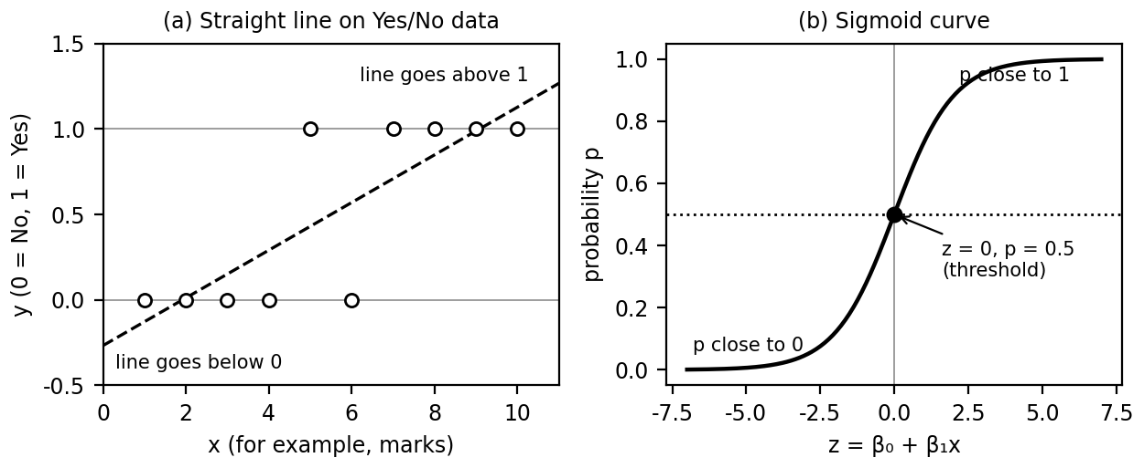
Figure 1. (a) A straight line leaves the 0 to 1 range, (b) the sigmoid stays inside it. Both panels are illustrative.

Question 3.2: What are odds? Give the formula and an example. (2 marks)
Odds compare the chance that an event happens with the chance that it does not. The formula is O = P/(1 - P), where P is the probability of the event. Odds range from 0 to infinity, while probability lies only between 0 and 1. For example, if P = 0.8, odds = 0.8/0.2 = 4, read as 4 to 1 in favour. If P = 0.5, odds = 1, so the event is equally likely to happen or not. Logistic regression first converts probability into odds, because odds are not capped at 1, and then takes the logarithm.
Probability P | Odds P/(1 - P) | Meaning
0.2 | 0.25 | 1 to 4 against
0.5 | 1 | even chance
0.8 | 4 | 4 to 1 in favour
0.9 | 9 | 9 to 1 in favour

Question 3.3: What is the logit (log-odds) transformation? (2 marks)
The logit, or log-odds, is the natural logarithm of the odds: ln(P/(1 - P)). The logarithm stretches odds, which lie between 0 and infinity, to any real number. That is exactly the range of a straight line, so logistic regression sets the log-odds equal to β₀ + β₁x. For the lecture model log(odds) = -64 + 2 × hours, a student who studies 33 hours has log-odds 2, so the odds are e² = 7.389. Solving the equation for P gives the sigmoid function. So the chain is probability, then odds, then log-odds, and the straight line is finally set equal to the log-odds.
ln( P(x) / (1 - P(x)) ) = β₀ + β₁x

Question 3.4: Write the sigmoid function and state its range. [High chance] (2 marks)
The sigmoid (logistic) function is g(z) = 1/(1 + e^{-z}), where z = β₀ + β₁x. It is an S-shaped curve that maps any real number to a value strictly between 0 and 1, so the output can be read as a probability. When z = 0 the output is exactly 0.5. Large positive z gives values close to 1, and large negative z gives values close to 0. It is obtained by exponentiating the log-odds equation and solving for P. The slide calls it the final equation of logistic regression.
z | e^{-z} | g(z)
-4 | 54.598 | 0.018
0 | 1.000 | 0.500
4 | 0.018 | 0.982

Question 3.5: What is the threshold value in logistic regression? (2 marks)
The threshold is the cut-off probability used to turn the model output into a class. The default is 0.5. If the predicted probability is at least the threshold, the class is Yes (1), otherwise it is No (0). Because the sigmoid equals 0.5 when z = 0, the decision boundary is where β₀ + β₁x = 0. The threshold can be changed to suit the problem, for example lowered to 0.3 in a medical test where missing a sick patient is costly. In the lecture table, probabilities 0.85 and 0.70 give Yes, while 0.40 and 0.15 give No.
Predicted probability | Threshold 0.5 | Class
0.85 | above 0.5 | Yes
0.70 | above 0.5 | Yes
0.40 | below 0.5 | No
0.15 | below 0.5 | No

Question 3.6: Differentiate linear regression and logistic regression. (2 marks)
Linear regression predicts a continuous numerical value, such as a salary or a price, and fits a straight line y = β₀ + β₁x. Logistic regression predicts the probability of a category, such as pass or fail, by passing the straight line through the sigmoid, so the output stays between 0 and 1. Linear regression is a regression technique, while logistic regression is a classification technique. A straight line used on Yes or No data can give values below 0 or above 1, which have no meaning as probabilities. That is why logistic regression is used for such problems.
Point | Linear regression | Logistic regression
Output | Any real number | Probability from 0 to 1, then a class
Curve | Straight line | S-shaped sigmoid
Use | Predict amounts | Classify Yes or No

Question 3.7: Find the probability of passing for a student who studied 33 hours, given log(odds) = -64 + 2 × hours. [High chance] (2 marks)
Step 1: compute z = -64 + 2 × 33 = -64 + 66 = 2. Step 2: apply the sigmoid, p = 1/(1 + e^{-z}) = 1/(1 + e⁻²). Step 3: e⁻² = 0.1353, so p = 1/1.1353 = 0.8808. The student has about an 88% chance of passing. Since 0.88 is above the threshold 0.5, the predicted class is Pass. Equivalently, the odds of passing are e² = 7.389 to 1. The slide states the model values were assumed because the optimiser output was not given, so always use the values provided in the question. Remember the order: compute z first, then apply the sigmoid, then compare with the threshold.

Question 3.8: How many hours must a student study to have a pass probability above 95%? (2 marks)
Set 1/(1 + e^{-z}) = 0.95. Then 1 + e^{-z} = 1/0.95 = 1.0526, so e^{-z} = 0.0526. Taking the natural log, -z = ln(0.0526) = -2.944, so z = 2.944. In the lecture the sigmoid variable x and z are the same quantity here. Now solve the line: 2.944 = -64 + 2 × hours, so 2 × hours = 66.944 and hours = 33.47. The student must study at least about 33.47 hours. A quick shortcut is z = ln(p/(1 - p)) = ln(19) = 2.944. In the exam, show each algebra step, because the answer 33.47 hours depends on rearranging the sigmoid correctly and then solving the straight line for the hours.

Question 3.9: What do the parameters β0 and β1 represent in logistic regression? (2 marks)
β₀ is the intercept, the value of the log-odds when x is zero. β₁ is the slope, the change in log-odds for one unit increase in x. Together they define z = β₀ + β₁x, which the sigmoid converts into a probability. They are normally learned from the training data by an optimiser, but in the lecture examples they are given. For the model z = -64 + 2 × hours, β₀ = -64 and β₁ = 2. Each extra hour of study adds 2 to the log-odds, which multiplies the odds by e² = 7.389. The boundary z = 0 occurs at 32 hours.

Question 3.10: What is the effect of a small k and a large k in KNN? [High chance] (2 marks)
The lecture states that a small k gives low bias and high variance, while a large k gives high bias and low variance. With k = 1 the prediction follows every nearby point, including noise, so the model overfits and changes a lot when the data changes. With a very large k the vote is dominated by the overall majority, so the model becomes too simple and underfits. The best k lies in between and is found by testing on validation data. So k is a balance between fitting the noise and ignoring the real pattern.
k | Bias | Variance | Risk
Small | Low | High | Overfitting
Large | High | Low | Underfitting

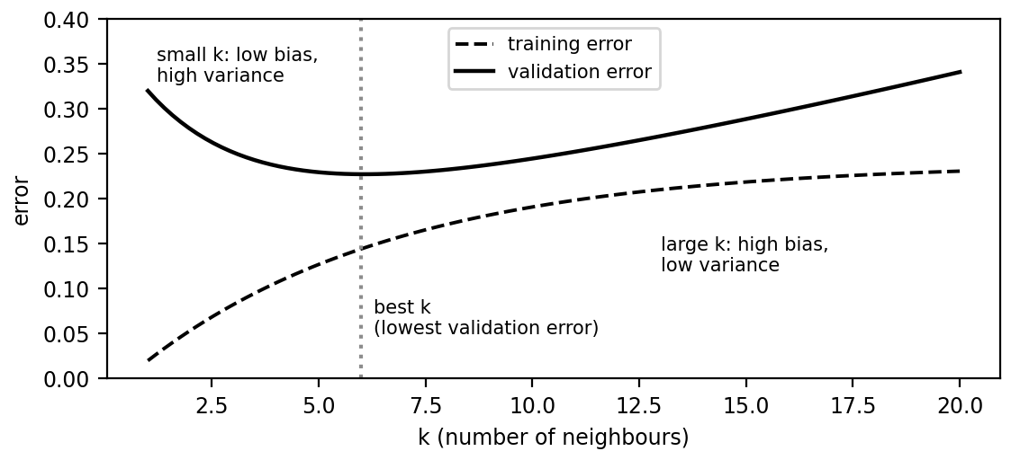
Figure 2. Typical effect of k on error. Illustrative curves, not measured values.

Question 3.11: How do you choose the value of k in KNN? [High chance] (2 marks)
The slide gives two methods. Method 1 is the square root method: k = √(number of data points in the training set), and k should be an odd number to avoid ties in classification. Method 2 is trial and error: try different values of k, evaluate each on validation data, and select the k that gives the best performance. With 100 training points, √100 = 10, so choose 9 or 11. Odd values stop a two-class vote from ending 50 to 50. Always confirm the chosen k with validation data, because the square root rule is only a starting point.
Training points n | √n | Chosen odd k
25 | 5 | 5
49 | 7 | 7
100 | 10 | 9 or 11

Question 3.12: Give three applications of logistic regression from the lecture. (2 marks)
The lecture uses three examples of a categorical outcome predicted from a numerical input. First, deciding whether a mail is spam or not spam. Second, deciding whether a student is selected for admission based on entrance marks. Third, predicting whether a student passes or fails an exam from the hours studied. In each case the model outputs a probability, and the threshold 0.5 converts it to a class. Other typical uses are disease diagnosis and customer churn, where the answer is also a Yes or No.
Application | Input x | Output y
Spam filter | Mail features | Spam (1) or not spam (0)
Admission | Entrance marks | Selected (1) or not (0)
Exam result | Hours studied | Pass (1) or fail (0)

Question 3.13: What is KNN? (2 marks)
KNN (k-nearest neighbours) is a supervised, distance based algorithm. To classify a new point, it measures the distance to every training point, picks the k closest ones, and gives the new point the majority class among them. For regression it takes the average of their values. It is a lazy learner because it does no training and simply stores the data. The common distance is Euclidean: d = √((p₁ - q₁)² + (p₂ - q₂)² + ...). Features should be scaled first so that a feature with large numbers does not dominate the distance.

Question 3.14: State Bayes' theorem. (2 marks)
Bayes' theorem updates the probability of a hypothesis H after seeing evidence E: P(H|E) = P(E|H) × P(H) / P(E). P(H) is the prior, the belief before the evidence. P(E|H) is the likelihood. P(H|E) is the posterior, the updated belief. P(E) scales the result so that probabilities add up to 1. Example: if 1% of people have a disease and a test has 90% sensitivity and a 5% false positive rate, a positive result gives P(disease|positive) = 0.009/0.0585 = 0.154, about 15.4%. Remember the order: prior, likelihood, evidence, posterior. Even a good test gives a modest posterior when the disease is rare.

Question 3.15: What is the naive assumption in Naive Bayes? (2 marks)
Naive Bayes classifies a sample by choosing the class C with the highest value of P(C) × P(x|C). To keep the calculation simple it assumes that all features are independent of each other once the class is known. Then P(x|C) is just the product P(x₁|C) × P(x₂|C) × ... × P(x_{n}|C). This assumption is rarely perfectly true, which is why the method is called naive, but it often works well, especially for text. If a count is zero, Laplace smoothing adds 1 to every count so the product does not become zero.

Unit 4: Model Ensembles
Likely 2 mark questions from the Unit 4 PDF. Ma'am confirmed two 2 mark questions in this unit, plus a gradient boosting numerical and one theory question on bagging or boosting. The numerical is in the full notes as Question 4.6. Each answer is about 100 words.

Question 4.1: What is ensemble learning? [High chance] (2 marks)
An ensemble model combines the predictions of several learned models, called base models or weak learners, to produce one final prediction. The base models can be KNN, decision trees, linear regression, SVM and so on. A group of reasonably accurate models can outperform any single model when their errors are not perfectly correlated, because mistakes of one model are corrected by the others. Ensembles reduce bias and variance and help prevent overfitting. Example: three models predict Spam, Spam and Not spam, and majority voting gives Spam as the final answer.

Question 4.2: State the wisdom of the crowd principle. (2 marks)
The wisdom of the crowd principle says that combining the opinions or decisions of many individuals can often produce a better decision than relying on a single individual. In machine learning, different models tend to make different errors, so the mistakes cancel out when the models are combined. Some models overfit while others underfit, and the ensemble balances these issues. For example, three independent classifiers that are each 70% accurate give a majority vote that is 78.4% accurate, since 3 × 0.7² × 0.3 + 0.7³ = 0.784. The idea works only if the models are accurate and make different errors, which is why ensembles use different samples or algorithms.
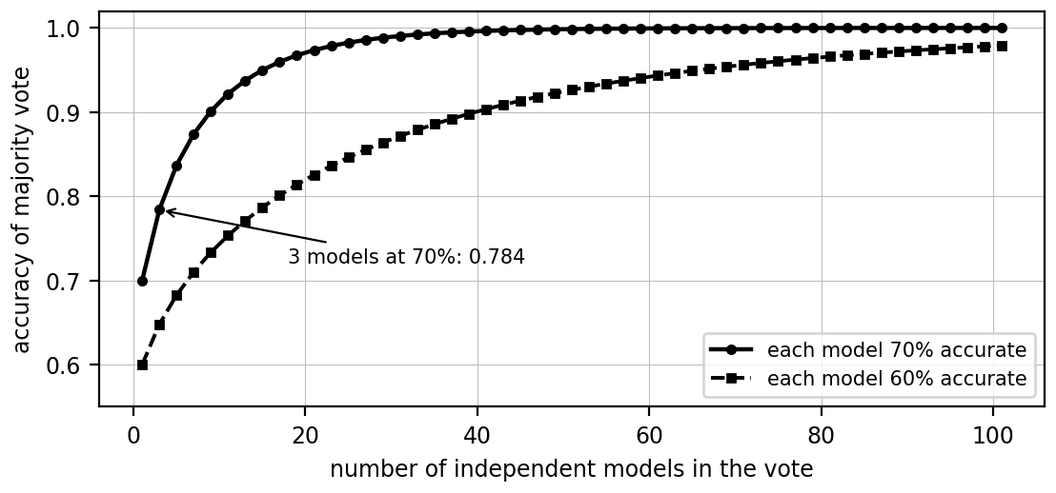
Figure 3. Accuracy of a majority vote of independent models, computed from the binomial formula.

Question 4.3: Why do we use ensembles? List the motivations. (2 marks)
Ensembles are used because several models together are usually more accurate, stable and reliable than one model. They reduce the effect of noise and overfitting, let the other models compensate when one model is wrong, improve robustness and performance on unseen data, and combine the different patterns that different algorithms learn from the same dataset. The cost is extra computation, memory and tuning effort, and a model that is harder to interpret. In the exam, name the motivation and add the matching one line example.
Motivation | Lecture example
Better predictions | Three spam models vote, majority gives Spam
Less variance and overfitting | Random forest instead of one deep tree
Errors compensate | One of three diagnosis models is wrong, majority is right
Robustness and generalisation | Digit recognition on unfamiliar handwriting
Different patterns combined | Tree for rules, logistic regression for probability, neural network for non-linear patterns

Question 4.4: Define bagging. [High chance] (2 marks)
Bagging (Bootstrap Aggregating) trains multiple models on different random subsets of the training data, each drawn with replacement. The models are trained independently, and their predictions are combined by majority voting for classification or by averaging for regression. Because each model sees a slightly different sample, their individual errors differ and cancel out, which reduces variance. The best known example is the Random Forest, which uses many decision trees. In the lecture, bagging turns a low bias, high variance model into a low bias, low variance model.
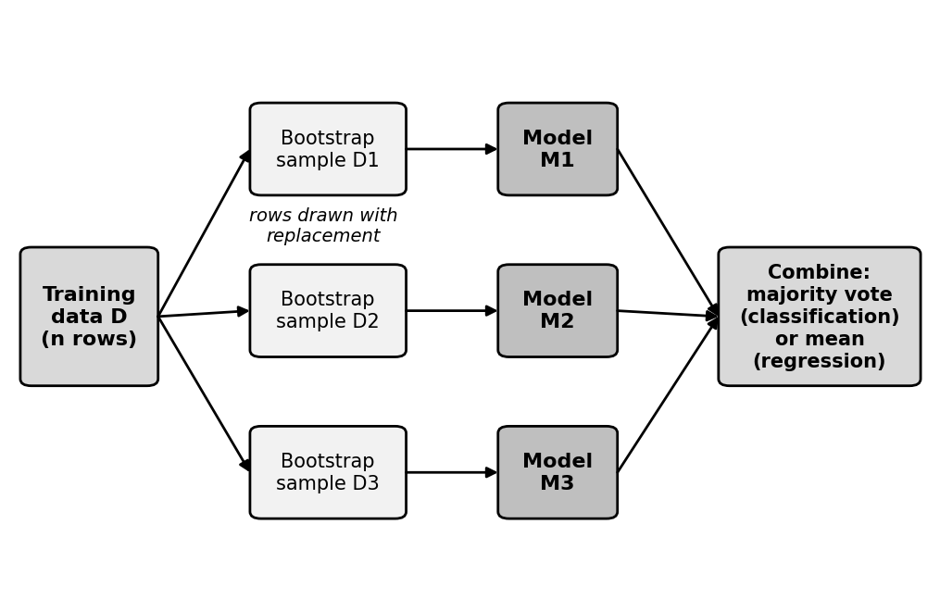
Figure 4. Bagging: bootstrap samples, one model per sample, then a vote or average.

Question 4.5: What is bootstrap sampling (row sampling with replacement)? (2 marks)
Bootstrap sampling means drawing n rows at random from a dataset of n rows with replacement, so the same row can appear more than once and some rows may not appear at all. Each bagging model is trained on one such sample. Example: from rows 1 to 6, one draw is {2, 2, 4, 5, 5, 6}. Rows 1 and 3 are left out and are called out-of-bag rows, which can be used to test the model. About 63.2% of the distinct rows appear in each sample, and about 36.8% are out-of-bag.

Question 4.6: How does a random forest differ from bagging? [High chance] (2 marks)
A random forest is a bagging method whose base model is a decision tree, with one extra step: besides row sampling, feature sampling is used. At each split the tree considers only a random subset of the features. This makes the trees different from each other, so their errors are less correlated and the average is more accurate. It can be used as a classifier, with majority voting, or as a regressor, with the mean of the outputs. The number of trees is a hyperparameter to tune.
Point | Bagging | Random forest
Row sampling | Yes | Yes
Feature sampling | No | Yes
Base model | Any model | Decision tree
Output | Vote or mean | Vote or mean

Question 4.7: Why does bagging reduce variance? (2 marks)
A fully grown decision tree has low bias, because it fits the training data well, but high variance, because it overfits and gives large errors on new data. In bagging many such trees are trained on different samples and their outputs are combined. For classification the majority vote, and for regression the mean, smooths out individual mistakes, so the high variance becomes low variance. The lecture adds that changing 200 samples out of 1000 hardly changes the final output because of majority voting. For independent models with variance σ², the average has variance σ²/B.

Question 4.8: Define boosting. [High chance] (2 marks)
Boosting trains models sequentially, where each new model focuses on correcting the mistakes of the previous ones, like fine tuning. The final prediction is a weighted sum of all models. It combines many weak learners, such as shallow decision trees, into a strong learner. In the lecture, boosting converts a high bias, low variance model into a low bias, low variance model by additive combining. The number of models is set by n_estimators, for example 10, 100 or 1000. Examples are AdaBoost, Gradient Boosting, XGBoost and LightGBM.
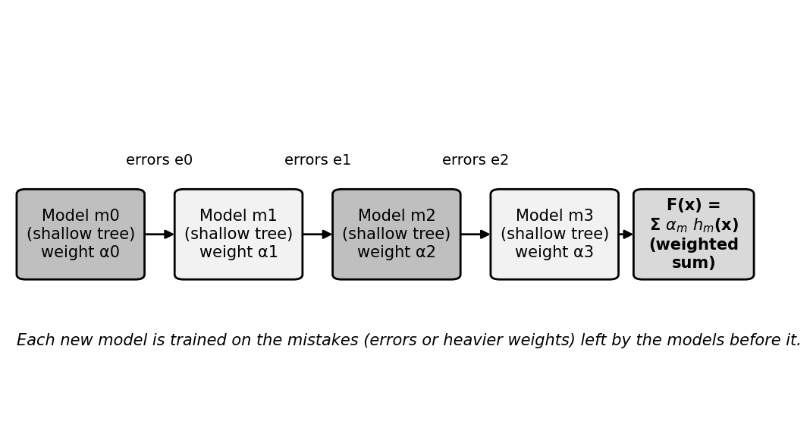
Figure 5. Boosting: models are built one after another, each trained on the errors left by the earlier ones.

Question 4.9: Differentiate bagging and boosting. [High chance] (2 marks)
Bagging builds independent models in parallel on bootstrap samples and combines them with an equal vote or average. Its aim is to reduce variance. Boosting builds models one after another, and each model learns from the errors of the previous one. Its predictions are combined by a weighted sum, and its aim is to reduce bias. Bagging starts with low bias, high variance models, while boosting starts with high bias, low variance models. Random forest is an example of bagging, and AdaBoost and gradient boosting are examples of boosting.
Point | Bagging | Boosting
Training | Parallel | Sequential
Combining | Vote or average | Weighted sum
Starts with | Low bias, high variance | High bias, low variance
Mainly reduces | Variance | Bias
Example | Random forest | AdaBoost, XGBoost

Question 4.10: What is a weak learner? What is a decision stump? (2 marks)
A weak learner is a simple model that performs only slightly better than random guessing, such as a shallow decision tree. Boosting combines many weak learners to form a strong learner, because each one corrects the errors of the earlier ones. A decision stump is the simplest decision tree: it has depth 1, so it asks a single question and makes a prediction from one feature. AdaBoost uses a stump for every estimator. For example, a stump on CGPA predicts Yes when CGPA is at least 9 and No otherwise.

Question 4.11: What is gradient boosting? Write its update formula. [High chance] (2 marks)
Gradient boosting is a technique for regression and classification that builds models sequentially, each correcting the errors of the previous ones. It combines weak learners, such as small decision trees, into a strong learner. Learning happens by minimising a loss function such as MSE. It starts from an initial prediction (the mean for regression), computes residuals, fits a new tree to the residuals and adds it to the model, scaled by the learning rate. The formula is F_{m}(x) = F_{m-1}(x) + η h_{m}(x). The number of trees and the learning rate are the key settings to tune.
Step | Action
1 | Initial prediction F₀ (mean of y)
2 | Compute residuals y - F
3 | Fit a tree on the residuals
4 | Update F = F + η × tree output
5 | Repeat until stopping rule

Question 4.12: What is the role of the learning rate in gradient boosting? (2 marks)
The learning rate η controls how much of each new tree's correction is added to the model. A small value learns slowly and usually generalises better but needs more trees. A large value learns fast but risks overfitting. For example, if student A has residual -15 and the starting prediction is 65, then η = 1 gives 65 - 15 = 50, while η = 0.1 gives 65 - 1.5 = 63.5. The lecture table lists 1.0 as very fast and rarely used, 0.3 as the XGBoost default, 0.1 as balanced, and 0.01 as slow but accurate.
η | Behaviour
1.0 | Very fast, high risk of overfitting
0.3 | Moderate, default in XGBoost
0.1 | Balanced, commonly used
0.01 | Very slow, needs many trees

Question 4.13: What is a residual? Give an example. (2 marks)
A residual is the error of the current model for a data point: residual = actual value - predicted value. A negative residual means the model overpredicts and a positive residual means it underpredicts. In gradient boosting each new tree is trained to predict these residuals. Example from the lecture: the average mark is 65 for all students, so student A with actual mark 40 has residual 40 - 65 = -25, and student D with actual mark 90 has residual 90 - 65 = +25. The tree then learns to correct these gaps.
Student | Actual y | Prediction | Residual
A | 40 | 65 | -25
B | 60 | 65 | -5
C | 70 | 65 | 5
D | 90 | 65 | 25

Question 4.14: How does AdaBoost update the sample weights? (2 marks)
AdaBoost starts with equal weights 1/n. After each stump it finds the total error ε, the sum of the weights of the misclassified samples, and computes the stump's performance α = ½ ln((1 - ε)/ε). Misclassified samples get weight × e^{α}, so they become heavier. Correctly classified samples get weight × e^{-α}, so they become lighter. The new weights are then normalised so that they add up to 1. Example: with ε = 1/3, α = 0.347, and the weights are multiplied by 1.414 for wrong and 0.707 for correct samples. So a stump with a small error gets a large α and a loud vote in the final prediction, and a stump with a large error gets a small say.
Case | New weight
Misclassified | old weight × e^{α}
Correctly classified | old weight × e^{-α}
Normalise | divide by the sum of all new weights

Question 4.15: Why is XGBoost fast and efficient? (2 marks)
XGBoost (eXtreme Gradient Boosting) is an optimised implementation of gradient boosting for tabular data. It is fast because candidate splits across features are evaluated in parallel, data is stored in compressed column blocks that are friendly to the CPU cache, and missing values learn a default branch direction without imputation. For huge datasets it uses a weighted quantile sketch, testing representative split points instead of every value. L1 and L2 regularisation are built in, and a learning rate shrinks each tree's contribution. Together these make it practical on large tabular datasets in finance, healthcare and e-commerce.
Feature | Benefit
Parallel split finding | Faster training
Cache-aware access | Efficient memory use
Sparsity-aware splits | Handles missing values
Weighted quantile sketch | Fast on huge data
Regularisation | Better generalisation
Shrinkage (η) | Controls learning speed

Question 4.16: What are the gradient and the Hessian in XGBoost? (2 marks)
The gradient is the first derivative of the loss with respect to the prediction. It shows the direction and size of the error. The Hessian is the second derivative, which shows the curvature of the loss and tells how large the update should be. XGBoost uses both, a Newton-style step, whereas plain gradient boosting uses only the gradient. For squared error L = (ŷ - y)², the gradient is g = 2(ŷ - y) and the Hessian is h = 2. The leaf weight is then w = -G/(H + λ). The extra curvature information lets XGBoost take better sized steps than plain gradient descent.

Question 4.17: Differentiate L1 and L2 regularisation in XGBoost. (2 marks)
Regularisation is a penalty on complex trees that helps the model generalise to unseen data. In XGBoost the penalties are part of the objective itself. L2 regularisation, controlled by λ, penalises large leaf weights and shrinks them toward zero, giving smoother predictions. L1 regularisation, controlled by α, encourages some leaf weights to become exactly zero, which gives a simpler tree. Example: a tree with 20 leaves may fit noise, and regularisation encourages a tree with fewer leaves. The learning rate η additionally scales each tree. Together with the learning rate, these penalties keep trees simple and reduce overfitting on unseen data.
Point | L2 (λ) | L1 (α)
Effect | Shrinks large leaf weights | Pushes some weights to zero
Penalty | ½ λ Σ w² | α Σ |w|

Question 4.18: Compare LightGBM and XGBoost. (2 marks)
LightGBM is a fast, distributed gradient boosting framework based on decision trees. Its main difference is leaf-wise tree growth: it splits the leaf that gives the greatest reduction in loss, even if that leaf is deeper than the others. XGBoost grows level-wise, splitting the eligible nodes level by level. The leaf-wise method often trains faster and can be more accurate, but it can overfit, which is controlled by limiting the depth. The lecture mentions image segmentation and breast cancer detection as uses of LightGBM. In short: XGBoost is level-wise and balanced, LightGBM is leaf-wise and more aggressive.
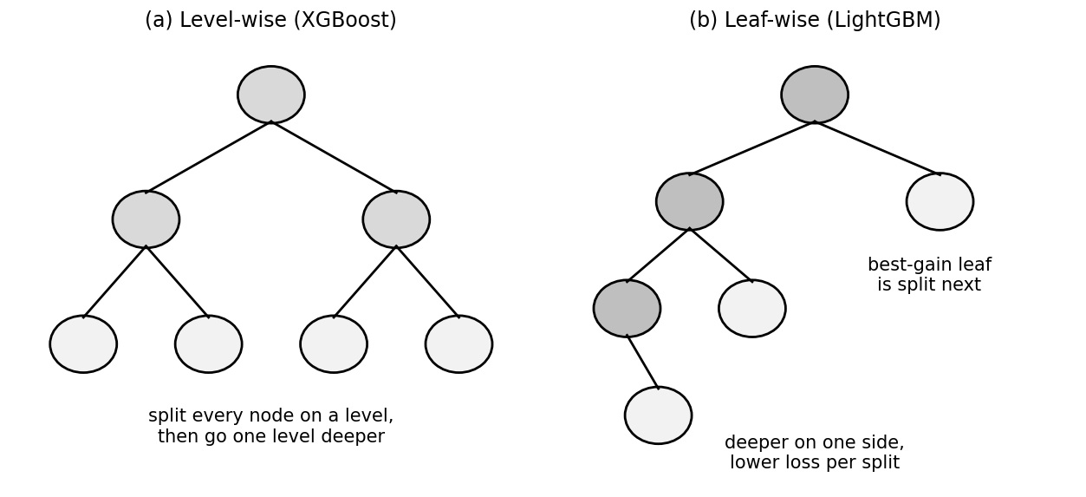
Figure 6. (a) Level-wise growth in XGBoost, (b) leaf-wise growth in LightGBM.

Question 4.19: What is stochastic gradient boosting? (2 marks)
Stochastic gradient boosting is a gradient boosting technique in which each new decision tree is trained on a randomly selected subset of the training data instead of the whole dataset. Like ordinary gradient boosting, each tree corrects the errors of the existing ensemble, but the random sampling reduces computation and helps reduce overfitting. The key parameter is subsample. A smaller value adds more randomness, but a value that is too small reduces learning quality. The subset is generally drawn anew for every boosting iteration. A value of 1.0 would mean ordinary gradient boosting, since every row is used.
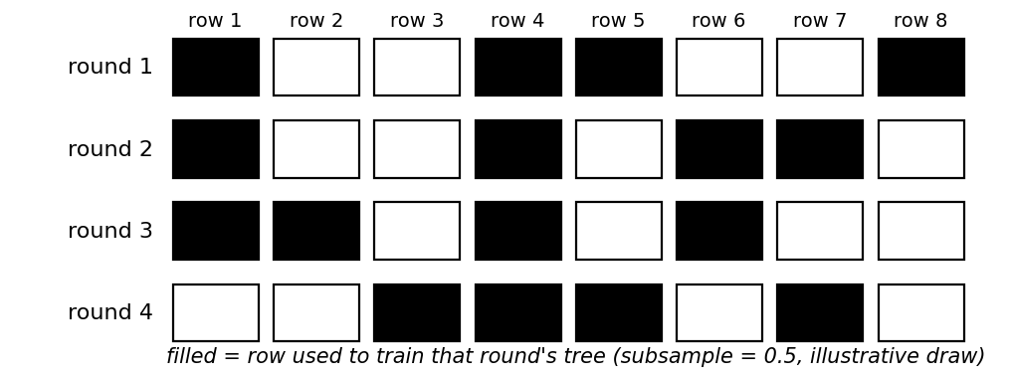
Figure 7. Rows used in each round when subsample = 0.5 (illustrative draw).

Question 4.20: Differentiate homogeneous and heterogeneous ensembles. [High chance] (2 marks)
In a homogeneous ensemble all base models are of the same type. Bagging and boosting are examples, because they use the same type of base learner with weighted inputs or contributions. In a heterogeneous ensemble the base models are of different types, such as SVM, ANN and decision trees. Stacking is the standard example. A heterogeneous ensemble can capture different kinds of patterns, but it needs a way to combine the outputs, usually another model called a meta-learner. In short, bagging and boosting repeat one kind of model, while stacking mixes different kinds.
Point | Homogeneous | Heterogeneous
Base models | Same type | Different types
Examples | Bagging, boosting | Stacking
Combining | Vote, average, weighted sum | Meta-learner

Question 4.21: What is stacking? (2 marks)
Stacking is a heterogeneous ensemble method. It first trains different types of models, for example a decision tree, logistic regression and an SVM, which are the base models. Their predictions are then given as input to another model, called the meta-learner, which learns how to combine them into the final prediction. The lecture example is a neural network combining the predictions of decision trees and logistic regression. Stacking can outperform each base model, but it is more complex and harder to interpret. Training the meta-learner on predictions made for data the base models did not see helps avoid leakage.
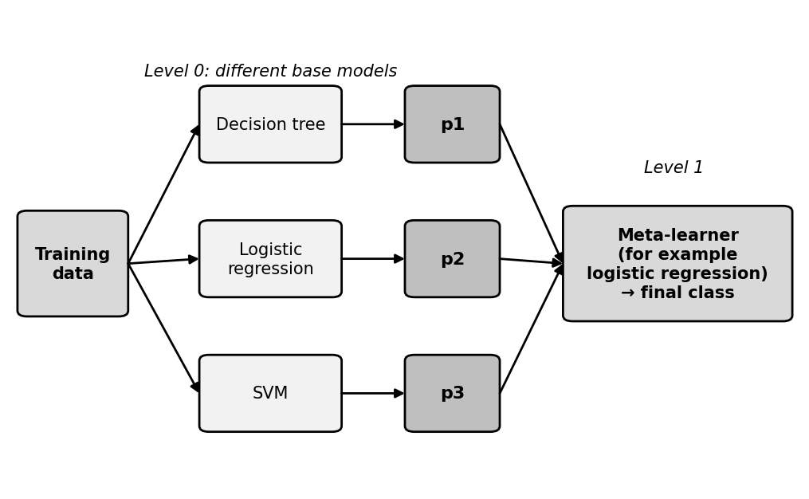
Figure 8. Stacking: different base models feed a meta-learner that gives the final class.

Question 4.22: State the advantages and disadvantages of ensemble learning. (2 marks)
Ensemble learning improves accuracy compared with a single model, reduces overfitting by averaging many models, and works well for complex problems. Its drawbacks are that it needs higher computation and memory, it is harder to interpret, especially when many models are combined, and it requires careful tuning of parameters. Choose an ensemble when one model is not accurate or stable enough and the extra cost is acceptable. In the exam, give at least two points on each side, as the lecture lists three advantages and three limitations in total.
Advantages | Disadvantages
Higher accuracy | More computation and memory
Less overfitting | Harder to interpret
Good for complex problems | Careful tuning needed

Unit 5: Case Studies in Text Mining
Likely 2 mark questions from the Unit 5 slides (survey analysis, question answering, persuasion by the numbers). Ma'am said the two 2 mark questions are direct, so definitions and short lists are the most likely. Each answer is about 100 words.

Question 5.1: What is survey analysis in machine learning? [High chance] (2 marks)
Survey analysis in machine learning uses algorithms to automatically extract patterns, themes and sentiment from large sets of survey responses, especially open-ended text. A survey has numerical answers, such as a rating from 1 to 5, and text answers, such as comments. Text mining and natural language processing (NLP) are used to understand the text. The objective is to transform unstructured text feedback into structured, quantifiable data, so that an organisation understands what respondents want, need and feel. It saves the time of reading thousands of comments by hand.
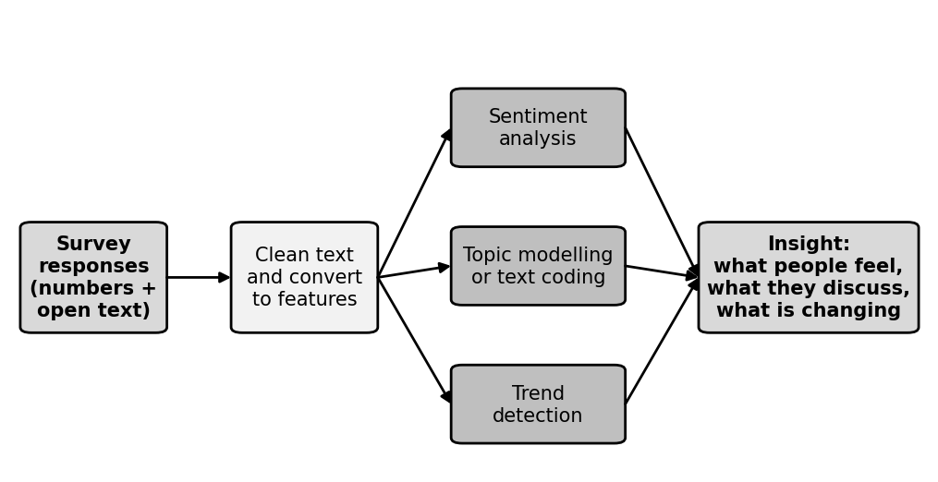
Figure 9. Survey analysis pipeline: responses are cleaned, analysed by three techniques and turned into insight.

Question 5.2: Differentiate quantitative and qualitative survey responses. (2 marks)
Quantitative responses are numerical data that can be counted and averaged, such as rating the quality of teaching from 1 to 5. Qualitative responses are descriptive or textual data, such as explaining what you liked about the teaching. Traditional statistics handles quantitative data well, while text mining and NLP are needed for qualitative data. Using both gives a fuller picture. Example from the slide: 500 students rate teaching and the average is 3.8 out of 5, and 300 comments show that students like faculty support but want more laboratory time.
Type | Meaning | Example
Quantitative | Numerical data | Rate teaching from 1 to 5
Qualitative | Descriptive or textual data | Explain what you liked about teaching

Question 5.3: What is sentiment analysis? Give examples. [High chance] (2 marks)
Sentiment analysis identifies whether the opinion in a piece of text is positive, negative or neutral. It helps an organisation see how respondents feel without reading every comment. Models such as logistic regression classifiers or BERT can do this after training on labelled text. In the telecom scenario, sentiment analysis showed negative sentiment spikes after network outages in certain regions, so the company prioritised upgrades there. Emotion mining goes a step further and detects emotions such as joy, anger or fear. Counting positive and negative words is the simplest approach, and trained classifiers handle context better.
Comment | Sentiment
The teacher explains concepts clearly | Positive
The laboratory sessions are too short | Negative
The course contains five units | Neutral

Question 5.4: What is topic modelling? (2 marks)
Topic modelling is a technique that automatically discovers the main topics in a large collection of text without any pre-assigned categories. A common algorithm is Latent Dirichlet Allocation (LDA). Words that often occur together form a topic. In the slide, the words teacher, explanation and faculty form the topic Teaching quality, while computers and equipment form Laboratory facilities. In the telecom case, LDA showed that billing confusion and slow internet were common themes, so the company launched a billing FAQ and improved network speed in the affected areas.
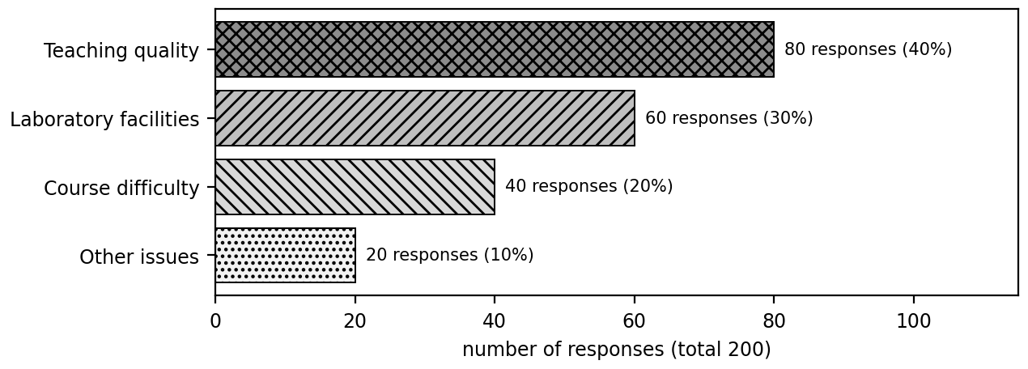
Figure 10. Topics found in 200 responses: 80, 60, 40 and 20 (data from the lecture table).

Question 5.5: Differentiate automated text coding and topic modelling. [High chance] (2 marks)
In text analysis, coding means assigning each comment to a category. Automated text coding uses a classifier trained on labelled comments to put new comments into predefined categories. For example, 'There are not enough computers' is assigned to Infrastructure. Topic modelling needs no labels: it discovers the topics from the data itself. Coding answers 'which of my known categories does this belong to?', while topic modelling answers 'what themes exist in this text?'. In the telecom case, coding tagged thousands of responses as technical issue, customer service or pricing.
Point | Text coding | Topic modelling
Categories | Predefined | Discovered from data
Labels needed | Yes | No
Example | Comment tagged Infrastructure | LDA finds a billing theme

Question 5.6: What is pattern and trend identification in survey analysis? (2 marks)
Pattern and trend identification finds recurring problems and changes in feedback over time, using techniques such as decision trees or clustering. In the slide, internet complaints rise from 20 to 35 to 60 over three semesters, while teaching complaints fall from 40 to 32 to 25. This shows that the main concern is moving from teaching to internet. The lecture warns that a relationship between two factors does not prove that one causes the other, so the findings should be investigated before action is taken.
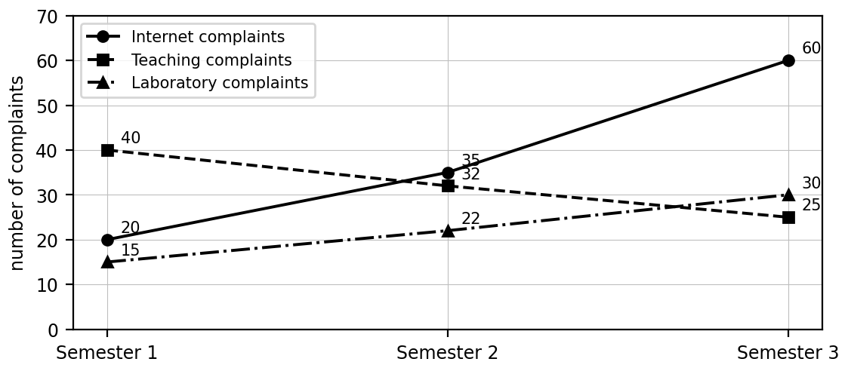
Figure 11. Complaints per semester from the lecture table.

Question 5.7: What is enhanced survey design? (2 marks)
Enhanced survey design means using the results of earlier surveys, analysed with machine learning, to improve future surveys. The analysis shows which questions give useful answers and which are vague. Vague questions are replaced with targeted ones, which increases response quality and completion rates. Example from the slide: if students keep mentioning internet problems in comments, the next survey adds specific questions about internet connectivity. In the telecom case, ML analysed past surveys to see which questions gave useful responses, and the company redesigned the weak ones.

Question 5.8: List the benefits of ML-based survey analysis at the telecom company. (2 marks)
The telecom company received thousands of feedback responses and used text mining and ML to analyse them. The main benefits are efficiency, scalability, accuracy, deeper insights and faster decisions. It analysed more than 50,000 responses in hours instead of weeks, handled feedback from millions of users, reduced manual coding errors and bias, discovered hidden issues such as billing confusion, and launched service improvements within days of receiving feedback. Overall the company moved from slow manual reading to quick, data-driven service improvements, which is the main point to write in a scenario answer.
Benefit | Impact
Efficiency | 50,000+ responses analysed in hours instead of weeks
Scalability | Feedback from millions of users handled
Accuracy | Fewer manual coding errors and less bias
Deeper insights | Hidden issues such as billing confusion found
Faster decisions | Improvements launched within days

Question 5.9: What is question answering (QA) in predictive analytics? [High chance] (2 marks)
Question answering lets a user ask a question in natural language and receive an answer from data, model results or documents, instead of searching and reading manually. The system finds the relevant information and presents it. In predictive analytics a telecom manager could ask: How many customers are likely to leave next month? Which customers have the highest churn risk? What factors are linked to churn? What would happen to predicted churn if we offered a discount? The difficulty is that human language is complex and much of the data is unstructured text.

Question 5.10: What are ambiguity and coreference resolution in QA? (2 marks)
Ambiguity means the same word or sentence can have different meanings depending on context. The system must understand the context to answer correctly. Coreference resolution means recognising that different words refer to the same entity, such as linking 'He' to the person named in the previous sentence. Both are linguistic and semantic challenges, because without them the system may retrieve or extract the wrong answer from the text. Resolving them correctly is a basic step before the system can find the exact answer.
Term | Example
Ambiguity | 'The bank is near the river' versus 'I deposited money in the bank'
Coreference | 'Barack Obama was the president... He served two terms': He refers to Obama

Question 5.11: List the main challenges of question answering in text mining. [High chance] (2 marks)
The lecture groups the challenges into five areas. Linguistic and semantic challenges include ambiguity, coreference resolution and complex questions with negation, hypotheticals or several parts. Data and knowledge representation challenges are unstructured data and the need for domain-specific knowledge. Information retrieval challenges are choosing the right document and extracting the exact answer. Technical limits are limited training data and high computational cost. Ethical and practical challenges are bias and fairness, and explainability. In the exam, name the five groups first and then give one example for each.
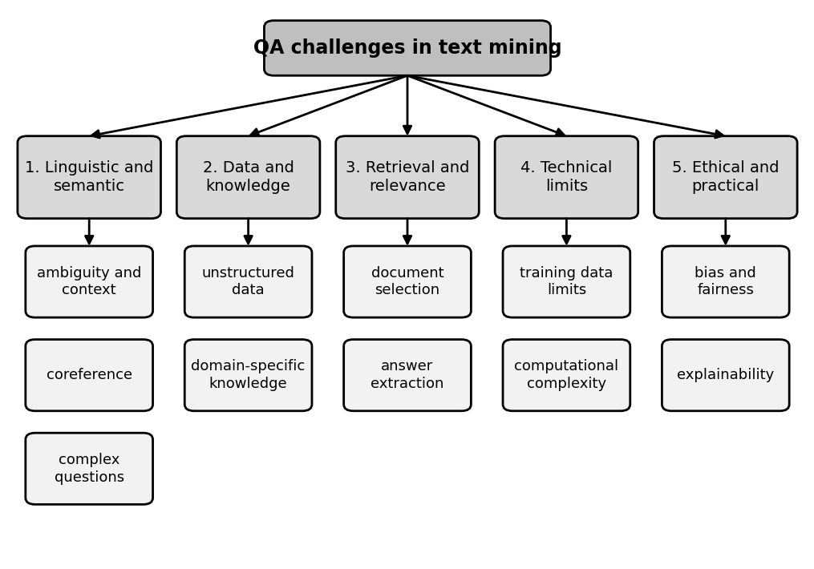
Figure 12. The five challenge groups in question answering.

Question 5.12: How can the challenges of QA be addressed? (2 marks)
Four approaches are given in the slide. Deep learning learns complex language patterns, for example a transformer understanding the context of a question. Transfer learning adapts a model trained on large data to a specific task, such as fine-tuning BERT for medical QA. Hybrid approaches combine neural networks with rule-based or symbolic reasoning. Retrieval-Augmented Generation (RAG) first retrieves relevant documents and then generates the answer. These methods reduce the problems but do not remove them completely. In the exam, name the approach and give its one line example from the slide.
Approach | Example
Deep learning | Transformer understands question context
Transfer learning | Fine-tuning BERT for medical QA
Hybrid approach | NLP plus a rule engine checking policy
RAG | Retrieve documents, then generate the answer

Question 5.13: What is Retrieval-Augmented Generation (RAG)? (2 marks)
Retrieval-Augmented Generation is an approach in which the system first retrieves the documents relevant to a question and then generates the answer using the retrieved text. Grounding the answer in real documents improves factual accuracy and lets the system show its evidence, which helps explainability. It helps with document selection and answer extraction, but it does not guarantee that every answer is correct, so the retrieved sources should still be checked. It is the recommended starting point when answers must be backed by a source.
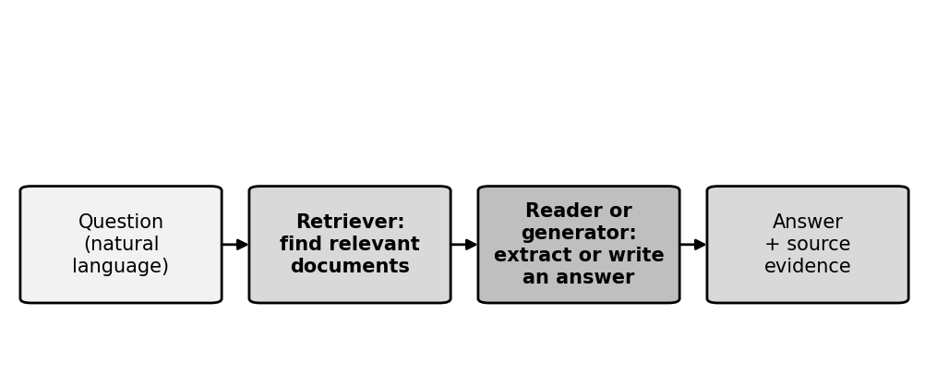
Figure 13. RAG pipeline: retrieve, then extract or generate, then show evidence.

Question 5.14: What is 'Persuasion by the numbers'? [High chance] (2 marks)
Persuasion by the numbers means using text mining and machine learning to measure how persuasive a piece of language is. A persuasive message tries to influence what people think, feel or do, for example a political speech, an advertisement or a review. Instead of asking people, the text is analysed for features such as rhetorical strategies, emotion, sentiment and style, and these are converted into numbers, such as a persuasion score. Applications include marketing, politics, social media, customer service and education. The score shows persuasive cues in the text. It is a guide and does not prove the effect on real people.

Question 5.15: Explain ethos, pathos and logos with examples. [High chance] (2 marks)
Rhetoric is the use of language to convince an audience, and there are three classical strategies. Ethos appeals to credibility, authority and trust. Pathos appeals to emotions such as hope, fear or sympathy. Logos appeals to logic, facts and statistics. Text mining detects them by finding references to experts, emotional words and numerical claims. The slide notes that numbers and evidence words can be found, but the claims still need to be verified. Real messages often mix all three strategies, for example an advert citing experts, a happy story and a statistic.
Strategy | Appeals to | Example
Ethos | Credibility | Recommended by experienced cardiologists
Pathos | Emotion | Help children build a brighter future
Logos | Logic and facts | Reduced processing time by 40% in testing

Question 5.16: How is a persuasion score produced? (2 marks)
The process has four steps. First, collect text such as adverts, speeches, tweets or reviews. Second, extract features such as keywords, emotional tone, repetition, statistics and credibility markers. Third, train a machine learning model on texts labelled as persuasive or not persuasive. Fourth, use the model to predict a persuasion score. In the slide, the advert 'Trusted by leading experts. Join thousands of happy customers today!' scores 82 out of 100, while 'This product contains 500 ml of liquid' scores 35 because it is mostly factual. These scores are illustrative.
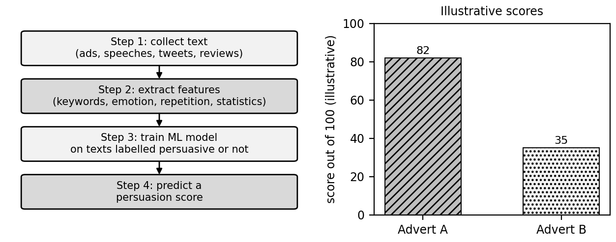
Figure 14. Persuasion analysis pipeline and the lecture's illustrative scores.

Question 5.17: Explain repetition, hyperbole and framing as stylistic features. (2 marks)
Stylistic features are the ways language is shaped to persuade. Repetition repeats words or phrases to reinforce an idea. Hyperbole is deliberate exaggeration to create impact. Framing presents the same information in a way that steers interpretation. Text mining quantifies these with n-gram analysis, which finds frequent word sequences such as 'limited time offer', with syntactic parsing, which studies grammatical structure, and with keyword extraction, which finds important terms. These features become numbers that a model can use to predict a persuasion score.
Feature | Example
Repetition | Save more. Spend less. Live better.
Hyperbole | The best phone in the entire world!
Framing | 90% survival rate versus 10% mortality rate

Question 5.18: State the limitations of measuring persuasion with text mining. (2 marks)
A persuasion score only measures persuasive cues in the text. It does not prove that real people will be convinced, because persuasion also depends on the audience, the context, trust and delivery. The slide lists these limitations: context sensitivity, cultural differences, bias inherited from the training data, and lack of explainability, since it is not always clear why a text received a score. For the future, it proposes real-time feedback on persuasive writing and ethical frameworks to prevent manipulative language. So the score should be used as a guide, not as proof of persuasion.

