QFHMIX01C
UHF frontend.

UHF frontend QFHMIX01C
Overview
QFHMIX01A is a UHF front-end purposed to work with four-port QHA antenna. Front-end operating form 300 MHz to 520 MHz.

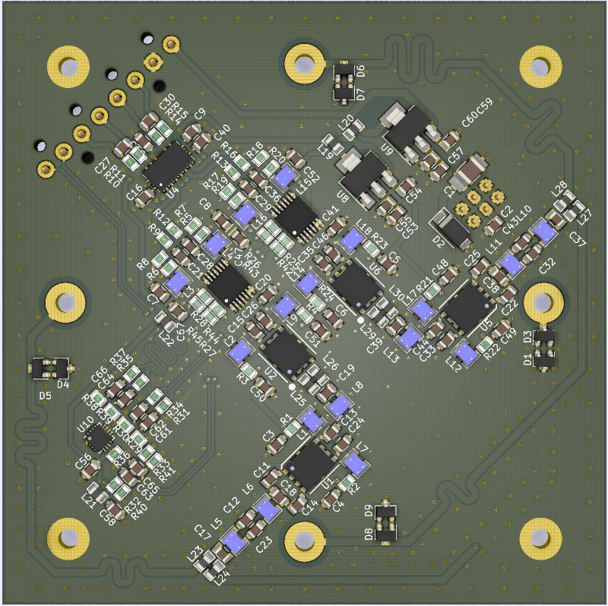

QHA antenna construction based on the four half-loops, which are connected togther on the one side and the terminated with the 40-50Ω port on the other side. The signal from each port have a phase shiftt 90º in compare to the next port.
0º

90º
270º

180º

The two single 50Ω ports with 180º phase shift can be considering as one differential 100Ω port. In this case the QHA antenna have two loops with 100Ω differential output ports with phase shift 90º in compare to each other. In this view, the QHA antenna function is the same as IQ demodulator function. The signals from each loop can be considered as I and Q signals and should be processed independently but in same way.

I

Q

CLK

The front-end have two processing lines fo I and Q signals. Each line contains LNA, mixer, ADC buffer. The front-end contains also clock buffer and power stabilizers . Module have two differential 100Ω ports for antenna, one differential LVPECL input for the clock signal and two 100Ω differential outputs for I and Q signals.
LNA.
The LNA structre contains the blocks concatenated from antenna input port to IQ demodulator input in this way: first BPF, gain block, second BPF, second gain block. First BPF is the 2-pole filter, which purpose is attenuate the signals outside of the band of interest, and thereby protect the first gain block from overdriving. The filter passband is from
380 MHz to 560 MHz (bandwidth: 180MHz) and have attenuation 1.7 dB.

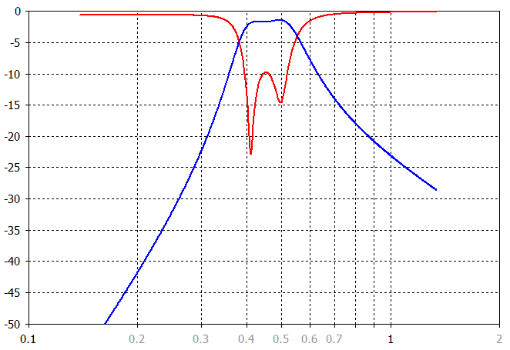

First gain block is based on the MPGA-105 chip from Minicircuits. In our application it have NF: 1.8dB, gain: 15dB and OIP3: 37.6dB.

Second filter is the 5-pole band pass filter. It have narrower bandwidth than first filter: 177Mhz (from 380 MHz to 557 Mhz) and passband attenuation 1.4dB.

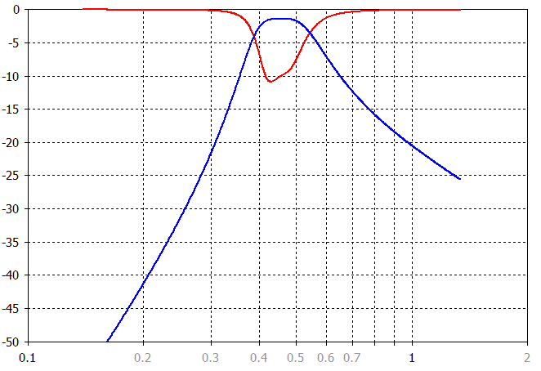

Second gain blok is based on the chip MGVA-63 from Minicircuits. This gain block have NF: 3.6dB, gain: 21.5dB and OIP3: 34.3dB.

Whole LNA part have this parameters: NF: 4.75dB and gain: 31.6dB

Mixer.
The purpose of the mixer is the converting received signals to the baseband. It is based on the AD8343 chip from Analog devices. The clock input of the mixer is connected to the clock buffer. The output is connected to the ADC buffer.

Clock buffer
Clock buffer is needed for the restoring clocks distributed by the wire, which connecting the base station electronic (DDS clock generator, ADC, etc.) and antenna electronic (frontend). As the clocks frequency is from 385 MHz to 525 MHz as clock buffer the Si53322 chip from Silicon labs with frequency range from DC to 1250MHz was chosen.

ADC buffer

The IQ signals, which are on the IQ demodulator output should be directed to the ADC input. For this is necessary lead signals trough the LPF to cut off the higher frequencies. In our case we use 10MHz bandwith of the baseband. So filter should cut off the frequencies higher than 10MHz. Also is necessary amplify IQ signals for the distribution by the cable from frontend to base station. For this purpose the LT6604-10 chip from Analog devices was chosen. This chip is the dual differential amplifyer with 10MHz lowpass filter. The output is the 100Ω differential.

Power stabilizers
The frontend electronic uses the power with the 3.3V and 5V voltages. For their generation from the input power the LM1117-5 and LM1117-3.3 are used.

PCB
PCB is produced from the 1.6mm thick FR4 laminate. All components, excludes the connectors, are SMD. The block of the frontend are separated to the different zones.
The frontend outputs IQ signals, input clock signal and power supply voltage are connected to the one IDC381-8-110 KRONE connector on the top side of the PCB. The parts are soldering on the bottom side of the PCB. The top side is the GND layer with some signal jumpers and power voltage tracks.
