VHM GUI USAGE

To start using the Raspberry Pi as a Virtual Heart Model, run “ALL_IN_ONE_BOARD.m” and a dialog box like the one shown below appears

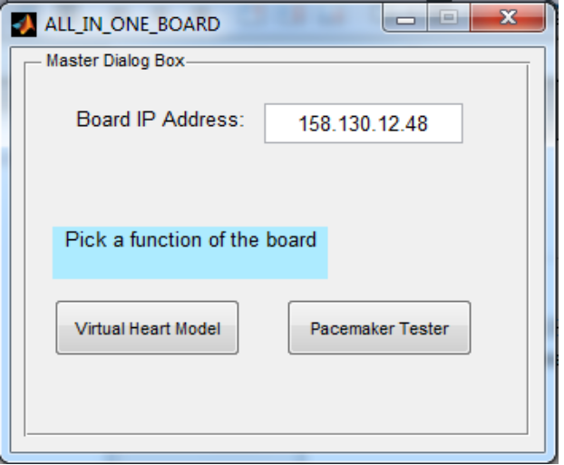

Enter the IP address of the board as shown on the LCD (for more information on how to navigate the LCD Menu, please refer section Titled “LCD Menu”). If the LCD shows the IP as 0.0.0.0, it probably means that the board was unable to acquire an IP automatically, please make sure that an ethernet cable connects the Raspberry Pi and your network. The IP can be shown as 0.0.0.0 even when you have connected the kit to the Ethernet port of your computer. If this is the case, you have to set the IP of the board manually. You also may have to manually set the IP of your computer. Use the command “netsh interface ipv4 set address name="Ethernet" source=static address=192.168.90.91 mask=255.255.255.0 gateway=198.168.1.1” to set the Ethernet IP to 192.168.90.91 on Windows machines. Make sure that the manually set IP of your computer and the IP of the board have “compatibility”. Refer the section “Setting an IP for the board” for information on how to use the buttons on the LCD KIT to set a suitable IP.

Once you have everything in order, click on the “Virtual Heart Model” button and this triggers the GUI related to VHM. The current dialog box closes and you are prompted for action with a new dialog box as shown below

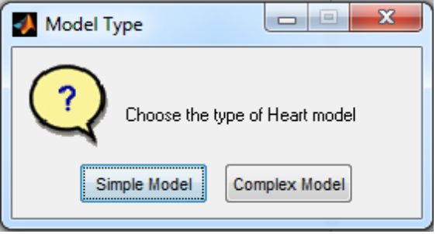
Click on the “Simple Model” button to use a simple abstraction of heart model.
You should see the below GUI open up.

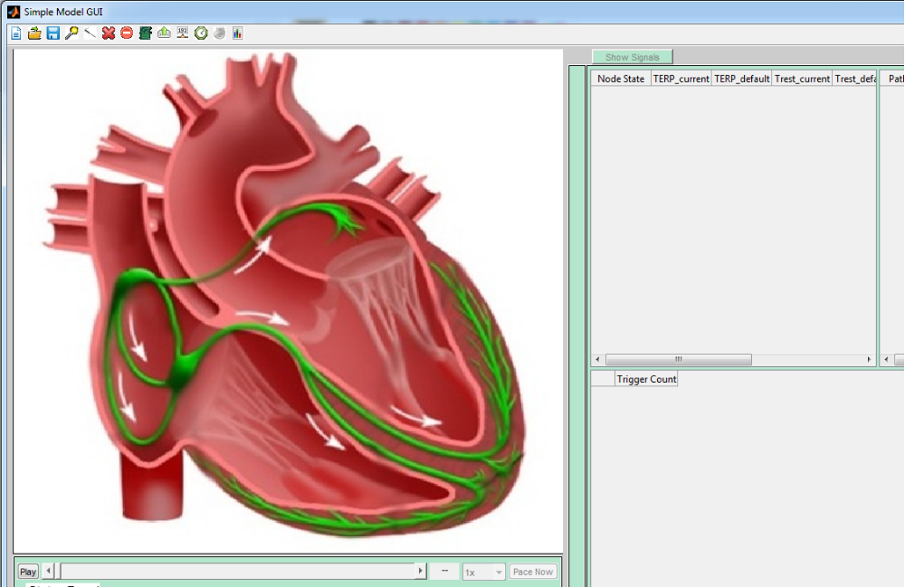

VHM GUI COMPONENTS

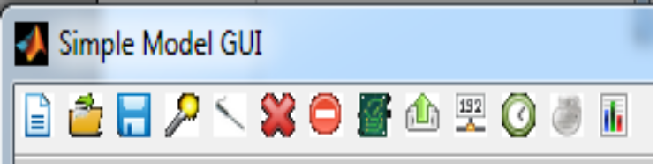
The first button, “new file”, is used to start from scratch, this allows you to create a heart model without any reference.

The easiest way to get acquainted with the GUI is by using a built-in standard heart model and working our way from there. The second button, “Open file”, opens a dialog box like this
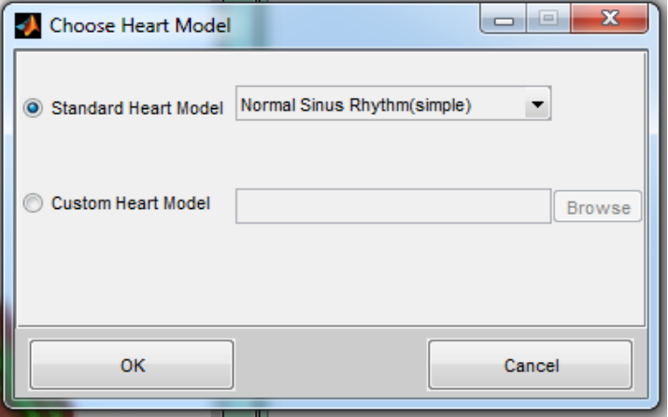
We will use a simple heart model for our demonstration, by default, the “Standard Heart Model” is selected by the dialog box, click on the down arrow to select any standard model of your choice. Click on OK to use Normal Sinus Rhythm for now.

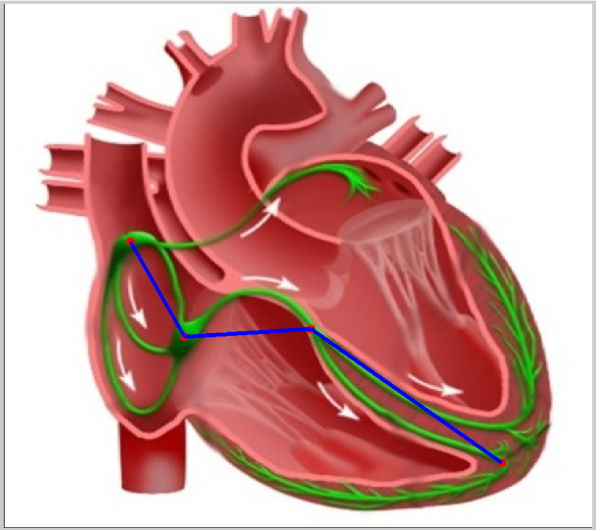
The blue lines you see on the heart are the paths for electrical conduction and the red dots at the end of paths are the nodes out of which some are source of electrical excitation in the heart. For more information about the topology of this and many more models, click on the following link http://medcps.org

Before fiddling with this simple model, let's check if this model works with the board. Click on the play button at the bottom left, pray to God for a few seconds. If God heard you, you should see a non zero heart rate on the top right corner of the heart with the nodes and paths changing colors. If aforementioned celebration didn't happen, be a man, buckle up, have a look at the “Status Panel” below the play button.

The status panel may look like this in our current situation.
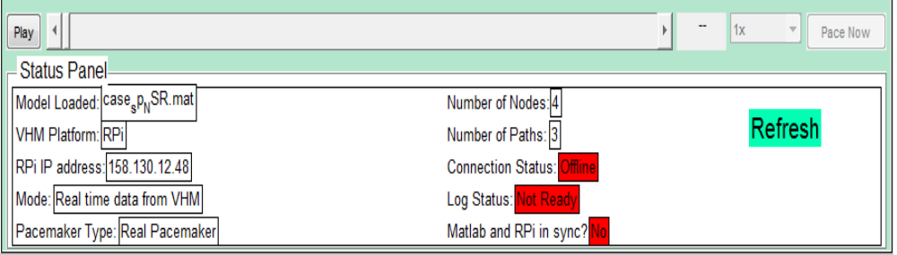

If the Panel says that the connection status is Offline, it either means that the IP address mentioned to its left, “RPI IP address”, is not what the board's IP address is or your computer is not configured with the right IP address. Please navigate to the IP address option on the LCD menu to make sure the IP addresses on the Status Panel matches with it. If there is a mismatch, this is the time to introduce a new button on the GUI.
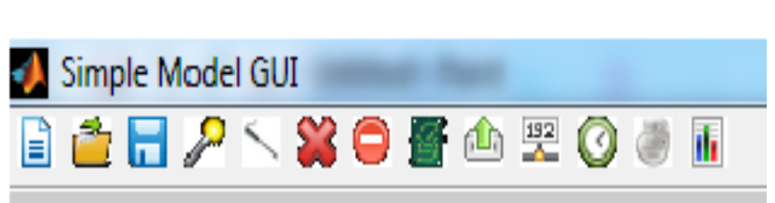

The tool button pointed to is used to set the IP address of the board, click on the button and the below box opens up
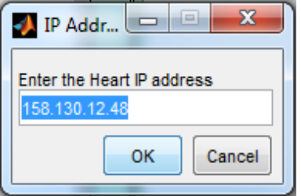
Type in the IP address shown on the LCD and click OK, this change should be reflected on the Status Panel. Press the “Play” button on the bottom left of the heart image and check if the paths and nodes change colors and a non zero heart rate is displayed.

If there is still a lack of activity, try pinging the board, if the ping fails, make sure that your computer has compatible IP settings with the board.

VHM GUI COMPONENTS CONTD.

Now that the connection

