Chess in the Park
Sunday, July 27 1:00 - 6:00 PM
Join the Waukesha Chess Club for a Sunday afternoon in the park. July 27 from 1:00 - 6:00
Mitchell Park in Brookfield
19805 W Capitol Dr, Brookfield
(follow signs to the Sharon Lynne Wilson Center for the Arts – we are next door).
We will be serving hamburgers, hot dogs, brats, chips, soda and a good time.

Bring your tailgate games such as ladder toss, corn hole, pocket passer and anything else. We will have chessboards and clocks for a speed tournament. You are invited to bring your own clock and set.

I need a head count for planning purposes so please let me know if you are coming. Friends are welcome!
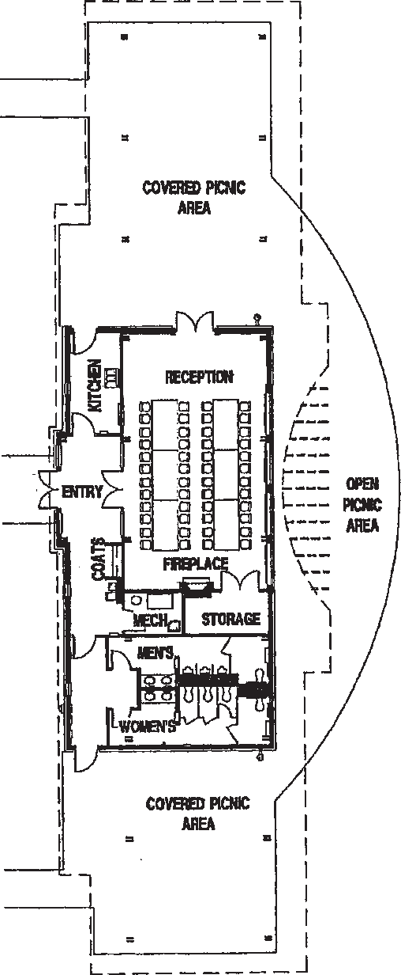
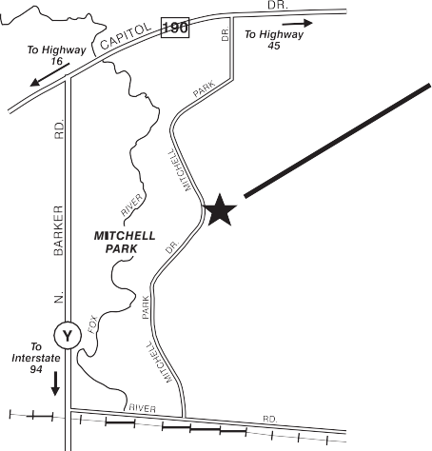
MITCHELL PARK PAVILION
19900 RIVER ROAD
NORTH SHELTER
LODGE

SHARON LYNNE WILSON CENTER FOR THE ARTS
SOUTH SHELTER

RSVP
Contact Kevin Klandrud
262-269-7052
kklandrud@wi.rr.com

