***Chess in the Park***

**Sunday, July 14 1:00 - 6:00 PM**

Join the Waukesha Chess Club for a Sunday afternoon in the park. July 14from 1:00 - 6:00

**Mitchell Park** **in Brookfield**

**19805 W Capitol Dr, Brookfield**

*(follow signs to the Sharon Lynne Wilson Center for the Arts – we are next door).*

We will be serving hamburgers, hot dogs, brats, chips, soda and a good time.

Bring your tailgate games such as ladder toss, corn hole, pocket passer and anything else. We will have chessboards and clocks for a speed tournament. You are invited to bring your own clock and set.

**I need a head count** for planning purposes so please let me know if you are coming. Friends are welcome!

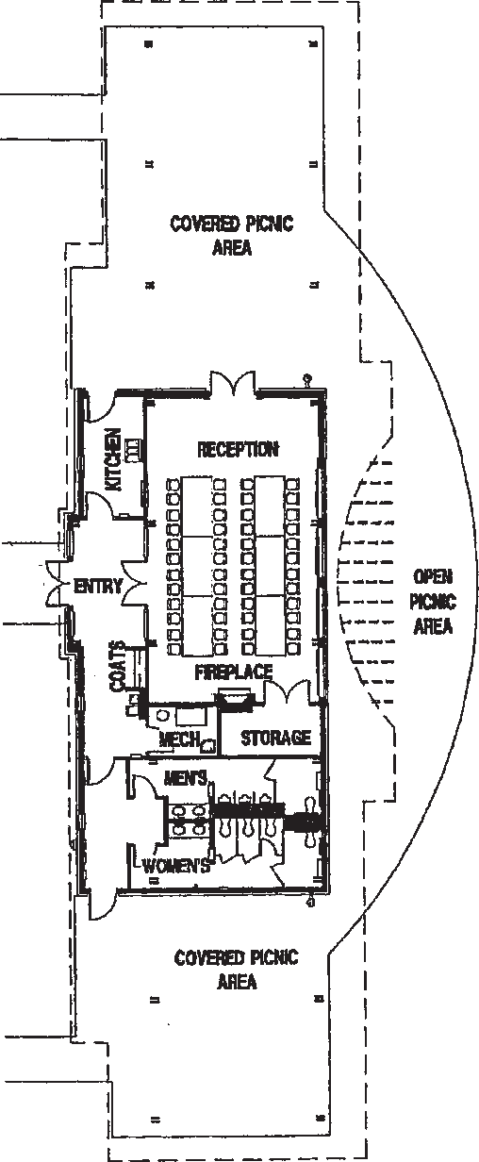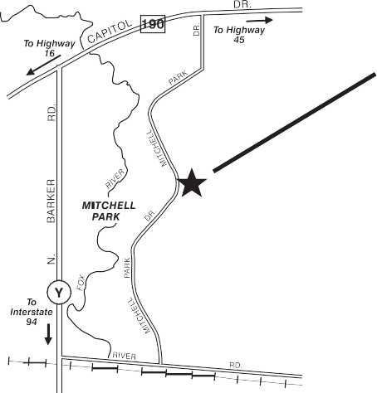

**MITCHELL PARK PAVILION**

**19900 RIVER ROAD**

**NORTH SHELTER**

**LODGE**

**SHARON LYNNE WILSON CENTER FOR THE ARTS**

**SOUTH SHELTER**

**RSVP**

Contact Kevin Klandrud

262-269-7052

kklandrud@wi.rr.com