 

15SEP2018

Dear Fellow Kings Gate Condo Owner,

I hope you’re keeping safe and well stocked in this hurricane season.

The marketing activity for our island is as follows:

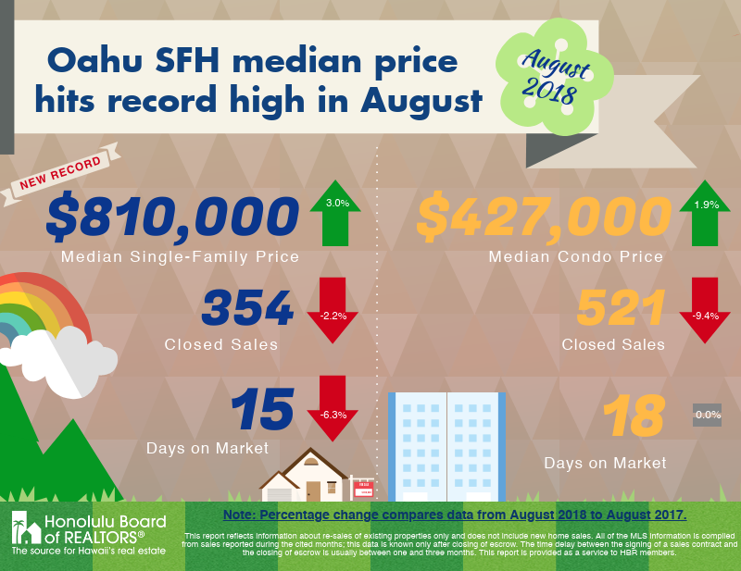

Thank you again for making my business a success. If you or anyone you know are thinking of buying or selling real estate in Hawaii, I would like to help. I ***love*** to reward referral sources. You can call or text message me at my cell: (808) 436 7459 or email me at [mlacks@newstarrealty.com](mailto:mlacks@newstarrealty.com) for any real estate questions you have.

Have a great day!

Michael Lacks,  
Newstar Realty



**Michael Lacks (RA)**

**New Star Hawaii Top Realty**

**(808) 436-7459 RA 808-99**

**Website:**[**Lacksan.com**](https://nam05.safelinks.protection.outlook.com/?url=http%3A%2F%2Fjeannieyu.newstarrealty.com%2F&data=02%7C01%7C%7Cf1e70c9e213b48002dd608d5cf700ed8%7C84df9e7fe9f640afb435aaaaaaaaaaaa%7C1%7C0%7C636643002544938029&sdata=9Ppv%2BMXHYDu2MZ12AueowkBwC%2FF9XB1Dyn3FLobZeqo%3D&reserved=0)

**The Thy Kingdom Come, Thy will be done, on earth as it is in Heaven. (Matt 6:10)**