 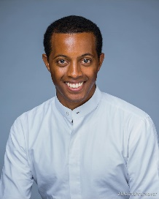

14SEP2018

Dear Fellow Kings Gate Condo Owner,

After you have purchased your home you may want to consider protecting your investment. Sometimes life brings unfortunate challenges. And disasters can happen.

As a fellow homeowner, it is my strong recommendation that you consider speaking with an attorney regarding placing your property into a trust.

A trust is needed should any homeowner become incapacitated or deceased as it transfers your property in the most seamless and non-litigious manner to a relative or loved one without involving probate and the courts.

I have several recommendations for attorneys who are fairly cost-effective in representing your needs in building a trust or doing other estate planning. Please don’t hesitate to ask!

Thank you again for making my business a success. If you or anyone you know are thinking of buying or selling real estate in Hawaii, I would like to help. I ***love*** to reward referral sources. You can call or text message me at my cell: (808) 436 7459 or email me at [mlacks@newstarrealty.com](mailto:mlacks@newstarrealty.com) for any real estate questions you have.

Have a great day!

Michael Lacks,  
Newstar Realty



**Michael Lacks (RA)**

**New Star Hawaii Top Realty**

**(808) 436-7459 RA 808-99**

**Website:**[**Lacksan.com**](https://nam05.safelinks.protection.outlook.com/?url=http%3A%2F%2Fjeannieyu.newstarrealty.com%2F&data=02%7C01%7C%7Cf1e70c9e213b48002dd608d5cf700ed8%7C84df9e7fe9f640afb435aaaaaaaaaaaa%7C1%7C0%7C636643002544938029&sdata=9Ppv%2BMXHYDu2MZ12AueowkBwC%2FF9XB1Dyn3FLobZeqo%3D&reserved=0)

**The Thy Kingdom Come, Thy will be done, on earth as it is in Heaven. (Matt 6:10)**