Electronic supplementary materials

Table S1. List of species used in the two common garden experiments with their habit, preferred distribution (based on abundance), range (based on presence/absence), site of collection (CL = Clayton, PNM = Metropolitano, PNS = Soberanía, PNSL = San Lorenzo), and whether it was used in the first, second or both experiments. Current species names, ranges and distributions were obtained from the sources detailed in previous publications (Brenes-Arguedas et al. 2008, 2009, references in the main text).
spcode | Species name | Family | habit | Preferred distribution | Range | Collection site | Exp
callat | Callychlamis latifolia | Bignonaceae | Liana | unclear | wide | Cl | 1
chryca | Chrysophyllum cainito | Sapotaceae | Tree | DRY | wide | CL | 1
cinncin | Cinnamomum triplinerve | Lauraceae | Tree | unclear | wide | Cl | 1
cnesru | Cnestidium rufescens | Connaraceae | Liana | DRY | dry | CL | 1
cojoru | Cojoba rufescens | Fabaceae/Mimos | Tree | DRY | wide | PNM | 1
faraoc | Faramea occidentalis | Rubiaceae | shrub | DRY | wide | PNS | 1
ingama | Inga marginata | Fabaceae/Mimos | Tree | WET | wet | PNSL | 1
licahy | Licania hypoleuca | Chrysobalanaceae | Tree | WET | wet | PNSL | 1
machmi | Machaerium sp. | Fabaceae/Papil | Liana | DRY | dry | PNM | 1
manibi | Manilkara bidentata | Sapotaceae | Tree | WET | wet | PNSL | 1
oxanpa | Oxandara panamensis | Annonaceae | Tree | WET | wet | PNSL | 1
peripr | Peritassa pruinosa | Hippocrataceae | Liana | DRY | wide | CL | 1
pipere | Piper reticulatum | Piperaceae | shrub | DRY | wide | PNM | 1
poutre | Pouteria reticulata | Sapotaceae | Tree | WET | wide | PNSL | 1
psycgl | Psychotria glomerulata | Rubiaceae | shrub | WET | wet | PNSL | 1
pterro | Pterocarpus rohrii | Fabaceae/Papil | Tree | WET | wet | PNS | 1
tapigu | Tapirira guianensis | Anacardiaceae | Tree | WET | wet | PNSL | 1
tripcu | Triplaris cumingiana | Polygonaceae | Tree | DRY | wide | PNS | 1
brosut | Brosimum utile | Moraceae | Tree | WET | wet | PNSL | 12
connpa | Connarus panamensis | Connaraceae | Liana | DRY | dry | CL | 12
hymeco | Hymenaea courbaril | Fabaceae/Caes | Tree | DRY | dry | PNS | 12
lacmpa | Lacmellea panamensis | Apocynaceae | Tree | WET | wet | PNSL | 12
ormoma | Ormosia macrocalyx | Fabaceae/Papil | Tree | DRY | wide | PNS | 12
protte | Protium tenuifolium | Burseraceae | Tree | DRY | dry | PNS | 12
tocopi | Tocoyena pittieri | Rubiaceae | Tree | WET | wet | PNSL | 12
apeimem | Apeiba membranacea | Tiliaceae | Tree | WET | wet | BCI | 2
cassmos | Cassia moscata | Fabaceae/Caes. | Tree | DRY | dry | CL | 2
ormococ | Ormosia coccinea | Fabaceae/Papil | Tree | WET | wide | BCI | 2
randlas | Randia lasiantha | Rubiaceae | Tree | DRY | wide | PNM | 2
swiemac | Swietenia macrophylla | Meliaceae | Tree | DRY | dry | PNM | 2

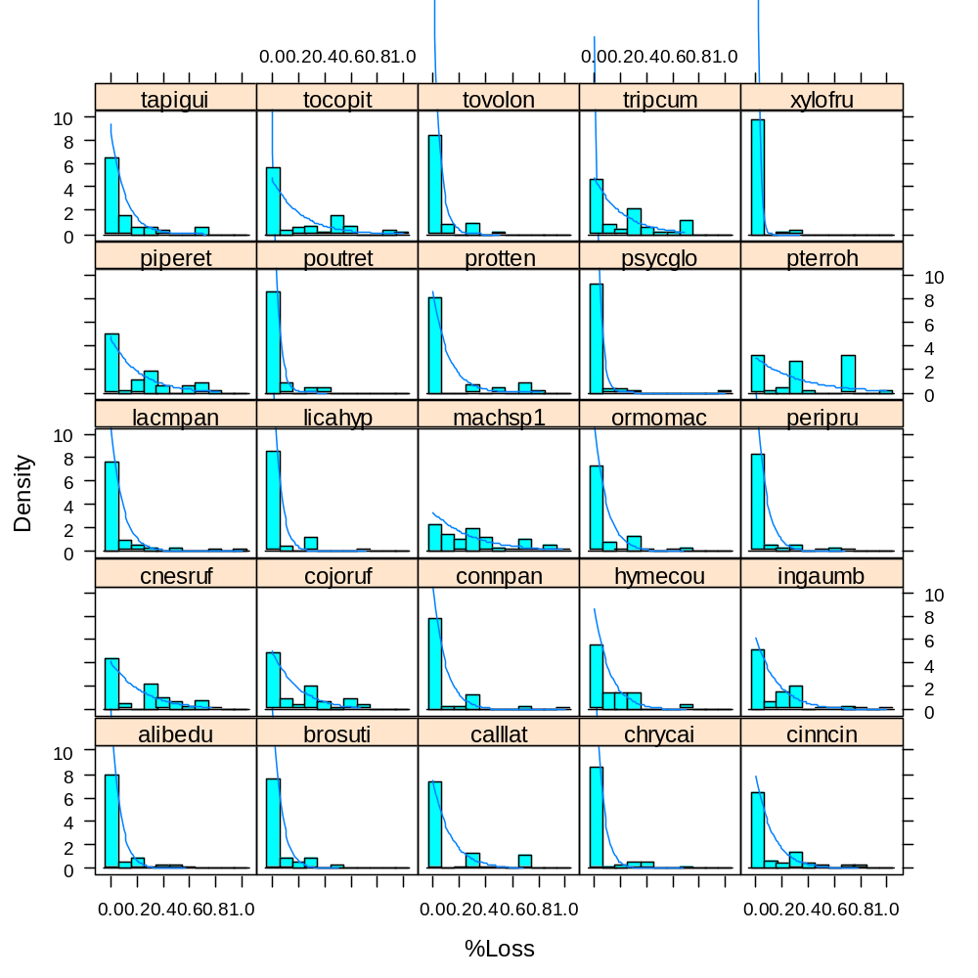
Figure S1: Example of the distribution of the herbivory measurements (mean percent damage per seedling) for all species planted during the first experiment. Density curves are the exponential distribution.
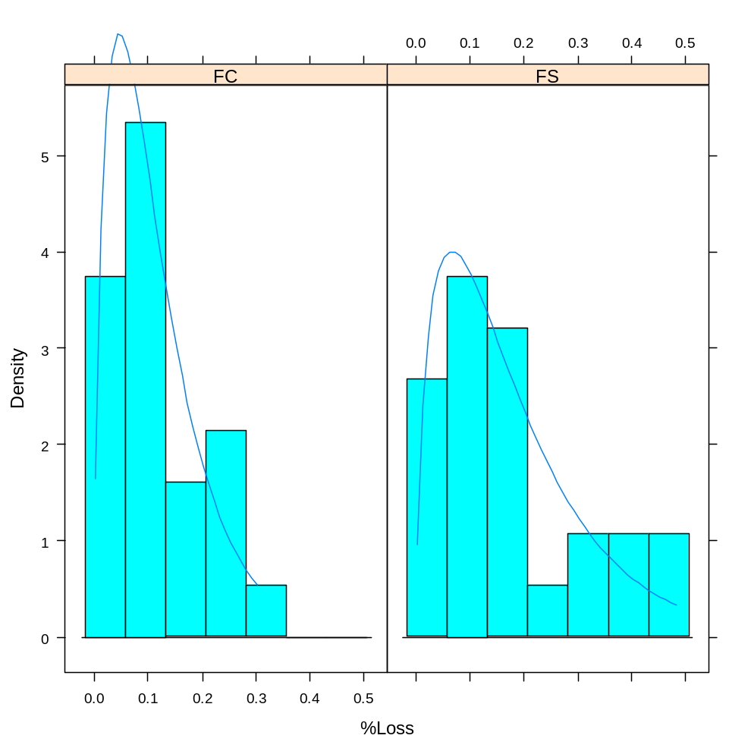
Figure S2: Example of the distribution of species’ mean herbivory levels (mean %Loss per species) in the two sites during the first experiment. Density curves are the gamma distribution.
R Code

## Functions to calculate posterior distributions for the parameters of a model to evaluate of changes in % leaf damage as a function of rainfall using Bayesian hierarchical model.

# These functions are adapted from (Rüger, N., A. Huth, S. P. Hubbell, and R. Condit. 2009. Response of recruitment to light availability across a tropical lowland rain forest community. Journal of Ecology 97:1360–1368). They use a hybrid of the Gibbs sampler and the Metropolis-Hastings algorithm. These functions should source in R2.13.1, and given a table of data in the correct format, will return a list with the posterior distribution of all parameters. Requires the package ‘coda’

# the input data file has three columns: sp = the species id for the individual (the blocking factor), rain= rainfall for the site (indepentent variable), and dmg = the mean percent damage per seedling (dependent variable).

# Model parameters are the average herbivory in the drier site (a) and the effect of rainfall on % damage (b). The four hyperparameters are: the mean (MuA) and SD (SdA) of the damage at the dry site (a); and the mean (MuB) and SD (SdB) of the site effect (wet-dry) (b). The argument start.param sets their starting values.

# start.scale sets the initial step size for the proposal distribution of the Metropolis-Hastings algorithm, the step size is adjusted scale.burnin steps (burn-in) into the run, so that acceptance rate is kept around 0.25. The number of cycles run by the Gibbs sampler is the argument steps, and the current state will be printed to the screen every showstep steps. Argument spp is a character vector listing the levels in the grouping factor, in this case the species’ acronyms.

# Output is a list with tables MuA, SdA, MuB, SdB, spa, spb, and scale for each chain showing the dispersion of parameters in each step in each chain; and a table of convergence showing the test of convergence of the two chains.

metrop.dmg.Gibbs=function(data, start.param=c(MuA=1, SdA=1, MuB=0, SdB=0, spa=1 ,spb=1), start.scale=0.01, scale.burnin=2000, steps=5000, showstep=500, spp)
{

MuA1=SdA1=MuB1=SdB1=MuA2=SdA2=MuB2=SdB2 = matrix(nrow=steps,ncol=3)
MuA1[1,1]= MuA2[1,1] = start.param["MuA"]
SdA1[1,1]= SdA2[1,1] = start.param["SdA"]
MuB1[1,1] = MuB2[1,1] = start.param["MuB"]
SdB1[1,1] = SdB2[1,1] = start.param["SdB"]
MuA1[1,3]=SdA1[1,3]=MuB1[1,3]=SdB1[1,3]=
MuA2[1,3]=SdA2[1,3]=MuB2[1,3]=SdB2[1,3]= start.scale

nospp=length(spp)

spa1 = spb1 = drawsa1 = drawsb1 = scalea1 = scaleb1 =
spa2 = spb2 = drawsa2 = drawsb2 = scalea2 = scaleb2 = matrix(ncol=steps,nrow=nospp)

rownames(spa1)=rownames(spa2)=rownames(drawsa1)=rownames(drawsa2)=rownames(scalea1)=rownames(scalea2) =
paste("a", spp, sep=".")
rownames(spb2)=rownames(spb1)=rownames(drawsb1)=rownames(drawsb2)=rownames(scaleb1)=rownames(scaleb2) = paste("b", spp, sep=".")

# chain 1 is initialized with average values
spa1[,1]= mean(data$dmg)
spb1[,1]= 0
# chain 2 is initialized with more extreme values
spa2[,1]= start.param["spa"]
spb2[,1]= start.param["spb"]

convergence = matrix(data=NA, ncol=2, nrow=nospp)
#converged = matrix(data=F, ncol=2, nrow=nospp)=dimnames(converged)
dimnames(convergence)= list(spp, c("a","b"))
scalea1[,1] = scaleb1[,1] = scalea2[,1] = scaleb2[,1] = start.scale

for(i in 2:steps)
{
adjust=ifelse((i <= scale.burnin), T, F)

MuA1[i,] = metrop1step(func=Mu.aGibbs, start.param=MuA1[i-1,1], scale.param=MuA1[i-1,3], SdA=SdA1[i-1,1], spa=spa1[,i-1], adjust.scale=adjust)

SdA1[i,] = metrop1step(func=Sd.aGibbs, start.param=SdA1[i-1,1], scale.param=SdA1[i-1,3], MuA=MuA1[i,1], spa=spa1[,i-1], adjust.scale=adjust)

MuB1[i,] = metrop1step(func=mu.bGibbs, start.param=MuB1[i-1,1], scale.param=MuB1[i-1,3], SdB=SdB1[i-1,1], spb=spb1[,i-1], adjust.scale=adjust)

SdB1[i,] = metrop1step(func=sd.bGibbs, start.param=SdB1[i-1,1], scale.param=SdB1[i-1,3], MuB=MuB1[i,1], spb=spb1[,i-1], adjust.scale=adjust)

MuA2[i,] = metrop1step(func=Mu.aGibbs, start.param=MuA2[i-1,1], scale.param=MuA2[i-1,3], SdA=SdA2[i-1,1], spa=spa2[,i-1], adjust.scale=adjust)

SdA2[i,] = metrop1step(func=Sd.aGibbs, start.param=SdA2[i-1,1], scale.param=SdA2[i-1,3], MuA=MuA2[i,1], spa=spa2[,i-1], adjust.scale=adjust)

MuB2[i,] = metrop1step(func=mu.bGibbs, start.param=MuB2[i-1,1], scale.param=MuB2[i-1,3], SdB=SdB2[i-1,1], spb=spb2[,i-1], adjust.scale=adjust)

SdB2[i,] = metrop1step(func=sd.bGibbs, start.param=SdB2[i-1,1], scale.param=SdB2[i-1,3], MuB=MuB2[i,1], spb=spb2[,i-1], adjust.scale=adjust)

for(j in 1:nospp)
{
nexta = metrop1step(func=spa.Gibbs, start.param=spa1[j,i-1], scale.param=scalea1[j,i-1], H=data[data$sp==spp[j],], spb=spb1[j,i-1], MuA=MuA1[i,1], SdA=SdA1[i,1], adjust.scale=adjust)
spa1[j,i] = nexta[1]
drawsa1[j,i] = nexta[2]
scalea1[j,i] = nexta[3]

nextb = metrop1step(func=spb.Gibbs, start.param=spb1[j,i-1], scale.param=scaleb1[j,i-1], H=data[data$sp==spp[j],], spa=spa1[j,i], MuB=MuB1[i,1], SdB=SdB1[i,1], adjust.scale=adjust)
spb1[j,i] = nextb[1]
drawsb1[j,i] = nextb[2]
scaleb1[j,i] = nextb[3]

nexta = metrop1step(func=spa.Gibbs, start.param=spa2[j,i-1], scale.param=scalea2[j,i-1], H=data[data$sp==spp[j],], spb=spb2[j,i-1], MuA=MuA2[i,1], SdA=SdA2[i,1], adjust.scale=adjust)
spa2[j,i] = nexta[1]
drawsa2[j,i] = nexta[2]
scalea2[j,i] = nexta[3]

nextb = metrop1step(func=spb.Gibbs, start.param=spb2[j,i-1], scale.param=scaleb2[j,i-1], H=data[data$sp==spp[j],], spa=spa2[j,i], MuB=MuB2[i,1], SdB=SdB2[i,1], adjust.scale=adjust)
spb2[j,i] = nextb[1]
drawsb2[j,i] = nextb[2]
scaleb2[j,i] = nextb[3]

# convergence test. Needs the coda library
if(i%%showstep==0 & i>=500)
{
g = gelman.diag(mcmc.list(mcmc(spa1[j,((i-500)+1):i]), mcmc(spa2[j,((i-500)+1):i])), confidence = 0.95,
transform=T, autoburnin=F)
if (g[[1]][1] < 1.1 & is.na(convergence[j,1])) convergence[j,1] = i

g = gelman.diag(mcmc.list(mcmc(spb1[j,((i-500)+1):i]), mcmc(spb2[j,((i-500)+1):i])), confidence = 0.95,
transform=T, autoburnin=F)
if (g[[1]][1] < 1.1 & is.na(convergence[j,2])) convergence[j,2] = i
}
} # end species loop

if(i%%showstep==0 & i>=50) cat(i, "MuA ",round(MuA2[i,1],4), "SdA ", round(sqrt(SdA2[i,1]),2), "MuB ",round(MuB2[i,1],1), "SdB ", round(SdB2[i,1],2), "\n")
} # end step loop

return(list(SdA1=SdA1, SdA2=SdA2, MuA1=MuA1, MuA2=MuA2, MuB1=MuB1, MuB2=MuB2, SdB1=SdB1, SdB2=SdB2, spa1=spa1, spa2=spa2, spb1=spb1, spb2=spb2, scalea1=scalea1, scaleb1=scaleb1, convergence=convergence) )
}

# likelihood of the mean of the gamma hyperdistribution for a
Mu.aGibbs=function(MuA,spa,SdA)
{
if(MuA<=0) return(-Inf)
if(SdA<=0) return(-Inf)
llike = dgamma(spa, scale=(SdA^2)/MuA, shape=(MuA/SdA)^2, log=T)
return(sum(llike) + dunif(MuA, min=0, max=1, log=T))
}

# likelihood of the SD of the gamma hyperdistribution for a
Sd.aGibbs=function(SdA,spa,MuA)
{
if(SdA<=0) return(-Inf)
llike = dgamma(spa, scale=(SdA^2)/MuA, shape=(MuA/SdA)^2, log=T)
return(sum(llike) + dunif(SdA, min=0, max=100, log=T))
}
# likelihood of the mean of the normal hyperdistribution for b
mu.bGibbs=function(MuB,spb,SdB)
{
if(SdB<=0) return(-Inf)
llike = dnorm(spb, mean=MuB, sd=SdB, log=T)
return(sum(llike) + dunif(MuB, min=-100, max=100, log=T))
}
# likelihood of the standard deviation of the normal hyperdistribution for b
sd.bGibbs=function(SdB,spb,MuB)
{
if(SdB<=0) return(-Inf)
llike = dnorm(spb, mean=MuB, sd=SdB, log=T)
return(sum(llike) + dunif(SdB, min=0, max=100, log=T))
}

# likelihood of the constant of the linear relationship between log light and log
# recruitment for one species
spa.Gibbs=function(spa,H,spb,MuA,SdA)
{
pred.herb = spa + spb*H$rain
if(any(pred.herb<=0)) return(-Inf)
lik.a = dexp(H$dmg, rate=1/pred.herb, log=T)
lik.A = dgamma(spa, scale=(SdA^2)/MuA, shape=(MuA/SdA)^2, log=T)
llike=sum(lik.a) + lik.A
return(llike)
}
# likelihood of the coefficient of light in the linear relationship between log
# light and log recruitment
spb.Gibbs=function(spb,H,spa,MuB,SdB)
{
pred.herb = spa + spb*H$rain
if(any(pred.herb<=0)) return(-Inf)
lik.b = dexp(H$dmg, rate=1/pred.herb, log=T)
lik.B = dnorm(spb, mean=MuB, sd=SdB, log=TRUE)
llike=sum(lik.b) + lik.B
return(llike)
}

# A generic routine for taking a single Metropolis step given any probability function, func, an initial parameter,
# start.param, and a scaling parameter for # the step size, scale.param. It returns the next parameter value as well as an
# acceptance indicator (0 if the value was accepted, 1 if rejected), and the new scale parameter. If adjust.scale=T, the
# scale parameter is adjusted to keep the acceptance rate at around 0.25, adjust.scale should be T only for
# steps<which.use (only during burnin period). Based on programs by Richard Condit and Helene Muller-Landau.
metrop1step=function(func,start.param,scale.param,adjust.scale=T,...)
{
new.scale = scale.param
probaccept = 0.25
multreject = 0.975
multaccept = multreject^(-(1-probaccept)/probaccept)
origlike = func(start.param,...)
newval = rnorm(1,mean=start.param,sd=scale.param)
newlike = func(newval,...)
if(!is.finite(newlike))
accept = F
else
{
if(newlike>=origlike) accept = T
else
{
likeratio=exp(newlike-origlike)
if(runif(1)<likeratio) accept = T
else accept = F
}
}
if(accept)
{
if(adjust.scale) new.scale=multaccept*scale.param
return(c(newval,0,new.scale))
}
else
{
if(adjust.scale) new.scale=multreject*scale.param
return(c(start.param,1,new.scale))
}
}

Table S2: Parameter estimates for the hierarchical models that evaluated herbivory and mortality as a function of rainfall for the two experiments. Estimates are the means of the posterior distributions. MuA= hyperparameter for the mean in dry site for all species combined; MuB = hyperparameter for the mean response of all species combined; a.spp = mean damage of each in the dry site (intercept); b.spp = response of each species to rainfall.

spcode | Preferred distribution | Range | param | %Dmg1 | %Dmg2 | %Loss1 | %Loss2 | attak1 | attak2 | death1 | death2
 |  |  | muA | 0.042 | 0.100 | 0.135 | 0.218 | -0.622 | -0.210 | -2.468 | -1.729
 |  |  | SdA | 0.043 | 0.046 | 0.133 | 0.126
 |  |  | muB | 0.006 | -0.019 | 0.060 | -0.027 | 0.465 | -0.246 | 0.740 | -0.009
 |  |  | SdB | 0.027 | 0.023 | 0.083 | 0.024
callat | unclear | wide | a | 0.053 |  | 0.109 |  | 0.293 |  | 0.049
chryca | DRY | wide | a | 0.028 |  | 0.052 |  | 0.239 |  | 0.085
cinncin | unclear | wide | a | 0.037 |  | 0.111 |  | 0.350 |  | 0.173
cnesru | DRY | dry | a | 0.072 |  | 0.269 |  | 0.588 |  | 0.107
cojoru | DRY | wide | a | 0.140 |  | 0.244 |  | 0.619
faraoc | DRY | wide | a | 0.020 |  | 0.065 |  | 0.327
ingama | WET | wet | a | 0.080 |  | 0.131 |  | 0.537 |  | 0.049
licahy | WET | wet | a | 0.018 |  | 0.055 |  | 0.218 |  | 0.070
machmi | DRY | dry | a | 0.020 |  | 0.250 |  | 0.651 |  | 0.104
manibi | WET | wet | a | 0.013 |  | 0.034 |  | 0.209 |  | 0.061
oxanpa | WET | wet | a | 0.003 |  | 0.003 |  | 0.138 |  | 0.035
peripr | DRY | wide | a | 0.053 |  | 0.064 |  | 0.325 |  | 0.035
pipere | DRY | wide | a | 0.091 |  | 0.178 |  | 0.477 |  | 0.071
poutre | WET | wide | a | 0.004 |  | 0.004 |  | 0.127 |  | 0.056
psycgl | WET | wet | a | 0.005 |  | 0.061 |  | 0.237 |  | 0.061
pterro | WET | wet | a | 0.002 |  | 0.301 |  | 0.555 |  | 0.191
tapigu | WET | wet | a | 0.030 |  | 0.065 |  | 0.312 |  | 0.194
tripcu | DRY | wide | a | 0.040 |  | 0.232 |  | 0.529 |  | 0.093
brosut | WET | wet | a | 0.003 | 0.086 | 0.004 | 0.144 | 0.236 | 0.278 | 0.122
connpa | DRY | dry | a | 0.007 | 0.056 | 0.146 | 0.149 | 0.383 | 0.368 | 0.055 | 0.061
hymeco | DRY | dry | a | 0.080 | 0.115 | 0.130 | 0.245 | 0.489 | 0.614 | 0.124 | 0.152
lacmpa | WET | wet | a | 0.019 | 0.120 | 0.118 | 0.212 | 0.371 | 0.517 | 0.067 | 0.125
ormoma | DRY | wide | a | 0.019 | 0.046 | 0.091 | 0.117 | 0.311 | 0.306 | 0.076
protte | DRY | dry | a | 0.007 | 0.077 | 0.053 | 0.127 | 0.192 | 0.287 | 0.133 | 0.329
tocopi | WET | wet | a | 0.047 | 0.132 | 0.178 | 0.170 | 0.470 | 0.423 |  | 0.047
apeimem | WET | wet | a |  | 0.086 |  | 0.255 |  | 0.511
cassmos | DRY | dry | a |  | 0.148 |  | 0.293 |  | 0.601 |  | 0.402
ormococ | WET | wide | a |  | 0.047 |  | 0.058 |  | 0.167
randlas | DRY | wide | a |  | 0.071 |  | 0.137 |  | 0.387 |  | 0.161
swiemac | DRY | dry | a |  | 0.149 |  | 0.490 |  | 0.894 |  | 0.200
callat | unclear | wide | b | -0.030 |  | 0.101 |  | 0.810 |  | 0.752
chryca | DRY | wide | b | -0.026 |  | 0.040 |  | 0.144 |  | 0.233
cinncin | unclear | wide | b | -0.002 |  | 0.089 |  | 0.373 |  | 1.466
cnesru | DRY | dry | b | -0.019 |  | 0.022 |  | 0.161 |  | 1.172
cojoru | DRY | wide | b | 0.024 |  | 0.103 |  | 0.924
faraoc | DRY | wide | b | 0.056 |  | 0.065 |  | 0.712
ingama | WET | wet | b | 0.017 |  | 0.156 |  | 0.986 |  | 0.770
licahy | WET | wet | b | 0.002 |  | -0.007 |  | 0.407 |  | 0.338
machmi | DRY | dry | b | 0.005 |  | 0.106 |  | 1.725 |  | 0.089
manibi | WET | wet | b | -0.012 |  | -0.036 |  | -0.718 |  | 1.100
oxanpa | WET | wet | b | 0.001 |  | 0.025 |  | 0.061 |  | 0.314
peripr | DRY | wide | b | -0.028 |  | 0.044 |  | -0.335 |  | 0.314
pipere | DRY | wide | b | -0.010 |  | 0.119 |  | 0.713 |  | 0.845
poutre | WET | wide | b | 0.012 |  | 0.084 |  | 0.408 |  | 0.958
psycgl | WET | wet | b | 0.016 |  | 0.027 |  | 0.141 |  | 0.108
pterro | WET | wet | b | 0.003 |  | 0.104 |  | 0.846 |  | 0.702
tapigu | WET | wet | b | -0.018 |  | -0.057 |  | 0.190 |  | 0.948
tripcu | DRY | wide | b | 0.021 |  | -0.021 |  | -0.344 |  | 0.848
brosut | WET | wet | b | 0.032 | -0.047 | 0.109 | -0.043 | 0.949 | -0.392 | 0.484
connpa | DRY | dry | b | 0.003 | -0.010 | -0.086 | -0.049 | -0.446 | -0.311 | 0.460 | 0.184
hymeco | DRY | dry | b | 0.016 | -0.008 | 0.065 | -0.012 | 0.655 | -0.113 | 1.448 | -0.010
lacmpa | WET | wet | b | 0.041 | -0.037 | 0.079 | -0.032 | 0.451 | -0.191 | 1.213 | 0.032
ormoma | DRY | wide | b | 0.002 | 0.005 | 0.042 | -0.022 | 0.245 | -0.366 | 0.525
protte | DRY | dry | b | 0.008 | -0.020 | 0.116 | -0.030 | 0.954 | -0.384 | 1.601 | -0.203
tocopi | WET | wet | b | 0.019 | -0.021 | 0.164 | -0.020 | 1.568 | -0.266 |  | 0.236
apeimem | WET | wet | b |  | -0.045 |  | -0.046 |  | -0.195
cassmos | DRY | dry | b |  | -0.027 |  | -0.032 |  | -0.123 |  | -0.263
ormococ | WET | wide | b |  | -0.004 |  | -0.005 |  | -0.522
randlas | DRY | wide | b |  | -0.012 |  | -0.012 |  | -0.295 |  | -0.024
swiemac | DRY | dry | b |  | 0.000 |  | -0.021 |  | 0.217 |  | -0.074

