Equation Editor

Microsoft Word 2007

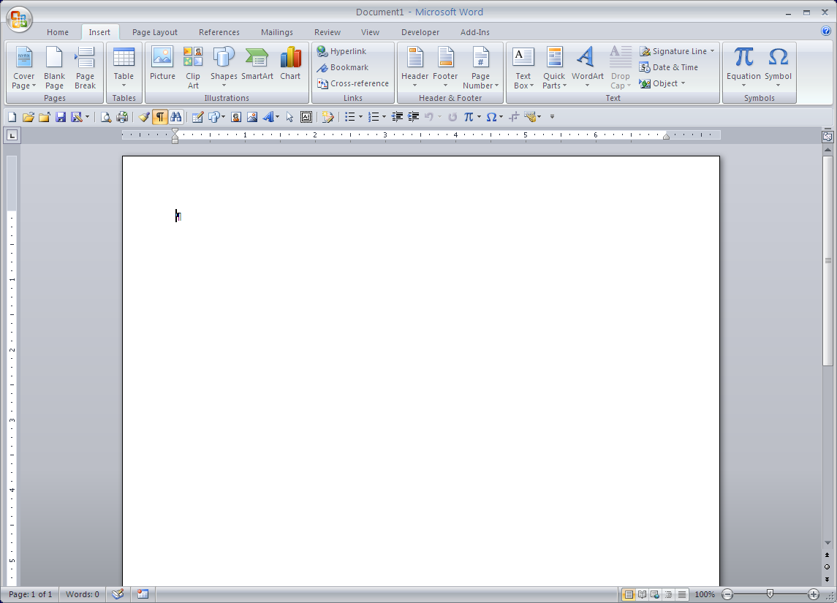

* Go to the **Insert** tab on the Ribbon. At the right end of the Ribbon is the **Symbols** section. Click on the **Equation** button (the **π** symbol). If a list of choices drops down from the button, choose **Insert New Equation** from the bottom of the list.
* 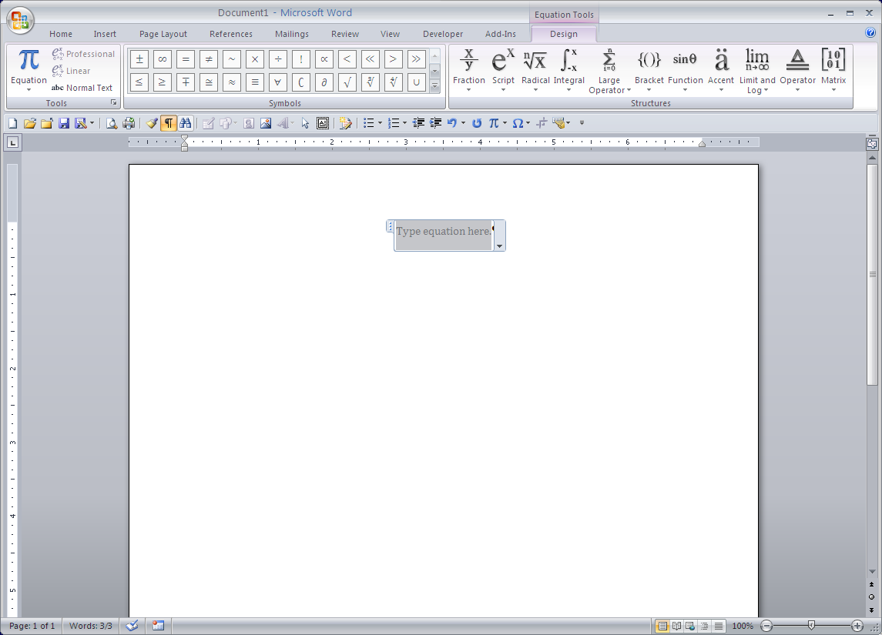A new equation box will appear on the page, and the **Equation Tools** Ribbon will appear.

**Equation Tools on the Ribbon**



|  |  |  |
| --- | --- | --- |
| Tools | This section allows you to insert common equations from a library and change the way the equation appears. Click on the small arrow at the bottom right corner of the section to open a dialog box with advanced options for organizing the appearance and behavior of equations. |  |
| Symbols | This section provides a library of various symbols that are not found on the keyboard. They are sorted into groups, based on categories. To access the various groups of symbols, click on the **More** arrow at the bottom of the arrow bar in the **Symbols** section. A drop-down list of categories will appear. |  |
| Structures | The various structures provided in Equation Editor are listed in this section of the **Equation Tools**. Each structure section has a down-pointing arrow under the name. Click on this arrow to access the list of structures offered for that category. Each list also provides commonly used fractions, functions, etc. that you can insert directly. Pay close attention in each gallery – many of them have scroll bars, and more structures are available by scrolling farther down the gallery. |  |

Button imagePlease Note: If you have documents which were created in earlier versions of Microsoft Word, you will not be able to access the equations through Word 2007 unless you convert your document and save it in Word 2007 format (the file name will have the extension **.docx**, not **.doc**).

To do this, click the **Microsoft Office Button** and choose **Convert**. Then go back to the same menu and choose **Save.**

Once the file has been saved in this format, older versions of Word will not be able to edit or alter equations in the document.

For additional help in using equations in Word 2007, click on the Help button (small 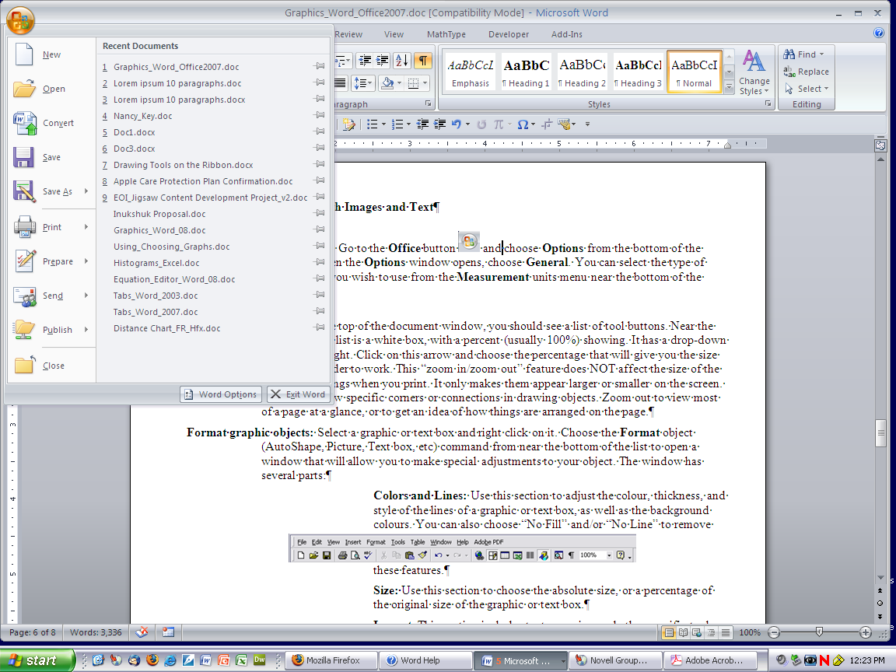 in the top right corner of the window) and follow this path:

**Browse Word Help – Writing** and select the Subcategory **Equations and Mathematical Symbols**.

The following samples can be used as a simple tutorial for creating equations. For each one, open a document in Word 2007 and either type a few lines of text or press the **Enter** key a few times. This will put your equation in a more realist spot in the document.

**Sample 1:**

To make this equation:

|  |  |  |
| --- | --- | --- |
|  | Select the **Insert** tab and choose **Equation**. |  |
|  | The new equation box will appear. |  |
|  | Type **y =** and choose the basic **square root** from the **Radical** structures. |  |
|  | Click in the small box outline under the square root symbol, and choose the **small fraction** from the **Fraction** structures. Click in each part of the fraction, putting **3** in the numerator and **16** in the denominator. |  |
|  | Use the right arrow key on the keyboard. You will have to press the key more than once, since you have to arrow out of the fraction and also out of the square root symbol. Once you are outside the radical, use the **Function** structure and select **sin**. Type the **minus** sign. |  |
|  | Go to **Structures** and choose **Script**. Select the first choice, **superscript**, and click in each box to make **c2**. Make sure you arrow to the right to move your cursor out of the superscript. |  |
|  | The **plus/minus** sign is the first option in the **Basic Math** part of the **Symbols** gallery. The ***μ*** symbol is in the **Greek Letters** section of the **Symbols** gallery. Click on the **More** arrow in the gallery and choose the correct library from the drop-down list at the top of the window. Use the **Function** section of the **Structures** to complete the equation. |  |

Please note: The parts of an equation can be quite small on the screen. You can view the equation more easily if you zoom in (use the slider in the bottom right corner of your document window.)

**Sample 2:**

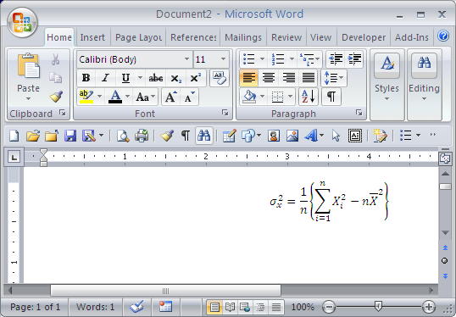

To make this equation:

|  |  |  |
| --- | --- | --- |
|  | Select the **Insert** tab and choose **Equation**. |  |
|  | The new equation box will appear. |  |
|  | Go to the **Scripts** structure and choose the option with superscript and subscript on the right of the base. Click in the base and add **sigma** (σ) from the **Greek Letters** library. Type **2** in the superscript box, and **x** in the subscript box. Arrow to the right to make sure you are no longer in any of the parts and type the equal sign. |  |
|  | Choose the full-sized **fraction** from the **Fraction** structure and fill in the correct numerator and denominator. Use the right arrow to move out of the fraction, and select the **braces** from the **Bracket** section. Click in the box within the braces to select it. |  |
|  | With the box selected, choose the third option in the **Large Operator** structure, with boxes above, below and to the right of the **Σ** |  |
|  | Fill in the correct information above and below the symbol. Click in the box to the right. While it is selected, go to **Script** and choose the third option again. Complete this portion of the equation and use the right arrow to be sure you are no longer in either the superscript or the subscript. |  |
|  | Type the **minus** sign and ***n*** and choose the **superscript** option in the **Script** structure. Click in the box for the base of the exponent and choose the **Overbar** option in the **Accents** structure. |  |
|  | Complete the equation by inserting the correct information for the exponent. |  |

Please note: The parts of an equation can be quite small on the screen. You can view the equation more easily if you zoom in (use the slider in the bottom right corner of your document window.)

**Sample 3**

Notes: Notice that this equation is much the same as Sample 2, except that it is inside a radical. You could copy the previous equation and paste it inside the radical symbol.

**Sample 4**

Notes: In the **Tools** section of **Equation Tools**, choose **Normal Text** when you want to type in text without italics. When this is selected, it can be turned off by clicking on **Normal Text** again.

**Sample 5**

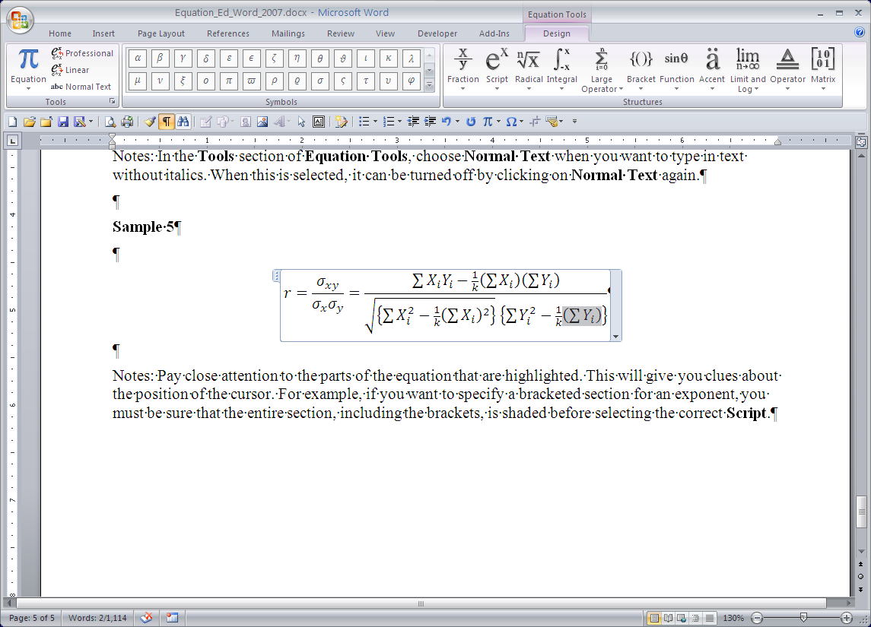Notes: Pay close attention to the parts of the equation that are highlighted. This will give you clues about the position of the cursor. For example, if you want to specify a bracketed section for an exponent, you must be sure that the entire section, including the brackets, is shaded before selecting the correct **Script**.   
**Example:**

**Sample 6:**

Notes: I used the **lim** choice from the **Limit and Log** structure. Then I typed a space and the letters **sup** within the **lim** section of the equation. This put the under the entire text. Basic bracket and letter combinations can be typed with the keyboard, without needing to insert them from the **Equation Tools**.

**Sample 7:**

Notes: The was made first with italicized letters. Then the I and the A were turned into normal text and made bold. The last section was made as a matrix with straight brackets, and the spacing was adjusted to make the parts line up better.

**Sample 8:**

Notes: The dot in <> is a **dot operator** and is found in the **Operators** menu within the **Symbols** section of the **Equation Tools**.