Outbreaks

Mladen Cucak

5/4/2020

## Libraries

list.of.packages <-  
 c(  
 "tidyverse",  
 "readxl",  
 "broom",   
 "data.table",  
 "minpack.lm",  
 "knitr",  
 "zoo",  
 "egg",  
 "ggthemes",  
 "here",  
 "stringr",  
 "lubridate",  
 "nlme",  
 "pander",  
 "maps",  
 "ggrepel",  
 "sf",  
 "ggspatial"  
 )  
  
new.packages <-  
 list.of.packages[!(list.of.packages %in% installed.packages()[, "Package"])]  
  
#Download packages that are not already present in the library  
if (length(new.packages))  
 install.packages(new.packages)  
  
if (length(new.packages))  
 install.packages(new.packages, repos = c(CRAN="https://cran.r-project.org/"))  
  
  
if ("reconPlots" %in% installed.packages() == FALSE) devtools::install_github("andrewheiss/reconPlots")  
  
packages_load <-  
 lapply(list.of.packages, require, character.only = TRUE)  
  
#Print warning if there is a problem with installing/loading some of packages  
if (any(as.numeric(packages_load) == 0)) {  
 warning(paste("Package/s", paste(list.of.packages[packages_load != TRUE]), "not loaded!"))  
} else {  
 print("All packages were successfully loaded.")  
}

## [1] "All packages were successfully loaded."

rm(packages_load, list.of.packages, new.packages)

## Background

I guess the whole idea about this is related to some of my PhD projects that I could not finish. I had a pile of yearbooks with initial disease outbreaks and follow-up assessments from early 1950s to late 1990s. The thickness of these yearbooks was slimmer and slimmer towards end of the last century, hence, beside the historical and theoretical value they would not be of much use for my current project. I have given up on digitising them, because both myself and few of my students started hating me, because they are really messy.  
(Very relevant paper by Zwankhuizen & Zadoks)[<https://bsppjournals.onlinelibrary.wiley.com/doi/full/10.1046/j.1365-3059.2002.00738.x>], which I think I have mentioned to Neil.  
The main idea related to the current data set is that it is a bit more relevant to current agrosystem. It might be interesting to see how the initial outbreaks, their distribution, rate of increase, etc., is changes over years. This is a observational “study” and comes with all its caveats. These are reports by blight scouts, and it is hard to know if some scouts are more active than others, and similar variables. However, this data is collected by Louise Cooke, and I am sure she would be happy to answer any queries, if it comes to that.

## Data

The disease outbreak data consisted of the date and coordinates of 352 late blight outbreaks from across Northern Ireland over an 11- year period (2005-2014). The NI data were collected every year as part of the Agriculture and Horticulture Development Board (AHDB) Potatoes ‘Fight Against Blight’ campaign (<https://potatoes.ahdb.org.uk/>). The coordinates of blight outbreak locations were obtained using the ‘geocoding’ function from the ‘ggmap’ package (Kahle and Wickham 2013) and confirmed manually. The same data set was used in revision of the Hutton Critera, previously known as Smith Periods (some details [here](https://euroblight.net/fileadmin/euroblight/Workshops/AArhus/Proceedings/5._Siobhan_Dancy-p53-58.pdf)).

outbreaks <- read_csv(file = here::here("dat", "outbreaks_fin.csv"))  
  
outbreaks$date <- lubridate::mdy(outbreaks$date)  
  
outbreaks$jday <- as.Date(outbreaks$date,format="%m/%d/%Y") %>% yday()  
  
  
#Remove outbreaks from   
outbreaks <-   
 outbreaks %>%  
 filter(lat>53.9)   
   
outbreaks <-   
 outbreaks %>%   
   
 mutate(source = tolower(source)) %>%   
 mutate(source = ifelse(source == "Crop", "crop",   
 ifelse(source == "crops", "crop",source))) %>%   
 mutate(source = ifelse(source == "groundkeepers", "groundkeeper", source)) %>%   
 mutate(source = ifelse(source == "allotments", "allotment", source))

A look at data set.

pander(head(outbreaks))

Table continues below

|  |  |  |  |  |  |
| --- | --- | --- | --- | --- | --- |
| date | yr | source | variety | varietyII | Location |
| 2003-05-21 | 2003 | crop | Lady Felicia | NA | Ards |
| 2003-05-31 | 2003 | crop | Home Guard | NA | BallyLagen,BClare |
| 2003-06-05 | 2003 | crop | Kerrs Pink | NA | Benagh, Kilkeel |
| 2003-06-06 | 2003 | crop | Kerrs Pink | NA | Glenkeen Colraine |
| 2003-06-06 | 2003 | crop | Home Guard | NA | Pollee B.Mena |
| 2003-06-07 | 2003 | crop | Kerrs Pink | NA | Dunamoy B.Clare |

Table continues below

|  |  |  |  |  |
| --- | --- | --- | --- | --- |
| County | Comments | loc_full | lon | lat |
| Down | NA | Ards, Down, UK | -5.664 | 54.66 |
| Antrim | NA | BallyLagen,BClare, Antrim, UK | -5.922 | 54.76 |
| Down | protected crop | Benagh, Kilkeel, Down, UK | -6.078 | 54.05 |
| Londonderry | NA | Glenkeen Colraine, Londonderry, UK | -7.305 | 54.99 |
| Antrim | NA | Pollee B.Mena, Antrim, UK | -6.121 | 54.55 |
| Antrim | NA | Dunamoy B.Clare, Antrim, UK | -6.041 | 54.78 |

|  |
| --- |
| jday |
| 141 |
| 151 |
| 156 |
| 157 |
| 157 |
| 158 |

Varieties present in the data. I know most of them, and all are traditional varieties with not partial resistance.

unique(outbreaks$ variety)

## [1] "Lady Felicia" "Home Guard"   
## [3] "Kerrs Pink" "British Queen"   
## [5] "Desiree" "Saxon"   
## [7] NA "Up to Date"   
## [9] "Dunbar Standard" "D.Standard"   
## [11] "King Edward" "Dundrod"   
## [13] "Sante" "Nicola"   
## [15] "Red Duke of York" "Navan"   
## [17] "Rooster" "Pentland Squire"   
## [19] "Arran Victory" "Milagro"   
## [21] "Sharpes Express" "Arran Banner"   
## [23] "Caberet" "Dunluce"   
## [25] "Maris Piper" "Desiree & Nicola"   
## [27] "Lady Claire" "Golden Wonder"   
## [29] "Pentland Ivory" "Marfona"   
## [31] "Pentland Javelin" "Pink Fir Apple"   
## [33] "Avalanche" "UpToDate"   
## [35] "Santee" "Romano"   
## [37] "Piccolo Star" "various"   
## [39] "Charlotte" "Lady Rosetta"   
## [41] "Paramount" "R1"   
## [43] "Up To Date" "Cara"   
## [45] "Sarpo Mira" "Hermes"   
## [47] "Cabaret" "Duke of York"   
## [49] "Tomato Money Maker" "Tomato Gardeners Delight"  
## [51] "Up-to-Date" "AFLO1_1"   
## [53] "VR808" "Golden Nugget"   
## [55] "Aphrodite" "Kifli"   
## [57] "Ramos" "Up-To-Date"

This is the data summary for different sources.

outbreaks %>%   
 group_by(yr, source) %>%   
 summarise(counts = n()) %>%   
 spread(yr, counts)%>%   
 replace(is.na(.), 0) %>%   
 pander()

Table continues below

|  |  |  |  |  |  |  |  |  |
| --- | --- | --- | --- | --- | --- | --- | --- | --- |
| source | 2003 | 2004 | 2005 | 2006 | 2007 | 2008 | 2009 | 2010 |
| allotment | 0 | 0 | 2 | 0 | 0 | 0 | 1 | 0 |
| crop | 43 | 21 | 46 | 15 | 43 | 9 | 36 | 9 |
| dump | 0 | 0 | 1 | 0 | 1 | 1 | 1 | 0 |
| field (under plastic) | 0 | 0 | 0 | 0 | 1 | 0 | 0 | 0 |
| garden | 2 | 4 | 2 | 0 | 3 | 0 | 1 | 0 |
| groundkeeper | 0 | 1 | 1 | 0 | 0 | 0 | 0 | 0 |
| trial | 0 | 0 | 0 | 0 | 0 | 0 | 0 | 1 |

|  |  |  |  |
| --- | --- | --- | --- |
| 2011 | 2012 | 2013 | 2014 |
| 0 | 0 | 0 | 0 |
| 25 | 35 | 16 | 32 |
| 0 | 0 | 0 | 0 |
| 0 | 0 | 0 | 0 |
| 2 | 1 | 0 | 2 |
| 0 | 0 | 0 | 0 |
| 0 | 0 | 0 | 0 |

The entire data set can be seen [here](https://github.com/mladencucak/Outbreaks/blob/master/dat/outbreaks_fin.csv)

!!TASK plot outbreak maps for each year

# ni_sf <-  
# all_counties.sf[all_counties.sf$CountyName == c("Tyrone","Antrim","Armagh", "Fermanagh","Londonderry","Down"),]  
# basemap <-   
# ggplot() +  
# # Plot borders (shapefile)  
# geom_sf(  
# data = ni_sf  
# ,  
# color= "darkolivegreen3",  
# fill = "darkolivegreen3"  
# ) +  
# #Set the theme  
# theme_bw(  
#   
# ) +  
# #limit the plotting area  
# coord_sf(xlim = c(-8.4, -4.9), ylim = c(54, 55.4), expand = FALSE) +  
# theme(axis.text.x=element_blank(),  
# axis.text.y=element_blank())  
# # Define names for labs  
# labs(x = "Longitude", y = "Latitude")+  
# #add fancy anotation  
# annotation_north_arrow(location = "br", which_north = "true",   
# pad_x = unit(0.35, "in"),  
# pad_y = unit(0.25, "in"),  
# style = north_arrow_fancy_orienteering) +  
#   
# annotation_scale(location = "br", width_hint = 0.4)   
#   
# plist <- list()  
# for(i in seq(unique(df_loc_sf$yr))){  
# yrs <- unique(df_loc_sf$yr)[i]  
#   
# plist[[i]] <-   
# basemap+  
# geom_sf(  
# data = df_loc_sf[df_loc_sf$yr == unique(df_loc_sf$yr)[i],],  
# aes(fill = source, color = source),  
# shape = 23,  
# size = 2  
# ) +  
# geom_point( size = .5)  
# }  
#

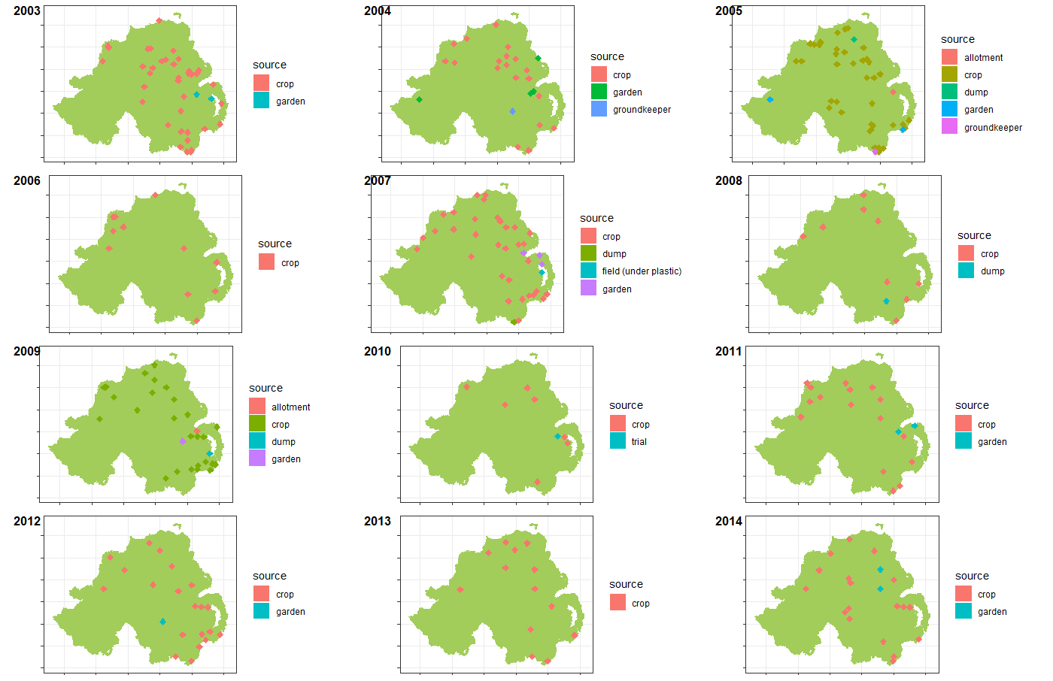 `

## Model fitting

### Prepare the data

Initially, a simple cumulative sum per year was calcualted with julian day and year as covariates.

cdfdt <-   
outbreaks[outbreaks$Location!= "Oak Park",] %>%  
 mutate(mon = month(date),  
 day = day(date)) %>%  
 group_by(mon, day) %>%  
 unite(., date, mon, day, sep = "-", remove = FALSE) %>%  
 mutate(d = as.Date(date, format = "%m-%d")) %>%  
 ungroup() %>%   
 select(yr,jday) %>%   
 group_by(yr,jday) %>%  
 summarise(count = n()) %>%   
 ungroup() %>%   
 group_by(yr) %>%   
 mutate(cums = cumsum(count)) %>%   
 dplyr::select(.,yr, jday, cums) %>%   
 ungroup() %>%   
 mutate(year = yr,  
 yr = as.factor(yr-min(yr-1)))  
  
pander::pander(cdfdt[1:20,])

|  |  |  |  |
| --- | --- | --- | --- |
| yr | jday | cums | year |
| 1 | 141 | 1 | 2003 |
| 1 | 151 | 2 | 2003 |
| 1 | 156 | 3 | 2003 |
| 1 | 157 | 5 | 2003 |
| 1 | 158 | 6 | 2003 |
| 1 | 164 | 7 | 2003 |
| 1 | 168 | 13 | 2003 |
| 1 | 170 | 14 | 2003 |
| 1 | 171 | 16 | 2003 |
| 1 | 177 | 19 | 2003 |
| 1 | 178 | 20 | 2003 |
| 1 | 179 | 21 | 2003 |
| 1 | 181 | 22 | 2003 |
| 1 | 182 | 27 | 2003 |
| 1 | 184 | 28 | 2003 |
| 1 | 186 | 29 | 2003 |
| 1 | 188 | 32 | 2003 |
| 1 | 189 | 33 | 2003 |
| 1 | 191 | 34 | 2003 |
| 1 | 197 | 37 | 2003 |

cdfdt %>%   
mutate(lab =paste0(year," (",yr,")")) %>%   
ggplot() +  
 geom_line(aes(jday, cums))+  
 facet_wrap(~ lab, ncol = 3)+  
 labs(y = "Cumulative sum of outbreaks",  
 x = "Date") +  
 theme_article()+  
ggsave(here::here("out", "Cumsum of outbreaks per year.png"),  
 width = 6,  
 height = 4.5,  
 dpi = 620)

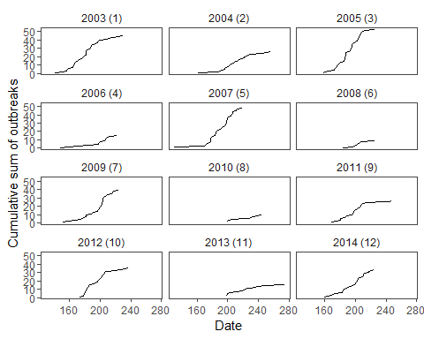

### Fit the model

Get the starting values.

start_vals <-   
 cdfdt %>%  
 # filter(yr != "8") %>%  
 nlsList(cums ~ SSlogis(jday, Asym, xmid, scal) | yr,  
 data = .)  
# broom::tidy(start_vals)

start_vals %>%  
 intervals %>%  
 plot

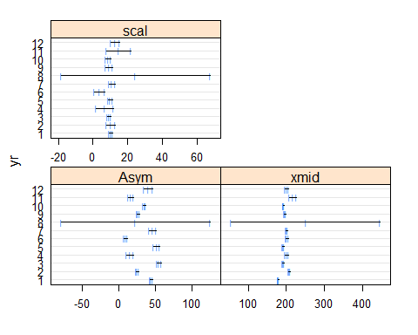

pairs(start_vals, id = 0.1)

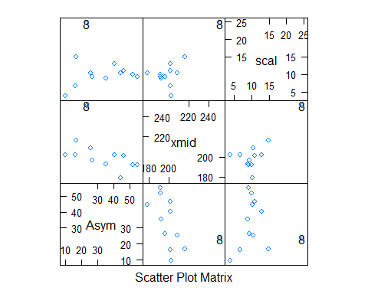

Logistic fit with julian day as predictor and year as random grouping variable.

# Fit on lnear model with logistic fuction  
w1 <-   
 cdfdt %>%  
 filter(yr != "8") %>%  
 nlme(cums ~ SSlogis(jday, Asym, xmid, scal),# model evaluates the logistic function and its gradient  
 fixed = list(Asym ~ 1,  
 xmid ~ 1,  
 scal ~ 1),#Fixed effects of the   
 #random parameters of the model grouped by year  
 #to reduce the number of parameters, the scale and it was excluded because it does not impact the model fit  
 random = Asym + xmid ~ 1 | yr,  
 data = .,  
 start = fixef(start_vals)#Start parameters for the optimisation alghorithm  
 )

Calculate the predictions.

cdfdt_pred <-   
 cdfdt %>%  
 filter(yr != "8") %>%  
 mutate(pred = predict(w1))

Plot predicted values.

cdfdt_pred %>%   
 mutate(lab =paste0(year," (",yr,")")) %>%   
ggplot() +  
 geom_line(aes(jday, cums))+  
 facet_wrap(~ lab, ncol = 3)+  
 labs(y = "Cumulative sum of outbreaks",  
 x = "Date") +  
 theme_article() +  
 geom_line(aes(jday, pred), col = 2)

