**Finding Lane Lines on the Road**

**The goals / steps of this project are the following:**

* Make a pipeline that finds lane lines on the road

* Reflect on your work in a written report

My pipeline consisted of the following steps. First, I converted the images to grayscale, then I use the gaussian filter to blur the image followed with finding edges with the help of the canny edge detector.

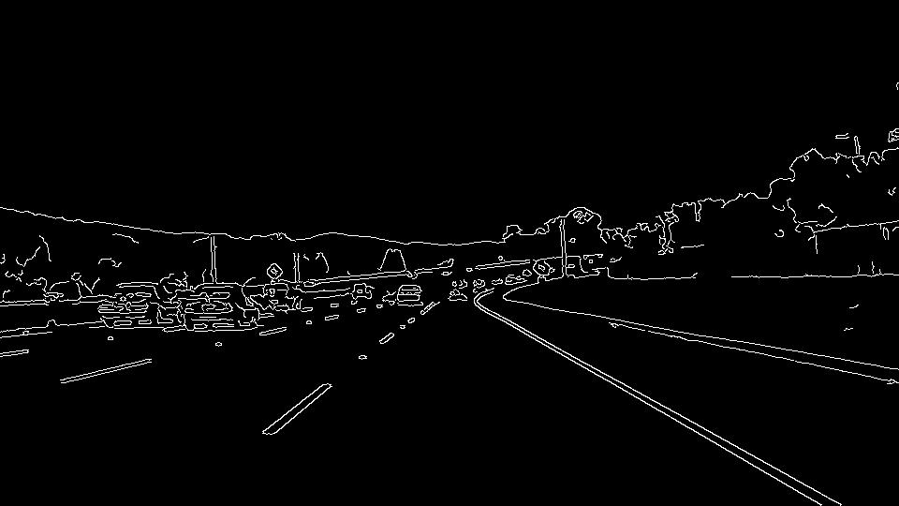Then, I calculated the region of interest and used then the Hough transform.After which I used the draw lines function wherein I separated the points for negative slope and postive slope and found the average of the points

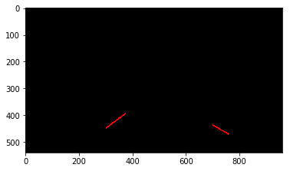

I used stats.linregress from spicy. extrapolated the average line. I thank my mentor Eren for telling me about stats.linegress.

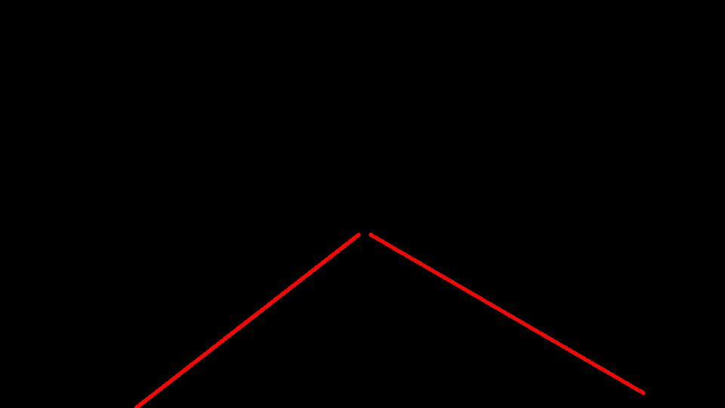

And then I used the weighted image function to draw the plot lines on the original image.

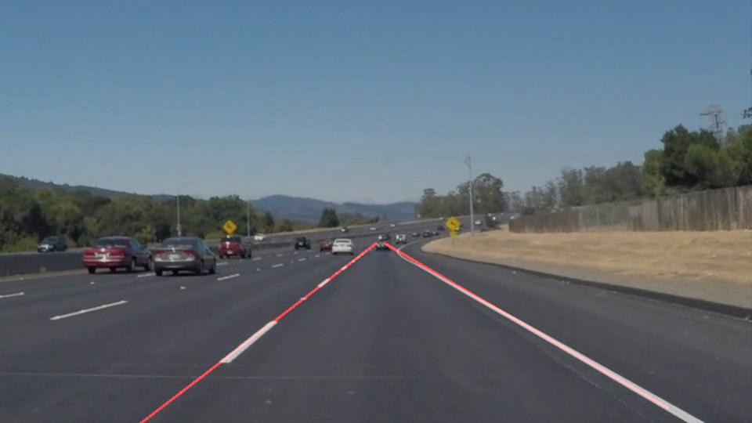

Shortcomings with current pipeline:

In case of dashed lines, sometimes it detected no lines on the image and hence no line was drawn. I can increase my area of concentration to overcome this issue.

Also, when we have curves, the line drawn is not expected.

Possible improvements:   
Make the above algorithm more robust by detecting the area of concentration and plotting the lines based on the detection (bonus project)

Also, improve drawing of lines in case of dashed lines.