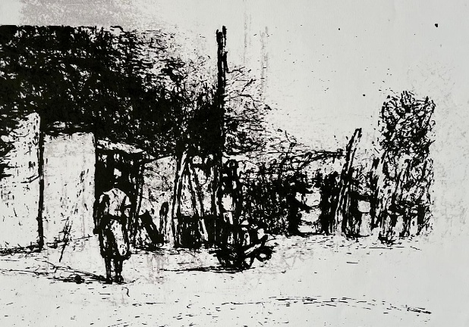 | Artist: Michael Selekane  Title: Mabopane  Medium: Silkscreen on fabriano  Year: 2014  Artist Price: R9 800.00  Gallery Price: R14 000.00  Size:42 x 55cm  Edition: 1/3
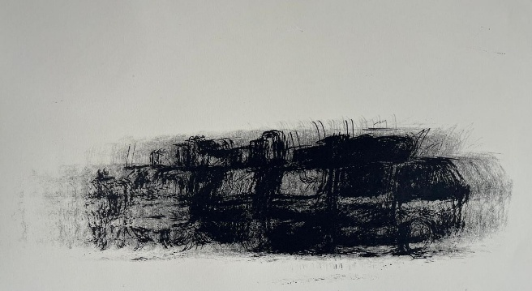 | Artist: Michael Selekane  Title: Last Song  Medium: Silkscreen on fabriano  Year: 2015  Artist Price: R11 200.00  Gallery Price: R16 000.00  Size:50 x 70cm  Edition: 1/1
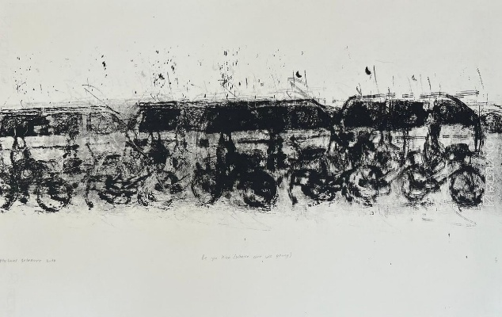 | Artist: Michael Selekane  Title: where are we going  Medium: Silkscreen on fabriano  Year:2015  Artist Price: R11 200.00  Gallery Price: R16 000.00  Size:50x70cm  Edition: 1/1
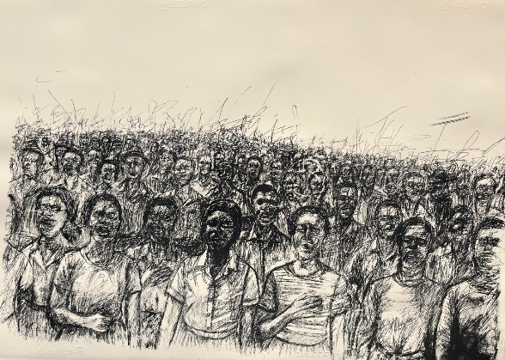 | Artist: Michael Selekane  Title: Aspirations  Medium: Silkscreen on fabriano  Year: 2025  Artist Price: R17 500  Gallery Price: R25 000.00  Size:70 x 100cm  Editions:3/5
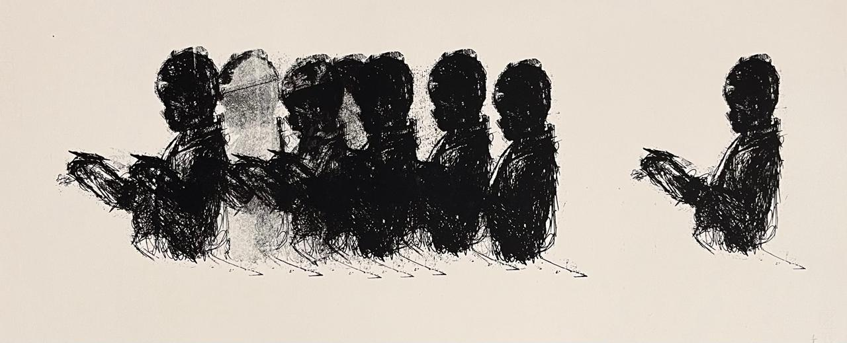 | Artist: Michael Selekane  Title: Tshepo  Medium: Silkscreen on fabriano  Year: 2025  Artist Price: R11 200.00  Gallery Price: R16000.00  Size:70x31cm  Edition: 1/1
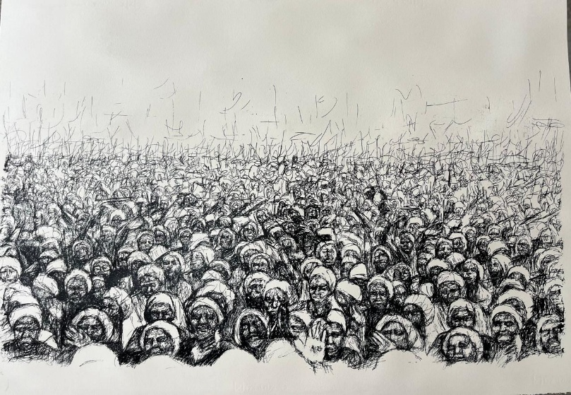 | Artist: Michael Selekane  Title: Global Village  Medium: Silkscreen on fabriano  Year: 2024  Artist Price: R17 500.00  Gallery Price: R25000.00  Size:70X1OOCM  Edition: 4/5

