Project Link: <https://psychic-garbanzo-890d4251.pages.github.io/>

**Name:** Michael Landu

**Student Number:** 13806815

**Module Title:** Visual Design and Web Project

**Introduction**

We were assigned the task of creating a range of creative material for our portfolio. The project was split into three parts:

* A GIF
* 6 Digital Images
* 3 User Interface Designs

**General Concept and Theme**

Initially, I had three ideas: a mobile application game for children, a text-based adventure mobile game and a website for an art gallery. I decided to go with the first idea because I found it most interesting.

**User Interface (UI) Designs**

I started with storyboards. This stage of the design process was the most explorative. I was able to conjure up the initial visual designs that I wanted to communicate to my target audience.

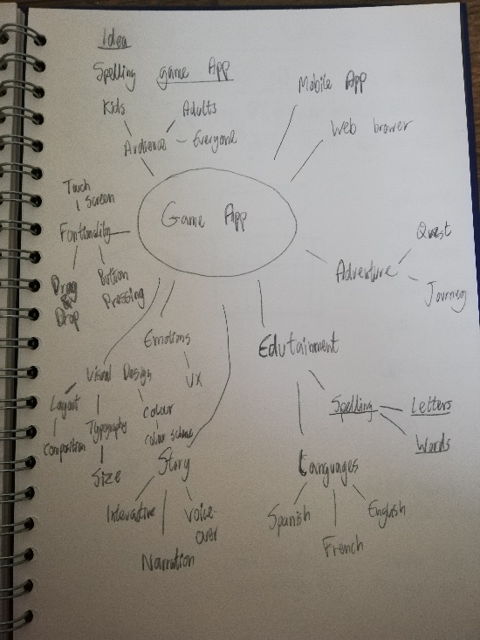 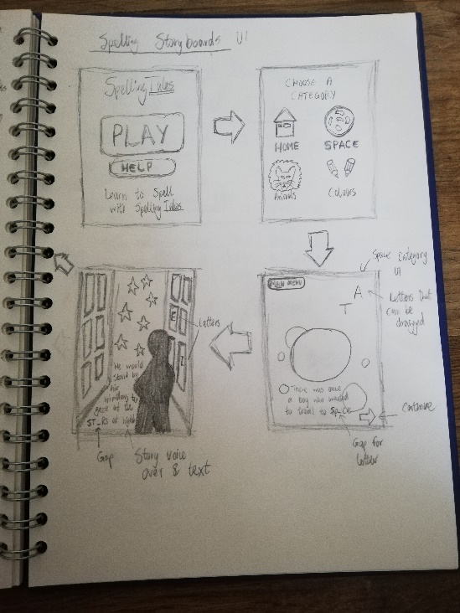

**Colour**

“Children spend more time looking at bright colors as opposed to looking at muted shades or pastels” (Pancare, 2018). So, I decided to choose bright colours.

I used Adobe Color to create colour schemes such as complementary and analogous. I was trying to find colours that were fun and engaging. I decided to make primary colours red, yellow and blue prominent in my design and also secondary colours such as orange and green.

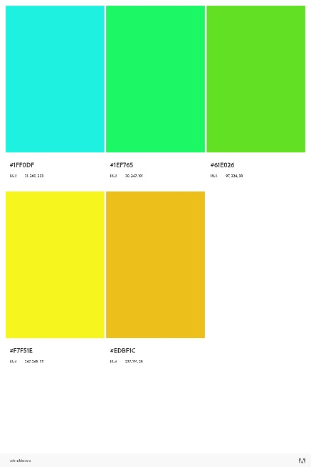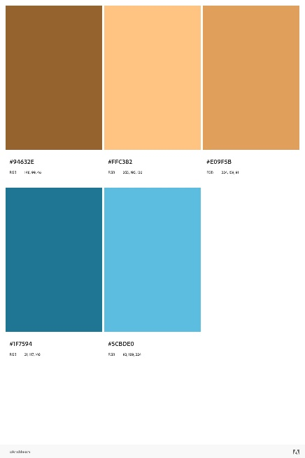 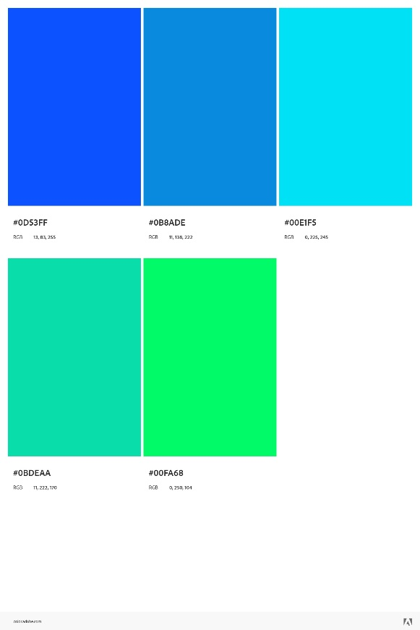 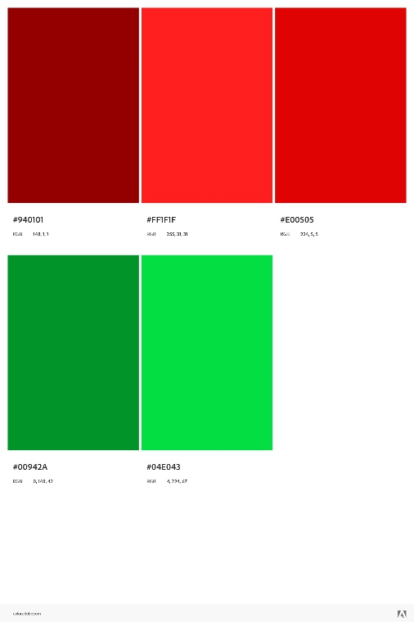

**Typography**

I used Adobe fontsto choose a font style for my designs. I wanted to choose fun engaging fonts. I chose fonts the Manteiga Gorda and Marvin.

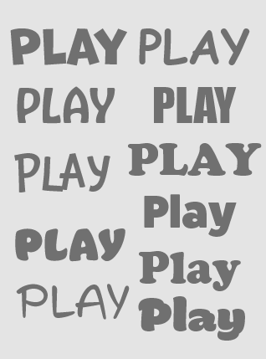

I started to combine colour and text to create a variety of mockups. I chose the size artboard dimension of the iPhone 12 Pro Max in Adobe Xd. It was later exported as a size 1x.

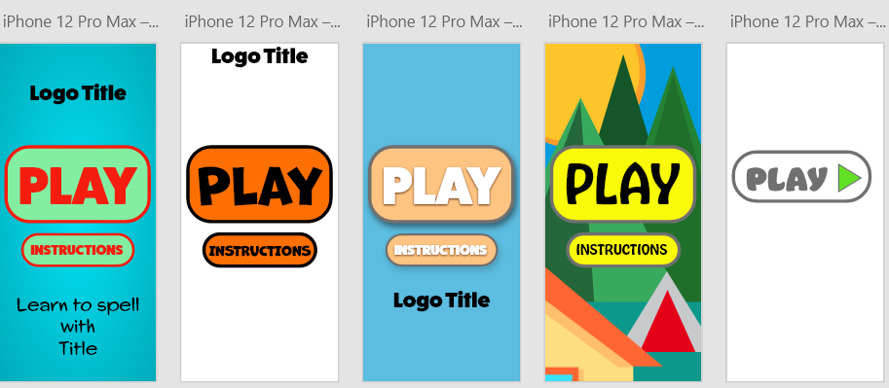

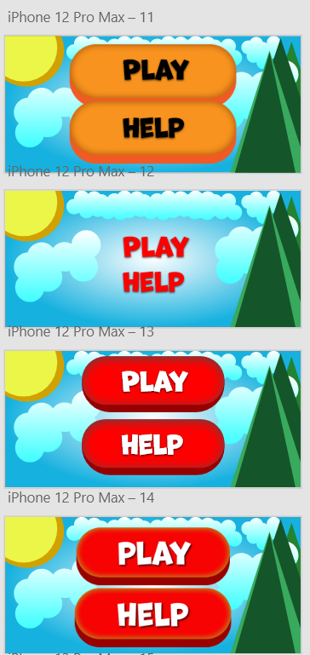

I chose to design for the mobile phone. It is a handheld device that is popular for apps. I chose Illustrator as the design software. Illustrator is best for creating illustrations. This is because it is vector based. The quality remains the same despite size.

For the main menu UI design, I created a background colour of blue. Specifically, I decided to create a radical gradient with a Hex value of #FDFEFE and #FFFFFF. I felt that the radial gradient made it dynamic. The clouds also have a gradient, a linear effect to make it feel like it is floating. The gradient helps combine blue with white to give it a transitional effect. I gave it a light blue hex code of ##41FFFF, #60FFFF, #AFFFFF and a white color #FFFFFF (below). I combined several ellipses to create a variety of different shaped clouds, filled them with white and removed the stroke. I saved them as an ai file, and then transferred them into Adobe Xd to place them in the background.

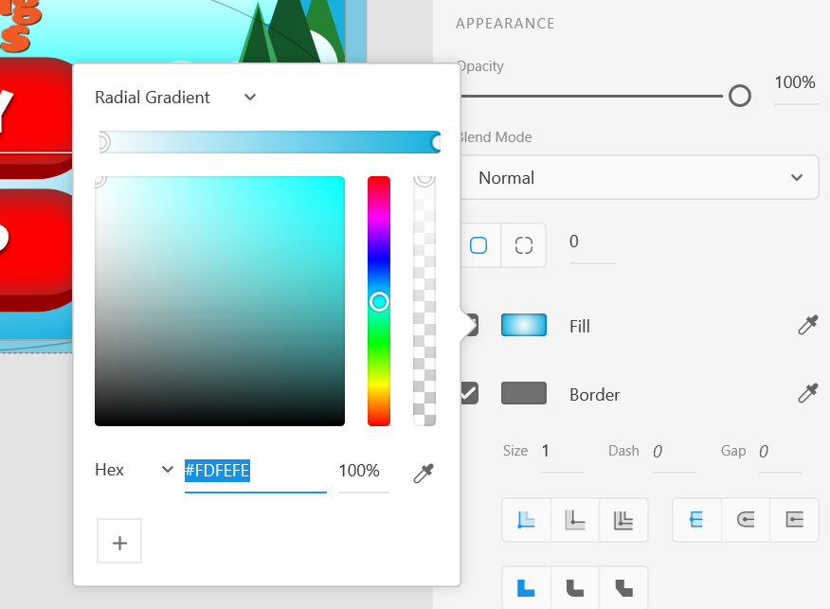 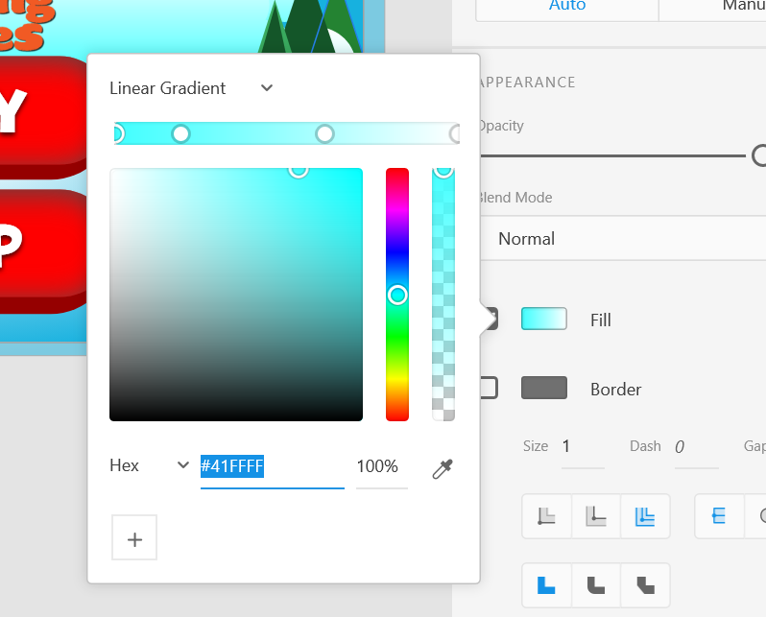

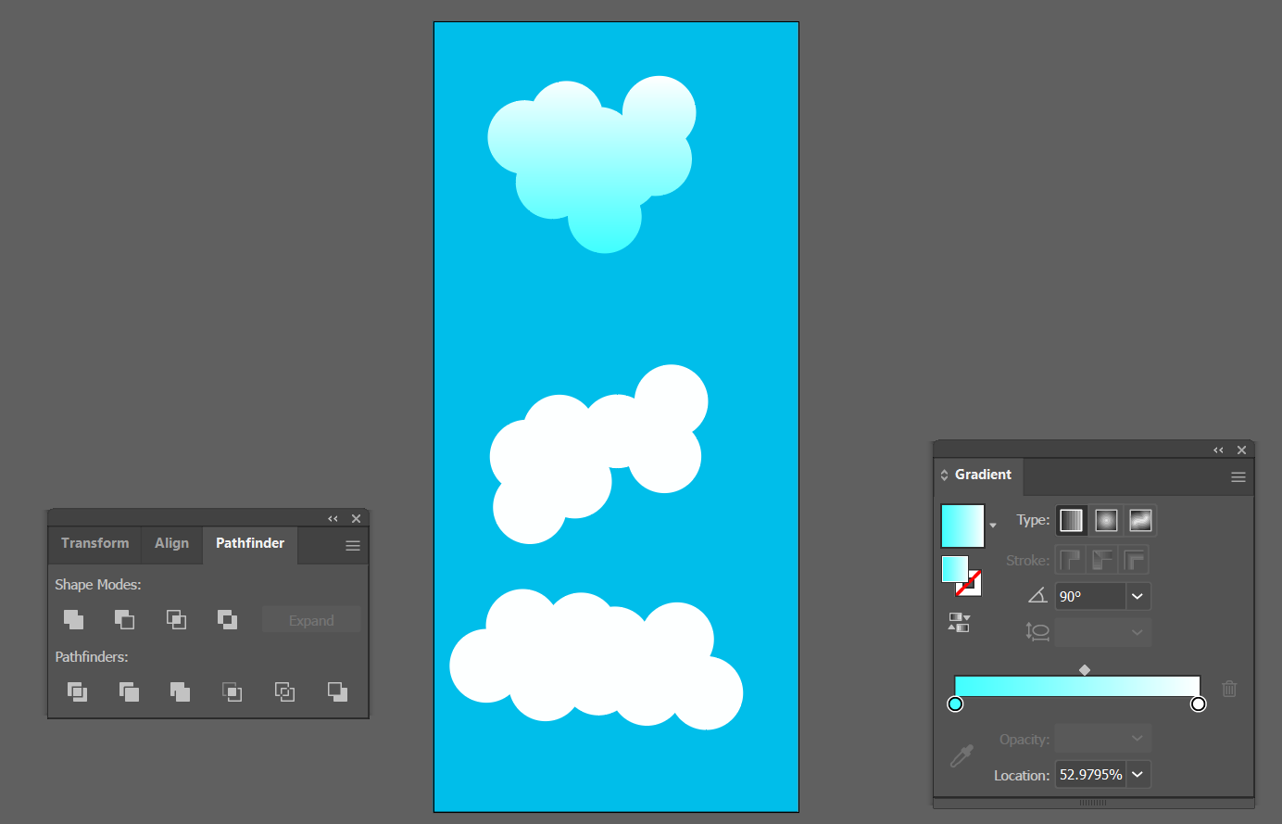

I used the polygon tool and changed the amount of sides to 3, this created a triangle for the mountains. I increased the size of the triangle and then gave it a colour of green. I used a combination of #145629, #248332 and #39A95E. I also duplicated the shapes. I used bright yellow #EBF648 for the sun and duplicated the ellipse to create a more depth with a darkest yellow colour #D1A102.

I gave the font a colour of white on a red (#FF0000) button background. The red buttons were created in Illustrator. I created a rectangle and smoothed the corners by dragging in the circle points inward. The red colour is combined with an inner shadow (#4C4C4C) to make it look 3D. I created a logo, to be discussed in the digital images section. It is placed at the top in the central position.

**Layout**

I wanted the central focus to be the buttons so I placed the buttons in the centre and the logo just above them to communicate the title. I made sure the buttons were the main focus by making them bigger. The alignment of the buttons and logo design gives it balance and cohesion. It draws attention. The proximity between the buttons and similarity in colour creates a relationship. The placement of the sun on the left and the mountains on the right create balance. They also create contrast, the sun is smooth and the mountains are sharp. I duplicated the mountains and clouds to create repetition. The space between the elements is also important, so that the elements are clearly visible and do not distract from one another. I also decided not to use strokes overall, because I felt this gave a cleaner look.

I decided to go with the landscape layout as opposed to portrait. Initially, I went with portrait but then I quickly discovered that most similar games use landscape. So, I decided to go with the conventional route.

For the category UI design, I used the same background as I did for the main menu design. I used the same font style but changed the colour to yellow. Yellow makes the font come to life. The icons will be discussed in the digital images section. However, I used 4 ellipses and gave it different colours with transparency to create the colour icon. I thought that combining images and text for this design, helps communicate the options better. I aligned the images and text and positioned the text centrally, creating balance. The red colour is consistent and creates a relationship with the category names. It is also in contrast to the text at the top in terms of colour, but at the same time consistent because it has the same font style. The clouds are similar to the main menu, but altered, to create a floating effect.

For the space game screen UI, I used a different background which was created in Illustrator and saved as a PNG, which I imported into Xd. I used a mixture of purple, blue and black for the linear gradient effect. The size was set to 926 x 428, same size as the final exported UI designs.

I used an ellipse to create the stars in Illustrator. Once I created the ellipse, I chose to distort the shape by using the pucker and bloat effect. I reduced the percentage to 90% and then gave it a fill of white. I duplicated the shape multiple times and dragging to positions of choice. I spread it across the canvas, resizing the shapes according to my desired look. I then gave it an outer white glow to make it shine bright.

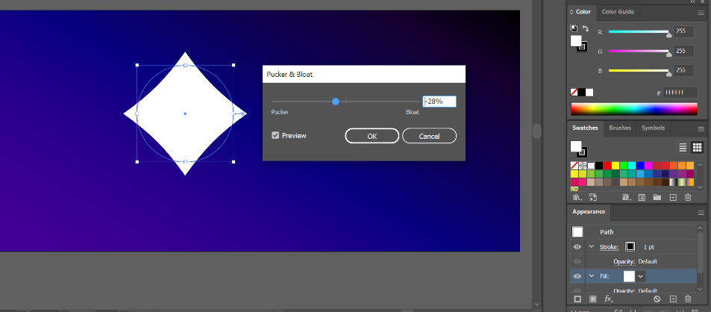

The font style and colour are the same as the category UI design. I made sure to contrast the background and foreground with complementary colours yellow and blue. The size of the fonts are large and visible, positioning the word to spell at the bottom and the words to drag on the right. The letters on the right are positioned to appear to be floating in space. The rocket and moon will be discussed in the digital images section. The moon is positioned on the left hand top corner and the rocket on the right to create balance and a sense of motion. The rocket is in full view and closest to the letters, this is to alert the user that this is the word to spell. The box creating the gap in the word, was created in Adobe Xd. I used a colour of #2FFFF8 and an inner shadow of black to create a glowing effect. These effects help it distinguish it and communicate a visual message of an empty void.

**Digital Images**

**Bird Image**

I created a bird silhouette. I used the help of a tutorial to learn how to use the pen tool and then I created a simple bird illustration in Illustrator. I exported it as a PNG via save for the web with a 400 x 600 dimension, and an SVG for the web. I smoothed the sharp edges by pushing and pulling the achor points with the direct selection tool.

**House Image**

The house was created in Illustrator. I decided to create unconventional cartoony windows as opposed to traditional straight lined windows. I used a pastel colour of #FFDE80 for the body and a solid orange #FF6633 for the roof, window sills and door frame. The door itself had a brighter orange colour #F4A795. A bright blue #39E3FF for the windows. The majority of the design is made up of rectangles and altered in size to create desired look. The roof was created with the pen tool and then duplicated and dragged down to create the shadow, with decreased opacity of 26%.

**Logo Designs**

Both logo designs (full and shorthand) were created in Illustrator. I chose to use the adobe font Mantiega Gorda as I wanted to keep the fun engaging style but also have a different font to the existing Marvin font. I chose to use a solid orange colour to differentiate it from the other visual elements from the main menu. I also gave it a drop shadow to make it more defined. I used the wave effect for the ‘T’ to give it an adventure fun filled look. This was done by going to the Object menu, Envelope distort, and then clicking on the Make with Mesh option. I chose 1 column and several rows to then manipulate the letter to my desired effect. I also used the star tool for the dot for the ‘I’ letter. I used the scribble effect for all letters. This gave it more of a hand-writing style.

The alternative logo used the same techniques, I simply used the S and T letters and positioned them vertically to create the logo.

**Rocket Design**

I used the ellipse to create the body of the rocket. It was stretched into a tall ellipse, and then converted into corners by using the anchor point tool. I created the thruster at the bottom by using an ellipse to cut out a curved shape by using the minus front button found in the pathfinder panel.

I drew basic rectangles for the thrusters and coloured them in red. I sent it to the back, by arranging it to back. The fire was coloured yellow and orange and created in the same way as the body of the rocket. I sent it to the back of the thrust. I used ellipses for the windows, duplicated them to create the window sills and colours it red, and the windows sea blue. The body was coloured grey, and darker grey for the reflection. The wings were created with a pen tool and the curved tip via an ellipse.

**Moon**

The moon was a simple ellipse created with grayscale colours. I duplicated the ellipse to create variations of the shape for the shadow effects too, inside the body. The curved shape was created via a pen tool.

**GIF**

I used a tutorial to help me create a GIF. I used a series of images repositioned via Illustrator. I saved them as PNG’s and loaded them into Photoshop. I created a frame animation in the timeline, selected all of my layers and made frames from the layers. I selected them all and set a delay of 0.2 seconds. I reversed the frame order and then saved it as a GIF with a dimension of 500 x 480, which I thought was a good size for the web.

**Accessibility**

I used the colour contrast tool to help distinguish best practices for foreground and background text.

**File Dimensions**

The files sizes for the digital images were between 200 wide (e.g. small logo) and 500 (large logo), and 250 height (large logo) and 600 (e.g. bird silhouette). This was because I did not need my images to be large for high quality, and it did not take up a lot of space. I thought this was a good size for the images displayed on the webpage. Not too big but not too small.

**PNG and SVG**

I decided to go with PNG images as opposed to JPEG. This is because I created simple graphic images using Illustrator, that did not require many colours. PNG-8 and PNG-24 are the options for the format. The main difference is the amount of colours available. PNG-8 has 256 while PNG-24 has 16 million. Despite this fact, I went with PNG-24 for the images that had colour and PNG-8 for the bird silhouette for example. I did not see major difference in quality between the two for my digital images.

I also chose to display my images as SVG. SVG is a vector based file, while PNG is bitmap. So, the quality does not decrease whether you zoom in or out of a vector based file. It does for PNG. This is the reason I wanted to make sure that the file size I chose to create as a PNG was the file size I wanted to display on the web.

**Improvements, Issues**

It may have been beneficial to explore different dimensions such as a tablet.

The fonts for the SVG user interface designs appear to revert to a default font style which is an issue (below). This could be because the browser window is not up to date or the font style is unavailable. “Marvin” is the name of the font which is an Adobe font.

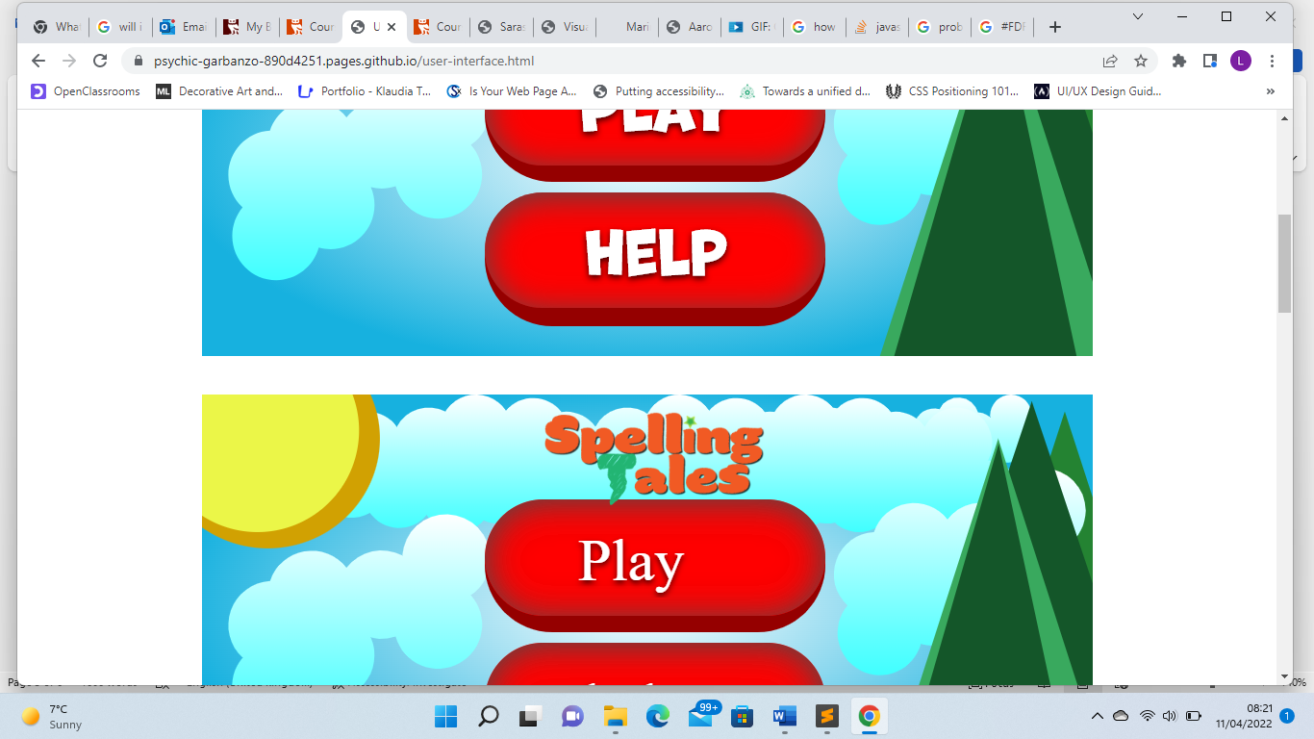

**References**

Adobe Color. 2022. *Adobe Color*. [online] Available at: <<https://color.adobe.com/create/color-wheel>> [Accessed 1 April 2022]

Adobe Fonts. 2022. Adobe Fonts. [online] Available at: <<https://fonts.adobe.com/> <Accessed 1 April 2022]

Pancare, R. 2018. *How do Bright Colors Appeal to Kids?*. [online] Available at: <<https://sciencing.com/do-bright-colors-appeal-kids-5476948.html>> [Accessed 4 April 2022]

<https://fonts.adobe.com/> [Accessed 7 April] – Adobe Fonts

<https://www.youtube.com/watch?v=ihZ5K_MW66k&list=PLwjb-STtxT2qhvlJwcbPBqeO4WPCiuUr3&index=54&t=115s> [Accessed 5 April 2022] – Cloud creation

<https://www.youtube.com/watch?v=jzRGm95wiSI&list=PLwjb-STtxT2qhvlJwcbPBqeO4WPCiuUr3&index=60&t=143s> [Accessed 5 April 2022] – Rocket creation

<https://www.linkedin.com/learning/photoshop-2022-essential-training/creating-animated-gifs?autoplay=true&u=36299332> [Accessed 5 April 2022] GIF animation

<https://www.coreldraw.com/en/tips/png-8-vs-png-24/> - png-8 v png-24 [Accessed 7 April 2022]

<https://support.giphy.com/hc/en-us/articles/360019914771-GIF-Creation-Best-Practices#:~:text=Uploads%2520are%2520limited%2520to%2520100MB,screens%2520or%2520smaller%2520messaging%2520windows> – best practices GIF [Accessed 8 April 2022]

<https://www.lovelytocu.ca/2020/06/svg-files-are-showing-up-as-html-in-my.html> - svg files format explained [Accessed 10 April 2022]