With the network Ids linked to each supply and demand point,

The next task is to develop a list of ‘candidate’ demands around each supply

These are all demands that are in straight-line distance of each supply

This can be done with SQL along the lines of

Create Table Candidates As

Select supply.gid as supid, supply.snapid as supsnp, demand.gid as demid, demand.snapid as demsnp, demand.pop, ST_Distance(supply.geom, demand.geom)

From crowflies.lsoasupplys As supply

Join crowflies.oademands As demand

On ST_DWithin(supply.geom, demand.geom, 1000)

Order By supid, demid;

This creates a table along the lines of…

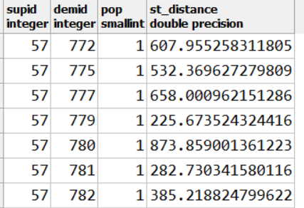

Which, visually, tracks all demands within distance of a given supply…

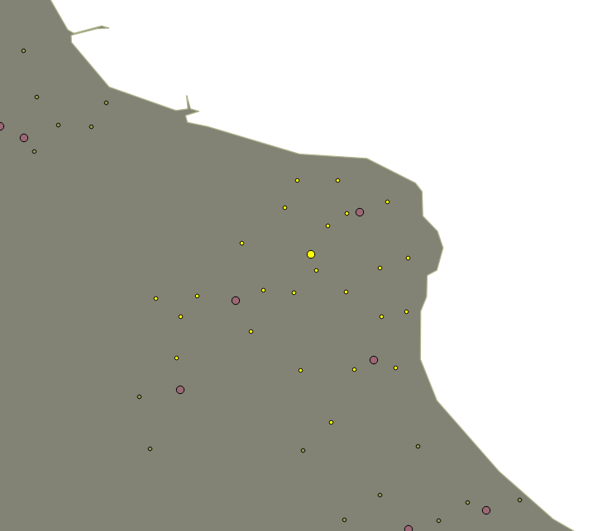

Then use the snapids to compute an actual network distance, and add this to the table

Example close-up of tracing

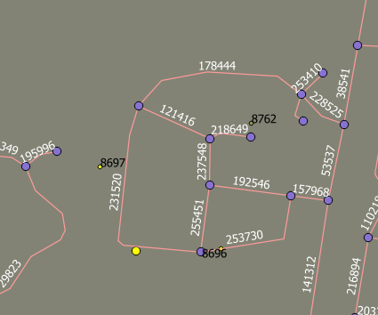

Supply is close to demands 869, 8697, and 8762  
These have straight-line distances of: 106m, 115m and 217m respectively.

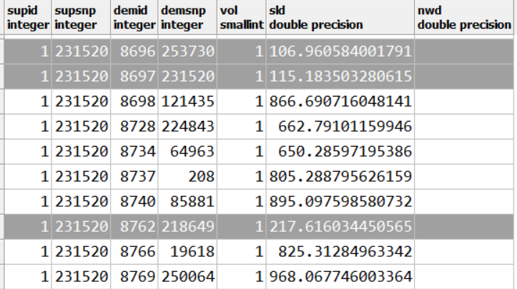

Now compute the network distance from **supsnp** to **demsnp**

**May need to use a one-to-many computation to speed things up, hopefilly** 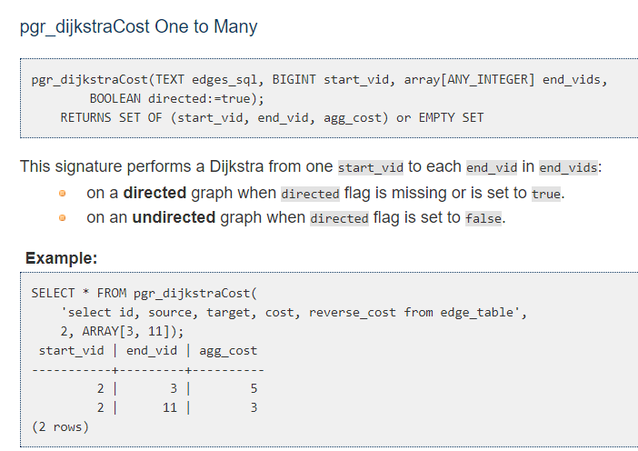

**Select * from pgr_dijkstraCost('Select id, source, target, cost_len as cost From or_apr17.jst_wales', 141100, 99511, false)**

**Select Sum(cost) from pgr_dijkstra('Select id, source, target, cost_len as Cost From or_apr17.jst_wales',141100,99511, false, false)**

**Select * from pgr_dijkstraCost(**

**'select id, source, target, cost_len as cost From or_apr17.jst_wales',**

**132195, array(select demsnp from candidates where supsnp = 132195), false)**

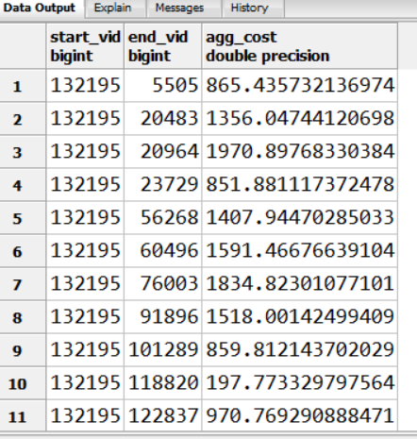

**select distinct supsnp from candidates limit 20**

**Select * from pgr_dijkstraCost(**

**'select id, source, target, cost_len as cost From or_apr17.jst_wales',**

**132195, array(select demsnp from candidates where supsnp = 132195), false)**

**Select * from pgr_dijkstraCost(**

**'select id, source, target, cost_len as cost From or_apr17.jst_wales',**

**96484, array(select demsnp from candidates where supsnp = 96484), false)**

