Baby Names in France (1900–2020)
Design Alternatives — Strengths & Weaknesses
For each set of questions we present three design alternatives, each with its strengths and weaknesses. The guiding principle is overview + detail on demand: one interactive visualization should answer all sub-questions. Popularity is normalized as a share of births (%) rather than raw counts, so years and departments are comparable.
Visualization 1 — Evolution over time
Questions: which names stay consistently (un)popular, which are suddenly or briefly popular, and are there temporal trends?
Design 1.1 — Diagonal heatmap (names × years, sorted by peak year)
Each row is a name, each column a year, color encodes the name's yearly share. Rows are ordered by their peak year, producing a diagonal that makes every name's era visible at once.
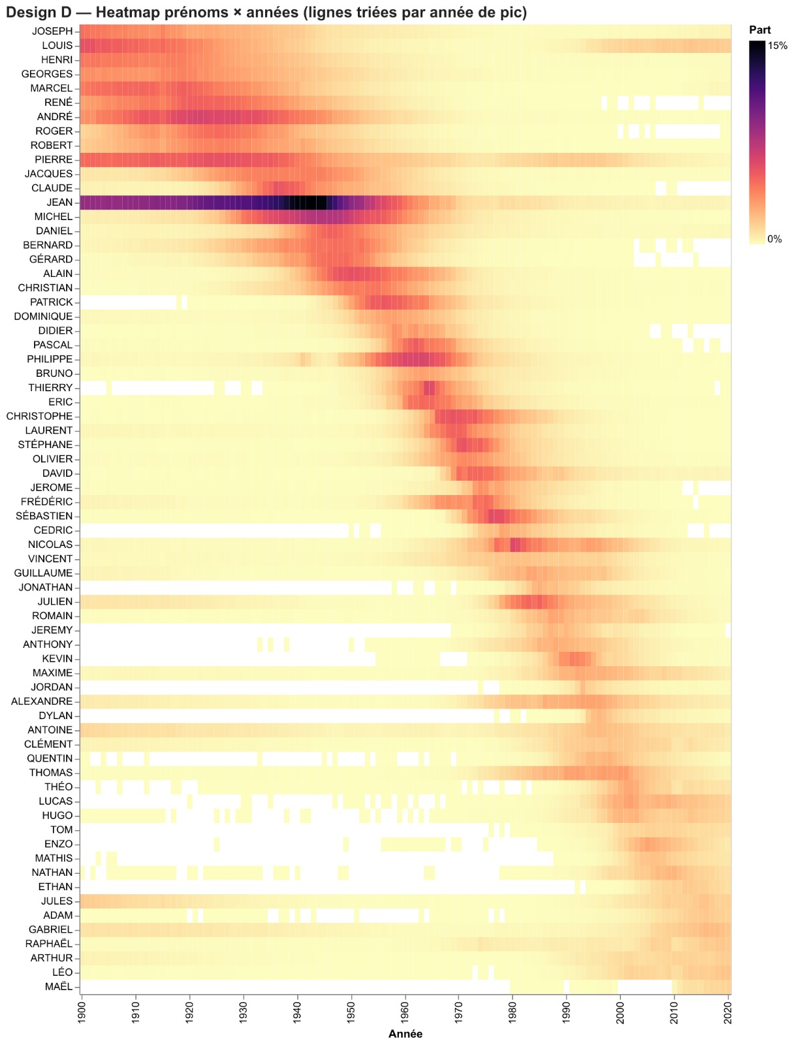
Strengths
- The diagonal reveals trends instantly: consistency (long horizontal bands), brief fads (short spots) and accelerating turnover toward recent decades.
- Shows many names simultaneously without clutter.
- Encodes magnitude (share) directly through color.
Weaknesses
- Static; reading one specific name precisely is hard.
- The Top-N of names to display must be chosen.
- Subtle differences can be lost in the color scale.
Design 1.2 — Longevity quadrant + linked time series
A scatter plot positions each name by peak year (X) and longevity — years spent above a popularity threshold (Y); bubble size = total births. Clicking a bubble shows its full time series below. Names sort into classics (top), fads (bottom), older/recent eras (left/right).
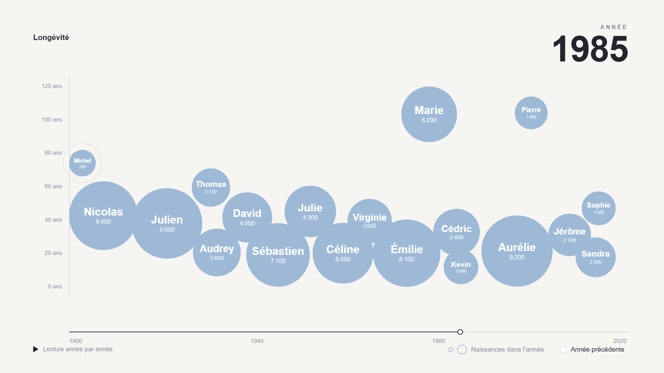
Strengths
- Directly answers 'consistent vs sudden/brief' — it is the chart's vertical axis.
- Overview + detail in one view via the linked time series on click.
- Bubble size keeps absolute magnitude visible, not just rank.
Weaknesses
- Bubble overplotting in dense areas needs zoom/jitter/opacity.
- 'Longevity' relies on an arbitrary threshold that must be stated.
- Locating a given name still requires interaction (search/hover).
Design 1.3 — Bump chart / 'metro' lines (Top-10 rank over time)
Lines track the yearly rank of the Top-10 names; crossings show overtakes and rank reversals across the century.
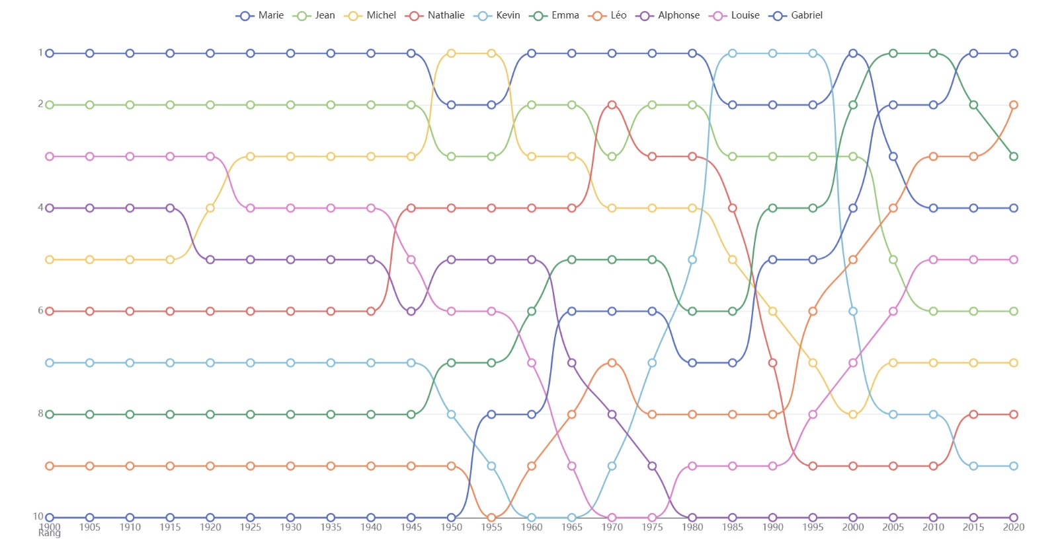
Strengths
- Excellent for crossings, comebacks and rank reversals.
- Very legible for a small set of leaders.
- Intuitive narrative of 'who was on top when'.
Weaknesses
- Limited to ~10 names — misses obscure or briefly popular names.
- Rank hides magnitude (the #1 name may be far ahead of #2).
- Becomes a tangle if too many names are shown.
Visualization 2 — Regional effect
Questions: are some names more popular in certain regions, and are popular names generally popular across the whole country?
Design 2.1 — Interactive choropleth of the location quotient (LQ)
A department map colored by a selected name's location quotient = local share ÷ national share. LQ > 1 (red) = over-represented locally; ~1 = national average. A name selector and a year slider let the user explore any name and watch its geographic diffusion over time.
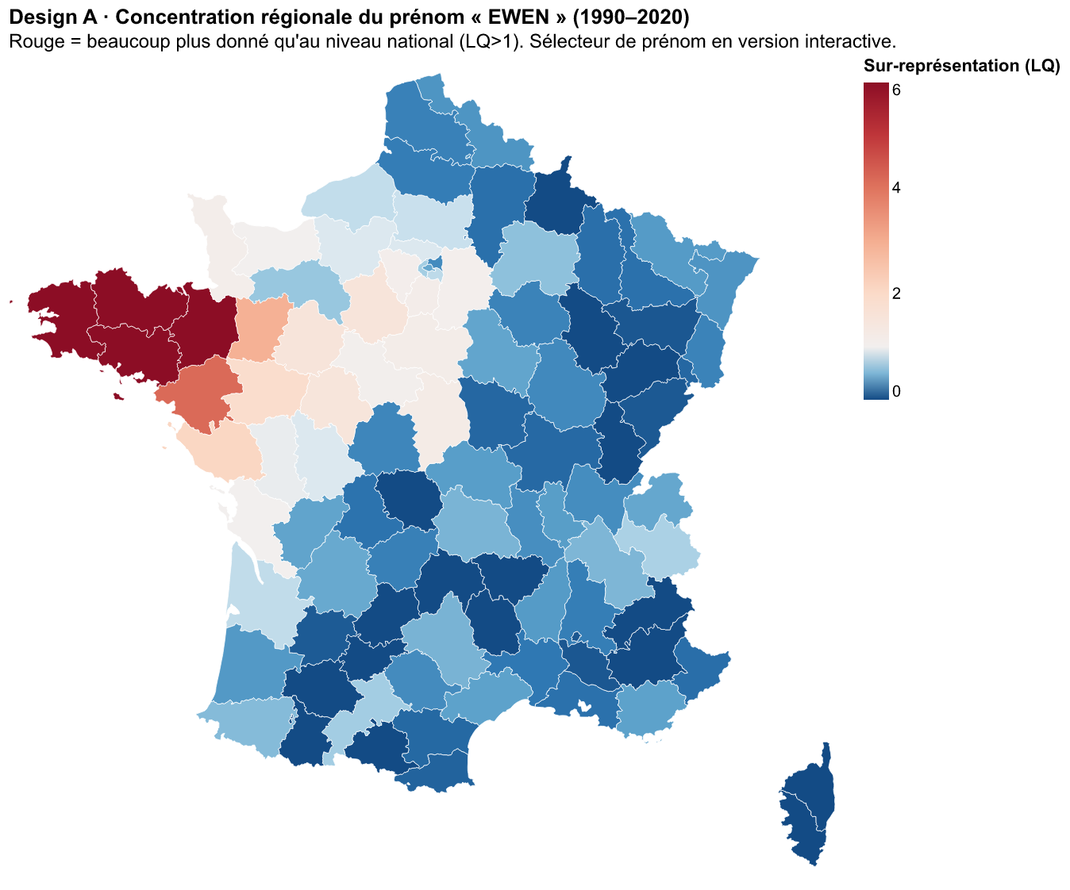
Strengths
- Geographic encoding is the natural answer to a geographic question.
- The LQ isolates the regional effect and corrects for department size.
- The year slider exposes diffusion (names often spread from a region outward).
Weaknesses
- Shows one name at a time; cross-name comparison needs another view.
- Insee codes Corsica as '20' while the map uses 2A/2B (reconciliation needed).
- Overseas departments are off-scale and excluded (metropolitan France only).
Design 2.2 — 'Signature name' per department map
Each department is labeled with its most over-represented name (highest LQ), exposing regional cultural identities — Breton, Basque, Catalan, Corsican signatures.
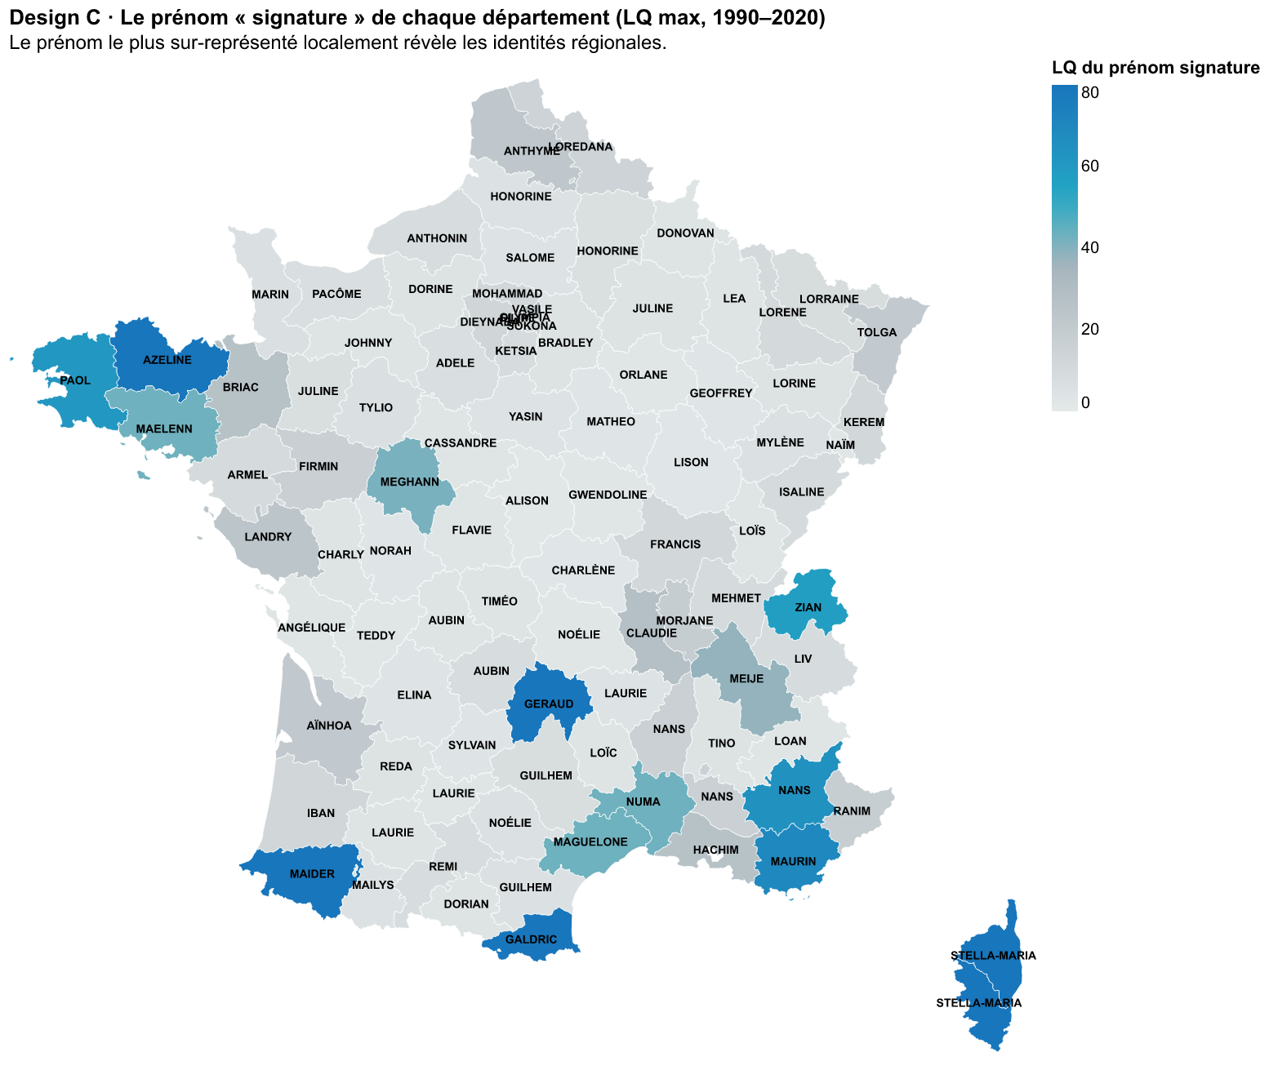
Strengths
- Reveals every region's identity in a single static picture.
- Strong, memorable storytelling of regional culture.
- Directly answers 'are some names more popular in some regions?'.
Weaknesses
- 96 labels make the map crowded.
- Sensitive to outliers and to the minimum-births threshold.
- Shows only the single top name, not the broader distribution.
Design 2.3 — Sunburst (region → department hierarchy)
Concentric rings break down births by region (inner ring) and department (outer ring), showing how each region is composed and the relative weight of its departments.
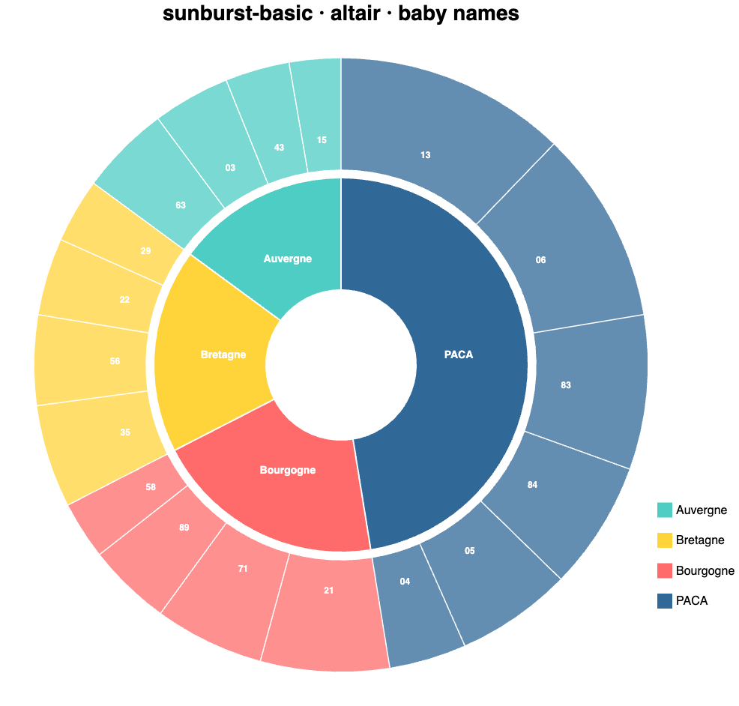
Strengths
- Clear hierarchical composition: region totals and their department breakdown together.
- Compact part-to-whole view; interactive drill-down is natural.
- Good complement to the map for 'how big is each region'.
Weaknesses
- No geographic dimension — cannot answer 'where' on the territory.
- Hard to compare angular slice sizes precisely.
- Does not express 'local vs national' popularity by itself (secondary view).
Visualization 3 — Gender effect
Questions: are there gender effects, and does the popularity of names given to both sexes evolve consistently across sexes?
Design 3.1 — Female-share heatmap per decade
Rows are unisex names, columns are decades, color is the female share on a diverging scale (blue = mostly male, orange = mostly female, grey = balanced). Gender flips appear as a row changing color over time.
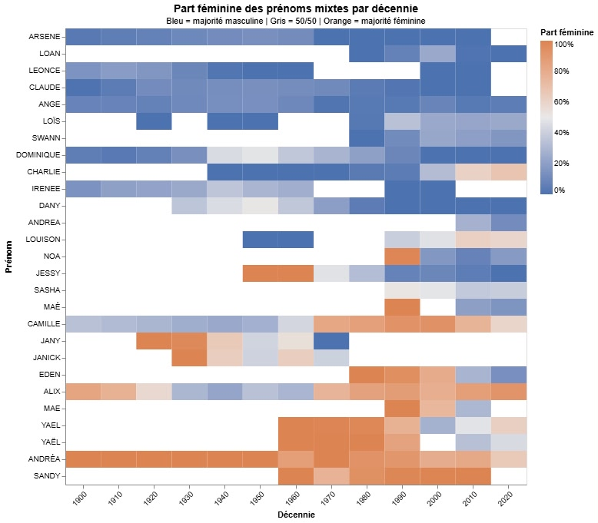
Strengths
- Surfaces gender flips (e.g. Camille, Alix) across many names at once.
- Diverging color makes 'consistent vs shifting' legible at a glance.
- Compact overview of the whole set of unisex names.
Weaknesses
- Decade aggregation smooths short-lived swings.
- Limited to names given to both sexes.
- Color alone cannot show the volume behind each share.
Design 3.2 — Female-share line chart (interactive, click to isolate)
One line per unisex name shows its female share year by year; clicking the legend isolates a name (Shift+click for several) for precise temporal reading.
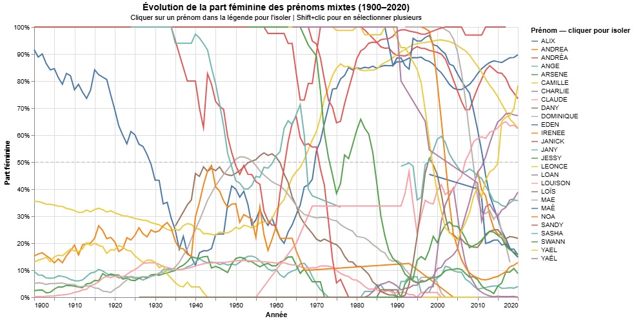
Strengths
- Year-level precision on each name's gender trajectory.
- Interaction (isolate/compare) tames the complexity on demand.
- Crossing the 50% line marks the exact moment a name flips.
Weaknesses
- Illegible spaghetti without default filtering to a few names.
- Hard to get an overview of all names at once.
- Overlapping lines obscure simultaneous trends.
Design 3.3 — Split male/female violins per name
For each unisex name, a split violin shows the distribution of births over years for males vs females, revealing each name's active periods by sex.
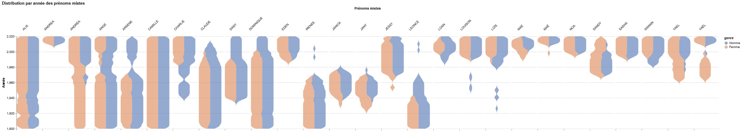
Strengths
- Shows each name's active period and its male/female balance together.
- Distribution shape conveys more than a single share value.
- Visually distinctive and compact across many names.
Weaknesses
- Answers 'when' more than 'does the gender flip'.
- Violin shapes are harder for a general audience to read.
- Comparing many names side by side becomes dense.
Cross-cutting consistency
Across all views we keep a consistent sex color encoding, reuse a shared 'heatmap' visual language (Viz 1 and Viz 3), and clean the data identically (rare names, dpt=XX and annais=XXXX excluded).

