Baby Names in France (1900–2020)
Final Visualizations — Presentation & Rationale
We implemented three interactive visualizations in Altair (Vega-Lite), one per set of questions. Each is a self-contained HTML file with a slider, tooltips and linked views. Popularity is measured as a share of births so that years, regions and sexes are comparable. Below, each visualization is presented with a snapshot and an explanation of why it is appropriate and effective for its target questions. (Screenshots here are static; the live files reveal the full interaction — we recommend a short screen-capture clip per visualization showing the slider being dragged.)
Visualization 1 — Evolution over time
Target questions: which names stay consistently (un)popular, which are suddenly or briefly popular, and are there temporal trends?
What it shows
An animated bubble cloud. Each bubble is a name in the selected year. The X-axis is the name's peak year, the Y-axis is its longevity (number of years it stayed in the national Top 100), bubble size is the number of births that year, and color encodes sex. The “Year” slider scrubs through 1900–2020; the giant year label and the moving, growing bubbles make the evolution tangible.
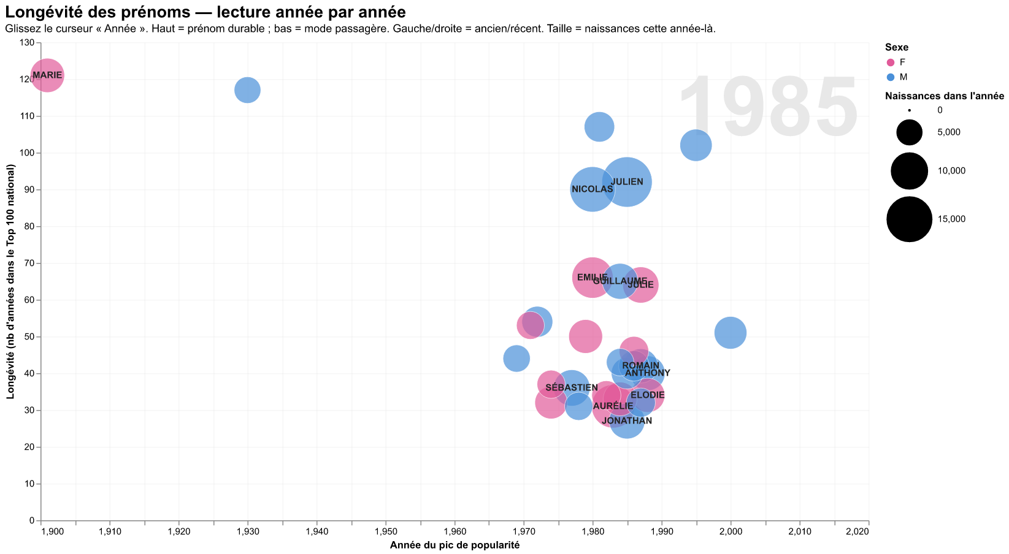
Static snapshot — the live HTML adds the slider, hover and linked views.
Why it is appropriate and effective
- Consistent vs brief popularity is read directly off the vertical axis: long-lived classics sit high (e.g. Marie), short-lived fads sit low — answering the core question by position.
- Temporal trends emerge from scrubbing: the cloud drifts rightward over the century and names are replaced faster in recent decades, making accelerating turnover visible.
- Sudden popularity is shown by a bubble that appears and inflates rapidly as the slider advances, while its low longevity keeps it near the bottom.
- Bubble size preserves absolute magnitude (births), so rank and volume are not confused.
- Hover tooltips give the exact name, sex, births, peak year and longevity for detail on demand.
Key points to demonstrate (screenshots / video)
- Snapshots at 1905, 1965 and 2015 to show how the set of names turns over.
- A long-lived name high on the axis (Marie/Jean) vs a brief fad low on the axis.
- A short clip dragging the slider to show the cloud shifting and bubbles growing.
Visualization 2 — Regional effect
Target questions: are some names more popular in some regions, and are popular names generally popular across the whole country?
What it shows
A two-ring sunburst of where births occur: the inner ring is the region, the outer ring its departments, and the angle of each arc is proportional to the number of births. The “Decade” slider recomposes the rings decade by decade; hovering a region highlights it and fades the rest.
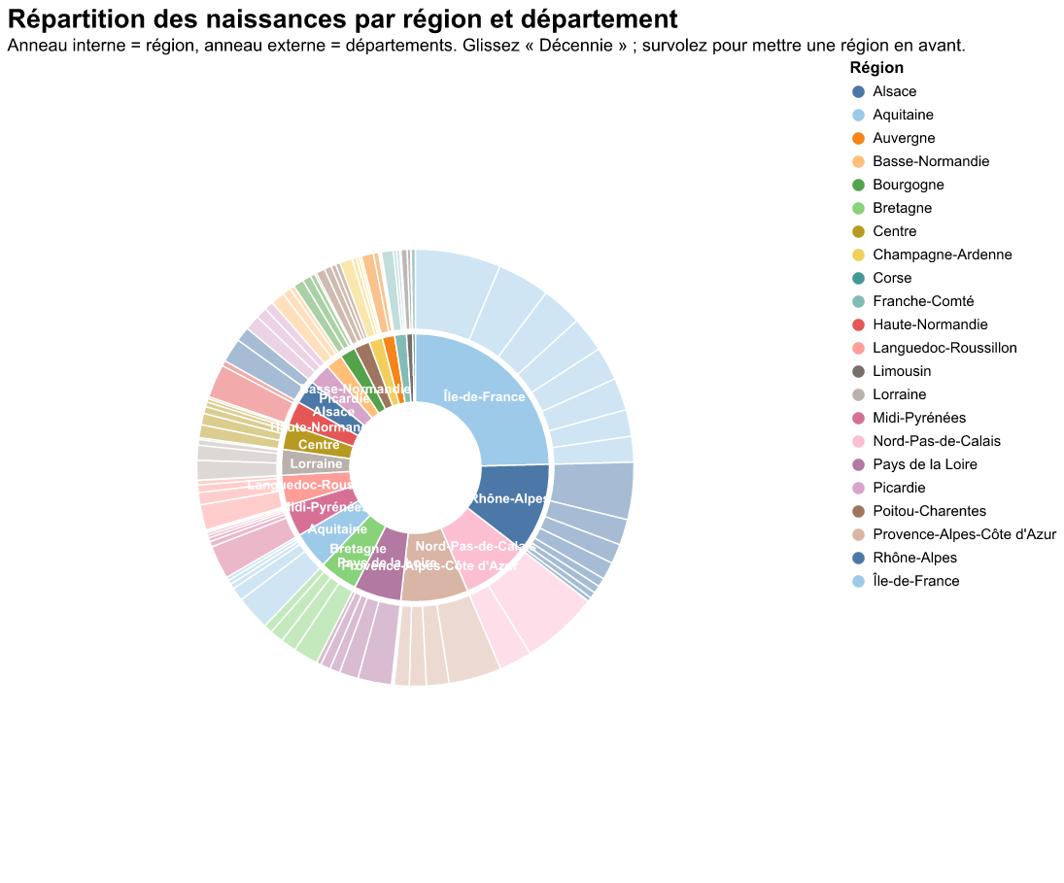
Static snapshot — the live HTML adds the slider, hover and linked views.
Why it is appropriate and effective
- It gives the geographic structure of the data in one part-to-whole picture: which regions and departments carry the most births (e.g. Île-de-France and Rhône-Alpes dominate).
- The decade slider exposes regional shifts over time — the demographic weight of regions is not constant across the century.
- Hover-to-highlight makes a single region and its departments easy to isolate and compare.
- It establishes the regional baseline needed to interpret any name: how many births each region contributes in the first place.
Honest limitation & complementary view (compare/contrast)
The sunburst answers “how are births distributed across regions?” but not, on its own, “is a given name unusually popular in a region?” To fully answer the regional question we pair it with a choropleth map of the location quotient (local share ÷ national share) with a name selector and year slider. Together they show that regional names (Breton EWEN, Catalan JORDI, Basque-area MAYLIS…) light up locally, whereas top national names (EMMA, LUCAS) stay uniform everywhere — which is exactly the second sub-question. The sunburst supplies the ‘how big is each region’ context; the choropleth supplies the ‘where is this name over-represented’ answer.
Visualization 3 — Gender effect
Target questions: are there gender effects, and does the popularity of names given to both sexes evolve consistently across sexes?
What it shows
A heatmap of unisex names (rows) by decade (columns), colored by the female share on a diverging scale (blue = mostly boys, orange = mostly girls, pale = balanced). Clicking a name opens, on the right, its year-by-year female-share curve with a dashed 50% reference line.
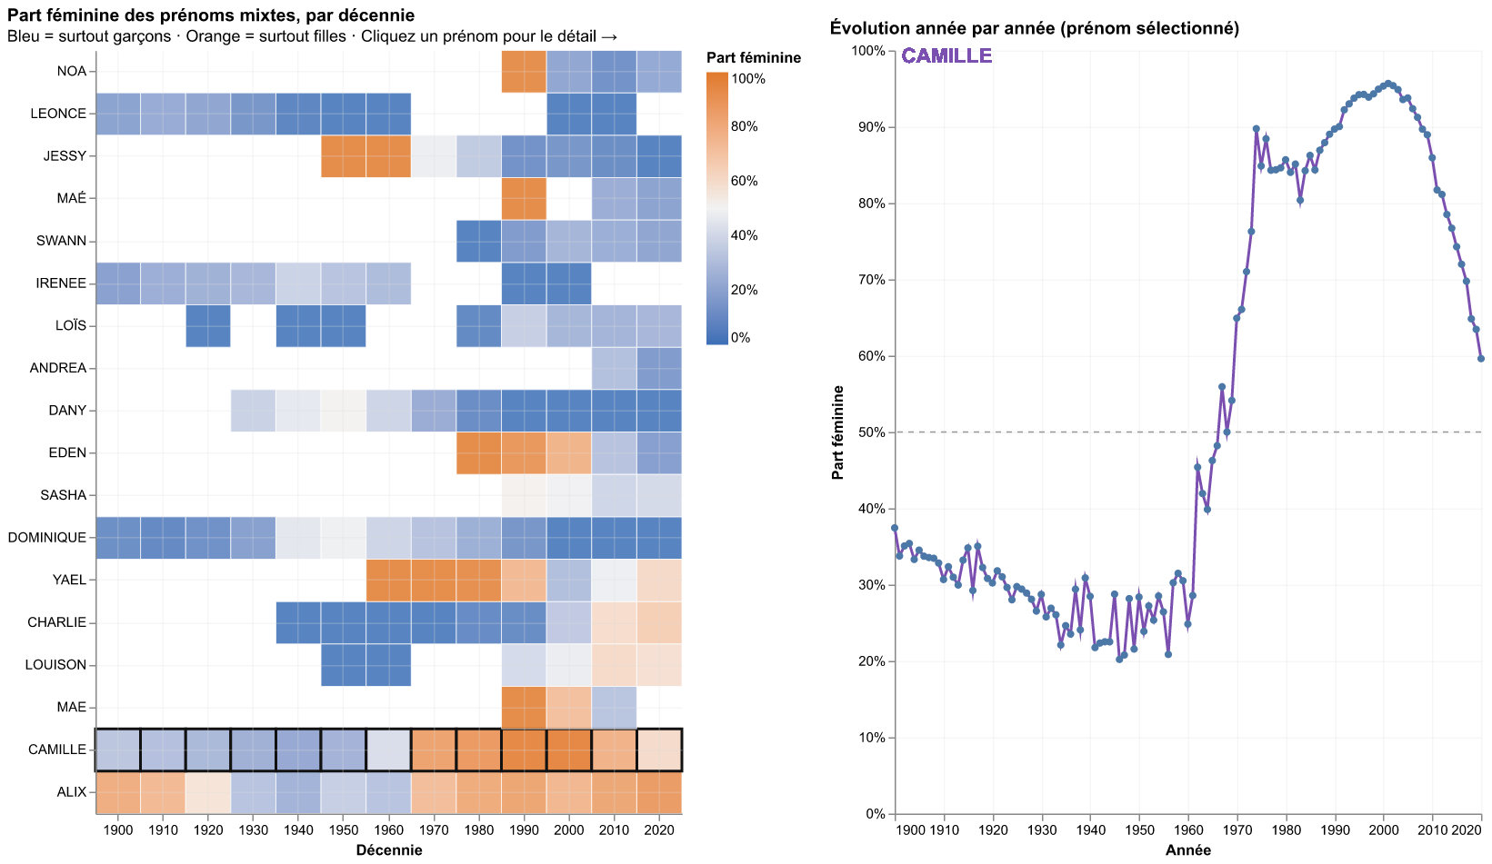
Static snapshot — the live HTML adds the slider, hover and linked views.
Why it is appropriate and effective
- It focuses on unisex names — the only names for which a gender question is meaningful — so the view is on-topic by construction.
- Whether a name evolves consistently is read along each row: a row that stays one color is stable, a row that changes from blue to orange has flipped sex over time (e.g. Camille).
- The diverging palette centered at 50% makes ‘mostly boys’, ‘balanced’ and ‘mostly girls’ instantly distinguishable across many names at once.
- The linked line chart gives the precise trajectory: when it crosses 50% and whether the shift is gradual or abrupt — the exact ‘consistent evolution?’ answer.
Key points to demonstrate (screenshots / video)
- The heatmap overview showing several names that flip color over the decades.
- Clicking Camille (or Dominique) to reveal the curve crossing the 50% line mid-century.
- A name that stays one color throughout as a stable counter-example.
Summary
Each visualization is matched to its question through a deliberate encoding: longevity on an axis for time, geographic arcs (plus a location-quotient map) for region, and a diverging female-share heatmap for gender. All three follow the same overview + detail-on-demand pattern (slider / hover / linked view) and share a consistent, accessible color language.

