Blockchain Algorithms – Functionality and Application in the Food Industry

Max Lattermann
Samford University
800 Lakeshore Dr
Birmingham, AL 35229
+1 205 593 9745
mlatterm@samford.edu
Brian Toone
Samford University
800 Lakeshore Dr
Birmingham, AL 35229
+1 205 726 2960
brtoone@samford.edu

ABSTRACT
The purpose of this project is to research the application purposes of blockchain algorithms and how they function to ensure unique identifiers for files and transactions. Furthermore, this knowledge will be used to create a solution that enables users to prove ownership over a specific file or collection of files to explore the security benefits of using blockchain algorithm outside of the crypto currency field.
Categories and Subject Descriptors
[Security and Privacy]: Systems security – Distributed systems security, Information flow control File system security.
General Terms
Algorithms, Management, Documentation, Performance, Security, Experimentation.
Keywords
Cryptocurrency, NFTs, Blockchain, Security, Data, Communication

INTRODUCTION
While most people have heard about Blockchain algorithms and their use in crypto currencies and Non-Fungible Tokens (NFTs), people usually lack an understanding of how they work and what their benefits are. For this reason, I am researching the functionality and applicability of these algorithms to create a survey of available resources and will attempt to design and create an algorithm that proves the ownership of a file to create a secure encryption protocol for data transmission. This file can be sent to another computer, enabling a transfer of ownership and with that a level of security that is not necessarily given when it comes to other security protocols that emphasize on the encryption of the data transmission alone, not the ability to prove if something belongs to oneself. The unique combination of hashing the data and relying on a trustworthy system can be used in many different contexts outside of the banking world and thus have a tremendous potential to revolutionize the way humans communicate virtually and store data.
Blockchain algorithms are the basis of functionality for virtual money pioneered by Satoshi Nakamoto with the introduction of Bitcoin in 2009. The algorithm that enables data to be stored in so-called blocks that are chained together to symbolize a transaction are not only self-sufficient and highly democratic in that they do not need a central authority keeping everything in check – a bank – but they also directly implement the pivotal security features that allow for secure connections. This enables a certification of ownership. Understanding how this certificate of ownership can be used in different contexts other than just proving that a specific financial transaction is really theirs is the purpose of this project. How this can be implemented is shown with a simple program using mock data that is being stored on a chain of blocks.

BACKGROUND
The initial boost in popularity of blockchain technology originated from the hype around cryptocurrencies, namely bitcoin as the first and most successful of these virtual means of payment. Finding out how this becomes more universally applicable and how the mechanism works in other fields is the purpose of this research project. The issues relating to security and anonymity resulting from the use of these algorithms have caused many discussions and concerns, as transactions are virtually untraceable. This points to the effectiveness of the algorithm in creating a protocol that allows for secure data transmission approaching the issues of security concerns for virtual transfers of any kind of data, such as money, files, or other information. The basic structure of a blockchain algorithm is based on multiple different security features and can be broken down into separate parts that need individual analysis. The central purpose of the mechanisms behind blockchain is that it eliminates the need for a trusted third party to execute and transaction, or trade. The institution that facilitates trading between two independent parties can be eliminated and thus the footprint of transactions is being decreased by relying on a peer-to-peer mechanism that is publicly and openly policed by the community of members inside the network [1]. The different computers involved in the network are referred to as nodes that are accessing the information about all transactions happening on that specific network, consisting of chains of blocks. This centrally available and openly accessible information can be understood as a ledger that includes all the transactions happening; that can be financial transactions or production stories but essential is that this is accessible to all members of the network. Any new trade or change is being recorded and added as a new block to the chain of transactions already existing and this is being broadcasted and thus can be compared to all the existing transactions by the other members of the network to validate its legitimacy. Each new addition is a “block” that includes a timestamp, the data itself, and a hash, which is – most commonly relying on the SHA-256 hashing algorithm – an encrypted message that points directly to the previous block, meaning the previous transaction of this “coin” or token which carries the data. This way, data such as the location of a specific fruit can be stored and each time it is moved, a new block is added to the chain with its new location. Similarly, general data about a specific produce can be stored on the chain of blocks and gets validated repeatedly by the fact that new blocks, meaning new data is added to the chain that the first piece of data sits on.
In case of attacking attempts, any falsified chains, where individual blocks were tampered with, meaning that they do not include the exact information that all the other copies of the ledger-chain, are identified as false since they are different than the as correct accepted chain available for all the other nodes in the network in a democratic fashion. This system is trusted because the longest chain is always the one being considered the right one, as the hash that corresponds to each block is being referenced in the next one, building up the chain of blocks. Once one block is being tampered with, all the subsequent blocks do not match up with the hashes available on the other copies of the chain, indicating that there has been an issue. It is virtually impossible to catch up with the correct chain for an attacker, as all the subsequent hashes would have to be corrected [2].
*More details on how the chain of blocks is created, verification, longest chain, mining*
*alternatives for mining*
*Details on security measures*
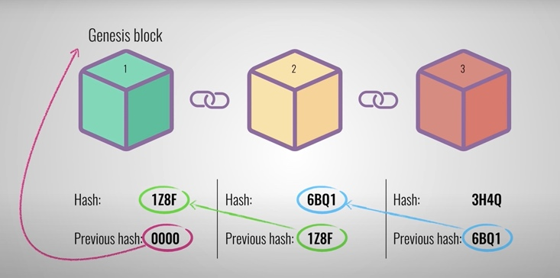
Consumers are oftentimes not well informed about the origin of the goods they buy daily. This is an existing issue in all parts of consumerism, from clothing to the coffee industry and most everything that is being traded internationally as different standards in health regulations and workers conditions can create ethical conflicts. How can the goods reliably be traced back to their origin to where companies cannot simply claim ethical sourcing with no actual guarantee? The graphic below depicts the different elements that are impacted by blockchain in the food industry. This translates into most other global networks of communication and trade, revealing the deep possible impact that the technology can have on globalization, our consumerism, and life overall.
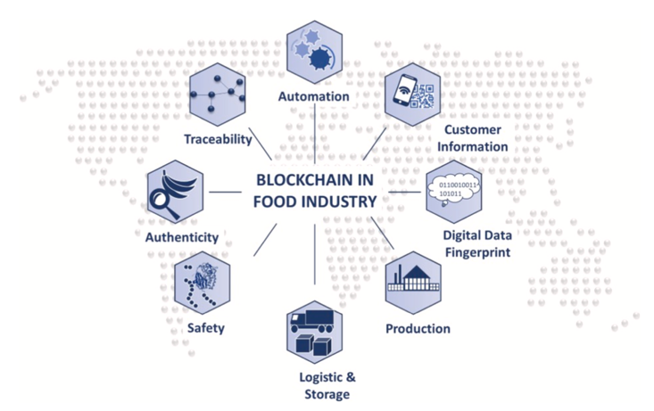

METHODOLOGY
The Project started out as a research project about the functionality of blockchain and crypto currency by itself. It quickly became apparent, however, that the possibilities of use for the algorithms are vast, so digging into how Blockchain can ensure moral and ethical behavior has been great fun that is hugely important. There are only a select few companies capitalizing on providing authentication methods for food producers that rely on blockchain yet, but it is an increasingly important field, partially because the general acceptance in society and the overall knowledge of the topic for most people is rather limited.
Thus, the initial step of this project is to gain a comprehensive understanding of both how blockchain algorithms work and what their different areas of application can be. The purpose of this research project is twofold. First, a survey of material available is supposed to create an easily accessible resource for students and other people interested to understand the deep impact of the blockchain technology on all aspects of life. Secondly, by creating a blockchain algorithm that utilizes this technology to improve a real-life scenario, the endless possibilities become more tangible, and it helps make the processes that go into creating a blockchain more readily available and understandable. For this purpose, it helps to consider the oftentimes questionable flow of information in the food production industry, especially when it comes to working conditions in areas like the chocolate and coffee production. A need for a clear understanding of the labor conditions for the workers involved in the production of certain foods is essential, however, the current opportunities for education of the consumers is very limited as companies often self-police and therefore can avoid any sort of critical investigation of labor conditions. Blockchain can help with this, by creating digitally signed and unique data that allows the consumer to see definitively how the food came to be [3]. For that purpose, the program that I created for this project applies the blockchain algorithm to a file that stores data about a specific produce to mockup the ingredients and working conditions, as well as any other possible information about the produce that would be of interest to the consumer, such as the carbon footprint, and any collection of things going into the production throughout the supply chain. A secure protocol that cannot be tampered with and changed by people with malicious intentions, such as corrupt supervisors, requires a system that can pass on the data step by step through the production line, creating a mutual checks and balances system providing accountability [4]. This serves as a great example for how different real-life scenarios can benefit from the implementation of the blockchain system into the application to give security, accountability, and decentralization a more effective foundation.
*Discussion of the coding of the actual mock app*

Permission to make digital or hard copies of all or part of this work for personal or classroom use is granted without fee provided that copies are not made or distributed for profit or commercial advantage and that copies bear this notice and the full citation on the first page. To copy otherwise, or republish, to post on servers or to redistribute to lists, requires prior specific permission and/or a fee.
Samford University Department of Math and Computer Science, May 2011, Birmingham, AL. Copyright 2011 Samford University…$10.00.

EXPECTED OUTCOME
Creating a comprehensive research paper that summarizes the functionality of blockchain algorithms and analyzes the benefits, downsides, and applicability of the technology for different fields should provide the reader with a great resource to understand the potential impact blockchains will have in the years to come. That combined with a rudimentary running application, that either uses a blockchain algorithm to demonstrate the benefits security and accountability will give a great case study for the way that blockchains can enhance people’s grocery shopping experience and most other parts of life.

CONCLUSION
Viewing the blockchain algorithm in the context of proving file ownership helps not only understand the functionality of said algorithms, which creates an accessible resource to get insight into the world of cryptocurrencies but gives the reader an understanding of how this technology allows for new possibilities to fight injustice in the world.
The sample application can be increased in functionality by adding more accurate data and can manually be tested for speed and security by adding more blocks, meaning more transactions.
Some general takeaways also include:
The idea behind Blockchain is much simpler than it seems at first sight.
Blockchain allows a user or producer to certify their claims to a virtual combination of words, numbers, or pixels, that can be the production story or the picture of a monkey, which is an example of a popular NFT).
It is highly portable and not just restricted to the financial market and food production is only one example field that can profit from the use of blockchain to ensure more accountability.
Every member of the production chain must be part of the blockchain network.
The cost of entry for implementation is relatively high, as enough members, ideally all participants in the production process and trade need to enter the network.
The human factor that needs to be relied on initially can be a potential risk for input data to be tampered with in the beginning, however, it takes away the control from central conglomerates dictating the narrative of what is an ethical standard and what not.

REFERENCES
- Nakamoto,

- Satoshi. “Bitcoin: A Peer-to-Peer Electronic Cash System.” 2008. https://bitcoin.org/bitcoin.pdf.
- Sanderson, Grant. “But how does bitcoin actually work?” YouTube, uploaded by 3Blue1Brown, 7 July 2017, https://www.youtube.com/watch?v=bBC-nXj3Ng4.
- “Blockchains: how can they be used? (Use cases for Blockchains).” YouTube, uploaded by Simply Explained, 29 March 2018, https://www.youtube.com/watch?v=aQWflNQuP_o.
- Creydt, M. and Fischer, M. “Blockchain and more – Algorithm driven food traceability.” Food Control. University of Hamburg, Germany, 2019.
- Nielsen, Michael. “How the Bitcoin protocol actually works.” https://michaelnielsen.org/ddi/how-the-bitcoin-protocol-actually-works/.
- Buterin, Vitalik. “Ethereum Whitepaper.” 2014. https://ethereum.org/en/whitepaper/.
- Zsigmond, Joao. “Creating a Blockchain from Scratch.” https://levelup.gitconnected.com/creating-a-blockchain-from-scratch-9a7b123e1f3e
- Sanderson, Grant. “How secure is 256-bit security?” YouTube, uploaded by 3Blue1Brown, 8 July 2017, https://www.youtube.com/watch?v=S9JGmA5_unY&t=0s.
- “How does a Blockchain work?” YouTube, uploaded by Simply Explained, 13 November 2017, https://www.youtube.com/watch?v=SSo_EIwHSd4&t=328s.
- Brownworth, Anders. “Blockchain 101 – A Visual Demo.” YouTube, 5 November 2016, https://www.youtube.com/watch?v=_160oMzblY8.

