Blockchain Algorithms – Functionality and Application in the Food Industry

Max Lattermann
Samford University
800 Lakeshore Dr
Birmingham, AL 35229
+1 205 593 9745
mlatterm@samford.edu
Brian Toone
Samford University
800 Lakeshore Dr
Birmingham, AL 35229
+1 205 726 2960
brtoone@samford.edu

ABSTRACT
The purpose of this project is to research the application purposes of blockchain algorithms and how they function to ensure unique identifiers for files and transactions. Furthermore, this knowledge will be used to create a solution that enables users to prove ownership over a specific file or collection of files to explore the security benefits of using blockchain algorithm outside of the crypto currency field.
Categories and Subject Descriptors
[Security and Privacy]: Systems security – Distributed systems security, Information flow control File system security.
General Terms
Algorithms, Management, Documentation, Performance, Security, Experimentation.
Keywords
Cryptocurrency, NFTs, Blockchain, Security, Data, Communication

INTRODUCTION
While most people have heard about Blockchain algorithms and their use in crypto currencies and Non-Fungible Tokens (NFTs), people usually lack an understanding of how they work and what their benefits are. For this reason, I am researching the functionality and applicability of these algorithms to create a survey of available resources and will attempt to design and create an algorithm that proves the ownership of a file to create a secure encryption protocol for data transmission. This file can be sent to another computer, enabling a transfer of ownership and with that a level of security that is not necessarily given when it comes to other security protocols that emphasize on the encryption of the data transmission alone, not the ability to prove if something belongs to oneself. The unique combination of hashing the data and relying on a trustworthy system can be used in many different contexts outside of the banking world and thus have a tremendous potential to revolutionize the way humans communicate virtually and store data.
Blockchain algorithms are the basis of functionality for virtual money pioneered by Satoshi Nakamoto with the introduction of Bitcoin in 2009. The algorithm that enables data to be stored in so-called blocks that are chained together to symbolize a transaction are not only self-sufficient and highly democratic in that they do not need a central authority keeping everything in check – a bank – but they also directly implement the pivotal security features that allow for secure connections. This enables a certification of ownership. Understanding how this certificate of ownership can be used in different contexts other than just proving that a specific financial transaction is really theirs is the purpose of this project [1]. How this can be implemented is shown with a simple program using mock data that is being stored on a chain of blocks.

BACKGROUND
The initial boost in popularity of blockchain technology originated from the hype around cryptocurrencies, namely bitcoin as the first and most successful of these virtual means of payment. Finding out how this becomes more universally applicable and how the mechanism works in other fields is the purpose of this research project. The issues relating to security and anonymity resulting from the use of these algorithms have caused many discussions and concerns, as transactions are virtually untraceable. This points to the effectiveness of the algorithm in creating a protocol that allows for secure data transmission approaching the issues of security concerns for virtual transfers of any kind of data, such as money, files, or other information. The basic structure of a blockchain algorithm is based on multiple different security features and can be broken down into separate parts that need individual analysis. The central purpose of the mechanisms behind blockchain is that it eliminates the need for a trusted third party to execute and transaction, or trade. The institution that facilitates trading between two independent parties can be eliminated and thus the footprint of transactions is being decreased by relying on a peer-to-peer mechanism that is publicly and openly policed by the community of members inside the network [2]. The different computers involved in the network are referred to as nodes that are accessing the information about all transactions happening on that specific network, consisting of chains of blocks. This centrally available and openly accessible information can be understood as a ledger that includes all the transactions happening; that can be financial transactions or production stories but essential is that this is accessible to all members of the network. Any new trade or change is being recorded and added as a new block to the chain of transactions already existing and this is being broadcasted and thus can be compared to all the existing transactions by the other members of the network to validate its legitimacy. Each new addition is a “block” that includes a timestamp, the data itself, and a hash, which is – most commonly relying on the SHA-256 hashing algorithm – an encrypted message that points directly to the previous block, meaning the previous transaction of this “coin” or token which carries the data. This way, data such as the location of a specific fruit can be stored and each time it is moved, a new block is added to the chain with its new location. Similarly, general data about a specific produce can be stored on the chain of blocks and gets validated repeatedly by the fact that new blocks, meaning new data is added to the chain that the first piece of data sits on.
In case of attacking attempts, any falsified chains, where individual blocks were tampered with, meaning that they do not include the exact information that all the other copies of the ledger-chain, are identified as false since they are different than the as correct accepted chain available for all the other nodes in the network in a democratic fashion. This system is trusted because the longest chain is always the one being considered the right one, as the hash that corresponds to each block is being referenced in the next one, building up the chain of blocks. Once one block is being tampered with, all the subsequent blocks do not match up with the hashes available on the other copies of the chain, indicating that there has been an issue. It is virtually impossible to catch up with the correct chain for an attacker, as all the subsequent hashes would have to be corrected [3].
Verification happens through the process of mining. This is a proof-of-work concept in which the hash of a block’s header needs to be lower or equal to a target number. That means that mathematically, a problem has to be solved in order for people to prove that a transaction is true and valid. The idea of the proof-of-work is described by Nielsen as “a competition to approve transactions. Each entry in the competition costs a little bit of computing power. A miner’s chance of winning the competition is (roughly, and with some caveats) equal to the proportion of the total computing power that they control. […] So provided a lot of computing power is being brought to bear on the competition, a dishonest miner is likely to have only a relatively small chance to corrupt the validation process” [4].
One of the most discussed criticisms of blockchains and specifically the crypto world is the ecological impact of mining. The process of mining is what generates new currency as a reward for nodes to verify transactions at random. This process requires a large amount of energy because of the intensive calculations that are required for verification. This means that entire data processing centers are concerned with only this one thing, using incredibly high amounts of energy for verification. There are, however, not any feasible alternatives to the current process of mining, as the democratic idea of majority rule – meaning the largest number of nodes in the network dictate what gets verified and what not – requires large sums of computers to work these complicated calculations. Therefore, there are no feasible alternatives to utilizing anything else but computing power for validation, although, the overall steps that need to be verified for each product are limited and thus less steps are involved, hence fewer need for verification is necessary in the food production context over the financial context of Bitcoin.
The element that makes the transactions stored in blocks secure is the process of hashing. The corresponding algorithm used is SHA-256, a hashing formula based on a 256-bit approach, meaning that the message of each transaction is turned into 256 bits based on an encryption key that generates the combination of bits completely random, meaning that even the slightest change, such as adding an extra period in the content of the message will completely and utterly change the 256 bits [5].
Figure 1. Graphical representation of a blockchain. Credits: Simply Explained [6].
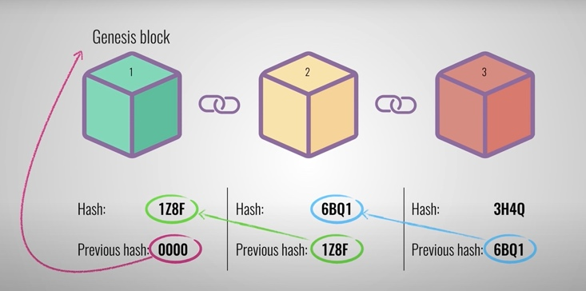
Consumers are oftentimes not well informed about the origin of the goods they buy daily. This is an existing issue in all parts of consumerism, from clothing to the coffee industry and most everything that is being traded internationally as different standards in health regulations and workers conditions can create ethical conflicts. How can the goods reliably be traced back to their origin to where companies cannot simply claim ethical sourcing with no actual guarantee? The graphic below depicts the different elements that are impacted by blockchain in the food industry. This translates into most other global networks of communication and trade, revealing the deep possible impact that the technology can have on globalization, our consumerism, and life overall.
Figure 2. Overview over what aspects of the food production can be influenced by the implementation of blockchain. Credits: Creydt, M. and Fischer, M. [7]
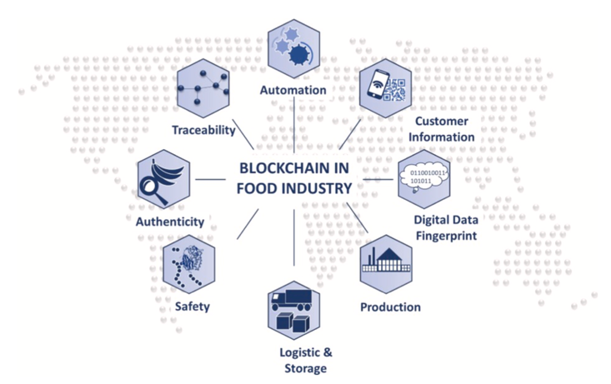

METHODOLOGY
The Project started out as a research project about the functionality of blockchain and crypto currency by itself. It quickly became apparent, however, that the possibilities of use for the algorithms are vast, so digging into how Blockchain can ensure moral and ethical behavior has been great fun that is hugely important. There are only a select few companies capitalizing on providing authentication methods for food producers that rely on blockchain yet, but it is an increasingly important field, partially because the general acceptance in society and the overall knowledge of the topic for most people is rather limited.
Thus, the initial step of this project is to gain a comprehensive understanding of both how blockchain algorithms work and what their different areas of application can be. The purpose of this research project is twofold. First, a survey of material available is supposed to create an easily accessible resource for students and other people interested to understand the deep impact of the blockchain technology on all aspects of life. Secondly, by creating a blockchain application that utilizes this algorithmic technology to improve a real-life scenario, the endless possibilities become more tangible, and it helps make the processes that go into creating a blockchain more readily available and understandable. For this purpose, it helps to consider the oftentimes questionable flow of information in the food production industry, especially when it comes to working conditions in areas like the chocolate and coffee production. A need for a clear understanding of the labor conditions for the workers involved in the production of certain foods is essential, however, the current opportunities for education of the consumers is very limited as companies often self-police and therefore can avoid any sort of critical investigation of labor conditions. Blockchain can help with this, by creating digitally signed and unique data that allows the consumer to see definitively how the food came to be [7]. For that purpose, the program that I created for this project applies the blockchain algorithm to simplified data about different specific products to mockup the ingredients and working conditions, as well as any other possible information about the produce that would be of interest to the consumer, such as the carbon footprint, and any collection of things going into the production throughout the supply chain. A secure protocol that cannot be tampered with and changed by people with malicious intentions, such as corrupt supervisors, requires a system that can pass on the data step by step through the production line, creating a mutual checks and balances system providing accountability [4]. This serves as a great example for how different real-life scenarios can benefit from the implementation of the blockchain system into the application to give security, accountability, and decentralization a more effective foundation.

Algorithm
The algorithm created is a program that in a very simple manner creates a genesis block and hashes the contents of said block with SHA-256. This block is then followed by a new block and before each new addition of a block, the program checks which one is the latest block “accepted” and adds the new block to it – since there is not a lot of traffic happening in this small scale manual network, there is no risk of having multiple blocks being created at roughly or exactly the same time, meaning that the proof-of-work validation to determine the correct strand of blocks is irrelevant for this specific example. The data gets hardcoded into the new additional items which make up the blocks and are then added in the manner described above.

Process

Permission to make digital or hard copies of all or part of this work for personal or classroom use is granted without fee provided that copies are not made or distributed for profit or commercial advantage and that copies bear this notice and the full citation on the first page. To copy otherwise, or republish, to post on servers or to redistribute to lists, requires prior specific permission and/or a fee.
Samford University Department of Math and Computer Science, May 2011, Birmingham, AL. Copyright 2011 Samford University…$10.00.

There were several different resources that allowed me to see code of how different people approached the creation of individual blocks and the chaining of them programmatically. These individual code examples all were focused on creating blockchains in relation to transactions, mostly financial. Thus, I utilized the different resources I found and adapted them to create a file that creates the blockchains in a universal way so that I could adjust the data to represent relevant information about different food products.

RESULTS/EVALUATION
Adjusting the data and changing it to make sure different datasets work properly as to where one block is being hashed and the next one can point to the first one through elimination in which process, I would get a completely new hash if I changed individual things in the item descriptions, such as a new word or even just a different spelling in capitalizing words or not. The intended audience for this software and this paper as a resource are college students and people involved in the material of computer science who would like to understand the concepts and basic functionality of blockchain and how it can be beneficial in other parts of the world than just the financial market. Presenting this research in the Research Colloquium at Samford was a great opportunity to showcase the work, walk people with no understanding about bitcoin or blockchain through the basic concepts. Furthermore, creating the poster was a refreshing exercise as it allowed me to condense some of the broad information into a few short sentences that I could print on the poster and use to catch people’s attention and make the topic approachable. The most problematic part of the whole project was to print the poster out. As the printing of an academic poster is relatively expensive, I opted to print the poster broken down into twenty-four separate sheets that would then need to be glued together. Since the printer does not print to the edge of the sheet, though but leaves a white border instead, most of the time spent on creating the poster was related to physically make the poster look presentable, requiring cutting and gluing.

CONCLUSION
Viewing the blockchain algorithm in the context of proving ownership over specific data and allowing for this data to be theoretically validated helps not only understand the functionality of said algorithms, which creates an accessible resource to get insight into the world of cryptocurrencies but gives the reader an understanding of how this technology allows for new possibilities to fight injustice in the world.

General Takeaways
The idea behind Blockchain is much simpler than it seems at first sight.
Blockchain allows a user or producer to certify their claims to a virtual combination of words, numbers, or pixels, that can be the production story or the picture of a monkey, which is an example of a popular NFT).
It is highly portable and not just restricted to the financial market and food production is only one example field that can profit from the use of blockchain to ensure more accountability.
Every member of the production chain must be part of the blockchain network.
The cost of entry for implementation is relatively high, as enough members, ideally all participants in the production process and trade need to enter the network.
The human factor that needs to be relied on initially can be a potential risk for input data to be tampered with in the beginning, however, it takes away the control from central conglomerates dictating the narrative of what is an ethical standard and what not.
Printing posters on individual pieces of paper to stick them together is a tedious task that can take up a lot of time as the white borders on each individual page needs to be cut off.

Where to go from here
The sample application can be increased in functionality by adding more accurate data and can manually be tested for speed and security by adding more blocks, meaning more transactions.

ACKNOWLEDGMENTS
I would like to thank Dr. Toone for his guidance in initially finding a project that interested me and then encouraging me to dig into different fields of application for the blockchain algorithms. I would also like to thank the entire COSC 495 class for the feedback and mutual exchange inside and outside of class time.

REFERENCES
- “Blockchains: how can they be used? (Use cases for Blockchains).” YouTube, uploaded by Simply Explained, 29 March 2018, https://www.youtube.com/watch?v=aQWflNQuP_o.
- Nakamoto,

- Satoshi. “Bitcoin: A Peer-to-Peer Electronic Cash System.” 2008. https://bitcoin.org/bitcoin.pdf.
- Sanderson, Grant. “But how does bitcoin actually work?” YouTube, uploaded by 3Blue1Brown, 7 July 2017, https://www.youtube.com/watch?v=bBC-nXj3Ng4.
- Nielsen, Michael. “How the Bitcoin protocol actually works.” https://michaelnielsen.org/ddi/how-the-bitcoin-protocol-actually-works/.
- Sanderson, Grant. “How secure is 256-bit security?” YouTube, uploaded by 3Blue1Brown, 8 July 2017, https://www.youtube.com/watch?v=S9JGmA5_unY&t=0s.
- “How does a Blockchain work?” YouTube, uploaded by Simply Explained, 13 November 2017, https://www.youtube.com/watch?v=SSo_EIwHSd4&t=328s.
- Creydt, M. and Fischer, M. “Blockchain and more – Algorithm driven food traceability.” Food Control. University of Hamburg, Germany, 2019.
- Zsigmond, Joao. “Creating a Blockchain from Scratch.” https://levelup.gitconnected.com/creating-a-blockchain-from-scratch-9a7b123e1f3e
- Brownworth, Anders. “Blockchain 101 – A Visual Demo.” YouTube, 5 November 2016, https://www.youtube.com/watch?v=_160oMzblY8.

