Self-Weight and Modal (Eigenvalue) Analysis - Bonded Model (No Task A Interfaces)
This section reports the self-weight static check and the modal (eigenvalue) analysis of the full Castelnuovo di Porto aggregate (cleaned geometry), modelled with fully bonded contacts between adjacent solids - i.e. without the Task A wall-to-wall contact interfaces described elsewhere in this chapter. The bonded assumption is used here deliberately: it removes the contact nonlinearity from the eigenproblem, giving a linear-elastic reference against which the effect of the contact interfaces can later be assessed. The mesh (20,192 nodes, 69,201 elements at 0.6 m global size, matching the static-only interface checks elsewhere in this chapter, with local refinement to 0.15 m at 4 specific joints - see "Mesh sensitivity and localized modes" below) is not domain-decomposed (a single MPI rank): this was necessary to make the eigenvalue solve (ARPACK, via OpenSees' built-in eigen command) converge at all - it stalled indefinitely under MPI domain partitioning regardless of mesh size or number of requested modes, a limitation also encountered with the serial STKO-based pipeline used in an earlier chapter.

Self-weight check
As with the interfaces model, the total vertical reaction at the base is compared against the independently calculated self-weight, ρ·g·V, as a basic correctness check on the boundary conditions and mass before trusting the eigenvalue results built on the same model.
Quantity | Value
Mesh nodes | 20,192
Mesh elements | 69,201
MPI ranks / partitions | 1 (no domain decomposition)
Total volume | 623.06 m³
Self-weight, calculated (ρ·g·V) | 12,224,371.0 N
Total base reaction, analysis | 12,227,789.5 N
Weight / reaction difference | 0.028 %

The base reaction matches the calculated self-weight to within 0.028%, confirming the bonded model's mass and boundary conditions before proceeding to the modal analysis.
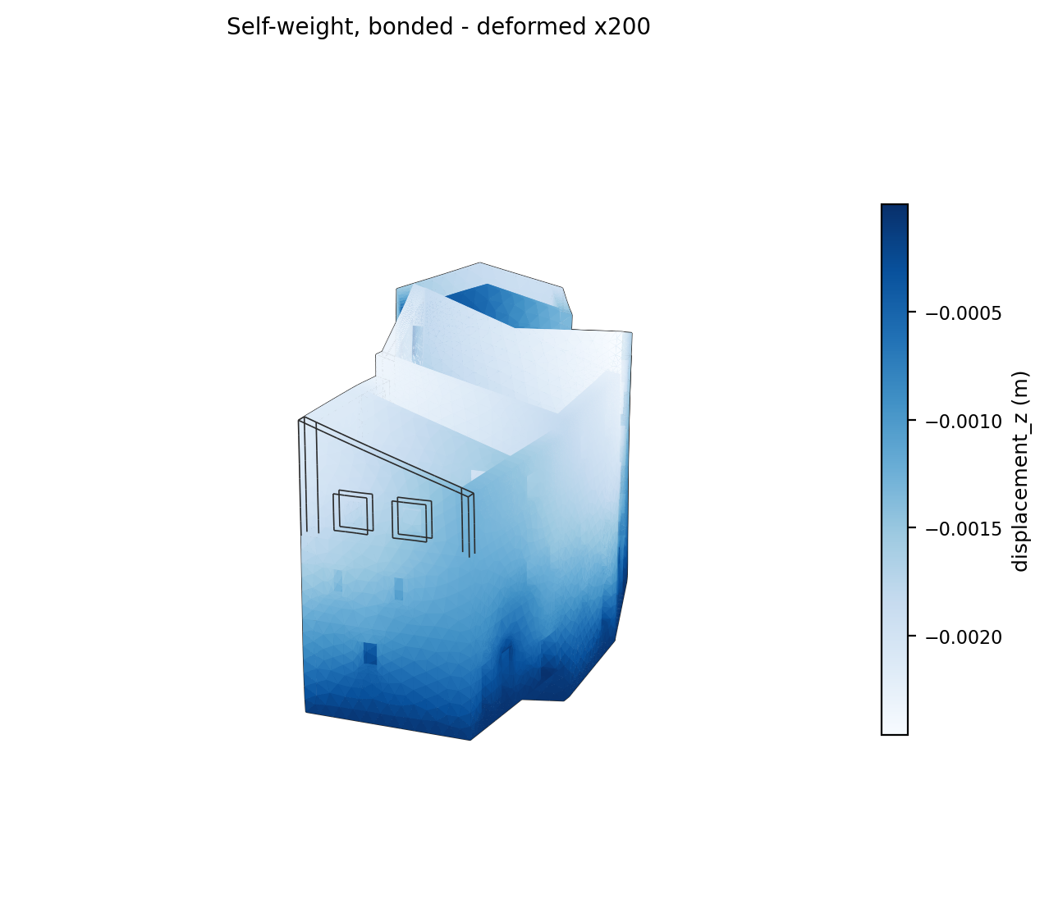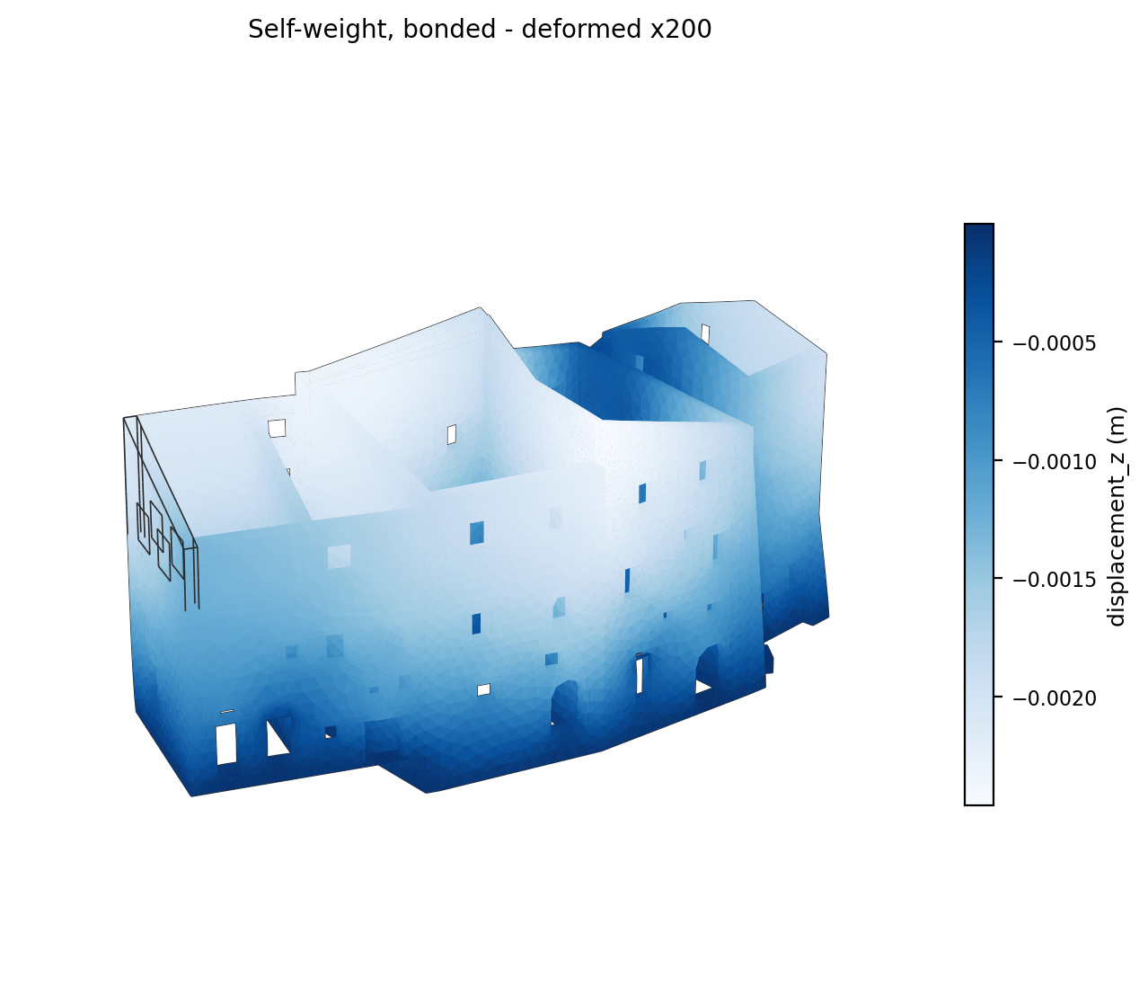
Figure 1 - Deformed shape under self-weight (bonded model), ×200 magnification.

Modal analysis
10 modes were computed. Table 1 lists, for every mode: the natural period T and frequency f, and the modal participation mass ratios in the two horizontal directions (MX, MY) and the vertical direction (MZ), each expressed as a percentage of the structure's total free mass in that direction - the standard measure of how much a given mode actually contributes to the structure's response, as opposed to its position in the eigenvalue ordering.

Table 1 - Modal analysis results (all modes)
Mode | T (s) | f (Hz) | MX (%) | MY (%) | MZ (%)
1 | 0.334 | 2.994 | 7.40 | 2.24 | 0.0013
2 | 0.307 | 3.256 | 1.14 | 3.11 | 0.0002
3 | 0.232 | 4.317 | 19.96 | 0.29 | 0.0050
4 | 0.218 | 4.595 | 2.07 | 7.12 | 0.0066
5 | 0.205 | 4.887 | 0.29 | 0.09 | 0.0466
6 | 0.186 | 5.378 | 0.00 | 4.33 | 0.0046
7 | 0.174 | 5.743 | 7.61 | 0.92 | 0.0091
8 | 0.172 | 5.807 | 1.61 | 20.06 | 0.0089
9 | 0.169 | 5.930 | 8.16 | 12.49 | 0.0514
10 | 0.153 | 6.540 | 0.04 | 1.33 | 0.0003

Cumulatively, the 10 computed modes capture 48.3% of the total mass in X and 52.0% in Y (vertical participation, MZ, remains negligible throughout, as expected for a self-weight-dominated masonry aggregate with no vertical excitation mechanism).
The three most significant modes by translational participation (MX + MY) are modes 8, 9, 3 (highlighted in Table 1), rather than the first three by eigenvalue order - mode 2, for instance, has a lower period than mode 3 but contributes comparatively little translational mass. Their deformed shapes are shown below, each normalised to a common maximum visual displacement (the eigenvectors themselves carry no physical amplitude) and coloured by relative modal displacement magnitude, with the underlying solid geometry's edges overlaid (drawn from the CAD curves the mesh was generated from, not the finite-element mesh itself) so individual blocks and openings stay identifiable.

Mesh sensitivity and localized modes
The mode shapes first computed at a coarser (1.0 m) mesh showed a small region moving with much larger relative amplitude than the rest of the structure in several modes, visually reading as two units separating - in a location with no Task A interface nearby, which is what prompted this closer look rather than accepting the images at face value. A dedicated check (docker/opensees/diagnose_mode_localization.py) attributed each localized region to specific volumes by cross-referencing high-displacement nodes with the same touching-surface detector (InterfaceDetection.find_touching_surface_pairs()) used to build the Task A interface candidate list, confirming first that fragment() had genuinely fused every touching pair (no unfused gap anywhere) - so any softness found is a property of the joint's geometry, not a modelling defect.
Two distinct causes were found, with two different implications:
Modes 1 and 3 both isolate almost entirely on one volume: a large, thin, flat solid (bounding box roughly 2.9 × 7.5 × 1.0 m) tied to its neighbours through only a 0.185 m² vertical face and a 3.857 m² horizontal bearing face - a slab-like element resting on, and only narrowly keyed into, the surrounding walls. Re-running the same check at the finer 0.6 m mesh (used for the results in this section) reproduces the identical localization on the identical volume, confirming this is a genuine structural weak point of the aggregate as modelled - a flexible slab/floor element with a comparatively small tie-in area - rather than a meshing artefact.
Mode 8, by contrast, isolated at 1.0 m on three small, slender volumes (roughly 0.2-1.4 m across) each meshed with only 16-18 nodes, connected to their neighbour through two 0.1 m² faces - too coarse to resolve those small contact areas with more than one or two elements. At the finer 0.6 m mesh, mode 8 no longer isolates on any single volume: the displacement spreads over a broad region of the façade instead (Figure showing Mode 8 below). This mode's earlier localized appearance was therefore a coarse-mesh artefact, not a real, isolated structural feature - the finer mesh used here was adopted for exactly this reason, confirmed by the fact that the eigenvalue solver's earlier stalling turned out to depend on MPI domain partitioning, not on mesh density, so refining the mesh without partitioning was always available as a check.
A second, independent check addressed the mode-1/3 slab's plotted shape directly: at the visual displacement scale first used (normalised so the single most-displaced node reaches 2 m), the free edges of a large, mostly free-standing slab rotating about a narrow bearing line swing far enough to look like a gap opening up, even though the joint itself does not move. docker/opensees/render_volume118_check.py confirms numerically - not just visually - that this is not the case: 41 mesh node ids are literally shared (identical row in the stiffness matrix) between volume 118 and its bearing neighbour, and 4 between volume 118 and its tied neighbour, with no node-splitting applied anywhere in this bonded model. The mode-shape figures below use a smaller, more proportionate 0.5 m visual scale and overlay the undeformed geometry in light grey for direct comparison, so the joints read as continuous without needing the underlying node count alongside them.
A third check went further still, after the same sharp colour transition was flagged again on mode 3's plot even at the smaller visual scale: local mesh refinement (0.6 m down to 0.15 m within 1 m of the 4 joints modes 1/3 concentrate on) increases the number of literally shared mesh nodes at those joints by 5-9× (e.g. 4 → 22 at volume 118's tied edge, 41 → 269 at its bearing face) without changing the mechanism at all - the same two volumes (118, 106) still dominate the same modes, and the sharp colour transition at their joints is unchanged in character. This rules out coarse joint resolution as the cause: it is a real, continuous, but geometrically narrow connection producing a genuinely steep displacement gradient, which a flat-shaded (one colour per mesh triangle) plot renders as a hard edge rather than a gradient. A related check (docker/opensees/diagnose_joint_gaps.py) also ruled out a second hypothesis - that the small joint areas are an artefact of fragment() only catching a thin sliver of a much larger near-miss in the source geometry: no larger nearby (within 1.5 m), roughly-parallel, un-fused face pair exists for any of the 4 joints, so the small area is the full, real extent of contact in the source geometry, not a tolerance artefact. The mode-shape figures below use this refined-joints mesh and colour the surface by Laplacian-smoothed (neighbour-averaged) nodal values rather than the raw per-node field, which reads as a smoother gradient without changing the underlying result.
Refining the joints did shift which modes rank as most significant by translational participation - mode 9's share rose from about 10% to 21% (overtaking mode 1, which fell from 11% to 10%), while modes 3 and 8 stayed the top two in both meshes - a genuine mesh-sensitivity finding worth noting in the methodology, distinct from the joint-continuity question above: the modes selected as "most significant" in Table 1 and shown individually below are computed on this refined-joints mesh.

Deformed shapes - all modes
All 10 computed modes are shown below (user request: images for all 10 modes, not just the 3 most significant). The 3 most significant by translational participation are marked accordingly.

Mode 1 (T = 0.334 s, f = 2.994 Hz)
Modal participation mass ratios: MX = 7.40%, MY = 2.24%, MZ = 0.0013%.
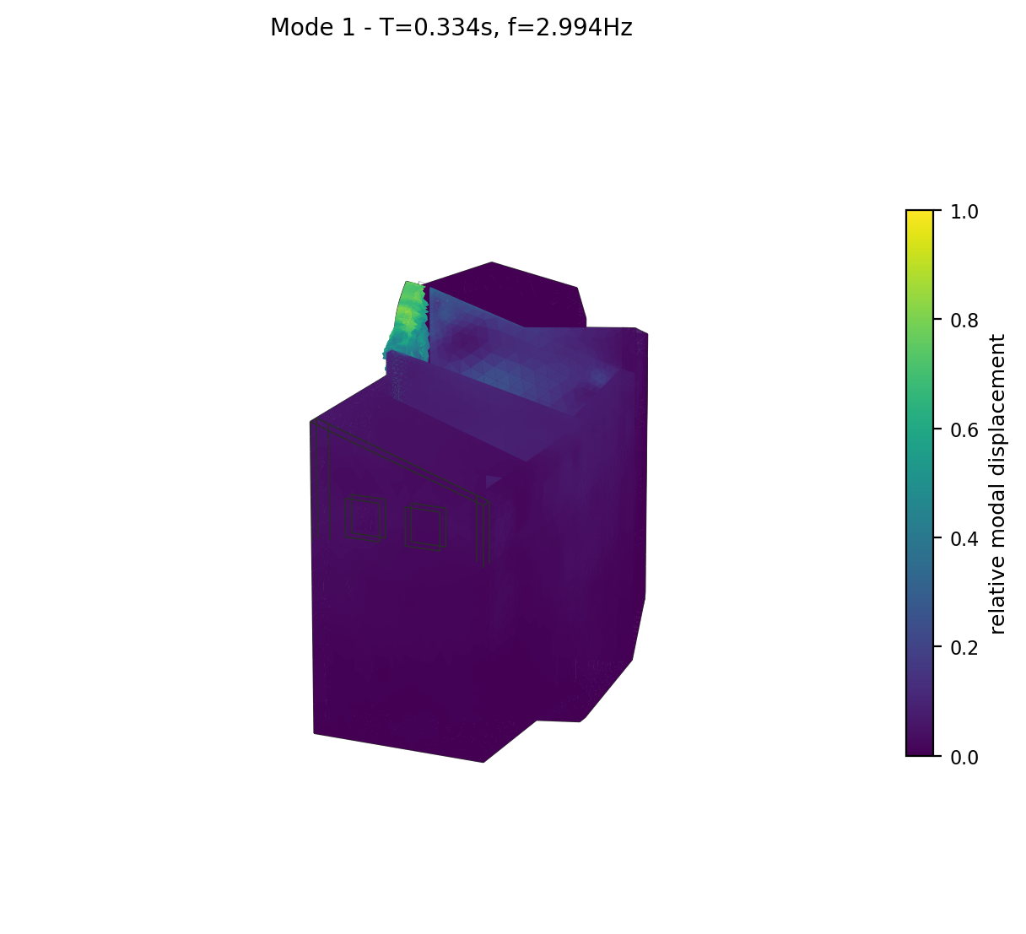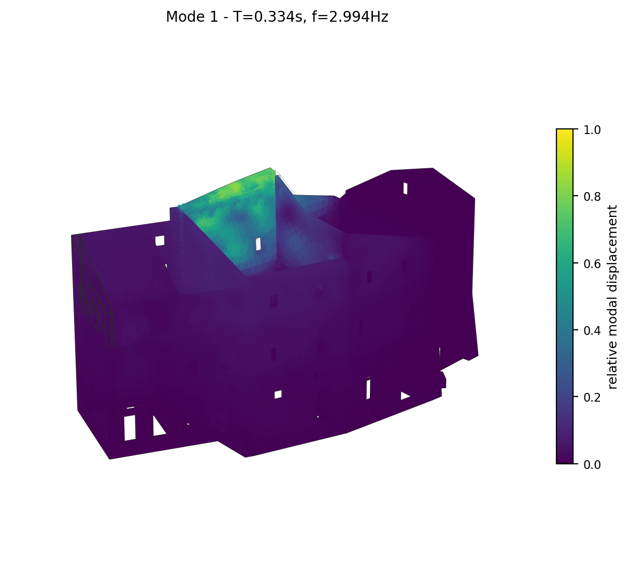
Mode 1 deformed shape (two views), coloured by relative modal displacement magnitude.

Mode 2 (T = 0.307 s, f = 3.256 Hz)
Modal participation mass ratios: MX = 1.14%, MY = 3.11%, MZ = 0.0002%.
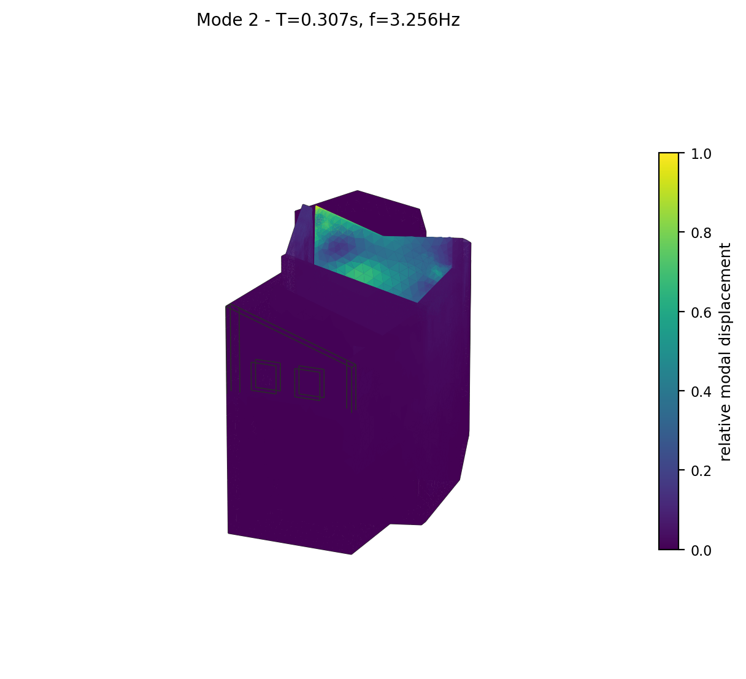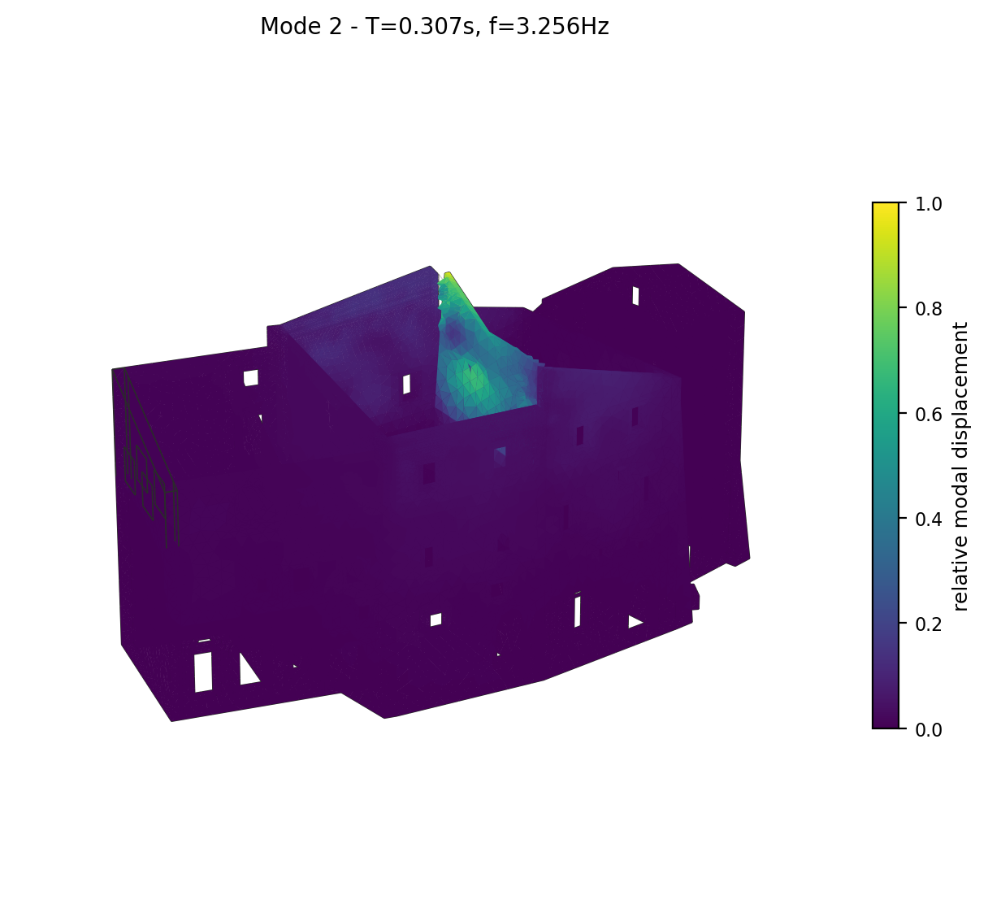
Mode 2 deformed shape (two views), coloured by relative modal displacement magnitude.

Mode 3 (most significant) (T = 0.232 s, f = 4.317 Hz)
Modal participation mass ratios: MX = 19.96%, MY = 0.29%, MZ = 0.0050%.
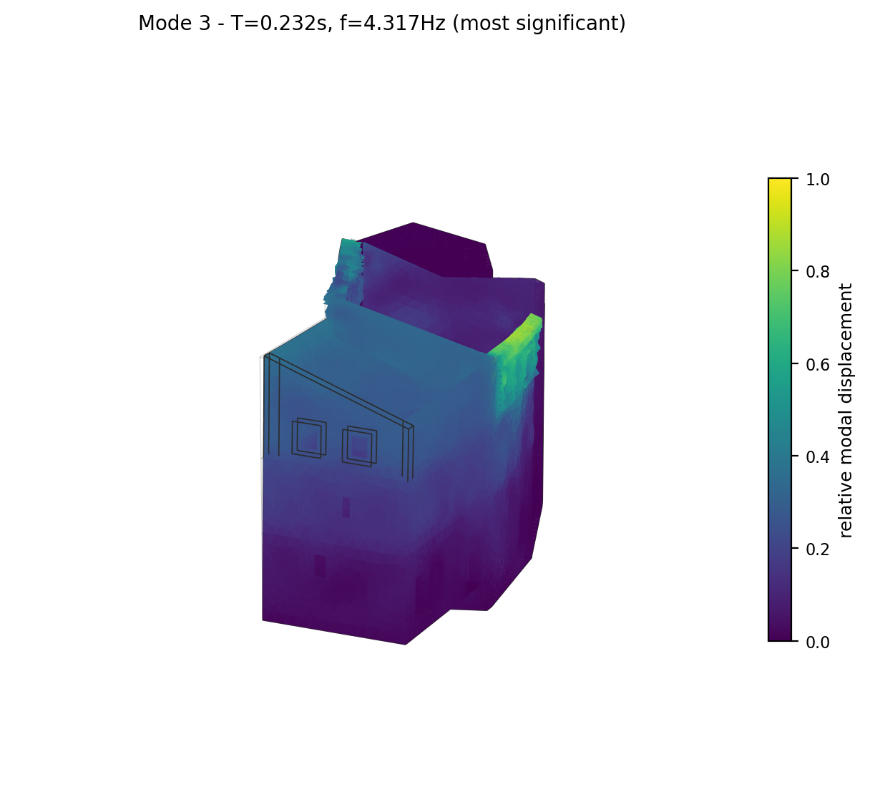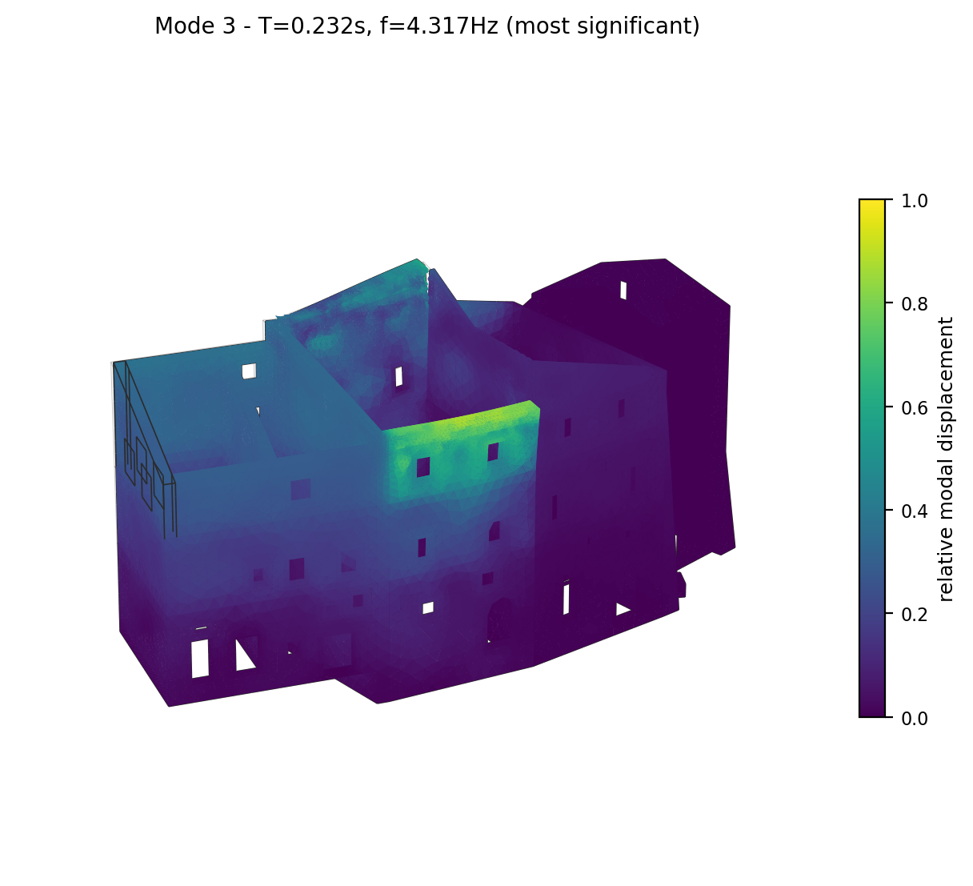
Mode 3 deformed shape (two views), coloured by relative modal displacement magnitude.

Mode 4 (T = 0.218 s, f = 4.595 Hz)
Modal participation mass ratios: MX = 2.07%, MY = 7.12%, MZ = 0.0066%.
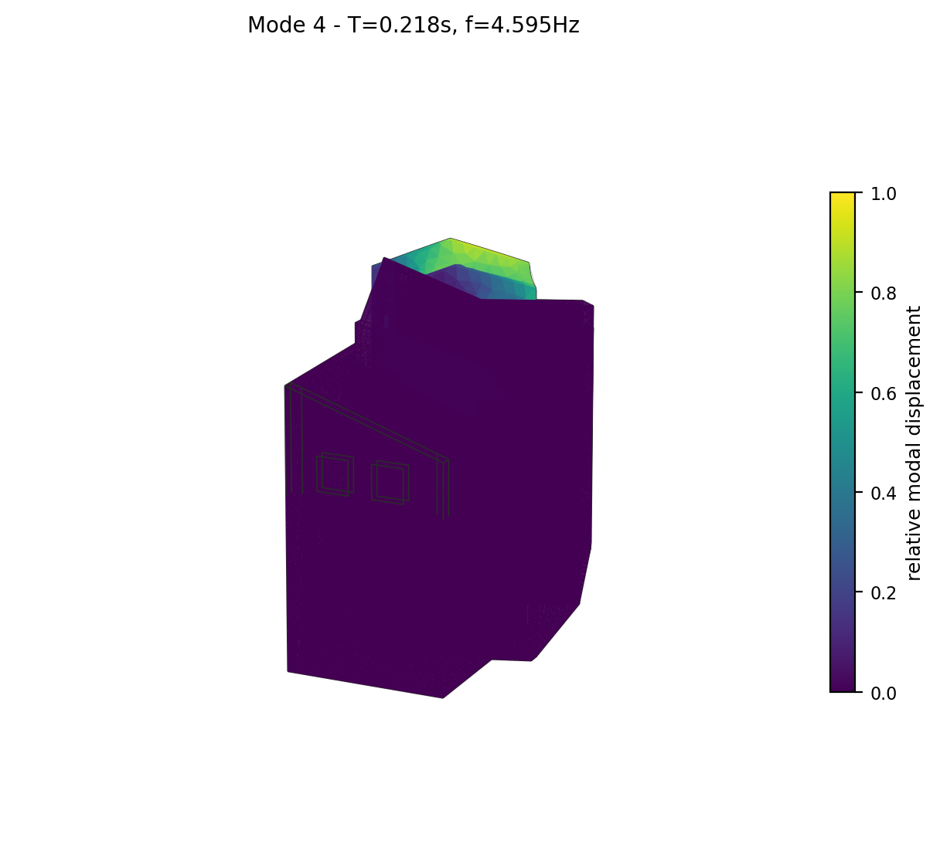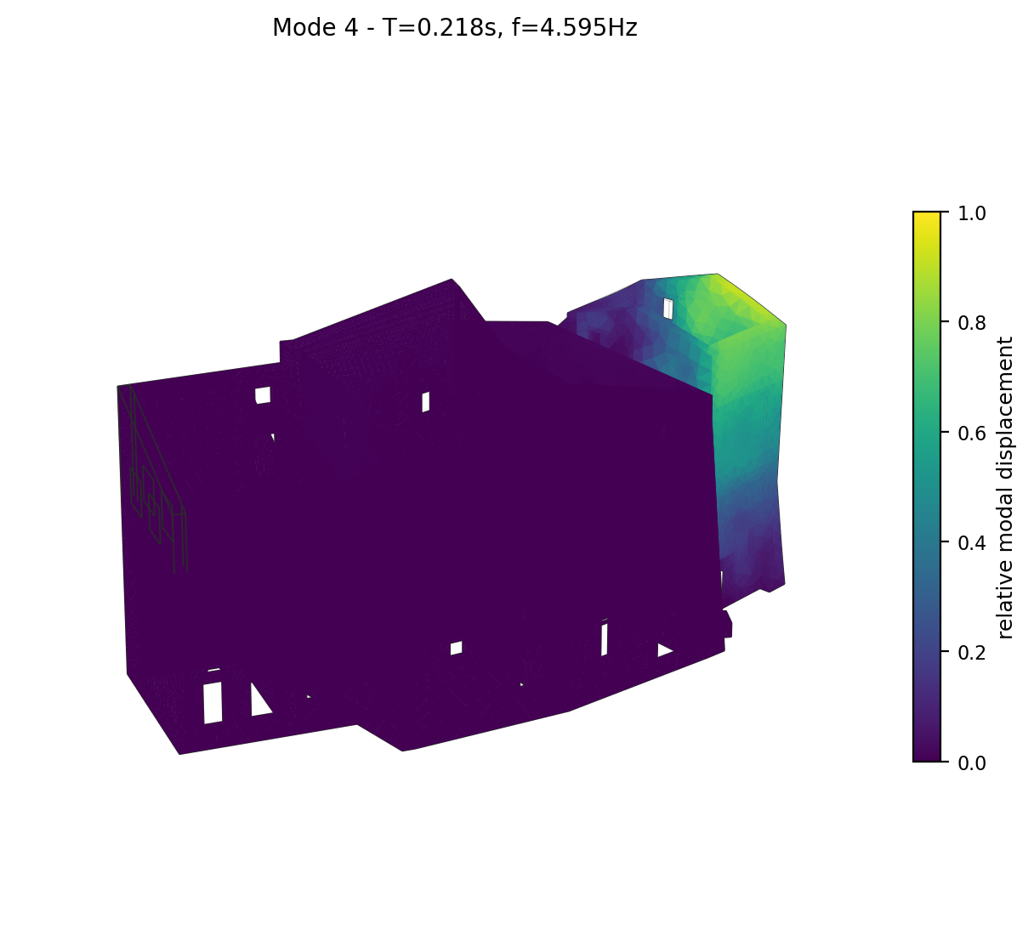
Mode 4 deformed shape (two views), coloured by relative modal displacement magnitude.

Mode 5 (T = 0.205 s, f = 4.887 Hz)
Modal participation mass ratios: MX = 0.29%, MY = 0.09%, MZ = 0.0466%.
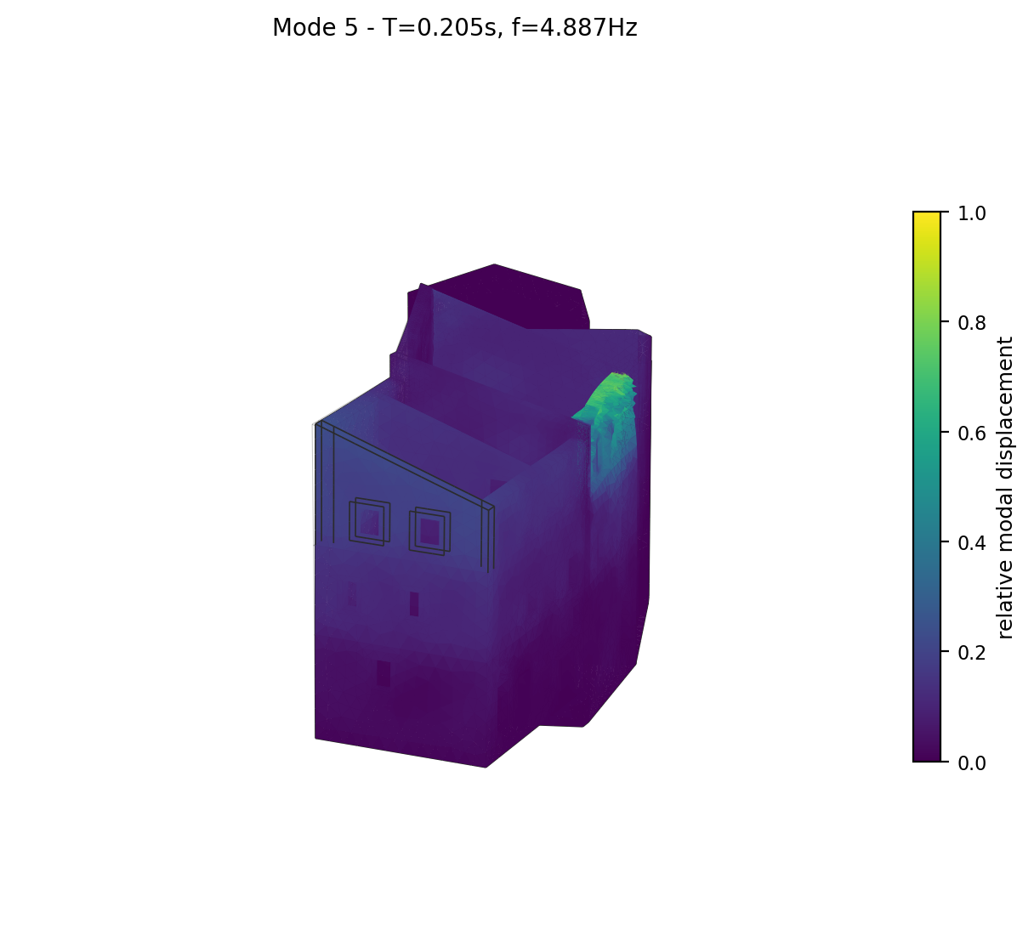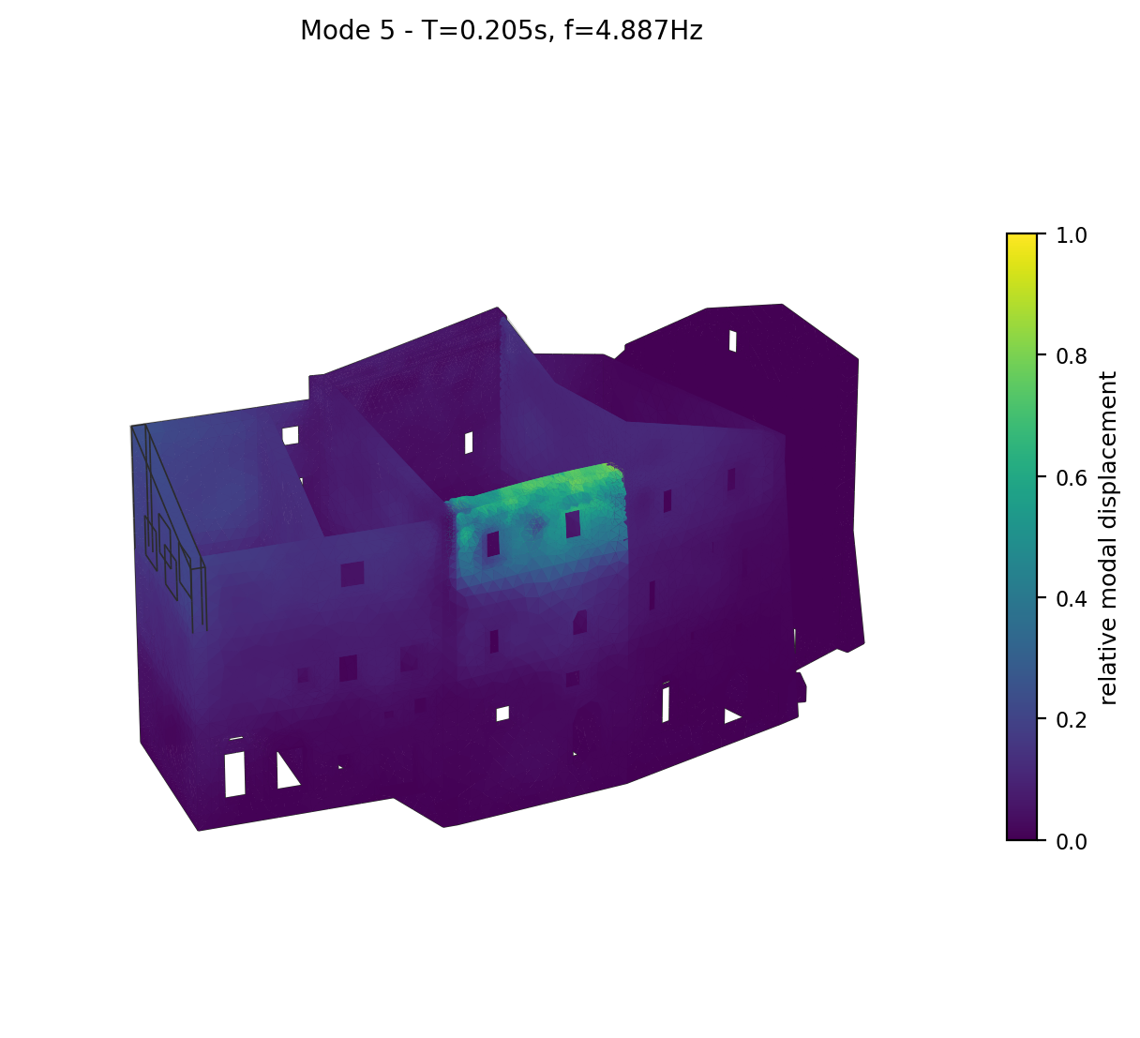
Mode 5 deformed shape (two views), coloured by relative modal displacement magnitude.

Mode 6 (T = 0.186 s, f = 5.378 Hz)
Modal participation mass ratios: MX = 0.00%, MY = 4.33%, MZ = 0.0046%.
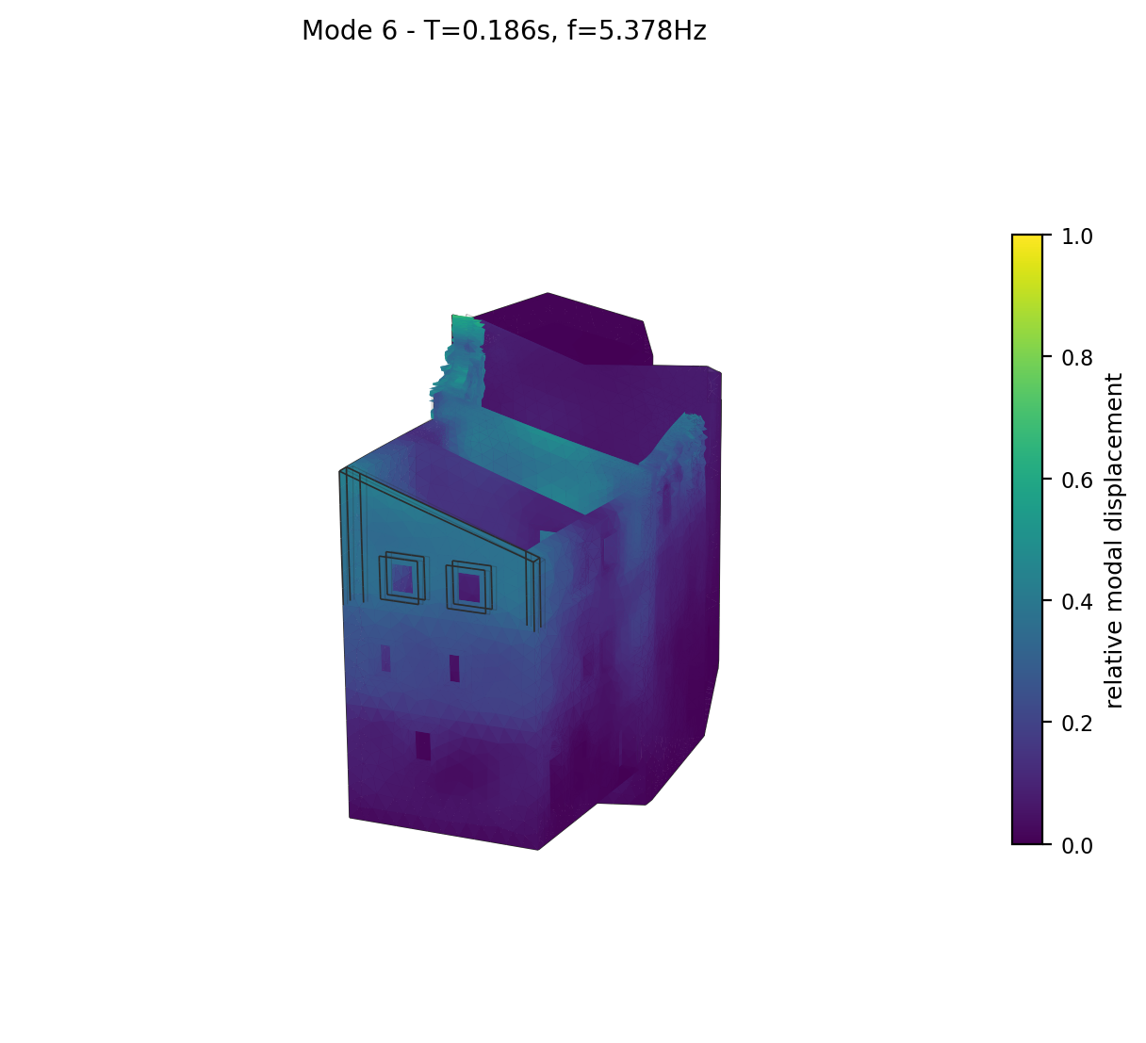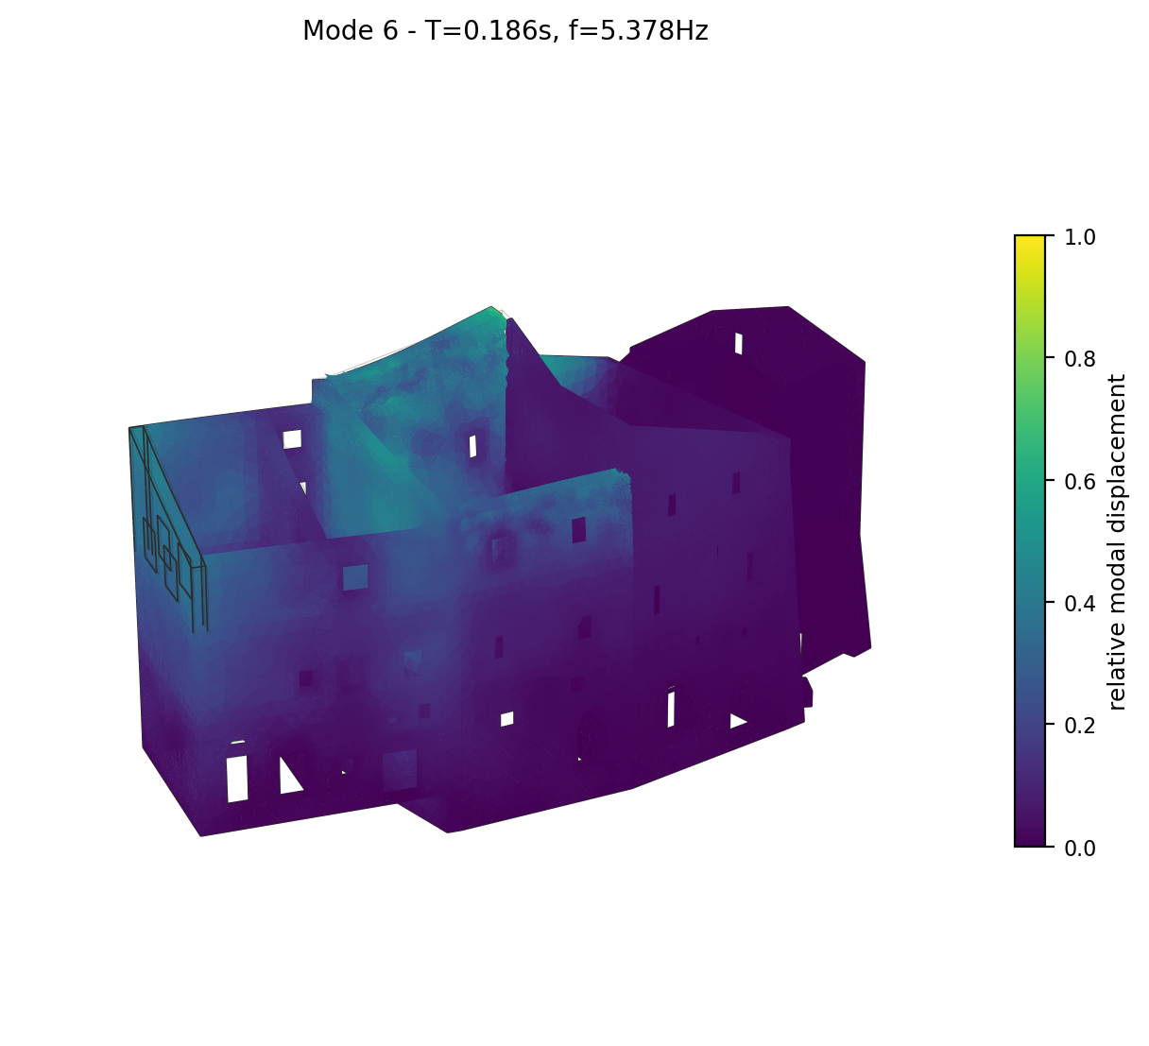
Mode 6 deformed shape (two views), coloured by relative modal displacement magnitude.

Mode 7 (T = 0.174 s, f = 5.743 Hz)
Modal participation mass ratios: MX = 7.61%, MY = 0.92%, MZ = 0.0091%.
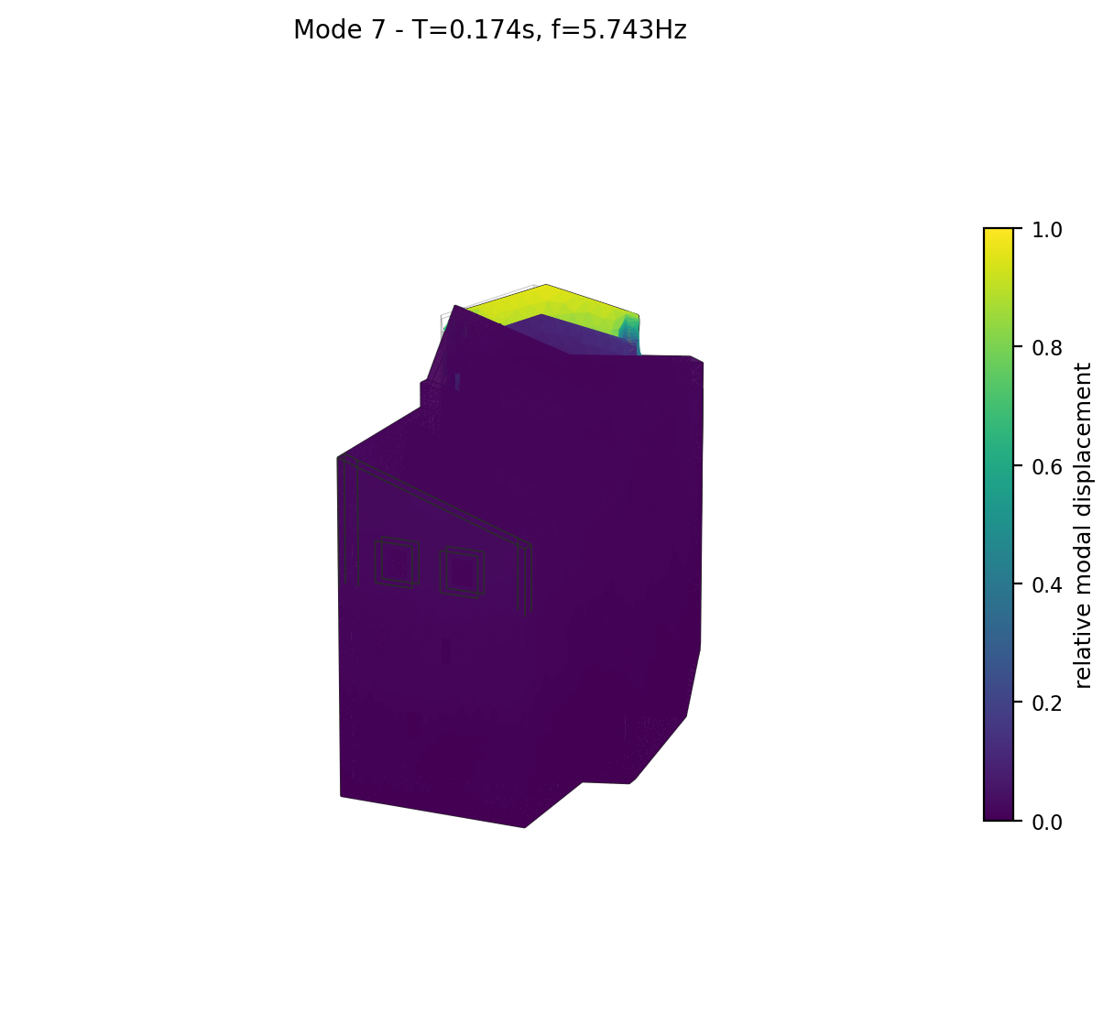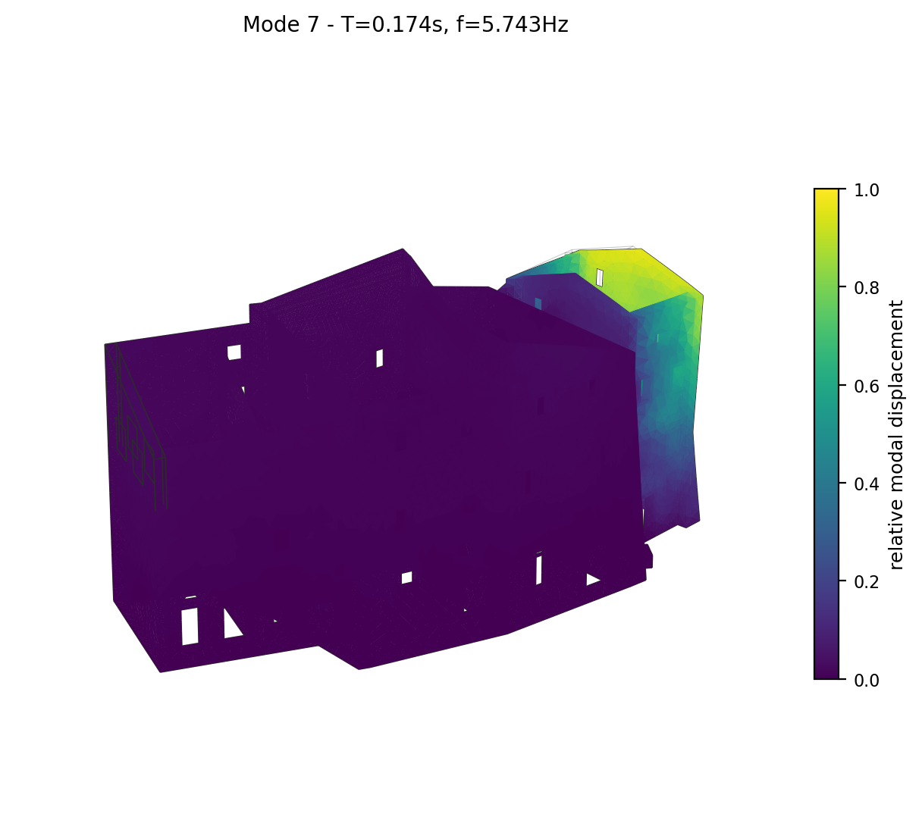
Mode 7 deformed shape (two views), coloured by relative modal displacement magnitude.

Mode 8 (most significant) (T = 0.172 s, f = 5.807 Hz)
Modal participation mass ratios: MX = 1.61%, MY = 20.06%, MZ = 0.0089%.
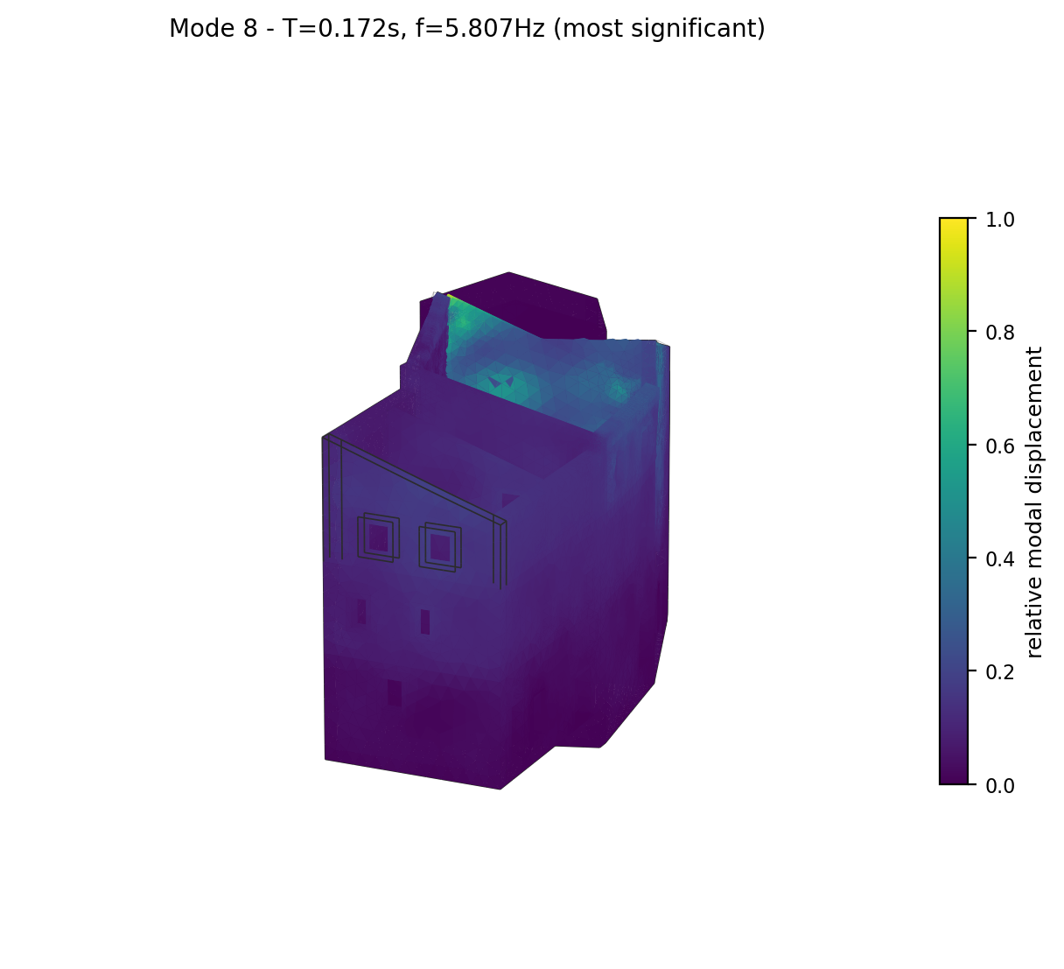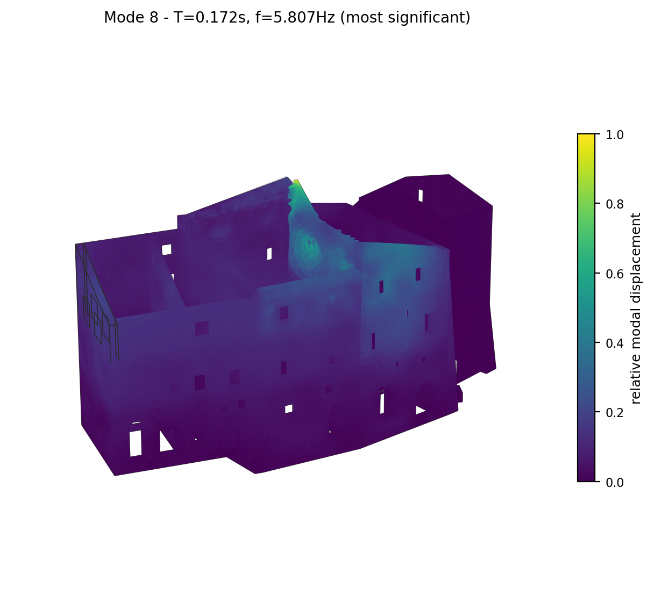
Mode 8 deformed shape (two views), coloured by relative modal displacement magnitude.

Mode 9 (most significant) (T = 0.169 s, f = 5.930 Hz)
Modal participation mass ratios: MX = 8.16%, MY = 12.49%, MZ = 0.0514%.
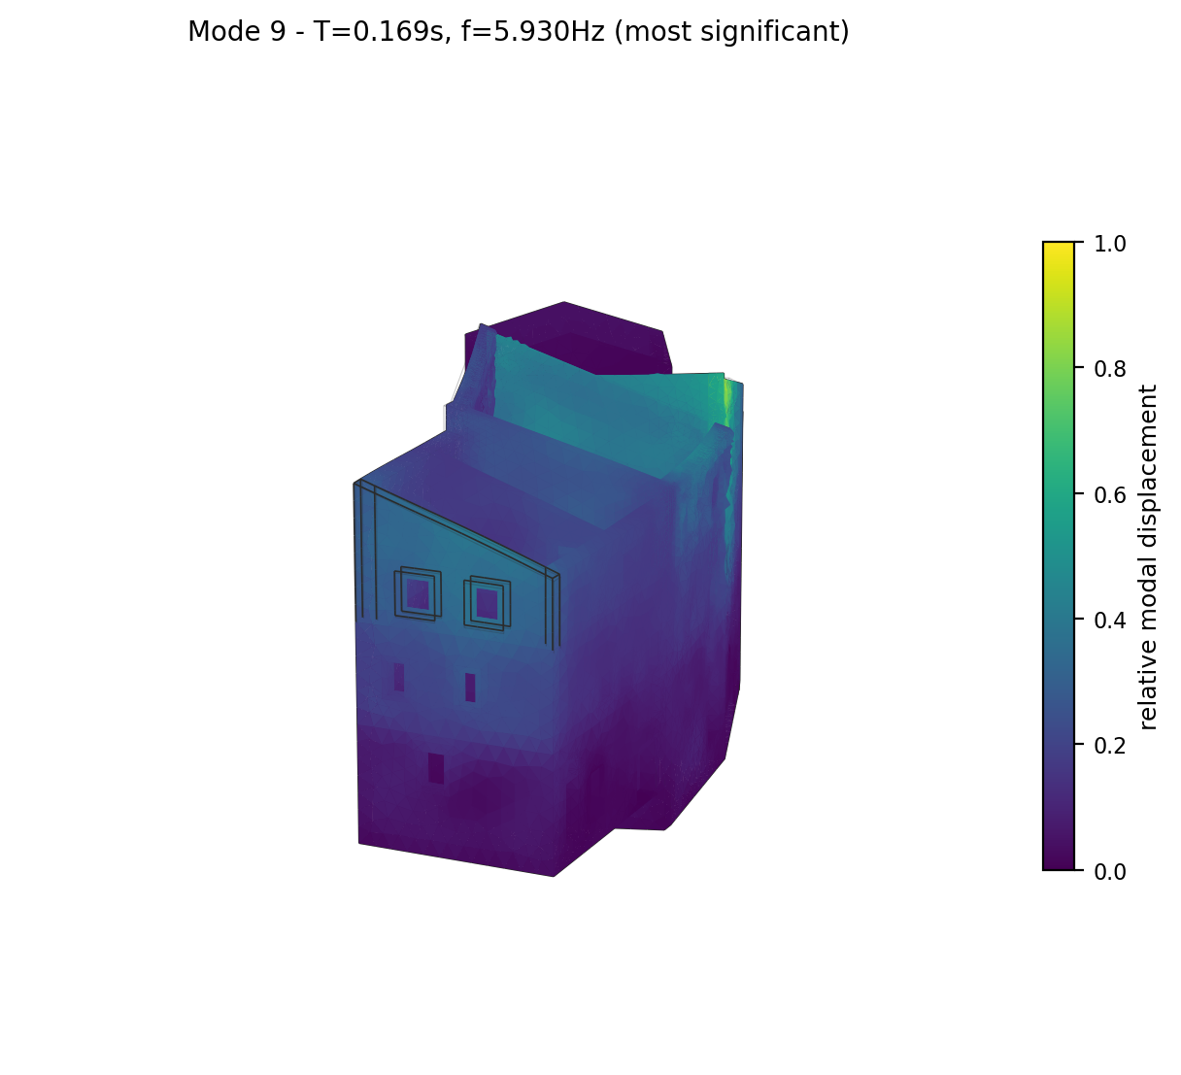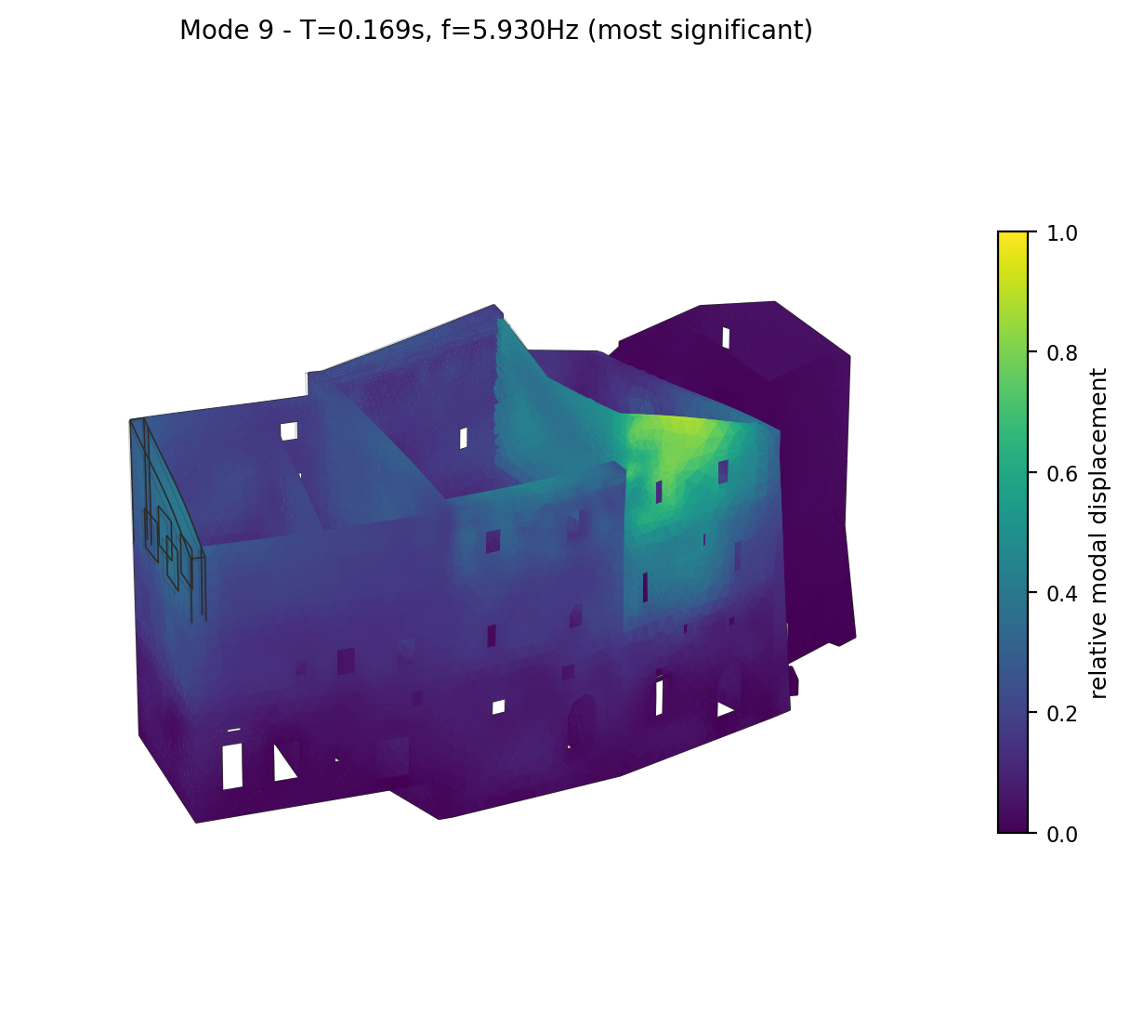
Mode 9 deformed shape (two views), coloured by relative modal displacement magnitude.

Mode 10 (T = 0.153 s, f = 6.540 Hz)
Modal participation mass ratios: MX = 0.04%, MY = 1.33%, MZ = 0.0003%.
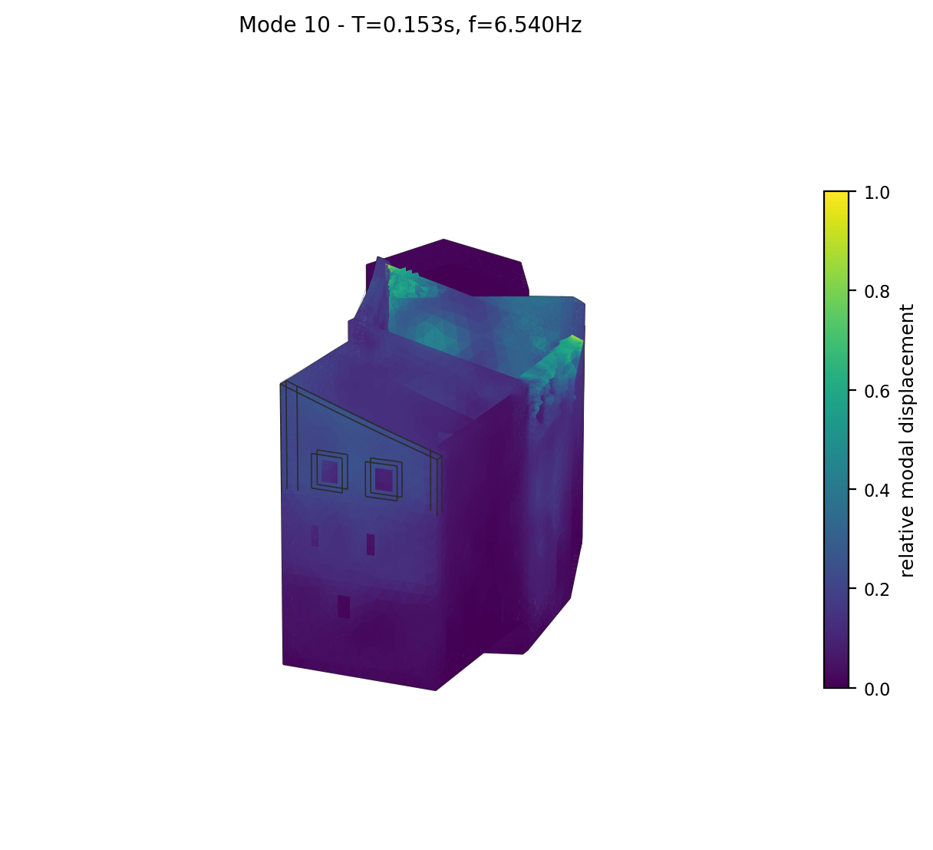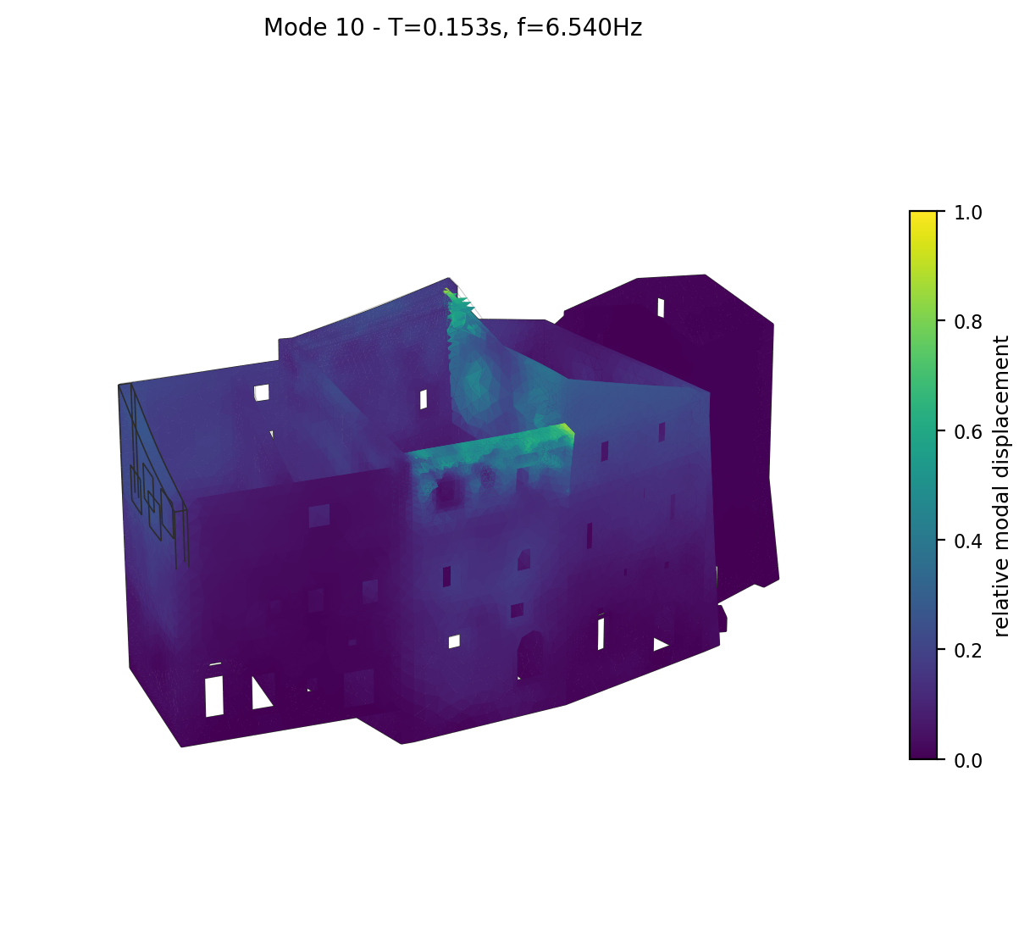
Mode 10 deformed shape (two views), coloured by relative modal displacement magnitude.

