Self-Weight and Modal Analysis of the Castelnuovo di Porto Aggregate
This section reports the self-weight static check and the modal (eigenvalue) analysis of the full Castelnuovo di Porto masonry aggregate. The model is linear elastic and fully bonded - the Task A wall-to-wall contact interfaces described elsewhere in this chapter are deliberately omitted, so that the contact nonlinearity is removed from the eigenproblem and the result serves as the linear reference against which the effect of those interfaces can later be assessed.
The analysis is built directly on the framework used throughout this work (gmsh for meshing, gmsh2opensees for the mesh-to-model transfer, and OpenSeesPy for the solution), run sequentially on a single process. Sequential execution is a requirement rather than a preference: the eigenvalue solve (ARPACK, through the OpenSees eigen command) stalls indefinitely under MPI domain partitioning regardless of mesh size or number of requested modes, so no domain decomposition is applied.

Material
The masonry is modelled as a homogeneous linear-elastic continuum with E = 1227.95 MPa, ν = 0.2 and ρ = 1450 kg/m³. The Young's modulus is the mean of the four masonry types calibrated for this aggregate through the HMO/MQI procedure (1526.6, 1198.7, 987.8 and 1198.7 MPa). The four types are weighted equally because assigning them per facade would require a volume-to-facade mapping that the current geometry does not carry; this is recorded as an open point of the methodology. This supersedes the generic placeholder values (700 MPa, ν = 0.25, 2000 kg/m³) used in the preliminary runs of this chapter.

Restoration of wall-to-wall continuity
A structural defect inherited from the source geometry had to be corrected before the modal results could be interpreted. In the cleaned STEP model, 21 wall-to-wall junctions have their two solids drawn between 1.5 and 47 mm apart rather than in contact. The boolean fragment operation correctly declines to fuse solids that do not touch, so at each of those junctions the two walls shared no mesh node and therefore no stiffness: a wall could be attached to the block along one edge and completely free where it should have abutted its orthogonal walls. The consequence was directly visible in the first computed mode shapes, where individual walls swung out of plane while the walls that should have braced them stood still.
Correcting this in the geometry was attempted first and did not succeed. Raising the import tolerance and removing duplicate entities recovered none of the 21 junctions; raising the boolean tolerance recovered 10 of 21 while renumbering the volumes; face sewing destroyed the model outright; and three variants of a purpose-built bridging-solid healing each made the topology worse rather than better, the count of open junctions rising from 21 to 145 and then to 479 as each added bridge introduced more near-coincident faces than it closed.
Continuity was therefore restored at the finite-element level, by means of 122 multi-point constraints (equalDOF) tying the facing nodes across the gaps - the standard treatment for coupling non-matching meshes, and the exact converse of the node-splitting used elsewhere in this chapter to decouple a Task A contact interface. Two implementation points govern the result. First, the analysis must use the Transformation constraint handler: the default Plain handler ignores multi-point constraints silently, so the ties would be declared and have no effect. Second, the mesh is locally refined to 0.10 m within 0.40 m of the facing surfaces only. At the 0.60 m global size the facing nodes lie roughly 0.6 m apart while the gaps themselves are millimetres, so almost no node pair is close enough to tie; refining locally produces many short ties instead of a few long ones, a long tie being a rigid link that would stiffen the junction far beyond anything the masonry does.
Six of the 21 junctions receive no tie of their own. These lie in a cluster where six volumes meet at a single corner with gaps of about 1.2 mm, and since each node may be used only once, the available ties are taken by the three principal pairs. Verification at cluster level confirms that all six pairs are nevertheless connected through a third volume at the same corner, so no wall is left unbraced. It should be noted that the aggregate forms a single connected component both with and without the ties: the open junctions were a local bracing defect, not a global disconnection, and the evidence that the ties corrected it is the modal behaviour reported below rather than any connectivity count.
The effect on the modal results is substantial and, importantly, selective. The three modes carrying the most translational mass move from modes 8, 3 and 9 - high-order, locally confined wall mechanisms - to modes 1, 7 and 2. The first two periods shorten by 14.8% and 20.4% respectively, while modes 3 to 10 change by only 0.7% to 6.6%. A uniform shortening across all periods would have indicated that the constraints were simply adding stiffness everywhere; the fact that the change is concentrated in the modes governed by the previously unbraced walls is what indicates that the ties act where continuity was missing and essentially nowhere else.

Self-weight check
The total vertical reaction at the base is compared against the independently calculated self-weight ρ·g·V, as a basic check on mass and boundary conditions before the eigenvalue results built on the same model are relied upon.
Quantity | Value
Mesh nodes | 34,821
Mesh elements | 119,953
Global mesh size | 0.6 m
Local refinement at junctions | 0.10 m within 0.40 m
equalDOF constraints | 122
MPI ranks / partitions | 1 (no domain decomposition)
Total volume | 623.06 m³
Self-weight, calculated (ρ·g·V) | 8,862,669.0 N
Total base reaction, analysis | 8,864,970.2 N
Weight / reaction difference | 0.026 %

The base reaction matches the calculated self-weight to within 0.026%.
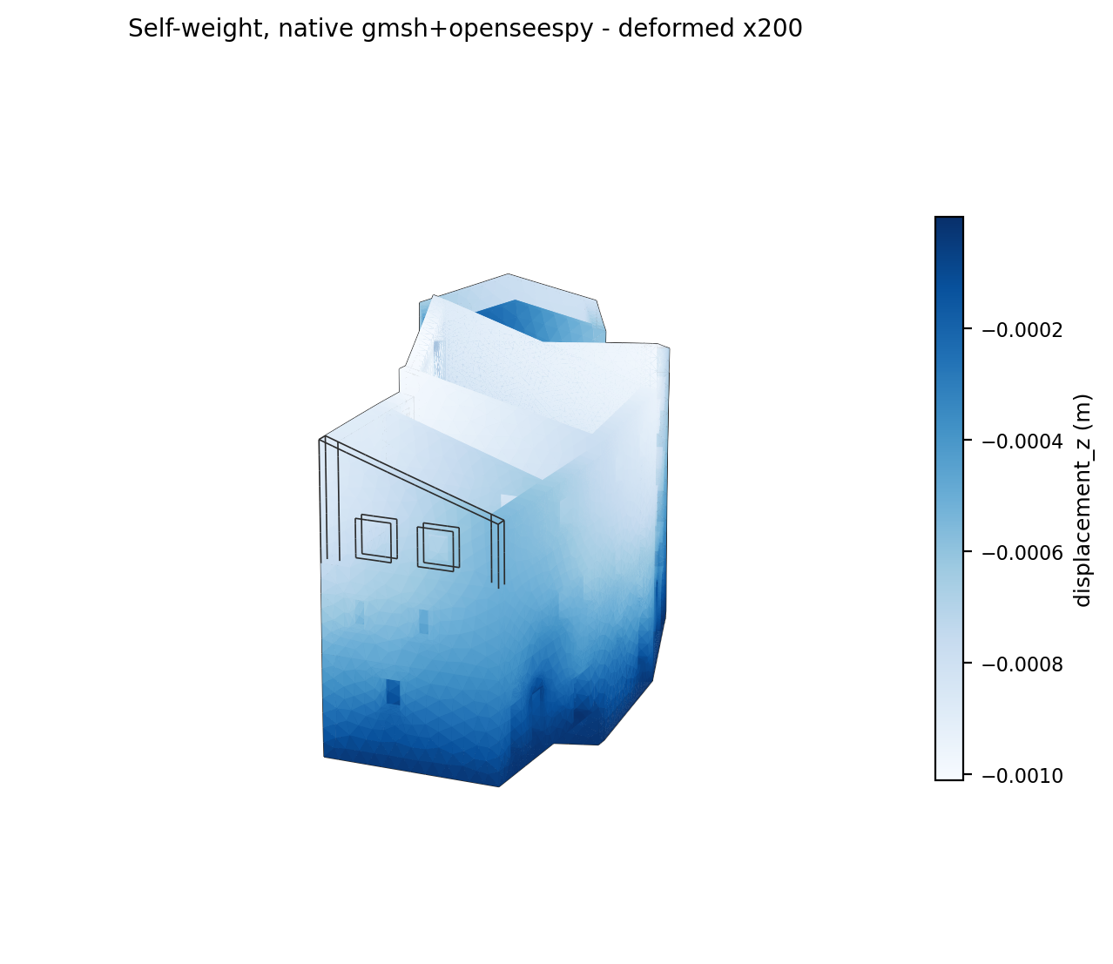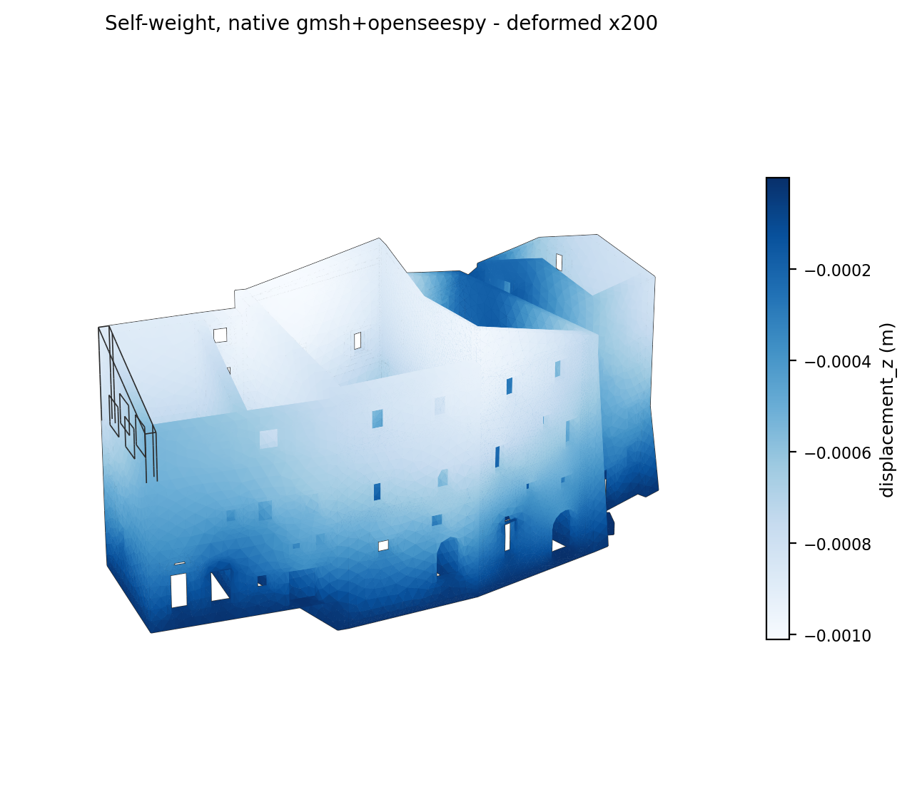
Figure 1 - Deformed shape under self-weight, ×200 magnification.

Modal analysis
80 modes were computed. Table 1 lists, for each mode, the natural period T, the frequency f, the modal participation mass ratios in the two horizontal directions (MX, MY) and in the vertical direction (MZ), and the running totals ΣMX and ΣMY. Each ratio is expressed as a percentage of the structure's total free mass in that direction, which measures how much a mode actually contributes to the response rather than merely where it falls in the eigenvalue ordering.
The three most significant modes by translational participation are modes 1, 7, 2, highlighted in green. Mode 1 alone carries 21.0% of the mass in X, and mode 7 carries 18.4% in Y, so the two principal horizontal directions are governed by distinct modes.
The cumulative participating mass reaches the 85% required by NTC2018 §7.3.3.1 and EC8 at mode 73 in Y (f = 30.87 Hz) and mode 75 in X (f = 31.16 Hz), highlighted in amber. Over all 80 computed modes the totals are ΣMX = 85.42% and ΣMY = 85.54%, so the requirement is satisfied in both horizontal directions.
Three qualifications belong with these figures. The vertical participation reaches only 70.6% and does not attain 85%; the requirement is satisfied in the horizontal directions, which are the directions of interest here, and the statement should not be generalised to the vertical one. The number of modes needed is itself a result: no single mode dominates this structure, and beyond the first ten no mode carries more than a few percent, so the final increments of participating mass accumulate from many small, locally confined wall mechanisms. Consequently the 85% threshold is only attained at frequencies around 31 Hz if it is attained at all - far above the energetic content of a realistic seismic input, so those high modes satisfy the code criterion while contributing little to the actual response.

Table 1 - Modal analysis results (all computed modes)
Mode | T (s) | f (Hz) | MX (%) | MY (%) | MZ (%) | ΣMX (%) | ΣMY (%)
1 | 0.1728 | 5.786 | 20.98 | 3.25 | 0.000 | 20.98 | 3.25
2 | 0.1535 | 6.515 | 5.66 | 5.65 | 0.001 | 26.65 | 8.89
3 | 0.1441 | 6.939 | 1.68 | 7.53 | 0.006 | 28.33 | 16.43
4 | 0.1333 | 7.504 | 2.50 | 1.90 | 0.043 | 30.83 | 18.33
5 | 0.1204 | 8.305 | 5.84 | 3.37 | 0.019 | 36.67 | 21.69
6 | 0.1133 | 8.825 | 8.82 | 0.47 | 0.008 | 45.49 | 22.16
7 | 0.1099 | 9.101 | 2.71 | 18.44 | 0.000 | 48.20 | 40.59
8 | 0.1041 | 9.609 | 2.63 | 7.47 | 0.007 | 50.83 | 48.06
9 | 0.1001 | 9.995 | 0.88 | 6.71 | 0.000 | 51.71 | 54.77
10 | 0.0935 | 10.695 | 0.03 | 0.43 | 0.004 | 51.73 | 55.20
11 | 0.0900 | 11.116 | 0.95 | 0.04 | 0.025 | 52.68 | 55.24
12 | 0.0820 | 12.196 | 0.03 | 0.32 | 0.001 | 52.71 | 55.56
13 | 0.0798 | 12.524 | 0.00 | 0.00 | 0.004 | 52.71 | 55.56
14 | 0.0791 | 12.634 | 1.08 | 0.83 | 0.035 | 53.78 | 56.39
15 | 0.0770 | 12.981 | 0.09 | 0.03 | 0.014 | 53.87 | 56.42
16 | 0.0731 | 13.674 | 0.09 | 0.74 | 0.019 | 53.96 | 57.16
17 | 0.0711 | 14.066 | 0.03 | 1.87 | 0.018 | 53.99 | 59.03
18 | 0.0706 | 14.160 | 2.70 | 2.73 | 0.064 | 56.69 | 61.76
19 | 0.0705 | 14.186 | 1.29 | 0.83 | 0.064 | 57.97 | 62.59
20 | 0.0678 | 14.750 | 0.19 | 1.37 | 0.011 | 58.17 | 63.96
21 | 0.0642 | 15.575 | 0.06 | 0.85 | 0.047 | 58.23 | 64.81
22 | 0.0638 | 15.674 | 0.70 | 0.00 | 0.000 | 58.93 | 64.81
23 | 0.0612 | 16.349 | 0.14 | 0.33 | 0.014 | 59.07 | 65.14
24 | 0.0594 | 16.840 | 0.00 | 5.22 | 0.229 | 59.07 | 70.36
25 | 0.0578 | 17.314 | 0.88 | 0.24 | 0.010 | 59.95 | 70.60
26 | 0.0573 | 17.458 | 0.02 | 0.13 | 2.694 | 59.97 | 70.74
27 | 0.0562 | 17.800 | 0.51 | 0.64 | 0.000 | 60.48 | 71.38
28 | 0.0552 | 18.112 | 3.06 | 0.00 | 0.330 | 63.54 | 71.38
29 | 0.0539 | 18.556 | 0.03 | 0.73 | 5.500 | 63.57 | 72.11
30 | 0.0535 | 18.703 | 7.49 | 1.87 | 1.574 | 71.06 | 73.98
31 | 0.0531 | 18.834 | 0.95 | 0.27 | 3.038 | 72.01 | 74.25
32 | 0.0527 | 18.958 | 0.09 | 0.67 | 24.101 | 72.11 | 74.92
33 | 0.0520 | 19.236 | 0.01 | 0.31 | 7.546 | 72.12 | 75.24
34 | 0.0495 | 20.200 | 0.16 | 0.50 | 0.017 | 72.28 | 75.74
35 | 0.0494 | 20.236 | 0.01 | 0.05 | 0.715 | 72.29 | 75.78
36 | 0.0490 | 20.424 | 1.03 | 0.28 | 4.655 | 73.33 | 76.06
37 | 0.0485 | 20.625 | 0.01 | 0.92 | 3.943 | 73.33 | 76.98
38 | 0.0484 | 20.669 | 4.24 | 0.89 | 0.191 | 77.57 | 77.87
39 | 0.0477 | 20.967 | 1.05 | 0.24 | 1.049 | 78.62 | 78.11
40 | 0.0476 | 21.029 | 0.26 | 0.03 | 1.532 | 78.88 | 78.14
41 | 0.0470 | 21.256 | 0.02 | 0.48 | 0.031 | 78.90 | 78.62
42 | 0.0457 | 21.899 | 0.92 | 0.17 | 3.148 | 79.82 | 78.79
43 | 0.0456 | 21.923 | 0.02 | 0.24 | 0.001 | 79.83 | 79.03
44 | 0.0447 | 22.391 | 0.55 | 0.01 | 0.547 | 80.38 | 79.04
45 | 0.0440 | 22.740 | 0.09 | 0.95 | 0.780 | 80.47 | 79.99
46 | 0.0434 | 23.053 | 0.03 | 0.00 | 0.044 | 80.51 | 79.99
47 | 0.0432 | 23.136 | 1.35 | 0.11 | 0.008 | 81.86 | 80.10
48 | 0.0428 | 23.387 | 0.01 | 0.30 | 0.021 | 81.87 | 80.40
49 | 0.0424 | 23.612 | 0.86 | 0.51 | 0.036 | 82.73 | 80.91
50 | 0.0416 | 24.047 | 0.04 | 0.09 | 0.314 | 82.77 | 81.00
51 | 0.0409 | 24.455 | 0.57 | 0.07 | 2.031 | 83.34 | 81.07
52 | 0.0406 | 24.651 | 0.01 | 0.86 | 0.055 | 83.35 | 81.93
53 | 0.0401 | 24.967 | 0.06 | 0.00 | 0.033 | 83.41 | 81.93
54 | 0.0399 | 25.066 | 0.00 | 0.19 | 0.588 | 83.41 | 82.12
55 | 0.0389 | 25.685 | 0.00 | 0.10 | 0.479 | 83.41 | 82.21
56 | 0.0386 | 25.894 | 0.16 | 0.02 | 0.161 | 83.57 | 82.24
57 | 0.0376 | 26.577 | 0.05 | 0.07 | 0.135 | 83.62 | 82.31
58 | 0.0376 | 26.602 | 0.00 | 0.13 | 0.313 | 83.62 | 82.44
59 | 0.0372 | 26.913 | 0.00 | 0.03 | 0.395 | 83.62 | 82.47
60 | 0.0363 | 27.535 | 0.11 | 0.02 | 0.026 | 83.73 | 82.49
61 | 0.0361 | 27.706 | 0.06 | 0.00 | 0.012 | 83.79 | 82.49
62 | 0.0359 | 27.861 | 0.01 | 0.24 | 0.162 | 83.80 | 82.73
63 | 0.0352 | 28.399 | 0.09 | 0.19 | 0.258 | 83.90 | 82.92
64 | 0.0351 | 28.515 | 0.38 | 0.05 | 0.063 | 84.28 | 82.96
65 | 0.0349 | 28.653 | 0.05 | 0.27 | 0.321 | 84.33 | 83.23
66 | 0.0347 | 28.786 | 0.00 | 0.16 | 0.004 | 84.33 | 83.39
67 | 0.0345 | 28.961 | 0.00 | 0.12 | 0.120 | 84.33 | 83.51
68 | 0.0344 | 29.103 | 0.08 | 0.26 | 0.128 | 84.41 | 83.77
69 | 0.0336 | 29.725 | 0.02 | 0.35 | 0.126 | 84.43 | 84.12
70 | 0.0334 | 29.906 | 0.00 | 0.00 | 0.019 | 84.43 | 84.12
71 | 0.0330 | 30.280 | 0.25 | 0.13 | 0.253 | 84.68 | 84.25
72 | 0.0327 | 30.609 | 0.01 | 0.72 | 0.003 | 84.68 | 84.97
73 | 0.0324 | 30.868 | 0.19 | 0.30 | 0.917 | 84.88 | 85.27
74 | 0.0322 | 31.038 | 0.00 | 0.00 | 1.218 | 84.88 | 85.27
75 | 0.0321 | 31.161 | 0.30 | 0.00 | 0.112 | 85.18 | 85.27
76 | 0.0319 | 31.320 | 0.00 | 0.00 | 0.039 | 85.18 | 85.27
77 | 0.0316 | 31.649 | 0.00 | 0.14 | 0.002 | 85.18 | 85.41
78 | 0.0315 | 31.743 | 0.01 | 0.01 | 0.011 | 85.19 | 85.43
79 | 0.0313 | 31.908 | 0.23 | 0.07 | 0.168 | 85.42 | 85.50
80 | 0.0313 | 31.951 | 0.00 | 0.05 | 0.002 | 85.42 | 85.54

Mode shapes
The mode shapes are normalised to a common maximum visual displacement, the eigenvectors carrying no physical amplitude of their own, and are coloured by relative modal displacement magnitude with the underlying CAD edges overlaid so that individual blocks and openings remain identifiable.

Mode 1 (most significant) (T = 0.1728 s, f = 5.786 Hz)
Modal participation mass ratios: MX = 20.98%, MY = 3.25%, MZ = 0.0002%.
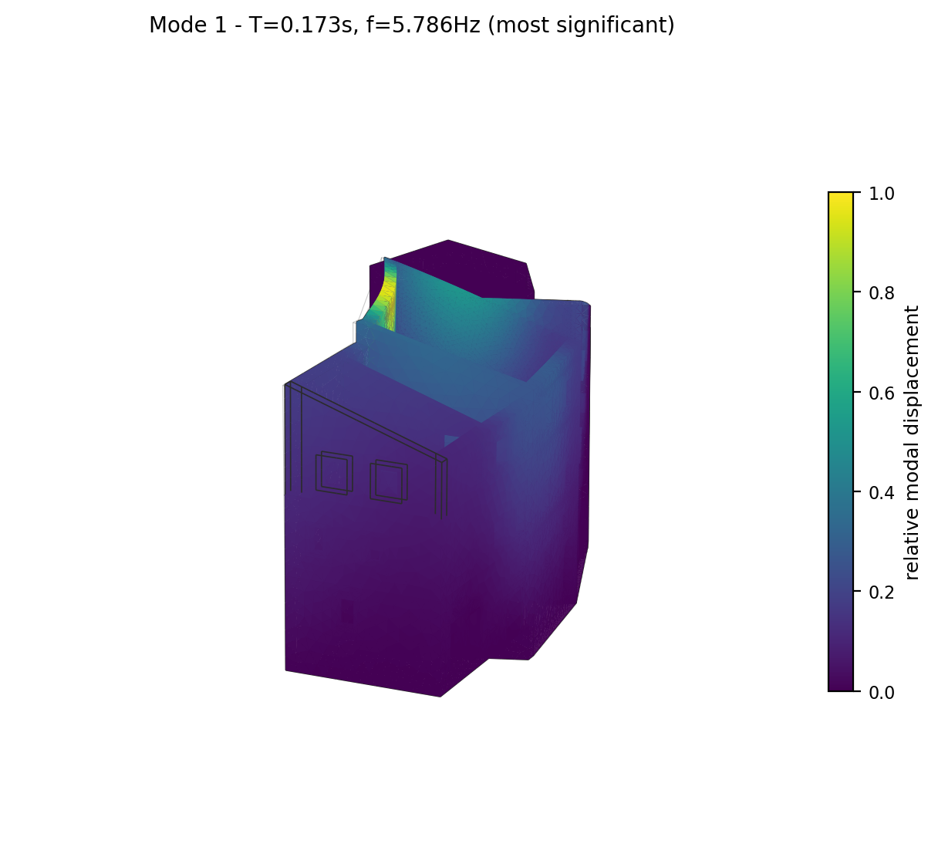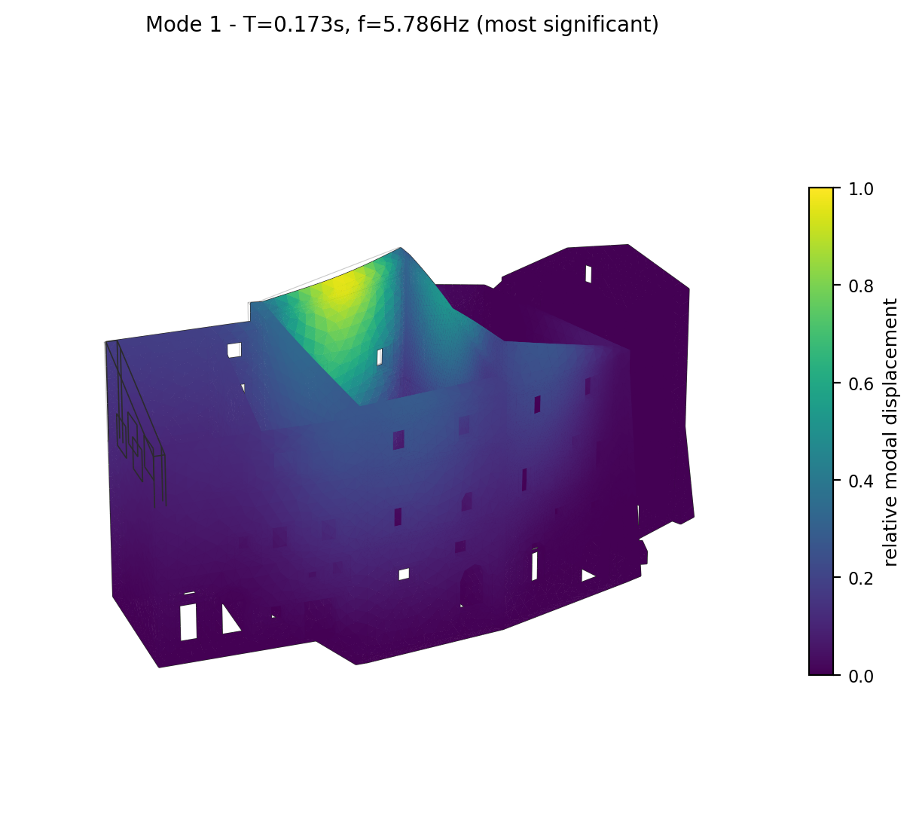
Mode 1 deformed shape (two views), coloured by relative modal displacement magnitude.

Mode 2 (most significant) (T = 0.1535 s, f = 6.515 Hz)
Modal participation mass ratios: MX = 5.66%, MY = 5.65%, MZ = 0.0013%.
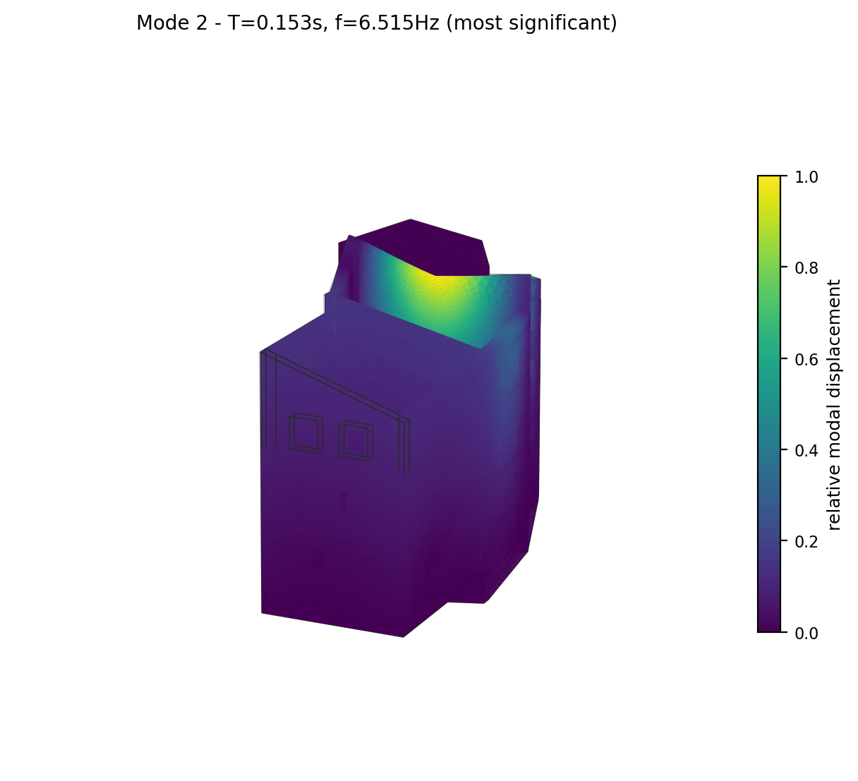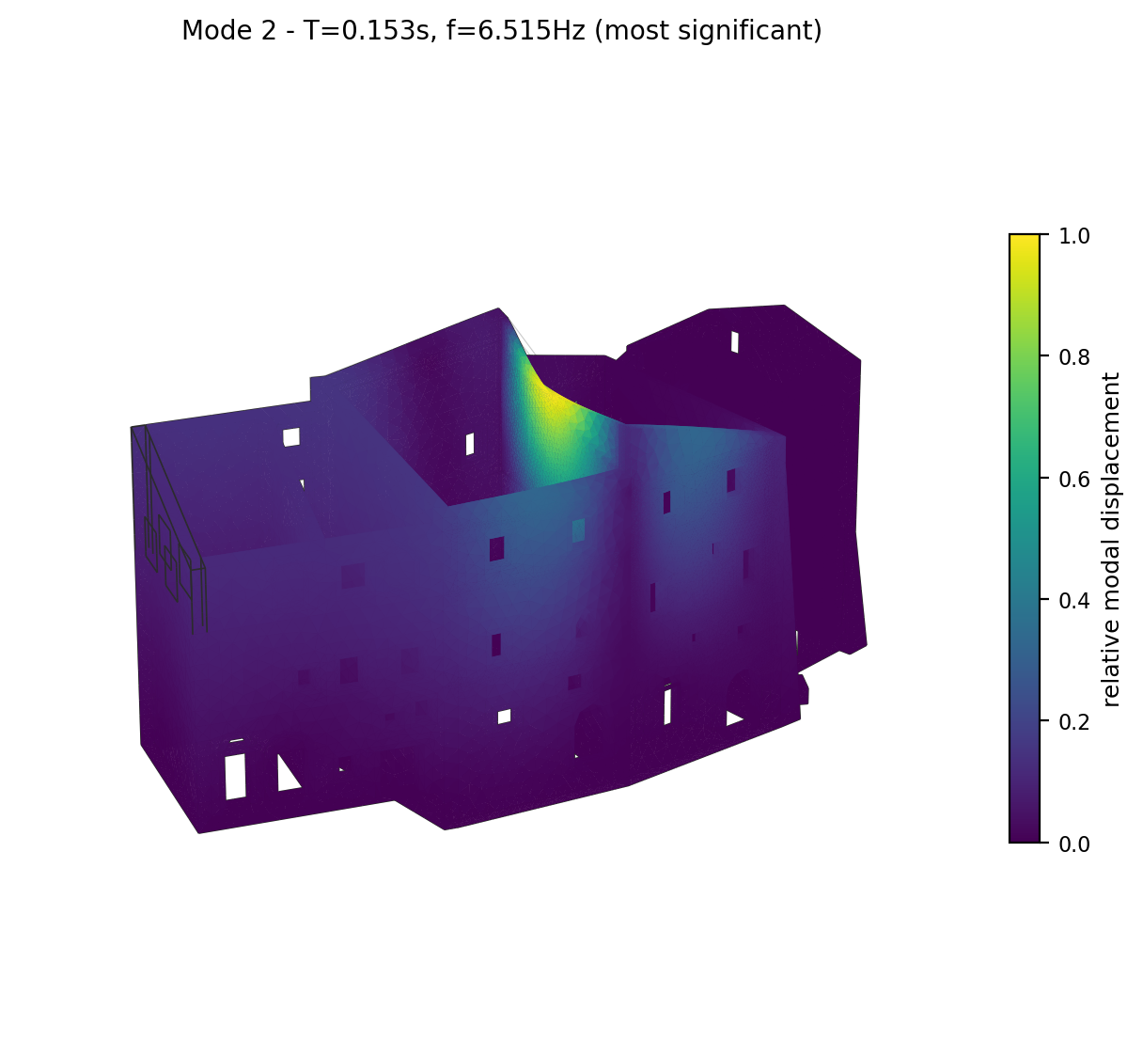
Mode 2 deformed shape (two views), coloured by relative modal displacement magnitude.

Mode 3 (T = 0.1441 s, f = 6.939 Hz)
Modal participation mass ratios: MX = 1.68%, MY = 7.53%, MZ = 0.0057%.
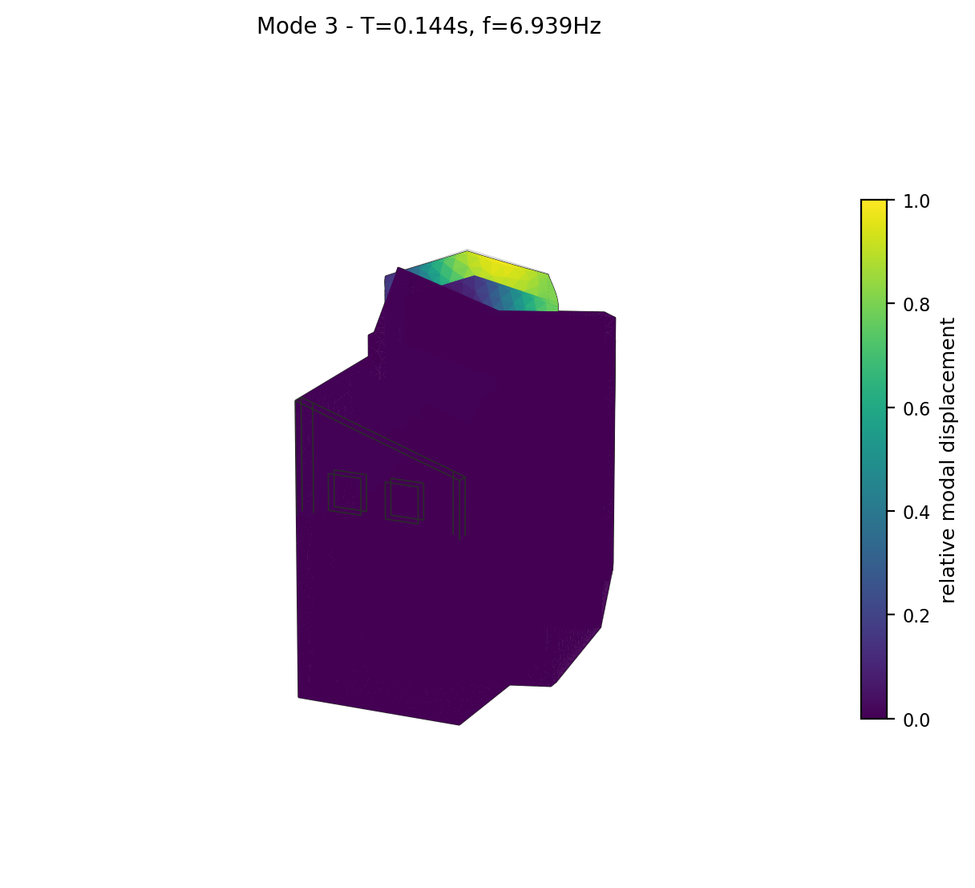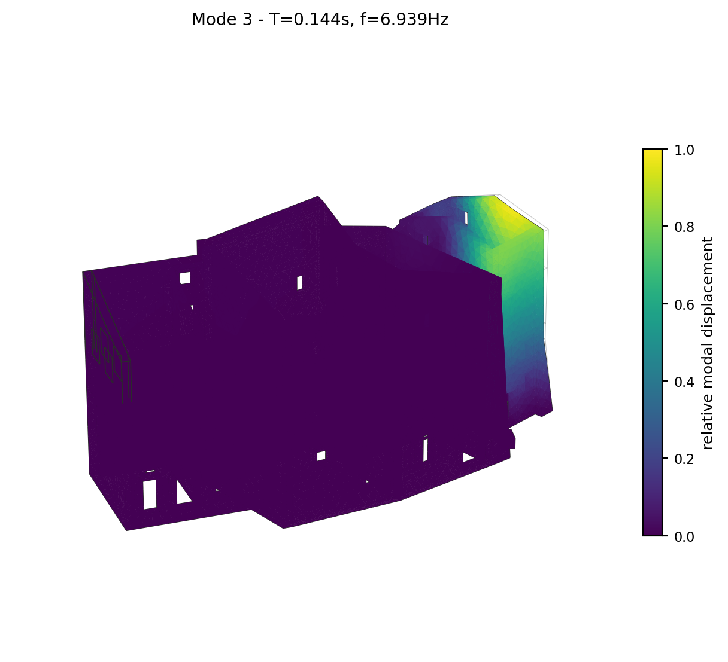
Mode 3 deformed shape (two views), coloured by relative modal displacement magnitude.

Mode 4 (T = 0.1333 s, f = 7.504 Hz)
Modal participation mass ratios: MX = 2.50%, MY = 1.90%, MZ = 0.0430%.
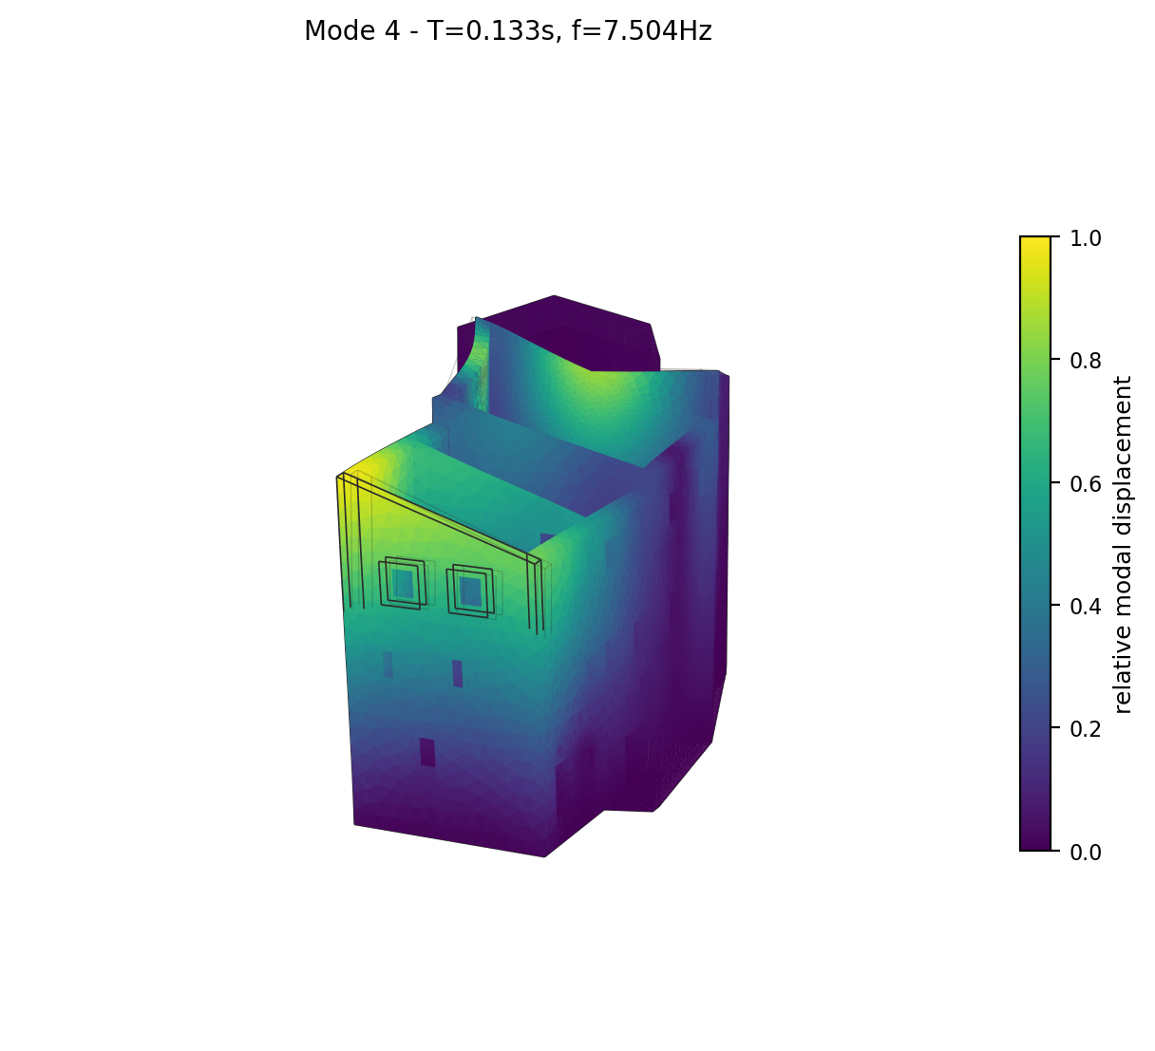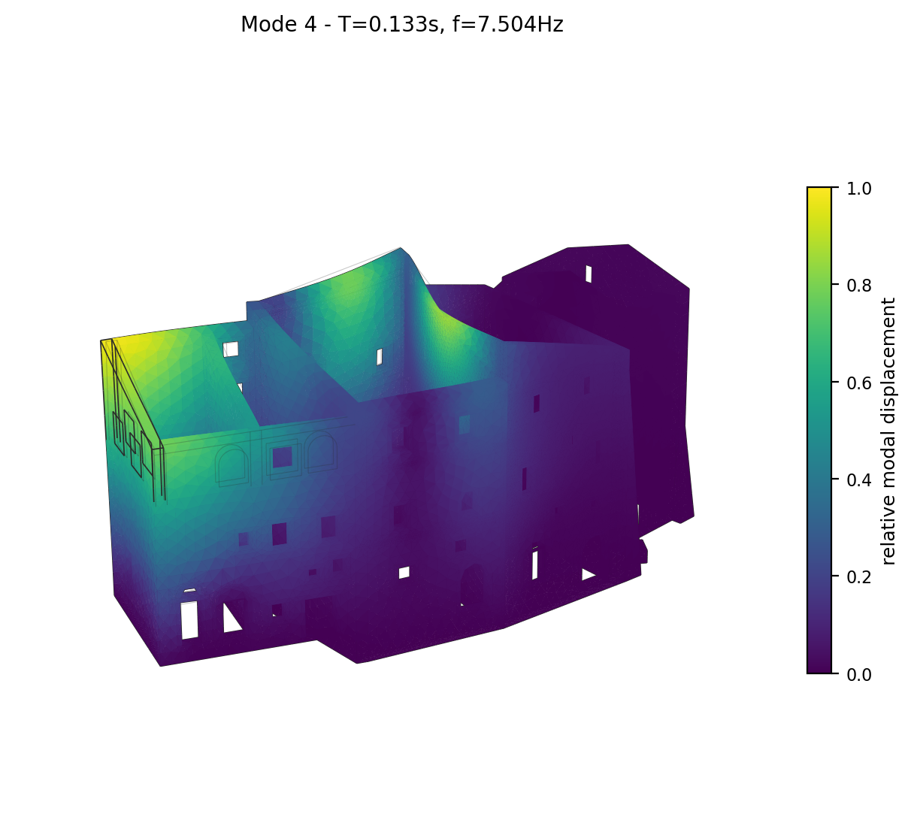
Mode 4 deformed shape (two views), coloured by relative modal displacement magnitude.

Mode 5 (T = 0.1204 s, f = 8.305 Hz)
Modal participation mass ratios: MX = 5.84%, MY = 3.37%, MZ = 0.0186%.
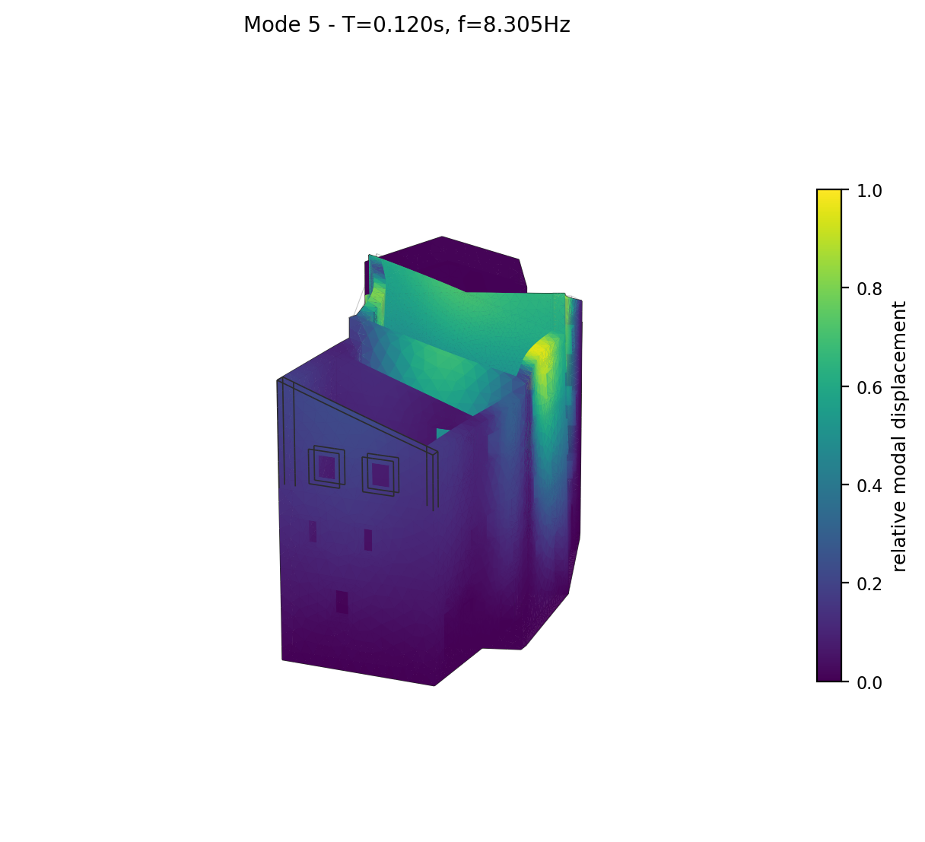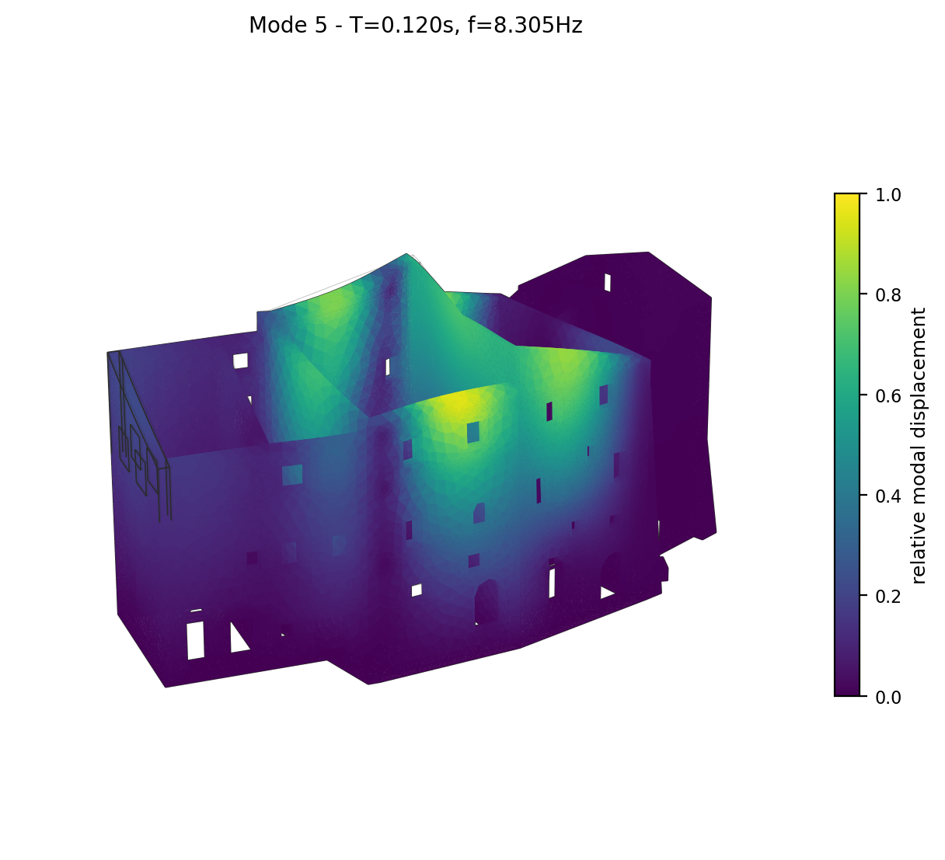
Mode 5 deformed shape (two views), coloured by relative modal displacement magnitude.

Mode 6 (T = 0.1133 s, f = 8.825 Hz)
Modal participation mass ratios: MX = 8.82%, MY = 0.47%, MZ = 0.0079%.
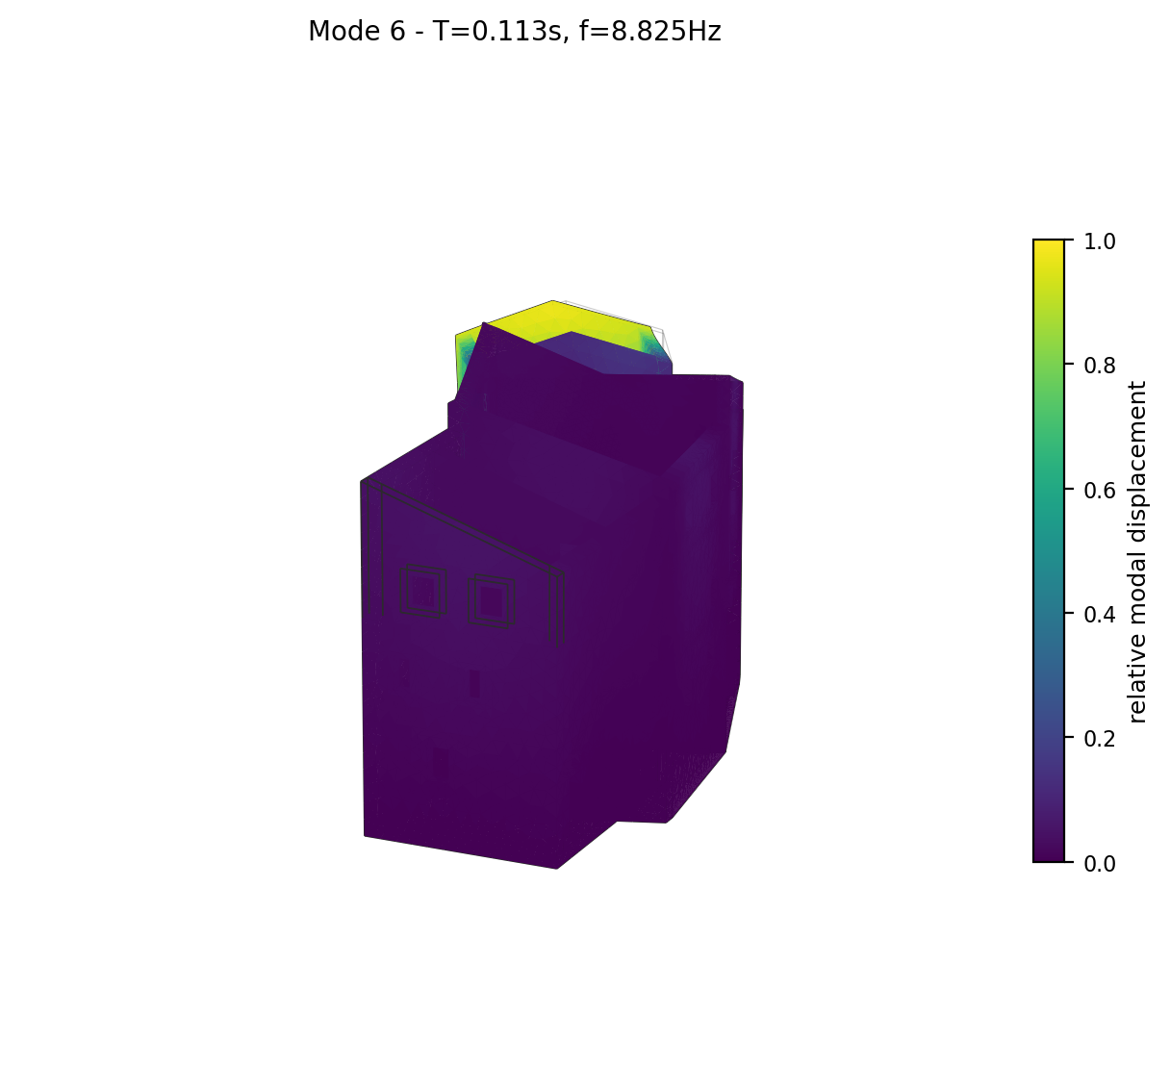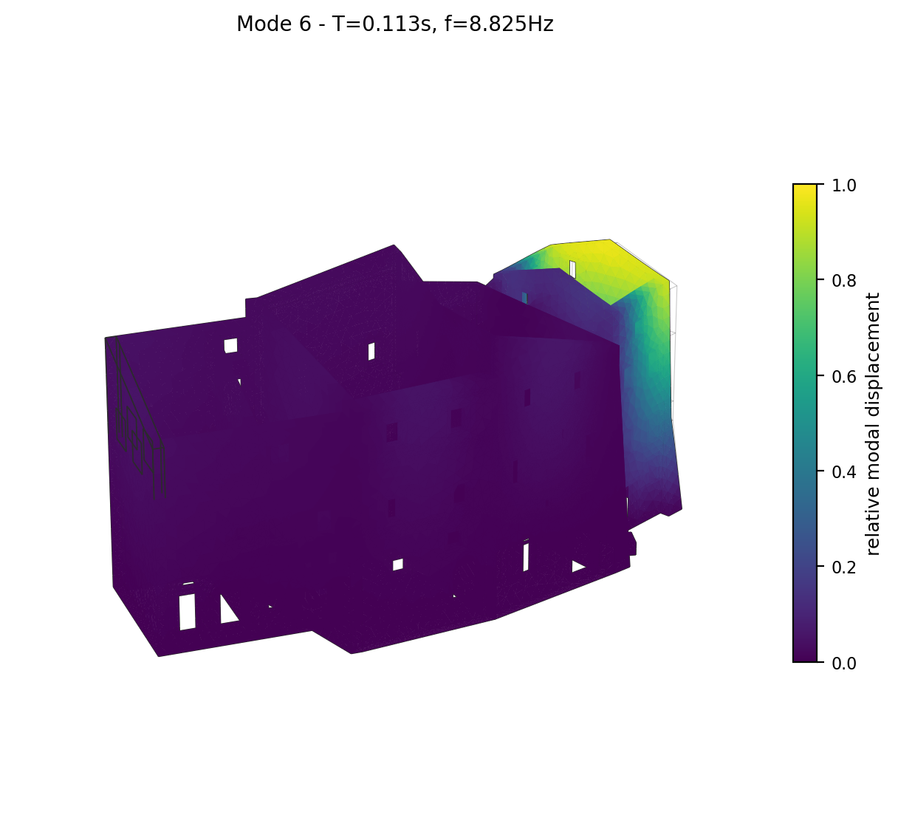
Mode 6 deformed shape (two views), coloured by relative modal displacement magnitude.

Mode 7 (most significant) (T = 0.1099 s, f = 9.101 Hz)
Modal participation mass ratios: MX = 2.71%, MY = 18.44%, MZ = 0.0000%.
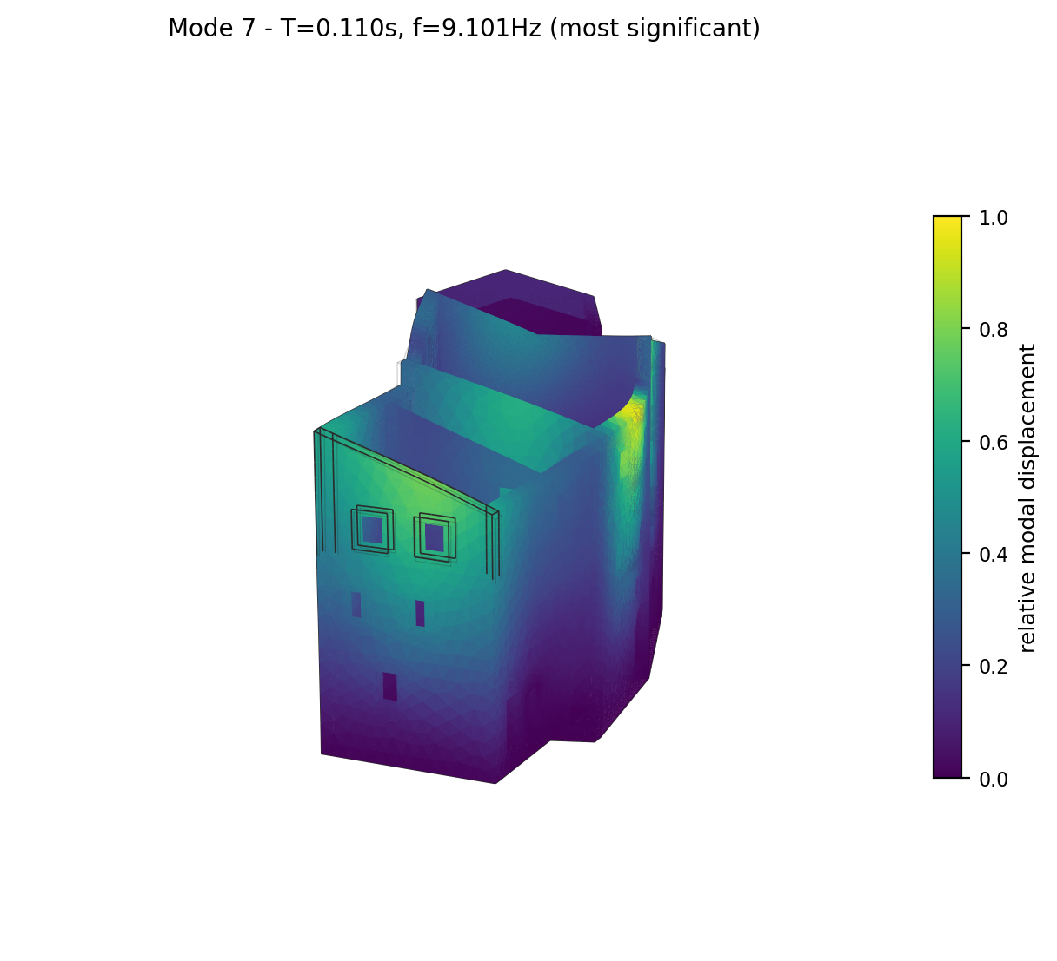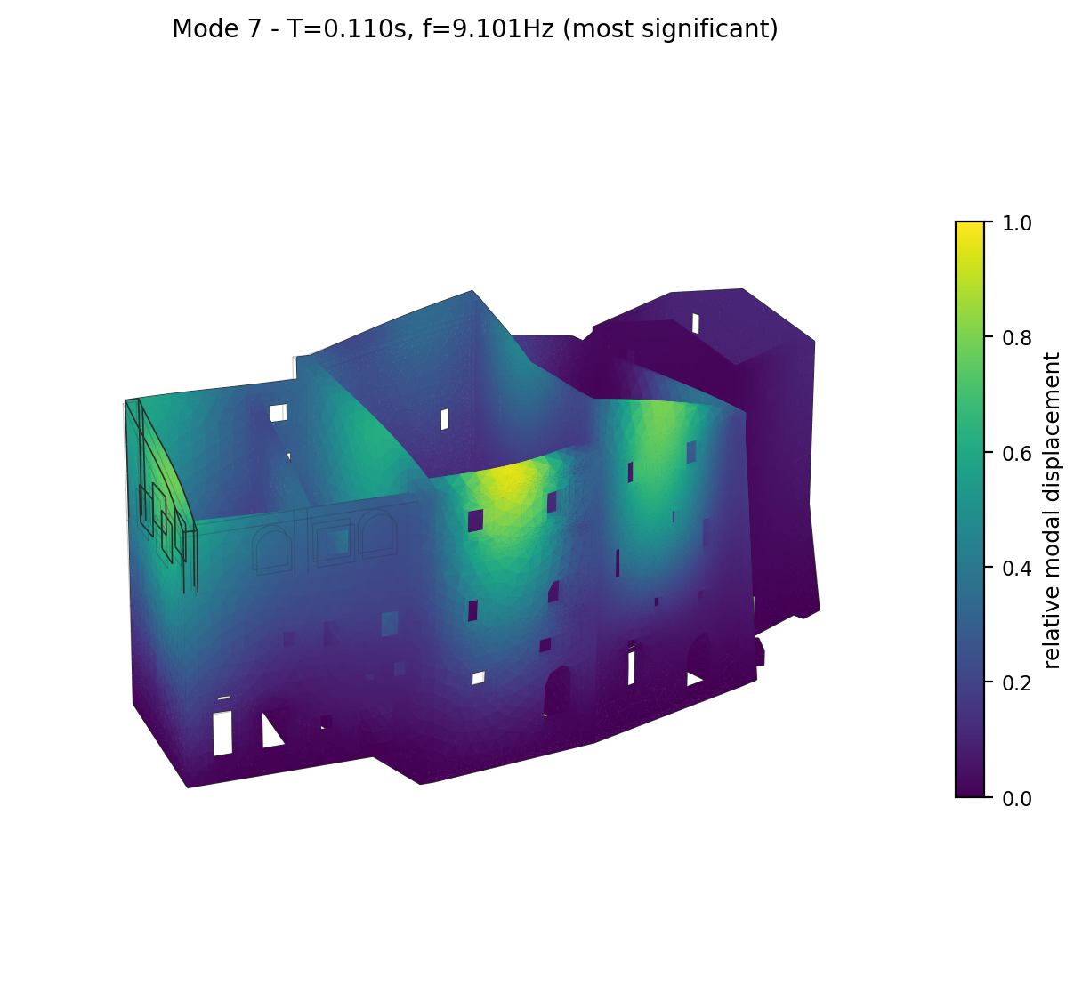
Mode 7 deformed shape (two views), coloured by relative modal displacement magnitude.

Mode 8 (T = 0.1041 s, f = 9.609 Hz)
Modal participation mass ratios: MX = 2.63%, MY = 7.47%, MZ = 0.0065%.
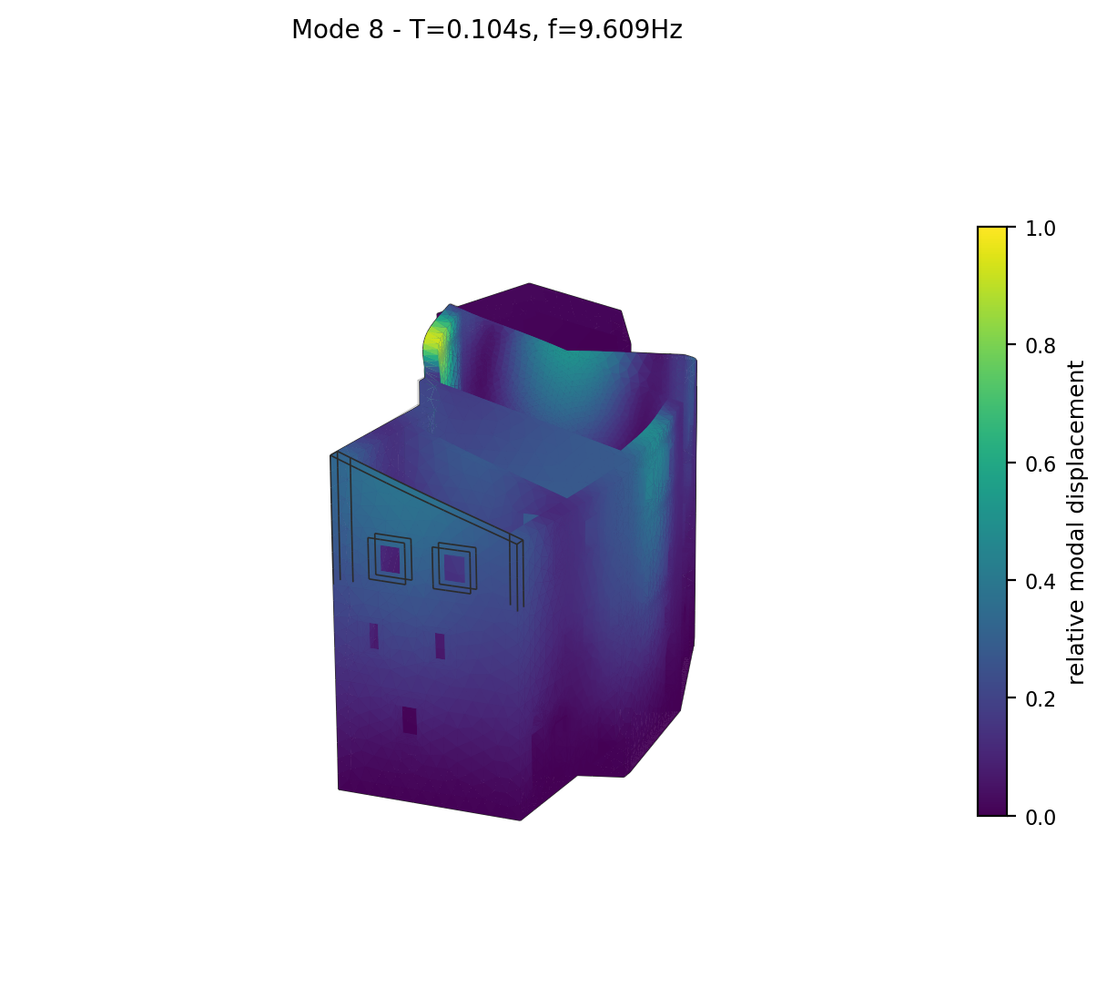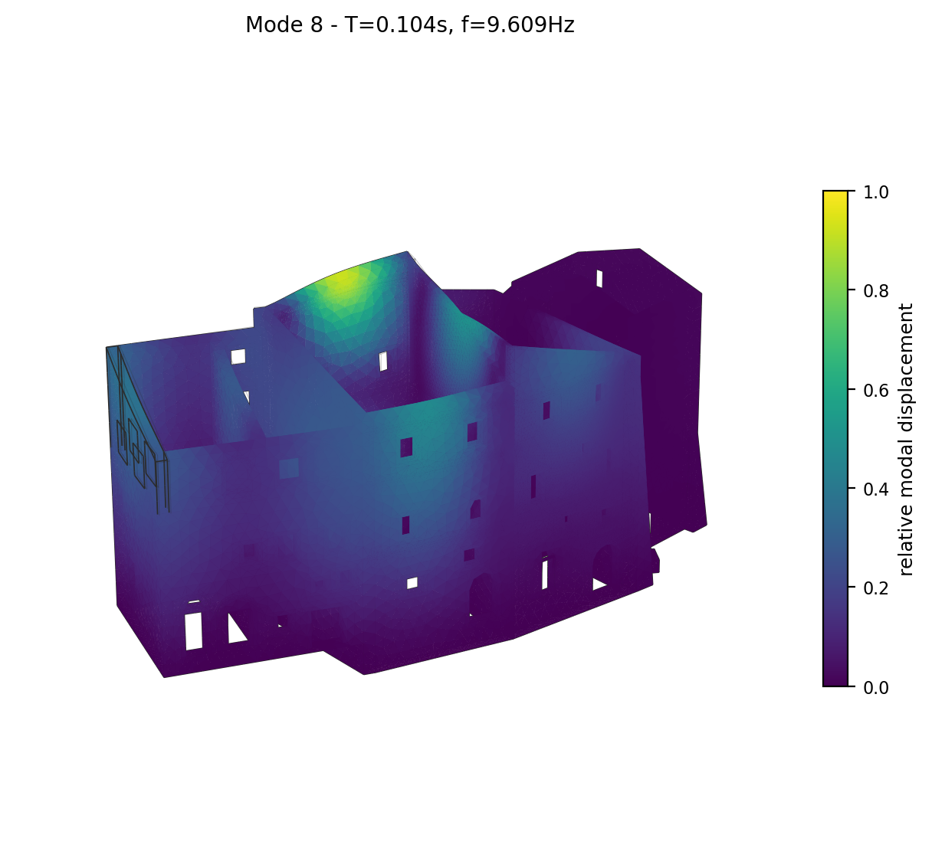
Mode 8 deformed shape (two views), coloured by relative modal displacement magnitude.

Mode 9 (T = 0.1001 s, f = 9.995 Hz)
Modal participation mass ratios: MX = 0.88%, MY = 6.71%, MZ = 0.0000%.
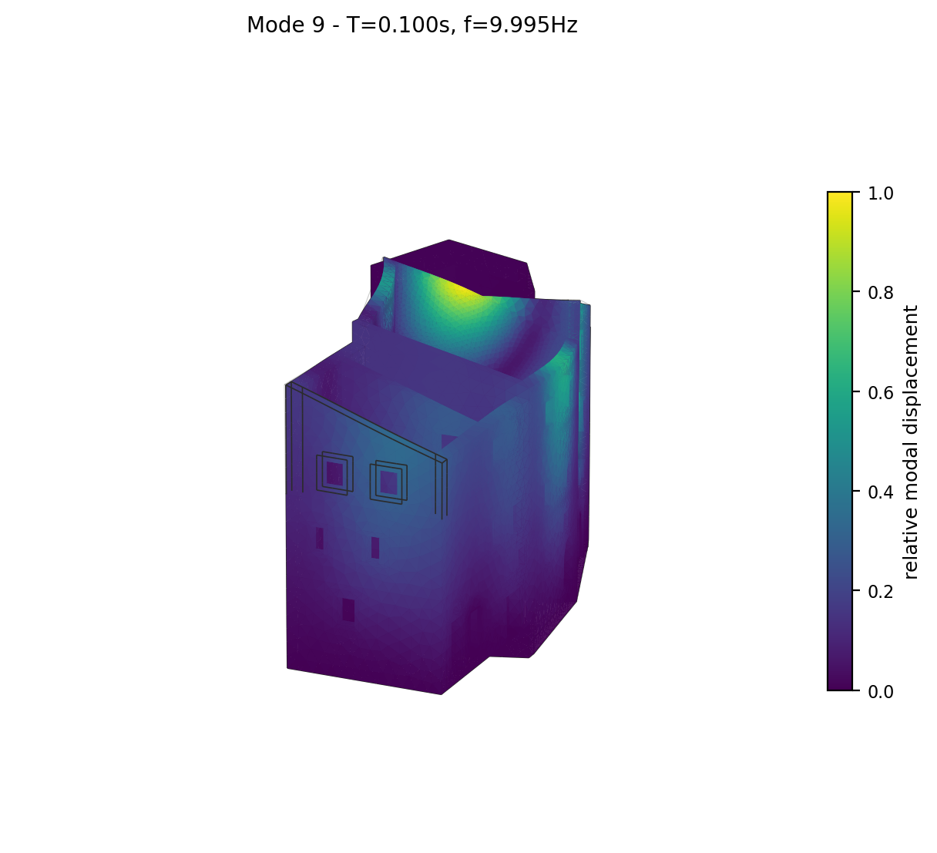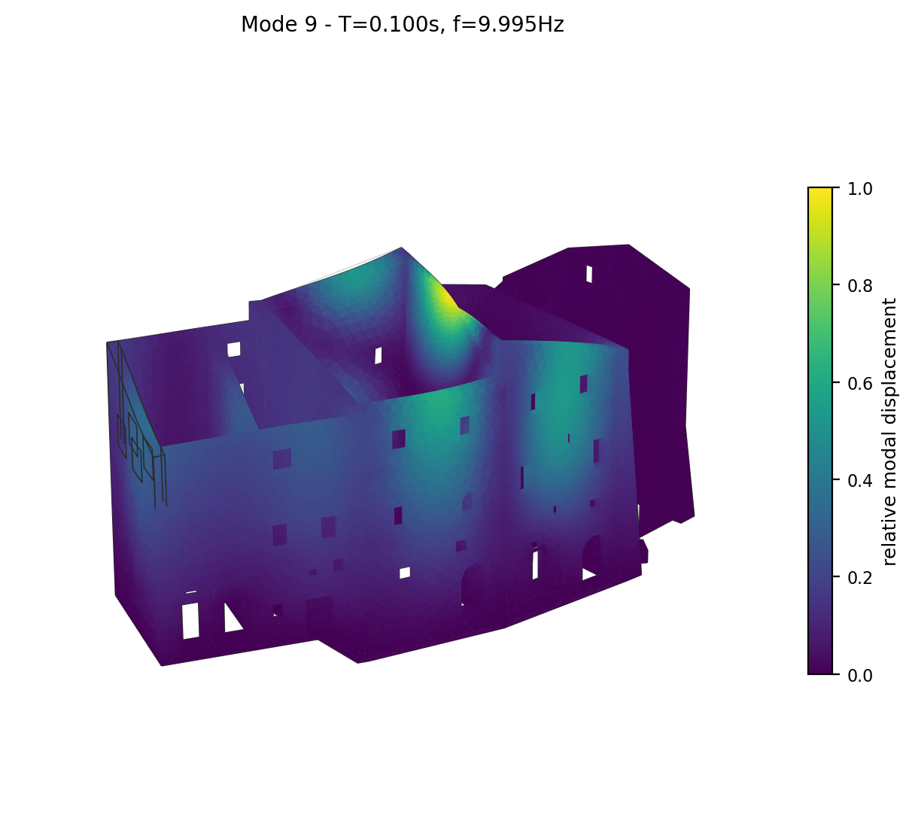
Mode 9 deformed shape (two views), coloured by relative modal displacement magnitude.

Mode 10 (T = 0.0935 s, f = 10.695 Hz)
Modal participation mass ratios: MX = 0.03%, MY = 0.43%, MZ = 0.0039%.
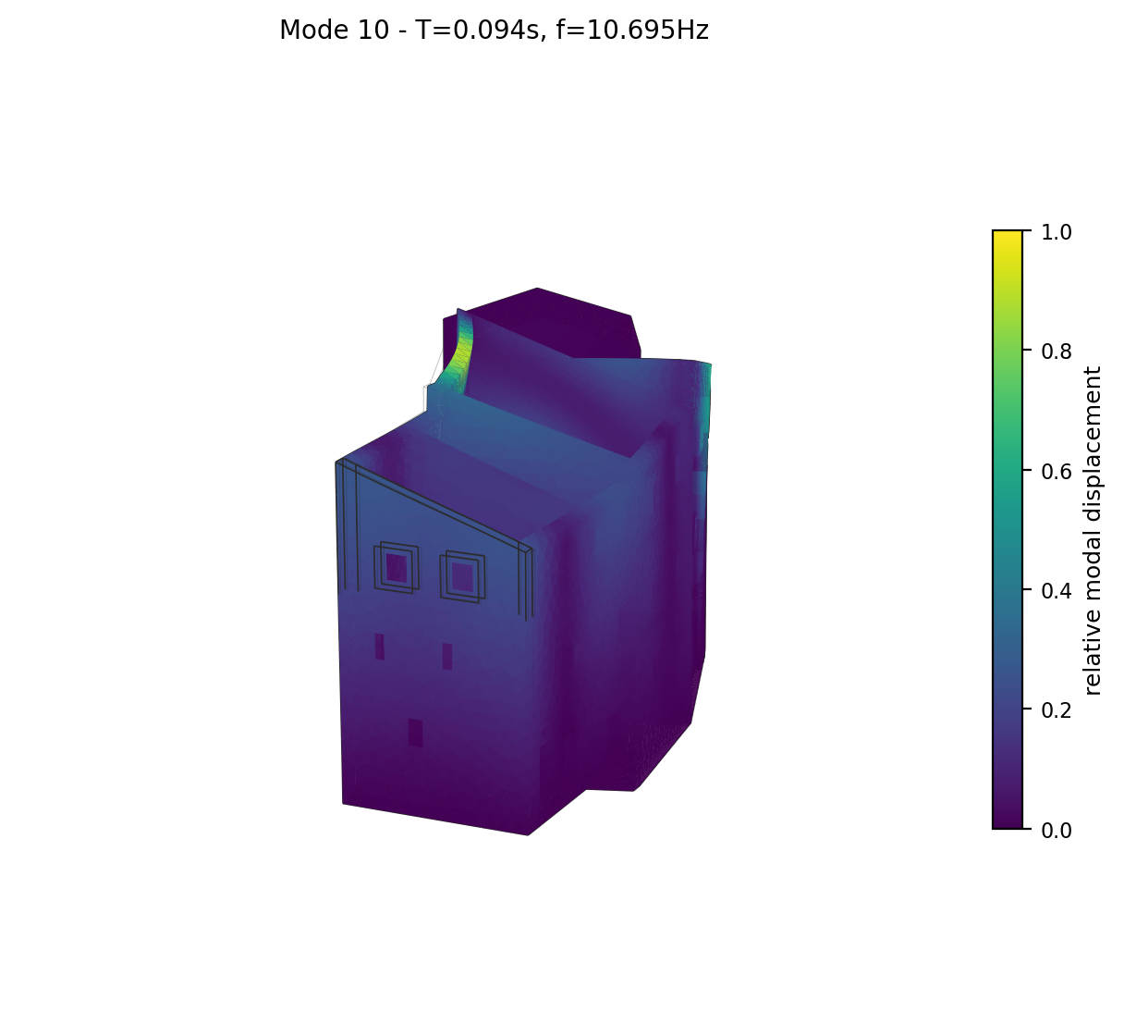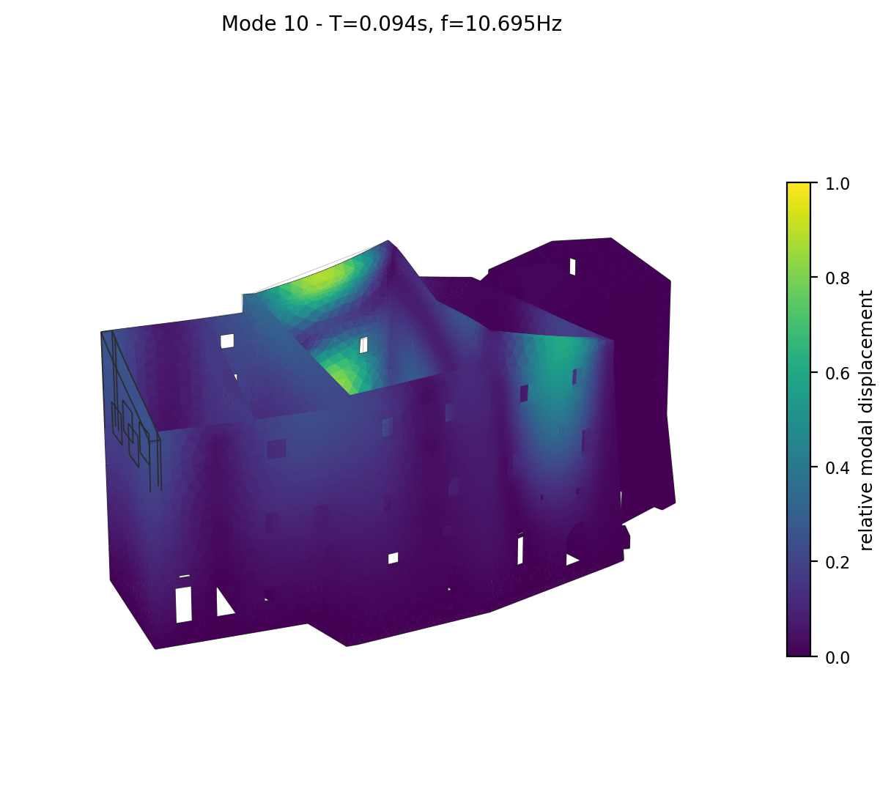
Mode 10 deformed shape (two views), coloured by relative modal displacement magnitude.

