Full-Aggregate Analysis with Task A Contact Interfaces
This section reports the results of a linear-elastic, self-weight-only static analysis of the full Castelnuovo di Porto aggregate (cleaned geometry, see § [geometry cleaning section]), including the wall-to-wall contact interfaces selected interactively with the tool described in § [interactive selection tool section]. The purpose of this run is twofold: to confirm that the analysis converges with a deliberately chosen, non-trivial set of contact interfaces (11, rather than an arbitrary small subset), and to verify the model's self-weight balance - the total base reaction should equal the independently calculated weight of the structure, ρ·g·V, to within numerical tolerance.
The analysis is distributed across 6 MPI ranks (OpenSeesMP, MUMPS parallel direct solver) via domain decomposition of the finite-element mesh. Table 1 summarises the geometry, mesh, and analysis outcome.

Table 1 - Model and results summary
Quantity | Value
Volumes (solids) | 279
Candidate interfaces detected | 885
Interfaces selected | 11
Duplicate nodes (split interfaces) | 326
Mesh nodes | 17,700
Mesh elements | 57,827
MPI ranks / partitions | 6
Ground-bearing volumes | 28
Base-fixed nodes | 576
Converged on all ranks | Yes
Total volume | 623.06 m³
Self-weight, calculated (ρ·g·V) | 12,224,371.0 N
Total base reaction, analysis | 12,227,819.4 N
Weight / reaction difference | 0.028 %
Max. downward displacement | -2.824 mm

The base reaction sum matches the independently calculated self-weight to within 0.028%, confirming that the base boundary conditions (per-volume ground-bearing detection, § [base fixity section]) and the contact-interface node-splitting (§ [Task A implementation section]) are both correctly represented in the assembled model - an incorrect node substitution, in particular, would either disconnect part of the structure (singular stiffness matrix, analysis fails to converge) or double-count/omit mass, both of which would show up here as a large imbalance rather than a numerical rounding-level one.

Domain decomposition
Figure 1 shows the 6-way MPI partition of the mesh, coloured by owning rank (each solid coloured by whichever rank owns the majority of its elements).
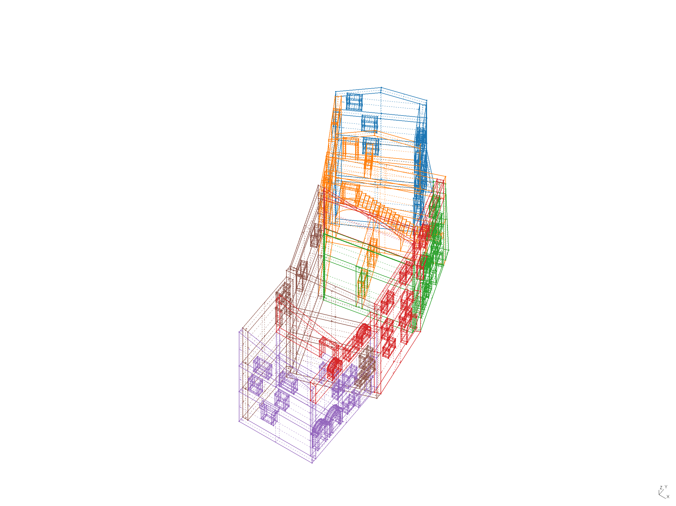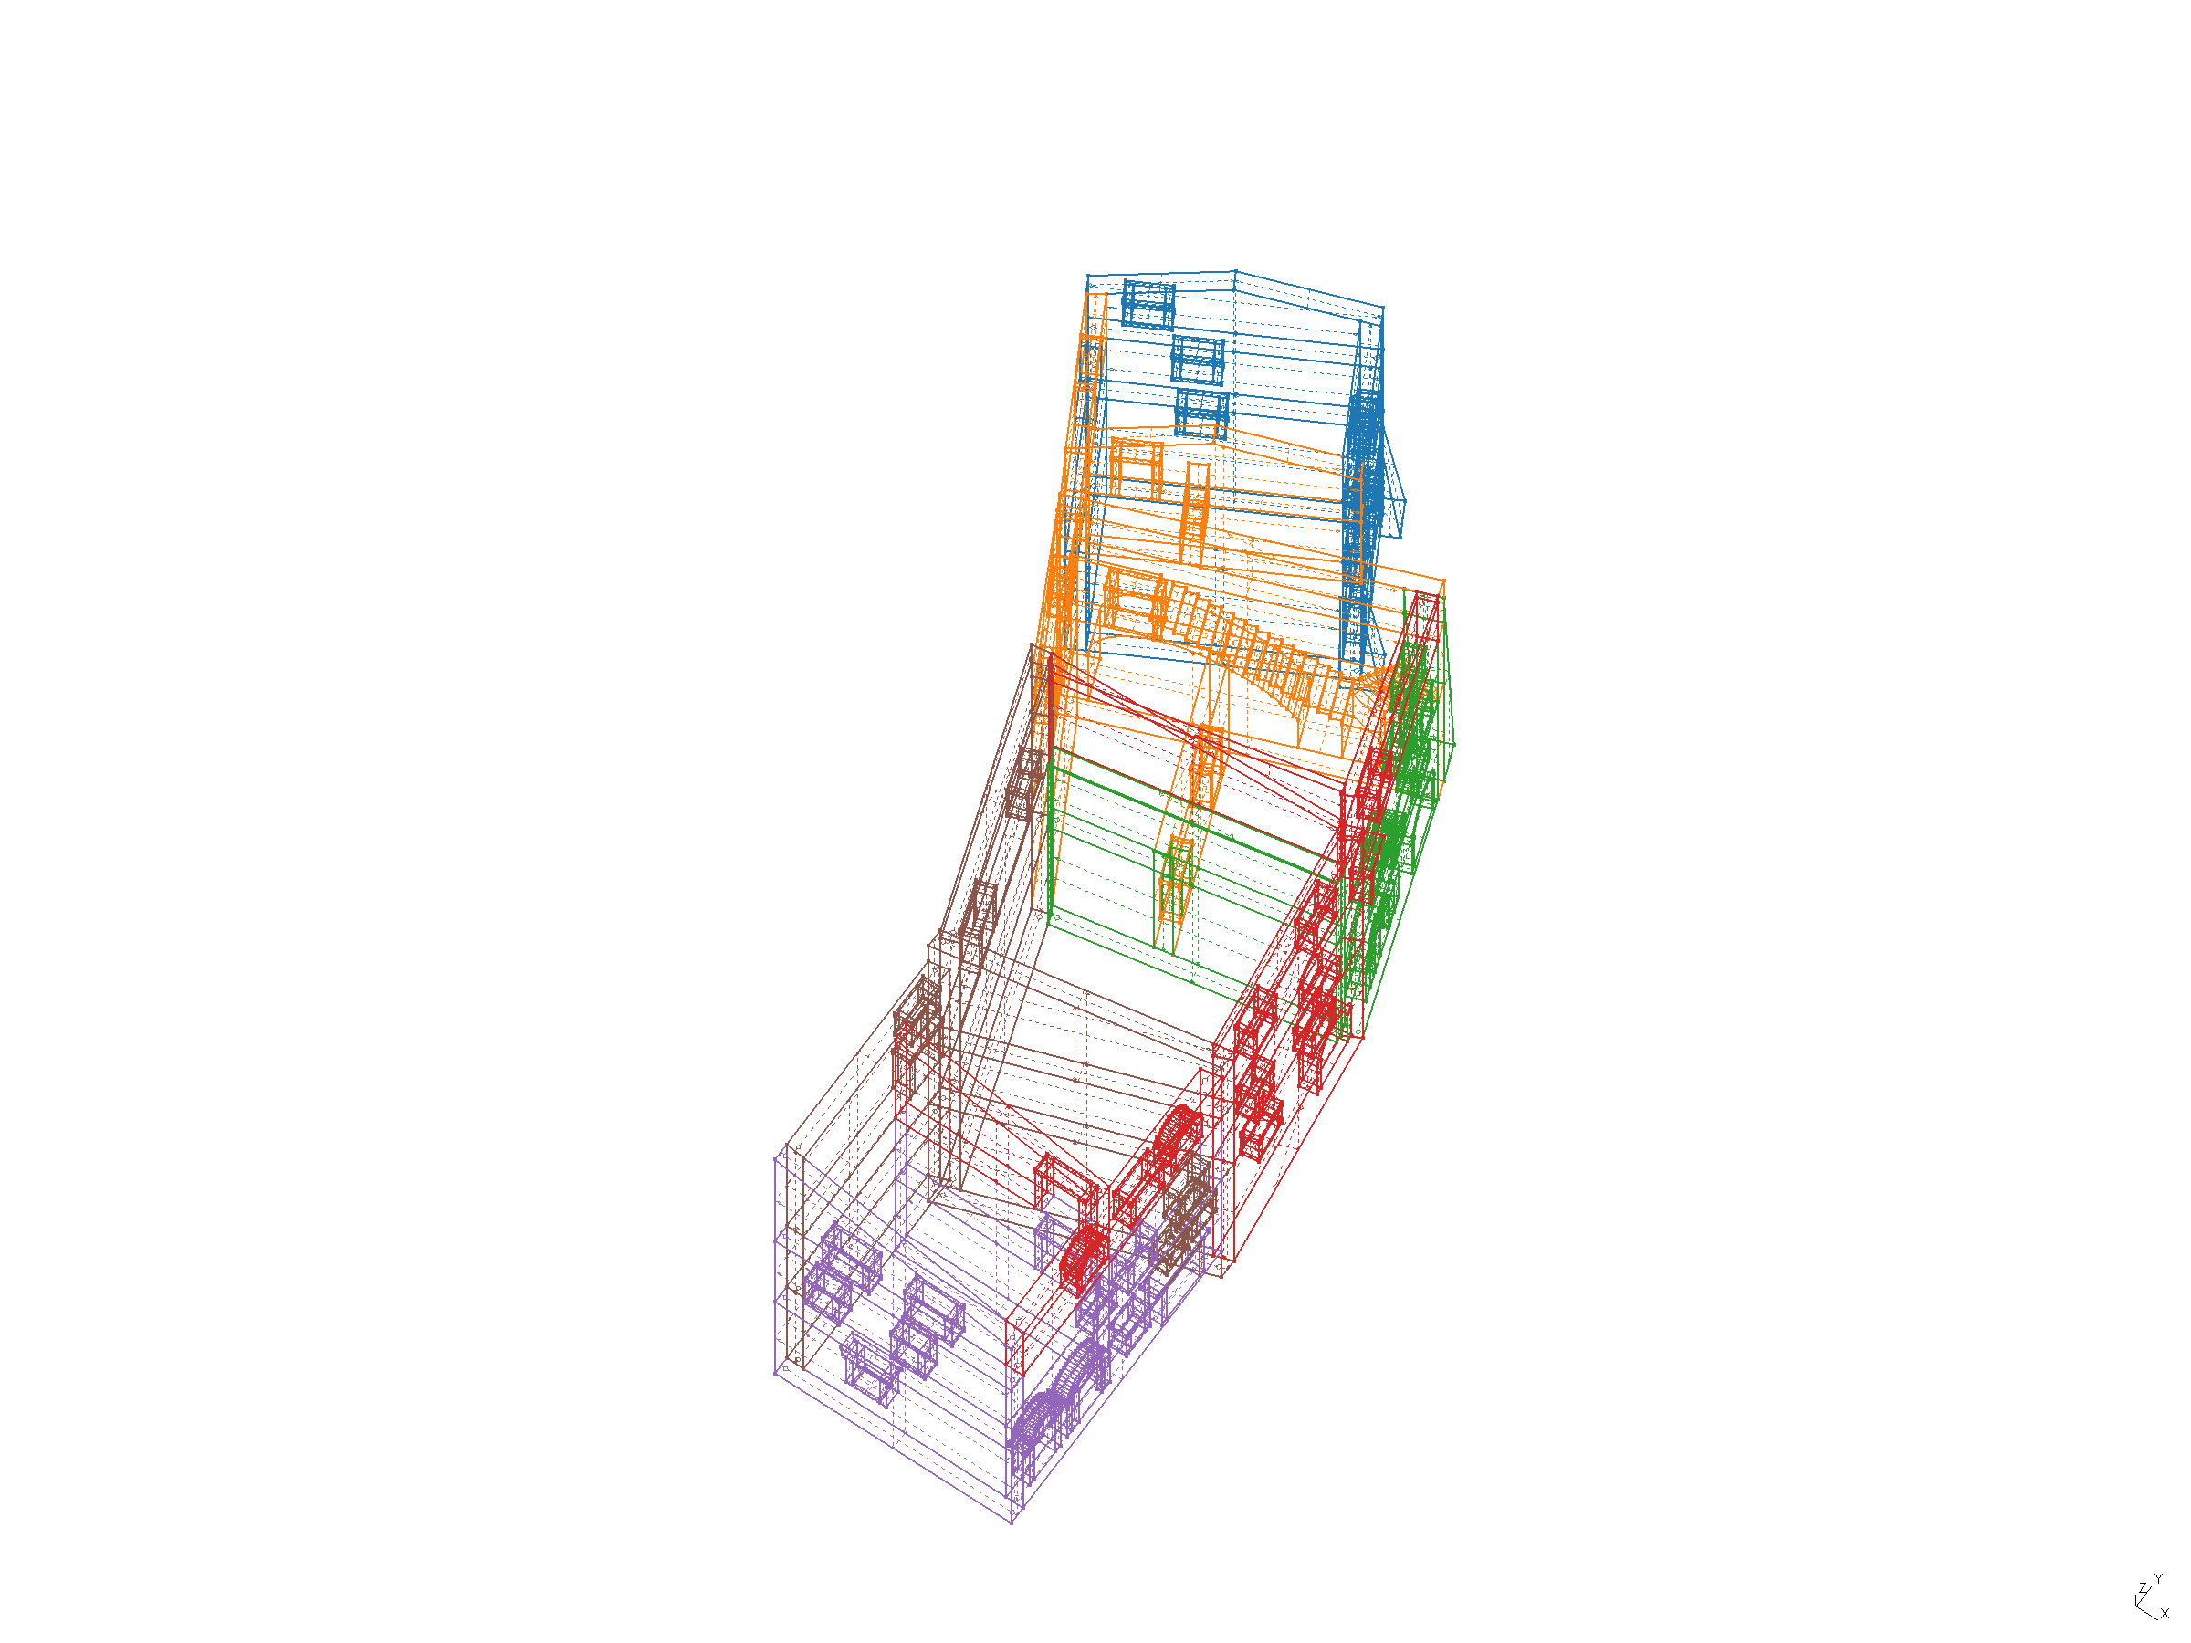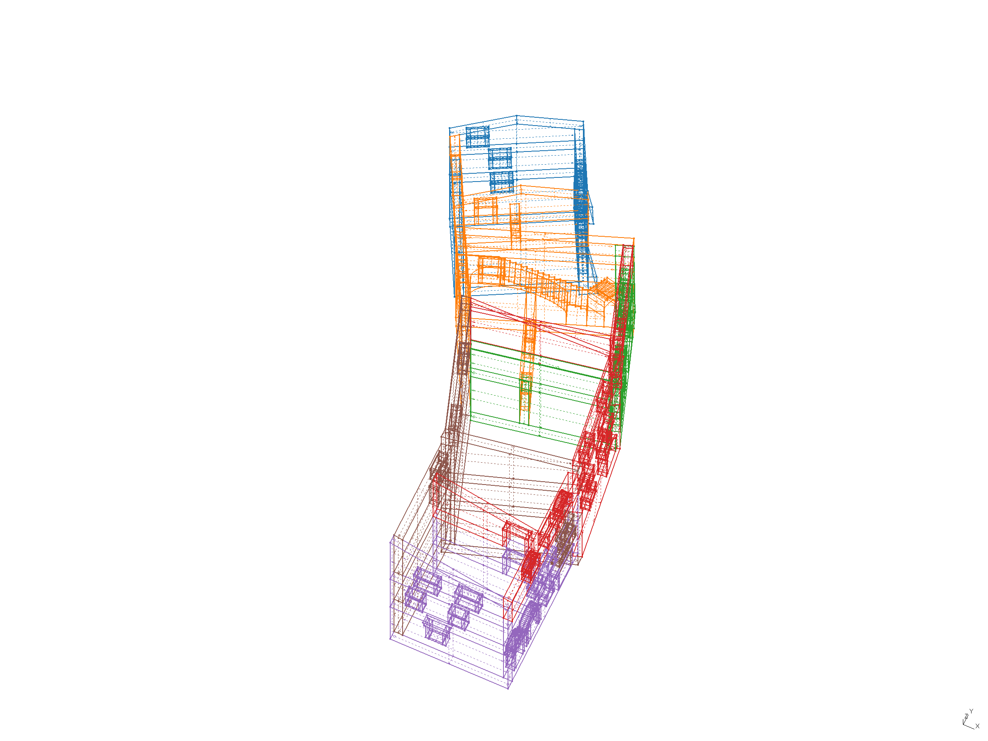
Figure 1 - Mesh partitioned across MPI ranks (Vista 1, 2, 3).

Deformed shape under self-weight
Figure 2 shows the deformed shape under self-weight alone, magnified ×200 for visibility (max. actual downward displacement: -2.824 mm).
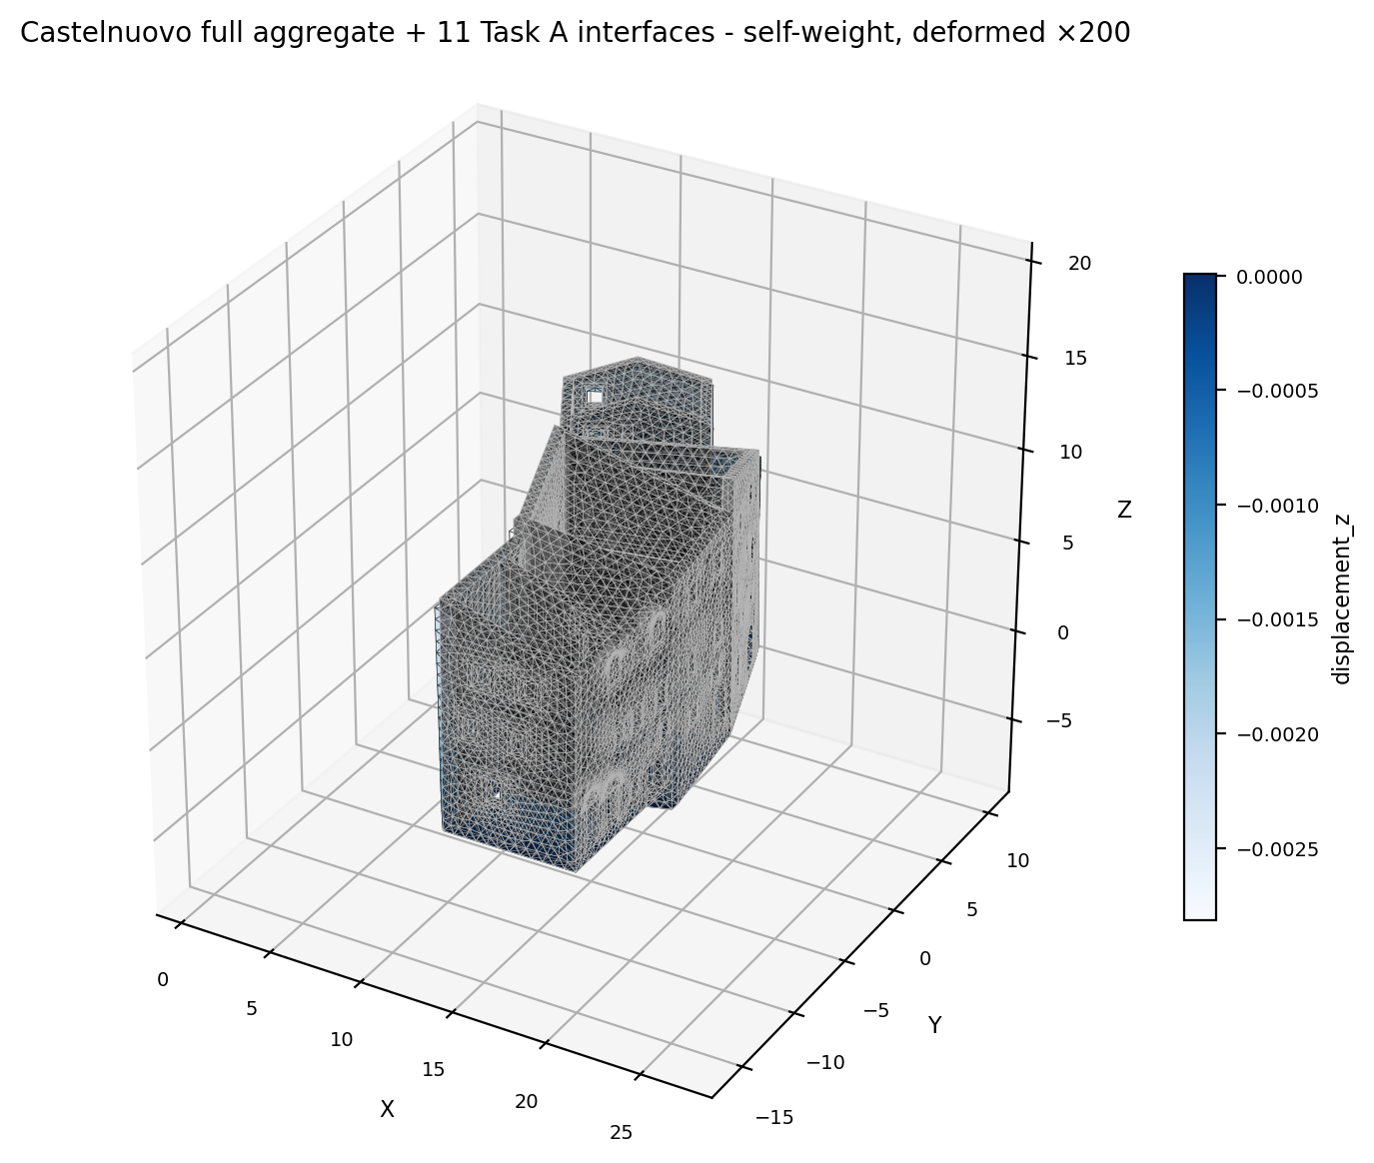
Figure 2 - Deformed shape under self-weight, ×200 magnification (undeformed shape overlaid in grey for reference).

Implementation verification: two defects found and corrected
Reaching the converged result above required diagnosing and fixing two implementation defects, both specific to the parallel (TCL/OpenSeesMP) export path rather than the geometry, the contact-element formulation, or the interface selection itself. Both are reported here because they affected earlier convergence results obtained with a smaller, hand-picked interface subset, and because the diagnostic process - not just the fix - is part of what establishes confidence in the final model.
First, the node-splitting step that decouples the two sides of a selected interface (so that a zeroLengthContactASDimplex element, rather than a rigidly shared node, connects them) was applying its substitution to every element in the model regardless of which volume that element actually belongs to. Since the boundary node in question is, by construction, shared with the neighbouring (non-split) volume as well, that volume's own elements were being silently rewritten too - leaving the original mesh node referenced by no solid element at all, connected to the rest of the model only through its own contact spring. This produces a numerically singular global stiffness matrix, and was traced by direct inspection of the exported model: counting, for a given interface, how many tetrahedral elements referenced its original node versus its duplicate confirmed the original was orphaned. The fix restricts the substitution to elements belonging to the interface's own split volume, determined before partitioning (see below) and passed explicitly into the element-export routine.
Second, the natural fix for the first defect - querying which elements belong to a given volume from inside the same export routine - returned no elements at all, because it was being called after the mesh had already been partitioned across MPI ranks; partitioning mutates the same internal bookkeeping that the query depends on. This mirrors an issue already known from the interface-detection step itself, which must also run before partitioning for the same reason. The corrected implementation computes the volume-to-element mapping once, before partitioning, and threads it through explicitly rather than recomputing it later.
A related, lower-severity issue was found while reconciling a selection made interactively (on one machine, one library version) with the analysis environment (a Docker image pinning a different, older version of the same meshing library): the two environments assign different internal numeric tags to the same solids, even from the identical input geometry, so a selection identified by volume tag failed to reload in the analysis environment. The candidate identity key was changed to use only each interface's geometric centroid - which matched to sub-millimetre precision across both environments - removing the dependency on any tool-internal numbering.

