ARGO Testing Scanner

Detailed Design Document

Team 5

Developers

Amanda Bosson

Matthew Freese

Jessica Jennings

Mazen Lawand

Hisham Nabi

Abstract

This document will discuss the planned design of the ARGO Testing Scanner and summarize how detailed design decisions were made based on requirements analysis and architectural decisions. The goal of the detailed design is to conceptualize and visualize workflows, system components, the interactions between components, and the structure of any graphical user interfaces (GUIs) that will be part of the final application. This document will provide diagrams of various aspects of the system and its components using Unified Modeling Language (UML), present views of the GUI, and trace detailed design decisions back to stated project requirements.

Table of Contents

**1. Introduction** **3**

1.1 Introduction to Detailed Design Document 3

1.2 Purpose of the Detailed Design Document 3

**2. GUI (Graphical User Interface) Design** **3**

2.1 Login Screen 3

2.1 Testing Interface 4

**3. Static Model Class Diagrams** **5**

3.1 Scan Controller 5

**4. Dynamic Model Sequence Diagrams** **5**

**5. Rationale for the Detailed Design Model** **5**

5.1 Rationale for 5

**6. Traceability from Requirements to Detailed Design Model** **6**

**7. Evidence the Design Model Has Been Placed Under Configuration Management** **6**

**8. References** **7**

List of Figures

**Figure 2.1 Login Screen GUI 3**

**Figure 2.2 Testing Interface GUI 4**

# 

# 

# 1. Introduction

## **1.1 Introduction to Detailed Design Document**

The ARGO Testing Scanner is an application that detects and notifies testers of errors and defects. This document provides a brief overview of the detailed design for the ARGO Testing Scanner.

## **1.2 Purpose of the Detailed Design Document**

This document will be used to describe the design details of the ARGO Testing Scanner. This will include examining GUI designs, class diagrams, sequence diagrams, and rationale for design decisions.

# 2. GUI (Graphical User Interface) Design

## **2.1 Login Screen**

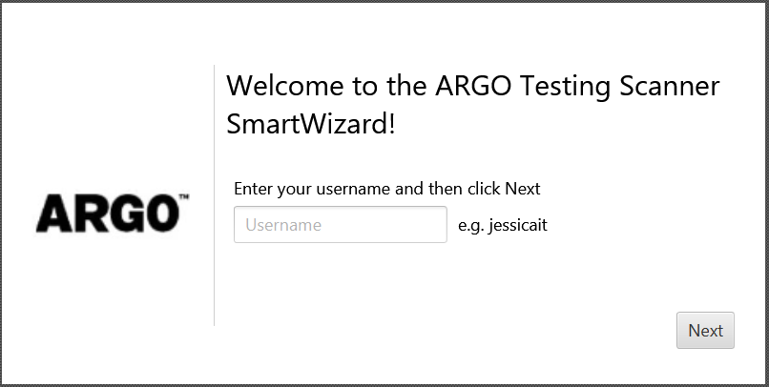

## 2.1 Testing Interface

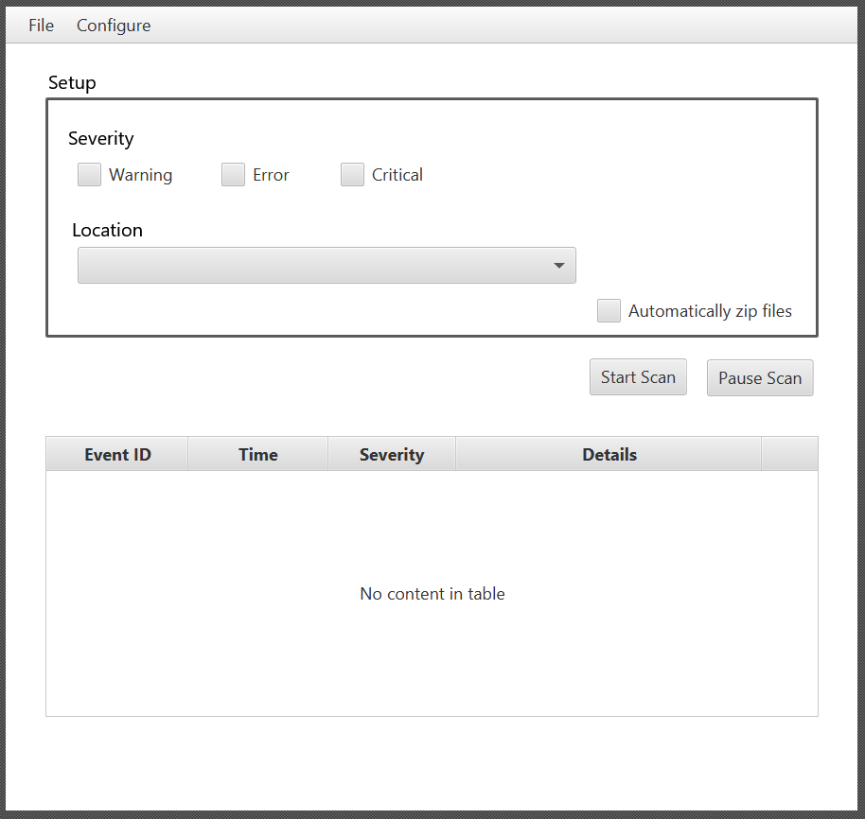

# 

# 

# 

# 3. Static Model Class Diagrams

## 

## 3.1 Scan Controller

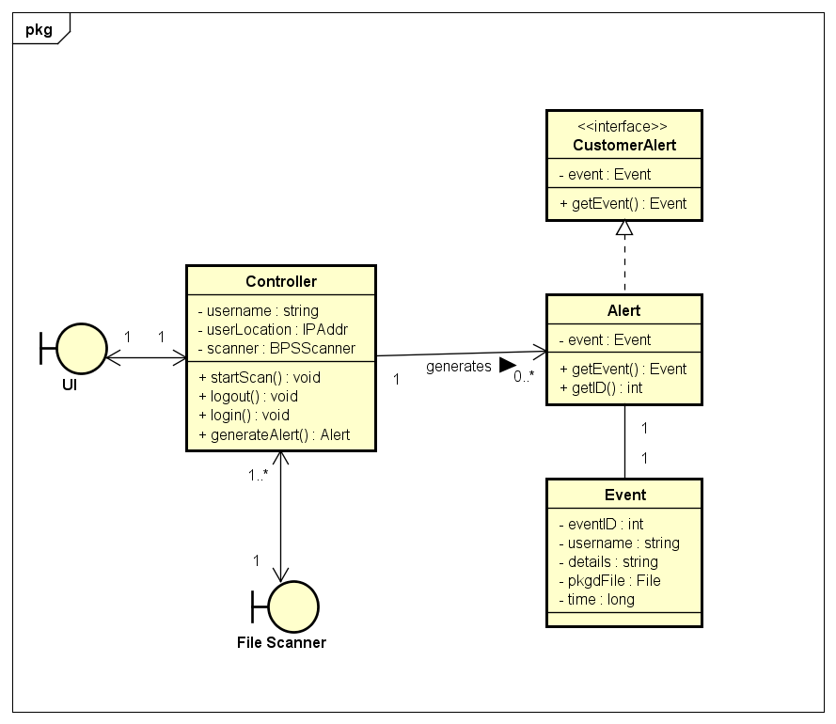

# 4. Dynamic Model Sequence Diagrams

# 

# 

# 5. Rationale for the Detailed Design Model

## **5.1 Rationale for Scan Controller** Design

The Scan Controller is the component that allows users of the testing scanner to login in order to trace testing activity to a particular user and starts the file scanning process. If the file scanner detects an event, the Scan Controller will generate an alert that will be presented to the user via the GUI. The Event class holds all relevant data of the critical event, including the information of the user who caused the event and packaged log files that will be delivered to the user.

# 6. Traceability from Requirements to Detailed Design Model

# 7. Evidence the Design Model Has Been Placed Under Configuration Management

Configuration management for this document will be handled using github. Changes will be tracked through making commits to this document to keep a record of change dates and the user who made changes.

The github repository can be accessed here: https://github.com/mjfreese/ARGOTestingScanner

# 8. References