Reproducible Research Assignment 1

Matthew Lawlor

Loading and preprocessing the data
The data is compressed to a .zip file in the repository, the process should include unzipping the data and pushing the dataset into R. The following code was used on the data. A structure function is called on the dataset.
filename <- unzip("activity.zip")
activity <- read.csv(filename, stringsAsFactors = FALSE)
str(activity)
## 'data.frame': 17568 obs. of 3 variables:
## $ steps : int NA NA NA NA NA NA NA NA NA NA ...
## $ date : chr "2012-10-01" "2012-10-01" "2012-10-01" "2012-10-01" ...
## $ interval: int 0 5 10 15 20 25 30 35 40 45 ...
From the summary of the dataset we can see that the column containing the dates is not properly formatted to a Date class so the next step is to adjust that now.
activity$date <- as.Date(activity$date)
str(activity)
## 'data.frame': 17568 obs. of 3 variables:
## $ steps : int NA NA NA NA NA NA NA NA NA NA ...
## $ date : Date, format: "2012-10-01" "2012-10-01" ...
## $ interval: int 0 5 10 15 20 25 30 35 40 45 ...
There are some missing values in the column of the steps, next we perform a count.
sum(is.na(activity$steps))
## [1] 2304

What is mean total number of steps taken per day?
The next step is to need a file that does not contain missing values.
It was detected that there are 2304 missing values which will be excluded from the analysis.
The dataset called “activity_rm” is created for this reason.
activity_rm<-activity[which(!is.na(activity$steps)),]
The number of steps taken is measured in timeslots, 5-minute intervals, so in order to compute the total number of steps taken for each day the analysis will aggregate the data by day.
perday<-tapply(activity_rm$steps, activity_rm$date, sum)
So, now the per day dataset contains the total number of steps taken for each day of October and November (total 53 days)
The next step is to make a histogram of the total number of steps taken each day.
hist(perday,10, main = "Total number of steps taken per day", xlab = "")
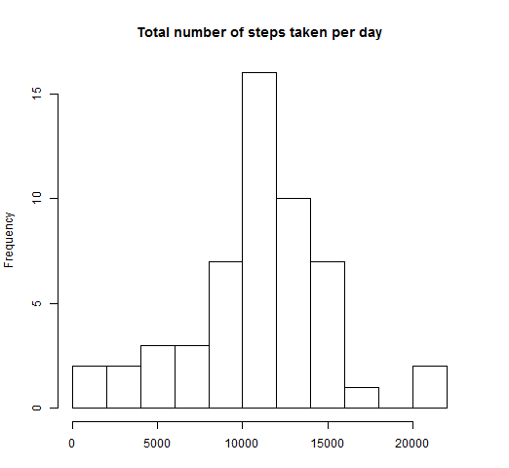
The mean total number of steps during a whole day is 1.0766 × 10⁴, while the median of the total steps is 10765.
mean(perday)
## [1] 10766
median(perday)
## [1] 10765

What is the average daily activity pattern?
In order to explore our data throughout the day, the next step is to need to aggregate the dataset by the intervals. A per interval array is created for this reason and a time series plot will also be created.
Please keep in mind that the x-axis point labels are the names of the intervals in the dataset. The coding of the interval names is such, so that e.g. 500 should be considered as 5:00 and 1000 as 10:00, and so on. So, one can consider the x-axis as a full 24-hour-day starting from midnight and ending at the next midnight hour.
dailyact<-tapply(activity_rm$steps, activity_rm$interval, mean)
plot(y = dailyact, x = names(dailyact), type = "l", xlab = "5-Minute-Interval",
main = "Daily Activity Pattern", ylab = "Average number of steps")

Finally, we find out that the interval with the maximum average number of steps throughout the days is 835 with 206.1698 steps.
dailyact[dailyact==max(dailyact)]
## 835
## 206.2

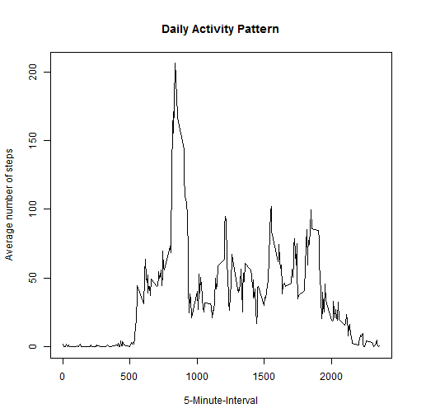

Input missing values
As discussed earlier in this report, there are a number of days/intervals where there are missing values (coded as NA). The presence of missing days may introduce bias into some calculations or summaries of the data.
Let's remind ourselves how many there were regarding the steps variable, and let's check that the other two variables do not have any missing data.
sum(is.na(activity$steps))
## [1] 2304
sum(is.na(activity))
## [1] 2304
The count of missing values for the column of steps equals to the total number missing in the whole dataset, so we can be sure that the intervals and the dates do not have any.
So, 2304 missing values is a percentage of 13.11% on the total observations, so obviously there will be some bias.
In order to exclude the bias we have to come up with a method for filling in all of the missing values in the dataset. Some quick ways are to use the mean/median for that day, or the mean for that 5-minute interval, etc.
The next step is to go with the option of using the mean of the 5-minute interval, and thus the next step is to now create a new dataset that is equal to the original dataset but with the missing data filled in.
act_new <- activity
act_new[which(is.na(act_new$steps)),1]<-
dailyact[as.character(act_new[which(is.na(act_new$steps)),3])]
No missing values are now in the new dataset:
sum(is.na(act_new))
## [1] 0
Now let's make the same histogram that we made in the first part of the analysis, in order to visually see if there is a big effect.
perday_new<-tapply(act_new$steps, act_new$date, sum)
par(mfrow=c(1,2))
hist(perday,10, main = "Total number of steps taken per day", xlab = "Steps"
, ylim =c(0, 25))
abline(v = median(perday), col = 4, lwd = 4)
hist(perday_new,10, main = "Total number of steps taken per day
(missing values replaced with mean of interval)", xlab = "Steps",
ylim =c(0, 25))
abline(v = median(perday_new), col = 4, lwd = 4)
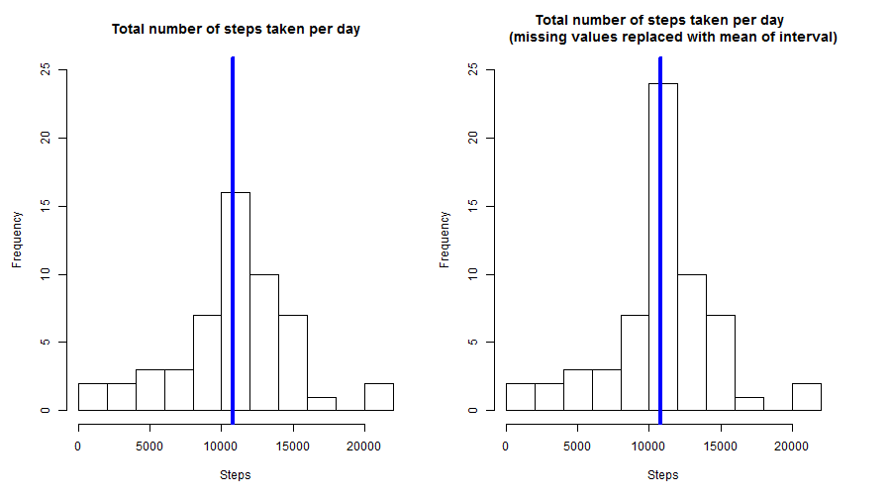
We now calculate the median and the mean of the filled in dataset
mean(perday_new)
## [1] 10766
median(perday_new)
## [1] 10766
The impact of inputting missing data is minimal, as only the median seems to be changing but by just over one step.
mean(perday_new)-mean(perday)
## [1] 0
median(perday_new)-median(perday)
## [1] 1.189

Are there differences in activity patterns between weekdays and weekends?
In this part of the assignment, the next step is to create factor variable in the dataset with two levels – “weekday” and “weekend” indicating whether a given date is a weekday or weekend day.
act_new$wd<-weekdays(act_new$date)
act_new$fwd<- as.factor(c("weekend", "weekday"))
act_new[act_new$wd == "Sunday" | act_new$wd == "Saturday" ,5]<- factor("weekend")
act_new[!(act_new$wd == "Sunday" | act_new$wd == "Saturday"),5 ]<- factor("weekday")
Now the next step is to create two aggregated arrays for the total number of steps taken per 5-minyute time interval for weekdays and weekends, and make a graph in order to compare it there is a difference.
Note that the plot has been created in the base system.
act_new_we <- subset(act_new, fwd == "weekend")
act_new_wd <- subset(act_new, fwd == "weekday")
dailyact_we<-tapply(act_new_we$steps, act_new_we$interval, mean)
dailyact_wd<-tapply(act_new_wd$steps, act_new_wd$interval, mean)
par(mfrow=c(2,1))
plot(y = dailyact_wd, x = names(dailyact_wd), type = "l", xlab = "5-Minute Interval",
main = "Daily Activity Pattern on Weekdays", ylab = "Average number of steps",
ylim =c(0, 250))
plot(y = dailyact_we, x = names(dailyact_we), type = "l", xlab = "5-Minute Interval",
main = "Daily Activity Pattern on Weekends", ylab = "Average number of steps",
ylim =c(0, 250))
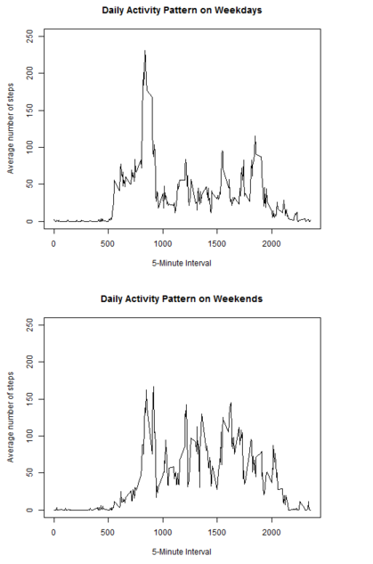
We can determine that the distribution throughout the day is quite different. The individual from whom the measurements were taken, seems to wake up at least one hour later at the weekends. There is a huge amount of steps taken on weekdays, which does not appear on Saturdays or Sundays. It is true that on average more steps are taken during a weekend day, than on a work day. So, this individual is currently employed (or a volunteer), he/she does not take the car to and from work.

