**(Matt Layman)**

**Data location:**

**Under Raster folder: Blacksburg_sub.img, elev**

**Under Shapefile folder: VTCampusTrees.shp, randompoints.shp**

**Question 1: adding a shapefile (VTCampusTrees.shp) and a raster file (Blacksburg.img) to ArcGIS (5 points)**

Generate a nice map showing campus tree data points using aerial photo as background. Your map should be made using good cartographic style and exported to JPEG’s and pasted in this document.

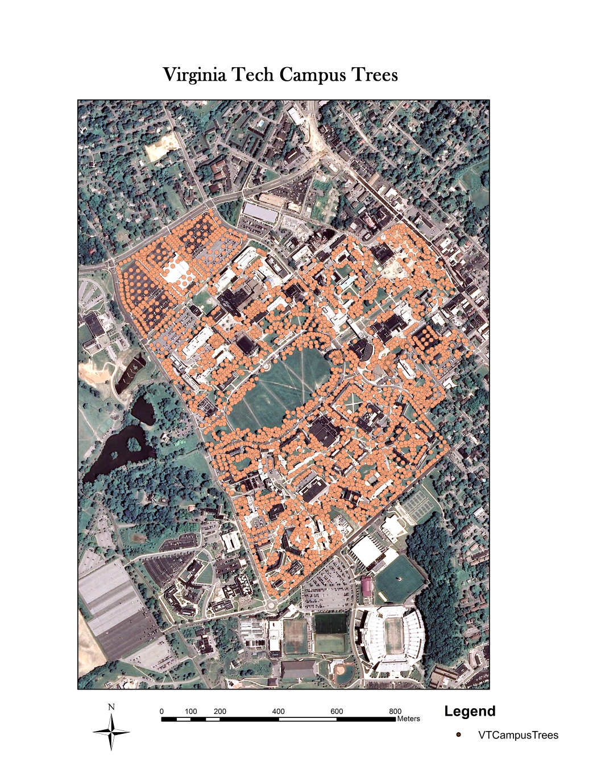

**Question 2: Add GPS Data into ArcGIS (5 points)**

You have collected one GPS point at VT’s Drillfield. The GPS reading is in degree/minutes format (N 37o13.66’, W 80o25.30’). Your task is to add this data point to ArcGIS and display the GPS location within ArcGIS environment. Please generate a map showing this GPS point. You need to use an aerial photo (Blacksburg.img) as your background or reference image.

Note that you need to convert the GPS reading from degree/minute format to decimal numbers before you add the point to ArcGIS. Also, please select Geographic coordinate system WGS 1984 as the coordinate system for the GPS data point.

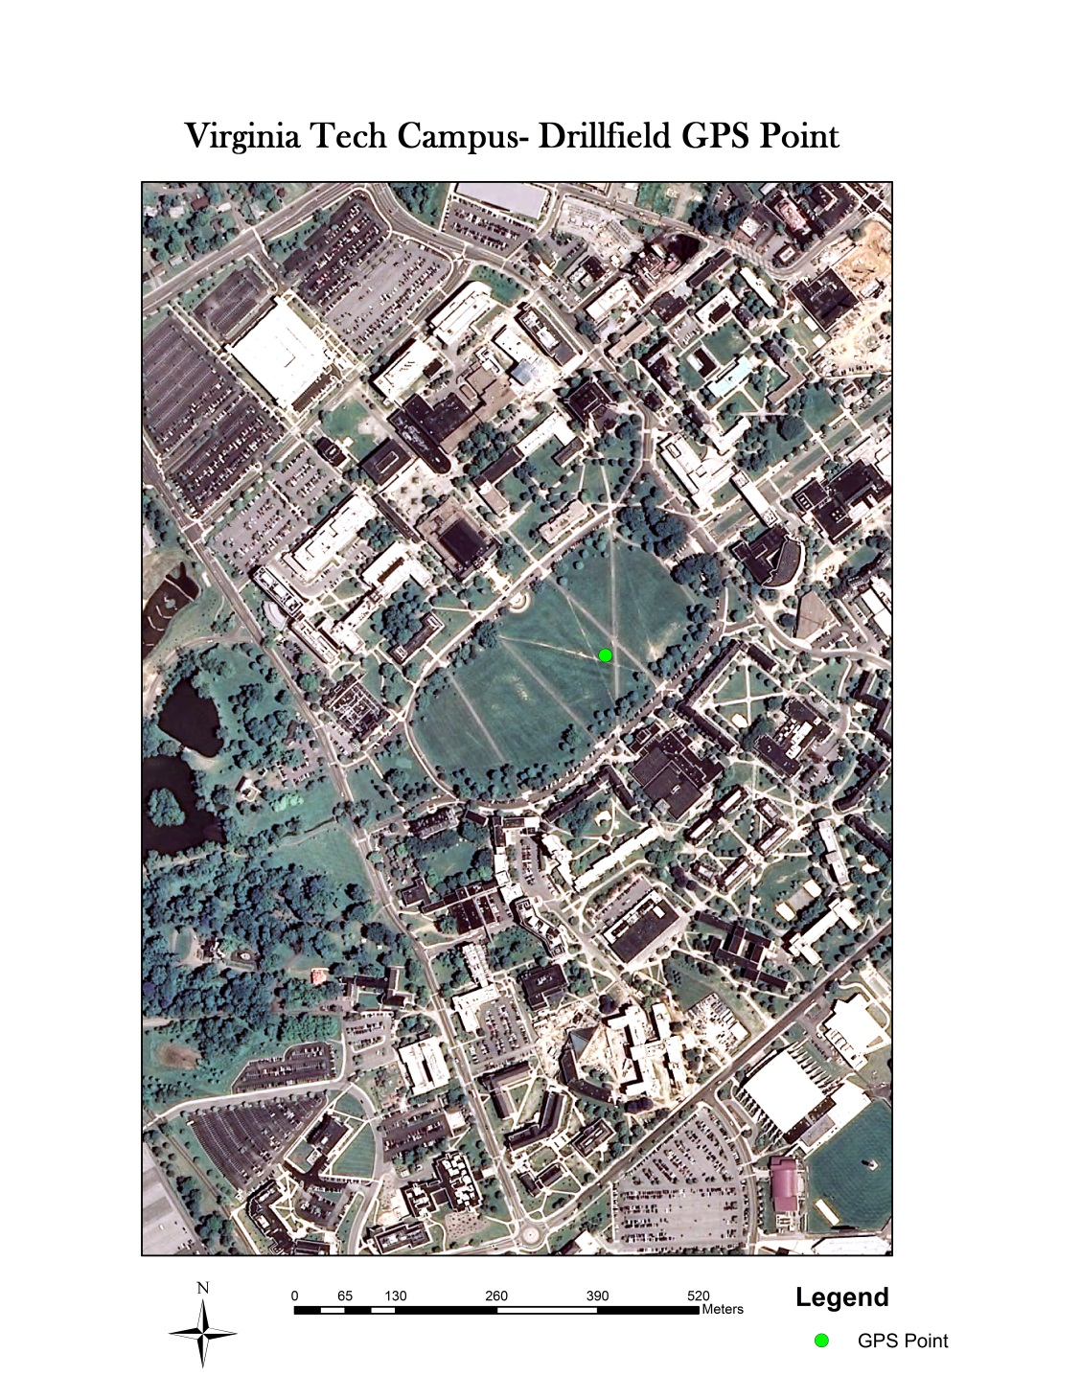

**Question 3: Spatial buffer and point in polygon analysis (5 points)**

I have generated 5 random points/locations (randompoints.shp) for VT campus. Please create 200 m buffer for those 5 random points. Please calculate the total number of red maple trees that are located within the five 200m buffer zones (3 points). The VT campus tree database is located under shapefile folder.

Total of Red Maples within the 5 200m buffer zones: 158

You also need to report the total number of red maple tree individually for each of the five buffer zones (2 point)

|  |  |  |  |  |  |
| --- | --- | --- | --- | --- | --- |
|  | Buffer 0 | Buffer 1 | Buffer 2 | Buffer 3 | Buffer 4 |
| # of red maple trees | 43 | 64 | 24 | 12 | 15 |

Note: If any red maple trees happen to fall within two or more buffers, please include the tree(s) within the total count for each buffer it occupies.

**Question 4: Map overlay (5 points)**

Using digital elevation data (*elev* in raster folder), please derive slope and aspect layer. You are also asked to locate areas where all of the following criteria are satisfied:

Slope > 40 degree

Aspect = Southwest facing

Elevation > 2000m

**Note**: If you added the random points and campus trees layers to the map before elev, then your *elev* layer may look poorly aligned. This is because the datasets are in different coordinate systems. In order to fix this, you’ll want to click “file” then “new.” Once you create this new map document, add the *elev* layer first.

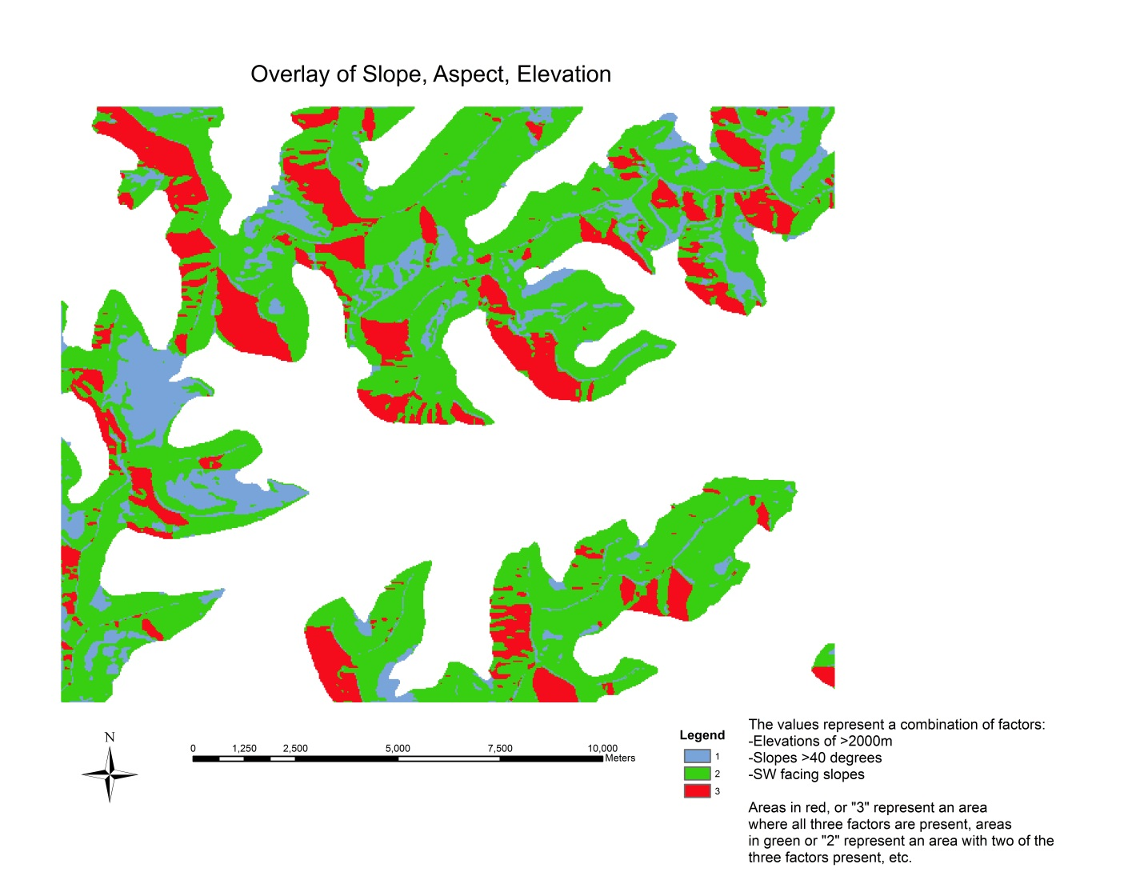

**Deliverables**

Insert your name at the top of this document. For question 3, fill in your answers above. For questions 1, 2, and 4, insert your JPEG map into this document. Please save the document with your full first and last name. To submit, log onto scholar, and upload just your word file to the drop box on scholar.