Machine Learning:

Basically of 3 types: Supervised, Unsupervised & Reinforcement
- Supervised:
Supervised learning algorithms try to model relationships and dependencies between the target prediction output and the input features such that we can predict the output values for new data based on those relationships which it learned from the previous data sets.
The main types of supervised learning problems include regression and classification problems.

- Unsupervised:
These are the family of machine learning algorithms which are mainly used in pattern detection and descriptive modelling. However, there are no output categories or labels here based on which the algorithm can try to model relationships. These algorithms try to use techniques on the input data to mine for rules, detect patterns, and summarize and group the data points which help in deriving meaningful insights and describe the data better to the users.

The main types of unsupervised learning algorithms include Clustering algorithms and Association rule learning algorithms.

- Reinforcement:
Branch of Artificial Intelligence. It allows machines and software agents to automatically determine the ideal behavior within a specific context, in order to maximize its performance. Simple reward feedback is required for the agent to learn its behavior; this is known as the reinforcement signal.
Reinforcement learning algorithm (called the agent) continuously learns from the environment in an iterative fashion. In the process, the agent learns from its experiences of the environment until it explores the full range of possible states.

LINEAR REGRESSION:
- Straight Line that attempts to predict the relationship between two data points.
- Simple LR is a method used to fit a best fit line between a set of data points.
- Regression would involve 2 variables, ie . dependent (target) & independent variables.
- Finding a BEST FIT LINE, a goal of LR and to minimize the SSE (Sum of Sqrs of Error)

Key Points in LR:
- Input, Independent (X): The data points/columns with which the target is predicted.
- Output, Dependent (Y): Variable which needs to be predicted and it is influenced with other data points.

- SST (Sum Of Squared Total) = SSR (Sum Of Squared Regression) + SSE (Sum of
Squares of Error).

- SSE (Sum of Squares of Error) : In order to achieve a better fit line , SSE should be minimal.
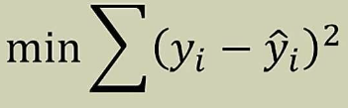
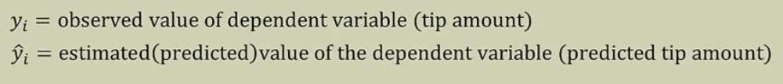

- Equation of straight line:
Y = mX + b (m -> slope ; b -> intercept) .
- Gradient Descent: First-order iterative optimization algorithm for finding the
minimum of a cost function.

This is done by taking the partial derivatives of m & b to a cost function. Derivative of Zero means either it is local maxima or minima.
Closer it goes to Zero, it is better.

Partial Differentiation: Is a method to differentiate function with resp to one independent var while treating another variable as constant.

With learning rate and distance to move, the new values are found for m and b , in order to find minimal cost/loss function.

- MSE: Mean Square Error

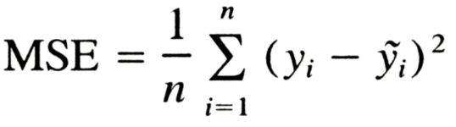

Where y is actual value and y~ is predicted value.

- Coefficient of Determination: R²
The coefficient of determination is the portion of the total variation in the dependent variable that is explained by variation in the independent variable.

R²tells how well the data fit the regression model (the goodness of fit).

R² = SSR/SST where 0 <= R2 <= 1
When R² = 0 --> No linear relationship between x & y
R² = 1 --> There is a perfect linear relationship
The sum of squares due to regression (SSR) measures how well the regression model represents the data that were used for modelling. The total sum of squares (SST) measures the variation in the observed data (data used in regression modelling).
- Metrics:

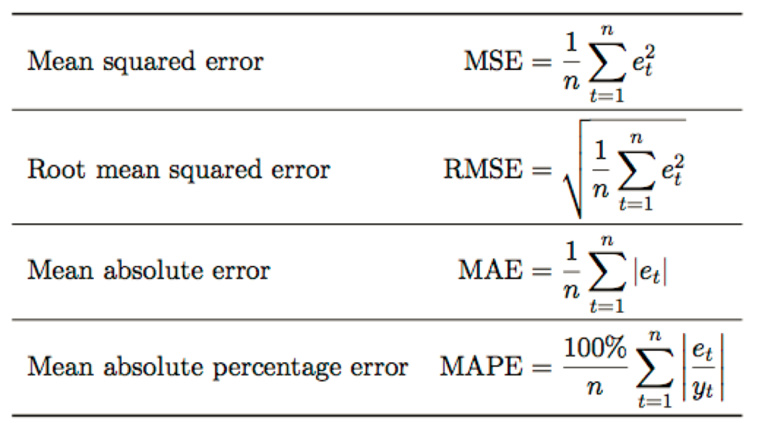

Where 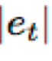 is the difference between the actual value and predicted value.

RMSE rep the sample std dev observed and predicted (called residuals).
MAE is average of absolute difference between observed Vs predicted values. MAE is a linear score which means that all the individual diff is weighted equally in the avg.

One important distinction between MAE & RMSE, is that minimizing the squared error over a set of numbers results in finding its mean and minimizing the absolute error results in finding its median. This is the reason why MAE is robust to outliers whereas RMSE is not.

RMSE inputs, there is a direct relationship with the correlation coefficient. For example, if the correlation coefficient is 1, the RMSE will be 0, because all of the points lie on the regression line (and therefore there are no errors).
RMSE is a measure of how spread out these residuals are. In other words, it tells you how concentrated the data is around the line of best fit.
MAE is proportional to total amount error , so model will not be penalised .
On Presence of Outliers, MSE have impact more and model is penalised more.

RMSE When model requires more acc and model penalised for ouliers
MAE Model will not be penalised for outliers.

Logistic Regression:
- Transforming Linear to Logistic:
- Let consider an input (-∞ to + ∞)
- Apply Exponential to i/p , it will convert input (0 to + ∞).
- Divide the number by number +1 , it will become (0,1) , ie. p/p+1

Deep Learning: Neural Networks using Tensor Workflow
“Deep Learning” systems are one type of representation systems where in which features are selected by the Algorithm.

In Traditional Based ML systems, experts decide what features needs to pay more attention. Feature selection done by experts.

In Representation systems, the system figures out by themselves which features to pay more attention.

- Tensor: Matrix of matrices.
- Deep Learning: Algo which learns what features matter or important.
- Neural Networks (NN): Most common class used in deep learning.
- Neural Networks are made of building blocks called NEURONS.
  - NEURONS: it is made of linear function and activation function.

Building Blocks of NN:
- Visible Layers: First and last layer of the NN are visible. There can be one first and one last layer.
    - While specifying the 1st layer, it must have the number of columns/labels.
    - While specifying the last layer, it must contain neuron and output labels. Incase of regression it must have one neuron and it case of classification it must have be the number of output labels.

- Hidden Layers: Intermediate Layers between 1st and last layers are hidden layers and there can be n numbers of hidden layers.
Each layer consists of individual interconnected neurons.
- Neurons: Build block of NN. Output of one neuron will be feed into another neuron of another layer.
- Weights: Each connection between a neuron is associated with a weight.
Each Neurons will be connected to multiple neurons of next layer and each connection will have their own weights.
- Bias : Any threshold value added to neurons.
- Activation Function: Used to convert linear function to non-linear function
- Affine Transformation: Can only learn linear relationships between inputs and outputs.
Combination of AF and AT can learn any arbitrary relationship.
Weights and bias of neurons are determined by training process.
Activation function set to identity function doesn’t do any non-linearity also called as linear neuron.

