

**Functional Specification Document (FSD)**

*Functional Specifications*

|  |  |  |
| --- | --- | --- |
| Project ID | 18002831 |  |
| Project Name | FCC Data Strategy |  |
| Document Confidentiality | Internal and Confidential |  |
| Document Status | In-progress |  |
| Document Version | V0.8 |  |
| Document Date | 13-Jan-2020 |  |

Template Version: 2016-v1df

**Table of Contents**

1 Document Presentation 5

1.1 Document Purpose 5

1.2 Document Intended Audience 5

2 Project Overview 6

3 Assumptions, Exclusions and Constraints 7

4 Solution Architecture 9

4.1 Architecture Overview 9

4.2 Architecture Specifications of FCC DM Core 9

5 Functional Specifications 11

5.1 Solution Requirements of FCC DM Core 11

**5.1.1** **Sourcing Systems** 12

**5.1.2** **Functional Modules** 12

5.1.2.1 Customer 13

5.1.2.1.1 Limitations of Customer Module Tables 13

5.1.2.2 Account 14

5.1.2.3 Transactions 14

5.1.2.3.1 Limitations of Transaction Tables 15

5.1.2.4 External Entities 15

5.1.2.4.1 Limitations of External Entity Tables 15

5.1.2.5 Events 15

5.1.2.6 Case Management 16

5.1.2.7 Summary 17

6 Report Requirements 19

7 Information Security Specifications 20

7.1 Identity & Access Management (IAM) specifications 20

**7.1.1** Authentication and Single Sign On 20

**7.1.2** Access Request 20

**7.1.3** Access Provisioning 20

**7.1.4** Access Matrix Maintenance (Roles and Entitlements) 20

**7.1.5** System Generated Feed for User List 20

**7.1.6** Security Administration Audit Logging 20

**7.1.7** Self- service password reset facility 21

**7.1.8** Account dormancy 21

7.2 Monitoring and Response Specs 21

7.3 Information Protection (IP) Specifications 21

**7.3.1** Protection of Data at Rest 21

**7.3.2** Protection of Data in Motion 21

**7.3.3** Protection of Data in Use 21

**7.3.4** Malware Protection 22

7.4 Risk and Compliance Specs 22

**7.4.1** Risk Assessment 22

**7.4.2** Code Security Review 22

7.5 Governance, Risk and Control Specifications 22

7.6 Policy & Awareness Specifications 22

8 Decommission Specifications 23

9 Data Quality Specifications 24

9.1 Data Quality Management 24

**9.1.1** Data Dictionary 24

**9.1.2** Data Sourcing and Transformation 24

**9.1.3** Controls and Exception Management 24

**9.1.4** Data Profiling 24

**9.1.5** Data Quality Monitoring and Governance 25

**9.1.6** Reference Data 26

10 Appendices 27

10.1 Reference Material 27

**10.1.1** BRD 27

**10.1.2** Entity Relationship 27

**10.1.3** Mapping sheets 27

10.2 Definitions and Acronyms 27

11 Document History 28

12 Document Reviews 29

13 Document Approvals 30

14 Performance Goals 31

15 Application Overview 32

**Tables**

Table 1‑1 Intended Audience 5

Table 3‑1 Overall Assumptions 7

Table 3‑2 Overall Exclusions 8

Table 3‑3 Overall Constraints 8

Table 5‑1 FCC DM Views- Customer 13

Table 5‑2 FCC DM Views- Account 14

Table 5‑3 FCC DM Views- Transactions 14

Table 5‑4 FCC DM Views- External Entities 15

Table 5‑5 FCC DM Views - Events 16

Table 5‑6 FCC DM Views- Case Management 16

Table 11- Summary of Views & Attributes 17

Table 7‑1 Spec - Protection of Data at Rest 21

Table 7‑2 Spec - Protection of Data in Use 21

Table 10‑1 Definitions and Acronyms 27

Table 11‑1 Document History 28

Table 12‑1 Document Reviews 29

Table 13‑1 Document Approvals 30

Table 15‑1 Existing Functionality 32

Table 15‑2 Intended changes 32

Table 15‑3 New/Changed Interfaces 32

**Figures**

Figure 1 FCC Data Strategy 6

Figure 2 FCC DM Core 10

Figure 3 FCC DM Core- Views 11

# Document Presentation

## Document Purpose

This document defines the functional specifications for **FCC Data Strategy Release 3 (Data Model**). It will be used as the basis for the following activities:

• Creating solution designs

• Developing test plans, test scripts, and test cases

Requirements not included in this document are out of scope for this project. Any change to requirements must be managed through the project’s Change Management process.

## Document Intended Audience

List the key stakeholders, include for each Stakeholder the -position and role in project refer to TOR. Include technology, test team and vendor (if applicable).

This document should be read by

Table 1‑1 Intended Audience

| # | Name | Role / Capacity |
| --- | --- | --- |
| 1 | Samson, Engelbert | Director, FCC Controls Strategy, Group FCC- Controls- Strategy |
| 3 | Naik, Pranav | Head Screening Technology, GSF- CIO, BAU |
| 5 | Sanyal, Mrinal Krishna | Vice President, Legal & Compliance Technology |
| 6 | Natarajan, Hari Haran | Delivery Manager, DQMF and Metadata projects |
| 7 | MosurNarasimhan, Harinee | Data - Senior Business Analyst, Legal & Compliance Technology |
| 8 | Rajaram, Anu Priya | Business Analyst, GBS MY GSF-CDO Data Svcs & Gov |
| 9 | Raman, Gunasekaran | Technical Manager, Legal & Compliance Technology |
| 10 | Joseph, Dean John | Test Manager, Legal & Compliance Technology |
| 11 | Czech, Artur | i3 Data Scientist Manager |
| 12 | Ng 3, Michelle | Director, i3 ASA, FCC Controls ASA |
| 13 | Sekhar Kaza, Kalyani | Spl'st, Ctrl, Process & Gov |
| 14 | Przybysz, Pawel | i3 Data Scientist |
|  |  |  |
|  |  |  |
|  |  |  |
|  |  |  |
|  |  |  |

# Project Overview

The main objective of FCC Data Strategy project is to build a standardized, modelled and consolidated common FCC data model in a cost effective EDMP HaaS platform which will act as the Single Source of Truth data for all FCC consumption teams with self-service capability for their day to day analytical and reporting requirements.

Figure 1 FCC Data Strategy

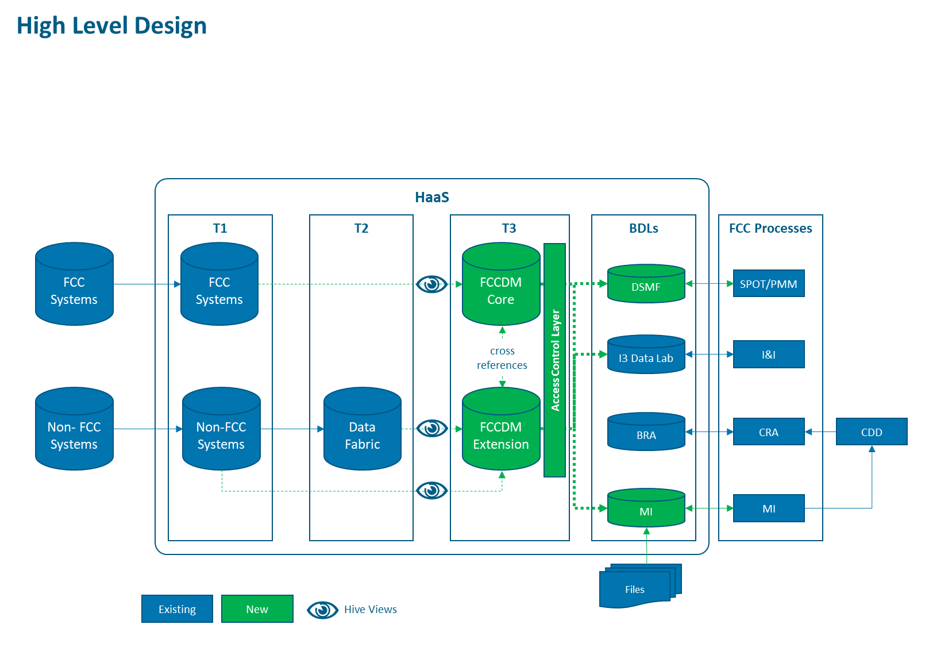

Multiple releases are planned for FCC Data strategy project to build Common FCC Data Model incrementally and deliver benefits to the business.

Release 1 – Re-platform MI (Hadoop to HaaS)

Release 2 - Re-platform DSMF (Oracle to HaaS)

Release 3 – FCC Data Model Core

Release 4 – FCC Data Model Extensions

Release 5 – FCC Data Model Supplementary

**This document is limited to Release 3 - FCC Data Model Core build.**

# Assumptions, Exclusions and Constraints

List the major assumptions and constraints on the specifications

Table 3‑1 Overall Assumptions

|  |  |  |
| --- | --- | --- |
| # | Item | Description |
| OAA-001 | ECM consolidation of Customers. | ECM system will consolidate all Transaction monitored customers of Mantas, Detica5.6, Detica 6.1 and alerted customers of TRDSAM, TRADERI (DTP and OTP) and CCAML (Credit cards). |
| OAA-002 | ECM consolidation of accounts. | ECM system will consolidate all Transaction monitored countries Accounts of Mantas, Detica5.6, Detica 6.1 instances. TRDSAM (DTP and OTP), TRADE RI (DTP and OTP) and CCAML (Credit cards) are not sourced into ECM accounts |
| OAA-004 | ECM -External Entities | ECM will have external entities detail of all Mantas transactions and only alerted transactions external entities of Detica. External entities of TRDSAM, TRADERI and CCAML are not sourced into ECM |
| OAA-005 | Detica to Mantas Migration -Historical Data | Customer & Account data will be sourced as latest snapshot.  Transactions of 13 months historical data will be sourced as monthly chunks with month end Business Dates. |
| OAA-006 | Detica to Mantas Migration Projects -Consumption | Consumption team will consume Mantas data from FCCDM only after the business go-live for the MANTAS country. |
| OAA-007 | ECM -New country migration | ECM consumes Mantas DSO Business data of Customers, Accounts & alerted transactions details from the Business live date onwards. |
| OAA-008 | Parallel execution of Mantas & Detica for US | For US, due to Detica and Mantas parallel execution, FCC Data Model should have both Detica and Mantas Transaction data in the common transaction table. Consumption team needs to filter them based on the system and consume. |
| OAA-009 | Non-FCC Systems | In future, FCCDM to be logically divided into two: FCCDM Core and FCCDM Extension. FCCDM core will contain data from other FCC systems GNS, TSAAS and FCCDM Extension from Non-FCC systems EBBS, HOGAN, DTP, OTP etc. FCCDM Extension will contain data from Non-FCC systems either via EDMP Tier2 Data Fabric or Tier1 Source tables.  In this document, FCCDM core source data from FCC systems- ECM, Mantas & Detica |
| OAA-010 | Referential Integrity | Referential integrity between the tables are maintained in the source tables |

Table 3‑2 Overall Exclusions

|  |  |  |
| --- | --- | --- |
| # | Item | Description |
| OAE-001 | TRDSAM, TRADE RI & CCAML non-alerted transactions. |  |
| OAE-002 | Schemas, Views, Tables and users not mentioned in this document |  |

Table 3‑3 Overall Constraints

|  |  |  |
| --- | --- | --- |
| # | Item | Description |
| OAC-001 | Detica to Mantas Migration Projects | Mantas will start sending Business Data FSDM to EDMP Tier 1 from the Tech Live onwards.  Consumption users should keep note of the Business live dates of Mantas and start consuming after the implementation. |
| OAC-002 | External Entities- Completeness | External entity details of the TM systems Detica 6.1, Detica 5.6 in FCCDM will be limited to availability in the ECM system.  TRDSAM, TRADERI & CCMAML systems don’t send external entities details due to current system functionality limitations. |

# Solution Architecture

## Architecture Overview

The Common FCC Data Model will be built on Common Infrastructure EDMP HaaS infrastructure and exposed to FCC consumption process via BDL’s with self-service capability.

FCC DM Core model will be built in EDMP T3 layer with data sourced from FCC System’s

1. Transaction Monitoring systems (Detica5.6/6.1 and MANTAS),
2. Alert/Case Management (ECM)

## Architecture Specifications of FCC DM Core

The FCC Data Model is logically partitioned as Layer 1 and Layer 2.

**Layer 1:**

Data is sourced from FCC Systems and Non-FCC Systems in EDMp Tier1 and exposed as views in EDMP Tier 3. These views form Layer 1, which are already created as part of Rel1 (FCC MI) & Rel2 (DSMF). Refer the [link](http://teamsites.sc.com/sites/PDR1/18002831/_layouts/15/WopiFrame.aspx?sourcedoc=/sites/PDR1/18002831/Shared%20Documents/18002831%20-%20FCC%20Data%20Strategy/04%20-%20Architecture%20and%20Design/Release%203/FCC%20DM-%20Layer1%20views-%20list.xlsx&action=default) for the list of FCC DM- Layer1 views

**Layer 2**:

Layer 2 expands on the views in Layer 1 and consolidates and standardizes the data into logical instances into FCC Data Core and FCC Data Extension.

FCC Data Core will be built on views from FCC Systems

Further down BDL’s will be created based on usage by different downstream systems like MI, I3, Link Analysis and others. The detailed diagram as below

Figure 2 FCC DM Core

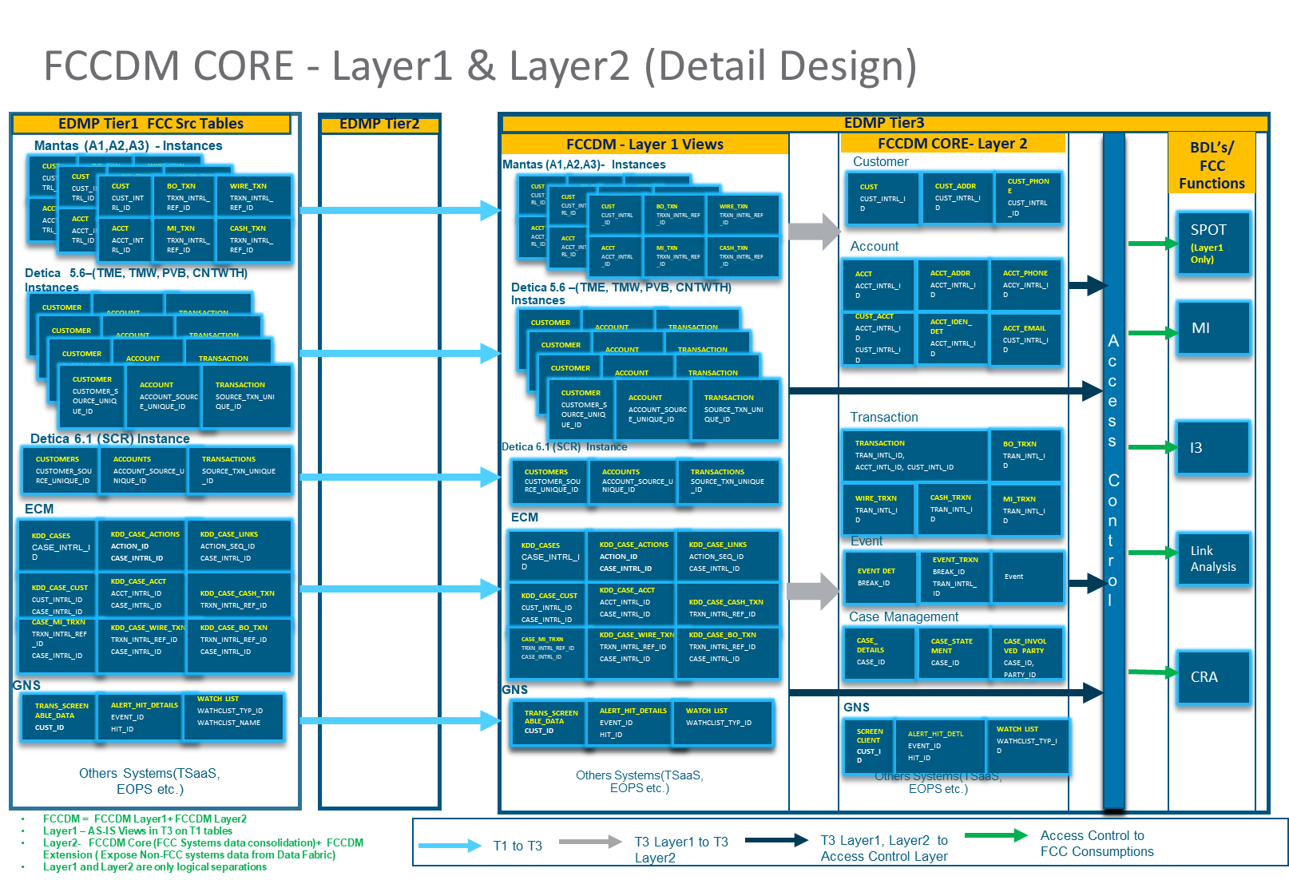

FCCDM core entities will be defined as Master, Transaction, Historical & Reference data to cater various needs of the consumers.

**Master Views** - Master entities will have only current state data about the key business entities. Attributes of these entities are seldom changed and commonly used by the consumption teams. For e.g.: Customer, Account Product etc

**History Views** – Historical entities will have current state data and historical changes of the business entities. For e.g.: Customer Address, Customer Phone changes etc

**Transaction Views -**Transaction entities will have activities performed by the master entities. The entities will have foreign key relationship with the master entities. For e.g.: Consolidated Transactions, Mantas -Wire transaction, Cash transactions, Detica Transactions etc.

**Reference tables** – Reference entities will have enumerated data for certain fields. For e.g.: Business segments, customer types, Customer status etc.

Master Views and Transaction Views is not same as EDM T1 Master & Transaction tables.

FCCDM views to be created with provision to have multiple levels of granularity like country, segment & table etc for granting access on need basis to Consumption BDL’s like MI, SPOT & I3 etc. All FCC processes like MI, SPOT, I3 will access FCCDM data via BDL’s and will have provision to store data for processing.

# Functional Specifications

This FSD primarily focuses on elements for building the FCC Core Model.

## Solution Requirements of FCC DM Core

FCC Core Model will involve a 2-step process

1. All data will be sourced from downstream systems mentioned in below section. All the data is already being sourced into EDMP Tier 1.
2. One-to-one direct Views of the T1 tables will be created in FCC DM - Layer1 over the EDMp T1 tables. Whereas, all the direct views required for this Release are already created as part of before Releases 1 & 2 of FCC Data Strategy.
3. FCC DM Views will be created in FCC DM – Layer2 over the Direct views.
4. Read Access by country wise to the FCC DM views will be available to Users based on user access profiles in BDL.
5. There is already Read+Write area used by I3 team, where schemas access will be restricted based on user profile. The same schema will be used by Business.
6. I3 Users can extract data through FCC DM Views, to Read+Write schema for their analysis.

Figure 3 FCC DM Core- Views

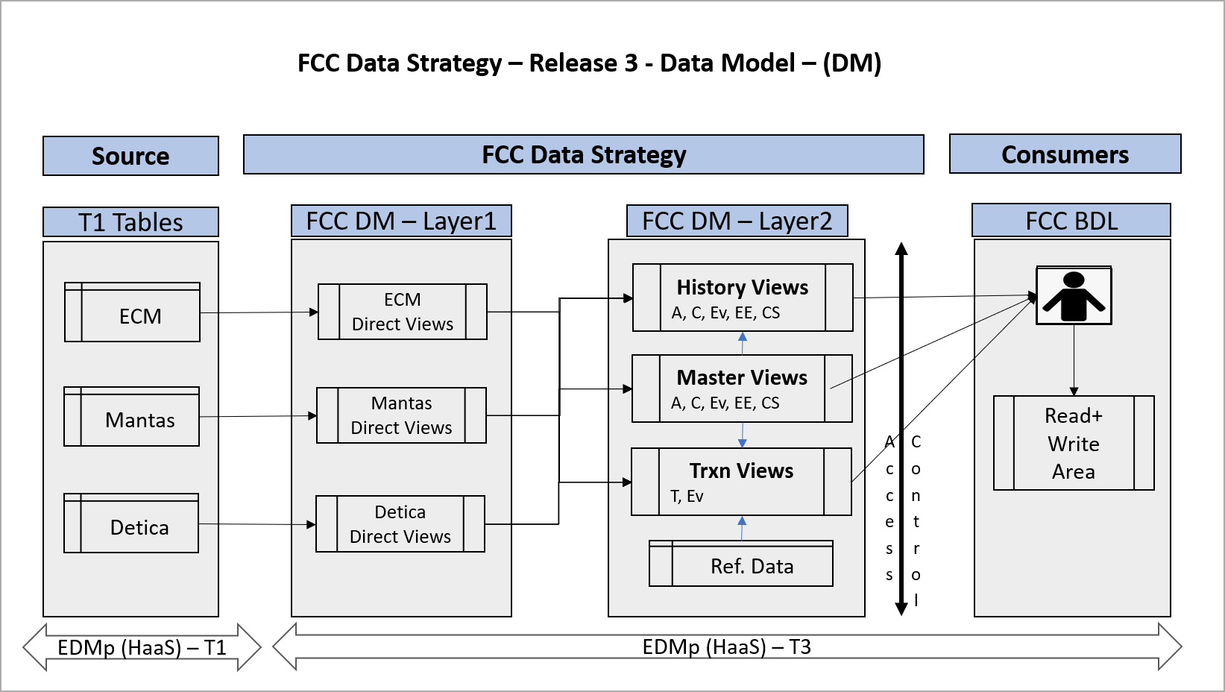

A-Account Module, C- Customer Module, Ev- Events Module, EE- External entity module, CS- Case Management Module

### **Sourcing Systems**

Sourcing system’s country list for Transaction Monitoring and Case Management (as of FSD written date),

**Detica:**

|  |  |  |
| --- | --- | --- |
| **VERSION** | **REGION/Instance** | **COUNTRY** |
| 5.6 | TME | India, Pakistan, Indonesia, Philippines |
| 5.6 | TMW | UAE, UK |
| 5.6 | PvB | Jersey, Switzerland, Hong Kong, UK, US |
| 5.6 | CNTHTW | China, Thailand, Taiwan |
| 6.1 | SCR | Oman, Bangladesh, Lebanon, Bahrain, Qatar, Jordan, Vietnam, Sri Lanka, Nepal, Mauritius, Ghana, Uganda, Tanzania, Botswana, Gambia, Zambia, Cote D'Ivoire, Brunei, Sierra Leone, Cameroon, South Africa, Zimbabwe, Macau, Labuan, Angola, Australia, Iraq, Falkland |

**Mantas:**

|  |  |
| --- | --- |
| **Instance** | **COUNTRY** |
| AS1 | Singapore, Bahrain, Kenya, United Arab Emirates, Jersey |
| AS2 | Nigeria, Germany, Hong Kong, Sri Lanka, United Kingdom |
| AS3 | Japan, US, Malaysia |

**ECM:**

|  |  |
| --- | --- |
| **Instance** | **COUNTRY** |
| All | All Countries |

### **Functional Modules**

FCCDM Core for Transaction Monitoring broadly classified into following functional modules. Horizontally & Vertically expandable entities to be created and grouped based on functional subject areas.

* Customer
* Account
* Transactions
* External Entities
* Events
* Case Management

#### Customer

Customer functional area will consolidate all customers from all Transaction Monitoring systems and build entities or views of sub functional areas like Customer Static Information, Customer Risk attributes, Customer Contact information like Address, Phone, Email address etc.

Table 5‑1 FCC DM Views- Customer

|  |  |  |  |
| --- | --- | --- | --- |
| **FCC DM Views** | **Source** | **FCC DM- Layer2 Master Views** | **FCC DM- Layer2 History Views** |
| Customer | ECM | v_fcc_m_cust | v_fcc_cust |
| Customer Address | ECM | NA | v_fcc_custaddr |
| Customer Phone | ECM | NA | v_fcc_custphon |
| Customer Email Address | ECM | NA | v_fcc_custemailaddr |
| Customer Supplemental Attribute | ECM | v_fcc_m_custsupplementalattr | v_fcc_custsupplementalattr |
| Customer to Customer | ECM | v_fcc_m_custcust | v_fcc_custcust |
| Customer Identification Document | Mantas | NA | v_fcc_custiddoc |

Following attached Customer Module Mapping document contains details of all the entities and their mapping with respective to the ECM systems. Alerted CCAML and TRDSAM customers details will be available in the ECM customer table.

Refer the below excel for the mapping details.



##### Limitations of Customer Module Tables

* TRDSAM and CCAML customers data is limited to alerted customers sourced to the ECM system.
* Non-alerted customers from the Non -strategic systems like CCAML TRDSAM etc will be gap and may not be able to link with events tables.

#### Account

Account functional area will consolidate the Accounts information from all systems mentioned and build entities or views of sub functional areas like Account Static Information, Account Risk attributes, Account Contact information like Address, Phone, Email address etc. These tables or views should be built with account data from the Transaction Monitoring systems Mantas, Detica only.

Table 5‑2 FCC DM Views- Account

|  |  |  |  |
| --- | --- | --- | --- |
| **Logical Table** | **Source System** | **FCC DM- Layer2 Master Views** | **FCC DM- Layer2 History Views** |
| Account | ECM | v_fcc_m_acct | v_fcc_acct |
| Account Address | ECM | NA | v_fcc_acctaddr |
| Account Phone | ECM | NA | v_fcc_acctphon |
| Account To Customer | ECM | v_fcc_m_custacct | v_fcc_custacct |
| Account Email Address | Mantas | NA | v_fcc_acctemailaddr |

Following Account Module Mapping document contains details of all the entities and their mapping with respective to the ECM system



#### Transactions

Transaction functional area consolidates the transaction from all Transaction Monitoring systems mentioned and build views for same.

A consolidated Common Transaction will link to views containing transactions like Back Office Transactions, Wire transactions, Monetary Instrument transaction and Cash transactions

Table 5‑3 FCC DM Views- Transactions

|  |  |  |
| --- | --- | --- |
| **FCC DM View Names** | **Source System** | **FCC DM - Layer2  Transaction Views** |
| Back Office Transaction | Mantas | v_fcc_backofficetrxn |
| Cash Transaction | Mantas | v_fcc_cashtrxn |
| Monetary Instrument Transactions | Mantas | v_fcc_mitrxn |
| Wire Transactions | Mantas | v_fcc_wiretrxn |
| Detica 5.6 Transcations | Detica | v_fcc_detica5trxn |
| Detica 6.1 Transcations | Detica | v_fcc_detica6trxn |
| Common Transactions | Mantas & Detica | v_fcc_transactions |

Following Transaction Module Mapping document contains details of all the entities and their mapping with respective to the Mantas & Detica system.



##### Limitations of Transaction Tables

* Alerted transactions are the unusual or suspicious transactions of the customers which are identified by the various Behaviour detection scenarios in the Transaction monitoring process.
* Only Alerted transactions of the Trade port systems TRADESAM, TRADE RI and Credit cards will be available in the transaction module.
* Transactions from Credit Cards and Trade Port systems (TRADESAM, TRADE-RI) are already received at ECM and will get included.

#### External Entities

External Entities are the external counter parties or derived entities found in the Front office transactions from Transaction Monitoring systems Detica 5.6/6.1 and Mantas. These external entities contain details of Entity name, address and their linkage to transactions.

Table 5‑4 FCC DM Views- External Entities

|  |  |  |  |
| --- | --- | --- | --- |
| **FCC DM View Names** | **Source System** | **FCC DM - Layer2  Master Views** | **FCC DM - Layer2  History Views** |
| Derived Entity Address | ECM | v_fcc_m_derivedaddress | v_fcc_derivedaddress |
| External Entity | ECM | v_fcc_m_externalentity | v_fcc_externalentity |
| External Entity to Derived Address | ECM | v_fcc_m_externalentityaddr | v_fcc_externalentityaddr |
| Derived Entity Link | ECM | v_fcc_m_externalentitylink | v_fcc_externalentitylink |

Following External Entity module mapping document contains details of the entities and their mappings with ECM systems.



##### Limitations of External Entity Tables

* Detica 6.1 does not store any details of external entities.
* Detica 5.6 does not store any details of external entities.
* Trade port systems TRADESAM, TRADE-RI and Credit Card external entity details are not sourced into the model due to current functional limitations.

#### Events

Events functional area covers the alerts triggered in the Transaction monitoring systems Detica, Mantas, Credit cards (CCAML), Trade port systems (TRDSAM & TRADE -RI) and sourced to ECM. The entities which will be built in this module are Event details, Event transactions by leveraging the alerts and their details in the ECM system.

Table 5‑5 FCC DM Views - Events

|  |  |  |  |  |
| --- | --- | --- | --- | --- |
| **Logical Table** | **Source System** | **FCC DM – Layer2**  **Transaction Views** | **FCC DM - Layer2  Master Views** | **FCC DM - Layer2  History Views** |
| Back Office Transaction Archival | ECM | v_fcc_backofficetrxnarc | NA | NA |
| Cash Transaction Archival | ECM | v_fcc_cashtrxnarc | NA | NA |
| Monetary Instrument Transaction Archival | ECM | v_fcc_mitrxnarc | NA | NA |
| Wire Transaction Archival | ECM | v_fcc_wiretrxnarc | NA | NA |
| Event Detail | ECM | NA | v_fcc_m_casedetail | v_fcc_casedetail |
| Event Case Link | ECM | NA | NA | v_fcc_eventcaselink |
| Event Transaction | ECM | v_fcc_eventtrxn | NA | NA |

Following Event module mapping Document contains details of the entities and their mappings from ECM.



#### Case Management

Case management functional area covers the cases created in the ECM for the Transaction Monitoring systems Detica, Mantas, TRADESAM, TRADERI & CCAML. The entities which will be built in this module are Case details, Case Involved parties, Case Customers, Case accounts, Case external entities etc.

Table 5‑6 FCC DM Views- Case Management

|  |  |  |  |
| --- | --- | --- | --- |
| **Logical Table** | **Source System** | **FCC DM - Layer2  Master Views** | **FCC DM - Layer2  History Views** |
| Case Detail | ECM | v_fcc_m_casedetails | v_fcc_casedetails |
| Case Customers | ECM | v_fcc_m_casecustomers | v_fcc_casecustomers |
| Case Accounts | ECM | v_fcc_m_caseaccounts | v_fcc_caseaccounts |
| Case External Entity | ECM | v_fcc_m_caseexternalentity | v_fcc_caseexternalentity |
| Case Derived Entity to Derived Address | ECM | v_fcc_m_caseextrnlntityaddr | v_fcc_caseextrnlntityaddr |
| Case Derived Address | ECM | v_fcc_m_casederivedaddress | v_fcc_casederivedaddress |
| Case Involved Parties Details | ECM | v_fcc_m_caseinvolvedpartydetail | v_fcc_caseinvolvedpartydetail |
| Case Institution Master | ECM | v_fcc_m_caseinstnmaster | v_fcc_caseinstnmaster |

Following Case Management module mapping Document contains details of the entities and their mappings from ECM.



#### Summary

Summary of Views & attributes of all the modules,

Table 11- Summary of Views & Attributes



Note: count of View count provides unique count of views. Due to this, View count (36) will not match with Count of Master (22) +History (25) +Transaction (9).

Attributes Classification,

**Direct:** Same attribute name available in the Source View.

**Derived:** These attributes are derived using some logic from other attributes

**Driving:** Some attributes are part of the Security Matrix, which manages data exposure to Consumers.

E.g. FCC_SRC_CNTRY_CD, FCC_BUS_DMN_LST_TX- Based on these field’s data will be exposed to Users. FCC_SRC_SYS_CD, FCC_SRC_TBL_NM – determines source system and source table name.

# Report Requirements

NA

# Information Security Specifications

## Identity & Access Management (IAM) specifications

### Authentication and Single Sign On

Users will use Peoplesoft (LDAPS) user-id and password to login.

### Access Request

Refer attached guide for the creation process [click for User on-boarding document](http://teamsites.sc.com/sites/PDR1/18002831/Shared%20Documents/Forms/AllItems.aspx?RootFolder=%2Fsites%2FPDR1%2F18002831%2FShared%20Documents%2F18002831%20%2D%20FCC%20Data%20Strategy%2F04%20%2D%20Architecture%20and%20Design%2FRelease%203%2FFSD%20References&FolderCTID=0x012000AD4168600253C6479F588D2C9A084B21&View=%7B15249EEF%2DBA55%2D4939%2D8ABC%2D8180510E3FBF%7D)

### Access Provisioning

Refer the document in Section 7.1.2

### Access Matrix Maintenance (Roles and Entitlements)

The access role matrix will be provided and maintained by FCC DataModel team. The user access in HaaS will be same as mentioned in Section 7.1.2

User Groups for FCC DataModel are,

1. ASA Group
2. WAW Group
3. AME Group
4. GCNA Group
5. LND Group
6. BIZ Owner Group

Refer the attached excel- for applicable access,



### System Generated Feed for User List

There is a user entitlement access report which is generated for all applications in the Hadoop environment and can be requested to GBS FSTS CH BAU EDM team by email mentioning the AD Group.

### Security Administration Audit Logging

OneCert and Splunk are not available at present.

### Self- service password reset facility

Access is via Peoplesoft login and password hence password can be reset using the RPT Self-Service facility

### Account dormancy

Application will not handle Account dormancy.

## Monitoring and Response Specs

Out of scope for this FSD.

## Information Protection (IP) Specifications

The specifications as mentioned in BRD Section 8 will be applied based on availability and applicability to the application and consensus from the Group Security team.

### Protection of Data at Rest

*The system must fulfill the following requirements for protection of data at rest.*

Table 7‑1 Spec - Protection of Data at Rest

| BRD Ref | FSD Ref | Specification |
| --- | --- | --- |
| BSR-1002 | FSS-1002 | Determine how the encryption will be used to secure login credentials, including transmit to/from the network device  The login will be done securely with encryption and obfuscation through OVD. |
| BSR-1006 | FSS-1006 | Determine how encryption will be used for File Transfer across or external networks using PGP or equivalent, with appropriate key exchange procedures.  Data exchange between T1 layer and source systems is as below:   |  |  | | --- | --- | | MANTAS/ECM | SFTP | | Detica 5.6/6.1 | CDC Replication | |

### Protection of Data in Motion

NA

### Protection of Data in Use

*The system must fulfill the following requirements for protection of data in use.*

Table 7‑2 Spec - Protection of Data in Use

| BRD Ref | FSD Ref | Specification |
| --- | --- | --- |
| BSR-1201 | FSS-1201 | Determine how sensitive data elements will be protected using access restrictions and encryption (where applicable) to prevent unauthorized access. Access to such data must be actively monitored  Country level and employee level access is restricted by Hadoop Ranger Policy, such that FCC DM- Layer2 access would be secure |
| BSR-1202 | FSS-1202 | Determine how sensitive or confidential data will be protected using secure communication channel for transmission across systems. Legal and regulatory requirements around handling of sensitive information such as PII/NPI/Private data as applicable for the geographies/regions should also be considered.  PII is not applicable as only views are accessible and should be handled by biz in the BDL layer  [**http://teamsites.sc.com/sites/PDR1/18002831/Shared%20Documents/18002831%20-%20FCC%20Data%20Strategy/02%20-%20Requirement%20Gathering/Release%202/RE_%20BDQ-EDC%20not%20showing%20in%20drop%20down_.msg**](http://teamsites.sc.com/sites/PDR1/18002831/Shared%20Documents/18002831%20-%20FCC%20Data%20Strategy/02%20-%20Requirement%20Gathering/Release%202/RE_%20BDQ-EDC%20not%20showing%20in%20drop%20down_.msg) |

### Malware Protection

NA

## Risk and Compliance Specs

### Risk Assessment

There will no addition of new servers and HAAS setup has been SAT certified and [CRISP](https://scsg.service-now.com) ASR will be done for the Release

### Code Security Review

As part of SIA-4880, code security review would be performed by [Codesecurityservice@sc.com](mailto:Codesecurityservice@sc.com).

## Governance, Risk and Control Specifications

SIA 4880, initiated

## Policy & Awareness Specifications

SIA 4880, initiated

# Decommission Specifications

NA

# Data Quality Specifications

## Data Quality Management

Separate DQ BRD/FSD created as for FCC Data Model (Release 3 and Release 4).

### Data Dictionary

Attributes for the FCCDM core model,



### Data Sourcing and Transformation

There is no new sourcing of tables into EDM Tier1. Available EDM T1 tables are accessed from FCC Data Model Layer1 Views. Already I3 Users have Read and Write Schema in BDL, to read data from the FCC Data Model Layer2 Views and create further objects for analytics.

Data will be transformed, based on the mapping sheets attached in section 5.1.2.1 & 5.1.2.2

### Controls and Exception Management

Recon Controls between source and EDM T1 tables are available,

|  |  |  |
| --- | --- | --- |
| **Source System** | **Recon table name in BIF** | **Recon table name in SDM** |
| ECM/Mantas | ecmprd_auto_recon from Day 0 till 2018-03-09  ecmprd_auto_new_recon 2018-03-10 -tillDate | ecm_all_integrated_recon  ecm_a1_integrated_recon  ecm_a2_integrated_recon  ecm_a3_integrated_recon |
| Detica | dtctsprd_recon | dtcts_sr_integrated_recon |

### Data Profiling

Data Profiling is an ongoing activity at EDM T1, being done by BDQ team and reports can be obtained by making a request from the link below

<http://teamsites.sc.com/sites/TSD_PSS/CoreServices/projects/sa/sar/_layouts/15/start.aspx#/Lists/Access%20Request/AllItems.aspx>

The current set of reports can be accessed from this link

<http://teamsites.sc.com/sites/PDR1/18002831/Shared%20Documents/18002831%20-%20FCC%20Data%20Strategy/02%20-%20Requirement%20Gathering/Release%202/DataProfiling/Report.zip>

### Data Quality Monitoring and Governance

The data is operationally assured from EDM T1 Operations team.

Based on the EDMp controls applicable to EDM T3, below controls are applicable to FCC DM Core,

|  |  |  |  |  |  |
| --- | --- | --- | --- | --- | --- |
| # | **EDMp Controls for FCCDM CORE** | **Applicable** | **Guidance - Conditions** | **Ownership** | **Comments** |
|  | Separate T3 ITAM | Yes |  |  |  |
| B | Daily operational assurance (and associated exception management) of T1/T2 to T3 feed –no loss of records/ files | Conditional based on solution | Not applicable: if technical design will not drop any single record 100% of the time; | FCCFM Core | ~Layer 1 Views - Recon not applicable due to one on one nature of Technical design and also there will not be any records drop. |
| Applicable: if there is a data movement from T1/T2 to T3 or joins and filter conditions are used | ~Layer 2 Views -To list down the patterns of Joins and Filter conditions and come up with appropriate Recon controls. ~ Additional Space required for the Recon space in T3 layer. |
| C | Daily operational assurance (and associated exception management) of T1/T2 to T3 feed – timeliness | Yes |  | ~OLA - T3 views OLA Tag to T1 OLA ~ Latency of Data to be documented.  ~ Model data reflects immediately after T1 Loading |
| E | Periodic comparison of record counts in T3 to those in T1/T2 | Conditional based on solution | Not applicable: if technical design will not drop any single record 100% of the time; | ~ Layer 1 Views Periodic reviews not applicable. |
| Applicable: if there is a data movement from T1/T2 to T3 or joins and filter conditions are used | ~ Periodic (six months) comparison of record counts for the Layer2 views in T3 to those in T1/T2 Underlying tables. |
| D | Periodic comparison of CDE values in T3 to those in T1/T2 | Yes | Option 1 – FCC T3 compares CDEs with T1/T2 AND BDL T3s compares CDEs with FCC T3 (or) | Option1 ~ Periodic (six months) comparison of the Transformed CDE's values in T3 views to those in T1/T2 Underlying tables. ~ DQ SLA needs to be signed between the FCDM consumer and Data Owner |
| Option 2 - The BDLs have to do with T1/T2 (so that if there are any breaks either in BDL or in FCC T3, it can be detected) | Option 2 Not applicable |
| I | Profiling of data in T3 to detect breaks in logic (e.g., referential integrity) but not to detect source system DQ issues | Yes |  | ~Not Applicable. |
| H | Periodic review of data mapping (T1 to T3)/ standardization/ transformation/ joining rules in T3 | Yes |  | ~BAU team needs to do Periodic review (six months) of standardizations/transformations/Join rules in T3. |
| J | Periodic review of Reference data used in T3 (comparison to bank/ external standard, internal consistency) | Yes |  | ~BAU team needs to do Periodic review (six months) of Reference data obtained from the source systems and refresh that in the T3. |
| K | Daily operation assurance (and associated exception management) for manual file upload | Conditional | Depending in Manual files uploads – if Manual files uploads are applicable then yes, else No | ~Not applicable. No daily Manual file uploads into T3. |

### Reference Data

Reference data is used in Transaction Module.

# Appendices

## Reference Material

### BRD

[BRD document](http://teamsites.sc.com/sites/PDR1/18002831/Shared%20Documents/Forms/AllItems.aspx?RootFolder=%2Fsites%2FPDR1%2F18002831%2FShared%20Documents%2F18002831%20%2D%20FCC%20Data%20Strategy%2F02%20%2D%20Requirement%20Gathering%2FRelease%203&FolderCTID=0x012000AD4168600253C6479F588D2C9A084B21&View=%7B15249EEF%2DBA55%2D4939%2D8ABC%2D8180510E3FBF%7D)

### Entity Relationship

[ER diagram](http://teamsites.sc.com/sites/PDR1/18002831/Shared%20Documents/Forms/AllItems.aspx?RootFolder=%2Fsites%2FPDR1%2F18002831%2FShared%20Documents%2F18002831%20%2D%20FCC%20Data%20Strategy%2F04%20%2D%20Architecture%20and%20Design%2FRelease%203%2FFSD%20References&FolderCTID=0x012000AD4168600253C6479F588D2C9A084B21&View=%7B15249EEF%2DBA55%2D4939%2D8ABC%2D8180510E3FBF%7D)

### Mapping sheets

[Mapping references](http://teamsites.sc.com/sites/PDR1/18002831/Shared%20Documents/Forms/AllItems.aspx?RootFolder=%2Fsites%2FPDR1%2F18002831%2FShared%20Documents%2F18002831%20%2D%20FCC%20Data%20Strategy%2F04%20%2D%20Architecture%20and%20Design%2FRelease%203%2FFSD%20References&FolderCTID=0x012000AD4168600253C6479F588D2C9A084B21&View=%7B15249EEF%2DBA55%2D4939%2D8ABC%2D8180510E3FBF%7D)

## Definitions and Acronyms

Table 10‑1 Definitions and Acronyms

|  |  |
| --- | --- |
| Acronym/Abbreviation | Description |
| FCC | Financial Crime Compliance |
| FCCDM | Financial Crime Compliance Data Mart |
| MI | Management Information |
| CDL | Common Data Lake |
| PDL | Private Data Lake |
| BDL | Business Data Lake |
| CRA | Customer Risk Assessment |
| EDMp | Enterprise-wide Data Management Repository |
| HaaS | Hadoop As A Service |
| SRM | Service Request Management |
| CR | Change Request |
| ECM | Enterprise Case Management |
| GNS | Global Name Screening |
| TSaaS | Transaction Screening As A Service |
| DSMF | Detection Scenario Management Framework |
| ECM | Enterprise Case Management |

# Document History

Table 11‑1 Document History

|  |  |  |  |  |
| --- | --- | --- | --- | --- |
| Version | Date | Summary of Changes | Author | Project Role |
| 0.1 | 1-Aug-2019 | Draft version | Harinee N | Senior Business Analyst |
| 0.2 | 18-Oct-2019 | 1. Included sec5.1.2- Reference tables 2. Attached mapping for Customers | Anu Priya Rajaram | Business Analyst |
| 0.3 | 13-Nov-2019 | 1. Updated all the mapping sheets & Reference table 2. Updated Access matrix & collected details on DQMF 3. Reference material- Link Analysis | Anu Priya Rajaram | Business Analyst |
| 0.4 | 27-Nov-19 | Revised all mapping sheets o ACCT & CUST. Other modules revisions are expected.  Removed section5.1.2 | Anu Priya Rajaram | Business Analyst |
| 0.5 | 2-Dec-19 | Based on the review comments of FCC DataModeller, revised the doc | Anu Priya Rajaram | Business Analyst |
| 0.6 | 17-Dec-19 | Based on the Review comments from Hari & Harinee | Anu Priya Rajaram | Business Analyst |
| 0.7 | 6-Feb-20 | Based on the review comments from Mrinal | Anu Priya Rajaram | Business Analyst |
|  |  |  |  |  |

# Document Reviews

The Functional Specifications must be gathered from the project stakeholders and impacted functions and businesses and the related technology partners. Refer to TOR members and Stakeholder review.

Table 12‑1 Document Reviews

|  |  |  |  |  |
| --- | --- | --- | --- | --- |
| Version | Reviewer Name | Reviewer Project Role | Reviewer | Approver |
| 0.4 | Sekhar Kaza, Kalyani | Spl'st, Ctrl, Process & Gov | X |  |
| 0.5 | Natarajan, Hari Haran | Delivery Manager, DQMF and Metadata projects | X |  |
| 0.5 | MosurNarasimhan, Harinee | Data - Senior Business Analyst, Legal & Compliance Technology | X |  |
| 0.6 | Sanyal, Mrinal Krishna | Vice President, Legal & Compliance Technology | X |  |
| 0.7 | Samson, Engelbert | Director, FCC Controls Strategy, Group FCC- Controls- Strategy |  | X |

# Document Approvals

Table 13‑1 Document Approvals

|  |  |  |  |  |
| --- | --- | --- | --- | --- |
| Version | Date | Approver Name | Approver Project Role | Approval |
|  |  | Samson, Engelbert | Director, FCC Controls Strategy, Group FCC- Controls- Strategy |  |
|  |  |  |  |  |
|  |  |  |  |  |
|  |  |  |  |  |

# Performance Goals

(Provide a further breakdown of performance goals based on requirements in Business Requirements Definition. E.g. Service Availability, Transaction Volume, Response Time)

# Application Overview

Describe the application to be built / functionality to be enhanced, how system functions address the requirements and list of systems to be interfaced. Also, describe in brief the major existing functionality.

Table 15‑1 Existing Functionality

| # | Strategic Issue | Implications |
| --- | --- | --- |
|  | User consolidation of data from multiple sources. | Potential inconsistencies in accuracy & availability. |
|  | FCC consumption team users don’t have single consolidated model from all FCC systems such as transaction monitoring, case management, name and transaction Screening models | User’s manual consolidation of data from multiple sources by writing complex joins & filters etc. This may lead to potential inconsistencies of accuracy, quality, availability etc. |
|  | Self service capability | SRM requests are raised for each system and country which may take a month or more to get the desired data. |

Table 15‑2 Intended changes

| # | Strategic Issue | Implications |
| --- | --- | --- |
|  | FCC consumption team users don’t have single consolidated model from all FCC systems such as transaction monitoring, case management, name and transaction Screening models | FCC DM design to have a Single Source of Truth, Data Consolidation, Multiple views of SSOT at BDL’s, Data Governance, Access controls, future proofing, common Infrastructure, Access Provisioning, Backup & Disaster recovery and Data Latency |

Table 15‑3 New/Changed Interfaces

| # | Strategic Issue | Implications |
| --- | --- | --- |
|  |  |  |