

**Neomace Travel and Tours  
Information Systems Plan**

Project Documentation Submitted to the

Faculty of School of Computing

and Information Technologies

Asia Pacific College

In Partial Fulfillment of the Requirements for

the Management Information System

and IT Trends

By

Belchez, Maica L.

Carpio, Aira Joyce A.

Haboc, Florence Gail G.

Subject Professor:

Ms. Jo Anne Dela Cuesta

August 25, 2017

**ACKNOWLEDGMENT**

The proponents would like to thank all who contributed in the completion of this document. First, the proponents give thanks to God for guidance and ability to do work.

The proponents give deep thanks to their professor, Ms. Jo Anne Dela Cuesta who encouraged and directed them. Her challenges and advices brought this work towards a completion. It is with her supervision that this work came into existence. For any faults, they take full responsibility.

The proponents also deeply thankful to their client, together with her company. Their names cannot be disclosed, but the proponents want to acknowledge and appreciate their help and transparency during their gathering of company’s data. Their information has helped them complete this document.

**Table of Contents**

**Executive Summary** **4**

**Company Overview**4

Brief History 4

Mission 4

Vision 4

Core Values 4

Company Goals 5

**Situational Overview**5

Company Strengths and Weaknesses 5

Opportunities and Threats 6

Value Chain 7

Gap Analysis 8

Industry Trends 8

# Executive Summary

This Information Systems Plan (ISP) is for a travel agency called Neomace Travel and Tours. It is a project wherein the proponents would know the problems encountered by the company and find the best solutions to solve them.

The ISP provides different pieces of information and objectives that would settle and improve the process of the company. Its main focus is the long-term development and improvement of the company. This ISP is done to ensure the company’s performance would increase more of its efficiency and time management. Also, it provides the basic information on the process of the company.

To extend the use of this ISP, it is important that the management of the company should cooperate with the proponents in this project and share the needed information to resolve problems in the company. This ISP is important to the current state of the company since it will have an effect to its future state.

# 

# Company Overview

## Brief History

Neomace Travel and Tours is more than just a conventional travel agency. It has proven to be an all-around travel management company that provides innovative travel advice to clients. Addresses to individual travelers with its aim to promote Health and Wellness as well as travel with fun and adventure. Neomace Travel and Tours goal is to provide best possible services to suit corporate, leisure as well as individual traveler.

## 

## Mission

1. We are seeking for excellence in service and will provide quality service at a cost that will enable us to remain competitive.
2. Promote health and wellness thru travel.

## 

## Vision

To be the leading travel agency that promotes health and wellness thru travel.

## 

## Core Values

Below are the following core values of Neomace Travel and Tours:

* Customer Care
* Putting the needs of clients first and striving to continuously provide an outstanding level of service.
* Commitment to Excellence
* Continuously seeking higher levels of performance.
* Cultural Diversity and Wellness
* Fostering respect and a team spirit in the workplace, embracing and leveraging the multicultural essence of the company, and providing equal opportunities to talented individuals.
* Reliability
* Being a dependable and trustworthy business partner, committed to offering industry-leading products and services.
* Entrepreneurial Spirit
* Approaching new challenges with creativity, resourcefulness and agility - reacting quickly and effectively to provide innovative solutions.
* Integrity
* Building productive, long-standing relationships by being truthful and promoting open communication.

## 

## Company Goals

Neomace travel and tours aims to provide best possible services to suit corporate, leisure as well as individual traveler.

# 

# Situational Overview

## Company Strengths and Weaknesses

## Strengths

1. Marketing skills

* The company has excellent strategies in marketing when it comes to acquiring customers, airfare promotions and package tours that attracts people to come back again for booking and reservation of airfare tickets.

1. Plenty customers

* Many people reserved and booked their airfare and package tours because they are satisfied with the service of the company.

1. Regular-basis customers

* The company has allied partners that provides regular customers in booking and reserving tickets and package tours.

1. Service-oriented

* The company offers quality service to customers that prompts them to come back for booking and reservation of airfare tickets and package tours because they are satisfied and enjoyed.
* Weaknesses

1. Delay of submission of documents by applicants for passports

* Due to lack of information and awareness about the documents they submitted where they need to provide other supporting documents, the company searches for ways and means to meet the deadline.

1. Requirements and instructions due to the delay in submission of clients’ other supporting documents

* Client not able to follow instructions immediately, it becomes a problem and serves as a challenge to the company to improve more of their service to the client.

1. Delay in processing the documents

* Due to failure of client to provide other supporting documents immediately, the company asks assistance with allied partners to speed up the processing.

1. Limited employees

* Due to multitasking job, the company is not able to process immediately the clients’ applications and demand where the company needs to supply the deficits.

1. Reminders to client and vice versa

* Due to limited employees, the company is not able to process immediately which cause delay where the company learns a lesson to improve their services for growth and development.

## 

## Opportunities and Threats

* Opportunities

1. The use of technology for better customer experience

* It provides better meet their customer’s needs with new and improved products and services.

1. Market branches

* Allow the company to expand their business and diversify their portfolio of products and services.

1. Growth of tourism worldwide

* Presents opportunity to increase the number of customers.

1. Online market strategy

* The online market offers company the ability to greatly expand their business. The company can market to a much wider audience for relatively little expense.
* Threats

1. Existing competition with other service providers

* Customer might look for better service provider and might easily switch to another. It has an impact to company such as the ability to raise the prices and can lower the company’s profit.

1. Economic uncertainties

* A slump in the economic growth will affect the customer's’ travel habit. This will decrease the number of potential customers.

1. Natural disaster and calamities or fortuitous events

* They might affect the general economy and willingness to travel.

1. Changes in technology

* May change the market beyond the company’s ability to adapt, some changes with the technology such as updates from software used consumes time for the employee to learn changes.

1. Consumers can change their tastes very quickly

* The company depends on knowing which goods and services consumers’ wants

## 

## Value Chain

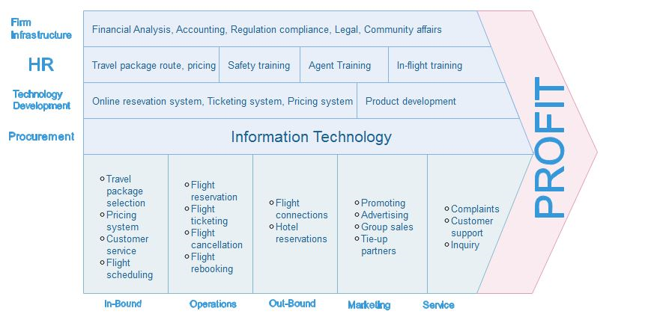

## Gap Analysis

|  |  |  |
| --- | --- | --- |
| Objectives | Current State | Future State |
| More branch | Company only have two branches in Makati and Bicol |  |
| Employee expansion | Limited number of employees. No proper designation of tasks | Propose Human Resourcethat can be used for proper delegation of employee |
| More customers | Have regular customer and built trust | More advertisementsand promotions |
| Improve services | Time consuming in processing services due to problems | Correcting problemsand obviating similar problems in the future |
| More secured system | System password usually gets hacked | Improve thesecurity of the system |

## 

## Industry Trends

Travel industry trends keeps evolving as global economy changing and technology drives new opportunities. These changes have profound impacts on the travel policies of all small and large businesses. Below are the corporate trends exist in the travel industry like Neomace Travel and Tours:

* Business Trend – Travel budgets always fluctuated in line with the economy, businesses are more relaxed about travel spending to get their work done while also enjoying. Based on research, business trend is predicted to be a very profitable trend for tour and travel agency, because business travel offers various promos that individual and business travelers avail.
* Economy Sharing – Existing partnership with other industries or business like hotels, resorts and other travel service providers will explore the sharing economy market as another way to reduce costs and increase productivity. These emerging or sharing of markets increases future travel expenditure of consumers, employment and overall growth of promoting local and outbound tourism.
* Investment in Technology – As technology continues to evolve, many businesses or industry where already adapt to these technological changes and take it as an advantage to upgrade their service. Technology invades corporate travel industry by having an online booking system, reservation and ticketing system. Like Neomace Travels and Tours they used efficient and accurate global distributed system such as Abacus and Amadeus for its reservation and ticketing function.
* Travel Spend Reduction– Companies are always looking for ways to reduce cost, especially travel industry since there are various travel industries offering low cost travel packages. Companies are getting smarter at reducing costs by associating with corporate travel industries and with the use of technology.

## Process Flow Diagram

