

**Neomace Travel and Tours  
Information Systems Plan**

Project Documentation Submitted to the

Faculty of School of Computing

and Information Technologies

Asia Pacific College

In Partial Fulfillment of the Requirements for

the Management Information System

and IT Trends

By:

Belchez, Maica L.

Carpio, Aira Joyce A.

Haboc, Florence Gail G.

Subject Professor:

Ms. Jo Anne Dela Cuesta

August 25, 2017

**ACKNOWLEDGMENT**

The proponents would like to thank all who contributed in the completion of this document. First, the proponents give thanks to God for guidance and ability to do work.

The proponents give deep thanks to their professor, Ms. Jo Anne Dela Cuesta who encouraged and directed them. Her challenges and advices brought this work towards a completion. It is with her supervision that this work came into existence. For any faults, they take full responsibility.

The proponents also deeply thankful to their client, together with her company. Their names cannot be disclosed, but the proponents want to acknowledge and appreciate their help and transparency during their gathering of company’s data. Their information has helped them complete this document.

**Table of Contents**

Executive Summary 1

Company Overview 1

Brief History 1

Mission 2

Vision 2

Core Values 2

Company Goals 3

Situational Review 3

Company Strengths and Weaknesses 3

Opportunities and Threats 4

Value Chain Analysis 6

Gap Analysis 6

Industry Trends 7

Business Context 7

Key Business Drivers 7

Strategic Priorities 8

Strategic Roadmap 9

Strategic Business Objectives 9

Strategic Initiatives 11

Financial Summary 11

Appendix 12

Detailed Business Processes 12

Project Estimate Cost 13

References 14

# **Executive Summary**

This Information Systems Plan (ISP) is for a travel agency called Neomace Travel and Tours. It is a project wherein the proponents would know the problems encountered by the company and find the best solutions to solve them.

The ISP provides different pieces of information and objectives that would settle and improve the process of the company. Its main focus is the long-term development and improvement of the company. This ISP is done to ensure the company’s performance would increase more of its efficiency and time management. Also, it provides the basic information on the process of the company.

To extend the use of this ISP, it is important that the management of the company should cooperate with the proponents in this project and share the needed information to resolve problems in the company. This ISP is important to the current state of the company since it will have an effect to its future state.

# **Company Overview**

## **Brief History**

Neomace Travel and Tours is more than just a conventional travel agency. It has proven to be an all-around travel management company that provides innovative travel advice to clients. Addresses to individual travelers with its aim to promote Health and Wellness as well as travel with fun and adventure. Neomace Travel and Tours goal is to provide best possible services to suit corporate, leisure as well as individual traveler.

Neomace Travel and Tours addresses key travel management objectives through value-based selling and support. It is committed to deliver the savings and program enhancements that companies look for. Designed for Overseas Filipino Workers (OFW), balikbayans, tourist and any market in affordable rate. They also utilize the world-renowned efficiency and accuracy of global distribution systems such as Abacus and Amadeus for its reservation and ticketing function. Below are the services provided by Neomace Travel and Tours:

* **Flight Reservations and Ticketing**
* Books your trip to any destination on any airline of your choice. We see to it that travel budget are wisely spent as we recommend the most cost effective routing.
* **Flight Cancellations and Rebooking**
* Provides reconfirmation, revalidation, rebooking and re-issuance of tickets.  Customers need not to worry about cancelled travel requirements and unutilized tickets as we immediately process airline refunds.
* **Meetings, Incentives, Conventions and Events**
* Helps clients consolidate and leverage all group travel. Uses advanced group booking and data management capabilities, which redound to measurable cost savings for clients.
* **Leisure Travel/Tours**
* Arranges all types of holiday and customize tour packages according to client preferences. Provides on "must-visit" sites, guided tours, ship/ferry schedules and other aspects on how to make advice on the most of your trip.
* **Hotel Reservations**
* Gives the best and lowest possible hotel rates using our negotiated and preferential rates.
* ***Value Added Services***
  + **Documentation Services –** Facilitates passport and/or visa applications, as well as provide advice and assistance on immigration applications and procedures.
  + **Travel Information/Advisories –** Provides customers with online and offline travel information on official destinations including but not limited to security and health advisories, airport transfers, and land transportation facilities, local points of interest and weather conditions.  Travelers are also updated on airport closures, delayed or cancelled flights, security procedures and other changes that may affect their departure time.

Neomace tagline is “It’s more fun to travel with Neomace Travel and Tours and travel beyond expectations.”

## **Mission**

1. We are seeking for excellence in service and will provide quality service at a cost that will enable us to remain competitive.
2. Promote health and wellness thru travel.

## **Vision**

To be the leading travel agency that promotes health and wellness thru travel.

## **Core Values**

Below are the following core values of Neomace Travel and Tours:

* Customer Care
* Putting the needs of clients first and striving to continuously provide an outstanding level of service.
* Commitment to Excellence
* Continuously seeking higher levels of performance.
* Cultural Diversity and Wellness
* Fostering respect and a team spirit in the workplace, embracing and leveraging the multicultural essence of the company, and providing equal opportunities to talented individuals.
* Reliability
* Being a dependable and trustworthy business partner, committed to offering industry-leading products and services.
* Entrepreneurial Spirit
* Approaching new challenges with creativity, resourcefulness and agility - reacting quickly and effectively to provide innovative solutions.
* Integrity
* Building productive, long-standing relationships by being truthful and promoting open communication.

## **Company Goals**

Neomace travel and tours aims to provide best possible services to suit corporate, leisure as well as individual traveler.

# **Situational Review**

## **Company Strengths and Weaknesses**

* Strengths

1. Marketing skills

* The company has excellent strategies in marketing when it comes to acquiring clients, airfare promotions and package tours that attracts people to come back again for booking and reservation of airfare tickets.

1. Plenty clients

* Many people reserved and booked their airfare and package tours because they are satisfied with the service of the company.

1. Regular-basis clients

* The company has allied partners that provides regular clients in booking and reserving tickets and package tours.

1. Service-oriented

* The company offers quality service to clients that prompts them to come back for booking and reservation of airfare tickets and package tours because they are satisfied and enjoyed.
* Weaknesses

1. Delay of submission of documents by applicants for passports

* Due to lack of information and awareness about the documents they submitted where they need to provide other supporting documents, the company searches for ways and means to meet the deadline.

1. Requirements and instructions due to the delay in submission of clients’ other supporting documents

* Client not able to follow instructions immediately, it becomes a problem and serves as a challenge to the company to improve more of their service to the client.

1. Delay in processing the documents

* Due to failure of client to provide other supporting documents immediately, the company asks assistance with allied partners to speed up the processing.

1. Limited employees

* Due to multitasking job, the company is not able to process immediately the clients’ applications and demand where the company needs to supply the deficits.

1. Reminders to client and vice versa

* Due to limited employees, the company is not able to process immediately which cause delay where the company learns a lesson to improve their services for growth and development.

## **Opportunities and Threats**

* Opportunities

1. The use of technology for better client experience

* It provides better meet their client’s needs with new and improved products and services.

1. Market branches

* Allow the company to expand their business and diversify their portfolio of products and services.

1. Growth of tourism worldwide

* Presents opportunity to increase the number of clients.

1. Online market strategy

* The online market offers company the ability to greatly expand their business. The company can market to a much wider audience for relatively little expense.
* Threats

1. Existing competition with other service providers

* Client might look for better service provider and might easily switch to another. It has an impact to company such as the ability to raise the prices and can lower the company’s profit.

1. Economic uncertainties

* A slump in the economic growth will affect the client's’ travel habit. This will decrease the number of potential clients.

1. Natural disaster and calamities or fortuitous events

* They might affect the general economy and willingness to travel.

1. Changes in technology

* May change the market beyond the company’s ability to adapt, some changes with the technology such as updates from software used consumes time for the employee to learn changes.

1. Consumers can change their tastes very quickly

* The company depends on knowing which goods and services consumers’ wants.

## **Value Chain Analysis**

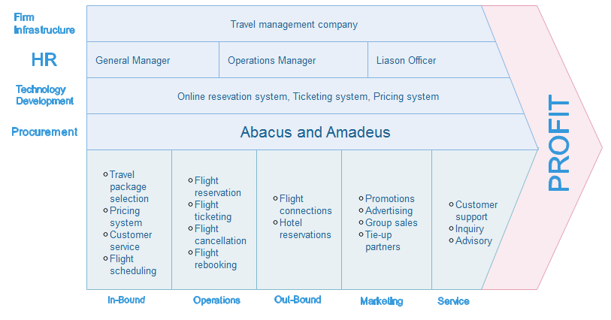

## **Gap Analysis**

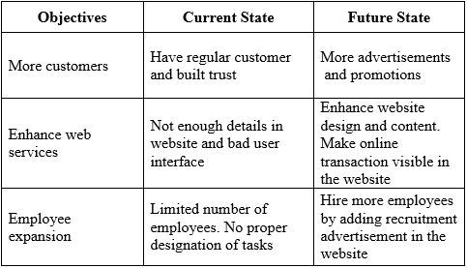  
Table 1 – Gap Analysis

## **Industry Trends**

Travel industry trends keeps evolving as global economy changing and technology drives new opportunities. These changes have profound impacts on the travel policies of all small and large businesses. Below are the corporate trends exist in the travel industry like Neomace Travel and Tours:

* Business Trend – Travel budgets always fluctuated in line with the economy, businesses are more relaxed about travel spending to get their work done while also enjoying. Based on research, business trend is predicted to be a very profitable trend for tour and travel agency, because business travel offers various promos that individual and business travelers avail.
* Economy Sharing – Existing partnership with other industries or business like hotels, resorts and other travel service providers will explore the sharing economy market as another way to reduce costs and increase productivity. These emerging or sharing of markets increases future travel expenditure of consumers, employment and overall growth of promoting local and outbound tourism.
* Investment in Technology – As technology continues to evolve, many businesses or industry where already adapt to these technological changes and take it as an advantage to upgrade their service. Technology invades corporate travel industry by having an online booking system, reservation and ticketing system. Like Neomace Travels and Tours they used efficient and accurate global distributed system such as Abacus and Amadeus for its reservation and ticketing function.
* Travel Spend Reduction– Companies are always looking for ways to reduce cost, especially travel industry since there are various travel industries offering low cost travel packages. Companies are getting smarter at reducing costs by associating with corporate travel industries and with the use of technology.

The following corporate trends contributes in the enhancement of Neomace travels and tours web services in terms of gaining more customers and educating people the services they can provide.

# **Business Context**

## **Key Business Drivers**

The critically important factors that will determine the success of the business are the members of the company, clients, purpose and procedures, and physical resources. The company’s objective must be met in order to have a successful process. Problems encountered should be obviated and processes that needs to be improved should be solved.

The following are the different key business drivers of Neomace Travels and Tours:

* Increase of customers
* In order to grow potential customers, using social media and putting the business online is a great technique to gain more customers and use it as way to gather feedbacks which will help the company have an idea in improving its offered services. This can also be the way to gain company popularity.
* Using of technologies for services
* Providing proper tool such as Amadeus e-Travel Management (AeTM), an online self-booking tool that serves every aspect of corporations’ travel needs through a single-entry point and Abacus, another travel technology provider which has come up with technological innovation for meeting the changing needs of the travel agents and travel suppliers. These tools enable the Neomace Company to enjoy enhanced productivity and efficiency for the purpose of meeting their business needs and to have increase the customer’s satisfaction and loyalty.
* Employee engagement
* Since they are the ones who serves the customers and the face of the company, employees performance and engagement is another key aspect of business success. It must be assured that the company have enough number employees with adequate skills to the jobs he/she is handling.

## **Strategic Priorities**

The strategic priorities that the company aims to address is to gain more customers and popularity. Therefore, the team decided to focus in enhancing their website by making it more reliable and more innovative. Having a reliable website will have a competitive advantage for the company because it will give their customer a convenience in availing the service offered. It is also an effective way for the market strategy because it is accessible around the clock and will serve as opportunity to tell consumers why they should trust the company and the testimonials and facts to back up those opportunities.

The team would also like to address another problem of the company which is the limited employee. Team come with the solution by adding recruitment advertisement in the enhanced website so that there will be an opportunity for the company to gain employees.

## **Strategic Roadmap**

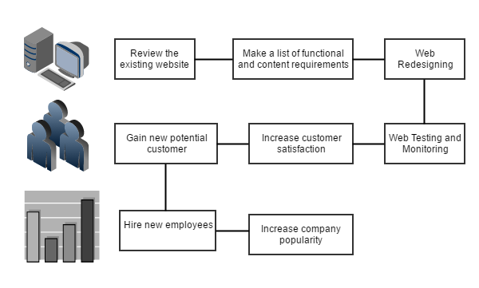  
Figure 1 – Strategic Roadmap

## **Strategic Business Objectives**

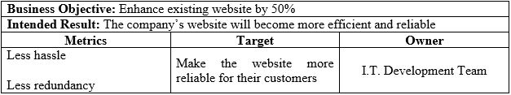Table 2.1 – Strategic Business Objective

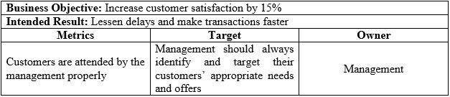Table 2.2 – Strategic Business Objective

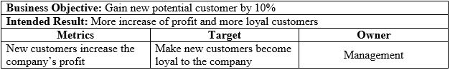  
Table 2.3 – Strategic Business Objective

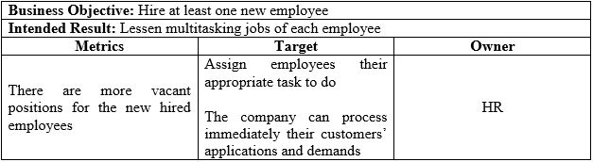  
Table 2.4 – Strategic Business Objective

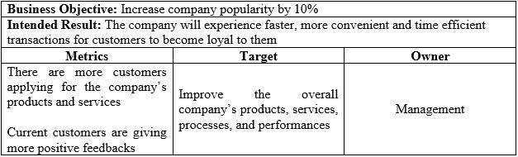  
Table 2.5 – Strategic Business Objective

# **Strategic Initiatives**

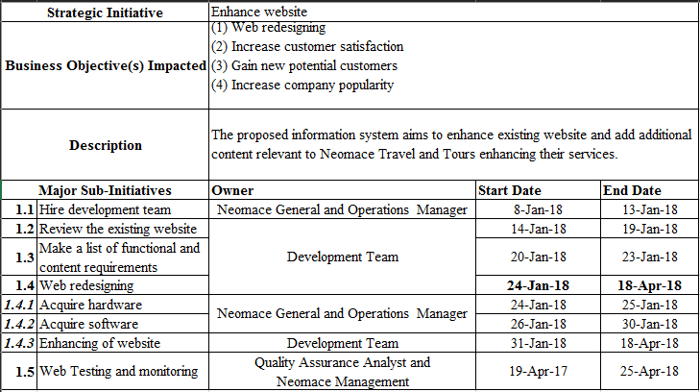

Table 3 – Strategic Initiatives

# **Financial Summary**

The proposed information system plan for Neomace travels and tours which is the enhance development of website service quality services for website design. Based on the team’s projection the proposed information system plan provides various requisites for its success completion. In Table 5 - Project Estimate Cost identifies the planned expenditure of the project.

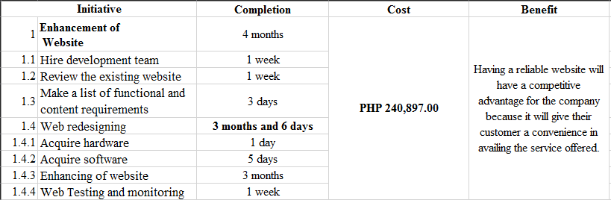

Table 4 – Financial Summary

# **Appendix**

## **Detailed Business Processes**

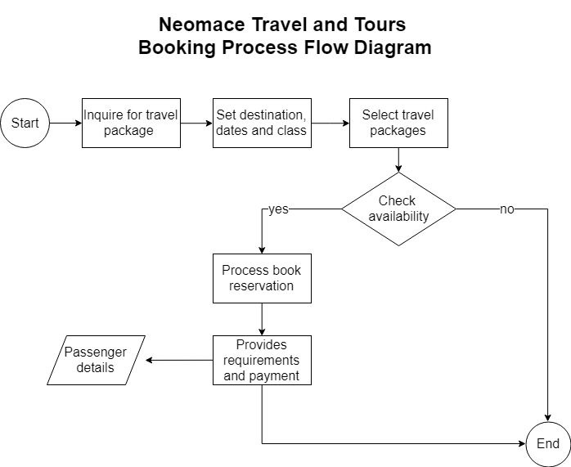

Figure 2 – Business Process Flow

## **Project Estimate Cost**

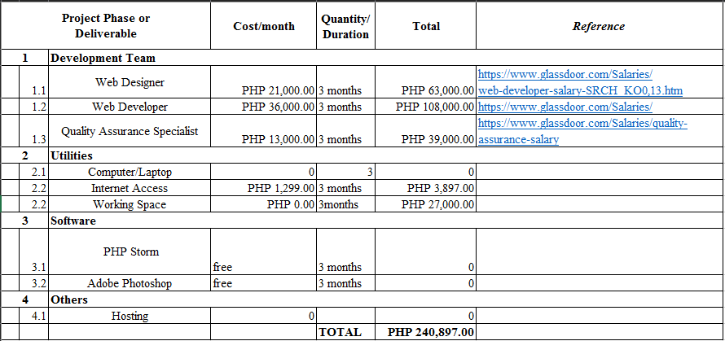

Table 5 – Project Estimate Cost

# **References**

Amadeus Global. (n.d.). Amadeus Global Website | Let's shape the future of travel. Retrieved from http://www.amadeus.com/web/amadeus/en_1A-corporate/Corporations/Our-portfolio/Serve/Trip-planning/Amadeus-e-Travel-Management/1319476468545-Solution_C-AMAD_ProductDetailPpal13195602181?industrySegment=1259068355719&level2=1319608955623&level3=1

Argonne National Laboratory, Papka, M., Messina, P., Coffey, R., & Drugan, C. (2011). *The Argonne Leadership Computing Facility 2010 annual report*. doi:10.2172/1049042

Dogulin Digital. (2016). 6 Reasons Why a Website is Important for your Business. Retrieved from https://www.dogulindigital.com.au/importance-of-website-for-business/

Fastuca, R. (n.d.). 5 Major Trends Affecting the Corporate Travel Industry [Web log post]. Retrieved from http://blog.locomote.com/5-major-trends-affecting-the-corporate-travel-industry

Neomace Travel and Tours. (2017). Travel Beyond Expectation: Neomace Travel and Tours. Retrieved from http://neomacetravel.com/

NetMBA. (2002). Value Chain Analysis. Retrieved from http://www.netmba.com/strategy/value-chain/

Provab Technosoft Pvt. Ltd. (2015). Abacus Travel Software, Abacus GDS system, Abacus integration. Retrieved from http://www.hotelreservationssystem.com/abacus-travel-software.html

SQUARE 2 MARKETING. (2017). 5 Roles Every Successful Web Design Project Needs. Retrieved from https://www.square2marketing.com/blog/5-roles-every-successful-web-design-project-needs