

**DAYALEKTOR  
BUSINESS PLAN**

Members:

Belchez, Maica L.

Carpio, Aira Joyce A.

Gardon, Jana Marie G.

Haboc, Florence Gail G.

Professor:

Sir Ernesto Boydon

**OWNERS**

Business name: Asia Pacific College

Address: #3 Humabon Place, Magallanes, Makati City

Telephone: +63 2 852 9232

Fax: +63 2 852 5834

Email: admissions@apc.edu.ph

**Table of Contents**

Executive Summary 1

Lean Canvas 1

Problems 1

Solutions 2

Features 2

Situational Benefits 3

Marketing Message 3

Channels 3

Customer Segments 4

Cost Structure 4

Revenue Streams 4

Business Startup Costs 4

Marketing Plan 8

Revenue Projection Based On Target Market Research 9

Online Surveys 9

Pain Points 9

Features 13

References 19

# **Executive Summary**

Translation is a process of changing the word but retains the meaning. The importance if this is the reason that it is one of the important discipline being very much useful in every human activity. Good communication starts with understanding each other. Philippines on the other hand has many different dialects then there are also so many tourists that visits the country. This would be hassle for both parties to have a conversation but do not fully understand each other. Based on the survey that the proponents conducted, when they we’re in a situation that they do not understand the person they are talking to, they instead ignore the person, end the conversation, apologize, or search for the translation on the internet which may lead to misunderstanding. Technology has improved the way we work and continuously creates useful resources. Combining together the translation and technology, the proponents would like to resolve these problems by having a mobile application called Dayalektor.

Dayalektor is a mobile app that translates English or Filipino words to different Philippine dialects and vice versa. The app breakthrough language barrier and misunderstanding between Filipinos and foreigners or Filipino that is not familiar with other dialects. It makes the communication comfortable and fun through offline dictionary and forum. By using the app, there would be featured Filipino Word of The Day on the homepage. The offline dictionary also provides voice translation of each word for the users to also determine how to correctly pronounce that specific word. For easier searching of the word, the app auto-generate the word upon searching. The translated words can be saved and bookmarked. While, if the word is not available, the user can sign up and ask on forum and whatever answer on the forum can be liked and it will be saved on the user’s activity log.

The primary market are the users who would like to travel in the Philippines that can use the app as a handy reference tool or translator when talking to Filipinos or even just to familiarize with the dialects and to learn new words in Filipino. Moreover, it can also be used by Filipinos who speaks to local dialects that can translate words into English.

The 18 months duration of the project’s cost structure is divided for the development of mobile application which are the software to be used, for marketing and advertising, for the salaries of personnel, and other expenses like facilities and fixtures. For every download of app will cost Php 100 for the maintenance and improvement.

# **Lean Canvas**

## **Problems**

* Language Barrier

Communication is one of the most important things in life. It is important that people understand each other for any communication. One important factor is the language. Unless you speak only one language or dialect, then you can never communicate effectively. Trying to learn a new language or dialect may be hectic and stressing and often requires one to spend a lot of time in it.

* Misunderstanding

Misunderstanding is the best example of effects of language barriers. Foreigners and local people who travel in the Philippines, where there are people speaking different dialects, may have trouble in communicating to one another.

## **Solutions**

Utilizing this app’s speech recognition technology and combining that with offline vocabulary and online forum, the Dayalektor provides you with all the features required to speak other dialects or language.

Dayalektor uses the following languages and dialects:

* + Languages
* English
* Filipino
  + Philippine Dialects
* Bikol
* Cebuano
* Hiligaynon (Ilonggo)
* Kapampangan
* Pangasinan
* Tagalog
* Ilocano
* Waray

Dayalektor also has a competitive advantage. Most translation app today that involve Filipino words are translating only English to Filipino and vice versa. While Dayalektor provides wide range of dialects that can be translated and which can still be accessed even offline. Whatever translation the user needs to know are all accessed in one platform.

## **Features**

* Offline Dictionary
* Much faster than searching that requires internet connection
* Words are auto-suggested as you type on the search box
* Ability to mark words as ‘Bookmark’ and pin them
* Shows ‘Word of the Day’ on the home screen
* Includes text-to-speech to determine how to correctly pronounce the words
* Forum
* Can use the forum when the word you are looking for is not available in the offline dictionary
* Requires an account to be able to ask or answer questions
* Upon registering, the user can input all its known dialects
* When asking question, the user can tag what kind of dialect he/she is looking for and all the users that know the dialect will receive notification
* Ability to mark answers as ‘Favorite’ and it will be saved on user’s account

## **Situational Benefits**

Using the Dayalektor app, it:

* + Improves vocabulary and check pronunciation
  + Builds self-confidence in talking with other people who speak different dialect

## **Marketing Message**

***“NEVER GET LOST IN TRANSLATION”***

Dayalektor provides translated English or Filipino word to Philippine dialects and wherever you are in the Philippine you will never get lost and prevents the users to not run out of translation. If the user doesn’t understand the person they are talking to, Dayalektor would be a great tool.

## **Channels**

The Dayalektor will be advertised so that it can be purchased by the customers through the following:

* Social networks
* Blog
* Advertisement
* Email
* Website

## **Customer Segments**

As of 2017, the world population is now 7.515 billion. For the Philippines, its population is 104.014 million. According to the Department of Tourism (DOT), International tourists who have visited the Philippines in the first quarter this year (January to March) was up by 11.4% to 1.784 million visitors.

The Dayalektor is mostly applicable within the Philippines, mainly, because of its features – First, translating Filipino or English words and phrases into Philippine dialects. Second, an offline dictionary that consists of known Philippine dialect words. And lastly, an online forum where users can ask certain questions of unfamiliar Philippine dialect words and phrases, then users who speak certain Philippine dialects will answer their questions.

## **Cost Structure**

These are the list of expenses the business has:

* Mobile development
* Marketing
* Advertising
* Salaries
* Utilities

## **Revenue Streams**

These are the list of what the business receives:

* Stakeholders
* Paid customers
* Development fees

# **Business Startup Costs**

For the duration of 18 months, the startup costs of Dayalektor is as follows:

The pre-operational costs consist of all the utilities needed

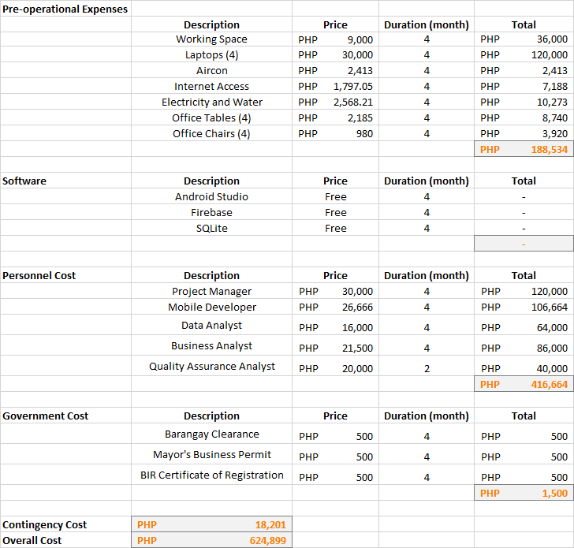

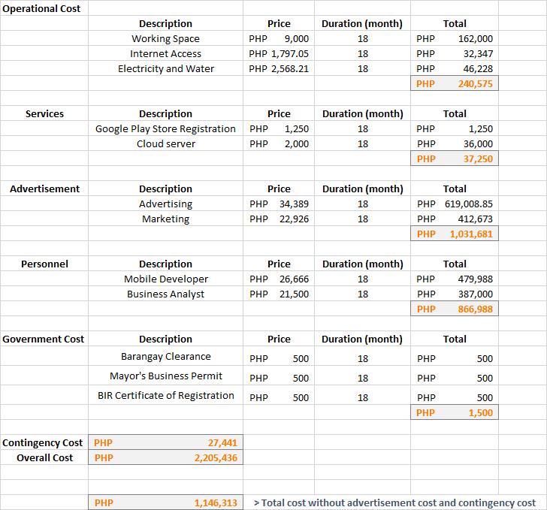

On the advertisement cost, the advertising cost was from 3% of the total cost excluding the contingency cost while 2% for the marketing cost which becomes the monthly cost of each advertisement channel.

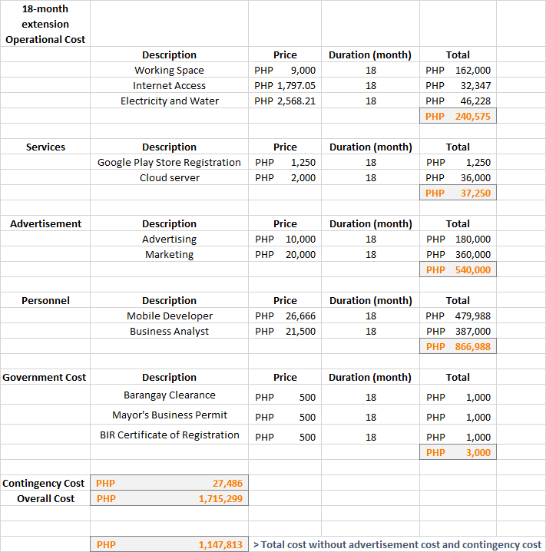

Extension of 18 months only increased on the Government cost. Since it will take 2 years for the renewal of the permit. For the maintenance of the app, only the mobile developer and business analyst will be concerned on this process.

The proponents got a total of Php 2,830,335 capital for the investors.

C:\Users\mlbel\AppData\Local\Microsoft\Windows\INetCache\Content.Word\CapProjV2.png

# **Marketing Plan**

The sales funnel is a visual representation of steps required to sell the product. This will tell whether the business have enough deals in the funnel to meet its goals, and whether it need to appoint special attention to certain deals.

The first stage is the travel agency, travel company website, and D.O.T. To make the app known to people, the proponents will seek help from a certain travel company. They will use the company’s website to advertise the app. When travelers and tourists access to their website, they will see the app’s advertisement. If they it, they will be redirected to the app in the Play Store. To convince them, the proponents will make a deal with the company. The company will get a 5% shares from them.

The second stage is the social media ads and influencer’s blog. To make the app acknowledge more, the proponents will seek help from an influential vlogger. They wanted Nas Daily to advertise their app. They will talk to Nuseir Yassin, founder of Nas Daily, to include the app in his one-minute video. They will convince him to advertise it by explaining to him the importance of the app, getting a 5% shares from them, and giving him the free-trial app.

And the last stage is the customers’ feedback. The proponents will get users’ comments or feedbacks about the app through online survey or interview. Then, they will post them on their website or Play Store and share their video interview to social medias. With this, more and more people will support their product.

# **Revenue Projection Based On Target Market Research**

|  |  |  |  |
| --- | --- | --- | --- |
| Asian Country | Tourist Arrival in the Philippines | Price per download | PHP 100 |
| Korea | 1475081 |
| China | 675663 |
| Japan | 535238 |
| Taiwan | 229303 |
| Singapore | 176057 |
|  |  |
| CTA | 3% |
|  | **92740.26** |
| Revenue | **9,274,026.00** |
| No. of days | 548 |
| Product cost | PHP 100 |
| Conversion rate | 2.35% |
| Downloads/day | 7201 |

# **Online Surveys**

## **Pain Points**

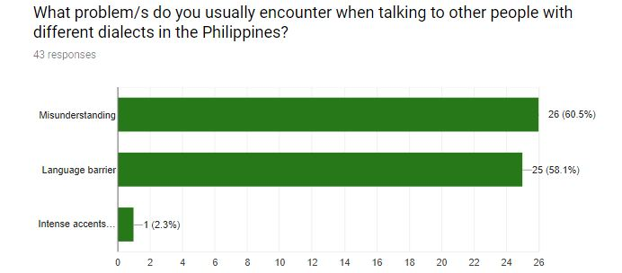

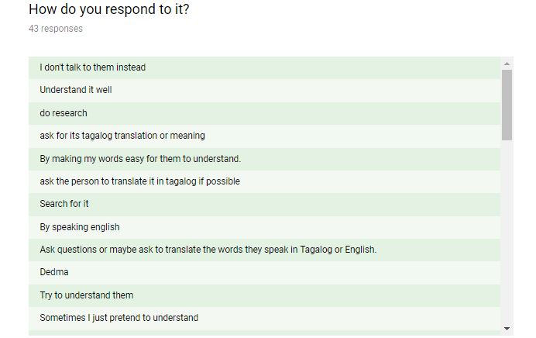

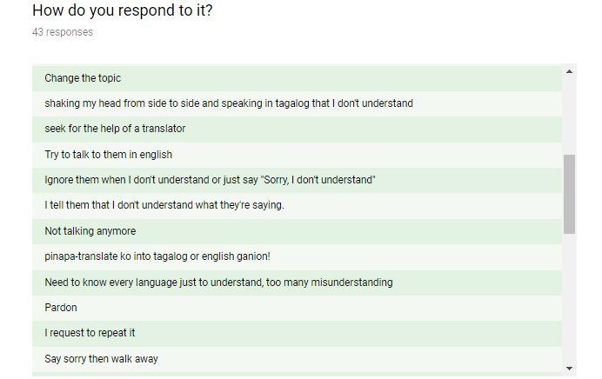

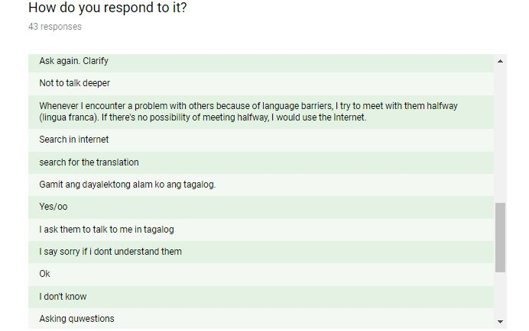

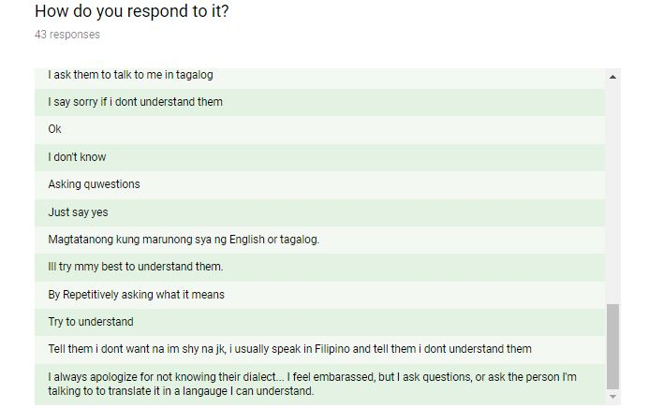

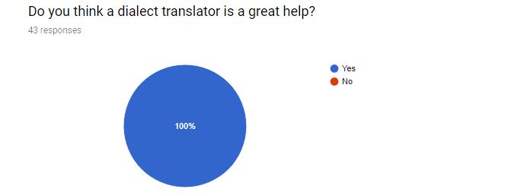

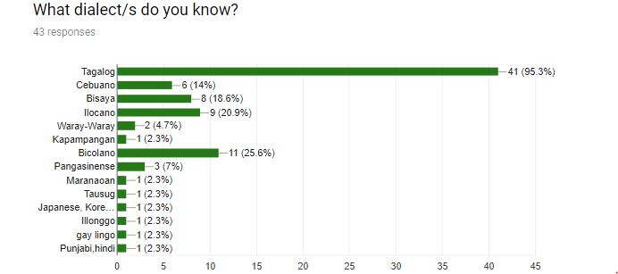

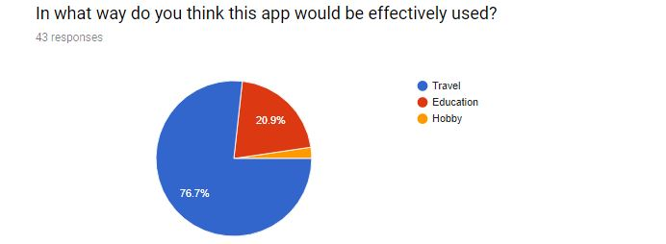

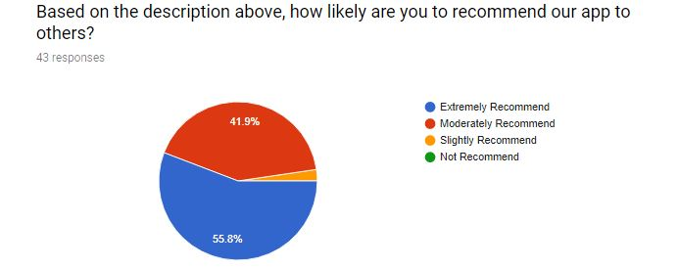

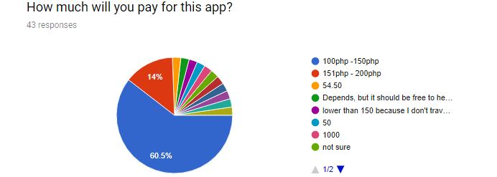

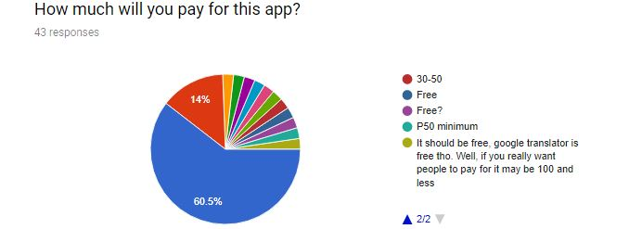

## **Features**

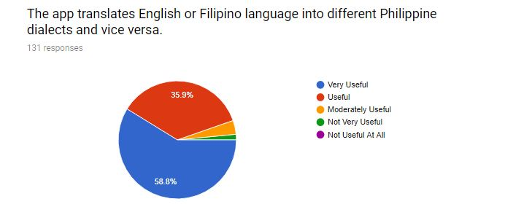

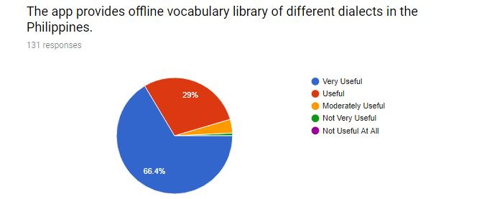

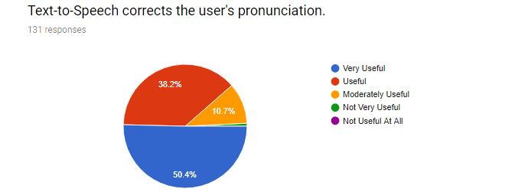

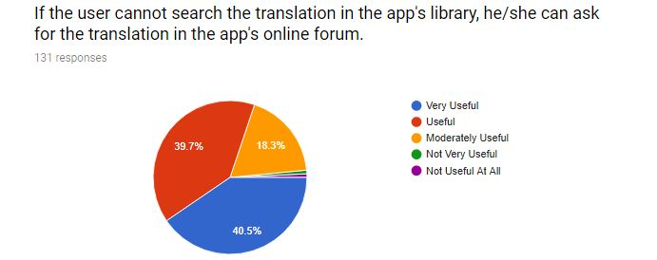

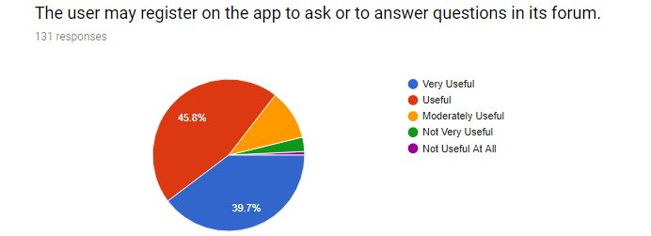

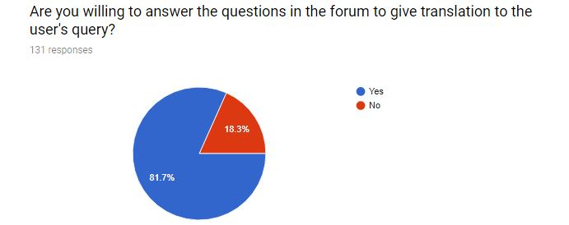

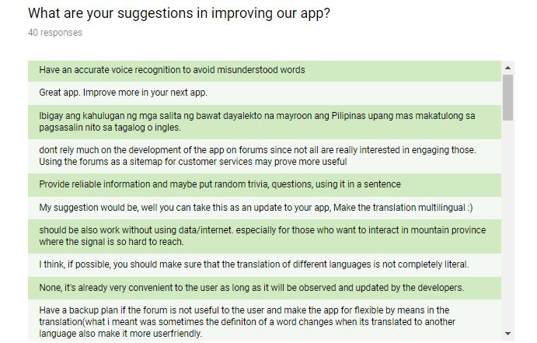

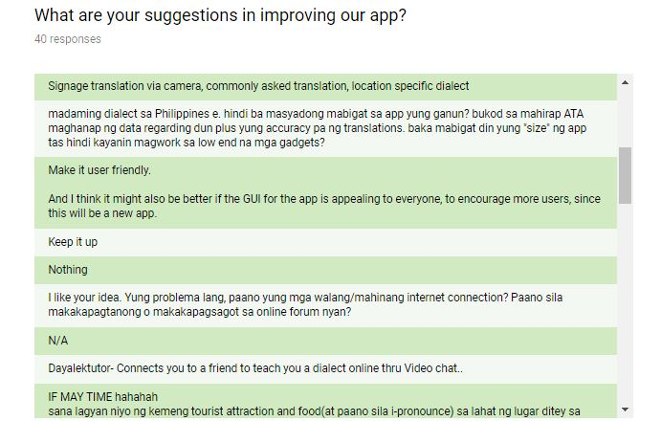

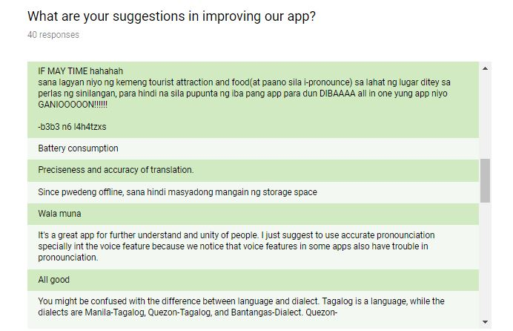

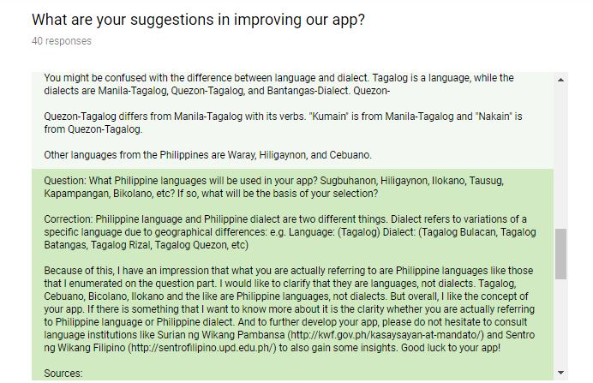

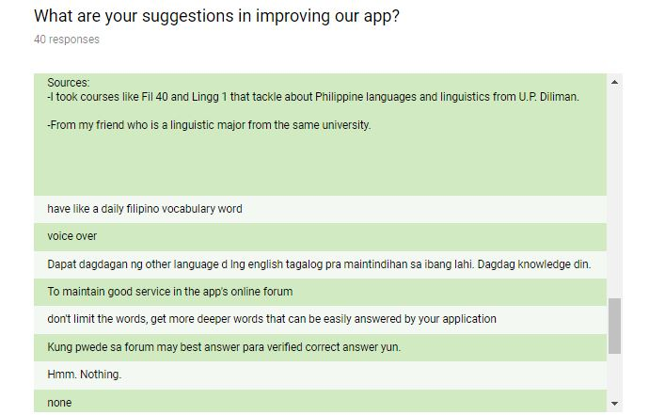

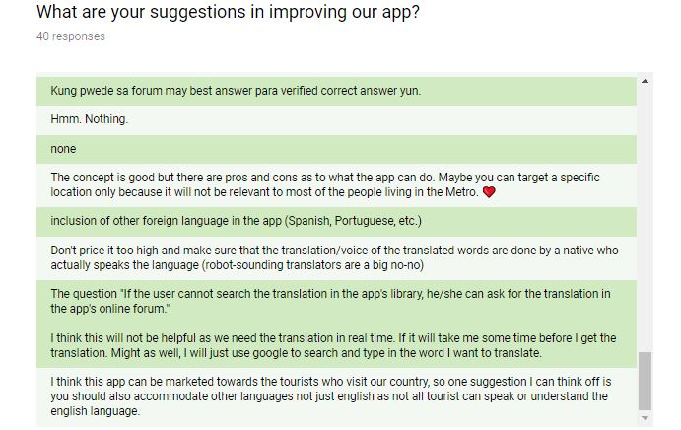

# **References**

EXPERTSCOLUMN.COM. (2017). Translation: Need,importance And Benefits. Retrieved from http://fareedsiddiqui.expertscolumn.com/article/translation-needimportance-and-benefits