## Syntax Errors:

1. **Screenshot**:  
   A close-up of a computer screen

   AI-generated content may be incorrect.  
     
   **Error**:  
   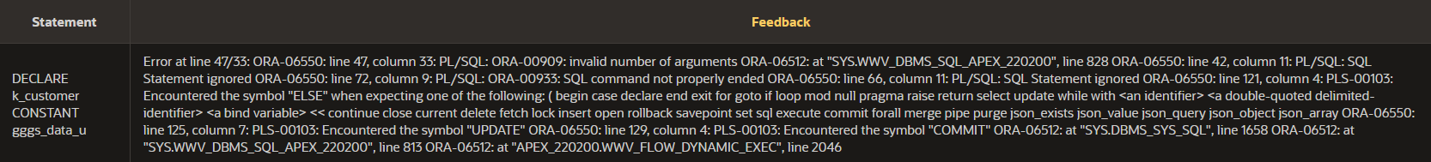  
     
   **Reason for Syntax Error**:  
   The phone number null value replacer (NVL function) is supposed to only have 2 arguments – one for if the value is null, one for if it’s not null. This has three.  
     
   **Correction**:  
   We need to remove the duplicate r_gggs.column6 argument so there are only 2 arguments.  
     
   **Corrected Code**:  
   A close-up of a text

   AI-generated content may be incorrect.
2. **Screenshot**:  
   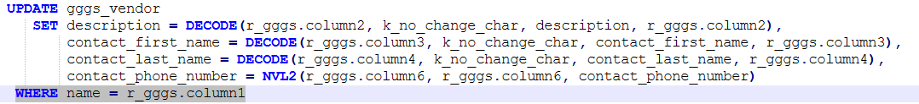  
     
   **Error**:  
     
     
   **Reason for Syntax Error**:  
   The WHERE clause should have a semicolon at the end.  
     
   **Correction**:  
   Add a semicolon at the end of the line.  
     
   **Corrected Code**:  
   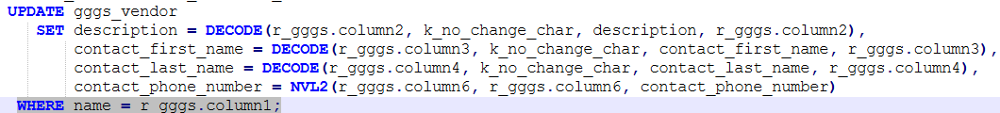
3. **Screenshot**:  
   A screenshot of a computer code

   AI-generated content may be incorrect.  
     
   **Error**:  
   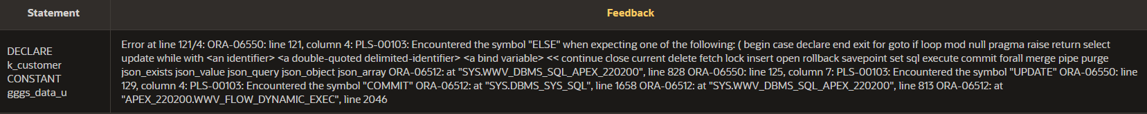  
     
   **Reason for Syntax Error**:  
   ELSE IF isn’t the right syntax, it should be ELSIF. This makes the next ELSE statement appear to be part of the wrong block.  
     
   **Correction**:  
   Change it to say ELSIF.  
     
   **Corrected Code**:  
   A screenshot of a computer code

   AI-generated content may be incorrect.
4. **Screenshot**:  
   A screenshot of a computer code

   AI-generated content may be incorrect.  
     
   **Error**:  
     
     
   **Reason for Syntax Error**:  
   The inner block doesn’t have an END; statement, between the COMMIT and END LOOP.  
     
   **Correction**:  
   Add an END; statement between the COMMIT and END LOOP.  
     
   **Corrected Code**:  
   A computer code with blue text

   AI-generated content may be incorrect.
5. **Screenshot**:  
     
     
   **Error**:  
     
     
   **Reason for Syntax Error**:  
   k_stats isn’t a real variable, it’s supposed to be k_status.  
     
   **Correction**:  
   Replace k_stats with k_status.  
     
   **Corrected Code**:  
   

## Logic Errors: