## Syntax Errors:

1. **Screenshot**:  
   A close-up of a computer screen

   AI-generated content may be incorrect.  
     
   **Error**:  
   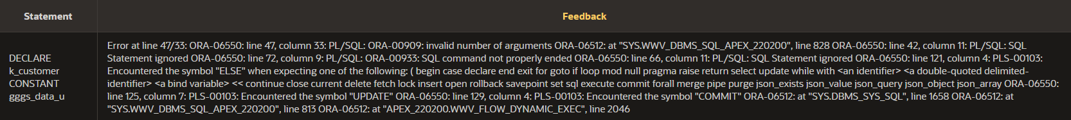  
     
   **Reason for Syntax Error**:  
   The phone number null value replacer (NVL function) is supposed to only have 2 arguments – one for if the value is null, one for if it’s not null. This has three.  
     
   **Correction**:  
   We need to remove the duplicate r_gggs.column6 argument so there are only 2 arguments.  
     
   **Corrected Code**:  
   A close-up of a text

   AI-generated content may be incorrect.
2. **Screenshot**:  
   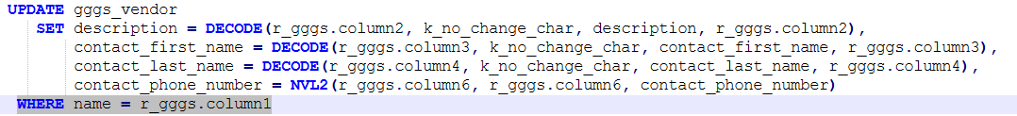  
     
   **Error**:  
     
     
   **Reason for Syntax Error**:  
   The WHERE clause should have a semicolon at the end.  
     
   **Correction**:  
   Add a semicolon at the end of the line.  
     
   **Corrected Code**:  
   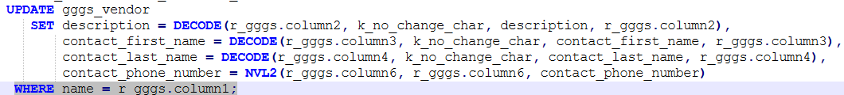
3. **Screenshot**:  
   A screenshot of a computer code

   AI-generated content may be incorrect.  
     
   **Error**:  
   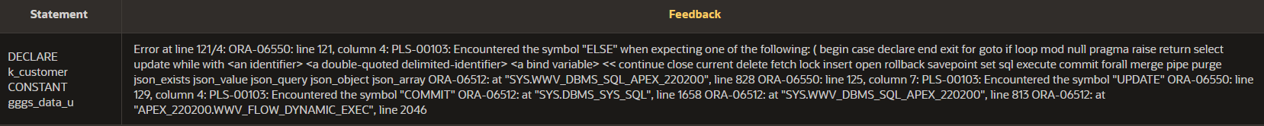  
     
   **Reason for Syntax Error**:  
   ELSE IF isn’t the right syntax, it should be ELSIF. This makes the next ELSE statement appear to be part of the wrong block.  
     
   **Correction**:  
   Change it to say ELSIF.  
     
   **Corrected Code**:  
   A screenshot of a computer code

   AI-generated content may be incorrect.
4. **Screenshot**:  
   A screenshot of a computer code

   AI-generated content may be incorrect.  
     
   **Error**:  
     
     
   **Reason for Syntax Error**:  
   The inner block doesn’t have an END; statement, between the COMMIT and END LOOP.  
     
   **Correction**:  
   Add an END; statement between the COMMIT and END LOOP.  
     
   **Corrected Code**:  
   A computer code with blue text

   AI-generated content may be incorrect.
5. **Screenshot**:  
     
     
   **Error**:  
     
     
   **Reason for Syntax Error**:  
   k_stats isn’t a real variable, it’s supposed to be k_status.  
     
   **Correction**:  
   Replace k_stats with k_status.  
     
   **Corrected Code**:  
   

## Logic Errors:

1. Logical Error 1
   * **Expected Result:** The variables v_name1 and v_name2 are meant to store numerical ID codes for categories and vendors. They should be set up to handle numbers.
   * **Actual Result:** Instead, they are currently defined to hold text (like names).
   * **Code Section in Error: A screen shot of a computer program

     Description automatically generated**
   * **Reason for Error:** The declared data types for v_name1 and v_name2 are trying to store numbers in a text field, which can lead to unexpected errors or issues because the variable is not designed for that kind of data.
   * **Correction:** **A screen shot of a computer program

     Description automatically generated**
2. Logical Error 2
   * **Expected Result:** When r_gggs.column6 contains the k_no_change_numb value (-1), the phone number should remain unchanged.
   * **Actual Result:** The NVL function sets the phone number to -1 which is an invalid phone number.
   * **Code Section in Error: A screenshot of a computer

     Description automatically generated**
   * **Reason for Error:** The NVL function only replaces NULL values. It does not recognize our special -1 code for no change leading to update incorrect data.
   * **Correction: A screenshot of a computer

     Description automatically generated**
3. Logical Error 3
   * **Expected Result:** When r_gggs.column6 contains the k_no_change_numb value (-1), the contact phone number should remain unchanged.
   * **Actual Result:** The NVL2 function sets the contact phone number to -1 which is an invalid phone number.
   * **Code Section in Error: A computer screen with text

     Description automatically generated**
   * **Reason for Error:** NVL2 replaces null values but does not recognize our special -1 code for no change leading to update incorrect data.
   * **Correction: A screen shot of a computer

     Description automatically generated**
4. Logical Error 4
   * **Expected Result:** When inserting a new stock record, the vendorID should be retrieved by looking up the vendor's name from r_gggs.column2.
   * **Actual Result:** The SELECT statement incorrectly uses r_gggs.column3 to find the vendor, which contains the stock name.
   * **Code Section in Error: A black background with white text

     Description automatically generated**
   * **Reason for Error:** The column entered is incorrect which eventually leads to finding the required information at wrong location.
   * **Correction: A black and red text

     Description automatically generated with medium confidence**
5. Logical Error 5
   * **Expected Result:** When updating stock, if a quantity is given to be subtracted, it should be applied correctly. If the input means "no change," the stock count should simply stay the same.
   * **Actual Result:** The column containing k_no_change_numb (-1) is increasing the stock quantity.
   * **Code Section in Error: A computer screen shot of text

     Description automatically generated**
   * **Reason for Error:** The NVL2 function does not correctly interpret “no change” during the calculation. So, subtracting -1 becomes adding 1 at the moment.
   * **Correction: A screen shot of a computer

     Description automatically generated**