**Using WinDAQ on the Dell Computer**

To start a **new** Recording Session

1. Press File 🡪 Record



1. Click on the folder you would like your recording to be saved.
2. Write your file name.
3. Press “OK”
4. Set either the desired time or bit size of the recording file.
5. Do not press “OK” until you are ready to start a recording session.



1. Do not press Ctrl + S unless you want to stop recording and save the file before the time runs out.
2. Press Ctrl + S after the file reaches 100.0% storage used.



To **Append** to an already existing Recording.

1. Press File 🡪 Record
2. Find the file you want to append to. Click on it and Press “Yes” on the message that appears. You cannot override a file – appending is your only option.

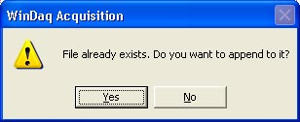

1. Set either the desired time or bit size that you want to append to the existing recording file.
2. Do not press “OK” until you are ready to start a recording session.
3. Do not press Ctrl + S unless you want to stop recording and save the file before the time runs out.
4. Press Ctrl + S after the file reaches 100.0% storage used.

To make an **Event Marker/Comment** during a Recording Session:

1. Highlight the channel you can to make a comment on by clicking on the channel number.
2. Click Edit 🡪 Insert Commented Mark

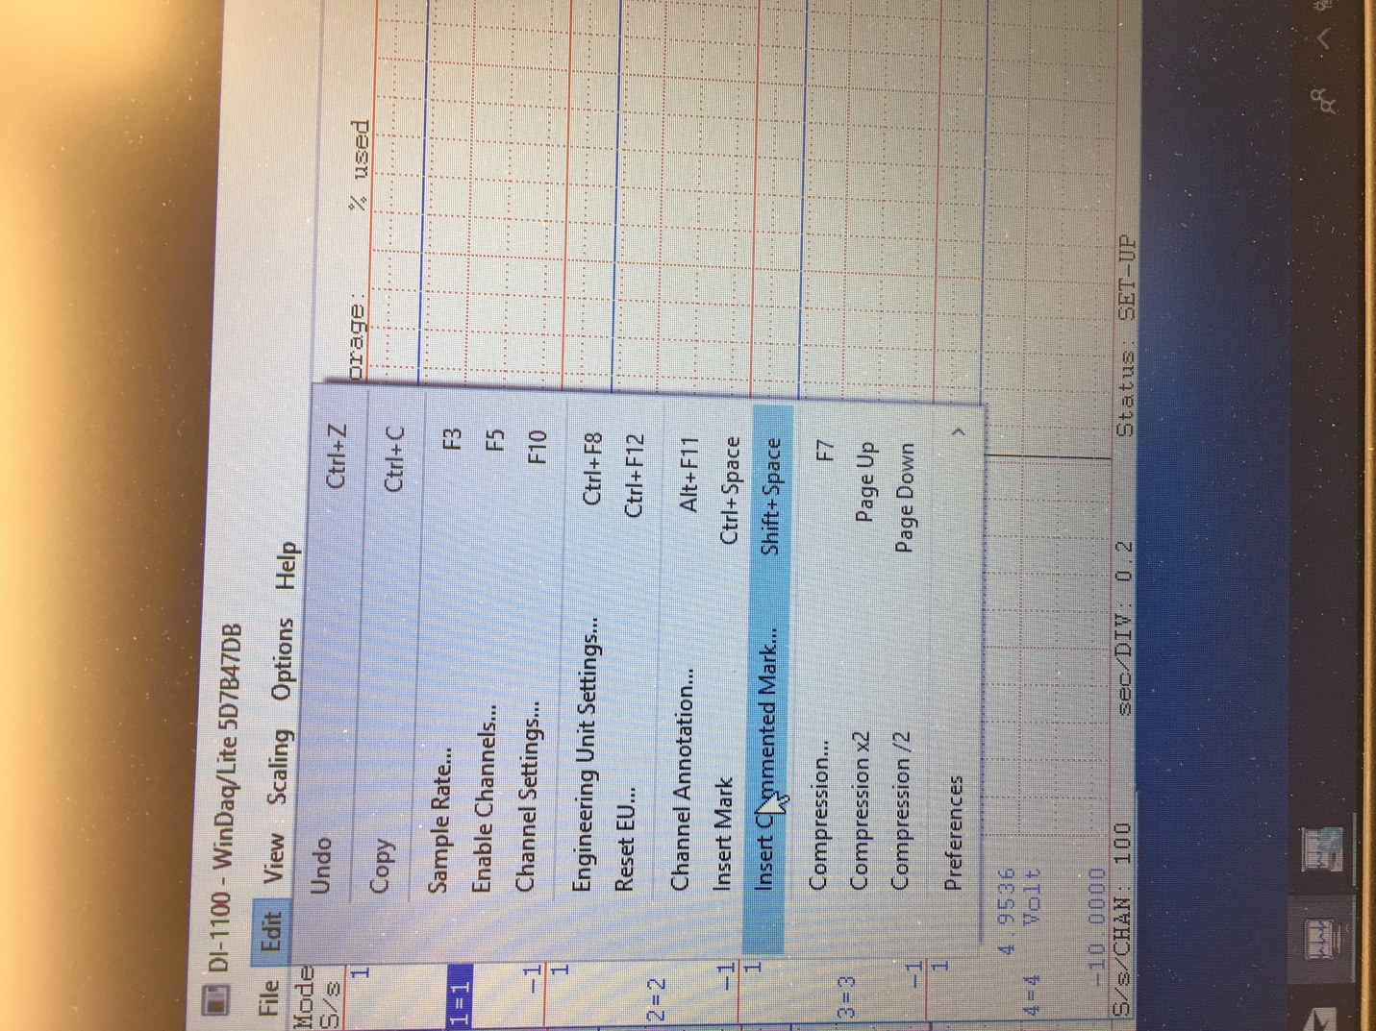

1. Write your comment. (E.g. “ID number of the bug” + “start” or “is on”)

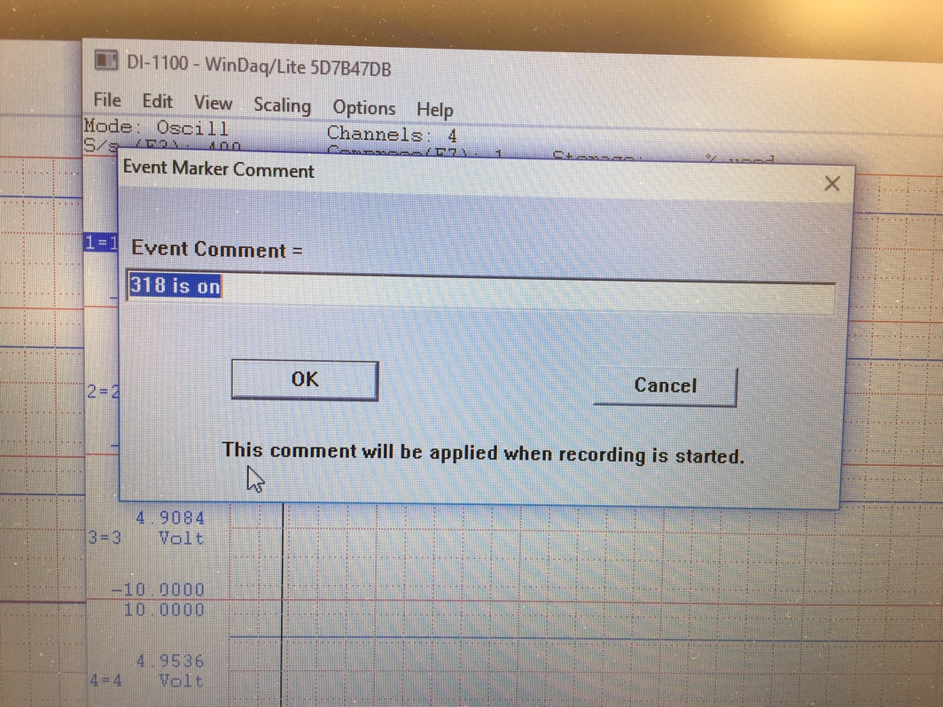

1. Press “OK”
2. Load your bug and ensure to match your chamber number to your channel number.