**Anodization and characterization of titanium electrodes for electrolytic capacitors**

**Abstract:**

This paper presents a custom circuit for controlling the anodization of titanium capacitors and characterizing their performance. This system provides a constant current source of 0-100mA up to a compliance voltage of 30V. The system can monitor and record leakage currents down to 10 nanoamperes over periods of up to 24 hours. Typical results obtained using sputtered titanium-zirconium capacitors are presented.

**Introduction:**

**The previous version of the introduction did not properly focus on the instrumentation.**

Titanium capacitors are being looked at more closely as a possible alternative to tantalum capacitors due to their lower material cost and better temperature characteristics (quote Welsch). In the past, titanium capacitors have not been feasible alternatives due to their high leakage currents of (##) (quote Li’s paper). In order to further research into titanium capacitors, custom anodization instrumentation has been developed to anodize and characterize prototype titanium capacitor materials. This instrumentation was necessary because conventional systems do not have the necessary dynamic range (1A-1nA measurement) or repeatability (need to get some kind of number) needed in this application.

* We want Ti caps
  + Why?
* They used to not be feasible
  + Why?
* They are now feasible
  + Says who?
* How will we make them?
  + Out board
* How will we evaluate them?
  + Our board
* There is interest in titanium capacitors as a possible alternative to tantalum capacitors
  + Lower cost materials
  + Better temperature characteristics
  + Quote one of Welsch’s slides.
* We have developed instrumentation to anodize and characterize prototype titanium capacitor materials.
* However, titanium electrolytic capacitors have been plagued by large leakage currents.
  + Quote -
    - TITANIUM SPONGE ON TITANIUM SUBSTRATE FOR TITANIUM ELECTROLYTIC CAPACITOR NODES by JUN-WAN KI, May 2005.
* Requirements of the research program
  + Anodize capacitors
  + Characterize leakage currents of a large number of materials.
    - Conventional data acquisition systems do not have the needed capabilities.
      * You can say more about this - dynamic range, repeatability, etc.

🡪 Begin old introduction:

Electrolytic capacitors are used in a myriad of different applications that we see in our every day lives. They appear in everything from switching power converters to signal filtering. The global aluminum electrolytic capacitor market is projected to grow to $4.2 billion by 2015 (quote: aluminum association). This is a large market for a potential competitor of much higher energy density and a comparable price.

|  |  |  |
| --- | --- | --- |
| Metal | Dielectric Constant | Relative Capacitance uF/cm^2 |
| Ta | 27 | 1 |
| Nb | 48 | 1.3 |
| Al | 10 | .43 |
| Ti | 107 | 1.2 |

*Characteristics of titanium electrolytic capacitors  
Fig #1.

Referring to Fig#1, Titanium has the advantages of a dielectric constant over twice as large as its competitors, and it has a relative capacitance 3 times as large as aluminum and comparable to niobium. In the past, titanium capacitors have been plagued by high leakage currents and high ESR, making them unsuitable for applications in power conversion circuitry. But research by (quote printed caps and welsch’s 1pager) suggests that these obstacles can be overcome by proper cleaning of the titanium anodes and by depositing a sponge like titanium surface onto a substrate to act as an anode. Current research suggests that leakage currents as low as 1uA/cm^2 should be able to be reached by these new methods. (quote microminiturization).

**Anodization Process and Requirements**

Anodization is the act of growing an oxide layer on top of a metal anode. This is useful in capacitors because it allows a capacitor to store significantly more energy then it would have otherwise. The anodization process is preformed by immersing an anode and a cathode into an electrolyte solution and then hooking up either a voltage or current source across the sample. This process can be seen in fig#:  
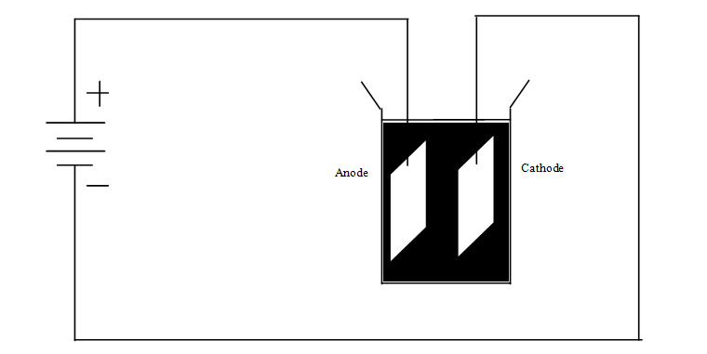

Figure : Anodization setup

Referring to Fig#1, in the simplest case, the current transfer is an ionic transfer where the Ti anode reacts with O2 to create a TiO2 oxide layer. The reaction at the metal-oxide surface can be written as:  
  
Ti + 02 => TiO2 + 4e (equ. 1)  
  
The titanium also reacts with the electrolyte solution to give off hydrogen:  
  
Ti + 2H20 => Ti02 + 4H+ (equ 2)  
  
This hydrogen reacts with the electrons at the cathode to create hydrogen gas and complete the ionic circuit.  
  
4H + 4e => 2H2 (equ 3)  
  
  
This process is very similar to anodizing aluminum. For an explanation of that process visit (---quote Case encyclopedia).

Since the rate of oxide formation is dependent on the charge transport into the anode during anodization, a current source was selected. A typical anodization process with a current source will see the current and voltage progress as in Fig#2  
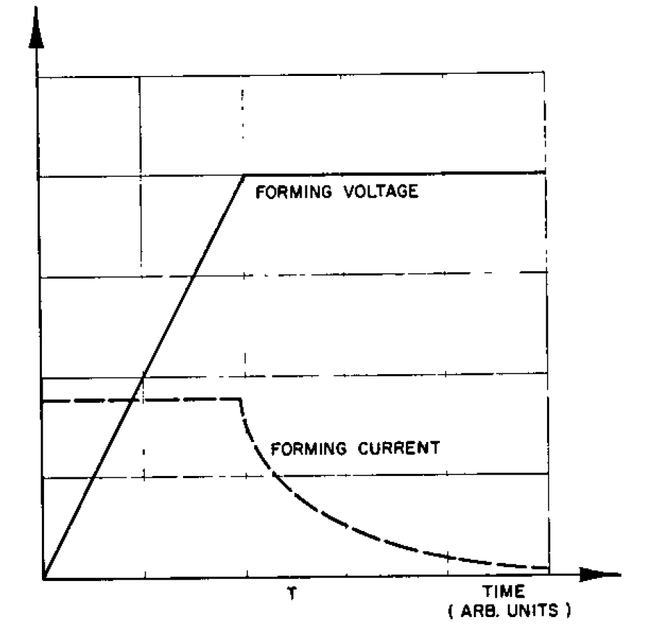

Figure : Anodization by a Constant Current – quote microminiturization

If a constant current is introduced, the voltage will (ideally) rise linearly with time. This will happen until the DUT reaches the compliance voltage, at which point the current through the DUT will begin to drop off until it reaches the leakage current of the unpackaged capacitor.   
  
  
**Design and Implementation of Custom System Used for Anodization**  
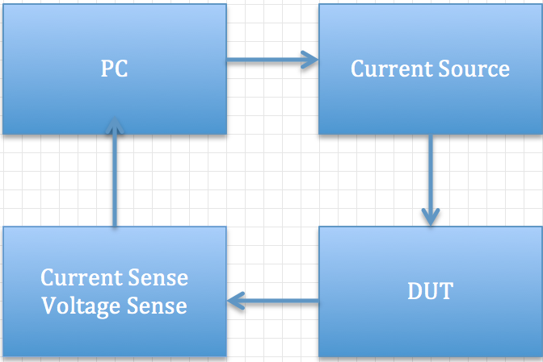

Figure : System Block Diagram

The overall system flow, fig #, is as follows:

The user sets the test parameters of current, voltage compliance, and testing time. Then the computer sends the configuration settings to the hardware with a command to start the test. The current source then turns on and regulates to the set current until the test is finished. The system is designed to work with a passive DUT. During the duration of the test, the current and voltage senses characterize the DUT and send the data to a PC for post processing.

**Computer**

The computer scripts for this setup are written in Python and are in charge of configuring the hardware for each test and logging data being sent from the board. The computer is not responsible for any real time control or system monitoring. Data is sent from the hardware at a high rate (see Current and Voltage Measurements section) and the PC subsamples this data and throws away what it does not want.

**Current Source:**

An ideal current source has the ability to output a constant, DC, current to any load with infinite voltage compliance. This ability makes a current source an attractive tool to use in anodization due to its ability to tightly control the rate of oxide growth on the anode.

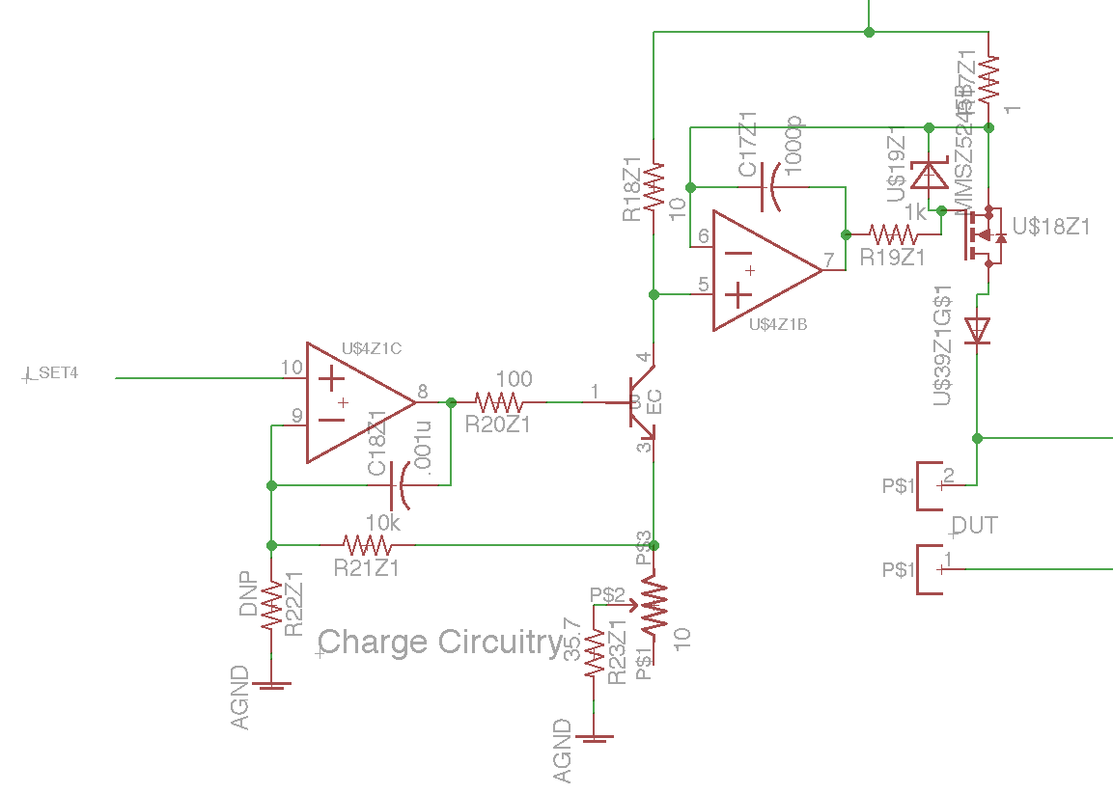

Figure : Current Mirror Schematic

The current source implementation, Fig 2, was chosen around an op-amp based current mirror. The op-amp on the left, U4Z1C, is used to set and regulate the current through R23. This current functions as the reference current on the left leg of the current mirror. The op-amp on the right, U4Z1B, forces the voltage drop across R17 and R18 to be the same, hence causing the current in the right leg to go as:

I2 = I1*R18/R17

With the values chosen in this design, this equates to a 10x current amplification from the reference to the current output. The adjustable supply voltage is applied to the node connecting resistors R17 and R18. The current source will be able supply a constant current up to an effective compliance voltage of the supply voltage minus the voltage drops of R17, the pass transistor, and the protection diode.

The real current source has several practical limitations that provide less than ideal performance.

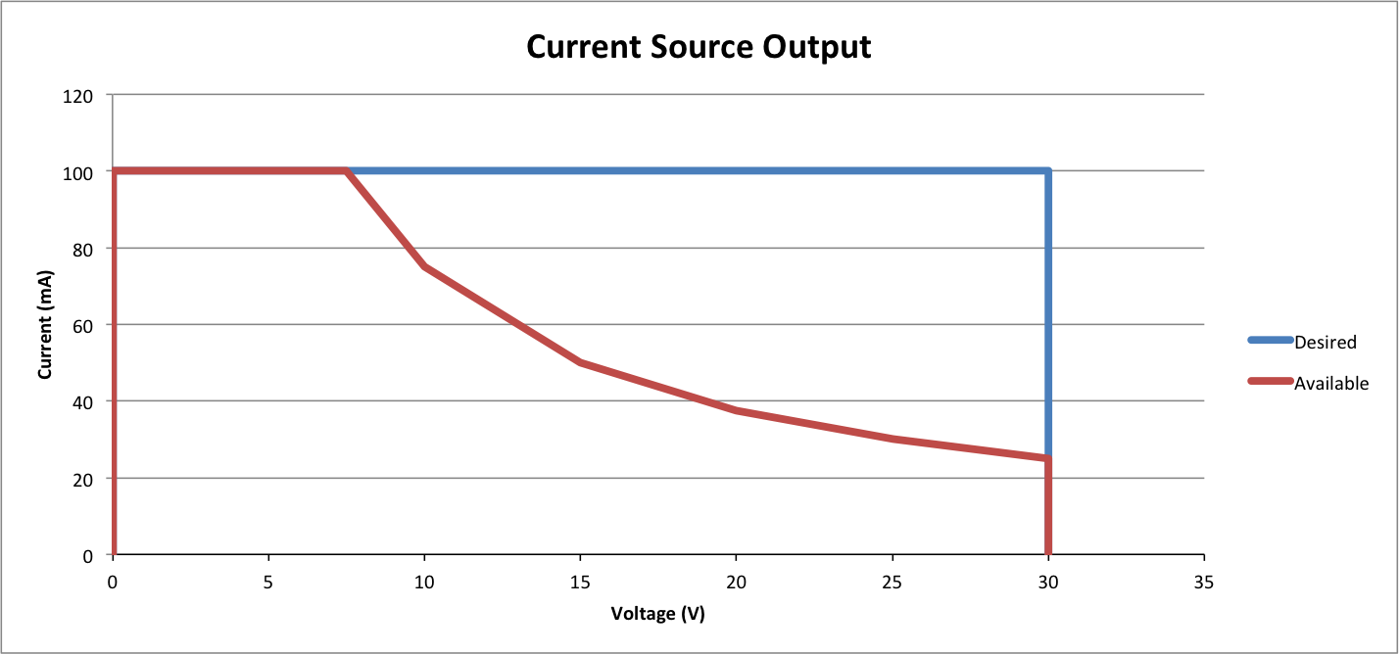

Figure : Current Source Safe Operating Area

The safe operating area, Fig. 3, is smaller than the desired operating output of 30V at 100mA. This difference comes from the limitations in the power dissipation of the pass transistor, U18Z1, in Fig. 2. Assuming the worse case scenario of a short on the output, the allowable output current for a given voltage compliance can be found as:

Iout = Prating / Vcomp

The current source operates by controlling the gate voltage of U18Z1 in Fig 2 to ensure a constant current as the voltage on the DUT changes. Ideally, the source would be able to respond to a change in load impedance instantaneous to keep the current output constant. The real current source of Fig 2 is limited by the Gain Bandwidth Product of U4X1B (1.8Mhz – reference datasheet). This limitation is of little concern, as the op-amp is still much faster then the fastest load change expected (See DUT section).

The ideal current source has the ability to output any desired current over its range with infinite precision. The current source in this design is limited in this regard by the discretization error of setting the current. Referring to Fig 2, the signal I_set4 is used as a control signal to set the reference current in the device. This signal is controlled by a Microchip MCP4812 10-bit DAC. A first approximation of the discretization uncertainty in selecting DAC outputs can be found by:

U = Vi_set /(2n-1) / (R23 + Rpot) *(R18/R17)

Which yields an uncertainty in the current output of +/- 0.5mA. This can be calibrated away for a single current output, but all other outputs would be off by as much as the uncertainty.

Also, the protection diode, U39, in Fig 2 has the effect of increasing the voltage compliance as the current drops off after anodization. Looking at a standard diode curve, the voltage drop across the diode is roughly a constant 0.7V for high currents and exponentially diminishes towards zero as the current decreases. The tests are designed to not only anodize, but also continue to measure the long-term leakage current afterwards. This means that the current draw will decrease to the nA range, causing the effective voltage compliance to increase to about a diode drop above its anodization level. This affect will need to be considered during the analysis of the anodization data.

**-----------------Add Sections on Accuracy, Precision, and Repeatability.**

**DUT**  
  
The device under test was typically meant to be a titanium anode to be anodized or a titanium capacitor. The device is able to operate with resistive loads and any capacitive loads (with capacitance large enough for the system to be able to respond.

**Current and Voltage Measurements**

The second part of the instrumentation is the measurement circuitry. An ideal measurement system would have no error or time delay when measuring the signal. It would also be able to perfectly reconstruct the signal for post analysis.

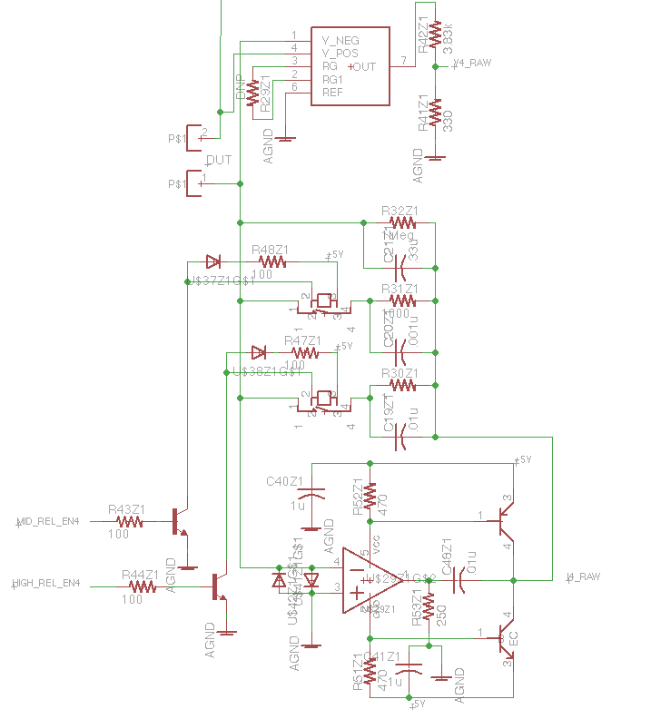

Figure : Measurement Circuitry

The measurement circuitry, Fig 4, implemented consists of two different parts, voltage and current measurements. The voltage of the DUT is measured differentially by Analog Device’s AD8220 JFET instrumentation amplifier. This output is scaled and then sent to a 12-bit DAC. The current through the DUT is measure from a low side measurement topology know and a transimpedance amplifier. The amplifier creates a virtual ground at the negative terminal of the op-amp,U39, that allows for a current reading without subjecting the measurement circuitry to a high voltage and without floating the bottom of the DUT above ground.

Since it is desirable the measure both the anodization current and the leakage current afterwards, a basic transimpedance amplifier design was modified to include 3 switched feedback paths. This allows the current measurement to measure currents over 8 orders of magnitude. The circuitry can handle currents from 10nA to 100mA.

The real measurement circuitry has several practical limitations that limit it from performing ideally. Both the differential amplifier and the transimpedance amplifier send their signals to 6-pole Sallen-Key filters. These filters have a cutoff frequency of 10kHz(quote S.thesis), in order to filter out high frequency harmonics and other undesirable noise. Any signals higher than this will be severely attenuated in the captured data.

The DACs inject digitization errors into the measurement signals. They are able to measure signals with resolutions shown in Table 1.

Table : DAC resolution

|  |  |  |
| --- | --- | --- |
| **Resolution** | **Full scale measurement** | **Comment** |
| **7.32mV** | **30V** |  |
| **.098mA** | **100mA** | **Hi current measurement** |
| **.98uA** | **1ma** | **Med current measurement** |
| **.98nA** | **1uA** | **Lo current measurement.\*** |

Once the data is collected onto the microcontroller, it is sent to a PC via USB for further analysis. The data is sampled by the ADCs at a rate of #baud and transferred to the PC at a rate of 2Mbaud. This allows for maximum flexibility on the PC side, where any data coming in at a rate greater than what is desired can simply be discarded.

**III. Experimental procedures.**

The experimental setup to anodize the anode of a titanium capacitor with the aforementioned circuitry is as follows. The anode sample is prepared by cleaning the surface oxide off with a chemical bath. It is then transported into a beaker of anodizing solution. The current source is connected to the DUT and acts as both a current source and data logger until the test is finished and the current through the DUT has dropped to the leakage current.  
  
  
**IV. Experimental results.  This can be a selection of the materials Don and Laurie have anodized.  To date I am not sure if we really have any from Don.**  
  
To date this method has anodized a number of different materials, including the following list:

|  |  |  |  |  |  |  |  |  |
| --- | --- | --- | --- | --- | --- | --- | --- | --- |
| **Test ID** | **Anode Material** | **Cathode Material** | **Electrolyte** | **Anodizing Current** | **Anodizing Compliance Voltage** | **Leakage Current (uA - 1kHz)** | **Series Resistance (ohms - 1kHz)** | **Capacitance (uF - 1kHz)** |
|  | **Ti2** | **Ti** | **1% H3PO4** |  |  |  |  |  |
| **06202011A** | **ZrIt 20/80** | **Ti** | **1%H3PO4** |  |  |  |  |  |
| **07052011E** | **ZrTi 20/80** |  | **1%H3PO4** |  |  |  |  |  |
| **07012011A** | **ZrTi 80/20** |  |  |  |  |  |  |  |
| **07012011B** | **ZrTi 50/50** |  |  |  |  |  |  |  |
| **06202011A** | **ZrTi 50/50** |  |  |  |  |  |  |  |
| **06202011B** | **ZrTi 50/50** |  |  |  |  |  |  |  |
| **06082001#3** | **Ti** |  | **5%H3PO4** | **20mA** | **30V** |  |  |  |