INSTRUMENTATION FOR ANODIZATION AND IN-SITU TESTING OF TITANIUM ALLOYS FOR CAPACITOR ANODES

by
STEVEN JOSEPH EHRET

Submitted in partial fulfillment of the requirements
For the degree of Master of Science

Thesis Advisor: Dr. Frank Merat

Department of Electrical Engineering

CASE WESTERN RESERVE UNIVERSITY

January, 2012

CASE WESTERN RESERVE UNIVERSITY
SCHOOL OF GRADUATE STUDIES

We hereby approve the thesis of

Steven Joseph Ehret_________________

candidate for the Master of Science degree*.

Dr. Frank Merat _____________________________________
(chair of the committee)
Dr. Christian Zorman _________________________________

Dr.Gerhard Welsch __________________________________

___________________________________________________

___________________________________________________

___________________________________________________

_July, 22 2011___
(date)

*We also certify that written approval has been obtained for any proprietary material contained therein.

Table of Contents
Table of Contents 1
Table of Figures 3
Table of Tables 5
Acknowledgements 6
Abstract 7
1. Introduction 8
1.1 Background 8
1.2 Aims of Work 8
1.3 Capacitors 10
1.3.1 Non-idealities of Capacitors 14
1.4 Titanium Alloy for Anode Material 15
1.4.1 Creation of Anode by Anodization 16
1.5 Instrumentation 19
1.5.1 Analog Control Circuitry 19
1.5.2 Analog to Digital Conversion 20
1.5.3 Microcontrollers 21
1.5.1 Software for User Interface and Data Acquisition 22
2. Experimental Procedure 23
2.1 System Level Design 23
2.1.1 Prototype I 26
2.1.2 Prototype II 27
2.1.3 Final Design 29
2.2 Physical Layout 47
2.3 Calibration 48
2.4 Test Setup 51
3. Results and Discussion 53
3.1 Anodization Mode 53
3.2 Testing Mode 65
4. Conclusions 68
5. Future Work 69
5.1 Improvements 69
5.2 High Voltage Version 69
Appendices 71
A. Circuit Schematics 71
B. Board Layout 75
C. Firmware (Pseudo code) 79
Bibliography 84

Table of Figures
Figure 1 – Structure of a parallel plate capacitor 10
Figure 2 – Representative layout of an electrolytic capacitor 12
Figure 3 – Non-ideal capacitor model 15
Figure 4 - Energy Density vs. Power Density for various types of energy storage devices. Goal 1 and Goal 2 areas represent research goals of ARPA-E funded research by G. Welsch (5) (6) 17
Figure 5 – Simplified experimental setup for anodization of sample 18
Figure 6 - Characteristic curve of anodic oxidation process (20) 18
Figure 7 – Top-level block diagram of instrumentation 25
Figure 8 - Voltage Compliance Circuitry 31
Figure 9 - Current source and control circuitry 33
Figure 10 - Current sink and control circuitry 35
Figure 11 - Transimpedance amplifier used to measure current through load 37
Figure 12 - Level shift and gain for current measurement signal conditioning 39
Figure 13 - Flowchart of firmware running on microcontroller 45
Figure 14 - Anode and cathode suspended in anodizing electrolyte by conducting metal clips 52
Figure 15 - Test setup to anodize two samples concurrently 52
Figure 16 - I V curves for aluminum electrolytic capacitor used as a reference test load 53
Figure 17 - Current vs. Time for repeated trials of reference capacitor 54
Figure 18 - Relative standard error for 17 trials of charging reference capacitor 54
Figure 19 - Results for 30 minute anodization of ZrTi 80/20 sample on Channel 1 56
Figure 20 - Results for 30 minute anodization of ZrTi 80/20 sample on Channel 2 57
Figure 21 - TiTa alloy sample showing large amounts of oxide breakdown and repair 58
Figure 22 - Results of anodizing titanium lead alloy with a 69/31 ratio of titanium to lead for 15 minutes 59
Figure 23 - Results of attempting to anodize a titanium lead alloy with a 50/50 ratio of titanium to lead 60
Figure 24 - Anodization results of a zirconium lead alloy with a ratio of Zi to Pb of 50/50 61
Figure 25 - Results for two samples of ZrTi 40/60 alloy showing possible contamination of the sample anodized on channel 2 of the instrument 62
Figure 26 - Results of anodizing ZrTi 50/50 for 24 hours. 63
Figure 27 - ZrTi - 50/50 leakage current testing at 2.5V for 2 minutes 64
Figure 28 - Energy required to form oxide during anodization, 1 second intervals 65
Figure 29 - Voltage across 1000 µF load with device in test mode 66
Figure 30 - Voltage across 1 µF load with device in test mode 66

Table of Tables
Table 1 – Dielectric constant (ε_{r}) and dielectric strength for various materials (2) 13
Table 2 - Final technical specifications 24

Acknowledgements
I would like to thank the following:

Dr. Frank Merat for his insight and guidance as my advisor throughout the process of performing the work contained within and writing this thesis,

Dr. C. C. Liu and Laurie Dudik for providing me with materials, lab space, and training to be able test the instrumentation designed for this thesis,

Dr. Gerhard Welsch and Donald McGervey for providing insight into the electrochemical processes and materials science behind anodization of capacitor anodes,

Friend and fellow student Morgan McClure for the use of his personal equipment and previous experience during assembly and debugging of the instrumentation designed for this thesis

And the United States’ Department of Energy’s ARPA-E Directorate for providing the funding to make this work possible.

Abstract
INSTRUMENTATION FOR ANODIZATION AND IN-SITU TESTING OF

TITANIUM ALLOYS FOR CAPACITOR ANODES

by

STEVEN JOSEPH EHRET

The development of smaller, more efficient energy storage devices is needed in industries ranging from consumer electronics to the automobile industry. One such device is the capacitor, which stores electrical energy in the form of an electric field. This electric field is established by the separation of charge between two conductors with an insulating dielectric between them. In electrolytic capacitors, this dielectric is an anodic oxide that is grown directly on the anode of the capacitor in an electrochemical process known as anodization. Research to develop electrolytic capacitors with increased power and energy densities using new materials and processes to create the capacitor anodes require the ability to record voltage and current data during the anodization process. This thesis presents the design of custom instrumentation that provides researchers with a platform to control the anodization parameters via a computer interface and record the current and voltage data necessary to aid in the development of advanced materials for capacitor anodes to a computer hard drive for later viewing and analysis. Initial results and performance analysis are also included.

1. Introduction

1.1 Background
In the electronics industry, the need for devices that have higher levels of performance is ever increasing. In particular, energy storage devices require greater energy and power densities, smaller physical size, and elimination of parasitic losses to allow the development of smaller, lighter, and more efficient technologies to be applied in areas ranging from portable consumer electronics to hybrid electric vehicles. One such energy storage device is a fundamental circuit element known as a capacitor. When a potential difference is applied to the conductors of a capacitor, energy is stored in the resulting electric field. An attractive feature of the capacitor is its ability to store and supply energy very quickly, resulting in capacitors being used in a multitude of applications where high power is needed for short periods of time. To achieve better performance in these areas, new materials and processes are being developed to manufacture capacitors. These processes would enable capacitors to achieve higher energy and power densities and have fewer parasitic losses (1). To facilitate the rapid development of these new materials, it is necessary to efficiently measure the pertinent electrical parameters to reject or further the development of samples.

1.2 Aims of Work
Research is being funded by ARPA-E to develop both materials and processes to create anodes for capacitors based on regular and surface enhanced titanium alloys. The goal of this thesis is to design, build, and test custom instrumentation that will facilitate the anodization and in-circuit testing of the titanium samples to determine the feasibility of a given sample as an anode material for an electrolytic capacitor. Parameters that will determine this feasibility will be interpreted from voltage and current data acquired by the instrumentation during anodization and subsequent testing. The instrumentation will interface directly with a computer, which will act as the user interface and save all sampled data to the computer’s hard disk drive for post-processing and analysis. To provide useful information to the research group’s members, the instrumentation must meet the following minimum requirements:
- Digitally programmable constant current source with upper voltage compliance of at least 30V capable of delivering a minimum controllable current of 1 mA and a maximum of at least 100 mA to the load for use in anodizing and testing a sample
- Sense and record the voltage across the sample during anodization and testing over a range of 0 - 30V while maintaining 10-bit accuracy at a sample rate capable of capturing all frequencies of interest (approximately, f < 10 kHz)
- Sense and record the current through the sample during anodization and testing over a range of 10 nA to 100 mA while maintaining 10-bit accuracy at a sample rate capable of capturing all frequencies of interest (approximately, f < 10 kHz)
- Capable of being a multiple channel device to facilitate faster, more efficient analysis of various anode materials
- Record all sensed data to a computer for post-processing and analysis
- Simple user interface running on the host computer to set up and control all channels of the instrumentation
This work will explore the various architectures and specific designs used to accomplish the specifications outlined above focusing primarily on the final design choices and initial results and performance analysis of the instrument. Analysis of data acquired with the instrumentation will illustrate its usefulness in determining the pertinent electrical characteristics of the sample during the anodization process and subsequent testing of the sample in the anodizing environment.

1.3 Capacitors
The simplest form of a capacitor consists of two parallel plates separated by a distance d filled with some dielectric with relative permittivity ε_{r} (see
Figure 1). This is known as a parallel plate capacitor and is the starting point for most analyses. The capacitance of this structure is described by the well-known equation
where C is the capacitance, ε₀ is the permittivity of free space, and A is the surface area of the plate and A >> d (2). In an ideal capacitor, the dielectric is a perfect insulator and
thus no charge will flow from one plate of the capacitor to the other. When a potential is applied across the plates, this leads to an accumulation of positive charge on one plate and negative charge on the opposite. This accumulation of charge causes an electric field to be established. The work required to cause the accumulation of charge on the plates of the capacitor is thus stored in this electric field. The amount of the energy stored in the capacitor can be calculated from the equation

Figure 1 – Structure of a parallel plate capacitor

d
ϵ_{r}
.
Ideally, all of this energy is able to be recovered if the charges stored on each of the plates are allowed to return to equilibrium. However, this is not possible in real devices due to parasitic effects of using real materials. One such effect is the equivalent series resistance (ESR) due to using imperfect conductors. The ESR causes heat to be dissipated internally to the capacitor while current flows during charging or discharging preventing recovery of all of the energy originally needed to charge the device. A second parasitic effect is due to imperfect insulating properties of the dielectric and packaging (3). These imperfections allow a small amount of current known as the leakage current to continuously flow from the anode to the cathode. It is impossible to recover the energy stored in the charge that comprises the leakage current when the capacitor is discharged.
Currently, there are two main types of capacitors commercially available. These are bulk dielectric and electrolytic capacitors. Basic bulk dielectric capacitors use an insulating material as the dielectric between two conductors similar to the parallel plate capacitor. Due to the symmetry of this type of capacitor, it is not polarized and can be used in any orientation in a circuit. This type of capacitor finds use in applications that involve high frequency signals, high temperatures and voltages, and signal filtering. Bulk dielectric capacitors are seldom used in applications requiring large amounts of energy storage. Another variation of this type of capacitor uses multiple layers of conductors and dielectrics to achieve larger capacitances and is known as a multilayer ceramic capacitor or MLCC.
Electrolytic capacitors differ in that the cathode of the capacitor is a liquid (wet) or solid (dry) electrolyte and the dielectric is an oxide (most often aluminum oxide, tantalum oxide, or niobium oxide) that is grown directly onto the anode substrate (see Figure 2). The electrolytes typically used commercially are an oxidizing acid in wet type

Figure 2 – Representative layout of an electrolytic capacitor
Electrolyte

Anode
Cathode

capacitors and solid manganese dioxide in dry type capacitors. Due to the asymmetry of the electrodes, these devices can only be used in a circuit in a single orientation. Table 1 lists various dielectrics that are used in modern capacitors. As can be seen, the dielectric constants and strengths of the oxide films are typically greater than those used in bulk dielectric capacitors. Referring to equation , the maximum amount of energy stored in a given capacitor occurs when V, A, and ϵ_{r} are maximized and d is minimized. The maximum voltage able to be applied to the capacitor is a function of the dielectric

strength and distance between the anode and cathode of the capacitor. The expression
,
where ξ is the dielectric strength of the insulating dielectric and d is its thickness, quantifies this relationship. Due to the coupled nature of V_{max} and d, the optimization of these parameters is simply a design choice and it makes more sense to discuss energy per volume of dielectric when comparing capacitor technologies. Assuming A∙d is the volume of the dielectric and substituting equations and ,
and it can be seen that maximizing ϵ_{r} and ξ maximizes the energy density of the dielectric. It is therefore evident that the dielectrics used in electrolytic capacitors allow greater energy densities for the same volume of dielectric. This leads to the common use of electrolytic capacitors in applications that require sourcing or sinking large amounts of charge in a short period of time (high power) such as power supply filtering, load balancing, and electric/hybrid-electric vehicles.
Material | Dielectric Constant | Dielectric Strength (V/m)
Air | 1.006 | 3 × 10⁶
Aluminum Oxide | 8.5 | 670 × 10⁶
Bakelite | 4.9 | 24 × 10⁶
Mica | ~5 | ~10-50 × 10⁶
Paper (kraft) | 3.7 | 16 × 10⁶
Polyethylene | ~2.3 | 50 × 10⁶
Tantalum Oxide | 26 | 500 × 10⁶
Teflon | 2.1 | 60 × 10⁶
Titanium Oxide (1) | 150 | 750 × 10⁶

Table 1 – Dielectric constant (ε_{r}) and dielectric strength for various materials (2)

1.3.1 Non-idealities of Capacitors

Because capacitors are real devices, the ideal capacitor is a theoretical construct good only for a first order analysis. Two important non-ideal characteristics of a capacitor are its equivalent series resistance (ESR) and leakage current (DCL) (this is also referred to as insulation resistance (IR) in capacitor technologies other than electrolytic capacitors). A third non-ideality is equivalent series inductance (ESL) that is less a function of the capacitor itself and more due to the packaging of the capacitor necessary to make it useful in real-world circuits.
The ESR of a capacitor is not caused by a single resistive loss in a certain part of the capacitor. It is the summation of all of the resistive losses in the capacitor during charging and discharging. For an electrolytic capacitor, this includes losses in the metallic leads of the anode and cathode and the electrolyte of the cathode. Similar to the series resistance of a battery, the ESR of a capacitor is the limiting factor of the power that the capacitors can deliver to a load because at high currents, too much voltage is dropped internally. Viewing the capacitor as represented in Figure 3, adding a load to the capacitor creates a standard voltage divider to which the maximum power delivered to the load is
when the load resistance is equal to R_{S}, the equivalent series resistance of the capacitor. In high power applications, it is desirable to achieve the smallest ESR possible.
C
R_{S}
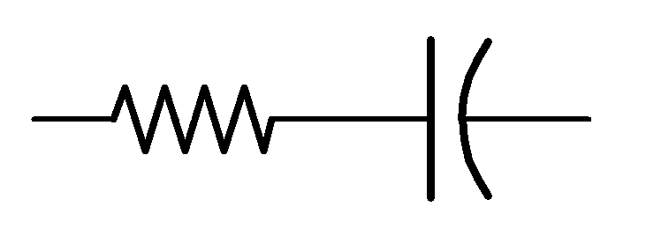
Figure 3 – Non-ideal capacitor model
The leakage current in a capacitor is current that flows from the cathode to the anode through one of many mechanisms. Some of these mechanisms are:
- Energy required to build up oxide layers
- Weaknesses in the dielectric which result in a low current flow
- Tunnel effects
- Dielectric absorption
- Cross currents outside the electrolytic capacitor winding, such as through the electrolyte films on surfaces such as the rubber sealing the capacitor (4)
The magnitude of the leakage current through an electrolytic capacitor is dependent on the capacitance, the voltage across, and the history of the capacitor. For this reason, many industry specifications state that a device’s leakage current is less than some threshold in the units of µA/µF∙V (3). This allows comparison among capacitors of different voltage ratings and capacitance. Leakage currents cause the capacitor to lose some of its stored energy over time. If used in a very low frequency application, the capacitor is allowed time to self-discharge and poor performance will be observed. Also, if used in a low current application, the capacitor may never fully charge if the leakage current is larger than the charging current. Minimizing the leakage current is essential to creating efficient capacitors.

1.4 Titanium Alloy for Anode Material
Research by G. Welsch, et al (5) argues that by controlling the composition, microstructure, and surface condition of titanium and titanium alloys it is possible to achieve very high energy and power density capacitors using TiO₂ or titanate-based dielectrics (5) (6). Past attempts to create capacitors using titanium based dielectrics were plagued by high leakage currents making them impractical for commercial applications, therefore ongoing research must ensure acceptable leakage currents in addition to high energy and power densities (3) (7). For applications such as hybrid electric vehicles, this combination of high energy and high power density is very desirable. Figure 4 depicts the energy density versus power density for various types of energy storage technologies. As can be seen, with respect to energy and power density, the titanium based capacitor technologies provide the best performance compared with current technologies.

1.4.1 Creation of Anode by Anodization
One process to form the anode in titanium based capacitors is anodic oxidation of the titanium or titanium alloy. This process involves setting up an electrical circuit such that the sample to be anodized is placed into an electrolyte bath and made the anode of the circuit by connecting it to the positive supply. The cathode is similarly placed into the bath and connected to the negative supply. A simplified experimental setup is depicted in Figure 5. The anodization process begins when the circuit is closed and current begins to flow. As electrons leave the positive anode, ions at the metal surface react with the electrolyte forming the oxide layer on the surface of the anode. The rate at which the 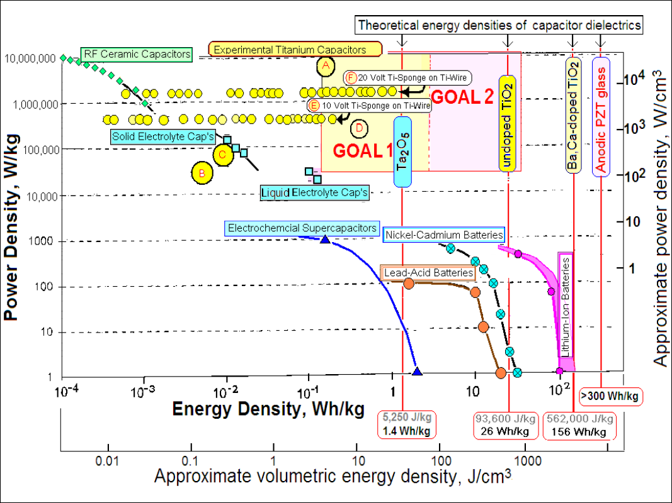oxide grows is proportional to the current density (A/cm²) entering the sample. Therefore it is possible to control the rate of oxide growth by using a current source instead of a simple battery or power supply as depicted in Figure 5. Due to the symmetry of the reaction across the entirety of the surface and the insulating material properties of the oxide, the thickness of the oxide is uniform across the entire sample because the potential difference from the anode to the electrolyte must be equal everywhere (8). The oxidation reaction will continue and the thickness will increase until the upper voltage limit of the power supply used in the experimental setup is reached. At this point, this voltage is known as the forming voltage and the thickness of the dielectric will be approximately equal to the anodization voltage divided by the dielectric strength as described in equation . At the forming voltage, the current through the sample begins to decrease, though the anodization process continues. The decreasing current indicates that the small defects and imperfections in the insulating oxide layer are being repaired and it is approaching an ideal insulator. After some amount of time, the residual current (usually in the microamp to nanoamp range) flowing from the anode to the cathode stops changing appreciably. This residual current is known as the leakage current. This is also how leakage current is defined and measured for packaged capacitors. Figure 6 shows the characteristic curve of a typical anodization process. As can be seen, the voltage increases linearly with time until the forming voltage in reached, at which point the oxide layer’s thickness no longer increases and the defects are repaired until the leakage current approaches zero (in the ideal case).
Figure 4 - Energy Density vs. Power Density for various types of energy storage devices. Goal 1 and Goal 2 areas represent research goals of ARPA-E funded research by G. Welsch (5) (6)

Electrolyte
Cathode
Anode
Figure 5 – Simplified experimental setup for anodization of sample
Figure 6 - Characteristic curve of anodic oxidation process (20)

1.5 Instrumentation
To facilitate the acquisition of data on large sets of materials and anodization parameters in an efficient manner, the development of instrumentation capable of automatically controlling the anodization parameters, testing electrical characteristics, and recording the resulting data of multiple samples simultaneously was necessary.

1.5.1 Analog Control Circuitry
Due to the fact that anodization is an electrochemical process that is sensitive to both current through and voltage across the sample, it is necessary to minimize the amount of time required to stabilize the anodizaton parameters of forming voltage and forming current. Implementing analog control circuitry eliminates the requirement for time-consuming analog-to-digital and digital-to-analog conversions and is limited only by the bandwidth of the components used to implement the controller. Also, interfacing the control circuitry to the analog components necessary to regulate the voltage and current requires few, if any, additional components. It is possible to control each of the aforementioned parameters using closed loop controllers implemented with a combination of active and passive circuit components with the set points being controlled by digital to analog converters.

1.5.2 Analog to Digital Conversion
The ability to record the necessary data observed during anodization of a sample requires analog data be transferred to the digital domain for long term storage and post-processing analysis. The process of analog to digital conversion involves sampling an unknown voltage and comparing this unknown voltage to a known reference voltage and finally representing the unknown voltage relative to the reference voltage as a digital number. Modern day analog to digital converters (ADCs) implemented on integrated circuits make this process relatively simple and minimally affect the system which is being measured. Because the digitally sampled version of the signal consists of discrete points, it is necessary to understand the limitations of digitally sampling a signal and take the necessary precautions to ensure that any information of interest is not lost during the conversion.
Because the sampled data must be represented digitally, there is an inherent limit to resolution of any measurement taken. This resolution is determined by the reference voltage the ADC uses and the number of bits it is capable of resolving. The resolution is described by
,
where n is the number of bits the ADC can resolve. The minimum required resolution and sampling rate must be determined before an ADC is selected for an application. As can be expected, higher sample rates yield lower resolution and vice versa. In applications where both a high sample rate is necessary to observe fast changing signals during some regions of operation and high resolution is necessary to obtain a high level of accuracy for slowly changing signals during other regions of operation, it is possible to increase the effective number of bits in software by a technique known as oversampling and decimation (9).
One of the most fundamental aspects of sampling theory is the commonly known Nyquist sampling theorem. This theorem states that to capture all of the frequency content of a given signal, the signal must be sampled at a frequency that is greater than twice the frequency of the highest frequency present in the signal. This theorem essentially limits the bandwidth of a signal to be sampled to one half of the sampling rate of the ADC used to make the conversion. In practice, in addition to ensuring a high enough sample rate to satisfy the Nyquist theorem, it is necessary to bandwidth limit any signal that is to be sampled to prevent any high frequency content (such as power supply or other noise) from aliasing into the sampled signal. This is accomplished by using analog low-pass filters before the signal is sampled. (10) (11)

1.5.3 Microcontrollers
A microcontroller is a small, dedicated computer that is often used in systems requiring embedded control and an interface between analog and digital realms. There are many families of microcontrollers produced by a large number of manufacturers, but the basic features of all microcontrollers are essentially the same. Each microcontroller contains memory which is programmed with a set of instructions that allow it to perform certain tasks. These tasks can vary widely and depend significantly on the feature set of the microcontroller in question. Common features present in modern microcontrollers include analog to digital converters, digital to analog converters, real time counters, serial communication protocols such as USARTs, SPI, I2C, etc., and general purpose digital input/output pins. All of these features are contained on a single integrated circuit making it an economic solution for applications requiring limited processing power coupled with interfaces to real world objects such as electrical and electromechanical systems (12).
The features required of a microcontroller to implement the instrumentation necessary for the present research are bi-directional serial communication to a PC, multi-channel ADC capable of sampling at a rate greater than 20 kSa/s at a resolution of at least 10 bits, multi-channel digital to analog converter (or serial interface to communicate with external DACs), and general purpose I/O pins capable of driving required loads such as indicator LEDs and transistors.

1.5.1 Software for User Interface and Data Acquisition
To enable the user to send commands to the instrumentation and save the acquired data for later analysis, it is necessary to implement a software interface on a computer to communicate with the microcontroller. This software allows the user to send start and stop signals for both anodization and testing modes for each individual channel as well as control the parameters for each mode of operation. The data acquired by the instrumentation is to be used for later analysis, so it is required to move the data from the microcontroller’s internal memory to a more permanent storage system such as a computer’s hard disk drive as the data is acquired. To accomplish this, the software must be able to interpret streaming serial data from the microcontroller and save it in a coherent file structure to the computer’s hard disk drive to be accessed at a later time.

2. Experimental Procedure
To begin the design process, it was necessary to fully define the required specifications of the device. The specifications were determined by examining the ranges of and modes of operation and the required level of accuracy to make meaningful conclusions from the data acquired by the device with respect to the electrochemical processes and electrical characteristics of the sample. From an electrical perspective, the primary mode of operation consists of being a constant current source for a capacitive load. The amount of current and upper voltage compliance level is set by the user from the user interface. The secondary mode of operation consists of being a constant current source and sink for a capacitive load. All modes of operation require the voltage across and the current through the load to be recorded and transmitted to a host computer for long term storage and later analysis. With these specifications in mind, circuits were designed, prototyped, and tested. Revisions to the original design were necessary to meet the original design goals and to accommodate changing technical specifications. Each design revision will be discussed, but a detailed analysis will be reserved for only the final design. A summary of the final technical specifications can be found in
Table 2.

2.1 System Level Design
From a system level perspective, the instrumentation requires three main design fronts. The three design fronts are the analog circuitry, the digital circuitry, and the software (including embedded firmware) required to communicate with and control the device and permanently record the data streaming from the device to a hard disk drive for later analysis. The device has two modes of operation: anodization and testing. The anodization mode provides a constant current to the load until the compliance voltage is reached. The testing mode uses the constant current source and the constant current sink to repeatedly charge and discharge the load between two voltage points. Due to the need for the digital circuitry and analog circuitry to interface with each other, it is necessary for both analog and digital signals to be present on the same circuit board. This requirement classifies the instrumentation as a mixed signal device and proper design techniques must be followed and implemented correctly to ensure on-board power and signal quality.
Description | Min | Normal | Max | Unit
Current Source | 1 | 20 | 1000 | mA
Compliance Voltage | 1 | 30 | 32 | V
Current Sink | 1 | 20 | 1000 | mA
Measurement Properties
Sample rate |  | 20 |  | kHz
Resolution | 8 | 12 | 13¹ | bits
Current  high range  middle range  low range | 1  1  1 |  | 1000  1000  1000 | mA  µA  nA
Voltage | 0 |  | 30.75 | V
Communication
Data rate |  | 2 |  | Mbits/s

Table 2 - Final technical specifications
Note 1: 13 bits achievable using oversampling and decimation
Though multiple designs and prototypes were tested before a final design was selected, the overall system level design has remained unchanged. Figure 7 depicts a block diagram of the system showing all of the major subsections required to implement the instrumentation and will be the basis of discussion for all design revisions. As can be seen, with this architecture there is little hardware overhead to manage multiple channels on a single device. This allows a single device to control as many channels as space constraints and the hardware will allow. Each subsection can be broken down further into either hardware or software blocks or some combination thereof and will be discussed as such.
User Interface
Bidirectional
PC - Instrument
Communication
State Machine
Analog
Front-end
Data Logging
DAC
ADC
Control
Circuitry
Data Interpreter/ Assembler
Contents of dashed box comprise one channel
Current/Voltage Measurement
Figure 7 – Top-level block diagram of instrumentation

2.1.1 Prototype I
In hopes of simplifying the overall project by eliminating the need for custom software or embedded firmware, the first design revision focused on the analog front-end of the device and tested the feasibility of using off-the-shelf solutions for data acquisition and storage. It was known before prototyping that this design served only as a proof of concept for the analog front-end and control circuitry and did not fulfill the requirements regarding the ability to control the anodization and testing parameters from the user interface. If using the off-the-shelf solution for data acquisition proved possible, the remaining features would be implemented.
Control of the current level and voltage compliance level was accomplished by simply using a single-turn potentiometer to establish the set points for the control circuitry. This approach did not provide precise control, but through repeated testing proved that the control circuitry and front-end was consistent and functioned as designed. The voltage across the sample was detected by using an op-amp in a differential amplifier configuration with buffered inputs connected to the high and low side of the sample. The current through the sample during anodization was sensed by using a low-side sense resistor and amplifying the resulting voltage in the same fashion as the voltage across the sample. When the voltage across the sense resistor was too small to be distinguishable from the noise in the system, the current path was switched from the circuit ground to the input of a logarithmic amplifier (TI LOG114 (13)) via solid-state relays. The LOG114 is specified to be able to amplify current inputs from 100 picoamps to 10 milliamps to a voltage to be read by an ADC, so it was necessary use two ADC channels to monitor the current through the sample over the full range of anodization currents down to low level leakage currents.
The data acquisition device used in this design was the National Instruments USB-6008 (14). This device is capable of recording 12-bit measurements at up to 10 kSa/s and connects to a computer running National Instruments LabVIEW via USB. Also, because the NI USB-6008 is fully supported by National Instruments LabVIEW, using this method for data acquisition would eliminate any need for custom software or firmware to record the required data from the device. Unfortunately, the data acquired using the NI USB-6008 proved to be mostly noise during low current measurements which was unsuitable for this application. It was determined that the NI USB-6008 was not the proper choice for this application due to its large absolute accuracy error, the necessity for external wiring, and its relatively high cost.

2.1.2 Prototype II

Given that the first prototype proved the validity of the design of the analog circuitry, the second design focused on incorporating the remaining features, moving the ADCs onboard, and improving the performance of the analog circuitry. Before working towards incremental improvements, determining the best architecture to implement the remaining features was necessary. The remaining features to be implemented at this point were the ability to set the mode of operation and necessary parameters from a computer interface, multiple channel support, and data acquisition. With these requirements in mind, it was realized that the feature sets of modern microcontrollers coupled with the ability to write custom firmware would be capable of accomplishing all of the needed tasks and thus the design mostly focused around implementation of the embedded solution.
Communication with the computer is accomplished via a serial connection using the microcontroller’s onboard universal asynchronous receiver/transmitter (UART) and the computers USB connection. The protocol for USB and UART are not the same so a separate USB to UART integrated circuit was necessary to facilitate the communication between the computer and the microcontroller. It was also necessary to define a custom packet structure for communication between the computer and the microcontroller.
Packets received by the microcontroller contain information regarding channel setup parameters (voltage compliance and current settings) and whether a channel’s output should be active or high impedance. To establish the set points for the voltage compliance control circuitry and the current control circuitry, a PWM signal was generated by the microcontroller with the duty cycle being set by the information contained in the setup packets. The PWM signal was then low pass filtered to achieve a DC voltage to be used by the control circuitry.
As shown in the block diagram of Figure 7, adding a channel is modular and can be done without affecting the hardware responsible for communicating with the computer. The total number of channels able to be present on one device is determined by the number of input/output pins on the microcontroller needed to monitor and control each channel. In the case of this design, that amounted to a four channel device with each channel operating completely independently.
In addition to general purpose I/O, modern microcontrollers often contain additional peripherals that can be enabled to allow enhanced functionality. One such feature used in this design is built in analog-to-digital converters. Coupled with multiplexed inputs, the integrated ADC allows multiple analog signal levels to be sampled and processed without any additional external hardware (aside from any necessary filtering). This design requires three analog measurements for each channel: voltage across, high current through, and low leakage current through the sample. Ultimately, the number of ADC channels available was the limiting factor when determining the total number of channels each device was capable of operating concurrently.
This design functioned as designed, but its performance was limited by the power ratings of some parts and the capabilities of the on-chip ADCs. Due to insufficient power ratings of some transistors, the current sourcing capability of the analog front-end was limited to approximately 50 milliamps. Also, due to the multiplexed nature of the ADC, the sampling rate on a per measurement per channel basis was not fast enough to capture all of the frequency content of interest, which ranged up to 10 kHz. Due to the compressive nature of the logarithmic amplifier used to measure the low valued leakage currents, the 10-bit resolution of the on-chip ADC lacked enough resolution to discern useful information from the data in some regions of operation.

2.1.3 Final Design

The final design follows the same structure as the second prototype, but major changes were implemented where necessary and the remaining circuitry improves performance and minimizes cost wherever possible. A detailed analysis of this design will be broken down into the three main areas of design: analog circuitry, digital circuitry, and the software/firmware.

2.1.3.1 Analog Circuitry
The analog circuitry consists of five main areas: voltage compliance and control, current source/sink and control, measurement, filtering and signal conditioning, and power. Each section can be designed and analyzed independently, but it must be kept in mind that all of the sections are interconnected and must be designed to work together. Due to this interdependence, some aspects of the design are iterative in nature and only the final result will be discussed.
The purpose of the voltage compliance circuitry is to enforce an upper voltage limit for the current source. An ideal current source can produce whatever voltage necessary to cause the desired amount of current to flow, but this behavior is not always desired. For example, if the load is only rated at 20V, it is desirable to limit the voltage applied to the load to 20V to prevent damage or destruction of the load even if the current delivered to the load ceases to be equal to what the current source is trying to deliver. The circuitry to accomplish this goal is depicted in Figure 8. This circuit configuration uses an op-amp in a non-inverting configuration with an external output stage. When connected to the current source circuitry correctly, the voltage at the emitter of the BJT is the maximum voltage available to the current source. This voltage level is set by the signal VSET and the ratio of R10 to R9:
.
To meet the design specifications, the compliance voltage must be capable of ranging from 0 – 30V, meaning that the op-amp’s output voltage must be capable of outputting at least 30 plus the transistors base-emitter voltage drop. Per the design specifications, the output transistor must be capable of handling a collector current of at least 1A. The power dissipated by the output transistor is approximately
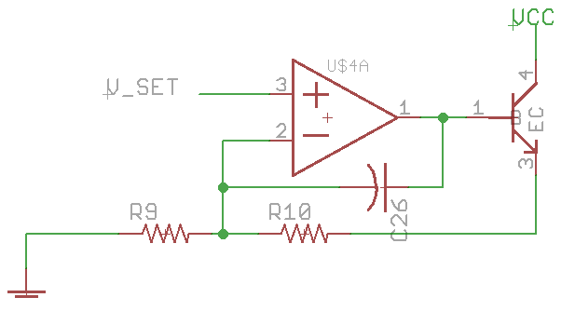
Figure 8 - Voltage Compliance Circuitry

It is obvious from equation that the amount of power dissipated by the output transistor would require a large heat sink to prevent destruction of the output transistor at high collector currents and low compliance voltages if operated continuously. Luckily, this application does not require continuous operation and therefore the average power dissipated by the output transistor does not require additional heat sinking. Even so, for large values of I_{C}, the safe operating area for the device requires the compliance voltage to approach V_{CC}. Finally, C26 serves as high frequency feedback to help stabilize the output of the amplifier. This is needed due to the phase-delay introduced by the addition of the external output stage.
The current source consists of one leg of an active current mirror. Figure 9 shows the circuitry necessary to construct the current mirror along with the circuitry necessary to actively control the current source. The current to be mirrored is set by the signal I_SET1 which is buffered through the left op-amp and subsequent output stage to the emitter of the output transistor. The voltage at this point in combination with the series resistance of R23 and the potentiometer sets the current to be
,
where R_{POT} is adjustable to calibrate the device. This is necessary due to discrepancies in the true resistance of R23. The feedback resistor R21 is not absolutely necessary, but in combination with C18, it helps stabilize the amplifier by isolating the emitter voltage from the non-inverting input of the op-amp. Without R21, the high frequency feedback provided by C18 would also affect the desired output voltage at the emitter of the output transistor, which defeats the purpose of including C18. The current mirror is designed to mirror the current to the device under test (DUT) in a ratio set by R17 and R18. In order for the right op-amp to achieve a stable operating point, the voltages at its inverting and non-inverting inputs must be equal. This condition is only true when the following equality holds:
.
Reducing, the current ratio is
.
This allows the value of I_{SET} to remain small compared to the desired current to be sourced to the device under test. This in turn reduces the amount of power needed to be dissipated by the output transistor. The control of the output current is governed by the right op-amp. Assuming that a constant current is flowing through R18, the voltage at the non-inverting input of the op-amp is also constant and equal to the left hand side of equation . If no current is flowing through R17, the voltage at the inverting input is equal to V_{compliance} and is less than the voltage at the non-inverting input. This causes the output of the op-amp to start decreasing, which in turn begins to turn on PMOS1 causing current to flow through R17. The output of the op-amp continues to decrease until enough current is flowing through R17 to satisfy equation . The presence of R19 slows the turn on time of PMOS1 causing the system to become overdamped, preventing undesirable overshoot of I_{desired}. C17 provides high frequency feedback to prevent oscillation at the output of the amplifier. The zener diode Z1 is present to preven the gate-source voltage of PMOS1 from exceeding its maximum rating. The reverse breakdown voltage of Z1 must therefore be greater than the gate threshold voltage of PMOS1 to ensure that it can fully turn on but less than the maximum gate-source voltage to prevent failure or reduced life of PMOS1. The diode D1 is present to prevent current from flowing through the body diode of PMOS1 in the case that V_{compliance} is less than the voltage on the device under test (recalling that under normal operating conditions the device under test will be capacitive).
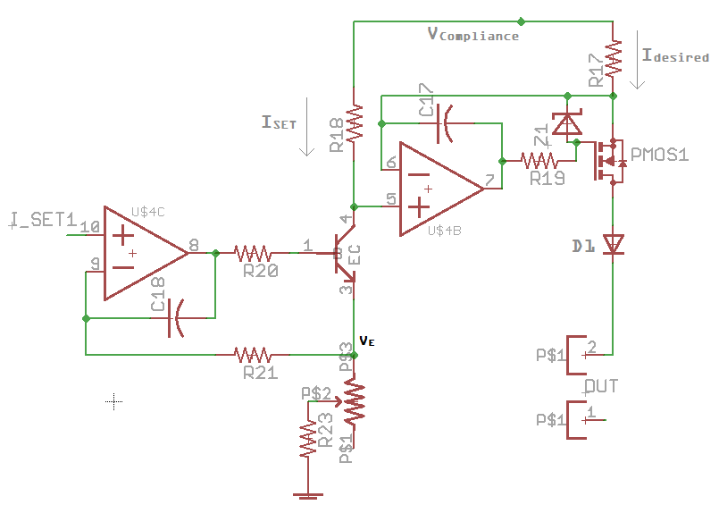
Figure 9 - Current source and control circuitry

The circuitry to implement the current sink is similar to that used to establish the set current for the current source. There is no need for a current mirror in this case because the capacitive load provides the source of the current and will continue to provide this current until the charge stored in the load is exhausted. Once this source is exhausted there is no need to try to continue sinking current as the load is already discharged. This is not the case during normal operation of the current source where small amounts of current are still drawn by the load even after the capacitance is fully charged. As can be seen in Figure 10, the signal ISET1 is buffered to the source of the N-channel MOSFET, which sets the drain current to be
.
The total value of the denominator of this equation is equal to one-tenth of the resistance of the denominator of equation to achieve equal source and sink currents with a single value of ISET_1. The choice to use a MOSFET in this case instead of a BJT arose from the fact that it was possible to pick a MOSFET with higher power dissipation capabilities for the same package and cost. Finally, the other MOSFET, U$24, is used to disable the current sink without affecting the value of ISET_1 necessary to operate the current source. When EN# is low, ISET_1 is present at the non-inverting input of the op-amp, but when EN# is high, the non-inverting input of the op-amp is shorted to ground through U$24, effectively commanding zero current to the current sink control circuitry. A combination of transistors used as switches implements logic preventing both the current source and sink from being active at the same time.
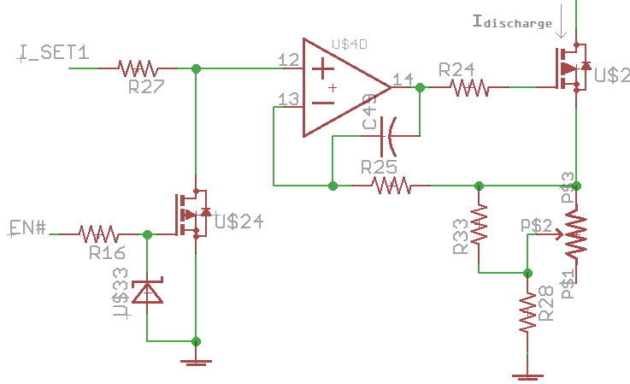
Figure 10 - Current sink and control circuitry

Measurement of the voltage across the load is accomplished by simply using an off-the-shelf instrumentation amplifier configured to have a gain of 1x. Because the load is only referenced to a virtual ground, the negative input of the instrumentation amplifier is connected to this point instead of the circuit ground. This provides the true voltage across the load even during transients when the virtual ground may be at a potential above or below the true circuit ground. The output of the instrumentation amplifier is resistively divided down so that the full range of 0 – 30V can be captured by the input range of the ADC, which is 0 – 2.44V. This circuitry can be seen in the full schematic in Appendix A.
Measuring the current through the sample over a dynamic range of 1 amp to 1 nanoamp proved to be a non-trivial task. The first attempt using a logarithmic amplifier to continuously measure the current over the range of 1 milliamp to 1 nanoamp proved too sensitive for this application and was plagued by oscillation issues. It was determined that a continuous measurement from 1 milliamp to 1 nanoamp was not absolutely necessary and it was possible to use an amplifier with multiple measurement ranges that auto-range as required. A transimpedance amplifier was constructed capable of measuring currents in three ranges. The circuitry implementing this amplifier is depicted in Figure 11. Assuming that zero current flows into the input terminals, the current to be measured, I_{measured}, flows completely through one of the selected combination of feedback resistors R₃₀, R₃₁, or R₃₂. The values of R₃₀, R₃₁, or R₃₂ each differ by a factor of 1000, so it is possible to keep the largest value of resistance, R₃₂ in the feedback path at all times without affecting the total feedback resistance by an amount greater than the tolerance of the parts (ie 1 Ω | | 1MΩ = 0.999999Ω). The gain of the amplifier in this configuration is
.
Relays controlled by the signals MID_REL_EN1 and HIGN_REL_EN1 set the value of the total feedback resistance to values of approximately1Ω, 1kΩ, and 1MΩ. With a desired V_{out} of -1V – 1V, this gives three current measurement ranges of: +/- 1A – 1mA, +/- 1mA - 1µA, and +/- 1µA – 1nA. A diode and resistor are included across the relay’s coil’s terminals to provide a current path with additional damping to prevent damage to the switching transistor when the inductive load is switched. The external output stage for the op-amp is necessary to enable the amplifier to source or sink up to 1A without risk of damaging the op-amp (15). Diodes placed across the inputs of the op-amp serve as protective clamps to prevent the voltage at the inverting input of the op-amp from exceeding values that could cause reverse polarity on the load in the event of device failure, maintaining the virtual ground at this point.
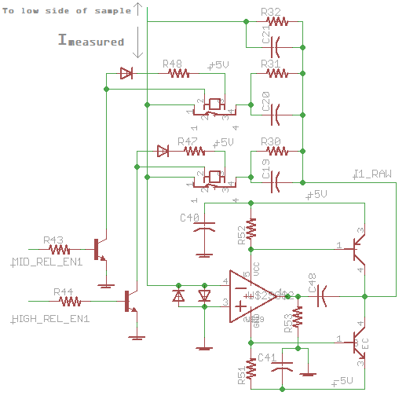
Figure 11 - Transimpedance amplifier used to measure current through load

Before sampling by the ADC, proper signal conditioning of the measurement signals is necessary. The signal must be amplified and level shifted to the appropriate voltage range that the ADC is capable of measuring. Low-pass filtering is also necessary to avoid aliasing of high frequencies into the digital signal. Both the voltage and current measurement signals are filtered using 6th-order active Butterworth filters using the Sallen-Key topology with a passband frequency of 10kHz. This provides a response that rolls of at -120 dB/decade, which is plenty of attenuation to ensure that frequencies greater than the Nyquist frequency of the system are not present in the sampled signal. As previously mentioned, the voltage measurement is scaled to the correct voltage level for measurement by a resistive divider at the output of the instrumentation amplifier before being filtered. The output of the transimpedance amplifier ranges from -1 to +1V, and therefore this signal must both be level shifted and amplified before being filtered to be within the ADCs measurement range of 0 – 2.44V. Inversion of the signal about 0V is also desired so that positive ADC results correspond to positive currents and vice-versa. This gain and level shift is accomplished by using an op-amp in a differential amplifier configuration shown in Figure 12. The amplifier in this configuration has a gain of
which satisfies the requirements of the input and output ranges of the ADC and transimpedance amplifier.
The power requirements of the circuitry are defined by the requirements of the necessary operating voltages of all of the components on the board. The resulting required voltage rails are +34V, +/- 5V, and +3.3V. Each of these voltage rails is created on board through the use of linear regulators from external +36V, +6V, and -6V sources, respectively. Using a switching regulator to avoid the need for a third voltage input (+6V) was considered but ultimately rejected to eliminate the possibility of switching noise on the power rails from affecting the sensitive analog measurements. The +34V rail is necessary to ensure voltage compliance levels up to 30V with some overhead for the control circuitry requiring higher voltages to maintain a voltage compliance of 30V. The +/- 5V rails are used to power op-amps needing to operate at or near circuit ground and as reference voltages. The +3.3V rail is used exclusively for powering the digital devices. Proper local bypassing of all components with .1 – 1µF capacitors is required to ensure clean power signals to all components. Components such as the ADC that require an even cleaner power rail also have series inductance near the component’s power pins to create a local LC low-pass filter on the power rail to further eliminate any high frequency noise.
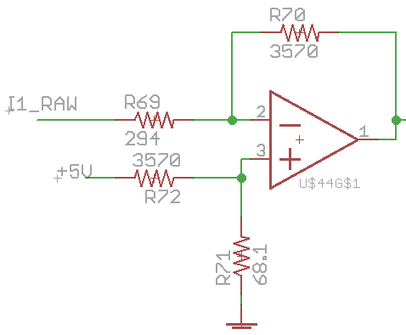
Figure 12 - Level shift and gain for current measurement signal conditioning

2.1.3.2 Digital Circuitry
The digital circuitry can be broken down into three main components: the microcontroller, microcontroller to computer communication, and digital to analog converters. The microcontroller is paramount to the function of all of the digital circuitry and will thus be the main focus of discussion.
The microcontroller to be used in this application must be capable of fulfilling the following roles: serial communication to a computer, analog to digital conversion at a sample rate fast enough to capture all frequencies of interest, serial communication to external peripherals, accurate internal timing, enough general purpose digital I/O pins for all control signals, in-circuit programming, and sufficient program memory to store the necessary firmware. One such microcontroller family that fulfills all of these requirements and is an economically viable solution is Atmel’s ATXMEGA A series (16). The specific microcontroller chosen for this application was the ATXMEGA64A3 (17). Each of the aforementioned required features and capabilities will be further discussed in the context of the ATXMEGA64A3.
One of the primary purposes of the microcontroller is to enable serial communication to the PC. This is accomplished using the microcontroller’s hardware UART. Once the proper registers are loaded with data to be transmitted, the hardware UART allows the serial communication to happen in the background saving system clock cycles for executing the main program code and handling interrupts. Likewise, the hardware UART is always listening for data to receive and only requires system clock cycles once a full byte has been received. Though a majority of modern computers support communication with a UART, not all are equipped with standard serial communication ports, especially laptop computers. To make the device simple to connect to most computers, an additional integrated circuit was included with the design that performs USB to UART conversion to allow the microcontroller to seamlessly talk to the computer via a USB connection (18). Due to the asynchronous nature of using a UART, it is only possible to achieve a data rate up to eight times the system clock. This is due to a minimum requirement of sampling each data bit eight times to guarantee accurate clock recovery. With a 32MHz system clock, the maximum data rate is 4Mbaud, but a data rate of 2Mbaud was chosen to help prevent any packet corruption that could possibly be caused by pushing the hardware capabilities to the absolute limit.
The second primary function of the microcontroller is to handle all of the analog to digital conversions. Using separate ADC chips could have possibly yielded faster sample rates and overall resolution, but at significant economic and software overhead costs. The ATXMEGA64A3 contains two physical pipeline ADCs capable of achieving 12 bit resolution at sample rates of up to 1 million samples per second. The pipeline architecture allows each ADC to convert multiple sampled signals simultaneously, though each conversion must start on separate ADC clock cycles. The ATXMEGA64A3 is limited to four simultaneous measurements per ADC, effectively allowing eight simultaneous analog to digital conversions. With each instrument channel requiring two analog to digital measurements, this limits the total number of channels per device to four.
The voltages at the inputs of the ADC are limited to the rails of the microcontroller which are circuit ground and 3.3V. Though it is possible to use the 3.3V rail as the basis for reference voltage, in the interest of achieving a more stable voltage reference, an external voltage reference of 1.22V was used. With 11 bits of resolution, this voltage reference sets the conversion factor of ADC counts to mV to be
.
Because the ADC takes a differential measurement, to achieve full 12 bit resolution the result is signed with respect to the negative input of the ADC. The ADC result is positive when the voltage at the positive input of the ADC is greater than the voltage at the negative input of the ADC and the result is negative when the opposite is true. To utilize the full-range of input to the ADC, a constant center voltage reference of 1.22V was provided to the negative input of the ADCs for all channels to mimic a 12 bit single ended measurement with upper and lower input bounds of 2.44V and 0V, respectively. These limits are defined by the fact that if a voltage is applied across the inverting and non-inverting pins of the ADC that is greater than the reference voltage, the output of the ADC will saturate. For the measurement of the voltage across the load, a positive and negative result does not make sense because the voltage will never be negative with respect to ground. In this case, the sign of the ADC result is only used to achieve full n bit resolution and a constant 2^{n-1} is added to the result to give a resulting conversion equation of
,
where V_{load} and V_{max} are in ADC counts. For the measurement of the current through the load, the sign of the ADC result has meaning due to the possibility of both positive and negative current flow through the load. Recalling from equation , the voltage output of the measurement circuitry is negative for positive currents and positive for negative currents. The signal conditioning circuitry then gains and level shifts this voltage such that when sampled by the ADC, the most negative ADC result corresponds to the most negative current possible to be measured, zero ADC result corresponds to zero current flow, and the maximum ADC result corresponds to the maximum positive current possible to be measured. Though all n bits of the ADC result are meaningful in this configuration, the effective result for each positive and negative current is only n – 1 bits.
Because one of the primary functions of the instrument is to serve as a data acquisition device, being able to deterministically tell when each sample was taken is not only desirable, but required. This is accomplished using a combination of features present on the ATXMEGA64A3. By using the overflow of a hardware timer to trigger the start of an ADC conversion automatically (no system clock cycles necessary), each group of ADC measurements is started at a predetermined and regular interval. By ensuring that the period of this interval is greater than the time necessary to complete all of the ADC conversions and any additional computations to process and transmit the raw data, the result transmitted to the computer is known to have been recorded periodically. Therefore, the time of each measurement can be fully determined relative to the first measurement taken given the system clock frequency and value at which the hardware timer overflows. This method of timing is subject only to error in the periodicity of the system clock, which is small enough to be disregarded given the frequencies of interest to be measured.
The microcontroller has the ability to communicate with external peripherals via the industry standard Serial Peripheral Interface Bus (SPI). This standard allows serial communication between a master and multiple slave devices through the use of common data lines and individual slave-select signals for each slave in the system. In this fashion it is possible to address any combination of slaves in a single write operation if the data to be sent to the slaves is the same. In this application, this interface is used to communicate to a single two-channel digital to analog converter per device channel to control the set points for the voltage compliance and current control circuitry. Each DAC has 10 bits of resolution and is capable of outputting 0 – 4.096V. Control of each channel of the DAC is accomplished by sending a two-byte communication via SPI to select channel A or B, enable or disable the output, and the 10 bit value to which the output should be set.

2.1.3.3 Firmware
The firmware consists of the code that resides in the microcontroller’s memory that is executed on device power-up. The purpose of the firmware in this application is to handle the data acquired by the ADCs, transmit the acquired data to the computer, and to keep track of and assign the correct state for each device channel. A flowchart of the firmware’s main program loop is depicted in Figure 13. This flowchart does not include any of the interrupt service routines that interact with the hardware peripherals such as the UART, SPI, and ADC. At any point during program operation, if an interrupt request generated by an event occurring on one of the hardware peripherals is received by the microcontroller’s internal interrupt controller, the next program line executed is the code located at the given interrupt vector. Once the interrupt code has been executed, program flow returns to the main program code depicted in Figure 13 and the next line of code executed is the same as if the interrupt never occurred. This allows multiple peripherals to function in parallel, even though the microcontroller only executes code serially.
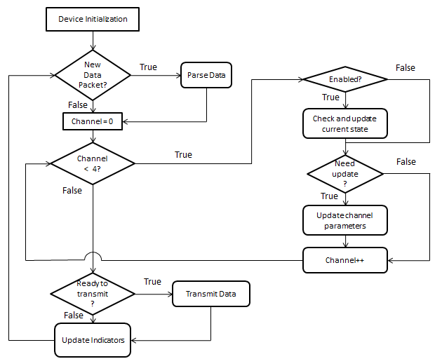
Figure 13 - Flowchart of firmware running on microcontroller

Even though it is a hardware implemented peripheral, the firmware is also responsible for controlling the ADC and performing any necessary digital filtering. Due to the low bandwidth of the signals of interest during anodization, it is possible to use the extra bandwidth of the ADC to implement a technique known as oversampling and decimation to achieve an extra effective bit of resolution in the ADC result (9). This technique is usable if there is zero-mean noise of sufficient amplitude in the signal being sampled to toggle the LSB of the ADC result. Referring to equation , the amplitude of the noise must only be greater than approximately 0.6 mV. The signals to be sampled were viewed using an oscilloscope and confirmed the zero-mean nature and amplitude of the noise component necessary to implement this technique. Oversampling and decimation was used to obtain one additional bit of resolution, yielding a final result of 13-bit resolution over the analog input range of 0 – 2.44V. To limit the amount of data transmitted to the computer for long-term storage, the oversampled and decimated data was time-averaged using 8 samples or 256 samples depending on the measurement range in which the device is operating.
Detailed pseudo-code for all of the firmware is presented in Appendix C.

2.1.3.4 Software
Software running on the computer connected to the device serves as a user interface and as a platform to permanently store the data acquired by the device. The data presented in this thesis was acquired using a preliminary version of the software created using MATLAB. The software allows the user to enter the desired anodization current and compliance voltage for each channel and the desired amount of time for the sample to run. This setup data is transmitted to the instrument followed by the packet commanding the instrument to enable the desired channels with the current setup data. At this point, data begins being transmitted to the computer. Before the computer’s serial buffer is exhausted, the data present in the buffer is moved from the buffer to be stored permanently to the computer’s hard disk drive freeing the serial buffer to accept additional incoming data. Once the desired amount of time for the channel to be enabled has passed, the software sends a packet commanding the instrument to disable the selected channels and stop transmitting data to the computer. The amount of data the software implemented in MATLAB is capable of handling in a given period of time is limited by the amount of system RAM available on the computer. Due to this limitation, excessively long periods of data acquisition are unachievable. Software to be run using National Instruments LabVIEW has been developed concurrently and eliminates this limitation while also providing a user-friendly GUI to setup, start, and stop each of the instrumentation channels.

2.2 Physical Layout
Due to the complexity of the analog and digital circuits and the fact that many parts chosen for the design are only available in surface mount packages, a custom four-layer printed circuit board (PCB) was necessary to produce and test the design. The PCB was designed using Cadsoft’s EAGLE PCB Software and fabricated by Advanced Circuits. Due to the mixed signal nature of the design, care had to be taken to ensure that noise caused by digital switching did not interfere with the performance of the analog circuitry. This was accomplished by using a hybridization of ground planes and star grounding techniques. The analog circuitry and the digital circuitry each had its own ground plane to provide low impedance paths for return currents. These two ground planes were joined at a single point directly at the circuit board’s connection to the power supply ground to prevent short spikes of high current due to digital switching from inducing voltage differentials across the analog ground plane. Also, an entire layer adjacent to the ground planes layer was dedicated to power supply planes. This structure of the power and ground planes essentially creates a large area parallel plate capacitor out of the power and ground planes. This additional capacitance helps reduce high frequency noise present in the power rails across the entirety of the circuit board. The power and ground planes occupied the inner two layers of the circuit board while both of the outer layers were reserved for signal traces only. Printouts of the individual copper layers used in the final design can be found in Appendix B.

2.3 Calibration
For each device channel there is a combination of hardware calibration and software calibration required to ensure accurate results when using the instrument. Hardware calibration is required to ensure equal source and sink currents from the single set point that is provided to both the current source and sink control circuitry. Software calibration is necessary to remove any offsets from the ADC. Characterization of the ADC output is also necessary to ensure that converting from ADC counts back to real units introduces minimal error.
The hardware calibration is accomplished by adjusting the 25-turn 10Ω potentiometer that is part of the control circuitry (refer to Figure 9 and Figure 10 for complete circuitry). Adjusting the value of this potentiometer’s resistance fine tunes the total resistance to ground that the control circuitry uses to set the source or sink current. Calibration was accomplished by commanding a set point of 20 mA to each channel and adjusting the potentiometer until 20 mA was achieved. The current through the load was observed by connecting an HP 34401A bench-top multimeter configured as an ammeter in series with the load connected to the circuitry. 20 mA was chosen as the calibration point because 20 mA is often used as the anodization current in the application in which this instrumentation is to be used. Due to discretization of the set point by using a digital to analog converter, it is known that only certain values of commanded current result in zero error. The error in all other commanded set points is unavoidable without significantly complex circuitry and this level of accuracy is not required in this application.
It is possible for the ADC to output a non-zero reading even if both the inverting and non-inverting inputs are connected to the same signal. This is known as the ADC’s offset error and it must be calibrated out to ensure correct results. This calibration is accomplished during the start-up sequence of the microcontroller automatically.

Once the ADC is initialized and stable, the inverting and non-inverting inputs of the ADC are assigned to the same physical pin of the microcontroller and sampled repeatedly. The samples are averaged over time and the result is stored as the ADCs inherent offset. This offset is subtracted from all subsequent ADC measurements to eliminate the offset caused by the ADC itself.

Additionally, a second unrelated offset caused by the current measurement’s active signal conditioning circuitry must also be calibrated out. This offset comes from the fact that the ideal values for the circuitry’s gain setting resistors are unobtainable and at zero current the signal conditioning circuitry will output a signal very close to, but not exactly equal to the reference voltage being used by the ADC. By measuring the voltage level being output by the signal conditioning circuitry with zero current flowing into the transimpedance amplifier, this offset can be measured and taken into account during subsequent data acquisition.

Where it was only necessary to measure the inherent offset for each ADC, this offset must be measured for all four ADC channels used to measure current. The voltage measurement channels do not require this calibration because a zero voltage level across the sample is not shifted to the center point of the ADC measurement range.
Finally, characterization of the ADC output to known inputs allows the generation of simple functions to convert ADC counts back to real units of measurement. Though somewhat tedious, this process ensures that the results are accurate. For each device channel, four separate characterizations are required: voltage, high current range, middle current range, and low current range. Characterization of the voltage ADC channel was accomplished by connecting a capacitive load to the device and charging the load with the device to the full range of voltage compliance values. Once the load was charged, the voltage across it was constant and could be measured using HP 34401A multimeter. The ADC readings recorded by the computer once the load reached a constant voltage were time averaged and recorded with the voltage measured by the HP 34401A. Once the full range of voltages had been tested, a linear fit of the data was performed using linear regression to yield a function to convert from ADC counts to voltage. Similarly, for each of the current ranges, a voltage source in series with a resistance was used to create a current to be measured. The resistance of the resistor and the voltage across it were each measured using the HP 34401A and using Ohm’s law, the current into the transimpedance amplifier was calculated. Again, a linear fit of the data was performed for each of the ranges to yield a function to convert from ADC counts to current. The coefficient of determination (R²) for all data sets was at least 0.998, indicating that the linear models are very good descriptors of the data.

2.4 Test Setup
Initial testing of the instrument used commercial aluminum electrolytic capacitors as test loads to verify full range functionality. Commercial capacitors were used as test loads because of their predictable behavior and the voltage and current curves for charging an aluminum electrolytic capacitor using a constant current source are very similar to those curves corresponding to the anodization of a sample electrode. This similarity is due to the self-repair process the aluminum oxide layer in the commercial capacitor undergoes once it is fully charged. Values of capacitance ranging from 1µF to 4.7mF were used as test loads to test the instrument over its full range of operation. Also, due to the predictable nature of charging a commercial capacitor, it is easy to verify correct operation of the instrument by using a commercial capacitor as a test load.
Final testing of the instrument was accomplished by using it to anodize various samples of thin-film alloys of titanium, zirconium, and tantalum. The alloy samples in this setup served as the anode while pure titanium strips were used as the cathode. The anodizing electrolyte was a weak phosphoric acid (1% or %5 H₃PO₄ by volume). The anode and cathode were suspended from above into a beaker of the anodizing electrolyte by metal clips connected to standard test cables to provide an electrical connection between the instrument and the sample (see Figure 14). The overall setup to run two samples concurrently is shown in Figure 15. Samples were anodized for time periods ranging from 10 minutes to 24 hours. Due to the limited number of samples available and the goals of the research group, all samples were anodized using a constant current of 20mA and a compliance voltage of 30V. 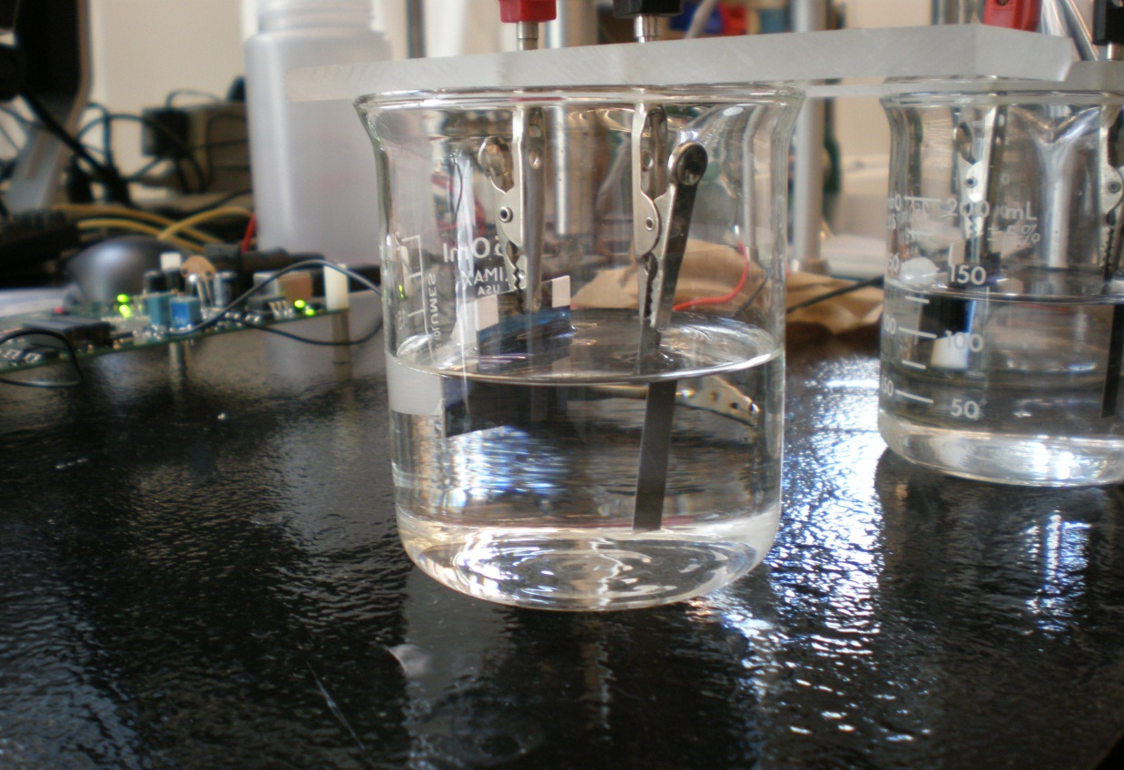 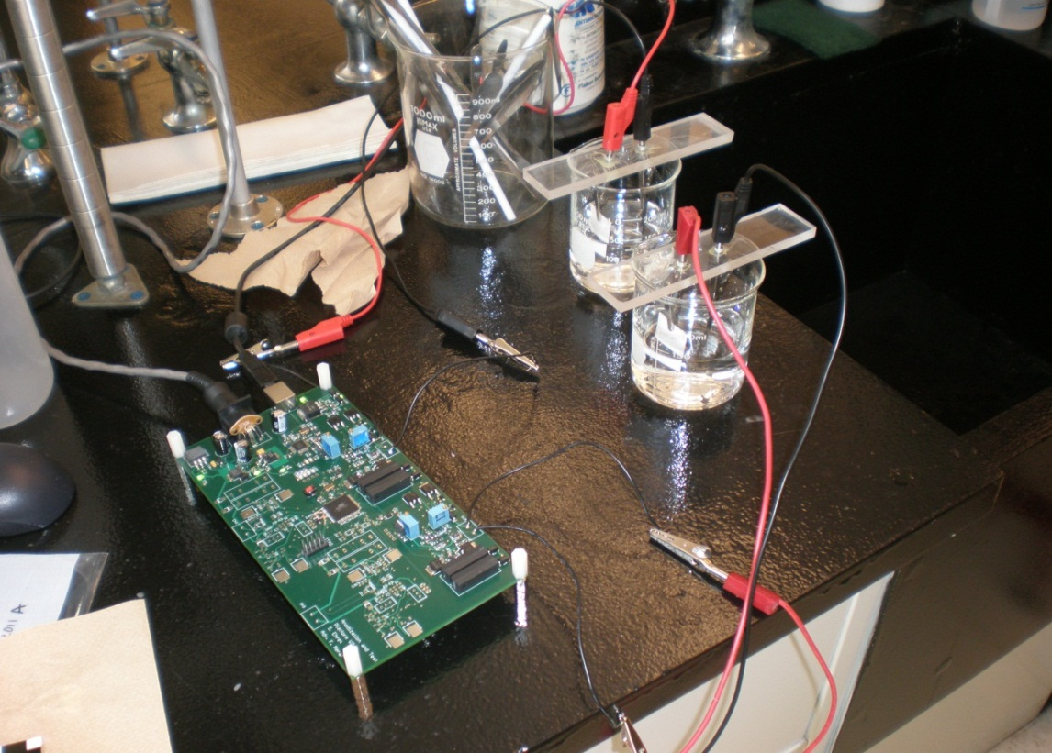
AnodeDielectric
Cathode
Anode
Cathode
Figure 14 - Anode and cathode suspended in anodizing electrolyte by conducting metal clips
Figure 15 - Test setup to anodize two samples concurrently

3. Results and Discussion

3.1 Anodization Mode
Anodization of several samples was successfully carried out using both channels of the instrument. The current and voltage curves were generated from the acquired data for each sample using MATLAB. Figure 16 shows the results of charging a commercial aluminum electrolytic capacitor to 30V at a constant current for 5 minutes, demonstrating that the instrument is functioning as intended. To verify the repeatability of results, the commercial capacitor was charged multiple times under the same conditions and the results were analyzed for consistency. Figure 17 shows the results of 17 trials and Figure 18 shows the relative standard error for this set of data. As can be seen, the relative standard error is less than 1% during the constant current charging of the capacitor and increases slightly during the self-healing of the oxide as the current decreases. This is expected given that this electrochemical process is slightly different every time it occurs. The spike near sample number 3250 is due to the instrument auto-ranging and does not represent true results.
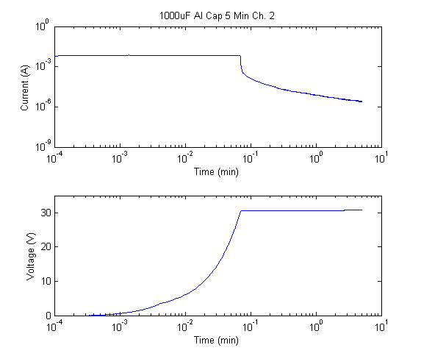
Figure 16 - I V curves for aluminum electrolytic capacitor used as a reference test load

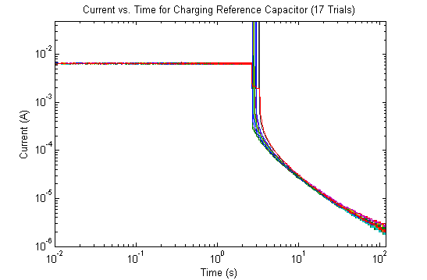
Figure 17 - Current vs. Time for repeated trials of reference capacitor

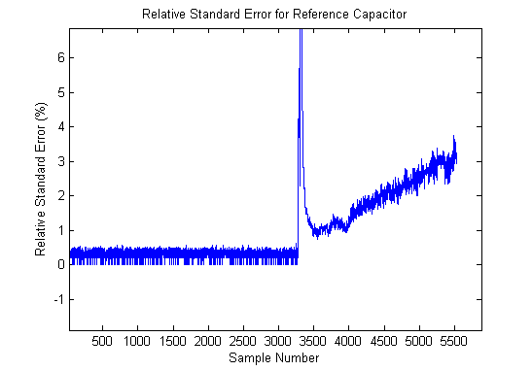
Figure 18 - Relative standard error for 17 trials of charging reference capacitor. Sample number indicates the numerical index of each data point. Each corresponding data point was taken at the same point in time after the charging process began, allowing comparison of all trials.

Interpretations of results were provided by Dr. Gerhard Welsch of Case Western Reserve University’s Department of Materials Science and Engineering (19). Figure 19 shows the results of a zirconium/titanium alloy (20/80% by weight) sample anodized for 30 minutes in an electrolyte solution of 5% H₃PO₄ by volume using channel 1 of the device. Figure 20 shows similar results using a sample of the same alloy under the same anodizing conditions, but using channel 2 of the device. As can be seen, the results are very similar showing a linear increase in voltage across the sample during oxide formation and a steady decrease in the anodization current to a minimum of approximately 50µA at the end of the anodization. This is expected given the conditions of the experiment were the same and shows there are no appreciable differences between device channels. At times of around 1 minute on each channel there is a slight discontinuity in the current curve due to the instrumentation auto-ranging. At this point, the instrument switched to the next current range, but the signal saturated the ADC for a small amount of time which is represented as the small horizontal line in the graphs of the data. With the current design, this is unavoidable, but will be possible to eliminate in future work.
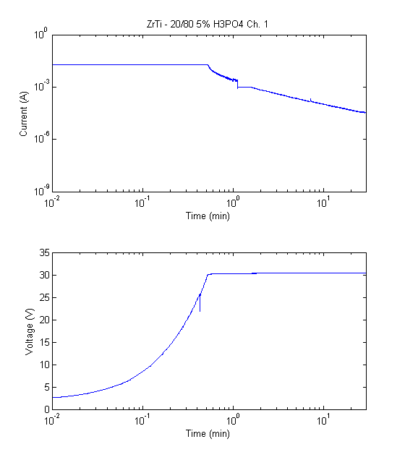
Figure 19 - Results for 30 minute anodization of ZrTi 80/20 sample on Channel 1

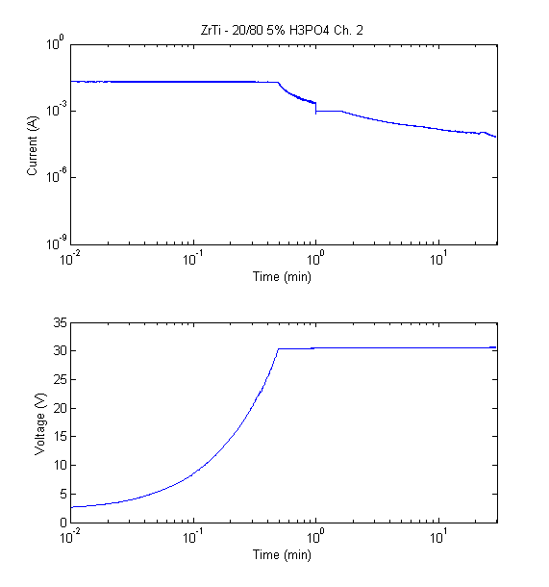
Figure 20 - Results for 30 minute anodization of ZrTi 80/20 sample on Channel 2

Figure 21 shows the results of the anodization of a titanium/tantalum sample that yielded results markedly different, and more interesting from an electrochemical perspective, than those previously shown. As can be seen, the current and voltage signals appear to be plagued with noise, but one can also notice that the spikes in the signals are bounded in one direction. This indicates that the signal is not noisy, and shows that the insulating oxide is poor and is repeatedly breaking down (current spiking in the positive direction/voltage spiking in the negative direction) and being repaired. This is also evidenced by the reduction of the frequency of the current and voltage spikes as time passes. This shows that the instrumentation is capable of providing feedback that would have been previously unobtainable using a standard benchtop current meter to monitor the anodization current over time.
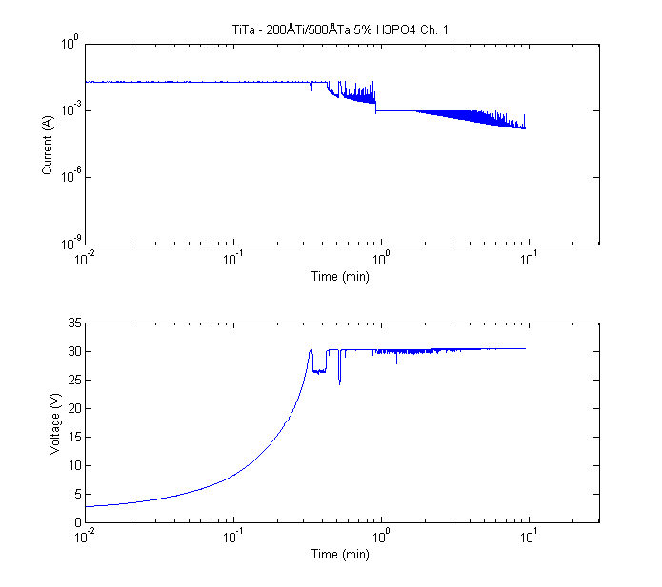
Figure 21 - TiTa alloy sample showing large amounts of oxide breakdown and repair

Figure 22 shows the results of successful anodization of a titanium lead alloy with a ratio of titanium to lead of 69/31. Figure 23 shows the results of attempting to anodize a similar alloy, but with the titanium to lead ratio at 50/50. As can be seen, this sample will not anodize. With the larger percentage of titanium, the sample was capable of being anodized.
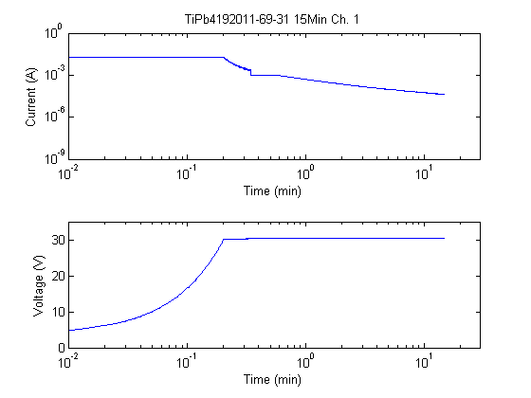
Figure 22 - Results of anodizing titanium lead alloy with a 69/31 ratio of titanium to lead for 15 minutes

Figure 24 shows the results of anodizing a zirconium lead alloy at a ratio of 50/50. This alloy anodized to the full voltage, but the forming current did not decrease as much as expected and illustrates a current weakness of the instrument. Because the current through the sample was near 1µA for an extended period of time, the measurement range was saturated and information was lost during this period of time. Even with the current flaw, the instrument shows that more samples of zirconium lead alloys should be examined to determine why the forming current did not decrease much less than 1 µA.
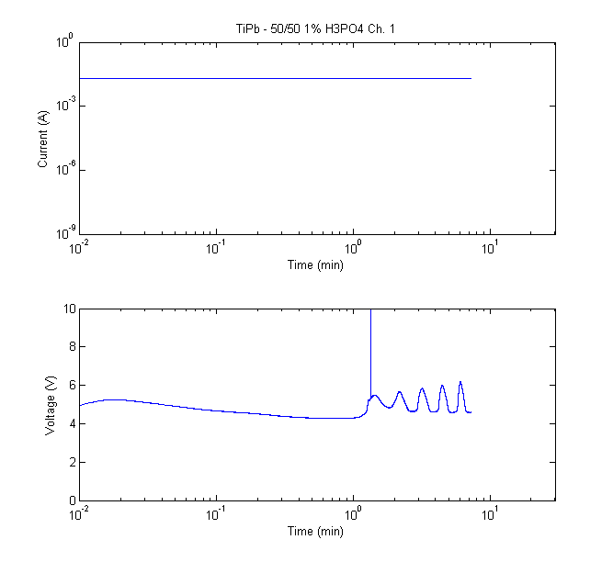
Figure 23 - Results of attempting to anodize a titanium lead alloy with a 50/50 ratio of titanium to lead

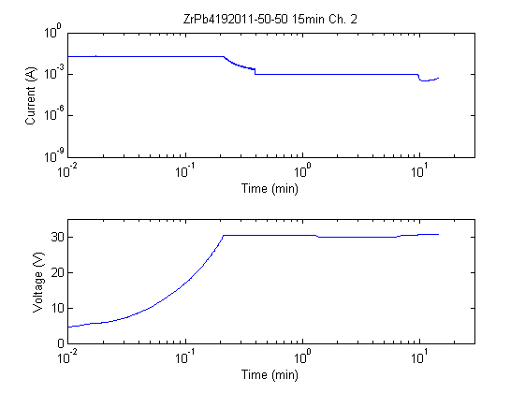
Figure 24 - Anodization results of a zirconium lead alloy with a ratio of Zi to Pb of 50/50

The instrument is also useful to compare results of two samples of the same material. Figure 25 shows the expected anodization I V curves for a ZrTi sample with a ratio of Zi to Ti of 40/60 and the results for a second sample of the same material, but with differing, poorer, results. This indicates that the material is not the problem, but that the sample or electrolyte may have been contaminated before or during the anodization process.
The instrument is also capable of recording data for longer periods of time to see the effects of anodizing samples for multiple hours or days. Figure 26 shows the results of anodizing a sample of ZrTi with a ratio of Zi to Ti of 50/50 for 24 hours. The results indicate that the sample anodized as expected during the first 10 minutes of anodization, but additional dynamics were not revealed until much later. This information would not have been revealed using previous data recording techniques due to the limitations of needing to have a researcher observe the magnitude of the current flowing through the sample. As the results show, after approximately 18 hours, the sample began to slowly conduct more current, indicating a reduction in the effectiveness of the insulating oxide developed during the anodization process (note the logarithmic time scale).
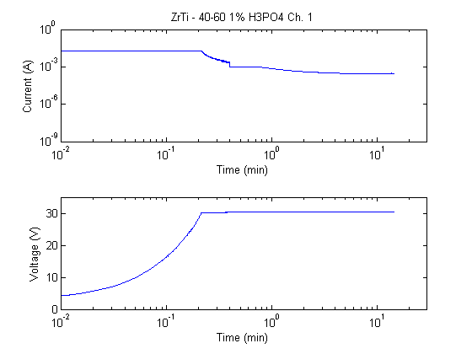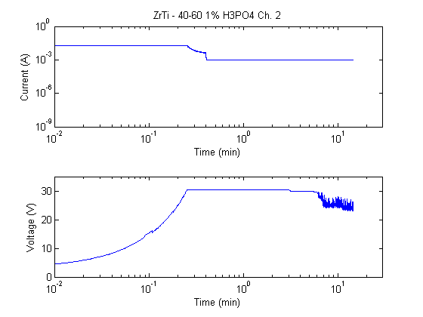
Figure 25 - Results for two samples of ZrTi 40/60 alloy showing possible contamination of the sample anodized on channel 2 of the instrument

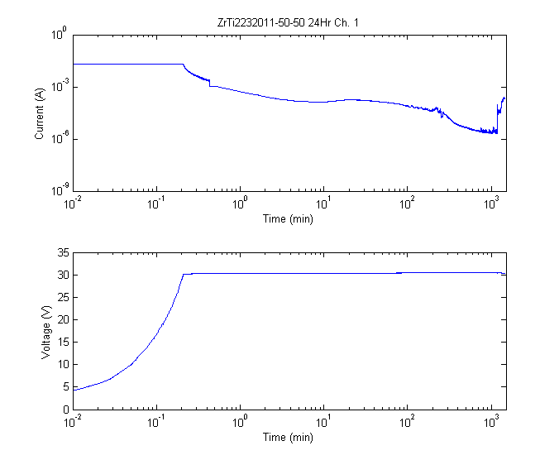
Figure 26 - Results of anodizing ZrTi 50/50 for 24 hours.

In addition to anodizing the samples, the instrumentation is capable of measuring the even lower leakage currents associated with charging the samples after anodization to some derated voltage. Figure 27 shows the results for a ZrTi – 50/50 sample that was anodized to 30V and subsequently charged at 2.5V for two minutes. The lowest current achieved was approximately 550 nA, as indicated by the data point marker in the figure. The sharp dip in the current curve at approximately 0.1 minutes is due to the capacitor in the transimpedance amplifier’s feedback loop charging immediately after the instrument’s auto-ranging functionality switched it into the lowest current range mode and does not represent the actual current through the load during this transititory phase.
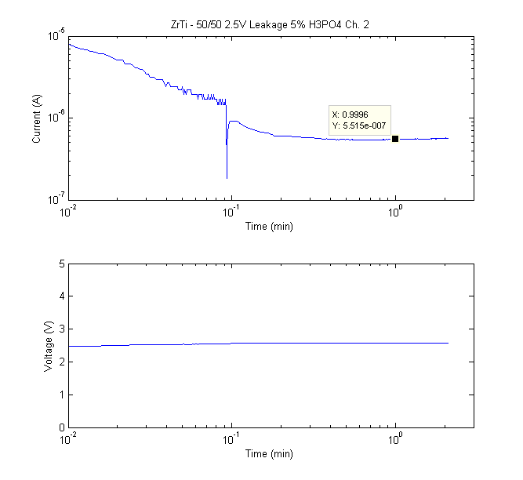
Figure 27 - ZrTi - 50/50 leakage current testing at 2.5V for 2 minutes

An additional measurement that is possible to be discerned from this data is the amount of energy required to form the oxide during each second of anodization. This is possible by multiplying each current and voltage data point and integrating the resulting power in increments of one second. Figure 28 shows this measurement for a ZrTi 80/20 sample.
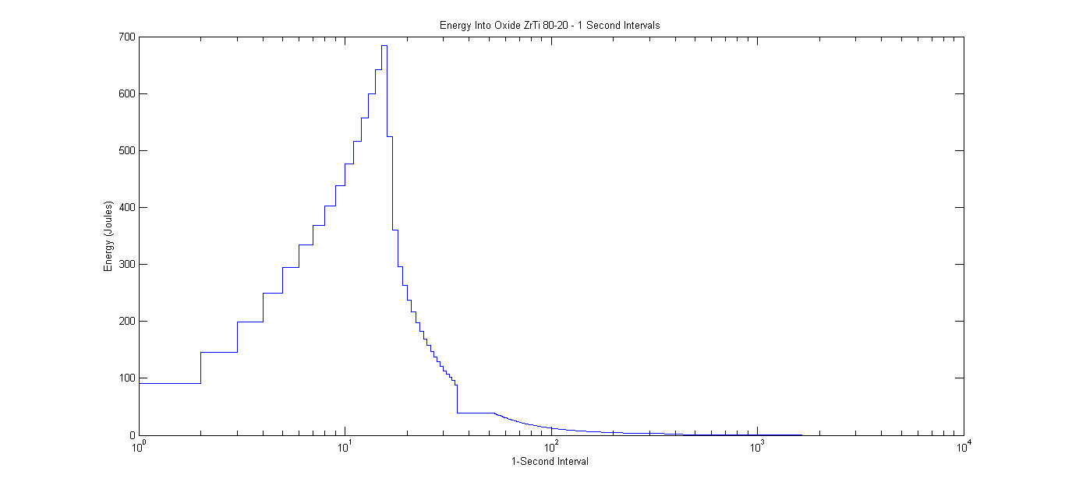
Figure 28 - Energy required to form oxide during anodization, 1 second intervals

3.2 Testing Mode
The testing mode was evaluated using various capacitive loads in the range of 1µF to 1000µF. For large values of capacitance, the instrument was capable of symmetrically charging and discharging the load between 10V and 20Vat the commanded current. This yielded the triangle waveform depicted in Figure 29. As the load capacitance was decreased, the performance of the test function diminished. This is evidenced by the waveform depicted in Figure 30. As can be seen, the waveform is no longer symmetric due to the large voltage step when the circuitry switches from discharging the load to charging the load. It was determined that this behavior is due to a flaw in the current source control circuitry that leaves the current source control circuitry in a state where it is trying to source current even when disconnected from the supply while the load is discharging. When the device disables the discharge circuitry and re-connects the current
source to the power supply, the MOSFET controlling the magnitude of the current is fully on and there is a surge current into the load during the delay before the control circuitry re-stabilizes. Given the fundamental current-voltage relation for a capacitor
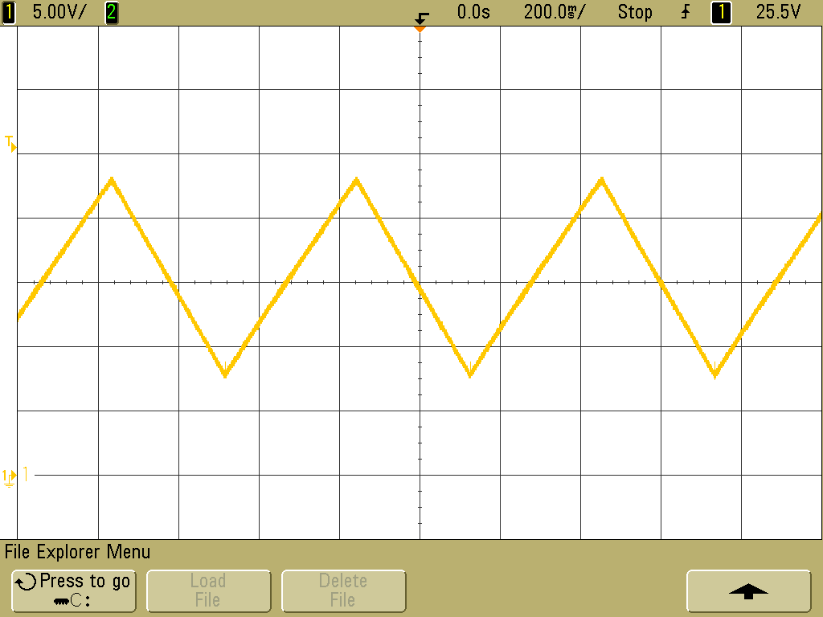
Figure 29 - Voltage across 1000 µF load with device in test mode

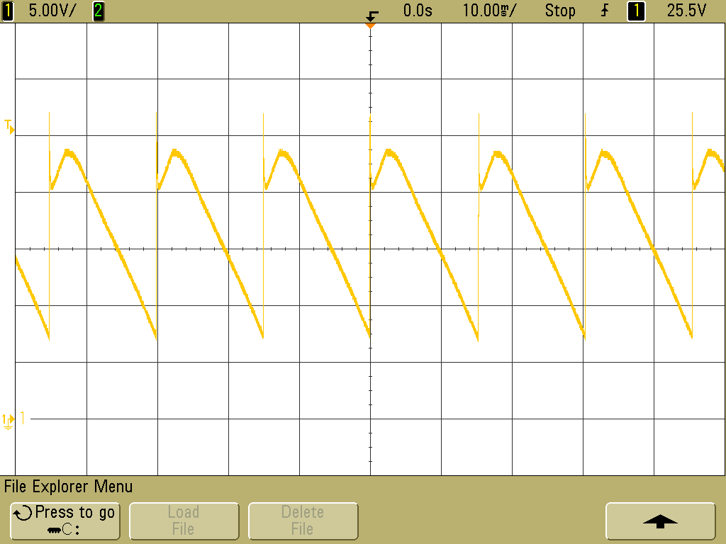
Figure 30 - Voltage across 1 µF load with device in test mode

it is readily evident that for similar values of I and dt, which in this case corresponds to the magnitude of the surge current and the time it takes the control circuitry to achieve a stable operating point, respectively, the magnitude of the voltage change across the sample, dV, varies inversely with the load capacitance. This is why for large capacitive loads, the effect of the design flaw in the control circuitry is diminished, but a significant problem for small capacitive loads. The surge current was measured to be approximately 3A and the time required for the control circuitry to establish a stable operating point was measured to be approximately 4.2 µs. Using equation , and assuming tolerance of a voltage step equal to 1% of the total voltage ramp (.15 V), the minimum capacitance that can be used is
.
Even though the testing mode of the device is not fully functional for all loads, it can still be used to obtain an estimate of the capacitance of even small loads by examining the discharge side of the curve. Using equation , the capacitance can be calculated given that dV, dt, and I are readily available in the current and voltage data collected by the device.

4. Conclusions
In this work, it was demonstrated that it is possible to design a device capable of simultaneously anodizing multiple titanium based alloys to be used as capacitor anodes while independently measuring and recording the voltage across and current through the samples while not affecting the electrochemical processes. The design was prototyped and subsequently tested using sputtered thin film alloys as the samples to be anodized. Anodization of the samples was successful and data acquired by the device was confirmed to provide useful information to the research group regarding the electrochemical processes involved in the anodization of the samples such as contamination of the electrodes and electrolyte, and identification of good and bad materials for capacitor anodes. Testing of the prototype device confirmed the specifications of the design. The device was able to measure current and voltage data over the full range of expected conditions at a sample rate sufficiently fast enough to capture all frequencies of interest. The device also permanently records this data to a computer hard disk for subsequent analysis and inclusion into a database of results.
Currently, the testing mode of the device which is to be used to estimate the capacitance of an anodized sample is limited to samples with capacitance values greater than approximately 100 µF. This is due to design flaw in the control circuitry for the current source and it is fully capable of being corrected in future work.

5. Future Work

5.1 Improvements
Before production of multiple instruments for use by the research group, improvements to the existing design are necessary to ensure successful use by the end user. There are a few minor changes to the physical board’s layout that will greatly enhance the functionality of the device. The primary improvement in this area will be to change the inputs to the ADCs to enable data recording capabilities on all four channels of the device. A second improvement to the board design will be the addition of a power switch on the device so that the end user does not need to be concerned with the power up sequence of any external power sources. A third improvement is to reverse the control circuitry for the current source such that the testing mode of the device is useful for all ranges of load capacitance.
The implementation of the user interface and data recording software in LabVIEW is a necessity for ease-of-use by the end user. This interface will allow any member of the research group using the instrument to easily control all anodization parameters and record the desired data without needing to know the inner-workings of the device and communication protocols as is currently required using the software implemented in MATLAB.

5.2 High Voltage Version
Expanded capabilities of extending the compliance voltage into the kilovolt range is desired to aid the development of anode materials for high voltage capacitors. The current framework of the instrument is mostly capable of dealing with high voltages if components are selected to be able to withstand the additional stresses of high voltage and power. The control circuitry will need the addition of high voltage output stages for the operational amplifiers and subsequent step-down stages for the feedback voltages to be within the tolerable input range of the amplifier. Accurately sensing the high voltage across the load without appreciably affecting any other measurements will be a challenge. Layout of the physical circuit board will need to take into account the effects of having high voltage signals present and implement mechanisms to maintain the integrity of the other signals and the safety of anyone using the device.

Appendices

Circuit Schematics
Power regulation and USB to UART interface
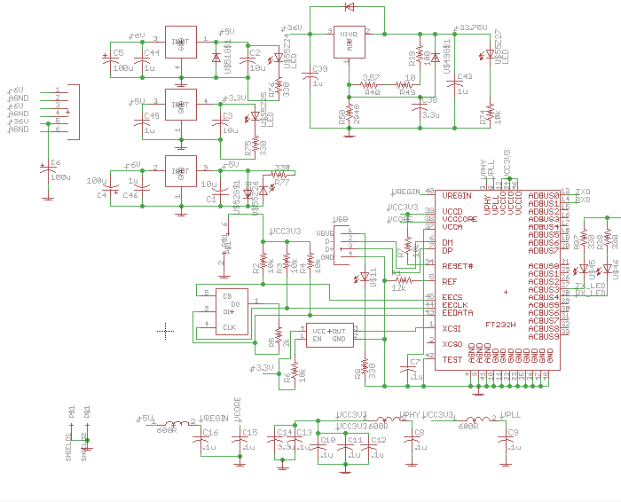

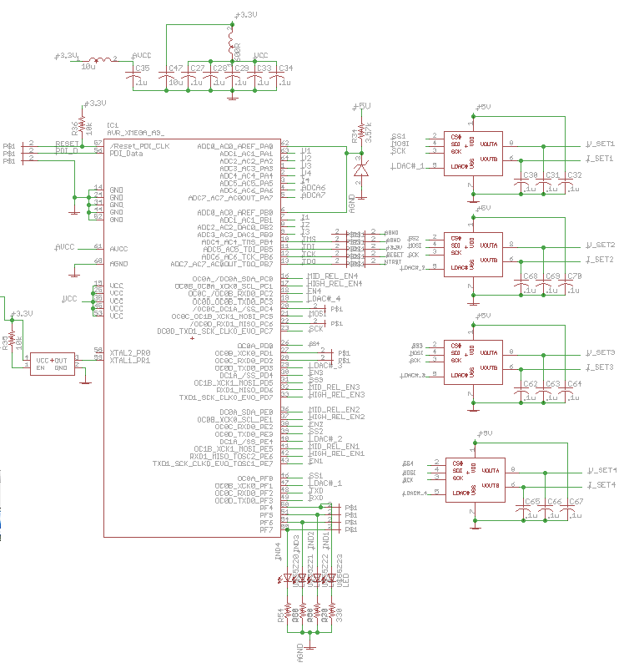
Microcontroller and DAC circuitry
Analog front end (one channel)
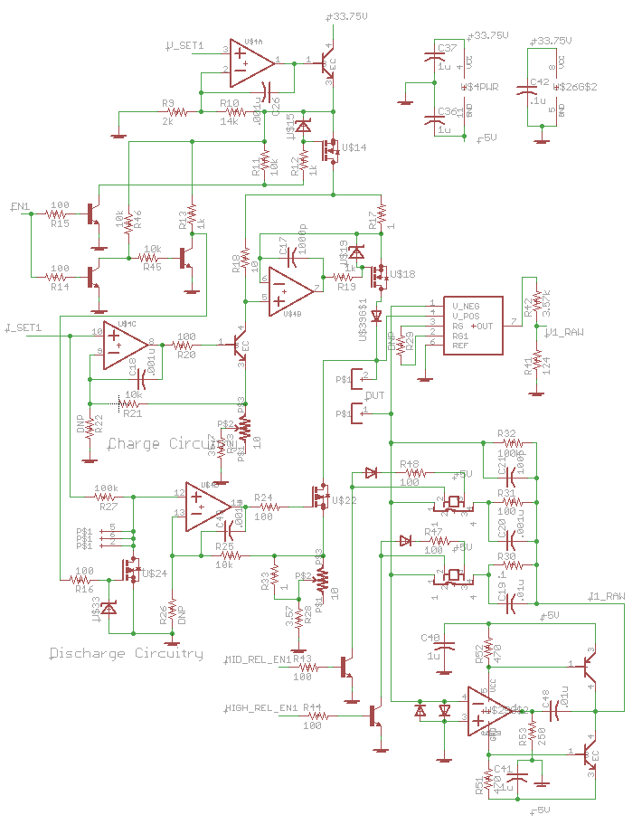
Signal conditioning circuitry
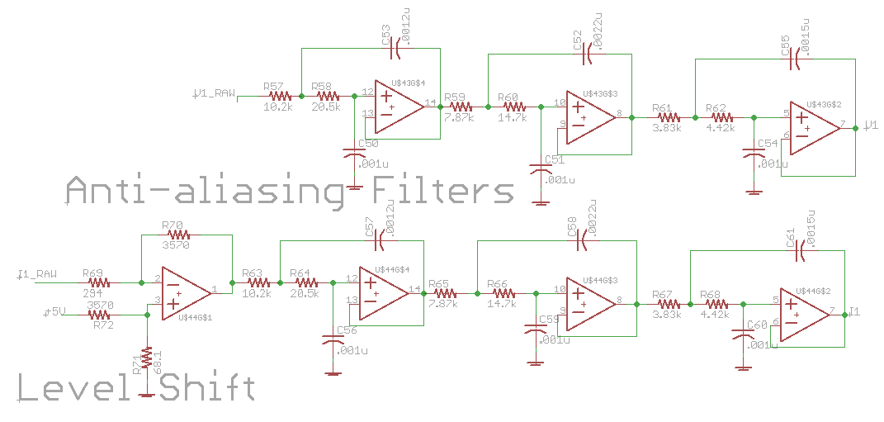

Board Layout
Top layer:
Inner power layer:
Inner ground layer:
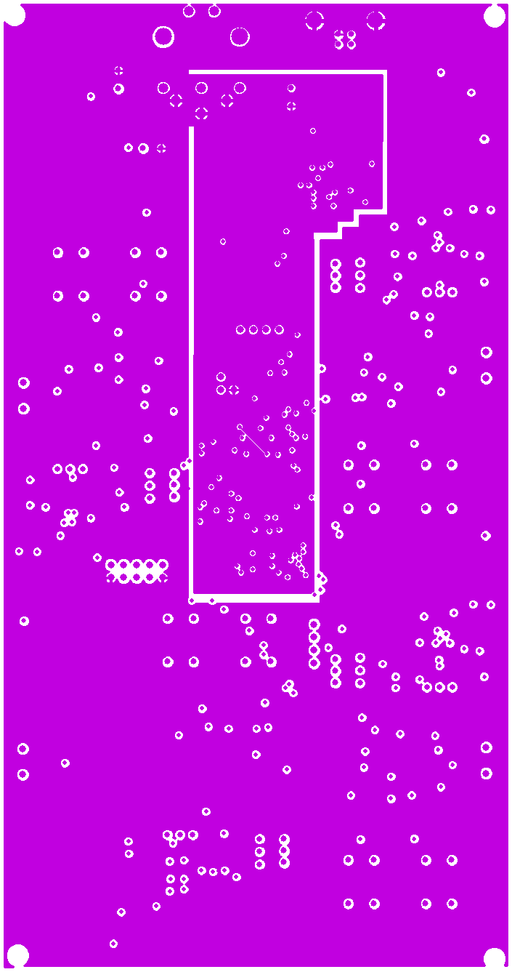
Bottom signal layer:

Firmware (Pseudo code)
// Initialize Peripherals and Output Pins
Disable Global Interrupts
Set Ports C, D, E as outputs
Set pins 7, 6, 5, 4, 3, 1, 0 on Port F as outputs
Set pin 2 on Port F as input

Set PLL input to external clock // External Clock is 16MHz
Set PLL gain to 2x
Set system clock to PLL output // SysClock set to 32MHz

Set up USART F0
Baud rate = 2000000
Data bits = 8
Parity = ODD
Interrupt Priority = HIGH

Set up SPI C
Mode = 0
Double Speed mode = FALSE
SPI Clock = SysClock/4
Interrupt Priority = HIGH

//Setup ADCs
Set Port A, B as inputs
Load Factory Calibration values from factory signature registers
Set up ADCA
Signed mode = TRUE
Resolution = 12 bits
Reference = AREFA
ADC Clock = SysClock/128

Set up ADCB
Signed mode = TRUE
Resolution = 12 bits
Reference = AREFA
ADC Clock = SysClock/128

Set up all ADC Channels
Input Mode = DIFFERENTIAL
Gain = 1x
Input pins assigned accordingly

Enable ADCA and ADCB
Wait for ADC clock to become stable
Measure and record ADCs offset values
Configure Event System Ch. 0123 to Trigger ADCA and ADCB in sweep mode
Configure Event System Ch. 0 to trigger on TimerC0 overflow

Initialize variables

Enable Global Interrupts

if(powering up from manual reset){
Reset all status variables
Set all DAC outputs to 0
}
Set up TimerC0 to overflow every 50uS

while(1){
if(new packet received){
Parse new packet
}

for(channel1 to channel4){
if(channel is enabled){
switch(state){
High Current State:
Set relay outputs for high current
if(channel.current < SWITCHING_THRESHOLD){
Switch to Middle Current State
}
break

Middle Current State:
Set relay outputs for middle current
if(channel.current < SWITCHING_THRESHOLD){
Switch to Low Current State
}
break

Low Current State:
Set relay outputs for low current
break

Testing V:
Set relay outputs for high current
if(channel.voltage > High voltage threshold){
Disable charging circuitry
Enable discharging circuitry
}
if(channel.voltage < Low voltage threshold){
Enable charging circuitry
Disable discharging circuitry
}
break
Default:
Set relay outputs for high current
break
}

}
Update output relays
if(new packet for channel received)
if(channel is enabled){
Update channel variables
Set DAC outputs accordingly
}
else{
Reset channel variables
Set DAC outputs to zero
}
}

if(next measurements ready to transmit){
Fill packet buffer with new data
Wait until USART buffer is empty
Begin sending measurement packet
}

}

// Interrupt Service Routines
ISR(New USART Byte Received){
if(Received Byte == START_BYTE && Not Currently ..
Receiving Packet){
Not Currently Receiving Packet = FALSE
}
else if(ReceivedByte == STOP_BYTE && Number of Bytes .. Received >= Bytes Expected){
Not Current Receiving Packet = TRUE
New Packet Received = TRUE
}
else if (Not Currently Receiving Packet == FALSE){
rx_buffer[byte_number] = received packet
new packet received = TRUE
if(rx_idx < 15)
byte_number++
else
byte_number = 0
}
}

ISR(USART Byte Transmitted){
if(currently sending packet){
current_byte++
if(current_byte >= packet_size){
current_byte = 0
currently sending packet = FALSE
}
else{
Send next byte in transmit buffer
}
}
}

ISR(SPI Byte Sent/Received){
if(transmission complete){
Release slave select pins
}
else{
Transmit next byte of packet
}
}

ISR(ADC conversion complete){
adc_cnt++
for(channel to channel4){
Read latest voltage measurement - offset
Read latest current measurement - offset

if(adc_cnt == OVERSAMPLING_SAMPLES){
avg_cnt++
save oversampled measurements
if(avg_cnt == AVERAGING_SAMPLES){
save averaged measurements
}
}
}
}

Bibliography
1. Energy and Power of Titanium Electrolytic Capacitors. McGervey, D and Welsch, G. Philadelphia, PA : s.n., 2002. Advances in Electrochemical Capacitors and Hybrid Power Systems, proceedings of electrochemical cpacitor and hybrid power sources Symposium, 201st Meeting of the Electrochemical Society. Vols. 2002-7, pp. 343-353.
2. Reese, Ronald Lane. University Physics. Pacific Grove : Brooks/Cole Publishing Company, 2000.
3. AVX Ltd. An Exploration of Leakage Current. [http://www.avx.com/docs/techinfo/leakage.pdf] Devon, UK : s.n.
4. Tadiran Batteries Gmbh. Leakage Current Properties of Modern Electrolytic Capacitors. [http://www.tadiranbatteries.de/eng/downloads/Both_Eng.pdf] Budingen, Germany : s.n.
5. Doped Titanium for Forming Capacitors with High Energy Density. Welsch, Gerhard E. Long Beach, CA : s.n., May 23-26, 2011. Abstract #27720.
6. Gerhard Welsch, Don McGervey. CWRU (2011) private communication of research to be published.
7. Ki, Jun-Wan. Titanium Sponge on Titanium Substrate for Titanium Electrolytic Capacitors. Cleveland : s.n., 2005.
8. Alwitt, Robert S. ANODIZING. Electrochemistry Encyclopedia. [Online] Ernest B. Yeager Center for Electrochemical Sciences (YCES) and the Chemical Engineering Department , Case Western Reserve University , Cleveland, Ohio., December 2002. http://electrochem.cwru.edu/encycl/art-a02-anodizing.htm.
9. Atmel. AVR121: Enhancing ADC resolution by oversampling. Atmel . [Online] 2005. http://www.atmel.com/dyn/resources/prod_documents/doc8003.pdf.
10. Ambardar, Ashok. Digital Signal Processing: A Modern Introduction. 2007.
11. Baker, Bonnie C. Anti-Aliasing, Analog Filters for Data Acquisition Systems. [http://ww1.microchip.com/downloads/en/AppNotes/00699b.pdf] 1999.
12. Heath, Steve. Embedded Systems Design, Second Edition. s.l. : Newnes, 2002. 0750655461.
13. Texas Instruments. [Online] http://focus.ti.com/lit/ds/symlink/log114.pdf.
14. National Instruments. [Online] www.ni.com/pdf/manuals/371303l.pdf.
15. National Semiconductor. Op Amp Circuit Collection. [Online] http://www.national.com/an/AN/AN-31.pdf.
16. Atmel. 8-bit AVR XMEGA A Microcontroller. [Online] http://www.atmel.com/dyn/resources/prod_documents/doc8077.pdf.
17. —. 8/16-bit AVR XMEGA A3 Microcontroller. [Online] http://www.atmel.com/dyn/resources/prod_documents/doc8068.pdf.
18. FTDI Ltd. FT232H - Hi-Speed Single Channel USB UART/FIFO IC. [Online] http://www.ftdichip.com/Support/Documents/DataSheets/ICs/DS_FT232H.pdf.
19. Welsch, Gerhard. Private communication.
20. F. Huber, J. Bloxsom. Titanium Printed Capacitors for Microminiaturization. IRE Transactions on Component Parts. 1961.

Research supported by the Department of Energy's ARPA-E Directorate under contract number DE--AR000016 "High Power Titanate Capacitors for Power.”
Requirements a, b, and c are based on previous results ascertained by J. Ki using similar anode materials (7), industry expectations for leakage current in electrolytic capacitors (3), and personal communication with G. Welsch et al (6)

