This is a screenshot of the completed workflow from the “Getting Started Guide” on the KNIME website.
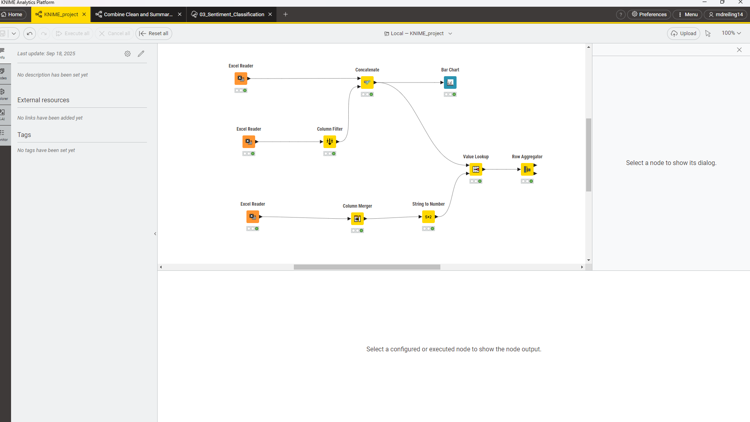
This screenshot shows the addition of the bar chart node.
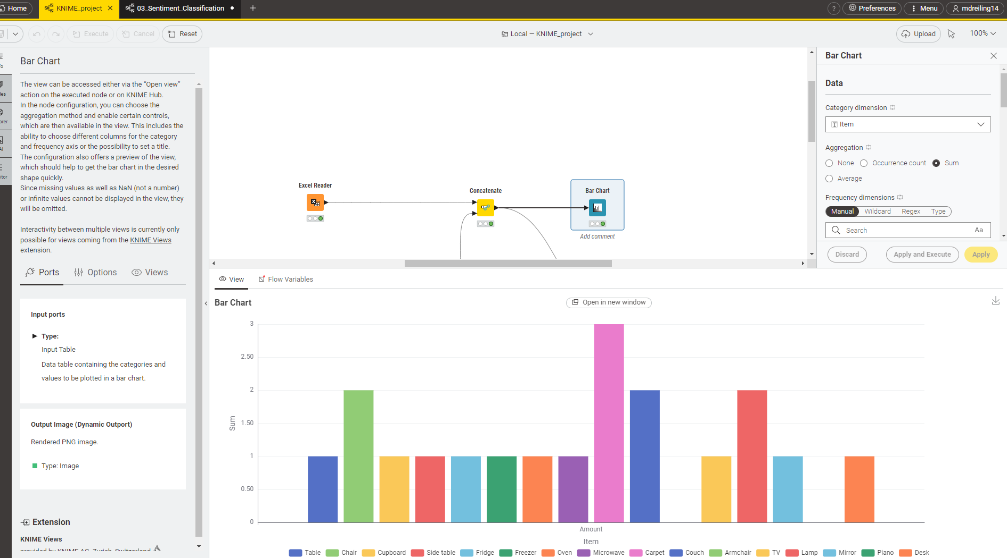

This screenshot shows the output of the value lookup node.
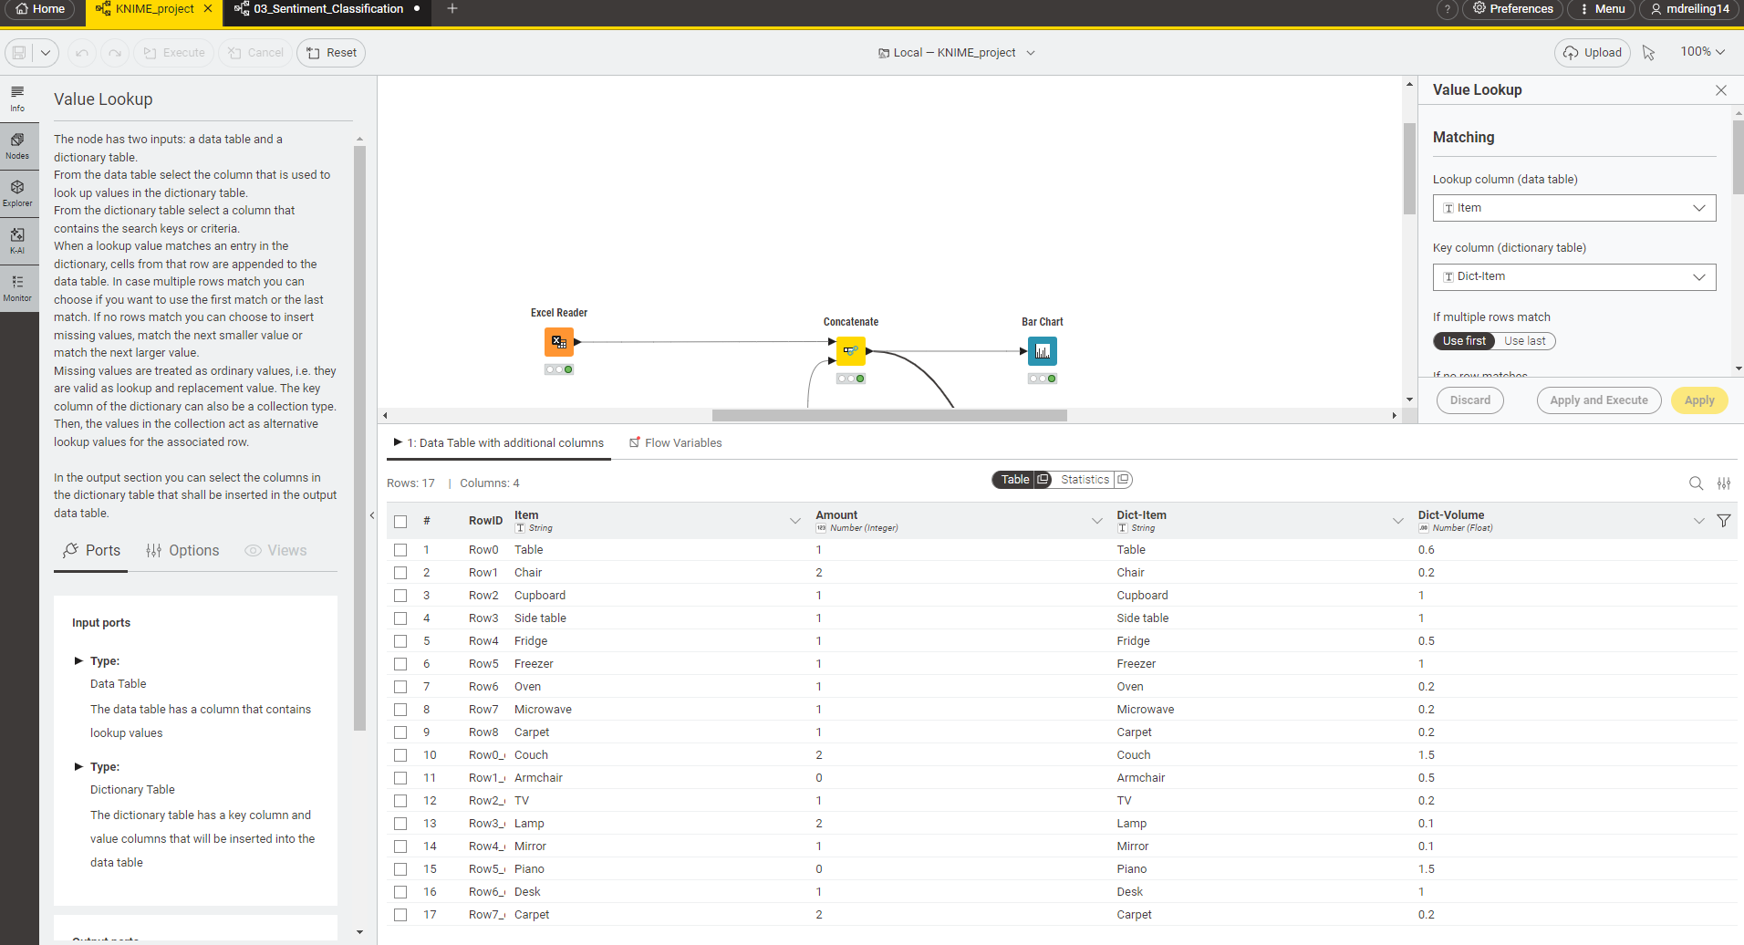

And finally, this shows the end goal of the aggregation results, and the output of the second output port data table with the results of the grand total calculation. 