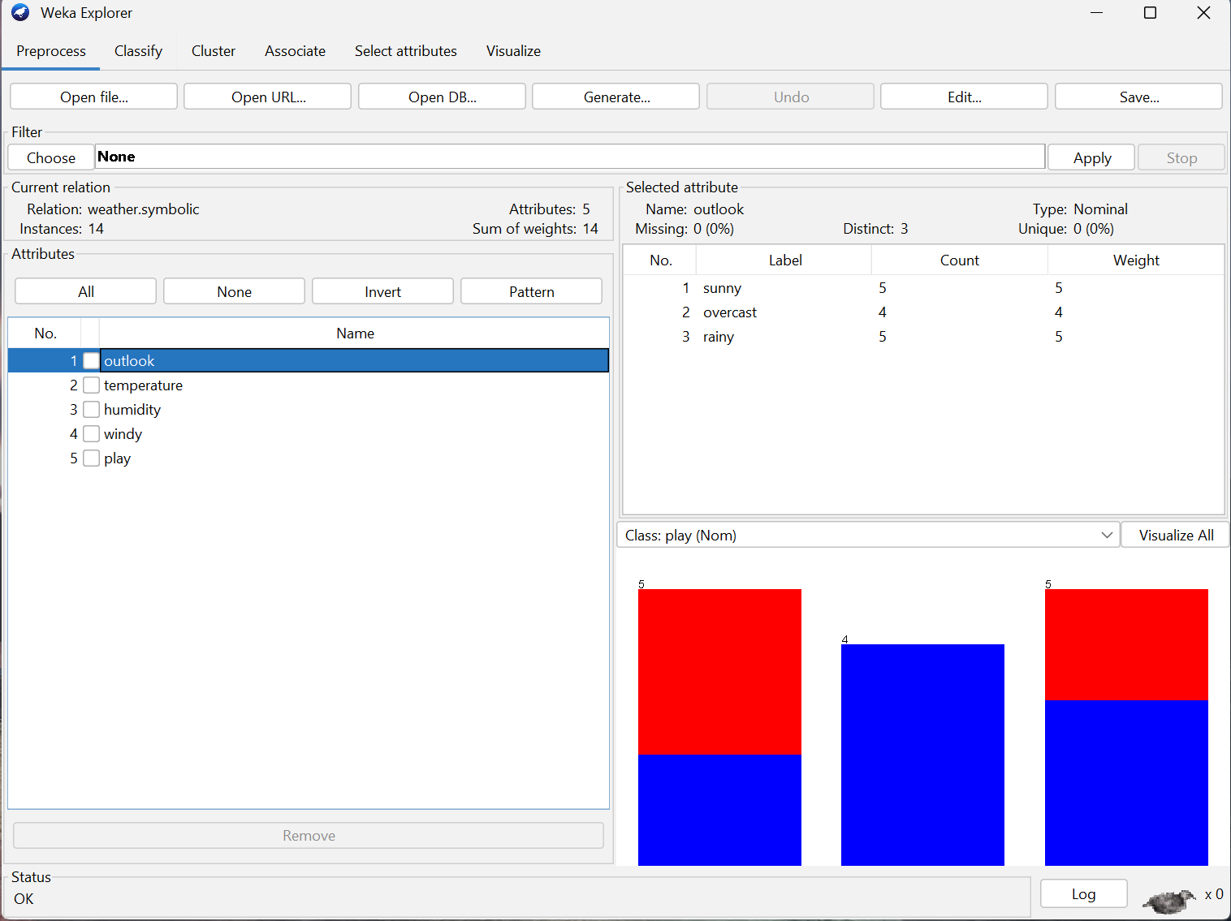
In this figure I have loaded up the weather dataset in Weka.
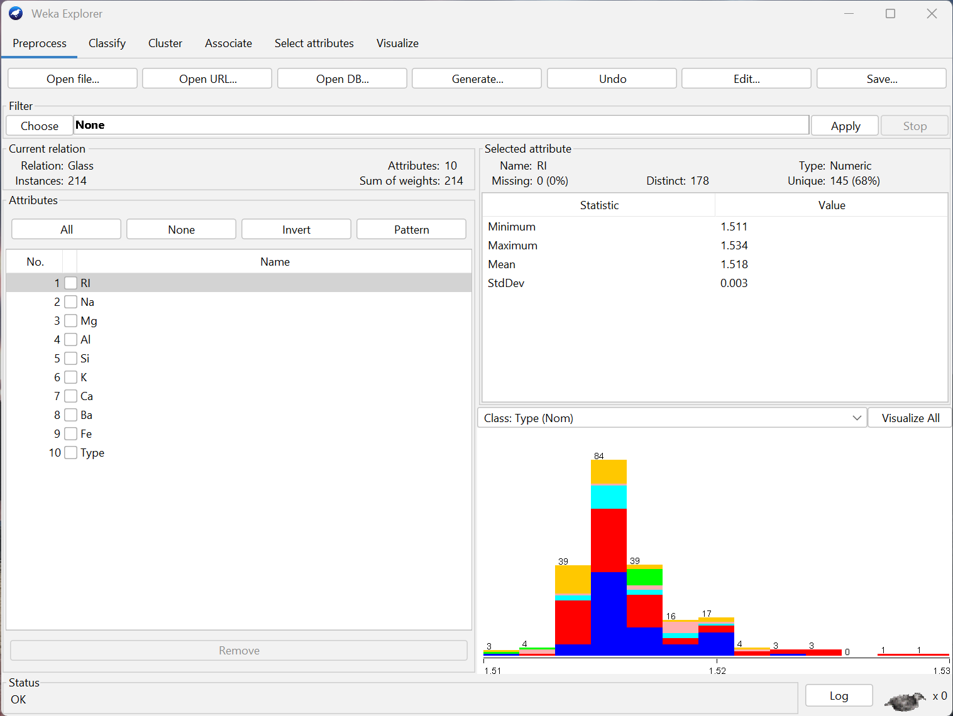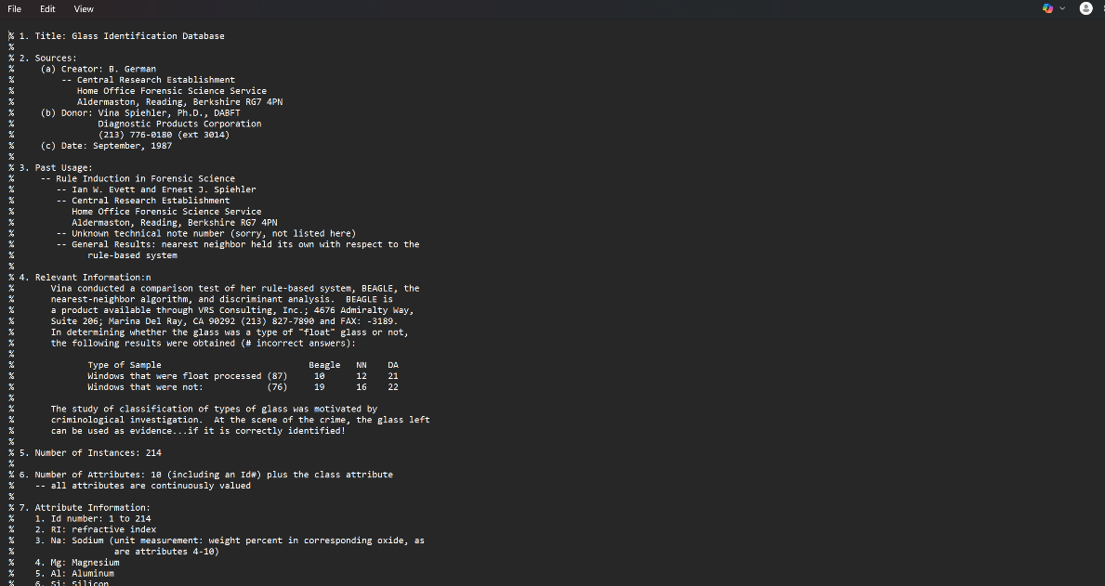
In these figures I have demonstrated how to load other datasets in Weka and explore .arff files.
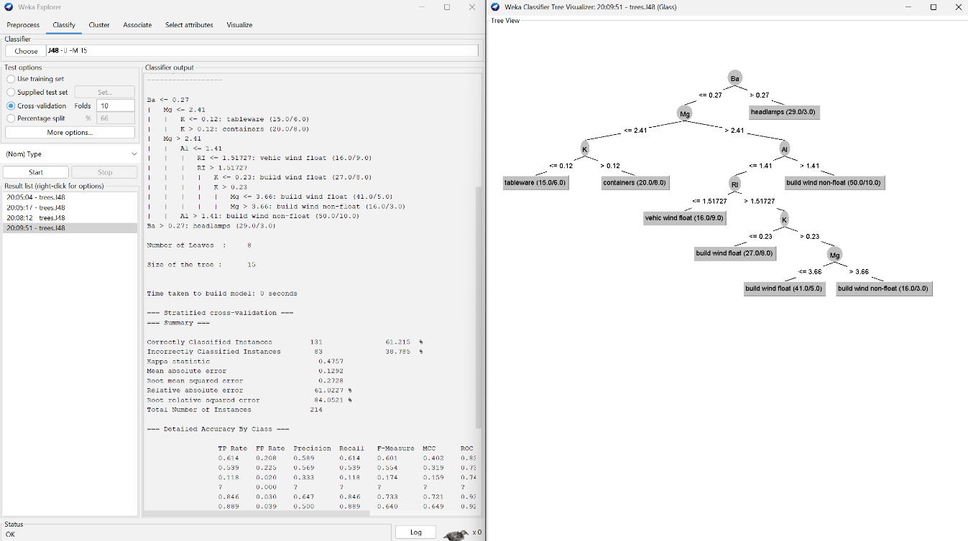
This image demonstrates my completion of the tutorial by building the classifier and viewing the tree shown in the videos.

