Lab 4 Report — Predicting Hospital Readmissions Using KNIME
Introduction
Hospital readmissions within 30 days of discharge are widely recognized as a critical quality metric in U.S. healthcare. The Centers for Medicare & Medicaid Services (CMS) established the Hospital Readmissions Reduction Program (HRRP) to penalize hospitals with higher-than-expected readmissions for specific conditions, including heart failure, pneumonia, chronic obstructive pulmonary disease (COPD), coronary artery bypass graft (CABG) surgery, and joint replacement procedures. Readmissions represent both patient outcome challenges and financial risks for hospitals, making them an important target for predictive analytics.
This project leverages two comprehensive CMS hospital-level datasets: the FY 2025 HRRP dataset and the Timely and Effective Care (T&E) dataset. The HRRP file provides outcome measures such as the excess readmission ratio (predicted vs expected readmissions, adjusted for case mix), predicted readmission rates, expected readmission rates, and counts of discharges and readmissions. These variables form the basis of the project’s target: whether a hospital overall is classified as having “excess” readmissions (target_excess = 1) or not (target_excess = 0). The T&E dataset provides hundreds of process-of-care measures — quality indicators such as emergency department throughput, outpatient imaging times, and timely administration of treatment. The Score variable in T&E required significant cleaning, as its format varies across measures: sometimes reported as percentages (e.g., 85%), sometimes as numeric decimals, sometimes as ordinal categories (“low,” “medium,” “high,” “very high”), and often as non-numeric placeholders (“Not Available,” “Too Few Cases”). Together, the datasets cover thousands of hospitals nationwide and offer a large, complex set of variables for data mining. By joining them on the CMS Certification Number (CCN/Facility ID), I constructed a single dataset containing both outcome and predictor measures to explore whether process-of-care performance can predict excess readmissions.
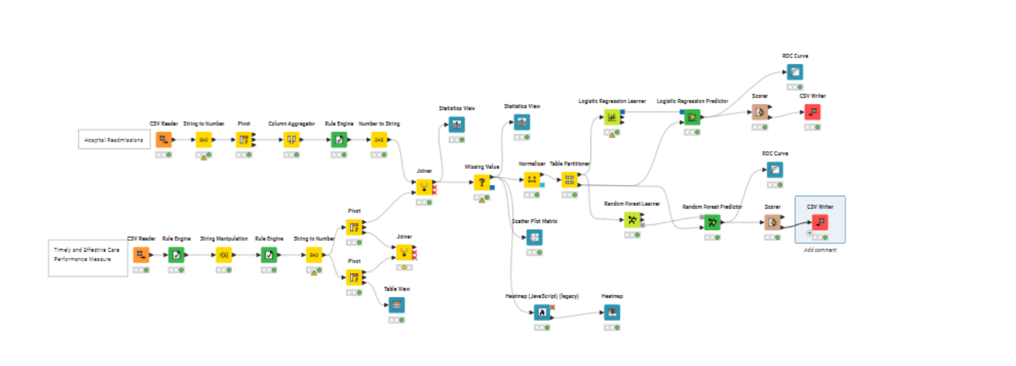

Process
The workflow began with data import and cleaning. Both datasets were read into KNIME with Facility ID specified as a string to avoid type mismatches during joining. The HRRP dataset required relatively little cleaning — I converted string columns such as “Number of Readmissions” into numeric format using the String to Number node. To prepare an outcome variable, I aggregated the six condition-specific excess readmission ratios and created a composite measure (HRRP_Excess_Avg). A Rule Engine node then created the binary target variable: hospitals with an average ratio greater than 1.0 were labeled target_excess = 1, while all others were labeled 0. This aligned directly with CMS’s definition of excess readmissions.
The T&E dataset required more intensive preparation due to its mixed data types in the Score column. I first replaced placeholder strings such as “Not Available,” “N/A,” and “Too Few Cases” with blanks, then removed the percent sign from scores reported as percentages. This allowed the String to Number node to successfully convert numeric scores into a new column (Score_num). For ordinal values such as “low” or “very high,” I created a parallel variable (Score_cat) coded from 1–4. Initially, I attempted to use both numeric and ordinal scores, but joining them at the pivot stage proved problematic, and I ultimately proceeded with the numeric measures for this analysis. Using the Pivoting node, I reshaped the T&E data from long to wide format, with each hospital represented as one row and each measure (Measure ID) as a separate column (e.g., OP18b, IMM_3, EDV). This transformation produced hundreds of predictor variables for each hospital.
After both datasets were cleaned, I performed a Joiner on Facility ID to merge the HRRP outcomes with the T&E predictors. The resulting table had one row per hospital, containing the target outcome, HRRP covariates, and T&E process-of-care scores. I addressed missing data with the Missing Value node, imputing numeric fields with their column median to prevent row loss while maintaining robustness against outliers. Because the predictors were reported on very different scales (percentages, rates, raw counts), I applied the Z-Score Normalizer to standardize numeric features prior to modeling. This step was critical to prevent variables measured on larger scales from dominating the models.
For exploratory analysis, I used the Linear Correlation and Correlation Matrix (JavaScript) nodes to visualize relationships among predictors. However, with hundreds of variables, the correlation heatmaps quickly became overwhelming and difficult to interpret. While these tools confirmed some redundancy among measures, they also highlighted the complexity of variable selection in such a large dataset.
Finally, I conducted modeling. The data was split 80/20 using the Partitioning node (stratified by target_excess), with the training set fed into two models: Logistic Regression Learner and Random Forest Learner. Each model’s predictions on the test set were evaluated using the Scorer node for confusion matrices and performance statistics. Logistic Regression served as a baseline due to its interpretability, while Random Forest offered a flexible ensemble method to capture non-linearities and complex interactions.

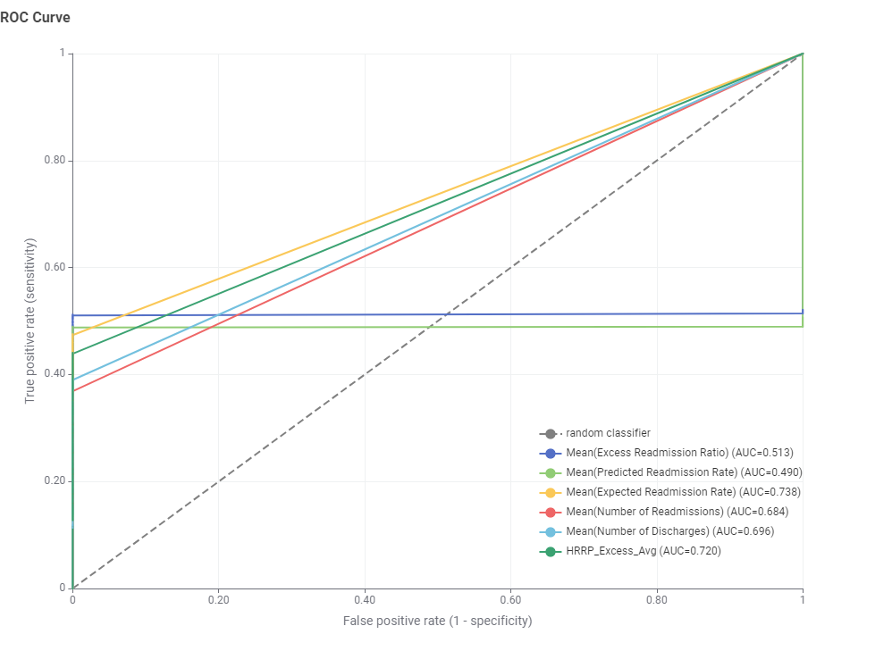

Figure 1. Logistic Regression ROC Curve

Table for Logistic Regression Model Accuracy
TruePositives | FalsePositives | TrueNegatives | FalseNegatives | Recall | Precision | Sensitivity | Specificity | F-measure | Accuracy | Cohen's kappa
567 | 44 | 1 | 5 | 0.991259 | 0.927987 | 0.991259 | 0.022222 | 0.95858
1 | 5 | 567 | 44 | 0.022222 | 0.166667 | 0.022222 | 0.991259 | 0.039216
 |  |  |  |  |  |  |  |  | 0.920583 | 0.02244

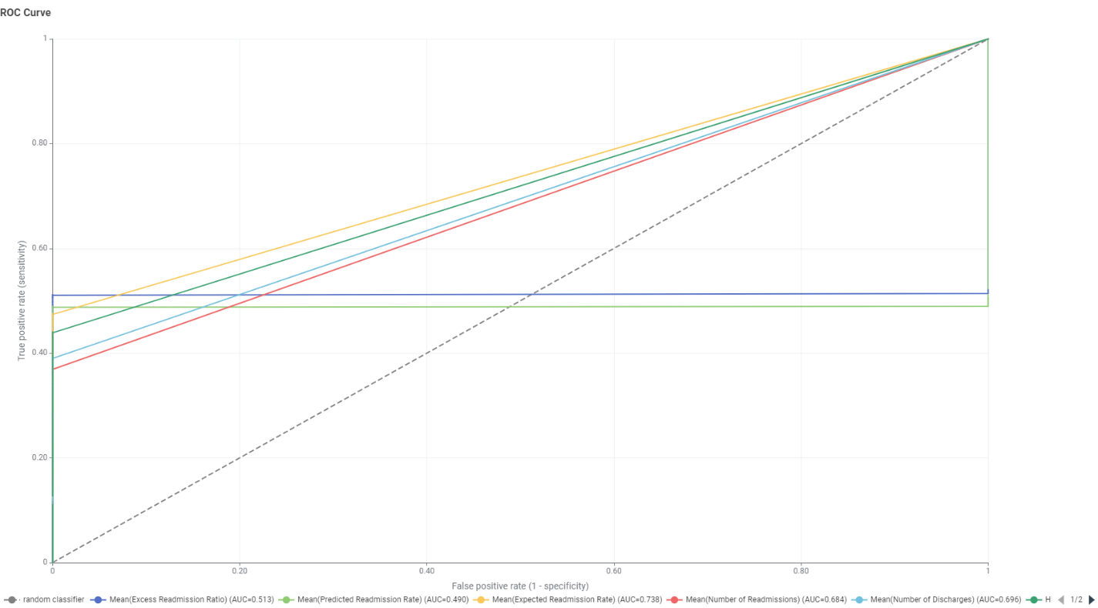
Figure 2. Random Forest ROC Curve

TruePositives | FalsePositives | TrueNegatives | FalseNegatives | Recall | Precision | Sensitivity | Specificity | F-measure | Accuracy | Cohen's kappa
572 | 0 | 45 | 0 | 1 | 1 | 1 | 1 | 1
45 | 0 | 572 | 0 | 1 | 1 | 1 | 1 | 1
 |  |  |  |  |  |  |  |  | 1 | 1

Results and Evaluation
The Logistic Regression model achieved an overall accuracy of ~92%, but closer inspection revealed that it was effectively predicting nearly all hospitals as “excess.” Recall for the excess class was extremely high (0.99), but recall for the non-excess class was almost zero (0.02). The resulting Cohen’s Kappa statistic was only 0.02, indicating the model added little predictive power beyond the majority class baseline.
In contrast, the Random Forest model achieved perfect classification: 100% accuracy, recall, precision, and F-measure, with Kappa = 1.0. While impressive on the surface, this result is suspicious and may reflect overfitting or leakage. Although I excluded HRRP_Excess_Avg from the predictor set, the large number of highly correlated features in the T&E dataset may have given the Random Forest too much capacity to separate classes exactly. To validate these results, cross-validation and additional feature engineering would be necessary.

Reflections and Learning
This lab provided valuable experience in working with real-world healthcare data and KNIME as a data mining tool. I learned that combining datasets is far more complicated than it appears, especially when dealing with variables that mix ordinal, nominal, and numeric formats. The T&E dataset in particular required extensive preprocessing, and I now better appreciate the importance of understanding the meaning and scaling of each variable.
KNIME was helpful for visualizing the workflow, and it made the process of joining, cleaning, and modeling more intuitive. However, I personally prefer R programming for its flexibility and direct control. While KNIME was initially difficult to learn, my background in information analytics gave me the foundation to work through the learning curve.
The greatest challenge was feature engineering. With hundreds of potential predictors, simple visualizations like correlation matrices did not provide clarity, and narrowing down to the most relevant variables was very difficult. I also encountered inconsistent scaling across measures, which complicated modeling. In the future, I would like to incorporate the ordinal data (Score_cat) alongside the numeric scores to see how they affect model performance. More thoughtful feature engineering — for example, grouping related measures, dimensionality reduction, or testing feature subsets — will likely be key to improving model accuracy and avoiding spurious results.
In summary, this project demonstrated the feasibility of predicting hospital readmissions using process-of-care measures but also highlighted the pitfalls of complex, messy datasets. Further research and refinement of feature engineering are necessary before these models can provide actionable insights for hospitals.

References
Most Used Resources:
https://www.youtube.com/@KNIMETV
https://www.youtube.com/watch?v=ogqwRmP5kLo

Other projects looked at:
http://kaggle.com/competitions/nfl-big-data-bowl-2026-prediction
https://www.kaggle.com/datasets/prasad22/healthcare-dataset
https://www.kaggle.com/datasets/mathchi/diabetes-data-set
https://www.kaggle.com/competitions/predict-hospital-readmission

Data:
https://data.cms.gov/provider-data/dataset/9n3s-kdb3
https://data.cms.gov/provider-data/dataset/yv7e-xc69

