Matlab game # 1

Objective:

Create game where a target will appear at a random location and your task is to click on the target as fast as you can. Generate 1 target at a time with a new target showing up each time you click correctly on the current target. After the target is hit 6 times the program should stop and display the total time it took. Only after clicking on target should the next target appear.

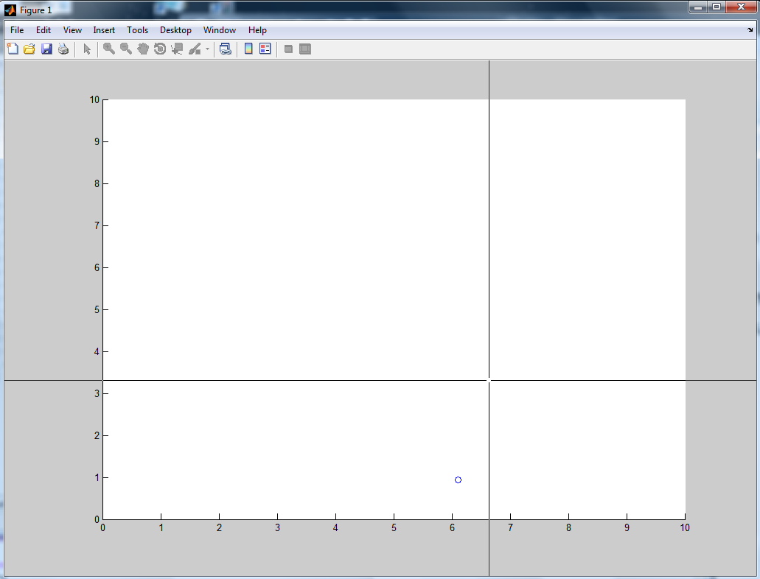

Fig. 1. Screen after 1st target appeared. Cross-section of the horizontal and vertical line indicates position of cursor.

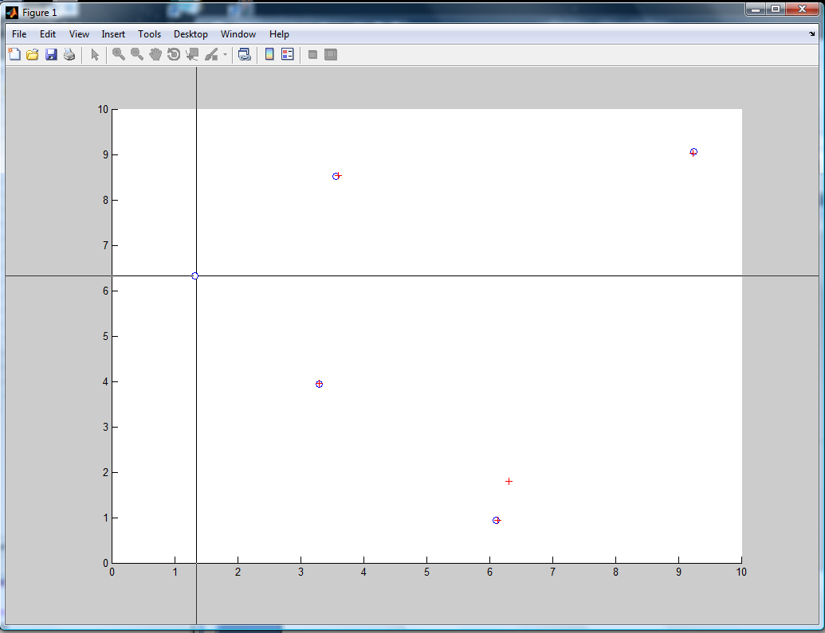

Fig. 2. Screen after 5th target appeared. Red crosses show location of clicks.

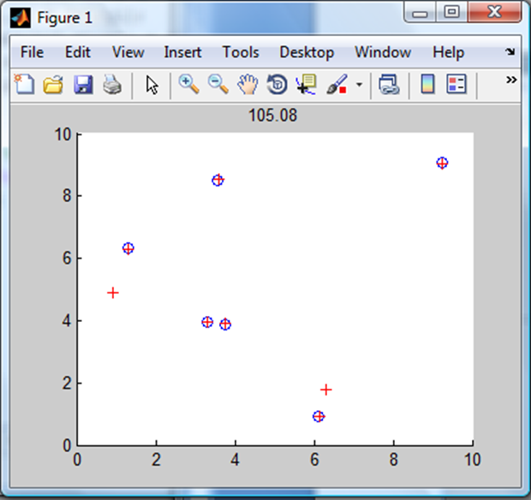

Fig. 3. Screen after game is finished with total time displayed as a figure title

Steps to accomplish it:

Start timer

Open figure; define axes

Insert loop to generate 6 targets

Generate random numbers for circle location

Draw circle/Generate 1 target at the time

Get user input from mouse and let Matlab to remember it

Mark location of click

Compare location of click with circle

Count number of correct clicks

When counter is 6 then stop game

Generate new location for circle

End screen with total time