CAse study – bl.A.nes

# Team members

Pawel Urbanowicz 108015016

Martin Ledl 108012012

# define

## Problem To be solved

Los Angeles is facing the problem that less hobby biker and tourists want to explore the city by bike. After investigation the origin of this phenomena it can be concluded that bikers don’t feel save anymore due to various crimes they had to face while exploring Los Angeles. BL.A.NES was founded in order to provide an overview over the safety of various bike lanes through L.A. and to make more people exploring the city using the bike.

## user to be addressed

This case study targets all kind of people who ride their bikes through Los Angeles and the user group is therefore really broad. It ranges from teenagers and families with children over different tourists to hobby and professional bikers. One thing that they have in common is that they want to enjoy Los Angeles’ bike lanes without being affected by any kind of crime. To achieve this goal, BL.A.NES supports all kind of bikers in planning their save trips.

# EMPATHY – WHAT PROBLEMS ARE USERS FACING?

Two groups of users can be identified by having a deeper look into the problem space. On the one side we have the officials of Los Angeles who wants to make people explore their city by bikes and enjoy their trips as well as to put their bike lanes onto the bucket lists of various tourists visiting L.A. On the other side we have the different types of bikers that want to have enjoyable rides along the bike lanes and enjoy the view at what the city offers to them.

## LOS ANGELES OFFICIALS

Crimes are a big problem in Los Angeles in general and their bad effect even gains power if they have a bad impact on tourism, visitors and people living in the city. Officials want people to enjoy what the city offers, including their beautiful bike lanes. Due to the committed crimes in the city, they want to support bikers and biking tourists in order to make their bike lanes as well as their city more attractive again.

## BIKERS

All kind of bikers want to enjoy their bike ride along the biking tracks of Los Angeles as well as the scenery the city provides to them without being distracted or even affected by any kind of crime. Bikers often don’t feel save while riding along the city’s tracks or have concerns about their safety while planning their tour. Due to these concerns there is a strong need to rate the safety of different bike lanes within the city to give the bikers a more save feeling and prevent them from being affected by any kind of crime.

# Ideate – What is Bl.a.nes?

BL.A.NES is a software solution that provides the user with the safest bike lanes in Los Angeles. To accomplish this functionality, datasets regarding bike tracks and committed crimes in L.A. are combined to extract information about safe and rather dangerous lanes concerning criminality in certain areas to be passed. This empowers user of BL.A.NES to plan save bike tours through beautiful places in Los Angeles without the danger of rushing into a crime. Properties of bike lanes (e.g. duration of the trip) and their geographical locations are used in combination with committed crimes in this area to classify tracks as save or rather not safe. The results are visualized properly to provide the user and easy overview and interaction with BL.A.NES.



# Prototype

The following image illustrates the first prototype from sight of a regular user (biker). The center of the main tab is a map which display the current tracks and the map is zoomable and adjusts the results in the right panel and the top 4 cards according to the zoom. A user can click the cards in order to display the specified class of bike lines on the map and the top 10 results of this class in the right panel. That’s the main functionality we will address within the HIDM class’ term project. Moreover, functionality empowering the user to report incidents on specific bike lanes and a tab for the favorite save bike lanes are also in improving the user’s experience.

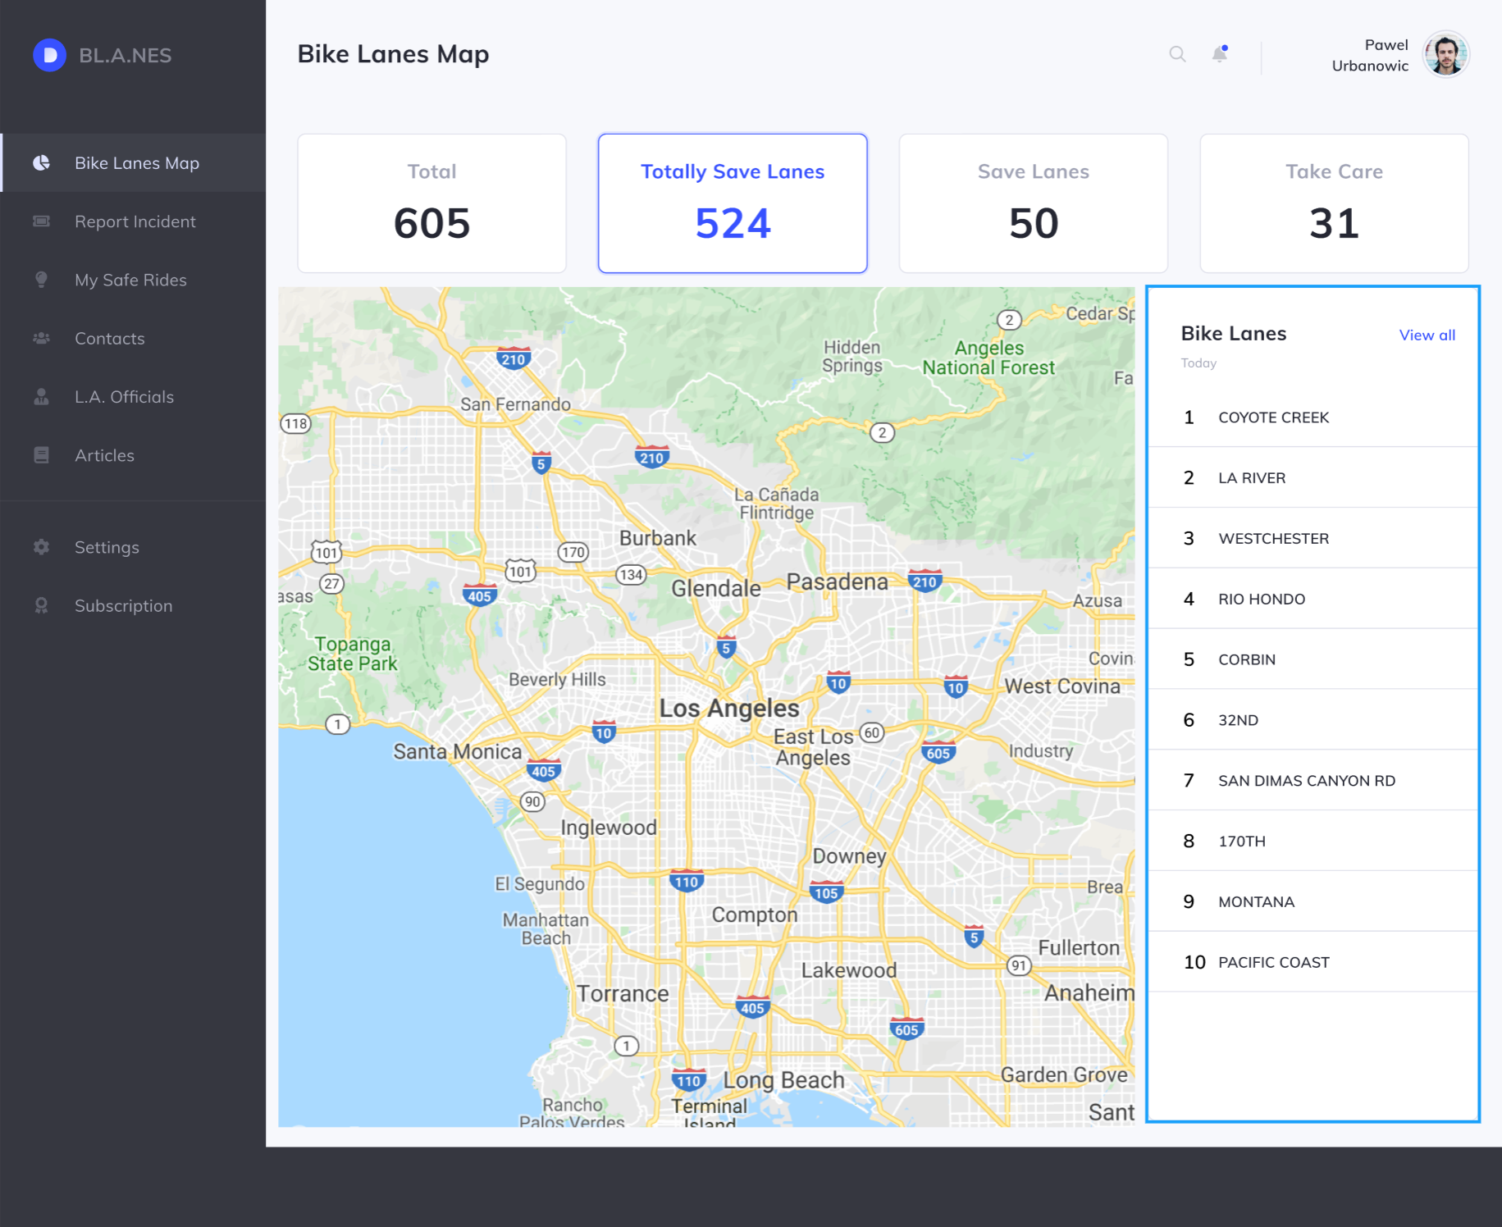

# Test

In order to test the BL.A.NES prototype application, a time range of 3 months is depicted and 500 users get access to the platform. This group of 500 users must contain people from a wide variety of groups as described earlier in this case study. Those test users should use the platform to plan their bike rides through Los Angeles and report is any incident has happened on any kind of lane. Moreover, positive rides should be added to the “My Save Ride” category. In the end we can obtain the accuracy of our bike lane classification under real life conditions.