<http://www.USScouts.Org> • <http://www.MeritBadge.Org>

Please submit errors, omissions, comments or suggestions about this **workbook** to: [Workbooks@USScouts.Org](mailto:Workbooks@usscouts.org?subject=Astronomy%20Merit%20Badge%20Workbook)

Comments or suggestions for changes to the **requirements** for the **merit badge** should be sent to: [Merit.Badge@Scouting.Org](mailto:merit.badge@scouting.org)

***______________________________________________________________________________________________________________________________________________***

1. Do the following:

a. Explain to your counselor the most likely hazards you may encounter while participating in astronomy activities, and what you should do to anticipate, help prevent, mitigate, and respond to these hazards.

Hazards:

|  |
| --- |
|  |
|  |
|  |
|  |
|  |
|  |
|  |
|  |
|  |

What you should do:

|  |
| --- |
|  |
|  |
|  |
|  |
|  |
|  |
|  |
|  |
|  |

b. Explain first aid for injuries or illnesses such as heat and cold reactions, dehydration, bites and stings, and damage to your eyes that could occur during observation.

|  |  |
| --- | --- |
| Heat reactions: |  |
|  |
|  |
|  |
| Cold reactions; |  |
|  |
|  |
|  |
| Dehydration; |  |
|  |
|  |
|  |
| Bites and stings: |  |
|  |
|  |
|  |
| Damage to your eyes: |  |
|  |
|  |
|  |

c. Describe the proper clothing and other precautions for safely making observations at night and in cold weather.

|  |  |
| --- | --- |
| Night: |  |
|  |
|  |
|  |
|  |
|  |
| Cold Weather: |  |
|  |
|  |
|  |
|  |
|  |

Then explain how to safely observe the Sun, objects near the Sun, and the Moon.

|  |
| --- |
|  |
|  |
|  |
|  |

2. Explain what light pollution is and how it and air pollution affect astronomy.

|  |
| --- |
|  |
|  |
|  |
|  |
|  |
|  |

3. With the aid of diagrams (or real telescopes if available), do each of the following:

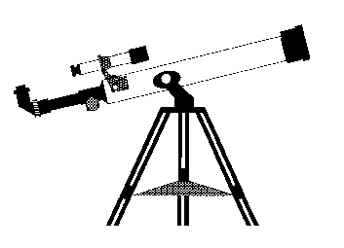 [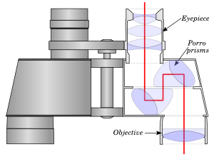](http://en.wikipedia.org/wiki/Image:Binocularp.svg)

a. Explain why binoculars and telescopes are important astronomical tools.

|  |
| --- |
|  |
|  |
|  |
|  |
|  |

Demonstrate or explain how these tools are used.

|  |
| --- |
|  |
|  |
|  |
|  |
|  |

b. Describe the similarities and differences of several types of astronomical telescopes, including at least one that observes light beyond the visible part of the spectrum (i.e., radio, X-ray, ultraviolet, or infrared).

|  |
| --- |
|  |
|  |
|  |
|  |
|  |
|  |
|  |
|  |
|  |

c. Explain the purposes of at least three instruments used with astronomical telescopes.

|  |
| --- |
|  |
|  |
|  |
|  |
|  |

d. Describe the proper care and storage of telescopes and binoculars both at home and in the field.

|  |
| --- |
|  |
|  |
|  |
|  |
|  |

4. Do the following:

a. Identify in the sky at least 10 constellations, at least four of which are in the zodiac.

|  |  |  |
| --- | --- | --- |
| ⬜ | 1. |  |
| ⬜ | 2. |  |
| ⬜ | 3. |  |
| ⬜ | 4. |  |
| ⬜ | 5. |  |
| ⬜ | 6. |  |
| ⬜ | 7. |  |
| ⬜ | 8. |  |
| ⬜ | 9. |  |
| ⬜ | 10. |  |

b. Identify at least eight conspicuous stars, five of which are of magnitude I or brighter.

Name of star Magnitude 1 or brighter?

|  |  |  |  |
| --- | --- | --- | --- |
| ⬜ | 1. |  |  |
| ⬜ | 2. |  |  |
| ⬜ | 3. |  |  |
| ⬜ | 4. |  |  |
| ⬜ | 5. |  |  |
| ⬜ | 6. |  |  |
| ⬜ | 7. |  |  |
| ⬜ | 8. |  |  |

c. Make two sketches of the Big Dipper. In one sketch, show the Big Dipper’s orientation in the early evening sky. In another sketch, show its position several hours later. In both sketches, show the North Star and the horizon. Record the date and time each sketch was made.

|  |
| --- |
| Date:___/___/___ Time: _____ Date:___/___/___ Time: _____ |
| ⏺North Star |
| West North East |
| ***Suggested procedure****: Choose a clear night when you will have time and the ability to make observations some hours apart. Looking north, draw the position of the Big Dipper with relation to the North Star. Note the time next to it. Several hours later (six hours are best but at least four hours and preferably more than five hours) draw the position of the big dipper with relation of the North Star and note the time next to it. (Be sure to clearly identify which diagram represents which observation)* |

d. Explain what we see when we look at the Milky Way.

|  |
| --- |
|  |
|  |
|  |
|  |
|  |
|  |
|  |
|  |
|  |
|  |
|  |
|  |

5. Do the following:

a. List the names of the five most visible planets. Explain which ones can appear in phases similar to lunar phases and which ones cannot, and explain why.

Five Most Visible Planets Phases? Why?

|  |  |  |
| --- | --- | --- |
|  |  |  |
|  |  |  |

b. Using the Internet (with your parent's permission), books, and other resources, find out when each of the five most visible planets that you identified in requirement 5a will be observable in the evening sky during the next 12 months, then compile this information in the form of a chart or table.

|  |  |  |  |  |  |
| --- | --- | --- | --- | --- | --- |
| Planet Name |  |  |  |  |  |
| Month |
| January |  |  |  |  |  |
| February |  |  |  |  |  |
| March |  |  |  |  |  |
| April |  |  |  |  |  |
| May |  |  |  |  |  |
| June |  |  |  |  |  |
| July |  |  |  |  |  |
| August |  |  |  |  |  |
| September |  |  |  |  |  |
| October |  |  |  |  |  |
| November |  |  |  |  |  |
| December |  |  |  |  |  |

c. Describe the motion of the planets across the sky.

|  |
| --- |
|  |
|  |
|  |
|  |
|  |
|  |
|  |

d. Observe a planet and describe what you saw.

|  |
| --- |
|  |
|  |
|  |
|  |

6. Do the following:

a. Sketch the face of the Moon and indicate at least five seas and five craters. Label these landmarks.

b. Sketch the phase and the daily position of the Moon, at the same hour and place, for four days in a row. Include landmarks on the horizon such as hills, trees, and buildings.

|  |
| --- |
| Date:___/___/___ Time: _____ Date:___/___/___ Time: _____ Date:___/___/___ Time: _____ Date:___/___/___ Time: _____ |
|  |
| East South West |
| ***Suggested procedure:***  *First check to see whether it is a morning or evening moon and chose a time to view the moon.* ***Avoid an observation period when there will be a new moon.*** *Choose a time and place you are going to be able to observe the moon each day. On the first day, sketch the relative position of the moon across the southern horizon noting its height and shape (phase). Draw some landmarks on the sketch as points of reference. On the same drawing, repeat this at the same time each day for the next three days, showing the height and shape of the moon for each observation.* ***Note the date and time of your observation next to each sketch of the moon****. If the sky is overcast and the moon is not visible, either extend the observations until you can make four of them, and/or using the other observations, estimate where the moon would have been and what shape it would have been on the overcast day(s) and indicate that what is an estimate due to overcast sky.* |

Explain the changes you observe.

|  |
| --- |
|  |
|  |
|  |
|  |
|  |
|  |

c. List the factors that keep the Moon in orbit around Earth.

|  |
| --- |
|  |
|  |
|  |
|  |
|  |
|  |
|  |
|  |
|  |

d. With the aid of diagrams, explain the relative positions of the Sun, Earth, and the Moon at the times of lunar and solar eclipses, and at the times of new, first-quarter, full, and last-quarter phases of the Moon.

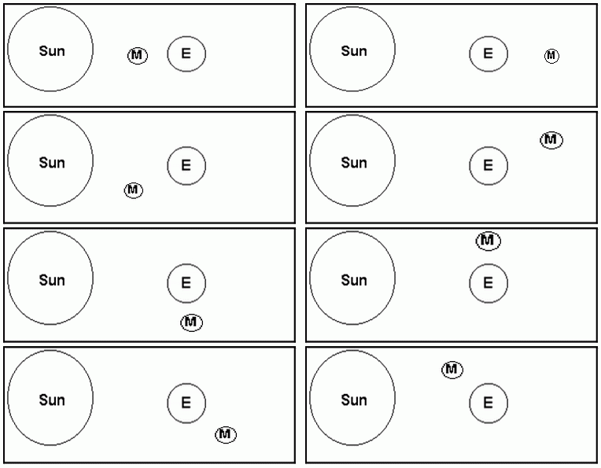

*Editor’s Note: These diagrams can be used to show the relative positions of the Sun, Earth, and Moon during the new, first-quarter, full, and last-quarter phases of the Moon as well as during the Waxing* *Gibbous”, “Waning* *Gibbous”, “Waxing* *Crescent”, and “Waning* *Crescent” phases of the Moon (which is not required for the merit badge). Two of the diagrams can be used to show the positions both for a phase of the Moon and during an eclipse*.

7. Do the following:

a. Describe the composition of the Sun, its relationship to other stars, and some effects of its radiation on Earth’s weather and communications.

|  |  |
| --- | --- |
| Composition: |  |
|  |
|  |
|  |
|  |
| Relationship to other stars: |  |
|  |
|  |
|  |
|  |
| Effects on Earth’s weather: |  |
|  |
|  |
|  |
|  |
| Effects on communications. |  |
|  |
|  |
|  |
|  |

b. Define sunspots and describe some of the effects they may have on solar radiation.

|  |  |
| --- | --- |
| Definition: |  |
|  |
|  |
|  |
|  |
| Effects: |  |
|  |
|  |
|  |
|  |

c. Identify at least one red star, one blue star, and one yellow star (other than the Sun).

|  |  |
| --- | --- |
| Red star: |  |
| Blue star: |  |
| Yellow star: |  |

Explain the meaning of these colors.

|  |
| --- |
|  |
|  |
|  |
|  |
|  |
|  |
|  |

8. With your counselor's approval and guidance, do ONE of the following:

⬜ a. Visit a planetarium or astronomical observatory. Submit a written report, a scrapbook, or a video presentation afterward to your counselor that includes the following information:

1. Activities occurring there

|  |
| --- |
|  |
|  |
|  |
|  |

2. Exhibits and displays you saw

|  |
| --- |
|  |
|  |
|  |
|  |

3. Telescopes and instruments being used

|  |
| --- |
|  |
|  |
|  |
|  |

4. Celestial objects you observed.

|  |
| --- |
|  |
|  |
|  |
|  |

⬜ b. Plan and participate in a three-hour observation session that includes using binoculars or a telescope. List the celestial objects you want to observe, and find each on a star chart or in a guidebook.

|  |
| --- |
|  |
|  |
|  |
|  |
|  |
|  |
|  |
|  |
|  |
|  |
|  |
|  |
|  |
|  |

⬜ Prepare an observing log or notebook. Show your plan, charts, and log or notebook to your counselor before making your observations. Review your log or notebook with your counselor afterward.

⬜ c. Plan and host a star party for your Scout troop or other group such as your class at school. Use binoculars or a telescope to show and explain celestial objects to the group.

⬜ d. Help an astronomy club in your community hold a star party that is open to the public.

⬜ e. Personally take a series of photographs or digital images of the movement of the Moon, a planet, an asteroid or meteoroid, or a comet. In your visual display, label each image and include the date and time it was taken. Show all positions on a star chart or map. Show your display at school or at a troop meeting. Explain the changes you observed.

|  |
| --- |
|  |
|  |
|  |
|  |
|  |
|  |
|  |
|  |
|  |
|  |
|  |
|  |

9. Find out about three career opportunities in astronomy.

|  |  |
| --- | --- |
| 1. |  |
| 2. |  |
| 3. |  |

Pick one and find out the education, training, and experience required for this profession

|  |
| --- |
|  |
|  |
|  |
|  |
|  |
|  |
|  |
|  |

Discuss this with your counselor, and explain why this profession might interest you.

|  |
| --- |
|  |
|  |
|  |
|  |
|  |
|  |
|  |
|  |
|  |
|  |
|  |
|  |

**Requirement resources can be found here:**

[http://www.meritbadge.org/wiki/index.php/Astronomy#Requirement resources](http://www.meritbadge.org/wiki/index.php/Astronomy#Requirement_resources)

**Important excerpts from the** [***Guide To Advancement - 2013***](http://www.scouting.org/filestore/pdf/33088.pdf)**, No. 33088 (SKU-618673)**

**[1.0.0.0] — Introduction**

The current edition of the *Guide to Advancement* is the official source for administering advancement in all Boy Scouts of America programs: Cub Scouting, Boy Scouting, Varsity Scouting, Venturing, and Sea Scouts. It replaces any previous BSA advancement manuals, including *Advancement Committee Policies and Procedures*, *Advancement and Recognition Policies and Procedures*, and previous editions of the *Guide to Advancement*.

**[Page 2, and 5.0.1.4] — Policy on Unauthorized Changes to Advancement Program**

***No council, committee, district, unit, or individual has the authority to add to, or subtract from, advancement requirements.*** There are limited exceptions relating only to youth members with special needs. For details see section 10, “Advancement for Members With Special Needs”.

**[Page 2] — The** [**“Guide to Safe Scouting”**](http://www.scouting.org/scoutsource/HealthandSafety/GSS/toc.aspx) **Applies**

Policies and procedures outlined in the ***Guide to Safe Scouting****,* No. 34416, apply to all BSA activities, including those related to advancement and Eagle Scout service projects.

**[7.0.3.1] — The Buddy System and Certifying Completion**

A youth member must not meet one-on-one with an adult. Sessions with counselors must take place where others can view the interaction, or the Scout must have a buddy: a friend, parent, guardian, brother, sister, or other relative—or better yet, another Scout working on the same badge—along with him attending the session.

When the Scout meets with the counselor, he should bring any required projects. If these cannot be transported, he should present evidence, such as photographs or adult verification. His unit leader, for example, might state that a satisfactory bridge or tower has been built for the Pioneering merit badge, or that meals were prepared for Cooking. If there are questions that requirements were met, a counselor may confirm with adults involved. Once satisfied, the counselor signs the blue card using the date upon which the Scout completed the requirements, or in the case of partials, initials the individual requirements passed.

Note that from time to time, it may be appropriate for a requirement that has been met for one badge to also count for another. See “Fulfilling More Than One Requirement With a Single Activity,” 4.2.3.6.

**[7.0.3.2] — Group Instruction**

It is acceptable—and sometimes desirable—for merit badges to be taught in group settings. This often occurs at camp and merit badge midways or similar events. Interactive group discussions can support learning. The method can also be attractive to “guest experts” assisting registered and approved counselors. Slide shows, skits, demonstrations, panels, and various other techniques can also be employed, but as any teacher can attest, not everyone will learn all the material.

There must be attention to each individual’s projects and his fulfillment of *all* requirements. We must know that every Scout —actually and *personally*— completed them. If, for example, a requirement uses words like “show,” “demonstrate,” or “discuss,” then every Scout must do that. It is unacceptable to award badges on the basis of sitting in classrooms *watching* demonstrations, or remaining silent during discussions.

It is sometimes reported that Scouts who have received merit badges through group instructional settings have not fulfilled all the requirements. To offer a quality merit badge program, council and district advancement committees should ensure the following are in place for all group instructional events.

* Merit badge counselors are known to be registered and approved.
* Any guest experts or guest speakers, or others assisting who are not registered and approved as merit badge counselors, do not accept the responsibilities of, or behave as, merit badge counselors, either at a group instructional event or at any other time. Their service is temporary, not ongoing.
* Counselors agree not to assume prerequisites have been completed without some level of evidence that the work has been done. Pictures and letters from other merit badge counselors or unit leaders are the best form of prerequisite documentation when the actual work done cannot be brought to the camp or site of the merit badge event.
* There is a mechanism for unit leaders or others to report concerns to a council advancement committee on summer camp merit badge programs, group instructional events, and any other merit badge counseling issues—especially in instances where it is believed BSA procedures are not followed. See “Reporting Merit Badge Counseling Concerns,” 11.1.0.0.
* There must be attention to each individual’s projects and his fulfillment of all requirements. We must know that every Scout—actually and personally—completed them.

**[7.0.3.3] — Partial Completions**

A Scout need not pass all the requirements of one merit badge with the same counselor. It may be that due to timing or location issues, etc., he must meet with a different counselor to finish the badge. The Application for Merit Badge has a place to record what has been finished—a “partial.” In the center section on the reverse of the blue card, the counselor initials for each requirement passed. In the case of a partial completion, the counselor does not retain his or her portion of the card. A subsequent counselor may choose not to accept partial work, but this should be rare. A Scout, if he believes he is being treated unfairly, may work with his unit leader to find another counselor. An example for the use of a signed partial would be to take it to camp as proof of prerequisites. Partials have no expiration except the Scout’s 18th birthday. Units, districts, or councils shall not establish other expiration dates for partial merit badges.

**[7.0.4.8] — Unofficial Worksheets and Learning Aids**

Worksheets and other materials that may be of assistance in earning merit badges are available from a variety of places including unofficial sources on the Internet and even troop libraries. Use of these aids is permissible as long as the materials can be correlated with the current requirements that Scouts must fulfill. Completing “worksheets” may suffice where a requirement calls for something in writing, but this would not work for a requirement where the Scout must discuss, tell, show, or demonstrate, etc. Note that Scouts shall not be required to use these learning aids in order to complete a merit badge.