Melissa Chudyk
Emily Fagerstrom
Steven Leuthe

Project 1 - 1D Quantum Scattering

Summary of the Author's Derivation

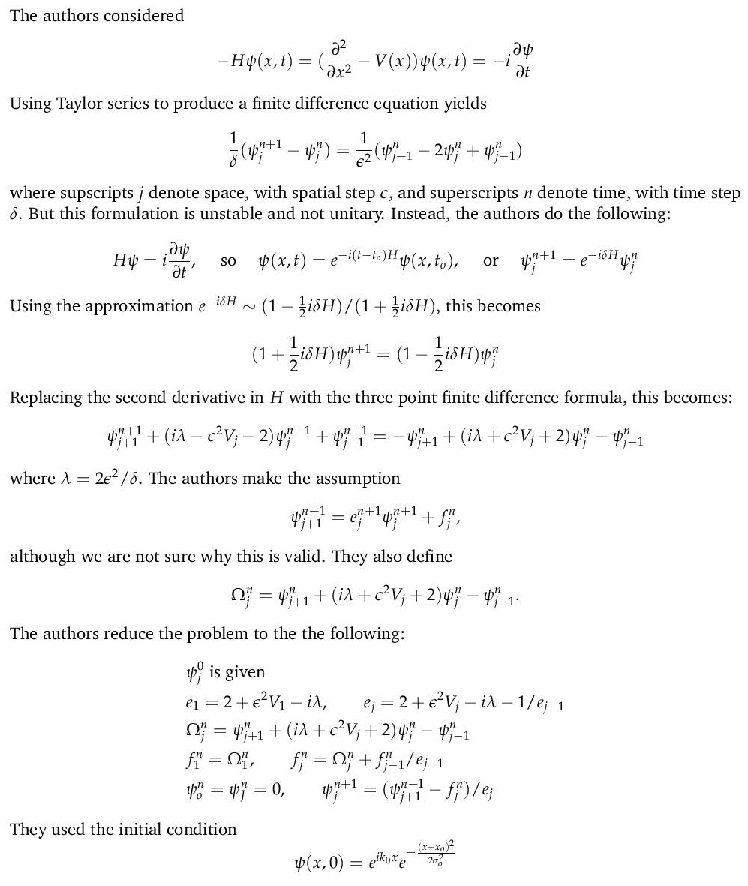

Pseudo Code

Set parameters
Create vector of spatial points, of length J+1
Create Psi, E, Omega, f to be complex vectors of length J+1
Initialize Psi to be initial waveform
Set E to be (as above)
Initialize Omega to be (as above)
Initialize f to be (as above)
for n = 0, 1, … , J:
Set Omega to be (as above)
for j = 2, 3, … , J:
set f[j] to be (as above)
for j = J-1, J-2, … , 2:
set Psi[j] to be (as above)
Plot Psi

Note: As each time step is taken, Numpy's vectorization abilities were utilized to update the “Omega” array. However, the updates for f and Psi could not be vectorized. Each value of f (after f[1]) depends on the value of f to the left on the spatial axis, and each value of Psi (before Psi[J-1]) depends on the value of Psi to the right on the spatial axis. Therefore, for loops needed to be implemented to update these at each time step, which does slow down the computations, but it was unavoidable.

Parameters

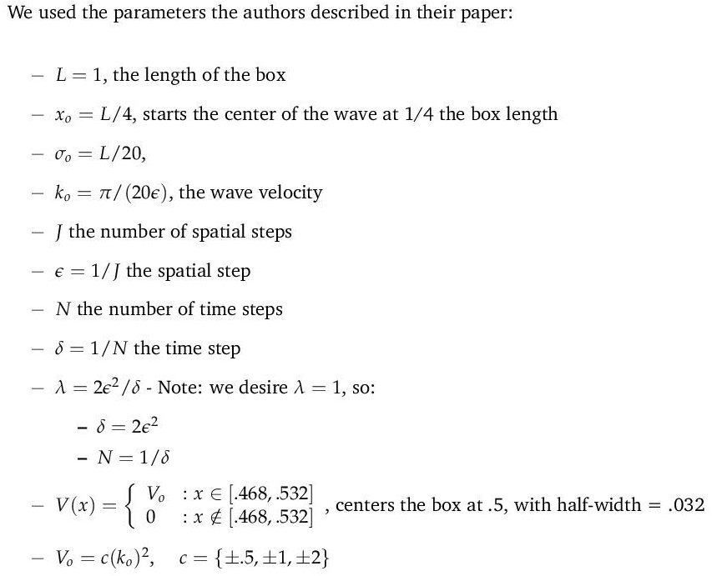

Plots: Figure 1:
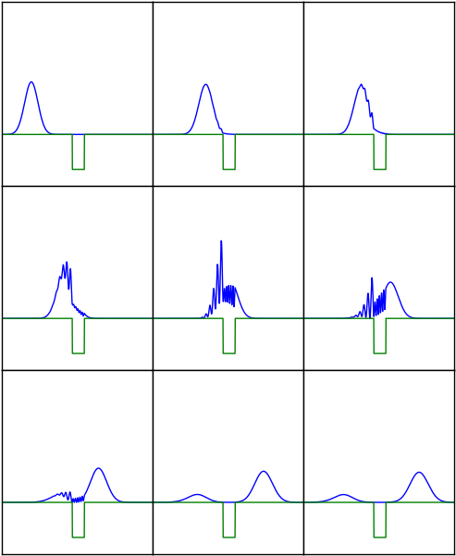
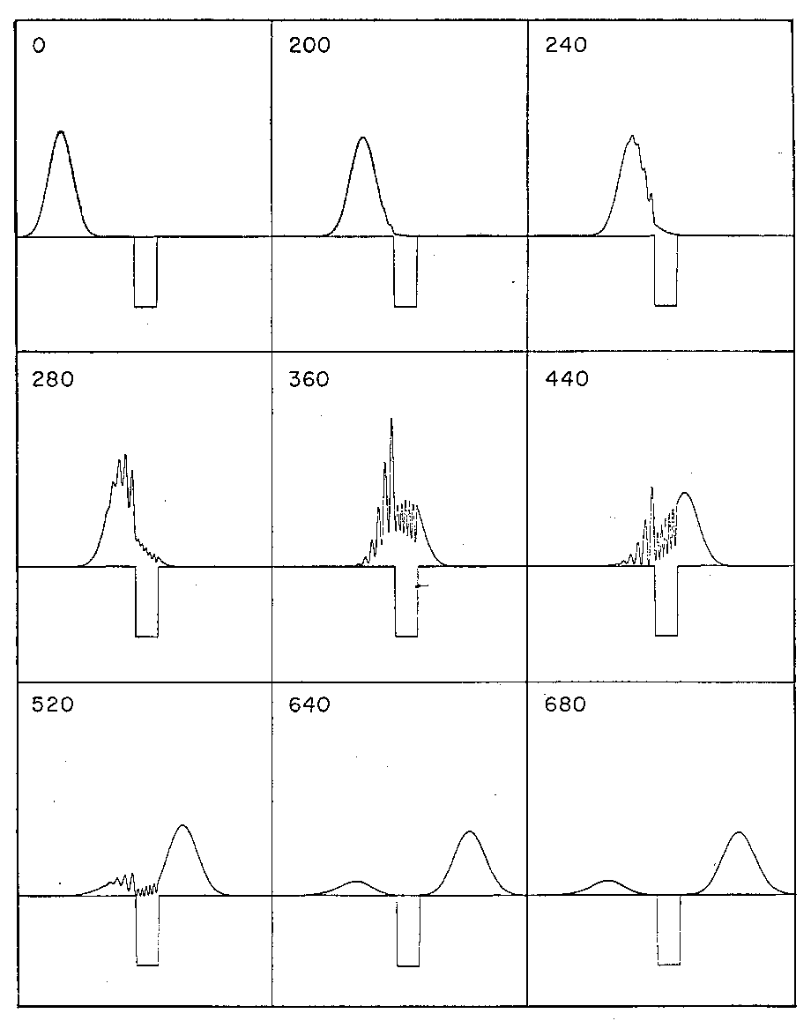

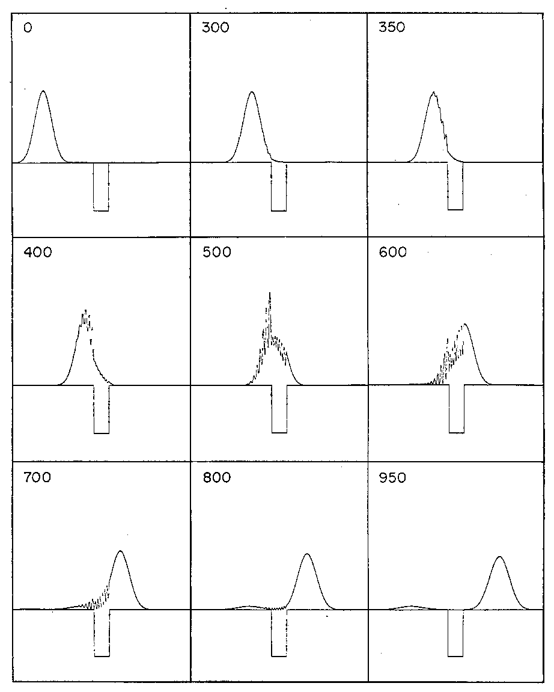
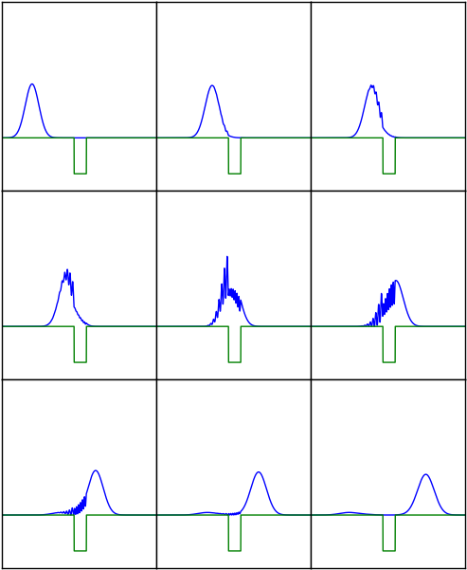
Figure #2

Figure #3
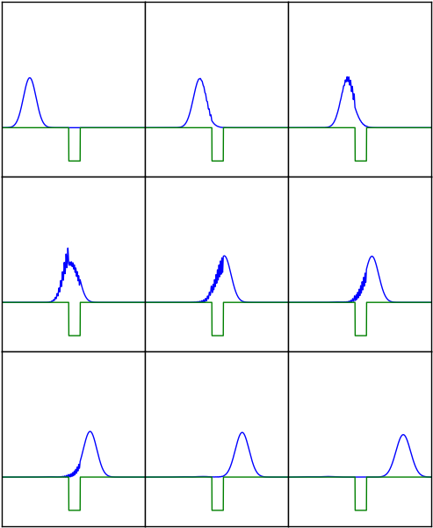
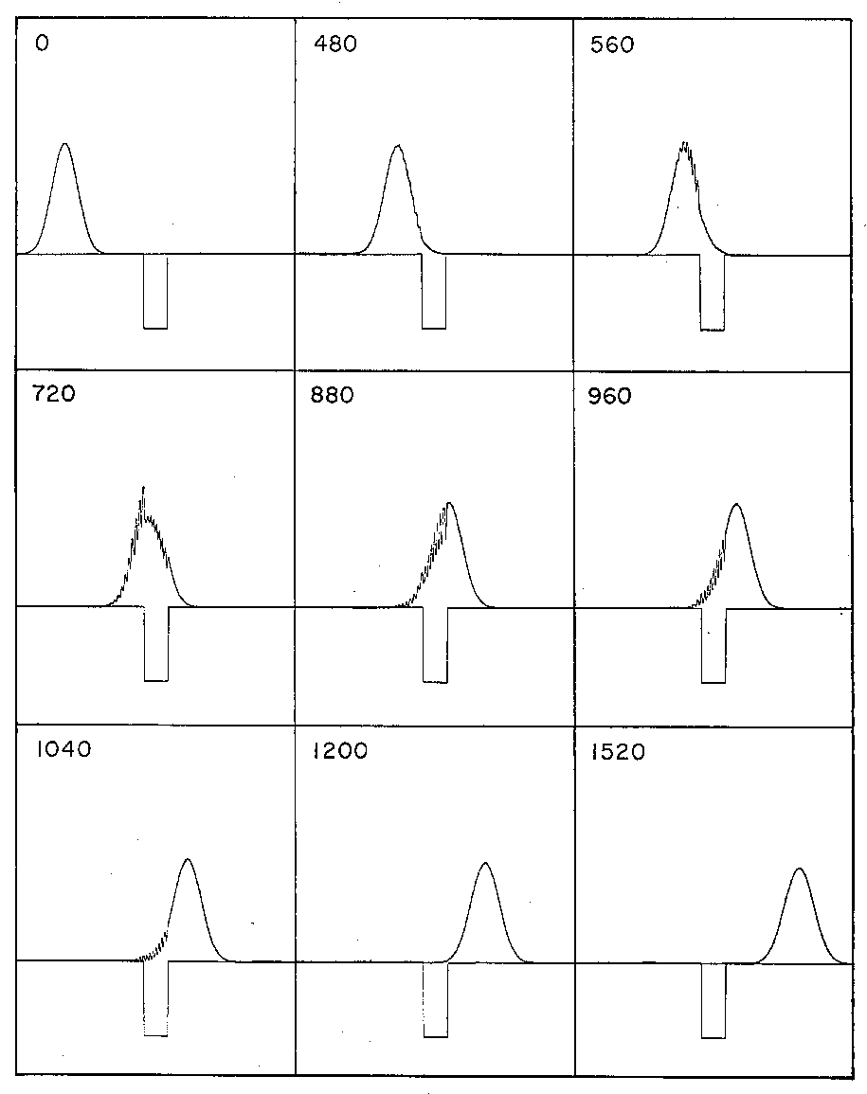

Figure #4
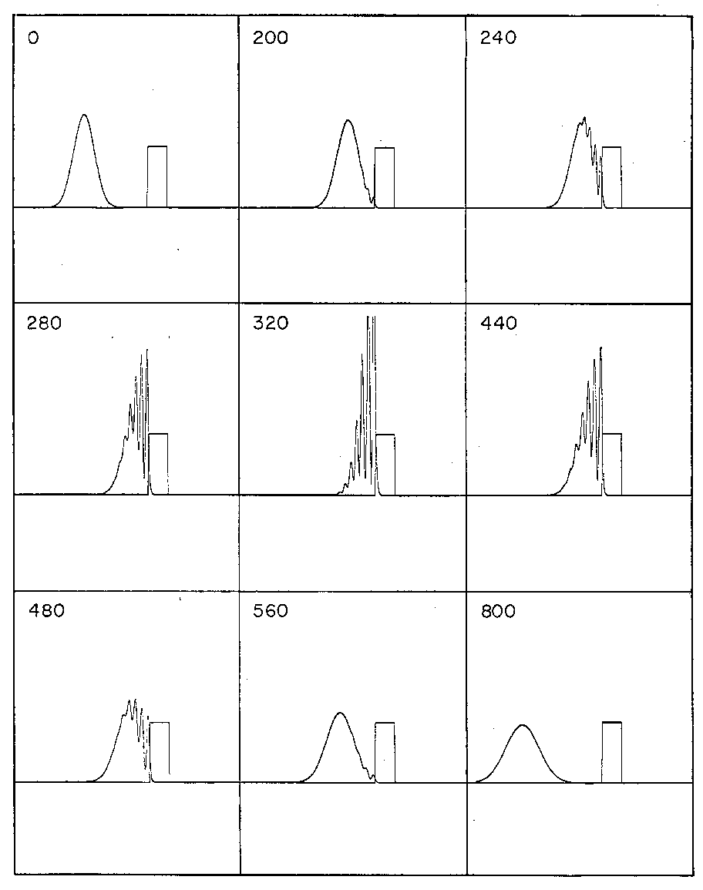
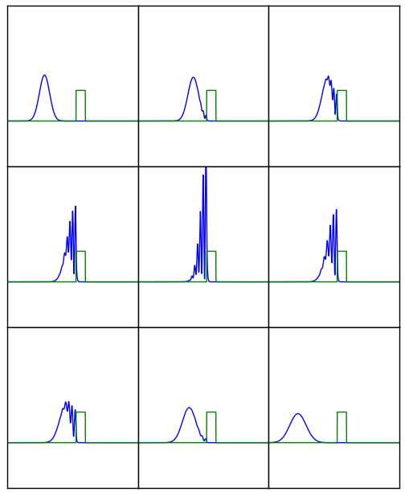

Figure #5
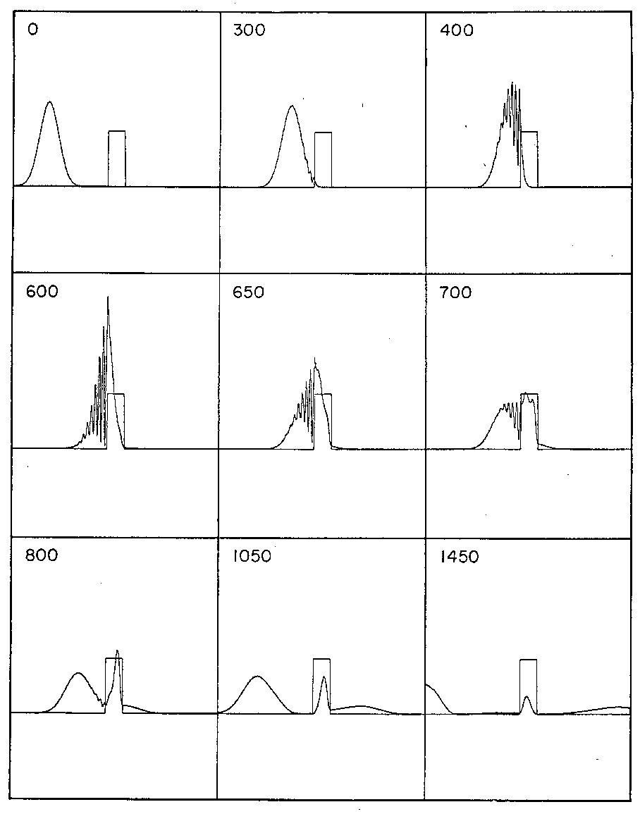
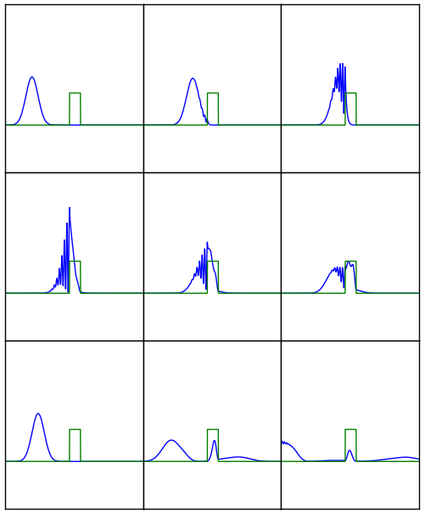

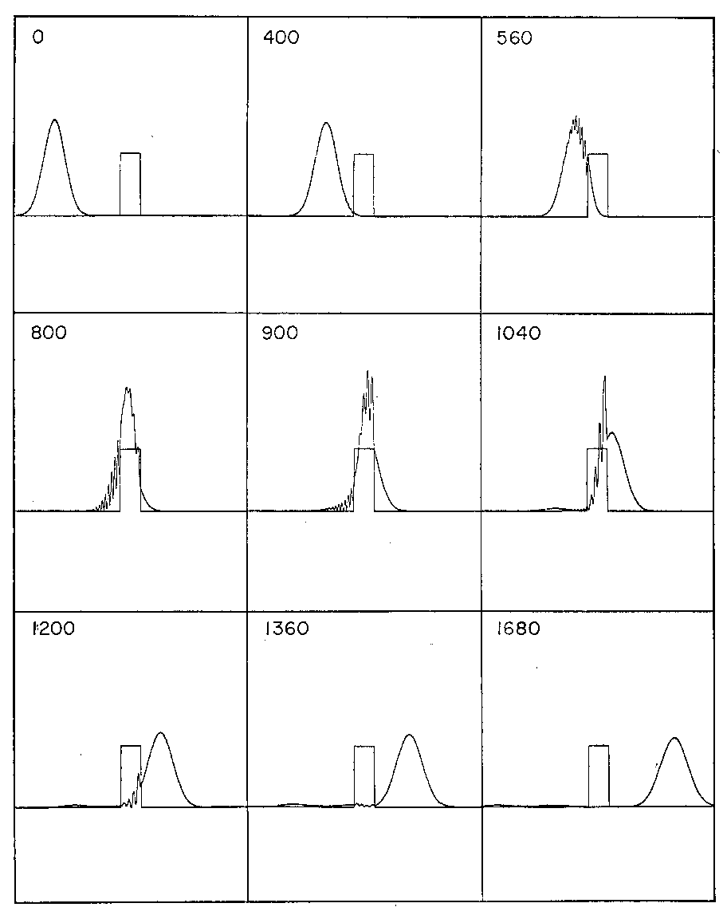
Figure #6
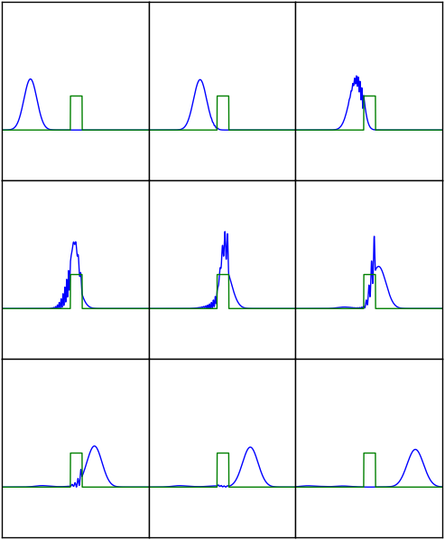

The figures here are analogous to those in the paper (including the times at which the images were taken):
Figure 1:
J = 1000
V0= -2(k0)^2
Figure 2:
J = 1414
V0= -(k0)^2
Figure 3:
J = 2000
V0= -.5(k0)^2
Figure 4:
J = 1000
V0= 2(k0)^2
Figure 5:
J = 1414
V0= (k0)^2
Figure 6:
J = 2000
V0= .5(k0)^2

Discussion/Conclusions:

We have recreated the figures 1-6 in the paper almost exactly.

Code – animation; various comments correspond to various potentials
from numpy import *
from pylab import *
from matplotlib import*
I=complex(0.,1.)
L=1. #length
T=1. #time
x0 = L/4.
sig0=L/20.
lamb=1. #lambda
# number spatial steps
#J=1000 # fig 1
#J=1414 # fig 2
#J=2000 # fig 3
#J=1000 # fig 4
#J=1414 # fig 5
J=2000 # fig 6
eps = L/float(J) #spatial step
delt=2.*eps**2/lamb
N=int(T/delt) #time iterations
k0 = pi/20./eps #50.*pi #pi/10./eps
#potential
V=zeros(J+1,dtype=complex)
a1=int((J+1)*(.5-.032))
a2=int((J+1)*(.5+.032))
#V[a1:a2]=-(2.*(k0)**2)*ones(a2-a1,dtype=complex) #fig 1
#V[a1:a2]=-(1.*(k0)**2)*ones(a2-a1,dtype=complex) #fig 2
#V[a1:a2]=-(.5*(k0)**2)*ones(a2-a1,dtype=complex) #fig 3
#V[a1:a2]=(2.*(k0)**2)*ones(a2-a1,dtype=complex) #fig 4
#V[a1:a2]=(1.*(k0)**2)*ones(a2-a1,dtype=complex) #fig 5
V[a1:a2]=(.5*(k0)**2)*ones(a2-a1,dtype=complex) #fig 6
Vtop=zeros(J+1,dtype=complex)
Vtop[a1:a2]=2./3.*ones(a2-a1,dtype=complex)
#initial condition
x=linspace(0,1,J+1)
psi = exp(I*k0*x)*exp(-(x-x0)**2/(2.*sig0**2))
#Build e vector
E=zeros(J+1)*complex(0.,0.)
E[1]=2.+eps**2*V[1]-I*lamb
for i in range(2,J+1):
E[i]=2.+eps**2*V[i]-I*lamb-(1/E[i-1])
#initializing vectors
Omega=zeros(J+1)*complex(0.,0.)
Psi = zeros(J+1)*complex(0.,0.)
f = zeros(J+1)*complex(0.,0.)
Psi[1:-1]=psi[1:-1]
ion()
p,=plot(x,abs(Psi)**2)
q,=plot(x,Vtop)
for n in range(0,2*N/J+1):
#print n
Omega[1:-1]=-Psi[2:]-Psi[0:-2]+(I*lamb+2.)*Psi[1:-1]+eps**2*(Psi[1:-1]*V[1:-1])
f[1]=Omega[1]
for i in range(2,J+1):
f[i]=Omega[i]+f[i-1]/E[i-1]
for i in range(2,J+1):
Psi[-i]=(Psi[-i+1]-f[-i])/E[-i]
if n%2==0:
p.set_ydata(abs(Psi)**2)
title(n)
ylim(-1,2.5)
xlim(.1,.9)
draw()
#if n==0: raw_input() #intial pause to allow change in aspect ratio
#if n%40==0: raw_input()
ioff()
show()

Code – produces Figure 1 of the paper
from numpy import *
from pylab import *
from matplotlib import*

I=complex(0.,1.)

L=1. #length
T=1. #time
x0 = L/4.
sig0=L/20.
lamb=1. #lambda
# number spatial steps
J=1000 # fig 1

eps = L/float(J) #spatial step
delt=2.*eps**2/lamb
N=int(T/delt) #time iterations
k0 = pi/20./eps #50.*pi #pi/10./eps

#potential
V=zeros(J+1,dtype=complex)
a1=int((J+1)*(.5-.032))
a2=int((J+1)*(.5+.032))
V[a1:a2]=-(2.*(k0)**2)*ones(a2-a1,dtype=complex) #fig 1

Vtop=zeros(J+1,dtype=complex)
Vtop[a1:a2]=-2./3.*ones(a2-a1,dtype=complex)

#initial condition
x=linspace(0,1,J+1)
psi = exp(I*k0*x)*exp(-(x-x0)**2/(2.*sig0**2))

#Build e vector
E=zeros(J+1)*complex(0.,0.)
E[1]=2.+eps**2*V[1]-I*lamb
for i in range(2,J+1):
E[i]=2.+eps**2*V[i]-I*lamb-(1/E[i-1])

#initializing vectors
Omega=zeros(J+1)*complex(0.,0.)
Psi = zeros(J+1)*complex(0.,0.)
f = zeros(J+1)*complex(0.,0.)
Psi[1:-1]=psi[1:-1]

Plots=zeros((9,J+1))*complex(0.,0.)
Plots[0]=Psi

ion()

#the iteration
for n in range(0,2*N/J+1):
#print n
Omega[1:-1]=-Psi[2:]-Psi[0:-2]+(I*lamb+2.)*Psi[1:-1]+eps**2*(Psi[1:-1]*V[1:-1])
f[1]=Omega[1]
for i in range(2,J+1):
f[i]=Omega[i]+f[i-1]/E[i-1]
for i in range(2,J+1):
Psi[-i]=(Psi[-i+1]-f[-i])/E[-i]

if n==200: Plots[1]=Psi
if n==240: Plots[2]=Psi
if n==280: Plots[3]=Psi
if n==360: Plots[4]=Psi
if n==440: Plots[5]=Psi
if n==520: Plots[6]=Psi
if n==640: Plots[7]=Psi
if n==680: Plots[8]=Psi

#figure(1)

ax0 = subplot(331, autoscale_on=False, xlim=[.1,.9], ylim=[-1,2.5])
ax0.set_xticks([])
ax0.set_yticks([])
ax0.plot(x,abs(Plots[0])**2)
ax0.plot(x,Vtop)
#ax0.set_title('Plot 2')

ax1 = subplot(332, autoscale_on=False, xlim=[.1,.9], ylim=[-1,2.5])
ax1.set_xticks([])
ax1.set_yticks([])
ax1.plot(x,abs(Plots[1])**2)
ax1.plot(x,Vtop)

ax0 = subplot(333, autoscale_on=False, xlim=[.1,.9], ylim=[-1,2.5])
ax0.set_xticks([])
ax0.set_yticks([])
ax0.plot(x,abs(Plots[2])**2)
ax0.plot(x,Vtop)

ax1 = subplot(334, autoscale_on=False, xlim=[.1,.9], ylim=[-1,2.5])
ax1.set_xticks([])
ax1.set_yticks([])
ax1.plot(x,abs(Plots[3])**2)
ax1.plot(x,Vtop)
#ax1.set_title('Plot 2')

ax0 = subplot(335, autoscale_on=False, xlim=[.1,.9], ylim=[-1,2.5])
ax0.set_xticks([])
ax0.set_yticks([])
ax0.plot(x,abs(Plots[4])**2)
ax0.plot(x,Vtop)

ax1 = subplot(336, autoscale_on=False, xlim=[.1,.9], ylim=[-1,2.5])
ax1.set_xticks([])
ax1.set_yticks([])
ax1.plot(x,abs(Plots[5])**2)
ax1.plot(x,Vtop)

ax0 = subplot(337, autoscale_on=False, xlim=[.1,.9], ylim=[-1,2.5])
ax0.set_xticks([])
ax0.set_yticks([])
ax0.plot(x,abs(Plots[6])**2)
ax0.plot(x,Vtop)

ax1 = subplot(338, autoscale_on=False, xlim=[.1,.9], ylim=[-1,2.5])
ax1.set_xticks([])
ax1.set_yticks([])
ax1.plot(x,abs(Plots[7])**2)
ax1.plot(x,Vtop)

ax0 = subplot(339, autoscale_on=False, xlim=[.1,.9], ylim=[-1,2.5])
ax0.set_xticks([])
ax0.set_yticks([])
ax0.plot(x,abs(Plots[8])**2)
ax0.plot(x,Vtop)

subplots_adjust(top=.98, bottom=0.01,left =.02,right=.62, wspace=0.,hspace=0.)
draw()
ioff()
show()

