Matthew Leming

COMP 775, Fall 2014, Stephen Pizer

Assignment 3

Code can be found at

<https://github.com/mleming/Registration>

These are the results (note: graphs for sum of squares and earth mover’s distance were multiplied by -1 so that the maxima were the peaks, and the function could be more consistent).

Image 1

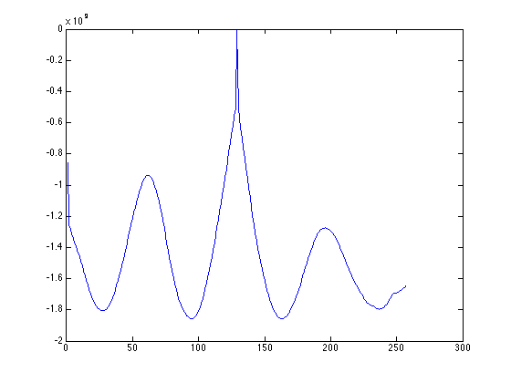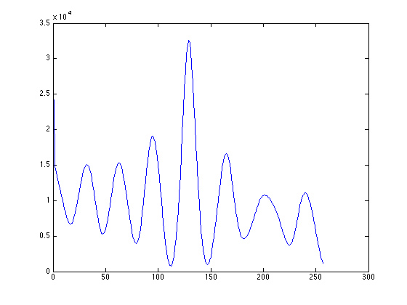

Sum of squares Normalized Cross correlation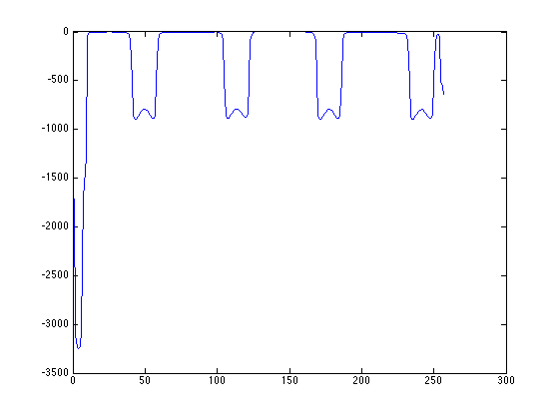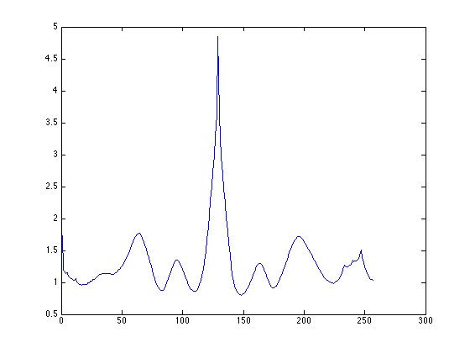

Earth Mover’s Distance Mutual Information

Image 2

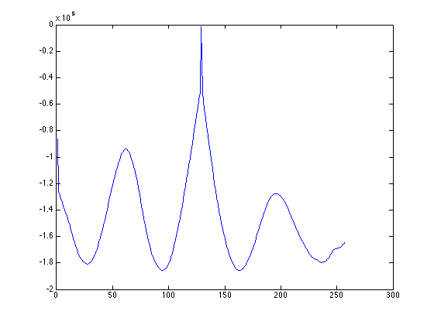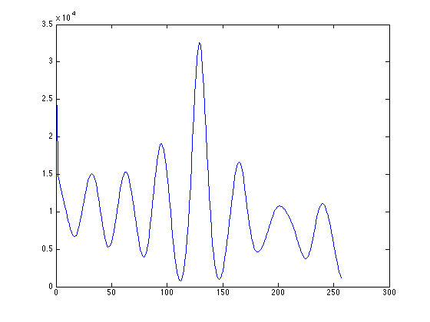

Sum of squares Normalized Cross correlation 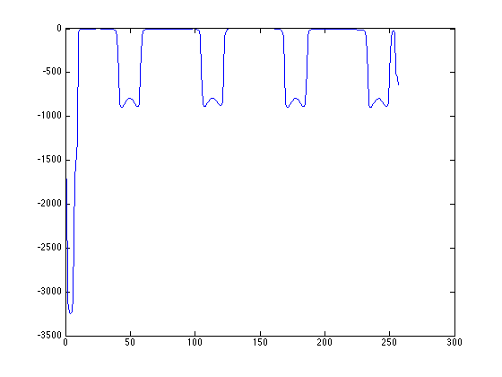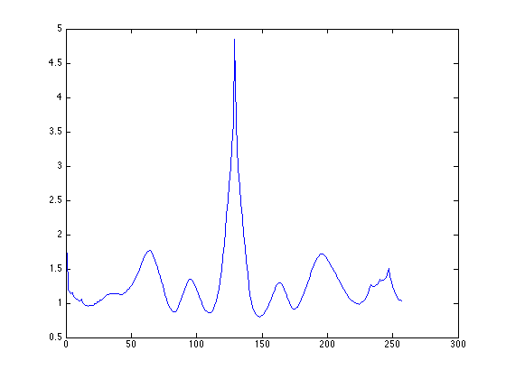

Earth Mover’s Distance Mutual Information

Image 3

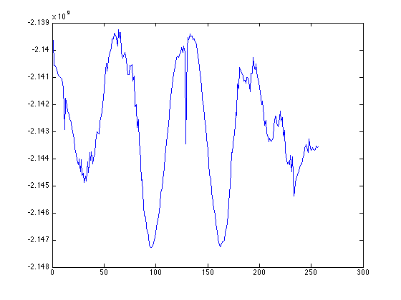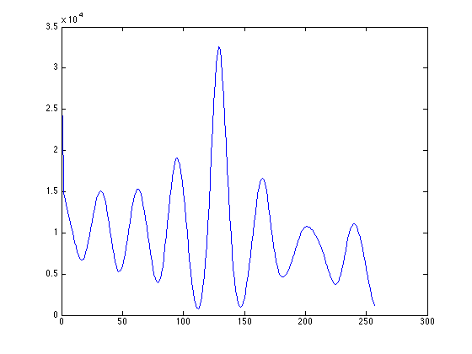

Sum of squares Normalized Cross correlation 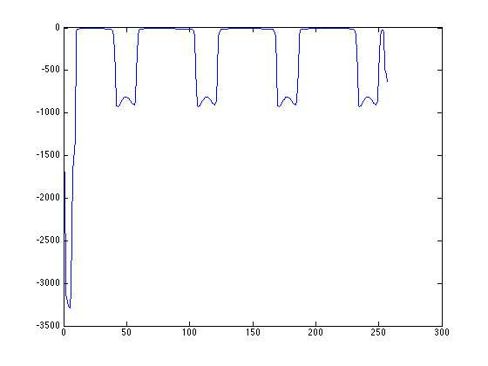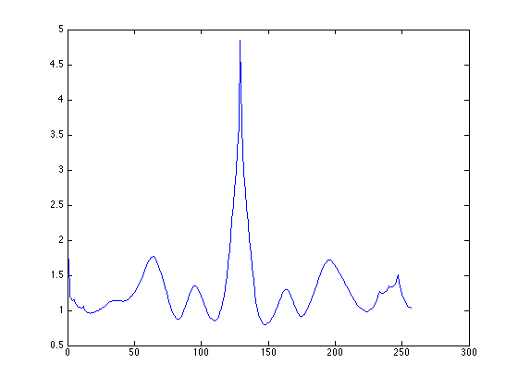

Earth Mover’s Distance Mutual Information

Image 4

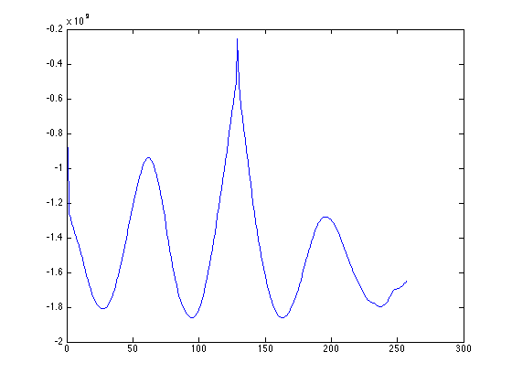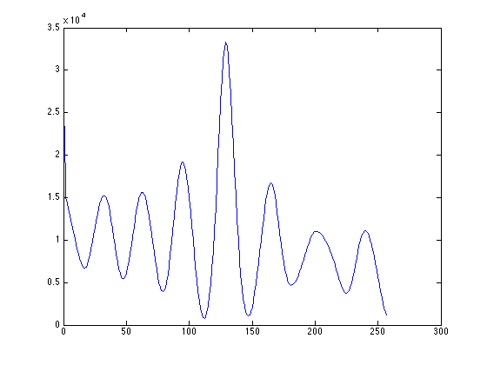

Sum of squares Normalized Cross correlation 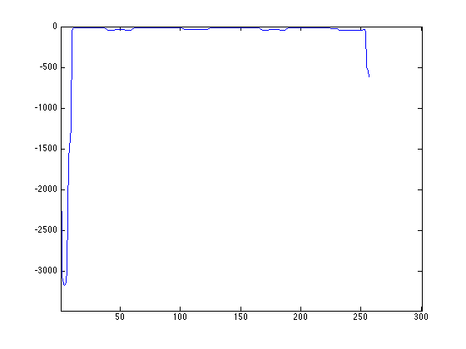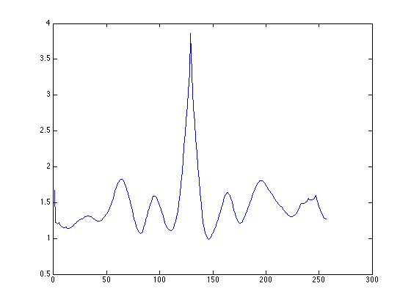

Earth Mover’s Distance Mutual Information

Removing the additive normalization of in the Euclidean Differences had the following effect on the four image mismatch values:

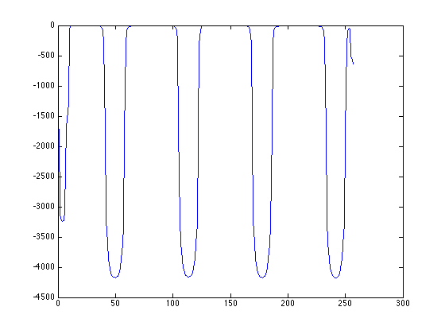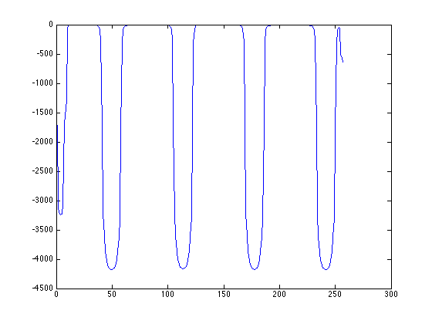

Image 1: Image 2:

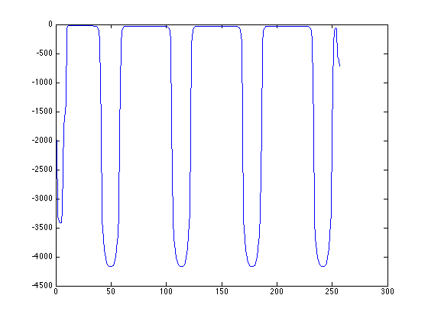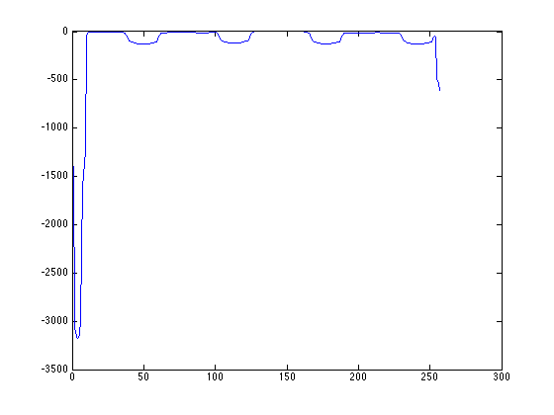

Image 3 (best delta: 107) Image 4:

Removing the divisive normalization has this effect:

Image 1:

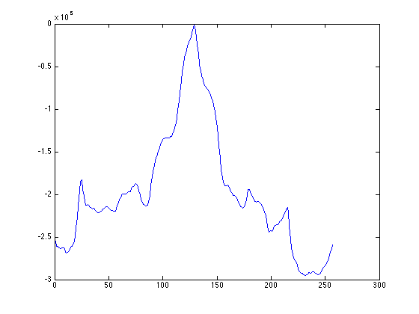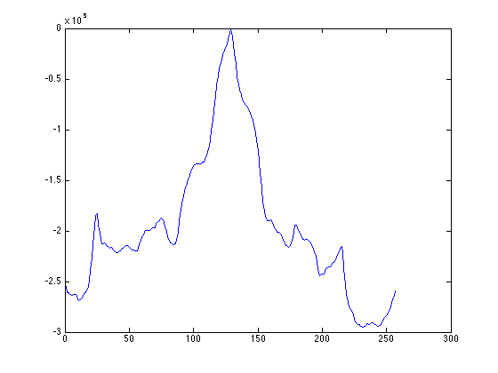

Image 1: Image 2:

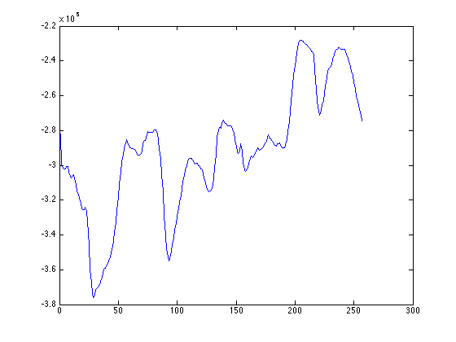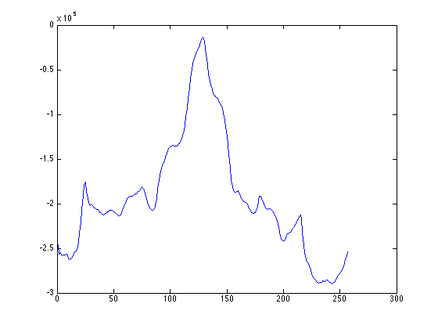

Image 3 (best delta: 204) Image 4:

And removing both does this:

Image 1:

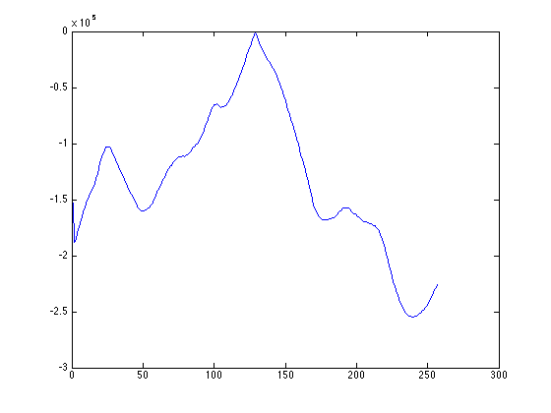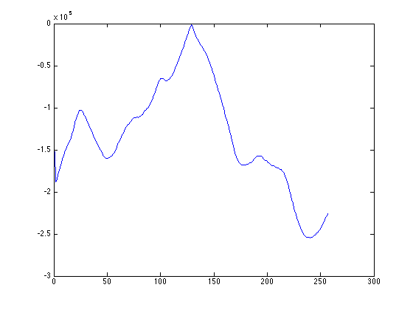

Image 1: Image 2:

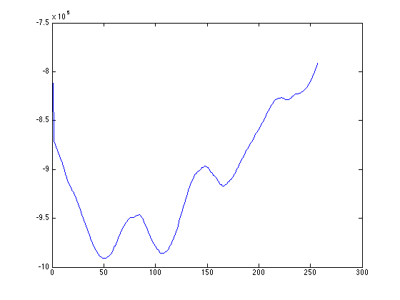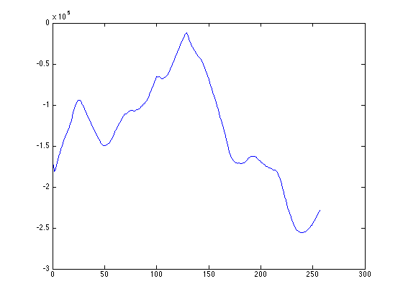

Image 3 (best delta: 256) Image 4:

Subtracting the median appeared to have a normalization effect (i.e., the differences in the dips where the images were clearly mismatched, were not so great), while dividing appeared to have a smoothing and leveling effect on the image mismatch values. In all cases except for reverse polarity, it did yield the correct best delta x, and by a large margin; so, they did detect very high image mismatches. Thus, these measures appeared to help image mismatches where the objects being matched were already *very* close spatially, but not really in other cases. So, these measures do help in registering image where the objects within the image are not already very well-aligned spatially, and it helps to yield more consistent results (i.e., smoothing).

Reverse Polarity

Reverse polarity was accounted for in Euclidean Differences by simply taking the absolute value of the quantile function differences, rather than the differences themselves. These results are reflected in all the graphs above. Without such a measure on a reverse polarity image, one sees a result like the following:

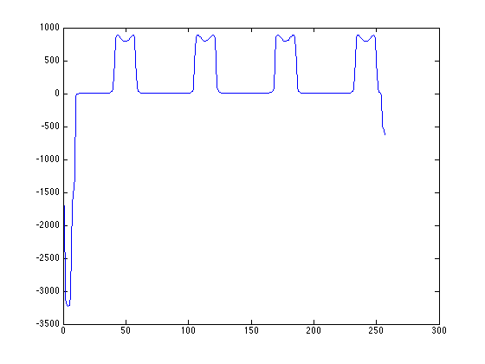

This is the reverse of the first moving image registered onto the fixed image. The best delta was 107. When absolute values were taken, this yielded the correct 128.

Proof of submission of A and B on the correct date (screenshots of commits for Github):



